Class: Final Year (Computer Science and Engineering)
Year: 2025-26 Semester: 1
Course: High Performance Computing Lab

Practical No. 4
Exam Seat No:
Title of practical:
Study and Implementation of Synchronization

Problem Statement 1:

Analyze and implement a Parallel code for below programs using OpenMP considering synchronization requirements. (Demonstrate the use of different clauses and constructs wherever applicable)

Fibonacci Computation:

Screenshots:
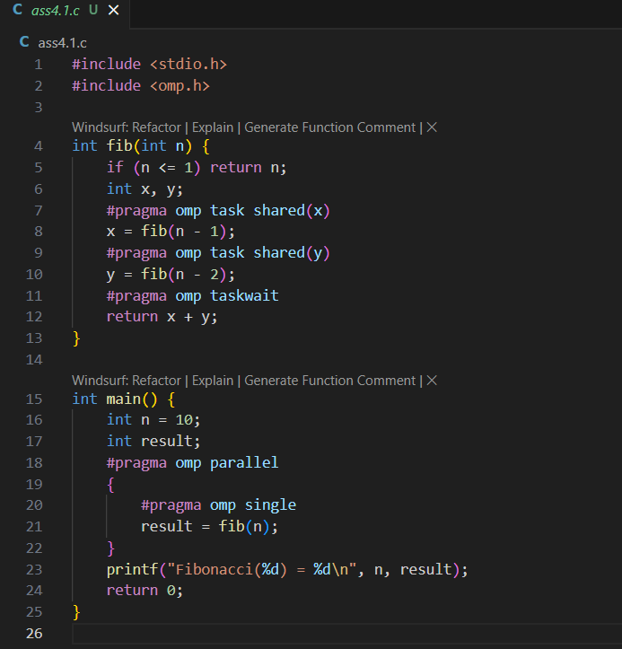

Information:
- Uses #pragma omp task to create parallel tasks for recursive calls.
- Uses #pragma omp taskwait to synchronize tasks.

Problem Statement 2:

Analyze and implement a Parallel code for below programs using OpenMP considering synchronization requirements. (Demonstrate the use of different clauses and constructs wherever applicable)

Producer Consumer Problem

Screenshots:
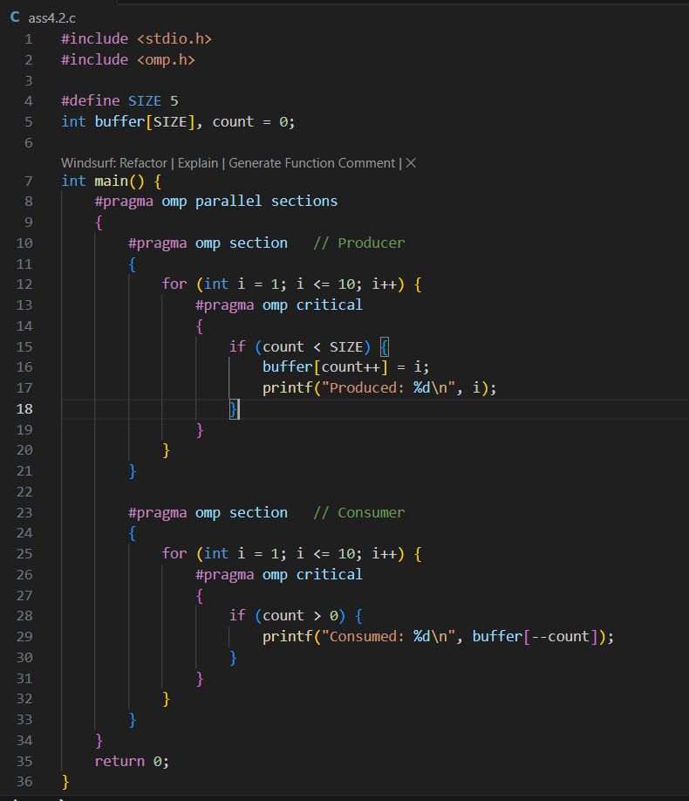
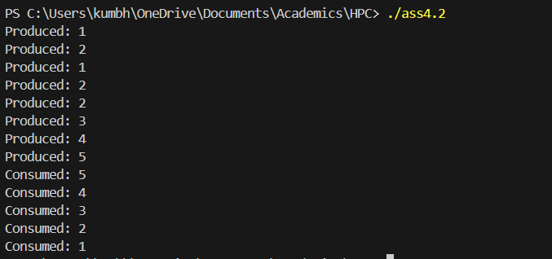

Information:
- Uses #pragma omp parallel sections to run producer and consumer in parallel.
- Uses #pragma omp critical to protect access to the shared buffer and count variable.
- Demonstrates synchronization using critical sections to avoid race conditions.
- Suitable for small-scale producer-consumer problems; for high performance, more advanced synchronization (like locks or atomic operations) may be needed.

Analysis:
- critical sections as a basic but effective way to ensure synchronization and prevent race conditions when multiple threads access shared resources. The document notes that while this approach is suitable for small-scale problems, for higher performance in more complex scenarios, more advanced synchronization mechanisms such as
- locks or atomic operations may be necessary

Github Link: https://github.com/Anjali1874/HPC-Lab

