Class: Final Year (Computer Science and Engineering)
Year: 2024-25 Semester: 1
Course: High Performance Computing Lab

Practical No. 5
Exam Seat No:

Title of practical: Implementation of OpenMP programs.
Implement following Programs using OpenMP with C:
- Implementation of Matrix-Matrix Multiplication.
- Implementation of Matrix-scalar Multiplication.
- Implementation of Matrix-Vector Multiplication.
- Implementation of Prefix sum.

Problem Statement 1:
Screenshots:
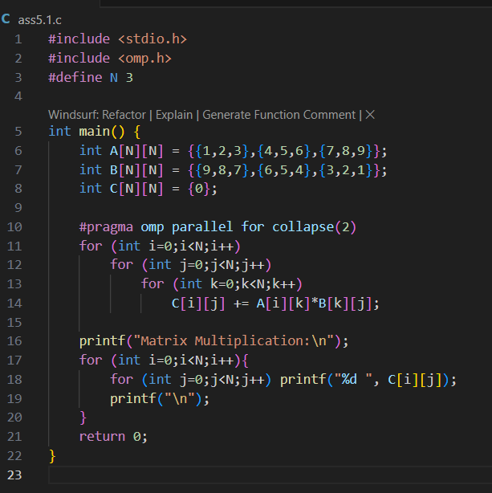
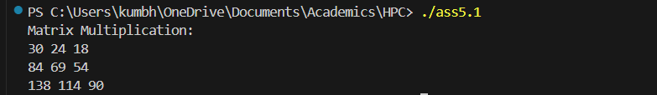
Information:
- Uses #pragma omp parallel for collapse(2) to parallelize both the outer and middle loops, distributing the computation of each element of C across threads.
- Prints the resulting matrix.
- Normally: Only outer loop (i) is parallelized, inner loop (j) stays serial inside each thread.
- With collapse(2):
  - OpenMP flattens the 2 loops → total iterations = 3 * 4 = 12.
  - Threads share these 12 iterations directly.

Analysis:
- Efficient for small matrices, but for larger matrices, memory access patterns and cache usage become important.
- The collapse(2) clause helps utilize more threads by flattening two loops, improving load balancing.

Problem Statement 2:
Screenshots:
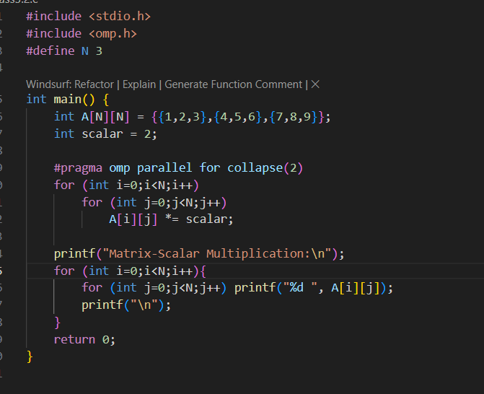
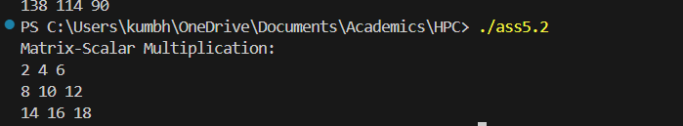
Information:
- Uses #pragma omp parallel for collapse(2) to parallelize both loops, so each element multiplication can be done by a different thread.
- Prints the resulting matrix.

Analysis:
- Demonstrates how element-wise operations on matrices can be easily parallelized.
- For very large matrices, this approach can significantly speed up computation.

Problem Statement 3:
Screenshots:
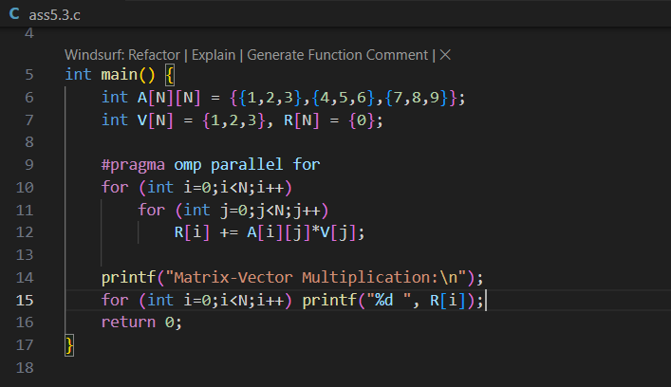
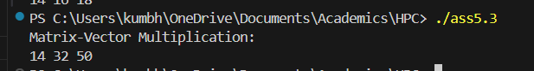
Information:
- Uses #pragma omp parallel for to parallelize the computation of each element of the result vector.
- Each thread computes one row of the result.

Analysis:
- Matrix-vector multiplication is a common operation in scientific computing and is highly parallelizable.
- For larger matrices, this approach scales well with more threads.

Problem Statement 4:
Screenshots:
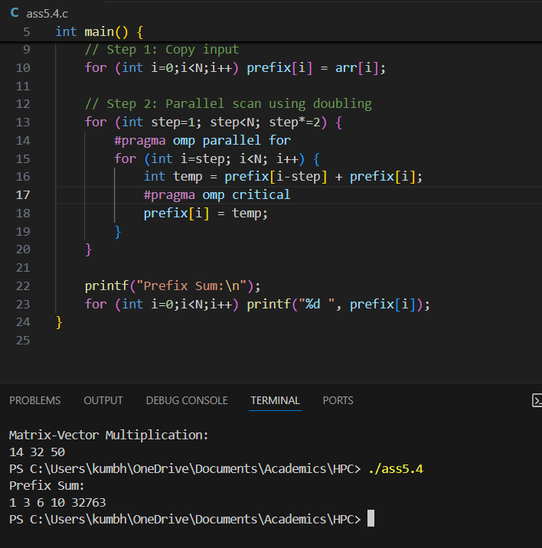

- Algorithm Explained
The algorithm used is a
parallel scan (or prefix sum) using doubling. It works in
log₂(N) steps.
- Step 1 (step=1): Each element adds its immediate left neighbor to its value.
- Step 2 (step=2): Each element adds the value of the element two places to its left.
- Step k (step = 2^k-1): Each element adds the value of the element 2^(k-1) places to its left.
process continues until the
step size is equal to or greater than the size of the array. At the end of the algorithm, each element
prefix[i] will hold the sum of all elements from arr[0] to arr[i]

Information:

- Uses #pragma omp parallel for to parallelize the loop that computes the prefix sum.
- Each outer loop (step) lets you add up numbers that are farther apart.
- First, you add each number to its immediate left neighbor.
- Next, you add each number to the sum two places to the left.
- Then, four places to the left, and so on.
- This way, each element accumulates the sum of all previous elements, building up the prefix sum in log₂(N) steps.

Analysis:
- The code efficiently computes the prefix sum in parallel using a tree-based approach.
- For small arrays, the benefit is minor, but for large arrays, this approach can be much faster than a serial loop

Github Link: https://github.com/Anjali1874/HPC-Lab

