Q1. Steps for Private Assembly
- Open Visual Studio → Create a new Class Library Project named UtilityLibrary.
- In Utilities.cs, write methods:
  - FormatText(string input) → returns text in uppercase.
  - ValidateNumber(string input) → checks if input is numeric using double.TryParse().
- Build the project → generates UtilityLibrary.dll inside “C:\Users\Hp\source\repos\UtilityLibrary\bin\Debug”
- Create a new Windows Forms App named AppPrivateDemo.
- Right-click AppPrivateDemo → Add Reference → Browse → select UtilityLibrary.dll.
- In Form1.cs, use the methods:
- string formatted = Utilities.FormatText("hello world");
- bool isNum = Utilities.ValidateNumber("123");
- Show results using MessageBox.Show().
- Run the app → message box shows formatted text and validation result.
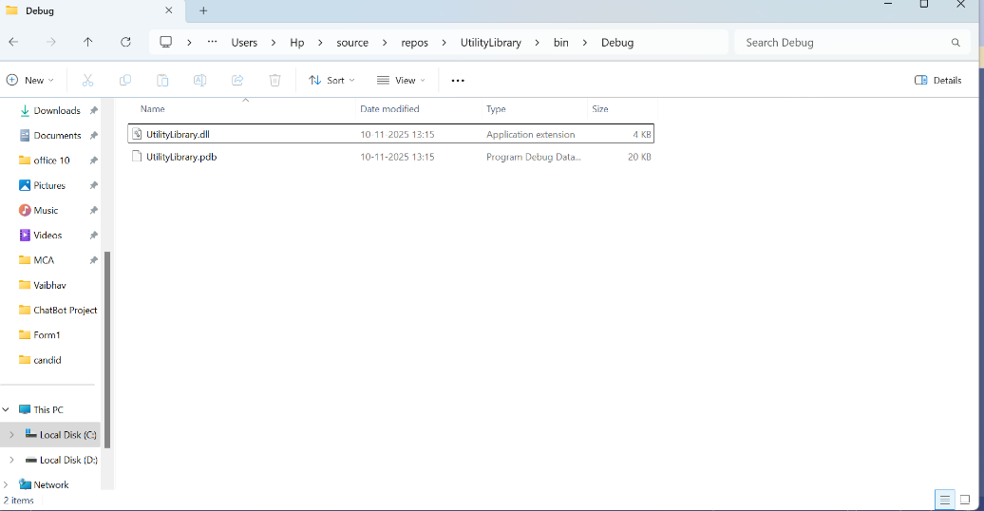

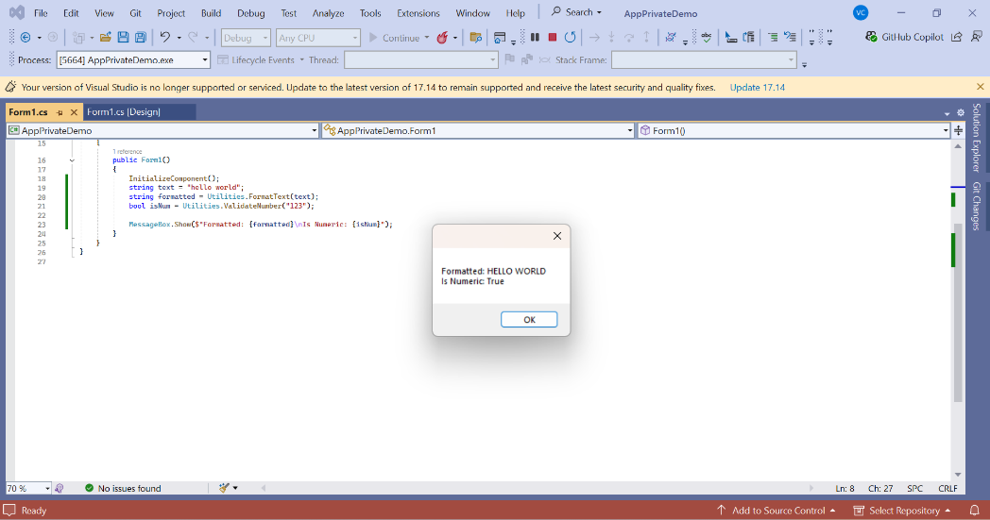

Q 2-3) Shared Assembly Steps
- Create SNK file:
sn -k "C:\UtilityKey.snk"
- Open UtilityLibrary → Properties → Signing → select SNK file.
- Check Sign the assembly → Save → Rebuild project.
- Open Developer Command Prompt (Admin).
- Install DLL to GAC:
gacutil /i "C:\Users\Hp\source\repos\UtilityLibrary\bin\Debug\UtilityLibrary.dll"
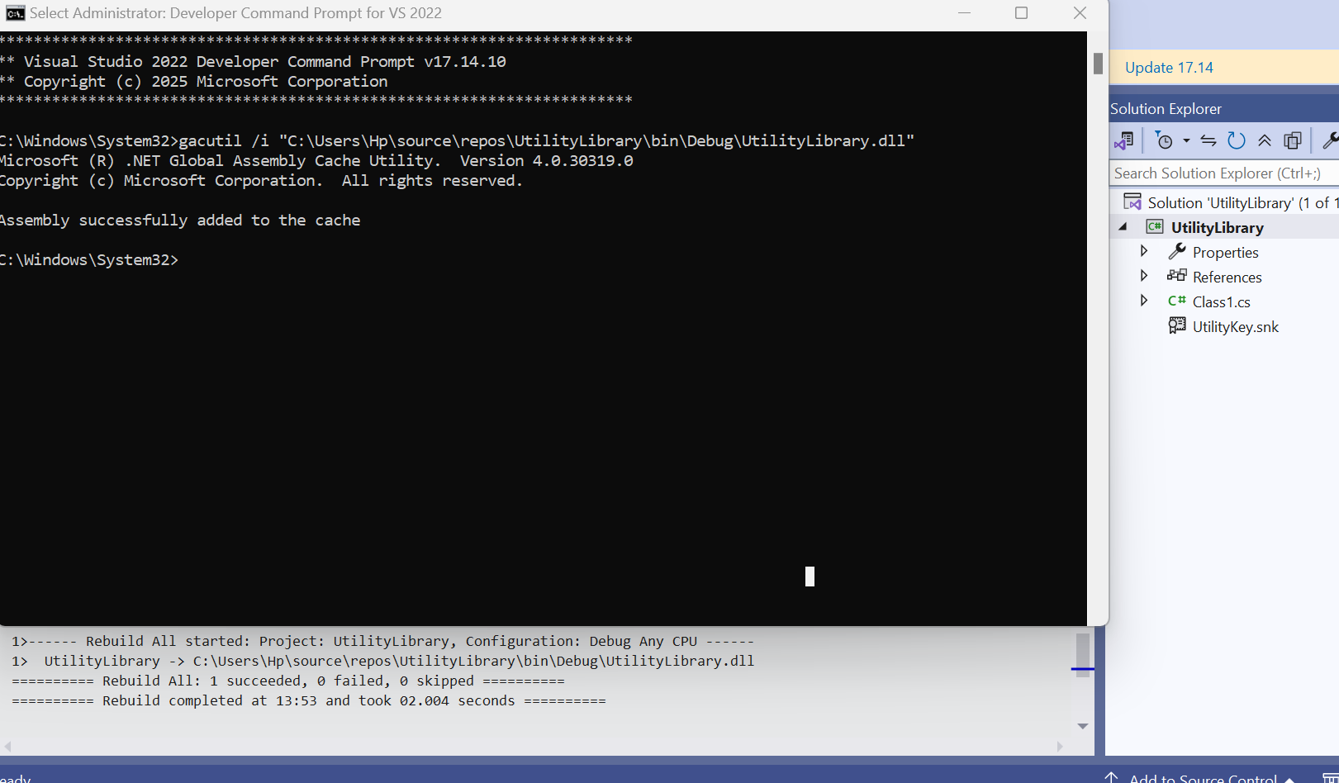
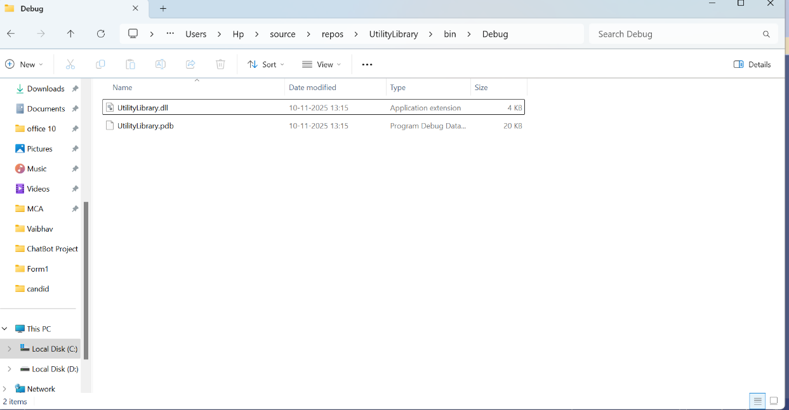

- Create new app AppSharedDemo.
- Add reference to UtilityLibrary from GAC.
- Use FormatText() and ValidateNumber() methods.
- Run app

