*Steps to create ARFF file*

* Fill the details in a notepad and save it with .arff extension .
* Open the weka file now.
* Select the attributes and notice the values and bar chart.
* Below is the sample data.

|  |
| --- |
| @relation students |
|  |

|  |
| --- |
| @attribute rollnumber numeric |
|  |

|  |
| --- |
| @attribute name string |
|  |

|  |
| --- |
| @attribute Dept {cse,ece,eee,it} |
|  |

|  |
| --- |
| @attribute age numeric |
|  |

|  |
| --- |
| @attribute year date "yyyy-mm-dd" |
|  |

|  |
| --- |
|  |
|  |

|  |
| --- |
| @data |
|  |

|  |
| --- |
| 4,anjali,cse,20,"2000-09-21" |
|  |

5,soujanya,eee,20,"2000-02-13"

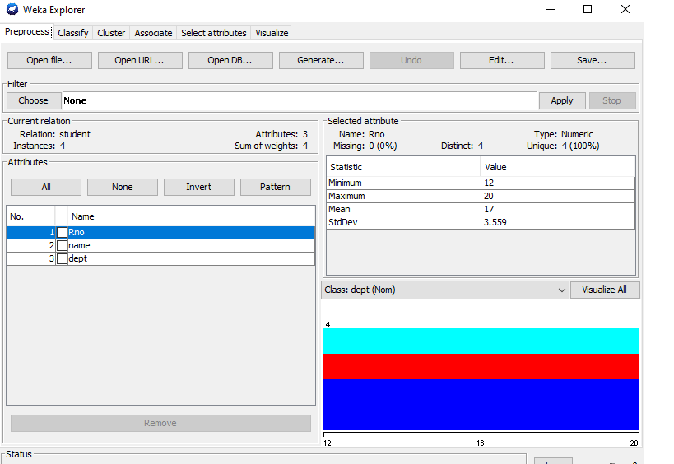

* Now select visualize all button. After visualizing it shows the piechart of all the attributes.
* The histogram chart is shown below:

