**ASSIGNMENT-1**

Load each dataset and Observe the Following:

**FOR IRIS DATASET:**

* Firstly open the iris arff file from Weka

1. List the attribute names and their types

|  |  |
| --- | --- |
| **Attribute Name** | **Attribute Type** |
| sepallength | Numeric |
| sepalwidth | Numeric |
| petallength | Numeric |
| petalwidth | Numeric |
| class | Nominal |

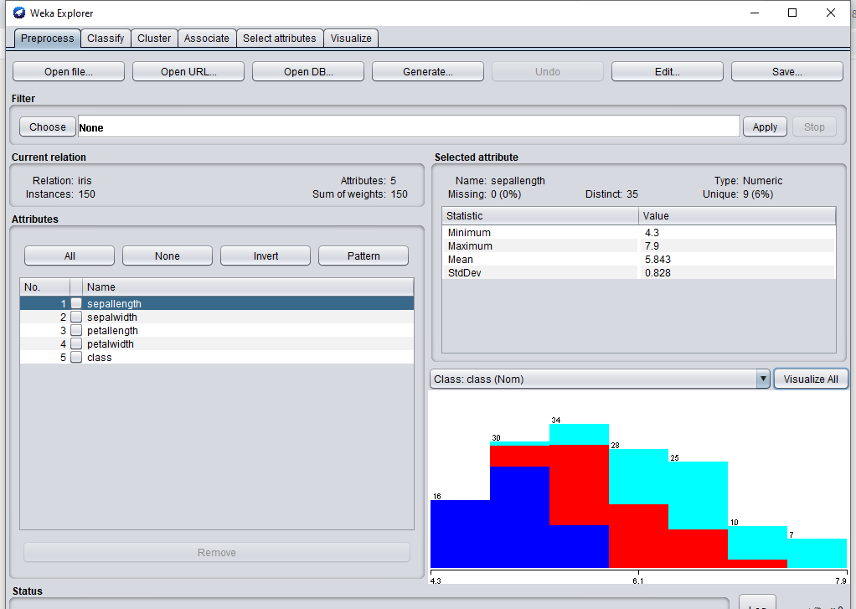

1. Number of records in the dataset

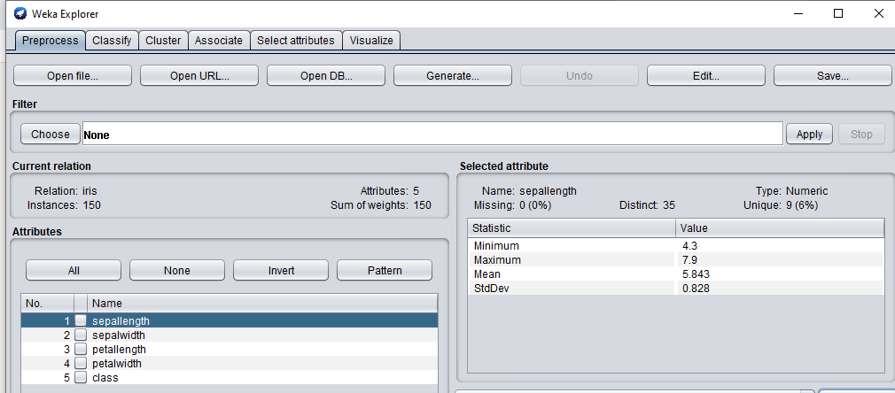

Therefore there are 150 records.

1. Identify the class attribute in the dataset : class

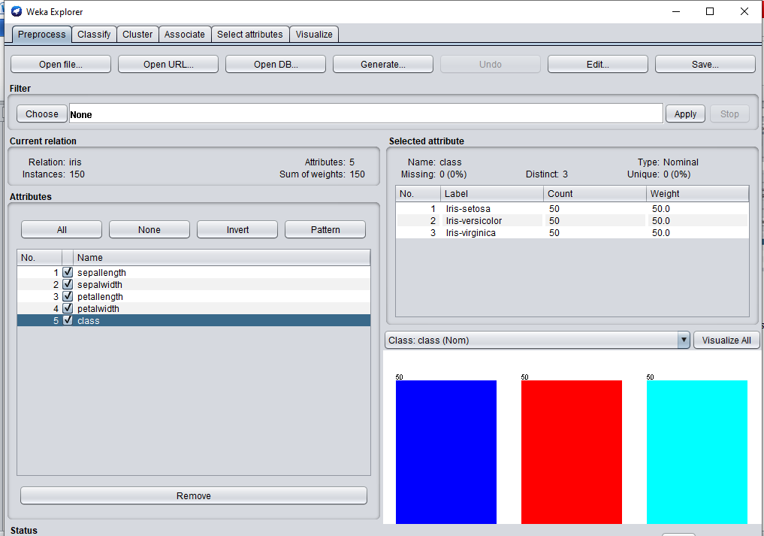

1. Graphical histogram representation of all attributes against class attribute

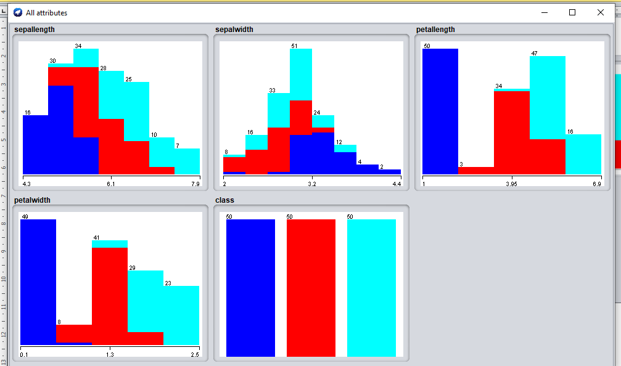

1. Determine the number of records for each class:

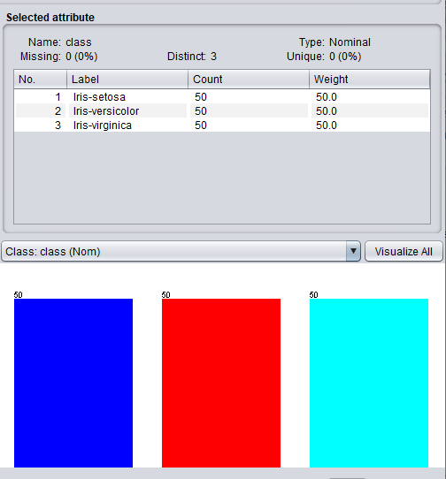

* Iris-setosa – 50 records
* Iris-virginica – 50 records
* Iris-versicolor – 50 records

**FOR GERMAN CREDIT DATASET :**

1. List the attribute names and their types:

|  |  |
| --- | --- |
| **Attribute Name** | **Attribute Type** |
| credit_history | Nominal |
| purpose | Nominal |
| credit_amount | Numeric |
| serving_status | Nominal |
| employment | Nominal |
| installment_commitment | Numeric |
| personal_status | Nominal |
| other_parties | Nominal |
| residence_since | Numeric |
| property_magnitude | Nominal |
| age | Numeric |
| duration | Numeric |
| housing | Nominal |
| existing_credits | Numeric |
| job | Nominal |
| other_payment_plans | Nominal |
| checking_status | Nominal |
| num_dependents | Numeric |
| own_telephone | Nominal |
| foreign_worker | Nominal |
| class | Nominal |

1. Number of records in the dataset

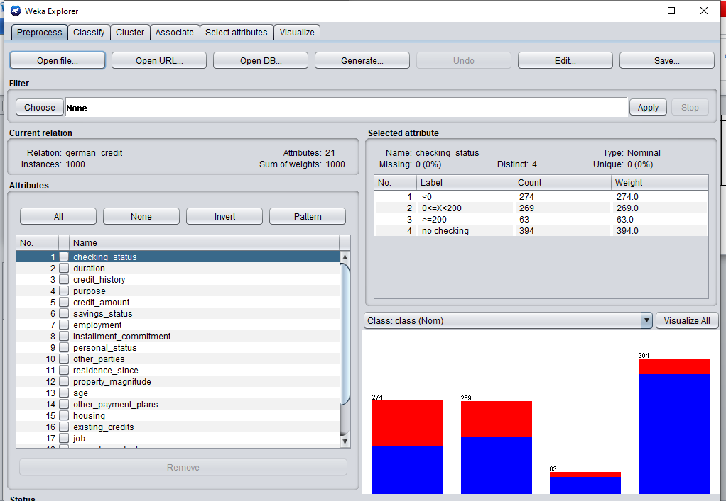

* Therefore there are 1000 Records

1. Identify the class attribute in the dataset : class

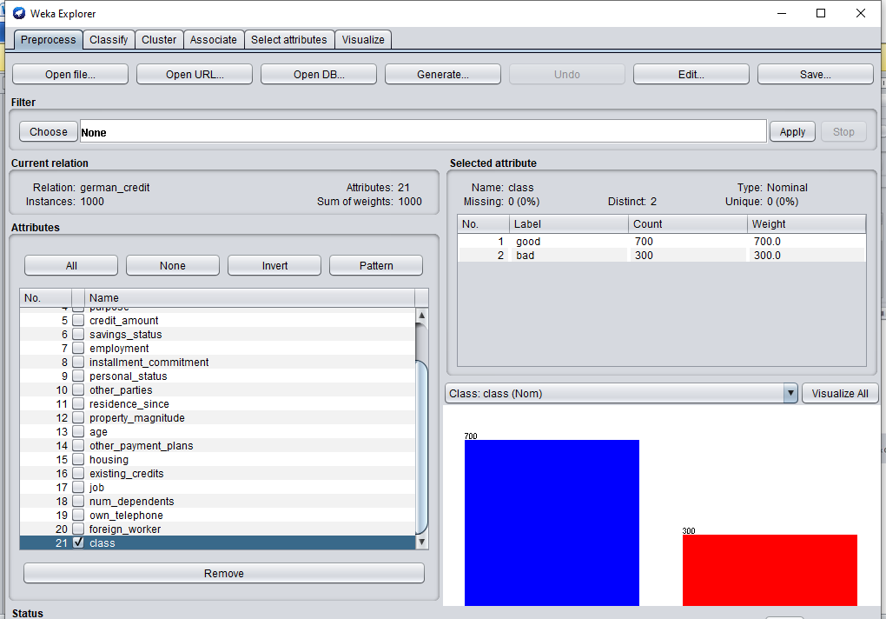

1. Graphical histogram representation of all attributes against class attribute

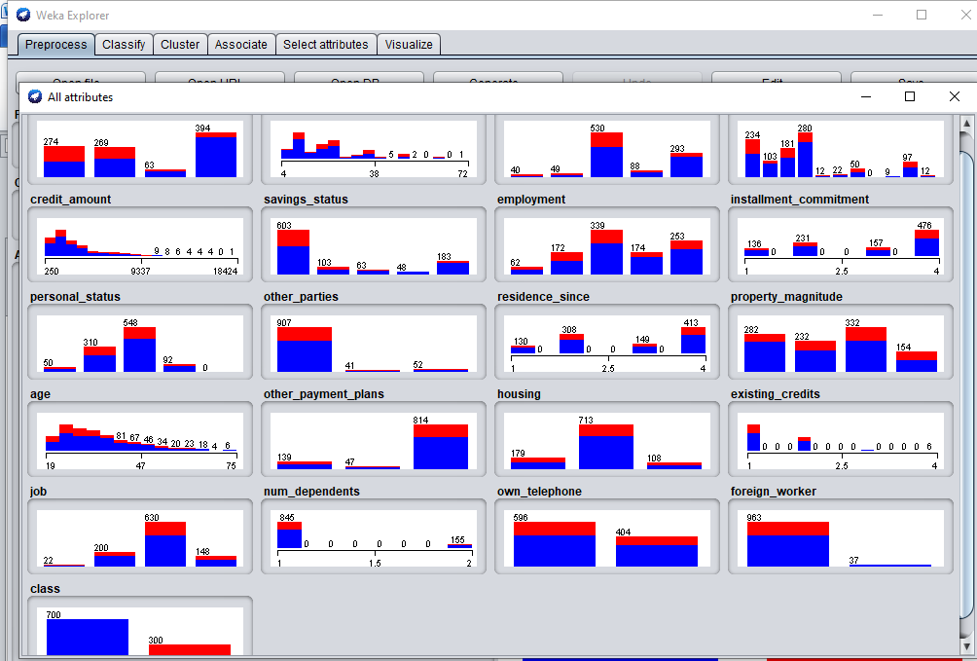

1. Determine the number of records for each class:

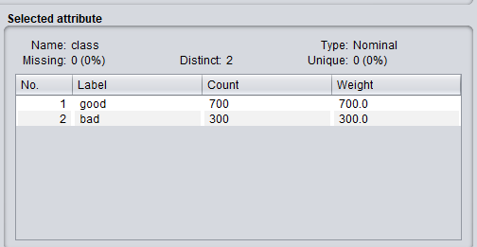

* Good – 700 records
* Bad – 300 records