**FINAL SEMESTER INTERNSHIP REPORT IV B.TECH II SEMESTER(2024-2025)**

**ON**

**FULL STACK WEBSITE DEVELOPMENT**

***An Internship Report Submitted to* JNTU,Anantapuramu**

*In partial fulfillment of the requirements for the award of the degree of*

## Bachelor of Technology Computer Science & Engineering

By

| **Name of Student** | Anjali Sanniboina |
| --- | --- |
| **Roll Number** | 21KB1A05E8 |
| **Organization** | Green Tech Industries Ind Pvt.Ltd. |
| **Name of Supervisor** | D.Viswanath Reddy |

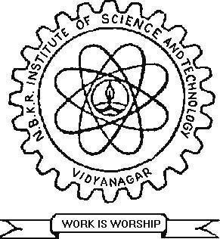

**DEPARTMENT OF COMPUTER SCIENCE AND ENGINEERING**

**N.B.K.R. INSTITUTE OF SCIENCE & TECHNOLOGY**

**(Autonomous)**

VIDYANAGAR – 524 413, TIRUPATI DIST, AP

**STUDENT’S DECLERATION**

I,Anjali Sanniboina, a student of the Btech program, Roll No. 21KB1A05E8 of the Department of CSE,NBKRIST College do hereby declare that I have completed the mandatory internship in Green Tech Industries Ind Pvt.Ltd.under the guidenship of D.Viswanath Reddy.The report of internship is prepared by me and submitted to the department.

***(Signature and Date)***

**CERTIFICATE OF INTERNSHIP**

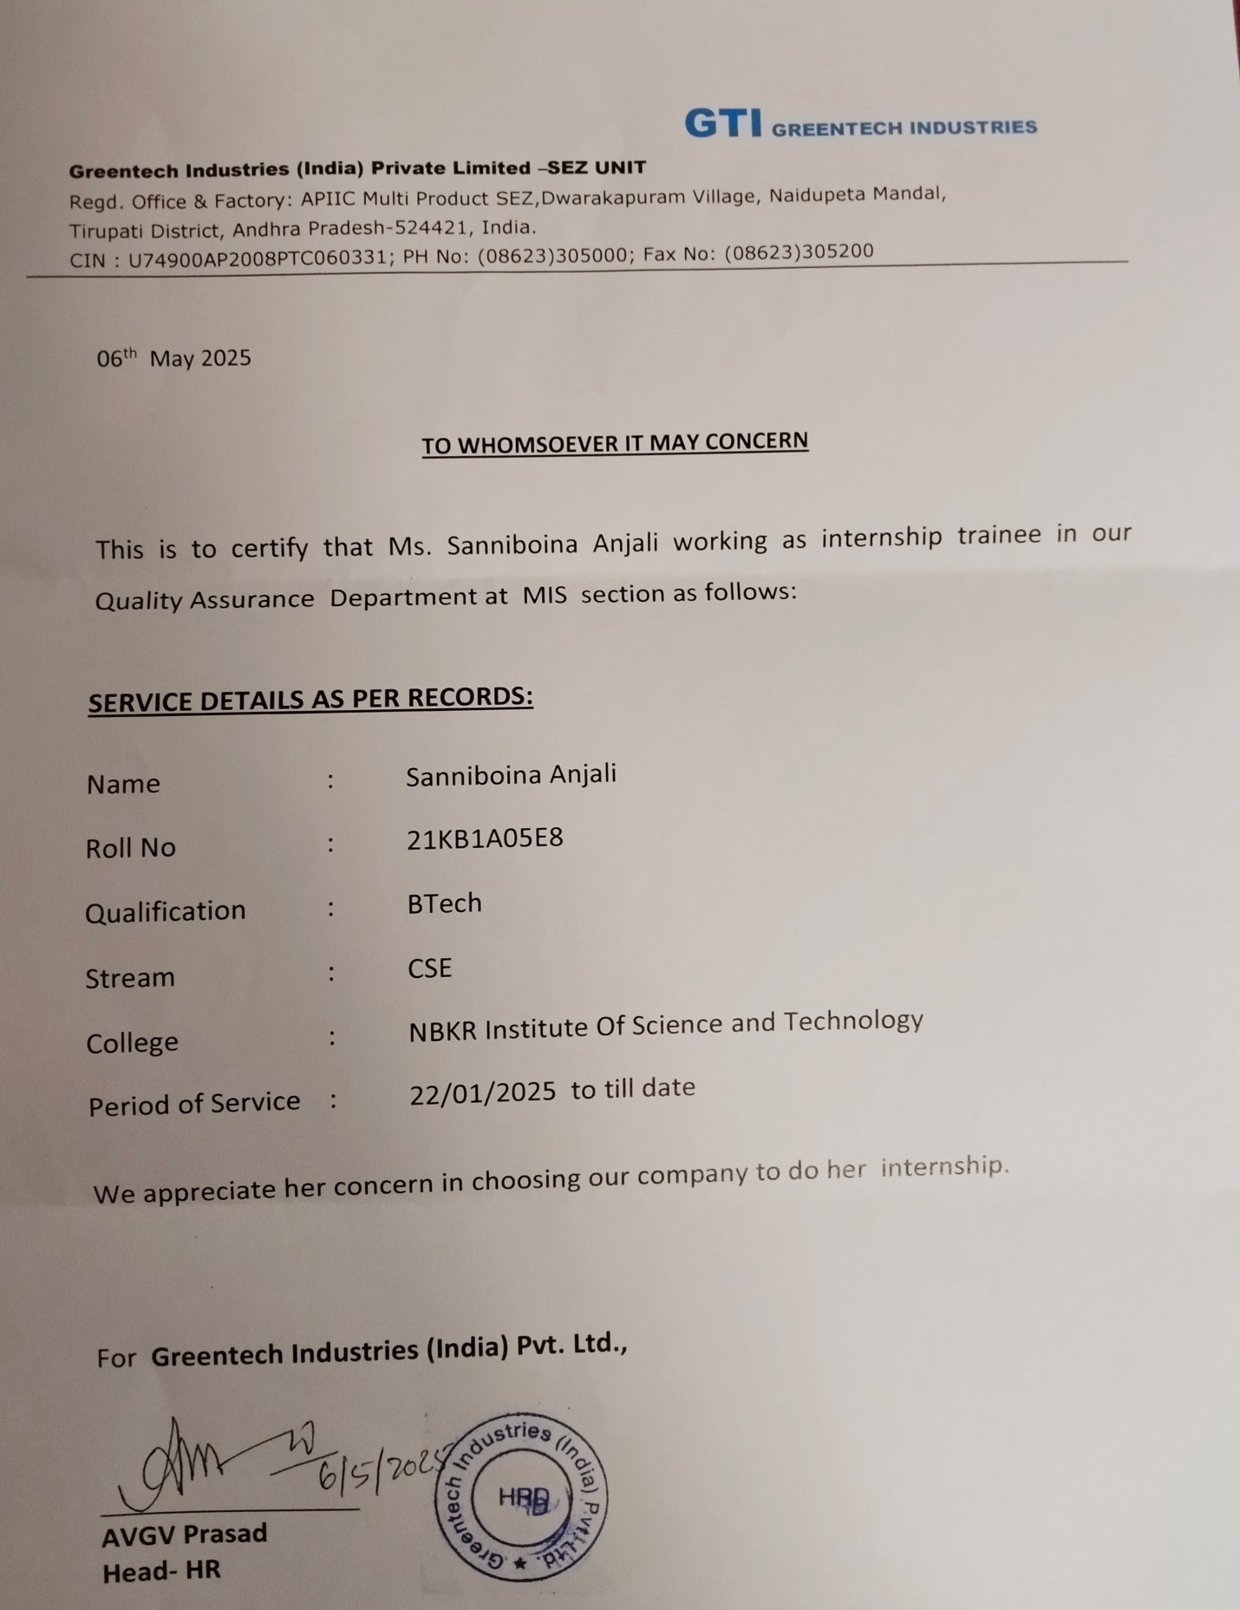

**ACKNOWLEDGEMENT**

I would like to thank **Mr.AVGV Prasad HR** Green Tech Industries Ind Pvt.Ltd me the opportunity to do an internship with the organization.

It is indeed with a great sense of pleasure and immense sense of gratitude that I acknowledge the help of the organization.

I am highly indebted to **Dr. V.VijayaKumar Reddy,** Director,N.B.K.R. Institute of Science andTechnology, for the facilities provided to accomplish this internship.

I would like to thank **Dr.A.Rajasekhar Reddy** Head of the Department,Computer Science and Engineering**,** N.B.K.R. Institute of Science and Technology, for his constructive criticism throughout my internship.

I would like to thank **Mr. P. Mutyalaiah** internship coordinator Department of ComputerScienceand Engineering, N.B.K.R.InstituteofScienceand Technology, for his support and advice to get and complete the internship in the above said organization.

I am extremely grateful to my department staff members and friends who helped me in successful completion of this internship.

**S.ANJALI (21KB1A05E8)**

**ABSTRACT**

The objective of this internship in full stack website development is to immerse interns in a dynamic and engaging learning environment, enabling them to gain hands-on experience and valuable insights across a range of web technologies. Our primary aim is to empower interns with the essential skills and knowledge required to effectively develop and manage both front-end and back-end components of web applications, with a specific emphasis on industry-standard frameworks and tools. Throughout the internship duration, interns will engage in a structured curriculum designed to provide comprehensive coverage of web development fundamentals and advanced concepts.

By actively participating in hands-on activities, practical exercises, and real-world projects, interns will cultivate a robust understanding of key principles, including user interface design, server-side programming, database management, API integration, and version control practices. As interns progress through the program, they will receive mentorship and guidance from experienced professionals in the field, enabling them to refine their technical abilities, enhance problem-solving skills, and develop a mindset geared towards innovation and continuous improvement.

Additionally, regular evaluations and feedback sessions will provide interns with valuable insights into their performance, allowing them to identify areas for growth and tailor their learning journey to align with their individual career aspirations. Ultimately, the overarching goal of this internship is to equip interns with the requisite knowledge, skills, and confidence to navigate the complexities of full stack web development effectively. By fostering a dynamic learning environment and providing hands-on experiences with leading web technologies, we aim to empower interns to emerge as proficient and versatile web developers, poised to make meaningful contributions to the rapidly evolving landscape of technology and digital innovation.

**ORGANIZATION’S INFORMATION**

**Green Tech Industries India Pvt. Ltd.** is a prominent entity in the Indian automobile industry, specializing in the manufacturing of high-quality engine components. The company is headquartered in the APIIC Multi Product SEZ, Dwarakapuram Village, Naidupet Mandal, SPSR Nellore District, Andhra Pradesh, India.

#### ****Vision****

To be at the forefront of the Indian automobile industry's anti-pollution efforts by introducing advanced engine components that meet international standards, thereby contributing to a cleaner and more sustainable environment.

#### ****Mission****

Dedicated to delivering world-class quality automobile products, Green Tech Industries aims to manufacture components that adhere to stringent environmental norms, ensuring the welfare of its employees, society, and the country.

#### ****Core Values****

* **Innovation**: Emphasizing continuous innovation and the adoption of emerging technologies to stay ahead in the industry.
* **Excellence**: Commitment to delivering the highest quality in every project, ensuring client satisfaction through superior solutions.
* **Integrity**: Upholding ethical practices and transparency in all business dealings.
* **Customer Focus**: Ensuring that the needs and expectations of clients are consistently met and exceeded.

#### ****Achievements****

Green Tech Industries India Pvt. Ltd. has been at the forefront of the Indian automobile industry’s anti-pollution efforts by introducing engine components that comply with Euro norms. It is the first Indian company to introduce Volvo engine spares with Euro standards. Fully owned by the company, the foundry and machine shop are equipped with the latest technology from advanced countries and managed by experienced engineers from Taiwan and China, ensuring top-grade quality in casting products.

.

**WEEKLY OVERVIEW OF INTERNSHI ACTIVITIES**

### ****Week 1: Introduction to Full Stack Development****

**Overview:**  
Introduced to the concept of full-stack development and the technologies involved.

**Activities:**

* Overview of front-end vs. back-end development.
* Introduction to popular tech stacks like **MERN** (MongoDB, Express.js, React, Node.js) and **LAMP** (Linux, Apache, MySQL, PHP).
* Hands-on tutorials setting up a development environment (Node.js, npm, Git).

### ****Week 2: HTML and CSS Fundamentals****

**Focus:**  
Learned the basics of web page structure and styling.

**Activities:**

* Hands-on exercises creating static web pages using **HTML5**.
* Introduction to **CSS3** for styling and layout (Flexbox, Grid).
* **Project:** Built a simple static website.

### ****Week 3: JavaScript Basics****

**Focus:**  
Understood JavaScript fundamentals for client-side scripting.

**Activities:**

* Learned core JavaScript concepts like variables, functions, loops, and events.
* Hands-on tutorials with **DOM** manipulation.
* **Project:** Enhanced the static website with JavaScript interactivity.

### ****Week 4: Version Control with Git****

**Focus:**  
Learned the importance of version control in development.

**Activities:**

* Introduction to **Git** and **GitHub** for version control.
* Hands-on exercises: cloning repositories, making commits, branching, and merging.
* **Project:** Collaborated on a small group project using Git.

### ****Week 5: Introduction to Front-End Frameworks****

**Focus:**  
Explored modern front-end frameworks for building dynamic applications.

**Activities:**

* Overview of frameworks like **React**, **Vue.js**, and **Angular**.
* Introduction to **React**: components, state, and props.
* **Project:** Built a simple application using React.

### ****Week 6: Back-End Development Basics****

**Focus:**  
Understood the server-side of web applications.

**Activities:**

* Introduction to **Node.js** and **Express.js**.
* Built a simple **RESTful API** with Express.
* **Project:** Created a basic server to handle CRUD operations.

### ****Week 7: Databases and Data Management****

**Focus:**  
Learned about databases and how to integrate them with applications.

**Activities:**

* Introduction to **SQL** (PostgreSQL/MySQL) and **NoSQL** (MongoDB) databases.
* Hands-on setup of a database and connecting it to the server.
* **Project:** Implemented data storage in the back-end application.

### ****Week 8: User Authentication and Authorization****

**Focus:**  
Implemented user management in the application.

**Activities:**

* Learned about authentication strategies like **JWT** and **OAuth**
* Hands-on implementation of user sign-up and login.
* **Project:** Added authentication to the application.

### ****Week 9: Building Full Stack Applications****

**Focus:**  
Integrated front-end and back-end components.

**Activities:**

* Connected the **React** front-end to the **Express** back-end.
* **Project:** Created a full-stack application with CRUD functionality.
* Discussion on best practices in full-stack development.

### ****Week 10: API Development and Integration****

**Focus:**  
Learned how to consume and create APIs.

**Activities:**

* Overview of **RESTful APIs** and **GraphQL**.
* Hands-on exercise: Consumed a public API in the front-end application.
* **Project:** Built and documented a RESTful API.

### ****Week 11: Deployment and Hosting****

**Focus:**  
Learned how to deploy web applications.

**Activities:**

* Deployed applications using hosting services like **Vercel**.
* Explored CI/CD pipelines for automated deployment.
* **Project:** Deployed the full-stack application on the web.

### ****Week 12: Advanced Front-End Development (React/Next.js)****

**Focus:**  
After mastering **React.js**, I advanced to learning **Next.js**.

**Activities:**

* **Next.js**: Learned server-side rendering, static site generation, and API routes.
* Created advanced pages and routes using **Next.js**.Implemented dynamic rendering and optimized performance for large-scale web applications.
* **Project:** Enhanced the project with advanced routing and SEO optimization using **Next.js**.

### ****Week 13: API Integration and Advanced Database Queries****

**Focus:**  
Worked on integrating multiple APIs and writing advanced database queries.

**Activities:**

* Integrated third-party APIs into the project for enhanced functionality (e.g., payment gateways, data fetching).
* Wrote **stored procedures** and optimized queries for the SQL database.
* **Project:** Integrated a complex API into the project for real-time data updates.

### ****Week 14: Final Project: Exports and Imports****

**Focus:**  
Worked on a project dealing with **exports and imports** functionality.

**Activities:**

* Built features to handle the import/export of large datasets (CSV, JSON, Excel) through a user-friendly interface.
* Optimized the back-end logic for handling large data sets efficiently.
* **Project:** Finalized and deployed a complete project with export and import functionality, demonstrating full-stack development knowledge.

**OUTCOME**

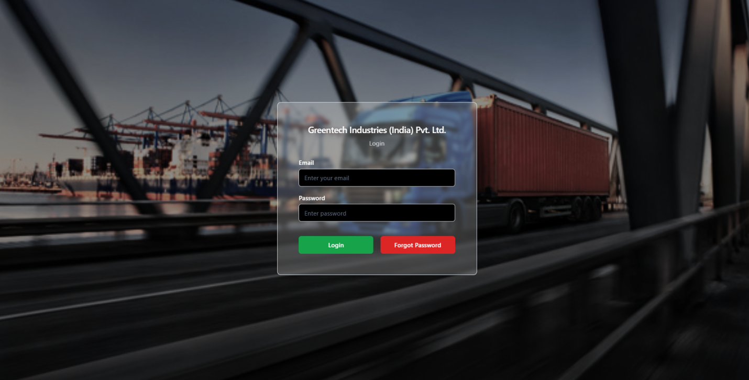

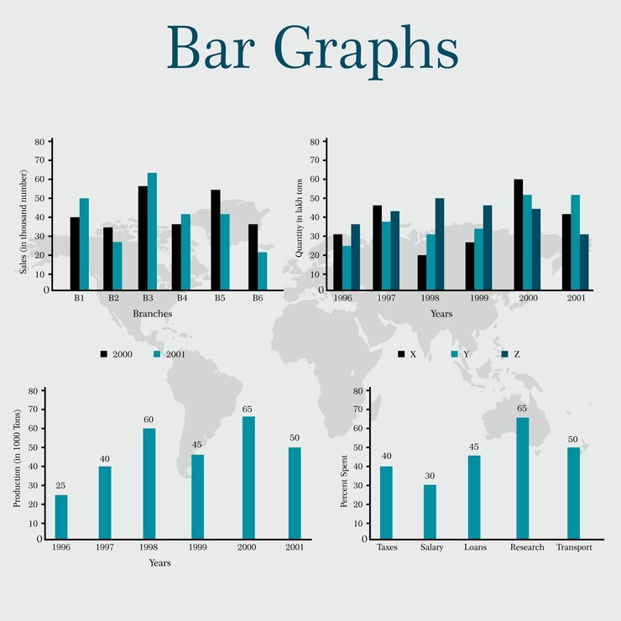

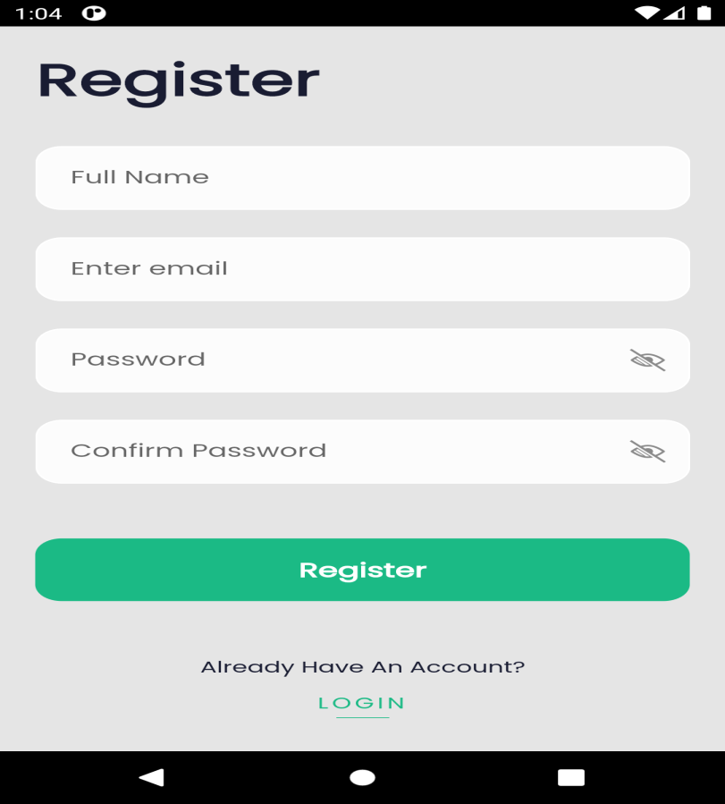

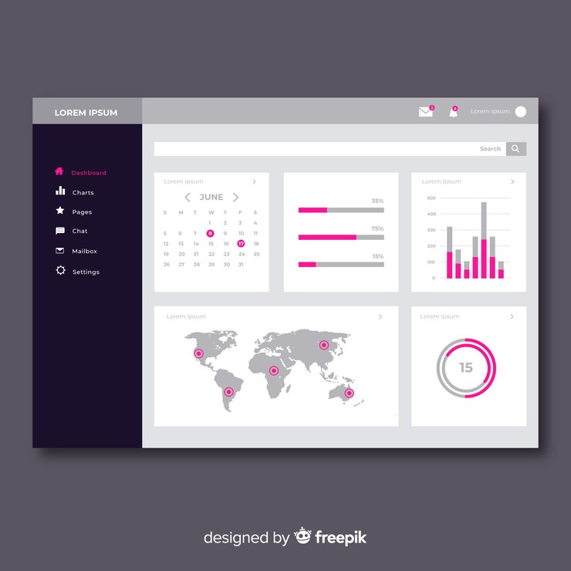

**CONCLUSION**

Reflecting on the Full Stack Web Development internship, it is evident that this experience has been a pivotal chapter in my professional journey. The internship served as an invaluable opportunity to bridge the gap between theoretical knowledge and practical application, greatly enhancing my skills and understanding of full stack development processes. The exposure to a professional environment, combined with the opportunity to work on diverse, real-world projects, proved to be essential in preparing me for a career in the technology sector.

The challenges encountered and overcome during this period not only honed my technical abilities but also contributed significantly to my personal and professional growth. From enhancing my communication and teamwork skills to developing a resilient and adaptable mindset, the internship has shaped me into a more well-rounded individual and professional.

Inspired by this experience, I have set forth clear goals and aspirations for my future. These goals reflect a commitment to continual learning and specialization in web development technologies. The relationships and professional network I developed during the internship are assets I cherish and look forward to nurturing as I advance in my career.

In conclusion, the Full Stack Web Development internship at [Company Name] has been an immensely rewarding and transformative experience. It has not only affirmed my passion for web development but also set me on a path of lifelong learning and professional growth in the dynamic world of technology. The skills, knowledge, and experiences gained during this period have laid a solid foundation for my future endeavors, positioning me well for success in the ever-evolving landscape of web development.