**ME301A (Energy Systems) Project   
 by Anant Kumar Nayak (210129) and Adarsh Mudgal (210050)**

Comparative Analysis of Enhanced Geothermal Systems (EGS) vs. Traditional Coal-Fired Power Plants

* **Overview of both systems**
* **Coal-fired power plants**, or coal-fired power stations, are facilities designed to produce electricity by burning coal. These plants fall under the category of fossil fuel power stations. The typical process involves pulverizing coal and burning it in a specialized boiler. The heat generated in the furnace transforms water in the boiler into steam, which, in turn, powers turbines, ultimately driving generators to produce electrical energy. This sequence represents the conversion of chemical energy stored in coal into thermal energy, followed by mechanical energy, and finally, electrical energy.
* An **enhanced geothermal system (EGS**) is a method of producing geothermal electricity that doesn't rely on naturally occurring convective hydrothermal resources. In the conventional approach to geothermal power, systems could only operate in areas where there was an adequate combination of natural heat, water, and permeable rock to facilitate energy extraction. However, a significant portion of geothermal energy accessible through conventional means is found in dry and impermeable rock formations. EGS technologies overcome this limitation by employing stimulation methods, such as 'hydraulic stimulation,' to enhance the availability of geothermal resources.
* **Thermodynamics principles and process**
* **Principle of Coal fired power plants and its processing**:

1. A coal-fired power station converts chemical energy stored in coal successively into thermal energy, mechanical energy and, finally, electrical energy. The coal is usually pulverized and then burned in a pulverized coal-fired boiler. The heat from the burning pulverized coal converts boiler water to steam, which is then used to spin turbines that turn generators.
2. The heat generated by burning coal is utilized to convert water into high-pressure steam. This conversion occurs in a boiler, where the water is heated, and the resulting steam is pressurized. The **principle of converting thermal energy (heat) into mechanical energy (steam) is fundamental to the functioning of a coal-fired power plant**.
3. The high-pressure steam is directed to a turbine. This steam has a significant amount of thermal and kinetic energy. The **turbine operates on the principle of converting the kinetic energy of the moving steam into mechanical energy by making the turbine blades rotate.**
4. The rotating turbine is connected to a generator. The generator contains a coil of wire and a magnet. As the turbine spins, it causes the magnet to rotate within the coil. According to the principles of electromagnetic induction discovered by Michael Faraday, the changing magnetic field induces an electric current in the wire coil. This current is the electricity generated by the power plant.

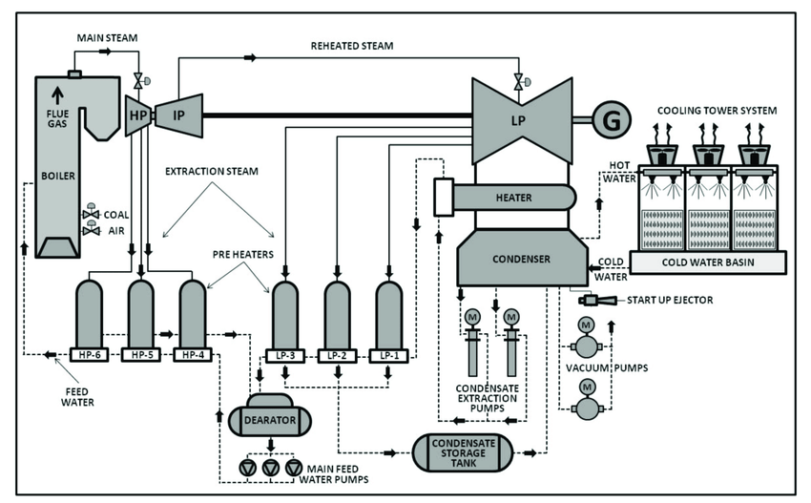

* **Principle of EGS and its processing:**

1. Heat Source: EGS sites are typically located in areas with high temperature gradients beneath the Earth's surface. This heat can be generated from the natural decay of radioactive elements in the Earth's crust or from molten rock (magma) at greater depths.
2. Drilling: Deep wells are drilled into the Earth's crust to access the geothermal reservoir. These wells can extend several kilometers below the surface to reach the desired heat source.
3. Injection and Circulation: Cold water or other heat-transfer fluids are injected into one well to create a fracture network or reservoir in the hot rock. This water circulates through the fractured rock, absorbing heat as it flows. The pressurized, heated fluid then rises to the surface through another well.
4. Heat Extraction: The geothermal fluid is brought to the surface at a high temperature and pressure, where its heat energy is extracted. This heat is then used to generate electricity through a binary power plant or for direct heating applications.
5. Sustainability: To maintain a sustainable EGS operation, the reservoir's pressure and temperature are managed, ensuring that the geothermal resource remains viable over time. This sometimes involves adjusting injection and extraction rates.

* **Capital Cost Analysis**:

1. **Coal-Fired Power Plants**:

* Capital Costs: Coal-fired power plants typically involve substantial capital investments. The costs include building the power plant infrastructure, purchasing and installing the pulverized coal-fired boiler, turbines, generators, environmental control systems, and other necessary equipment.
* Infrastructure Expenses: Costs are incurred for constructing facilities to handle and store coal, as well as for developing the necessary transportation and supply chain infrastructure.
* Environmental Compliance: Meeting environmental regulations can lead to additional expenses, such as installing pollution control technologies.

1. **Enhanced Geothermal Systems (EGS**):

* Capital Costs: EGS projects involve initial capital investments for drilling wells into hot rock formations and creating the necessary reservoirs. This includes the cost of drilling equipment, well construction, and stimulation methods like hydraulic fracturing.
* Exploration and Site Assessment: Costs are incurred in the exploration phase to identify suitable geothermal reservoirs and assess the site's potential for enhanced geothermal power generation.
* Surface Facilities: Expenses are associated with building surface facilities, such as power plants, turbines, and electricity generation infrastructure.
* **Efficiency comparison:**

Comparison of the efficiency for 2 systems:

1. Thermal Efficiency:

* Enhanced Geothermal Power Plant: Enhanced geothermal power plants typically have high thermal efficiency, often exceeding 90%. This high efficiency results from the direct conversion of geothermal heat into electricity through binary cycle power plants or flash steam power plants.
* Coal-Based Thermal Power Plant: Coal power plants have lower thermal efficiency, typically ranging from 30% to 40%. The lower efficiency is due to the combustion of coal to produce heat, which results in significant heat losses in the process.

1. Overall Conversion Efficiency:

* Enhanced Geothermal Power Plant: The overall conversion efficiency of geothermal power plants is relatively high, as they efficiently convert the heat from the Earth's interior into electricity. Their efficiency is also not significantly affected by weather conditions.
* Coal-Based Thermal Power Plant: Coal power plants have lower overall conversion efficiency due to the additional losses associated with coal mining, transportation, combustion, and emissions control. These losses can reduce the effective electrical output relative to the energy content of the coal.

1. Combined Heat and Power (CHP) Efficiency:

* Enhanced Geothermal Power Plant: Geothermal power plants are primarily used for electricity generation. However, in some cases, they can also be designed for combined heat and power (CHP) applications, where the excess heat is used for heating or other industrial processes, improving overall efficiency.
* Coal-Based Thermal Power Plant: Coal plants can also be configured for CHP, where waste heat is used for district heating or industrial processes, increasing their overall efficiency. However, coal power plants are less efficient in CHP compared to geothermal plants.

* In summary, enhanced geothermal power plants are known for their high thermal and overall conversion efficiencies, making them a clean and efficient source of electricity. In contrast, coal-based thermal power plants have lower thermal and overall conversion efficiencies due to the inherent inefficiencies associated with coal combustion and the environmental controls required. As a result, geothermal power plants are a more efficient and environmentally friendly choice for electricity generation compared to coal-based thermal power plants.
* **References:**

1. Wikipedia
2. <https://www.energy.gov/eere/geothermal/enhanced-geothermal-systems>
3. <https://energyeducation.ca/encyclopedia/Coal_fired_power_plant>