Game Design Document

Team Name : Gambience Flippers
Team Members : Anjali Jain
Game Name : Tiles Flippers
Game genre/
catogory : Entertainment

Language : React Native
Platform : Android
Deployment : Mobile
User i/p device : Touch screen
No. of players : 1(with computer)/ 2
No of screens : 5
Game strategy : This is a touch Android game where the player can play either with a computer or with another player. There will be a 3*3 and 4*4 grid available, and the player needs to select the grid where they want to cover more adjacent edges with the same colour heart.
vertical, horizontal, and diagonal, along with adjacent edges, will get a bonus point. This could be a winner.

Basic layout :
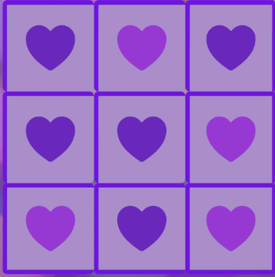
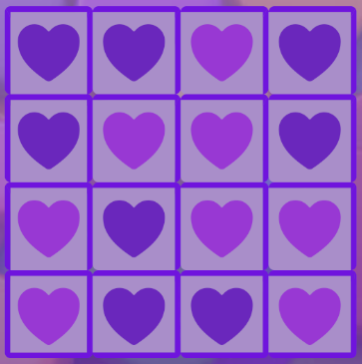

Detailed Game explanation
Tiles Flippers is an android game app, with following screens
Option Screen:
This screen will contain play option player have choice to play with computer(single player) or play with friends.

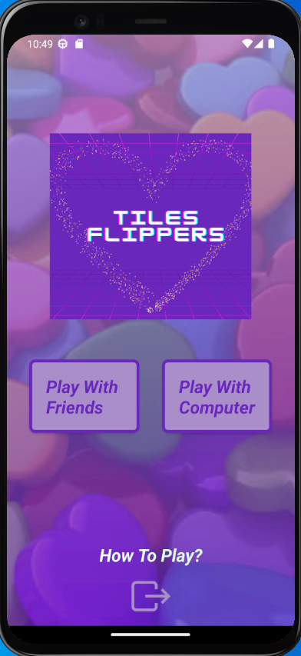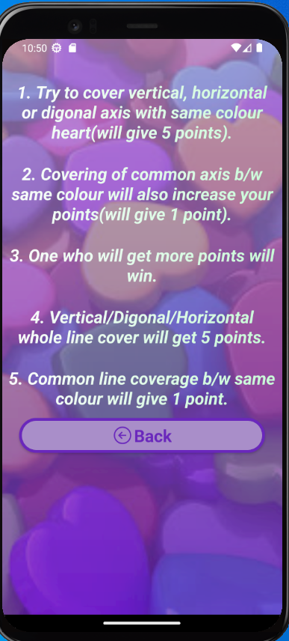

Start Game Screen:
This Screen will contain player inputs like name and give option to start the game.
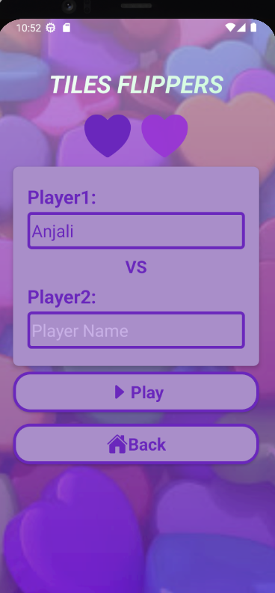

Game Screen Level 1:
This screen will have 3*3 grid where player need’s to be clicked on a particular grid for selection and try to cover more adjacent edges as well as vertical, horizontal, diagonal axis, one who will cover more will be winner.

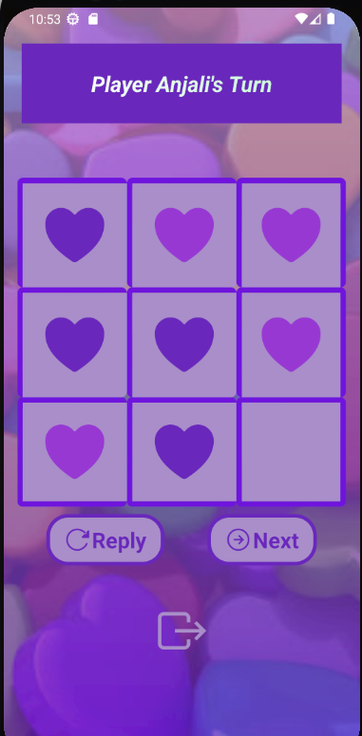

Game Screen Level 2:
This screen will have 4*4 grid with more adjacent edges & vertical, horizontal, diagonal axis cover.

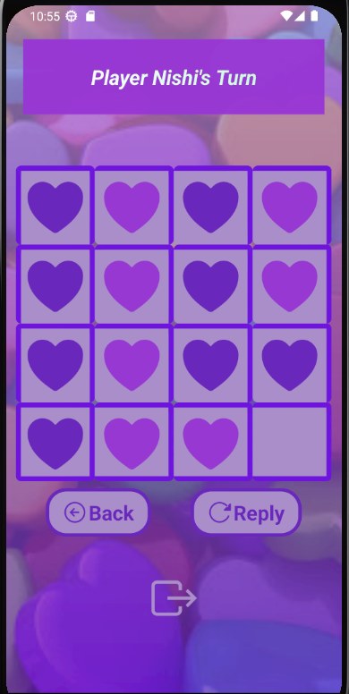

Game Over Screen:
This screen will display the winning result with respected scores.

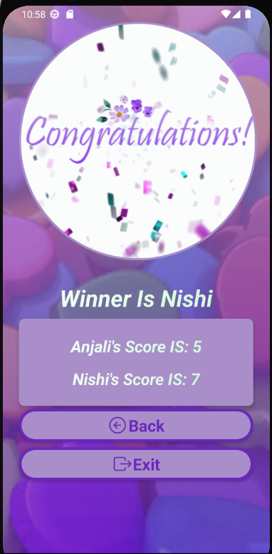
Good luck and Have fun!

