1.Read data from two excel and load into one SQL DB table.

Dataflow for loading data:

Destination with loaded data:

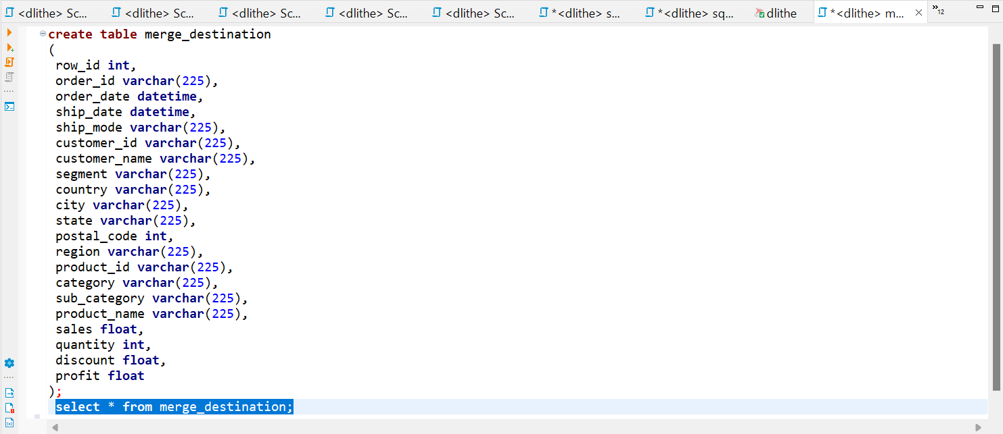

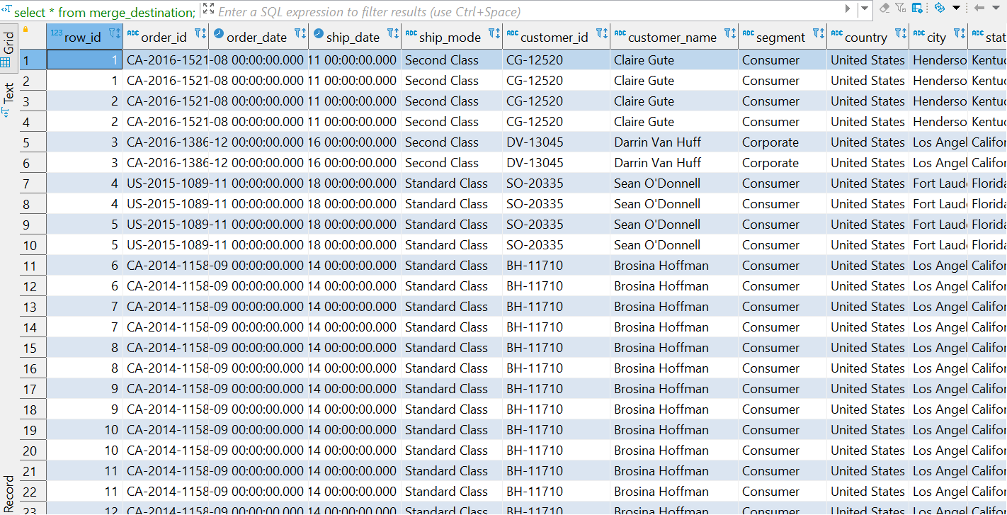

2) Read data from two SQL DB and load into one SQL DB table.

Dataflow for loading data:

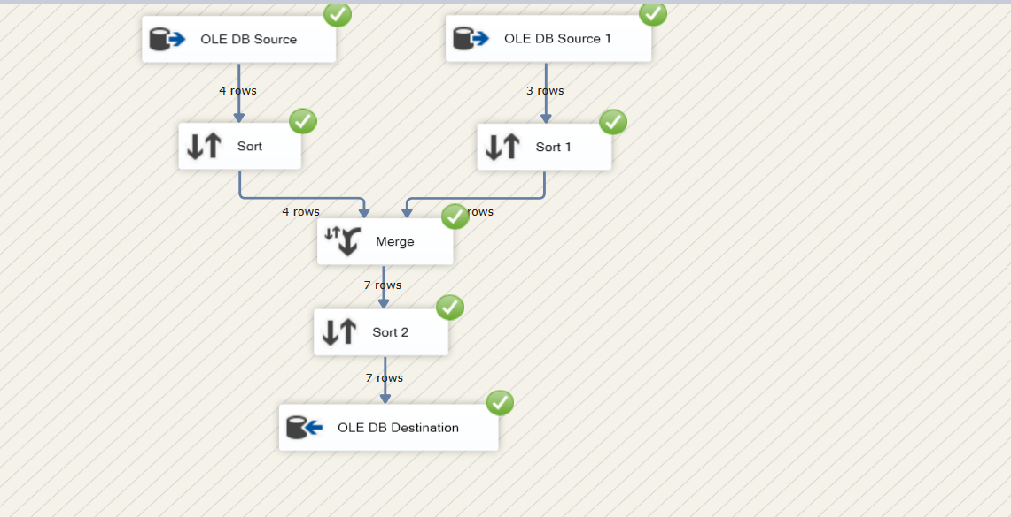

Source 1:

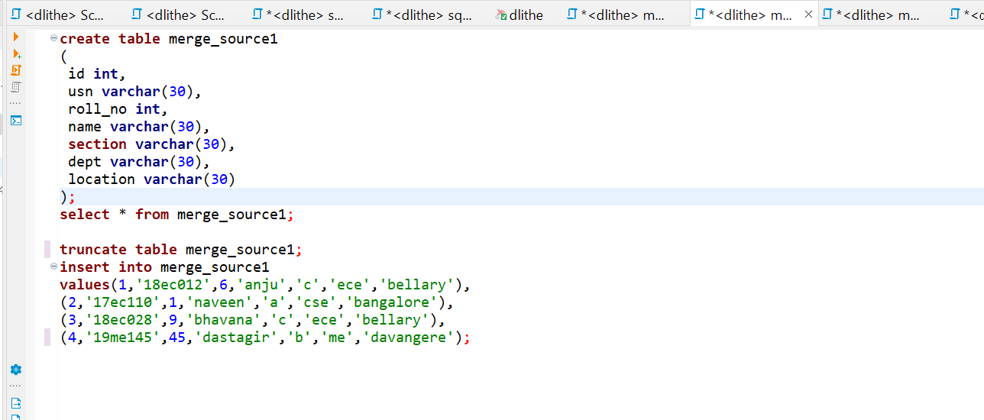

Source 2 :

Destination with loaded data:

