**Devops**

**Git Lab URL:-** <https://git.nagarro.com/GITG00641/DotNet/guddanti-anjali-.git>

1. **Create freestyle Jenkins job to download code from Git**

Login to the Jenkins portal. Select new item from the dashboard.

Provide Job name and select Freestyle project.

Give Job Description to provide additional information about the Job.

Provide git URL along with credentials.

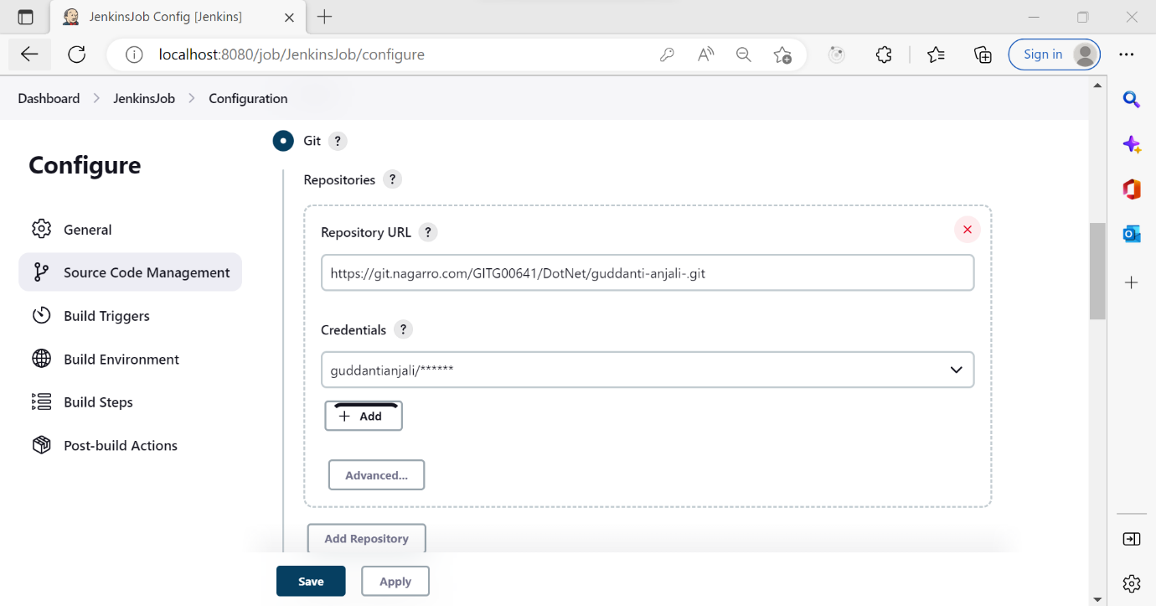

Select the required branch which you want to clone and click on save.

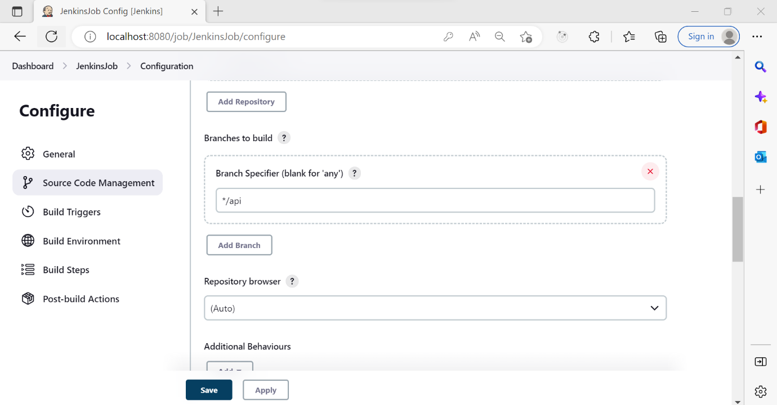

Click on the “Build now” to build the Job.

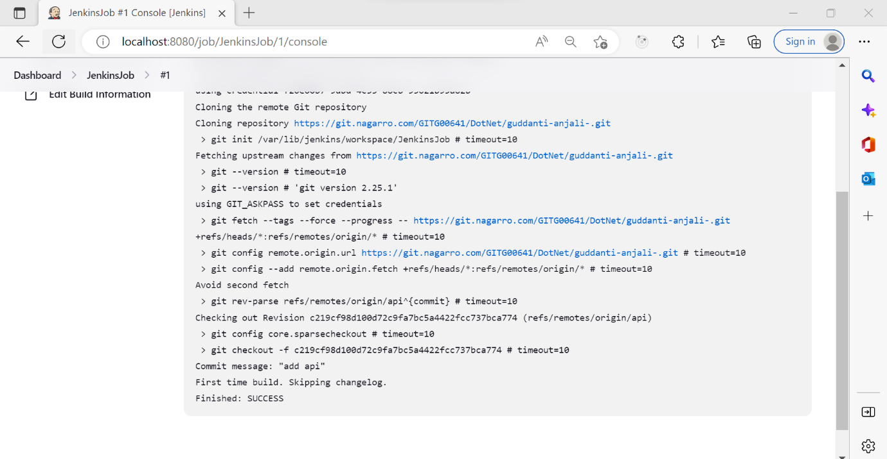

1. **Create pipeline to build and test basic .net project code**

Select new item from the dashboard. Enter the Job name and select Pipeline.

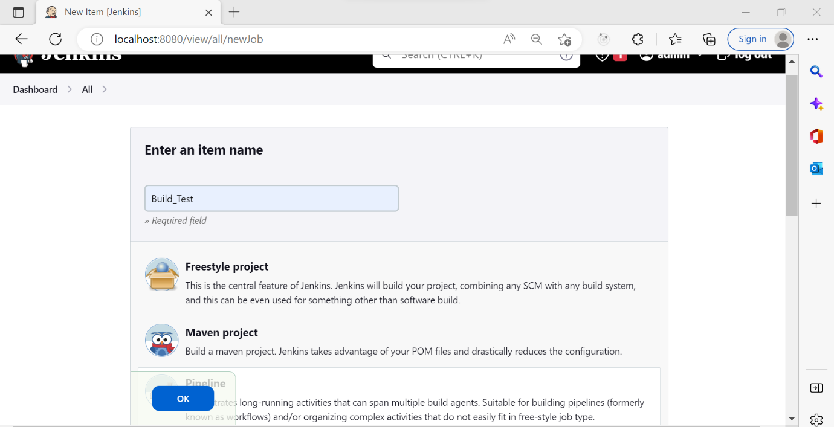

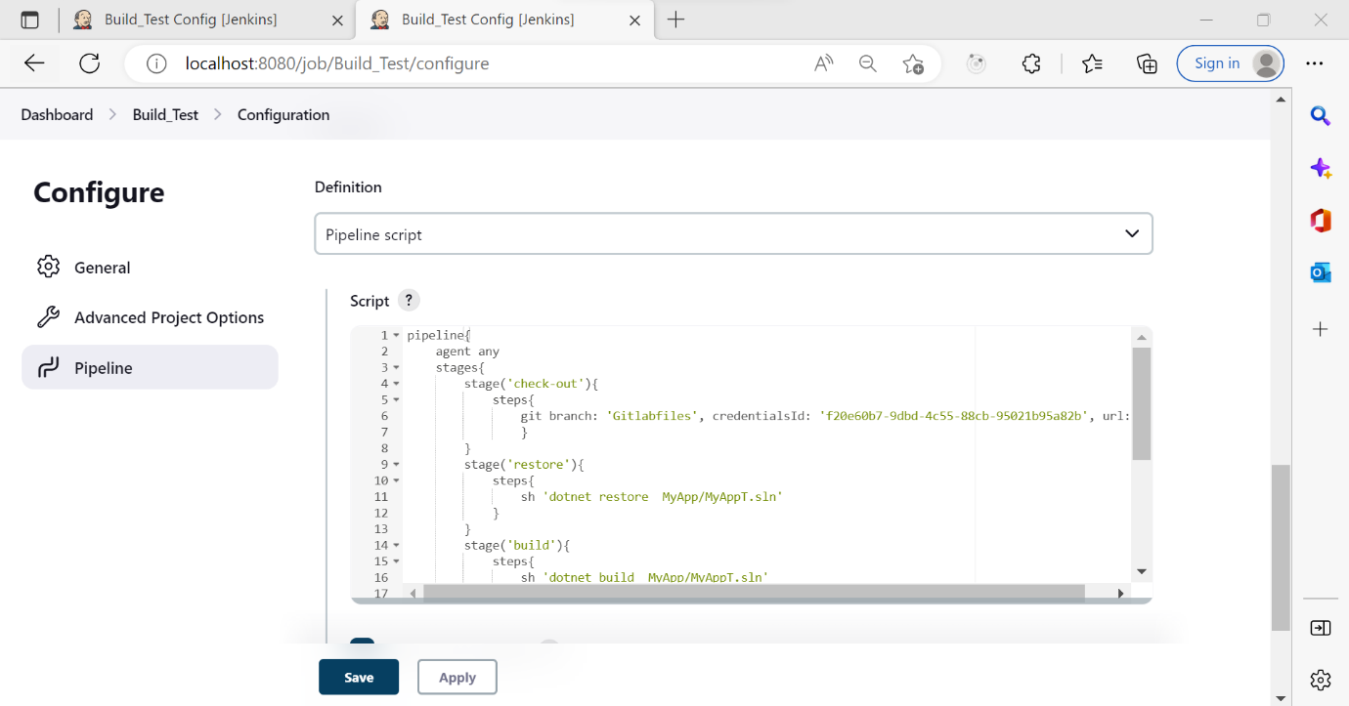

**Pipeline Script:-**

pipeline{

agent any

stages{

stage('check-out'){

steps{

git branch: 'Gitlabfiles', credentialsId: 'f20e60b7-9dbd-4c55-88cb-95021b95a82b', url: 'https://git.nagarro.com/GITG00641/DotNet/guddanti-anjali-.git'

}

}

stage('restore'){

steps{

sh 'dotnet restore MyApp/MyAppT.sln'

}

}

stage('build'){

steps{

sh 'dotnet build MyApp/MyAppT.sln'

}

}

stage('test'){

steps{

sh 'dotnet test MyApp/TestingProject/TestingProject.csproj'

}

}

stage('run'){

steps{

sh 'dotnet run --project MyApp/MyAppT'

}

}

}

}

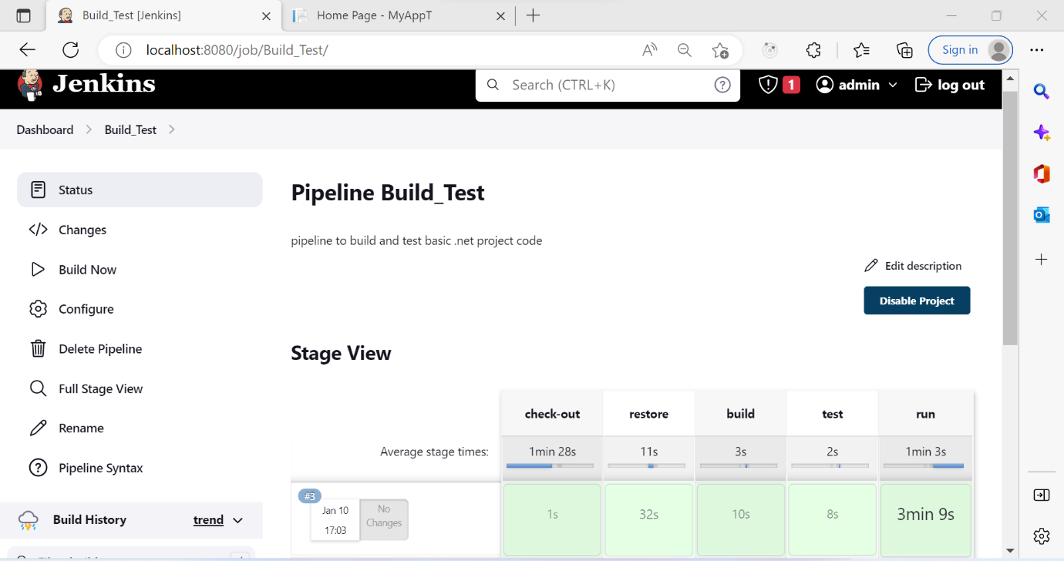

**Console output:-**

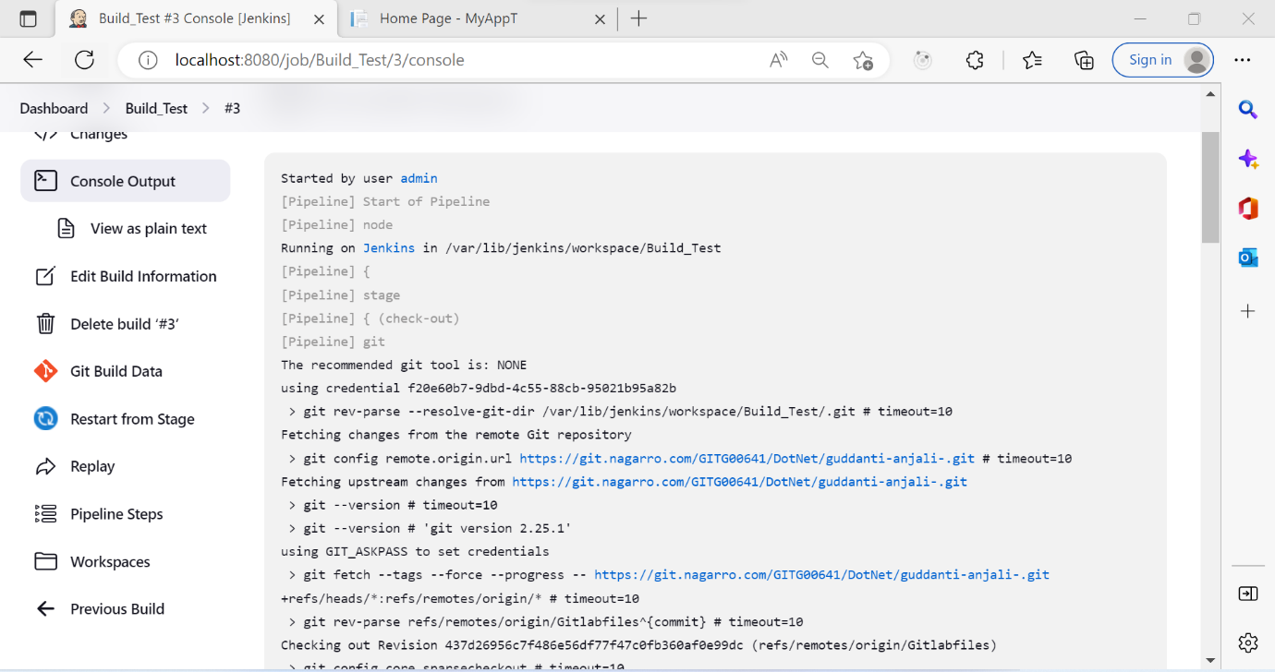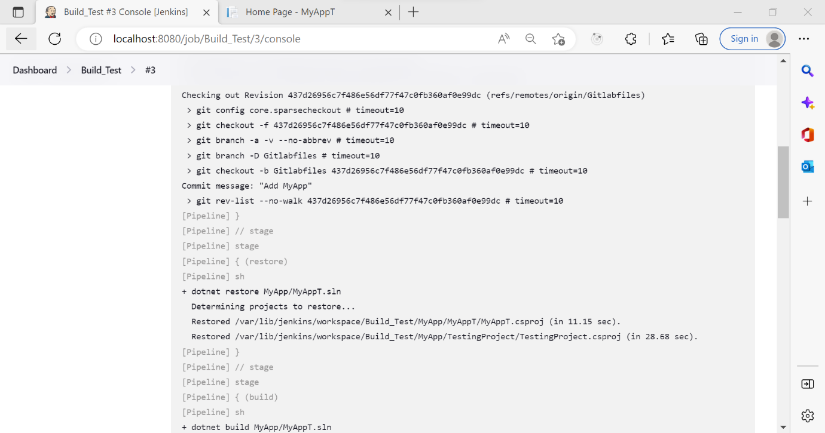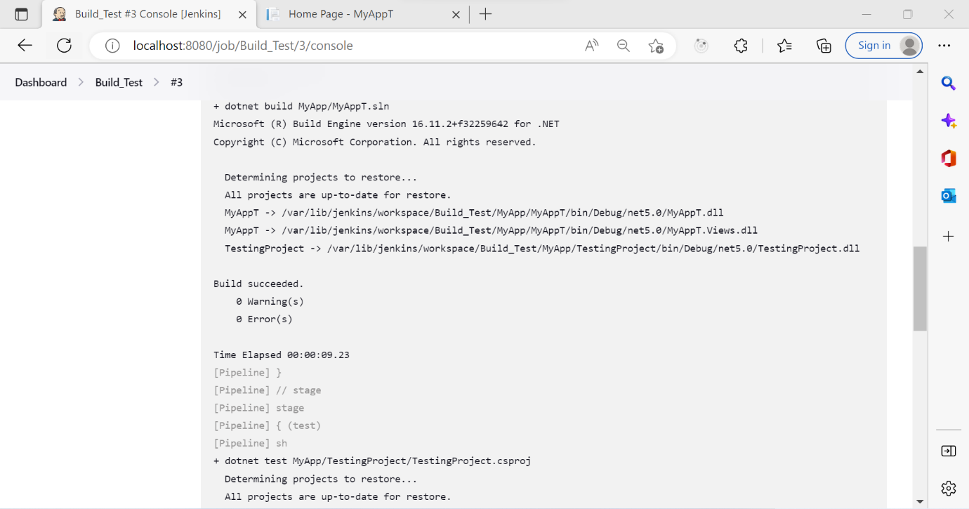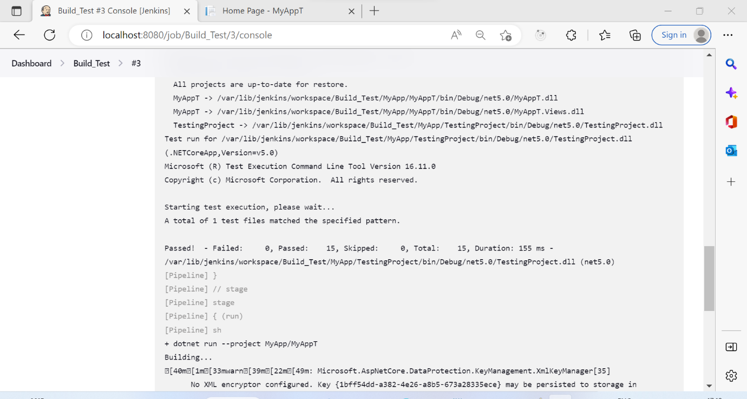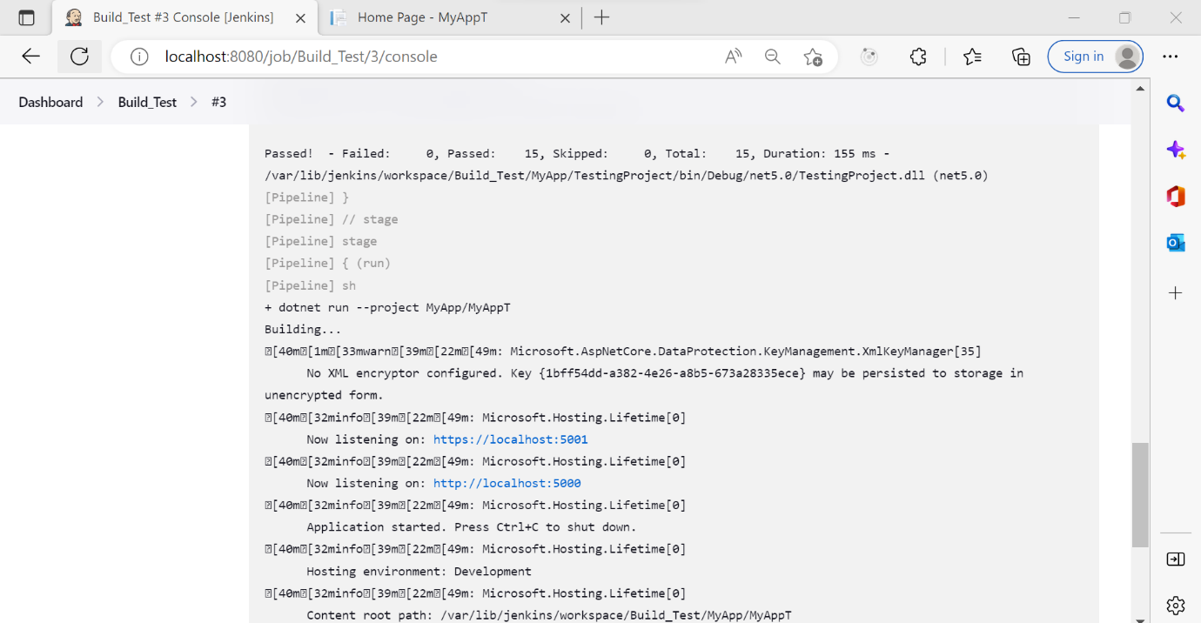

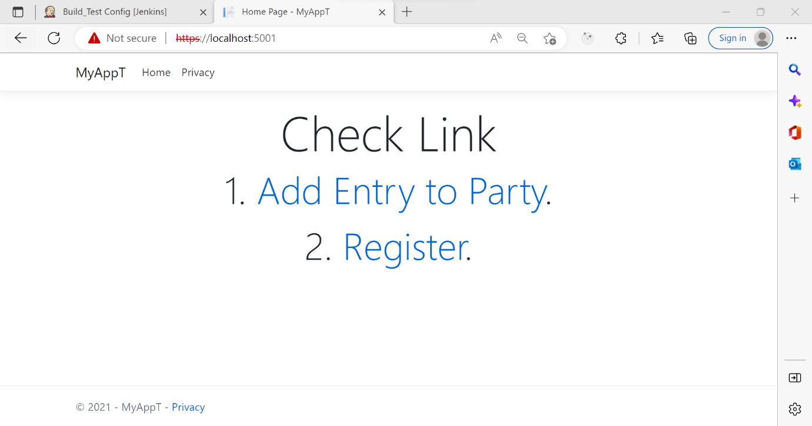

1. **Create freestyle Jenkins pipeline to build and deploy a .NET Core API/Web App using Docker**

Select new item from the Dashboard. Provide Job name and select Freestyle project.

Provide git URL along with credentials.

Select required branch.

Console output:-



