PROJECT TITLE

Machine Learning Framework for Urban Traffic Accident Risk Prediction

BACHELOR OF TECHNOLOGY
In

DEPARTMENT OF COMPUTER SCIENCE AND ENGINEERING
By
Anjali Kasarla – 2420030170.
Vinusha Muppala – 2420030212.
Lasya Geethika – 2420030686.

Under the Esteemed Guidance of
Dr. Katanguri Swanthana





K L (Deemed to be) University

DEPARTMENT OF COMPUTER SCIENCE AND ENGINEERING

DECLARATION

The mini-project report entitled “Machine Learning Framework for Urban Traffic Accident Risk Prediction” is a record of bona fide work carried out by [Names and Roll Numbers] in partial fulfillment of the requirements for the award of the B.Tech degree at K L (Deemed to be) University. The work presented in this report is original to the best of our knowledge, and all datasets, tools, code, and external sources used have been appropriately acknowledged.
Anjali Kasarla – 2420030170,
Vinusha Muppala – 2420030212,
Lasya Geethika – 2420030686.
K L (Deemed to be) University

DEPARTMENT OF COMPUTER SCIENCE AND ENGINEERING

CERTIFICATE

This is to certify that the mini-project report entitled “Machine Learning Framework for Urban Traffic Accident Risk Prediction” is a bona fide work carried out by [Student Names and Roll Numbers] under the supervision of [Faculty Guide] during the academic year [20 –20 ], in partial fulfillment of the requirements for the award of the Bachelor of Technology degree at K L (Deemed to be) University.

Signature of the Project Supervisor

Signature of the HOD Signature of the External Examiner

ACKNOWLEDGEMENT
The success in this project would not have been possible but for the timely help and guidance rendered by many people. Our wish to express my sincere thanks to all those who has assisted us in one way or the other for the completion of my project.

Our greatest appreciation to my guide, Dr. Katanguri Swanthana, Department of Computer Science which cannot be expressed in words for his/her tremendous support, encouragement and guidance for this project.

We express our gratitude to Dr. P.Venkateshwar Sir (CSE), Head of the Department for Computer Science Engineering for providing us with adequate facilities, ways and means by which we are able to complete this project-based Lab.

We thank all the members of teaching and non-teaching staff members, and also who have assisted me directly or indirectly for successful completion of this project. Finally, I sincerely thank my parents, friends and classmates for their kind help and cooperation during my work.

Anjali Kasarla – 2420030170,
Vinusha Muppala – 2420030212,
Lasya Geethika – 2420030686

TABLE OF CONTENTS

S.No. | Contents | Page no.
1. | Abstract | 6
2. | Introduction | 7
3. | Literature survey | 9
4. | Problem Statement and Objectives | 12
5. | Hardware and Software requirements | 13
6. | Implementation | 14
7. | Results & Discussion | 27
8. | Conclusion & Future Scope | 34
9. | References | 36

ABSTRACT

Traffic accident severity analysis is an important application of machine learning that can support road-safety assessment and data-driven decision-making. This project presents an integrated system for Urban Traffic Accident Severity Prediction using machine learning, explainable artificial intelligence (XAI), natural language processing (NLP), and retrieval-augmented generation (RAG). The study uses a structured road accident dataset obtained from Kaggle, containing 307,973 records and 23 columns. After removing one duplicate record, 307,972 records were retained for analysis. The target variable, Accident_Severity, contains three classes: Slight, Serious, and Fatal.

The preprocessing pipeline handles missing values, encodes categorical attributes, scales numerical features, and engineers temporal and geographical features. Logistic Regression, Decision Tree, Random Forest, and XGBoost were evaluated using stratified training, validation, and testing partitions. TF-IDF and DistilBERT representations were also implemented as NLP components, although their independent contribution to classification performance has not yet been established. SHAP is used to interpret model predictions, while a RAG-based component retrieves relevant road-safety guidance to support contextual explanations.

Among the evaluated configurations, optimized XGBoost achieved the highest validation macro F1-score of 0.3568. The system integrates these capabilities through a FastAPI backend and a React-based interface. It demonstrates the potential of combining severity classification, explainability, and safety information within a unified application.

Team No: 5

Team Logo (optional):

Team Members and Responsibilities:

- 1. [Name, Roll No. – role/responsibility]
- 2. [Name, Roll No. – role/responsibility]
- 3. [Name, Roll No. – role/responsibility]
- 4. [Name, Roll No. – role/responsibility]
- Dataset/source and project repository (if applicable):
- [Dataset URL / repository URL]

INTRODUCTION

2.1 Background

Road traffic accidents are a major public safety concern, resulting in injuries, fatalities, and economic losses. Analyzing accident-related data can help identify patterns associated with road conditions, environmental factors, vehicle characteristics, and temporal variations. Machine learning techniques provide a way to analyze these relationships and classify reported accident severity based on historical data.

Traditional analysis may struggle to capture complex relationships among numerous accident attributes. Machine learning models, including Logistic Regression, Decision Tree, Random Forest, and XGBoost, can be evaluated to identify suitable approaches for severity classification. However, differences in the frequency of severity categories can affect model performance, making appropriate evaluation metrics essential.

2.2 Problem Context

Traffic accident datasets contain structured attributes such as speed limits, junction details, road types, weather conditions, road surface conditions, vehicle types, dates, times, and geographical coordinates. Analyzing these attributes can help a model distinguish between slight, serious, and fatal accident categories.

However, accident datasets frequently contain missing values and imbalanced class distributions. A model may perform well on the majority class while producing less reliable predictions for minority classes. Furthermore, numerical predictions alone may not provide sufficient context for users who need to understand the factors influencing a classification.

2.3 Motivation

The motivation for this project is to develop an integrated application that combines accident severity classification with model explainability and contextual road-safety information. In addition to producing a severity prediction, the system uses SHAP to examine feature contributions and retrieval-augmented generation to provide relevant safety guidance.

Natural language processing techniques, including TF-IDF and DistilBERT, are also implemented as part of the broader project. Their independent contribution to predictive performance requires further controlled evaluation.2.4 Proposed Approach

The project uses a structured road accident dataset containing 307,973 records and 23 columns. After removing one duplicate record, 307,972 records remain for analysis. The target variable, Accident_Severity, contains three categories: Slight, Serious, and Fatal.

The workflow includes data cleaning, missing-value handling, feature engineering, categorical encoding, numerical scaling, model training, and performance evaluation. Logistic Regression, Decision Tree, Random Forest, and XGBoost are compared using stratified training, validation, and test partitions.

The selected XGBoost model generates severity predictions, while SHAP provides feature-attribution explanations. A retrieval-augmented generation component retrieves relevant passages from a road-safety knowledge base and uses a language model to formulate contextual explanations. The application integrates these components through a FastAPI backend and a React-based frontend.

2.4 Scope of the Project

The scope of this project includes historical accident severity classification, exploratory data analysis, feature engineering, model comparison, explainability, and retrieval-based road-safety guidance. It also includes a web interface for presenting predictions and related information.

The system predicts the reported severity category of an accident from the available attributes. It does not currently establish the probability of a future accident occurring at a particular location or time.The application is intended as a research and decision-support prototype rather than a replacement for professional road-safety assessment.

LITERATURE SURVEY

1. Road Accident Severity Prediction Using Machine Learning
Khanum et al. [1] proposed a machine-learning framework for predicting road accident severity on Indian highways. The study used 8,116 accident records collected from four highway stretches and investigated Random Forest and Gradient Boosting models. SHAP was employed for feature selection and interpretation, while class-specific evaluation and misclassification analysis were used to examine model performance. The study demonstrates the relevance of combining predictive modelling with explainability for road-safety analysis. However, its dataset is restricted to selected highway corridors, which may limit the generalizability of the findings to other road networks.

2. Optimized XGBoost for Traffic Accident Severity Prediction
Chen et al. [2] developed an accident-severity prediction approach combining XGBoost with a Modified Stochastic Crested Porcupine Optimizer. Their experiments used 4,287 accident records from China's National Automobile Accident In-depth Investigation System, collected between 2018 and 2023. The approach applied SMOTE to the training data and optimized XGBoost hyperparameters before comparing the model against several baseline algorithms. The authors reported an accuracy of 83.57%, an F1-score of 84.30%, and an AUC of 92.82% for their proposed model. However, the dataset is relatively small and region-specific, and its results cannot be directly compared with those obtained from a different dataset and evaluation protocol.

3. XGBoost: A Scalable Tree Boosting System
Chen and Guestrin [3] introduced XGBoost, a scalable gradient-boosting framework designed to improve computational efficiency and predictive performance. Their work presented a regularized tree-boosting objective and system optimizations for handling large datasets. The authors evaluated the framework using multiple machine-learning benchmark tasks and compared it with existing approaches. Their findings demonstrated the effectiveness of scalable gradient boosting across several predictive applications. Nevertheless, this paper presents a general-purpose learning algorithm rather than a dedicated traffic-accident severity model, so its findings do not establish the performance of XGBoost on the dataset used in this project.

4. SHAP for Explainable Machine Learning
Lundberg and Lee [4] introduced SHAP (SHapley Additive exPlanations), a unified framework for explaining individual model predictions using feature-attribution values. Their approach connects additive feature-attribution methods with desirable theoretical properties and provides a consistent way to examine model outputs. The paper develops the theoretical framework and demonstrates its use for interpreting complex predictive models. SHAP is relevant to accident-severity applications because it can help identify which input attributes contribute to individual predictions. However, feature attribution explains model behaviour rather than establishing causal relationships, and explanations alone do not guarantee predictive accuracy or fairness.

5. BERT for Contextual Text Representation
Devlin et al. [5] introduced BERT, a bidirectional Transformer-based language model pretrained to learn contextual representations of text. The authors evaluated the model on several natural-language understanding benchmarks, including GLUE and question-answering tasks. BERT achieved strong results across these evaluations, demonstrating the value of contextual representations compared with conventional approaches. Its architecture provides a foundation for extracting semantic information from text. However, the original study did not investigate traffic accident severity prediction, and applying BERT to accident-related text requires suitable textual inputs and task-specific evaluation.

6. DistilBERT: Efficient Transformer-Based NLP
Sanh et al. [6] introduced DistilBERT, a smaller Transformer model developed through knowledge distillation from BERT. Their work aimed to reduce computational and memory requirements while retaining much of the teacher model's language-understanding capability. The authors evaluated DistilBERT on language-understanding benchmarks and reported that it retained approximately 97% of BERT's language-understanding capabilities while using fewer parameters and running faster. This makes DistilBERT a potential option when computational efficiency is important. However, the reported findings concern general NLP benchmarks and do not demonstrate that DistilBERT embeddings improve classification performance on structured accident data.

7. Retrieval-Augmented Generation for Knowledge-Intensive Tasks
Lewis et al. [7] introduced Retrieval-Augmented Generation (RAG), combining a pretrained language model with a neural retriever that accesses an external document collection. The authors evaluated the approach on several knowledge-intensive natural-language processing tasks, including open-domain question answering. Their experiments showed improvements over specified parametric-only and retrieval-based baselines on several evaluated tasks, with generated responses offering greater specificity and diversity in relevant settings. RAG provides a foundation for connecting language generation with retrieved supporting information. However, the original study did not focus on traffic safety, and its findings do not guarantee that generated road-safety explanations will always be accurate or adequately supported.

Comparative Analysis
The reviewed studies demonstrate complementary approaches to predictive modelling, text representation, explainability, and knowledge-grounded generation. Accident-severity research uses machine-learning models to classify outcomes from accident-related attributes, while XGBoost provides an efficient framework for learning nonlinear relationships. SHAP adds feature-level interpretability, whereas BERT and DistilBERT provide contextual text representations. RAG extends language generation by incorporating information retrieved from an external knowledge source.
However, these approaches address different parts of the problem and should not be treated as interchangeable. Strong performance reported on one accident dataset or NLP benchmark does not guarantee similar performance on another dataset. Differences in class distributions, feature availability, geographical coverage, and evaluation protocols can substantially affect results.
Research Gap
Many of the reviewed approaches focus primarily on predictive performance, individual modelling techniques, text representation, explainability, or knowledge-intensive language generation. There is an opportunity to integrate these capabilities into a single application while preserving a clear separation between classification and generated explanations.
This project addresses that integration opportunity by combining structured-feature accident-severity classification, SHAP-based explanations, NLP components, and retrieval-based road-safety guidance. Logistic Regression, Decision Tree, Random Forest, and XGBoost are evaluated, while TF-IDF and DistilBERT are implemented as additional text-representation components. The independent contribution of these NLP representations to classification performance remains to be established through controlled experiments. The resulting application connects severity predictions with feature attribution and contextual safety information without allowing the language model to determine or override the classifier's output.

PROBLEM STATEMENT AND OBJECTIVES

Problem Statement

To develop a machine-learning-based text analytics and accident severity classification system that analyzes structured road accident attributes, predicts the reported accident severity as Slight, Serious, or Fatal, and provides interpretable predictions with relevant road-safety guidance.

Problem Description

Road accident datasets contain information about road conditions, weather, vehicle types, junctions, locations, and accident timing. Manually analyzing these attributes to identify patterns and classify accident severity can be time-consuming and may not adequately capture complex relationships among multiple variables. This project uses machine learning to automate severity classification and explainable AI to interpret model predictions. The intended users include students, researchers, and road-safety analysts exploring accident data. The system predicts reported accident severity rather than forecasting the occurrence of future accidents.

Objectives

The objectives of this project are:
- To obtain and inspect a labelled road accident dataset and document its source, dimensions, attributes, missing values, and severity-class distribution.
- To clean the dataset by identifying duplicates, handling missing values, and correcting data types where necessary.
- To engineer temporal, geographical, and accident-context features from the available structured attributes.
- To implement TF-IDF and DistilBERT-based text representations as NLP components of the broader system.
- To train and compare Logistic Regression, Decision Tree, Random Forest, and XGBoost classifiers for three-class accident severity prediction.
- To evaluate classification performance using accuracy, macro precision, macro recall, macro F1-score, ROC-AUC, and a confusion matrix, where applicable.
- To apply SHAP to interpret feature contributions and examine model behaviour.
- To implement a retrieval-augmented generation component that retrieves relevant road-safety information and supports contextual explanations.
- To develop a web application using FastAPI and React for presenting severity predictions, explanations, and safety-related information.
- To analyze classification errors, class imbalance, generalization limitations, and potential improvements to the system.

HARDWARE AND SOFTWARE REQUIREMENTS

5.1 Hardware Requirements

- Processor: A modern multi-core processor capable of handling data preprocessing, feature engineering, and machine learning model training.
- RAM: Minimum 8 GB RAM; 16 GB or more is recommended for processing the large accident dataset and generating DistilBERT embeddings.
- Storage: Sufficient disk space to store the accident dataset, processed data, model files, NLP embeddings, and project dependencies.
- GPU: Optional for traditional machine learning models. A GPU may accelerate transformer-based embedding generation, but CPU execution is also supported.
- Internet Connection: Required for downloading the dataset, installing Python and Node.js packages, accessing model repositories, and using the configured LLM service.

5.2 Software Requirements

- Operating System: Windows, Linux, or macOS.
- Programming Languages: Python 3.11 for backend development and machine learning; JavaScript/TypeScript for frontend development.
- Development Environment: Visual Studio Code or another compatible code editor.
- Machine Learning and Data Processing: pandas, NumPy, scikit-learn, XGBoost, and SHAP.
- Natural Language Processing: Transformers, PyTorch, and Sentence Transformers for DistilBERT embeddings and semantic retrieval.
- Backend Framework: FastAPI and Pydantic for developing prediction and explanation APIs.
- Frontend Technologies: React, TypeScript, Vite, Tailwind CSS, and Recharts for the interactive dashboard.
- Retrieval-Augmented Generation: A Markdown-based road-safety knowledge base, sentence embeddings, vector similarity search, and a configured large language model.
- Dataset: A structured road accident dataset stored in CSV format, containing accident attributes and the Accident_Severity target column with Slight, Serious, and Fatal categories. The exact dataset source and licence should be confirmed and documented.
- Version Control: Git and GitHub for source-code management and project collaboration.

5.3 Tools and Technologies

The system combines machine learning for accident severity classification, SHAP for prediction explainability, and Retrieval-Augmented Generation (RAG) for retrieving relevant road-safety guidance. A FastAPI backend connects these components to a React-based web interface, allowing users to access predictions, analytics, explanations, and safety information.

IMPLEMENTATION

6.1 Data and Task

import pandas as pd

df = pd.read_csv("data/raw/road_accident/Road Accident Data.csv")

print("Dataset Shape:", df.shape)
print(df.head())
print(df.columns.tolist())
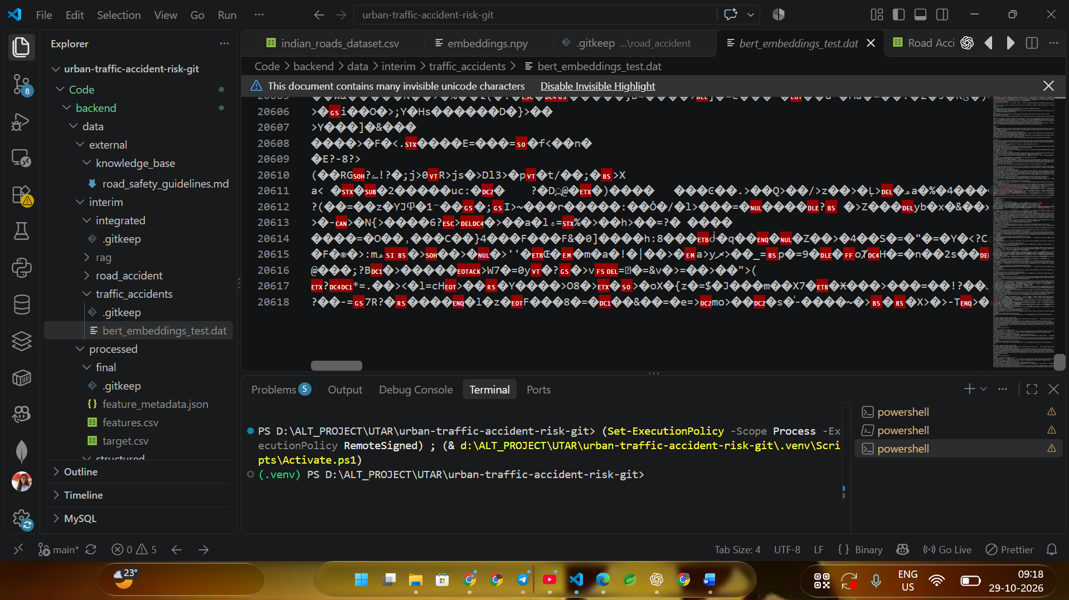
Figure 6.1: Preview of the Road Accident Dataset.
Dataset Information and Class Distribution
Capture the output of:
print(df.info())
print(df["Accident_Severity"].value_counts())
print(df["Accident_Severity"].value_counts(normalize=True) * 100)

Missing Values and Duplicate Removal
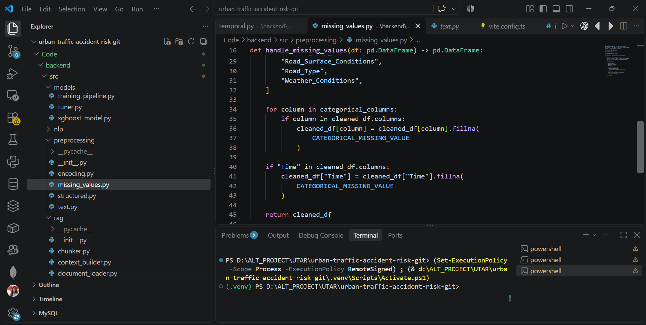
Figure 6.1.1: Missing Values and Duplicate Removal
6.2 NLP Preprocessing and Feature Extraction
Your project uses structured accident attributes, engineered features, TF-IDF, and DistilBERT embeddings. Explain these separately and avoid claiming that the NLP representations improved the final classifier unless you have experimental evidence.
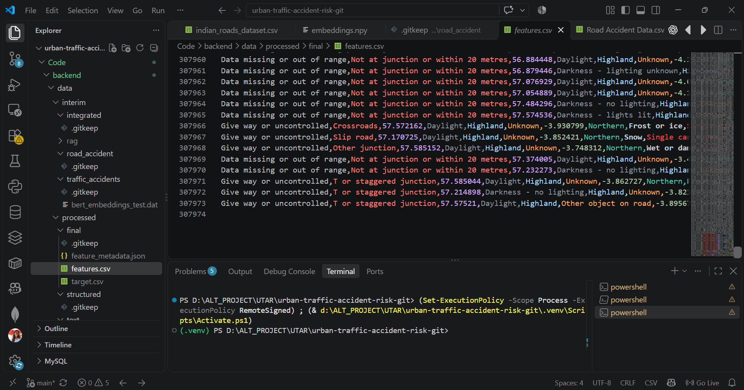
Figure 6.2: Data Preprocessing and Feature Engineering.

TF-IDF Feature Extraction
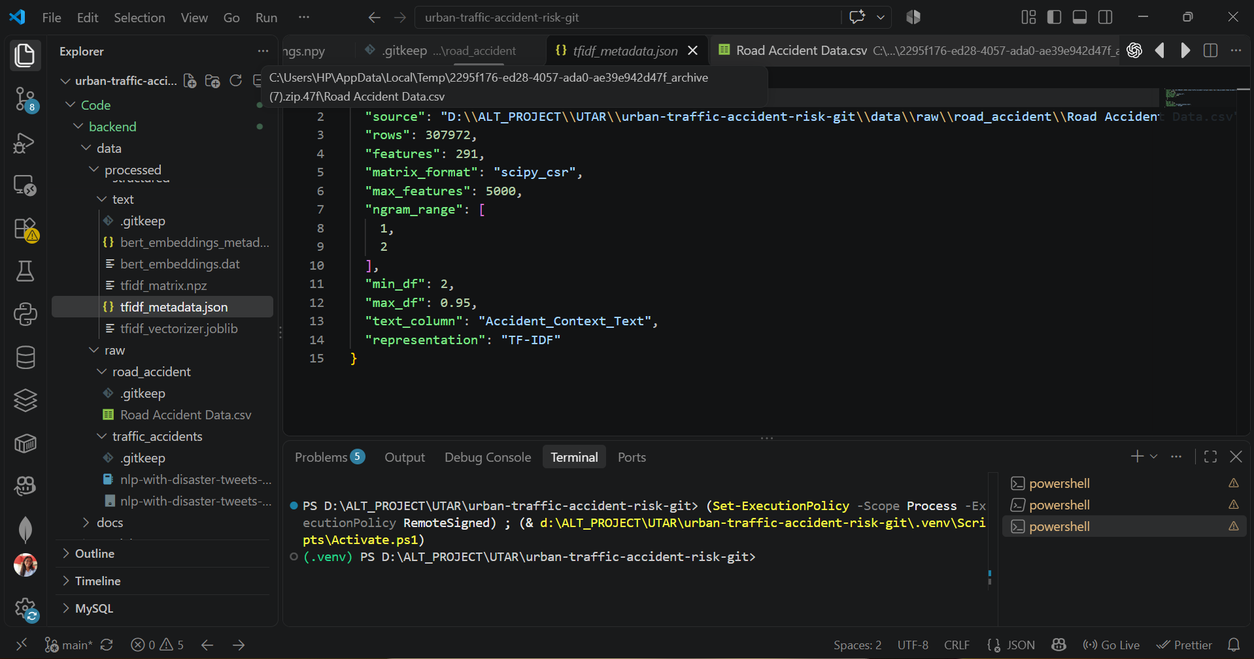
Figure 6.2.1: TF-IDF Feature Extraction from Accident Context Text.

DistilBERT Embeddings
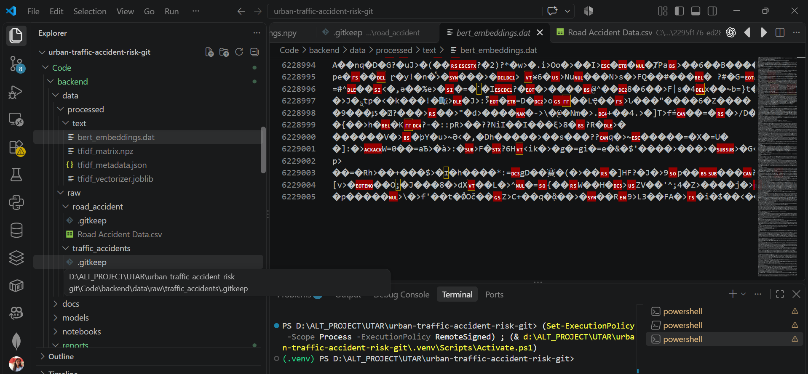 Figure 6.2.2 : Generation of Contextual Embeddings Using DistilBERT.

6.3 Model Training and Evaluation
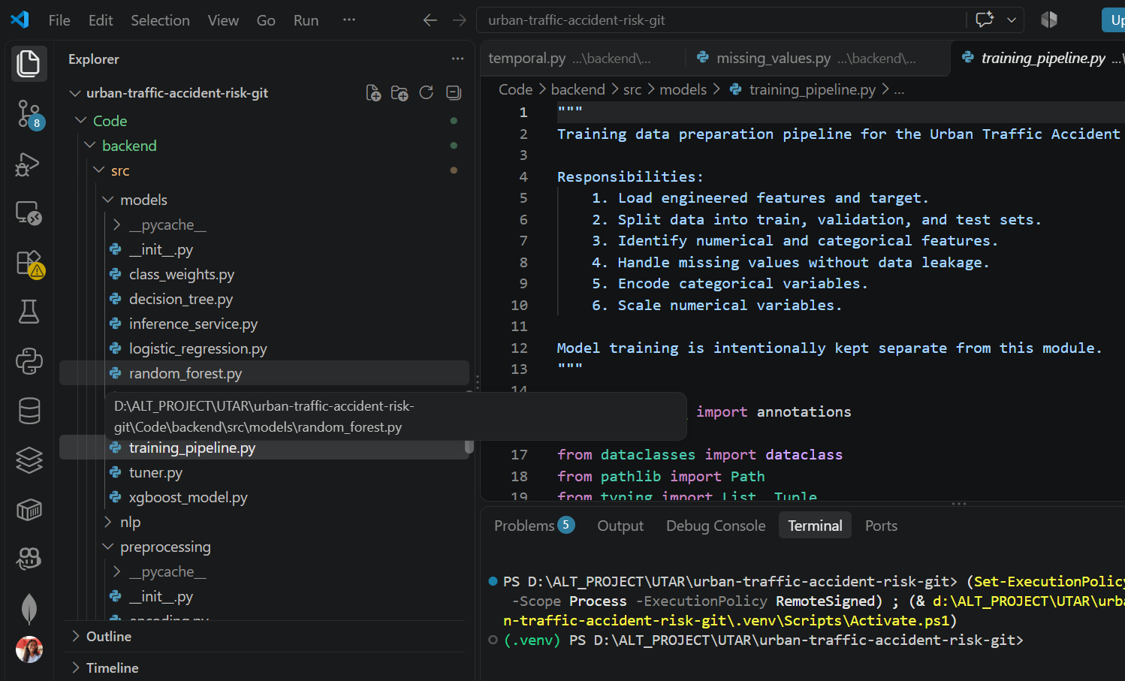
Dataset Splitting and Preprocessing Pipeline 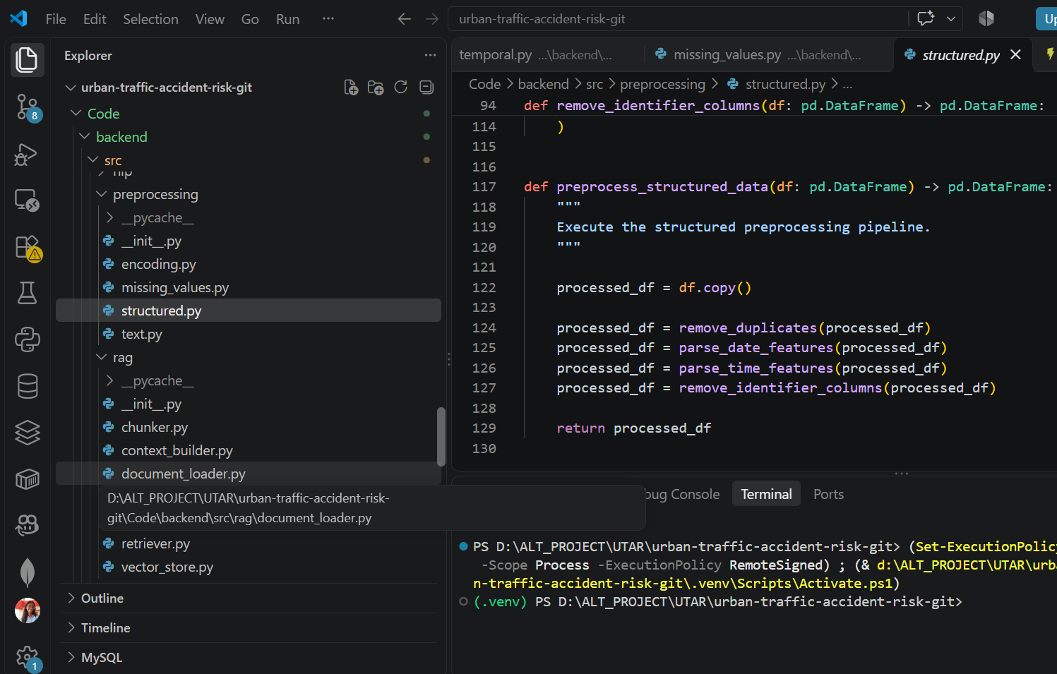 Figure 6.7: Stratified Dataset Splitting and Training-Only Preprocessing.
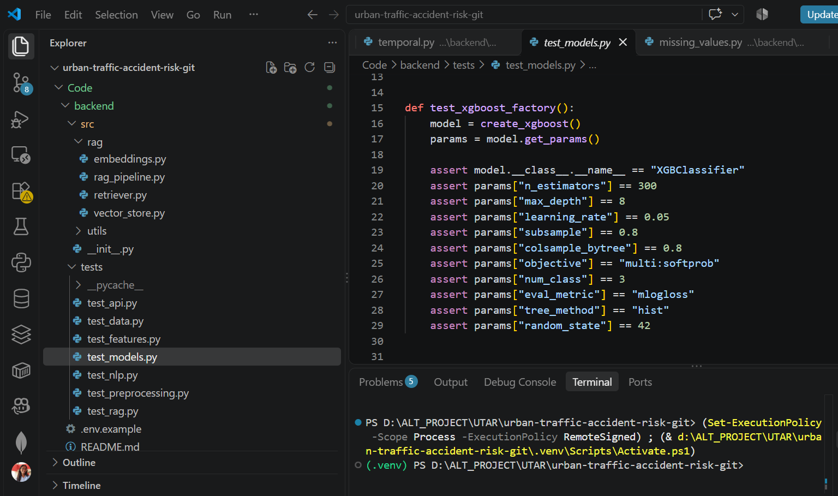
Figure 6.8: Training and Comparison of Machine Learning Models.
Hyperparameter Tuning
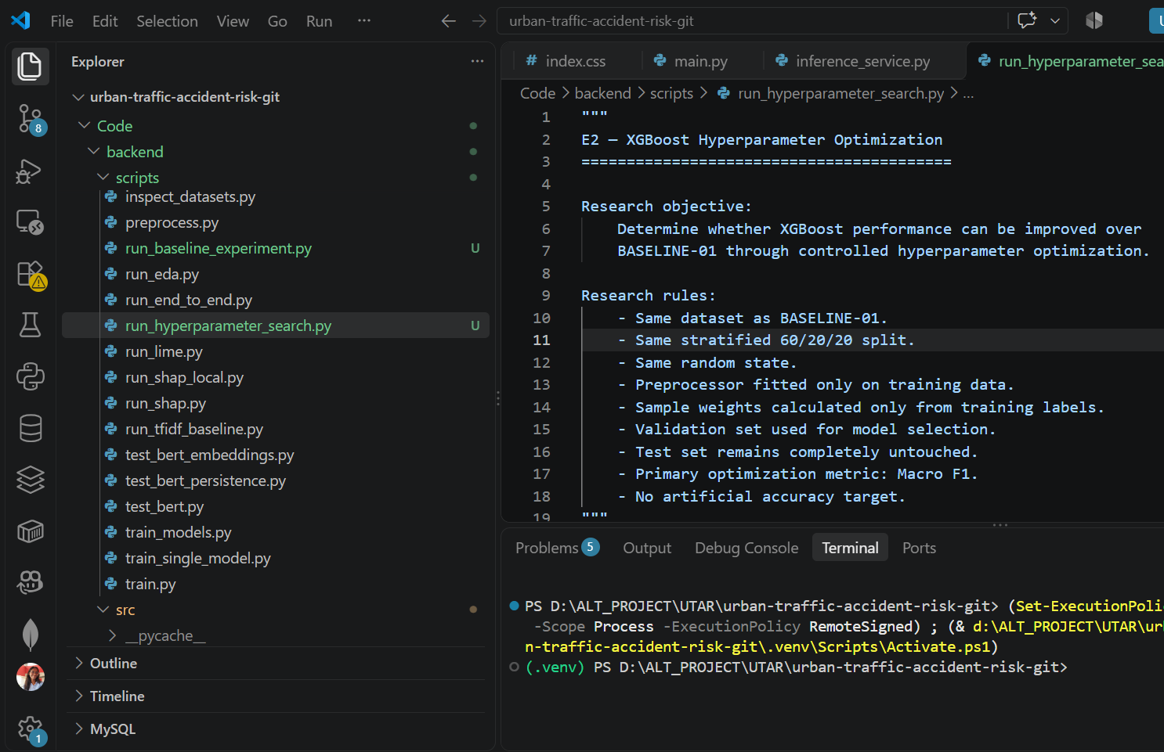
Figure 6.9: XGBoost Hyperparameter Optimization Using Validation Data.

Model Evaluation Results
Accuracy: 61.35%
- Macro F1-score: 0.3568
- Macro recall: 0.4669
- ROC-AUC: 0.6539
Confusion Matrix
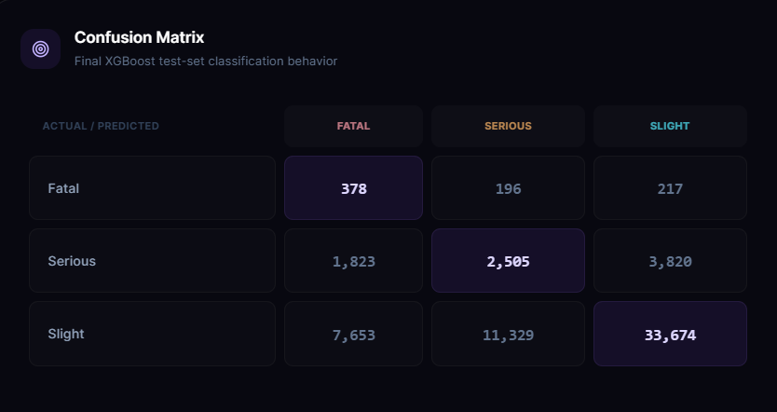
Figure 6.11: Confusion Matrix for Accident Severity Classification.
SHAP Explainability
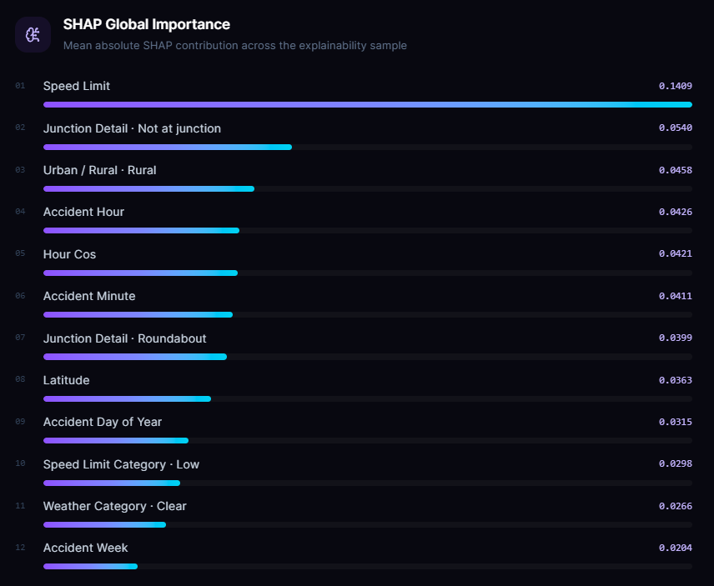
Figure 6.12: SHAP-Based Feature Importance for Accident Severity Classification.

6.4 Project Workflow and Modules
Module | explaination
Data loading and EDA | Loading the CSV and examining data quality
Preprocessing | Handling missing values, duplicates, and feature engineering
Feature extraction | TF-IDF and DistilBERT embeddings
Model training | Training and comparing classification models
Model evaluation | Metrics, confusion matrix, and error analysis
Explainability | SHAP feature attribution
RAG safety guidance | Retrieving relevant road-safety knowledge
Backend API | Receiving inputs and returning predictions
Frontend dashboard | Presenting predictions, analytics, and explanations

6.5 Machine-Learning Implementation
The machine-learning component of the proposed system classifies traffic accidents into three severity categories: Slight, Serious, and Fatal. Multiple classification algorithms were implemented and evaluated to identify a suitable model for the accident severity classification task. Logistic Regression, Decision Tree, Random Forest, and XGBoost were used for the primary model comparison. An additional Support Vector Machine (SVM) benchmark was conducted using a sample of 10,000 records.
6.5.1 Baseline and Comparison Models
Logistic Regression: Logistic Regression was used as a baseline model to establish an initial performance reference. It estimates the relationship between the input accident attributes and the possible severity categories. Its results provide a basis for comparing a linear classification approach with more complex models.
Decision Tree: The Decision Tree classifier was used to identify nonlinear relationships between accident attributes and severity. It creates decision rules based on feature values and provides an interpretable approach to classification.
Random Forest: Random Forest combines predictions from multiple decision trees. It was included to evaluate whether an ensemble of trees could improve classification performance and capture more complex relationships within the accident data.
XGBoost: Extreme Gradient Boosting was selected as the main model for further optimization. It builds an ensemble of decision trees sequentially, with each stage improving the model's ability to address errors made by previous stages. Its ability to represent nonlinear relationships makes it suitable for structured accident data.
Support Vector Machine: SVM was evaluated separately on a 10,000-record sample as an additional benchmark. Its results were not treated as directly equivalent to the primary full-dataset model comparison unless evaluated under the same data split and conditions.
6.5.2 XGBoost Model Configuration
The initial XGBoost model was configured with 300 estimators, a maximum tree depth of 8, and a learning rate of 0.05. Subsampling and feature subsampling were both set to 0.8. The model used the multiclass probability objective, with three target classes and multiclass log-loss as its evaluation function.
The initial model configuration is shown below:
from xgboost import XGBClassifier

model = XGBClassifier(
n_estimators=300,
max_depth=8,
learning_rate=0.05,
subsample=0.8,
colsample_bytree=0.8,
objective="multi:softprob",
num_class=3,
eval_metric="mlogloss",
tree_method="hist",
random_state=42,
n_jobs=-1
)
The n_estimators parameter specifies the number of boosting trees, while max_depth controls tree complexity. The learning rate determines the contribution of each boosting stage. Subsampling and feature subsampling introduce randomness that can help reduce overfitting. The multi:softprob objective generates class probabilities for the three severity categories, and random_state=42 supports reproducibility.
6.5.3 Hyperparameter Optimization
Hyperparameter tuning was performed to identify an improved XGBoost configuration. The validation set was used to compare candidate configurations, with macro F1-score considered an important selection metric because the dataset contains a substantial imbalance between severity classes.
The best recorded validation configuration, identified as Trial 9, used the following parameters:
Hyperparameter | Selected Value
Number of estimators | 400
Maximum tree depth | 9
Learning rate | 0.04
Minimum child weight | 5
Subsample ratio | 0.8
Column subsample ratio | 0.8
Gamma | 0.1
L1 regularization (reg_alpha) | 0.1
L2 regularization (reg_lambda) | 2
The selected configuration achieved a validation accuracy of 61.35%, macro F1-score of 0.3568, macro recall of 0.4669, and ROC-AUC of 0.6539. These results describe validation performance and should not be presented as final test-set results.
6.5.4 Evaluation Metrics and Model Selection
The models were evaluated using accuracy, macro F1-score, macro recall, ROC-AUC, and confusion-matrix analysis.
- Accuracy: Measures the proportion of correctly classified accident records.
- Macro F1-score: Calculates the F1-score independently for each severity class and then averages the three scores equally.
- Macro recall: Measures the average recall across the Slight, Serious, and Fatal categories.
- ROC-AUC: Evaluates how well the model distinguishes between classes using predicted scores, with multiclass aggregation used where applicable.
- Confusion matrix: Shows the actual and predicted severity categories, helping identify the types of classification errors made by the model.
Macro F1-score was emphasized because the dataset is highly imbalanced. Slight accidents account for approximately 85.49% of records, Serious accidents for 13.23%, and Fatal accidents for 1.28%. Under this distribution, a model can achieve a seemingly reasonable accuracy while performing poorly on minority classes.
Macro F1-score gives each class equal weight, making it more informative than accuracy alone when assessing performance across all severity categories. Macro recall was also considered to examine how effectively the model identified records belonging to each class.
6.5.5 Model Comparison
The recorded validation results for the primary comparison models are summarized below.
Model | Accuracy | Macro F1-score | Macro Recall | ROC-AUC
Logistic Regression | 0.4171 | 0.2748 | 0.4386 | 0.5939
Decision Tree | 0.5942 | 0.3412 | 0.4200 | 0.5293
Random Forest | 0.6144 | 0.3487 | 0.4726 | 0.6377
XGBoost — baseline | 0.6018 | 0.3512 | 0.4716 | 0.6533
XGBoost — optimized | 0.6135 | 0.3568 | 0.4669 | 0.6539
The optimized XGBoost configuration achieved the highest macro F1-score among the listed validation results. Random Forest achieved slightly higher accuracy and macro recall, while optimized XGBoost obtained a marginally higher ROC-AUC than the baseline XGBoost model.
These results illustrate that model selection depends on the evaluation objective rather than accuracy alone. Although the optimized XGBoost configuration was selected based on validation macro F1-score, its performance on the minority severity classes still requires careful assessment. In particular, the low representation of Fatal accidents remains a challenge for reliable classification.
6.5.6 Implementation and Reproducibility
The implementation uses a stratified 60:20:20 split for training, validation, and testing, with random seed 42. Data preprocessing is fitted on the training set and then applied to the validation and test sets to reduce data leakage. The validation set is used for hyperparameter selection, while the test set should remain separate until final evaluation.
The project source code is maintained in the following GitHub repository:
Repository: https://github.com/AnjaliKasarla/KLH-CSE-2026-27-2420030170-UrbanTrafficAccidentRisk
The model training, preprocessing, evaluation, and explainability modules support the overall classification pipeline. SHAP is used separately to examine the features influencing model predictions. These explanations indicate model associations and should not be interpreted as proof that a feature causes an accident or determines its severity.

XGBoost Implementation
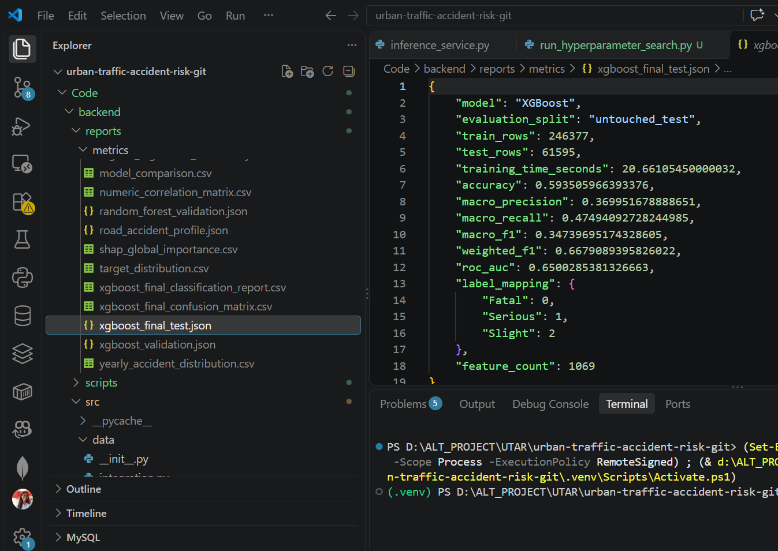
Figure 6.13: Implementation of the XGBoost Accident Severity Classifier.

6.6 Demonstration / API
FastAPI Swagger UI
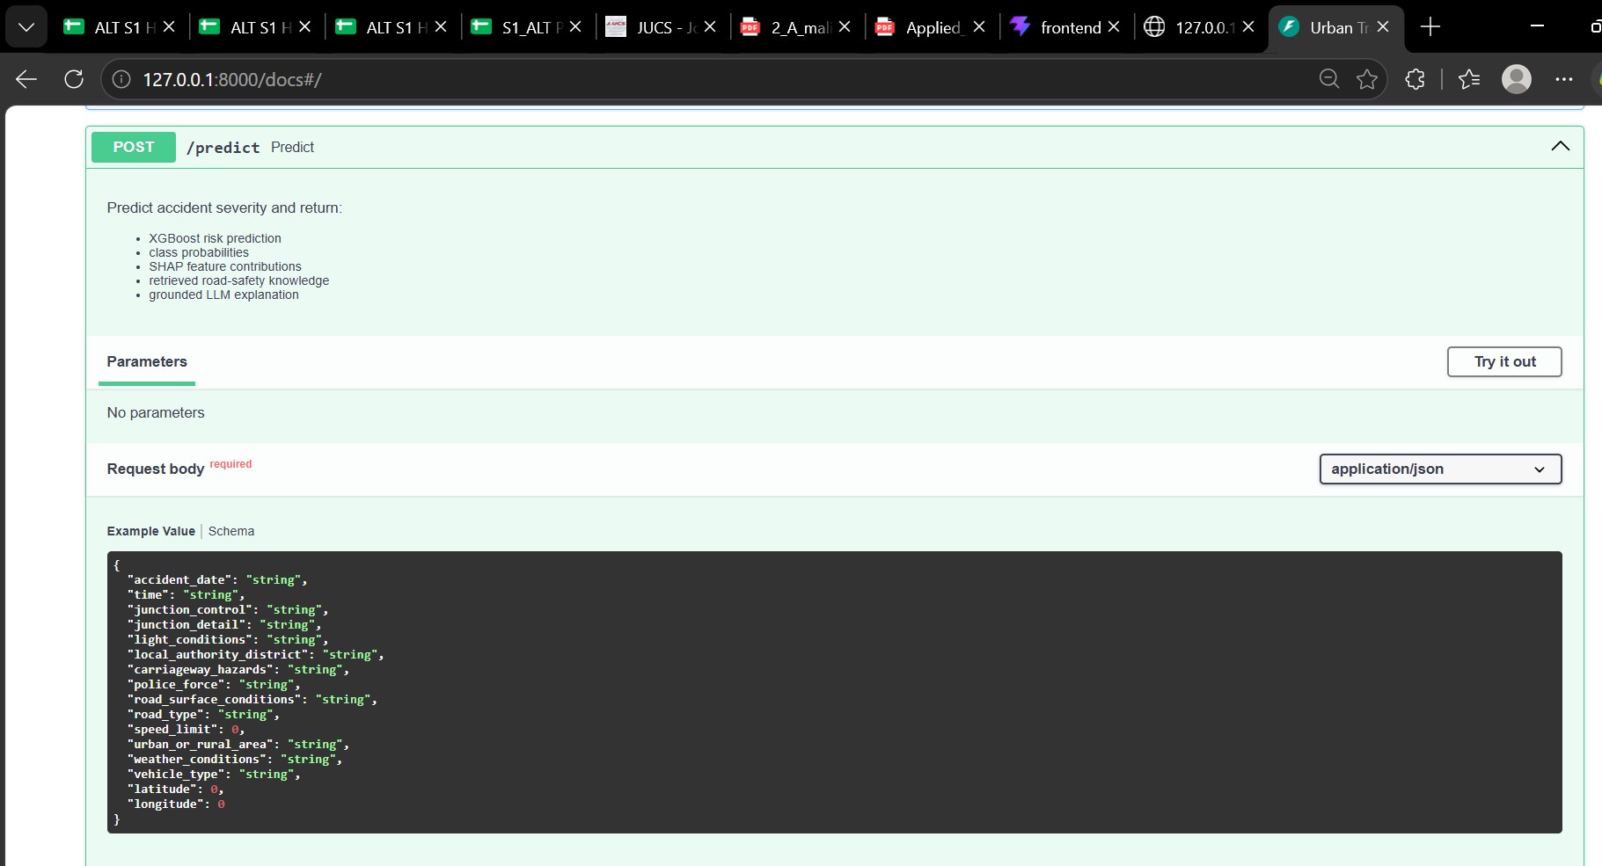
Figure 6.14: FastAPI Documentation and Prediction Endpoint.
📸 Screenshot 15 — Main Dashboard
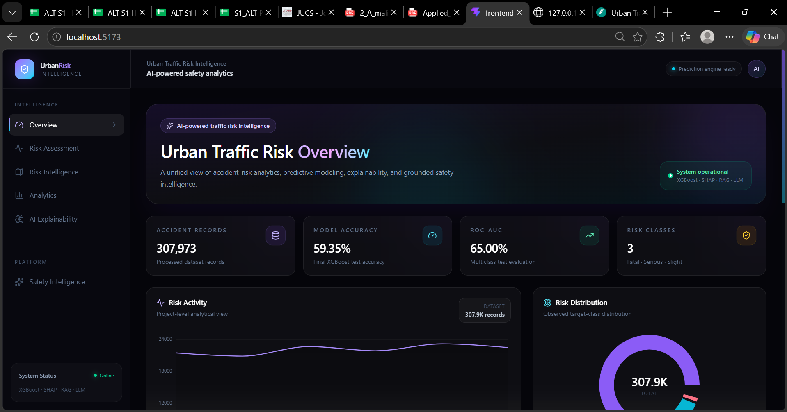
Figure 6.15: Urban Traffic Accident Risk Assessment Dashboard.

Risk Assessment
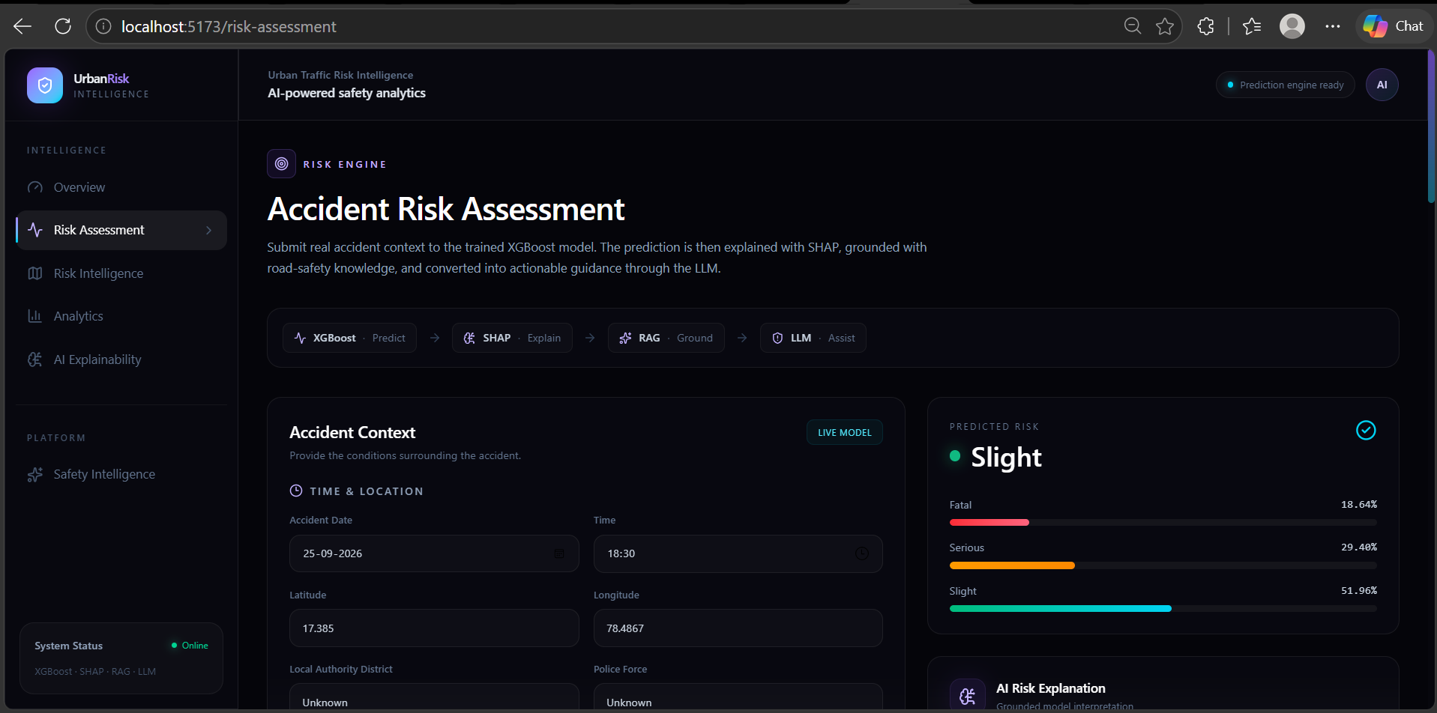
Figure 6.16: Accident Severity Prediction Interface.
Risk Intelligence and Safety Guidance
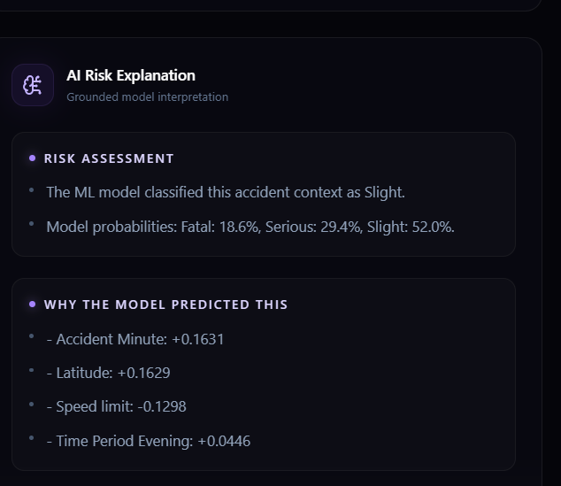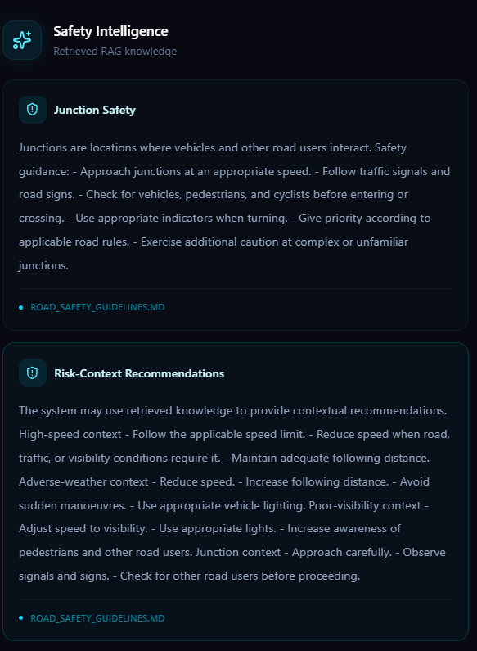
Figure 6.17: Retrieval-Augmented Road-Safety Guidance.

Analytics and Explainability
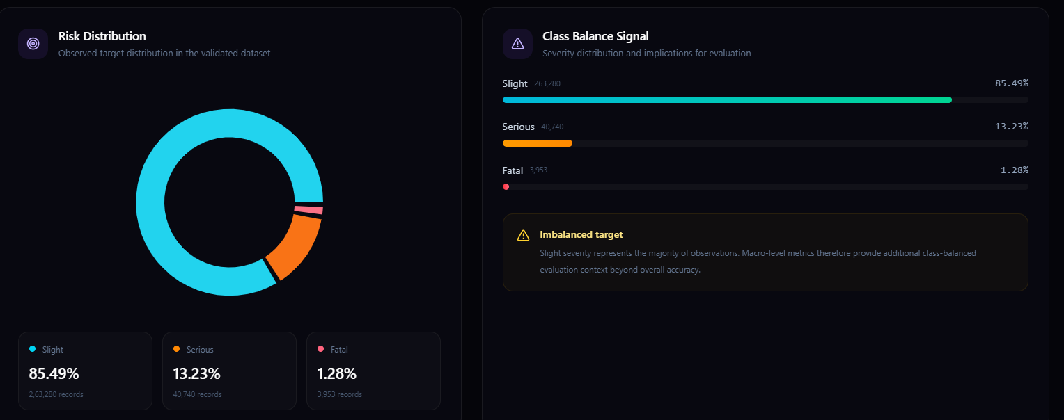
Figure 6.18: Analytics and Model Explainability Interface.

7.RESULTS AND DISCUSSION

7.1 Dataset Summary
The road accident dataset was analyzed to understand its structure, data quality, and target-class distribution before model training. The original dataset contained 307,973 records and 23 columns. After removing one duplicate record, 307,972 records were retained for further analysis. The target variable, Accident_Severity, represents three categories: Slight, Serious, and Fatal.
Table 7.1: Summary of the Dataset
Attribute | Value
Original records | 307,973
Records after duplicate removal | 307,972
Original columns | 23
Target variable | Accident_Severity
Severity categories | 3
Training records | 184,782
Validation records | 61,595
Test records | 61,595
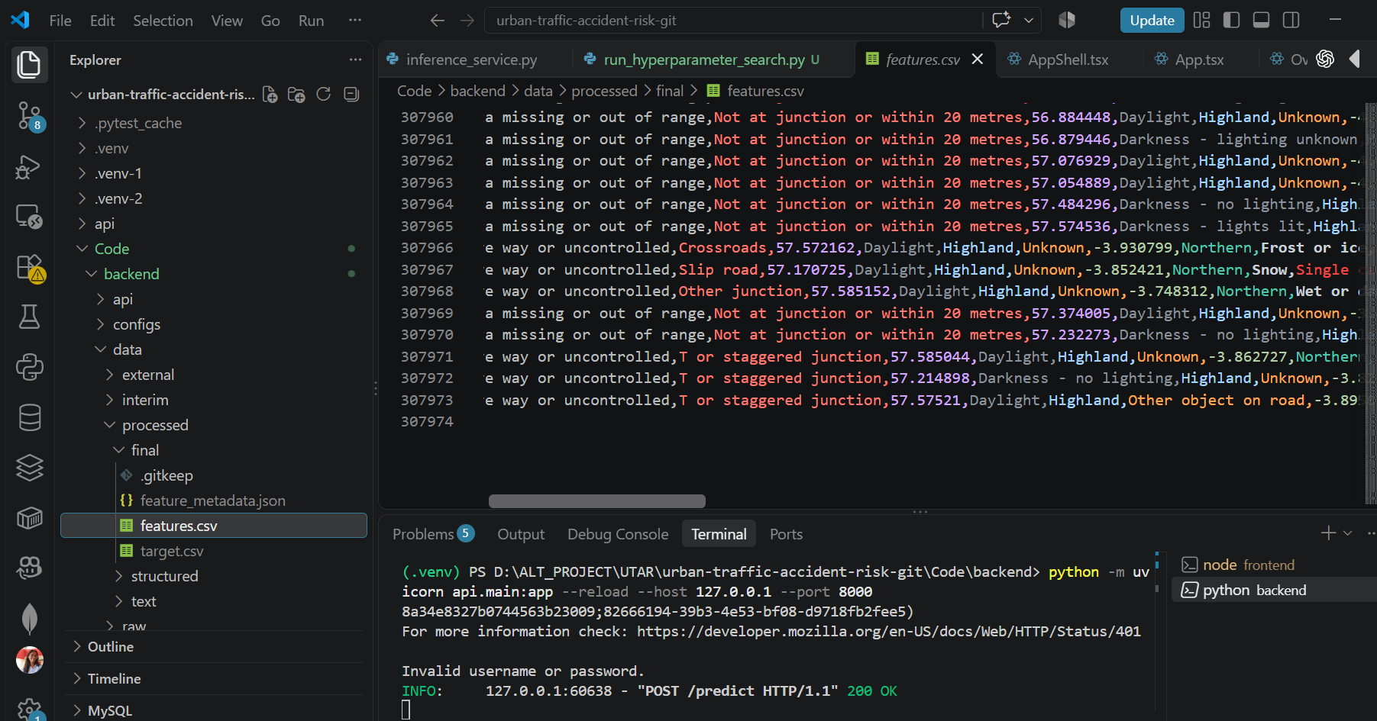
Figure 7.1: Dataset Overview and Class Distribution.

Discussion: The dataset provides a substantial number of records for training and evaluating machine-learning classifiers. However, the target classes are not equally represented, which makes reliable classification of less frequent severity categories more challenging.
7.2 Class Distribution Analysis
The target distribution indicates that Slight accidents form the majority of the dataset, whereas Fatal accidents represent a much smaller proportion.
Table 7.2: Accident Severity Distribution
Severity Class | Number of Records | Percentage
Slight | 263,280 | 85.49%
Serious | 40,740 | 13.23%
Fatal | 3,953 | 1.28%
Total | 307,973 | 100% approximately
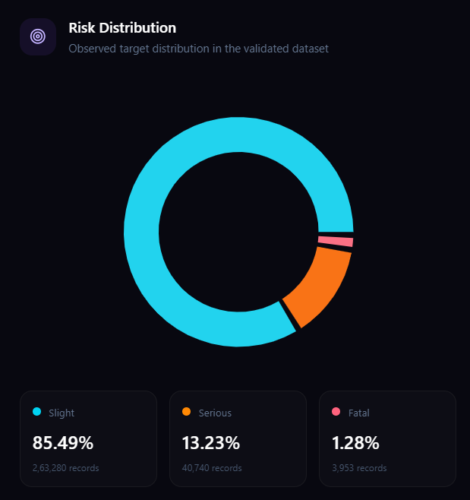
Figure 7.2: Distribution of Accident Severity Classes.
Discussion: The strong dominance of the Slight category creates a class-imbalance problem. A model may classify the majority category reasonably well while missing many Serious or Fatal cases. Therefore, accuracy alone is insufficient to assess model quality, and macro F1-score, macro recall, and class-wise metrics are also important.
7.3 Model Comparison
Four primary machine-learning models were evaluated using the validation set: Logistic Regression, Decision Tree, Random Forest, and XGBoost. Their performance was compared using accuracy, macro F1-score, macro recall, and ROC-AUC.
Table 7.3: Validation Performance Comparison
Model | Accuracy | Macro F1-score | Macro Recall | ROC-AUC
Logistic Regression | 0.4171 | 0.2748 | 0.4386 | 0.5939
Decision Tree | 0.5942 | 0.3412 | 0.4200 | 0.5293
Random Forest | 0.6144 | 0.3487 | 0.4726 | 0.6377
XGBoost — baseline | 0.6018 | 0.3512 | 0.4716 | 0.6533
XGBoost — optimized | 0.6135 | 0.3568 | 0.4669 | 0.6539
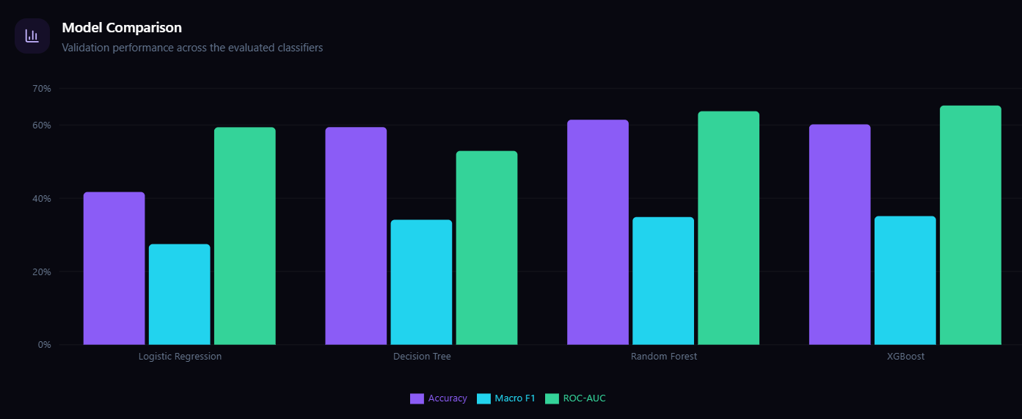
Figure 7.3: Comparison of Machine-Learning Models on the Validation Set.
Discussion: The optimized XGBoost configuration achieved the highest macro F1-score among the listed validation results, at 0.3568. Random Forest achieved slightly higher validation accuracy and macro recall. The results demonstrate that selecting a model involves balancing overall correctness with performance across the individual severity classes.
7.4 Final Test-Set Evaluation
The recorded final test evaluation for the earlier XGBoost configuration produced an accuracy of 59.35%, macro precision of 0.3700, macro recall of 0.4749, macro F1-score of 0.3474, weighted F1-score of 0.6679, and ROC-AUC of 0.6500.
Table 7.4: Recorded XGBoost Test-Set Results
Metric | Score
Accuracy | 0.5935
Macro Precision | 0.3700
Macro Recall | 0.4749
Macro F1-score | 0.3474
Weighted F1-score | 0.6679
ROC-AUC | 0.6500
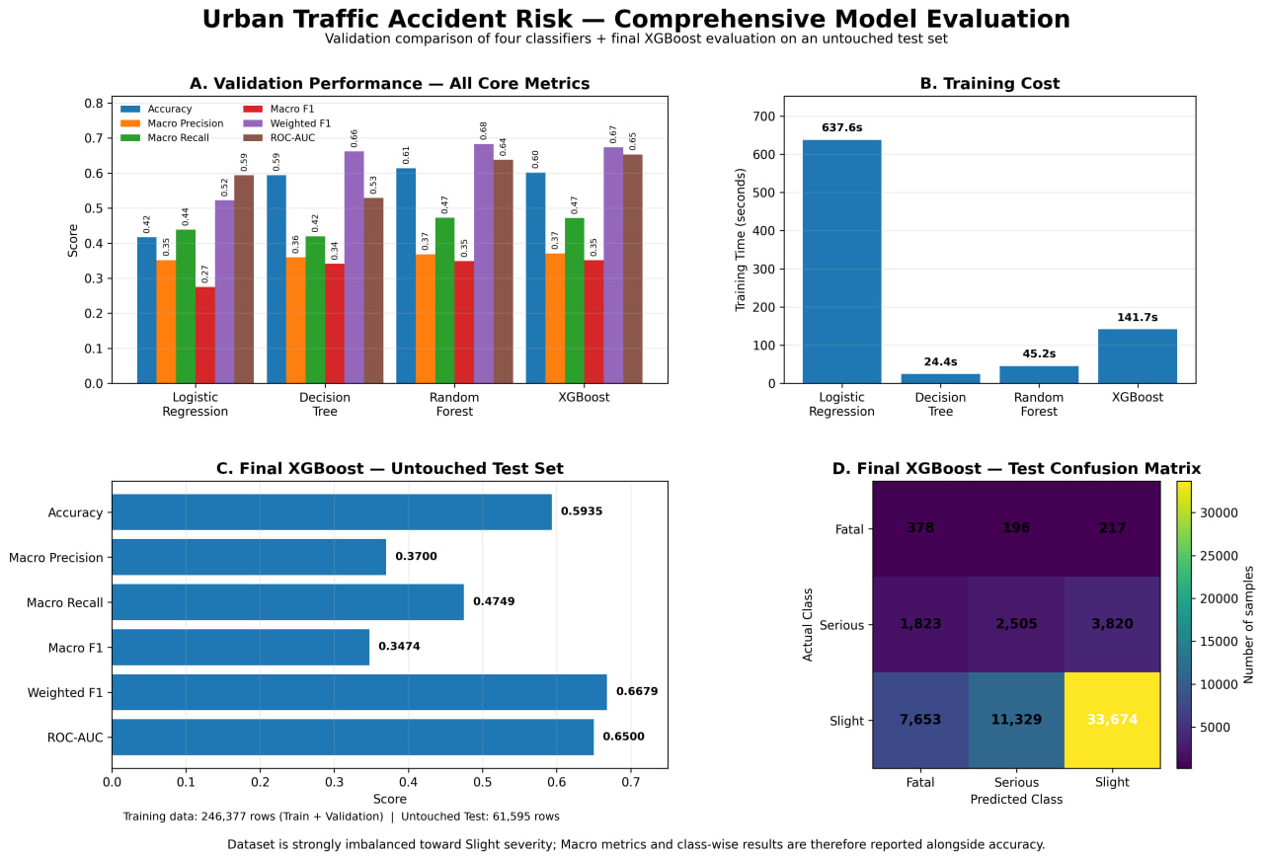

Figure 7.4: Evaluation Metrics of the Recorded XGBoost Test Run.
Discussion: The weighted F1-score is higher than the macro F1-score, reflecting the influence of the dominant Slight category on overall performance. The macro F1-score provides a more balanced view of performance across all three classes. These test results belong to the previously evaluated XGBoost configuration and must not be presented as the final test results of the optimized configuration unless that configuration has also been evaluated on the test set.
7.5 Confusion Matrix and Class-Wise Performance
The confusion matrix provides a detailed view of the model's predictions for each accident severity category. The recorded test confusion matrix is shown below, with actual classes represented by rows and predicted classes by columns.
Table 7.5: Recorded XGBoost Test Confusion Matrix
Actual Class | Predicted Fatal | Predicted Serious | Predicted Slight
Fatal | 378 | 196 | 217
Serious | 1,823 | 2,505 | 3,820
Slight | 7,653 | 11,329 | 33,674
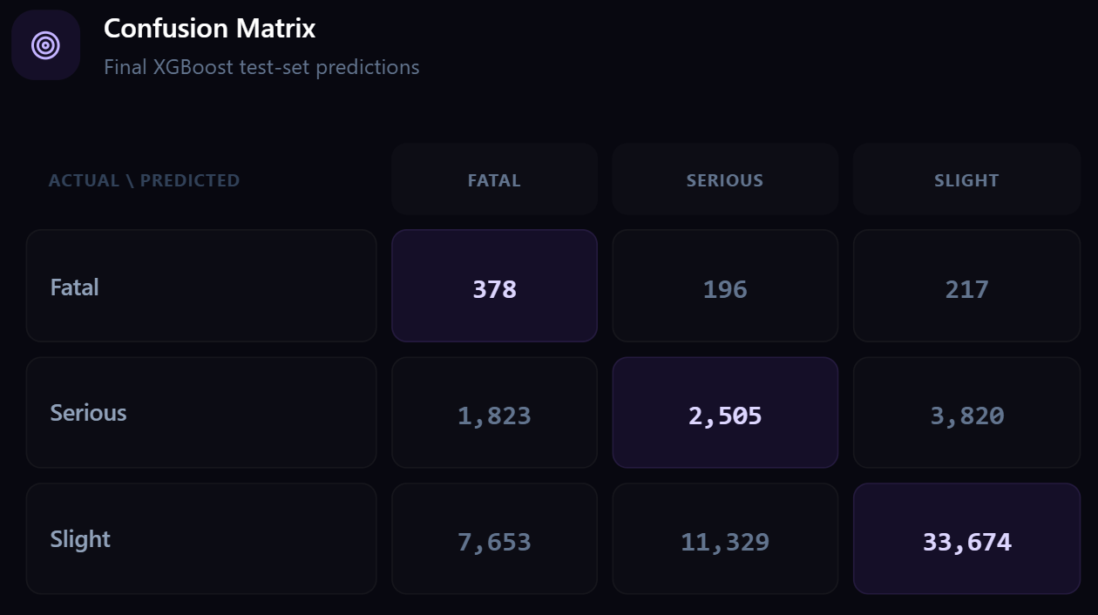
Figure 7.5: Confusion Matrix for XGBoost Accident Severity Classification.
Discussion: The confusion matrix shows that many Serious and Slight accidents are assigned to other severity categories. For the Fatal class, 378 of 791 actual cases were correctly classified. This illustrates the difficulty of learning reliable decision boundaries for minority classes in an imbalanced dataset.
Table 7.6: Class-Wise Test Performance
Severity Class | Precision | Recall | F1-score
Fatal | 0.0384 | 0.4779 | 0.0710
Serious | 0.1786 | 0.3074 | 0.2259
Slight | 0.8930 | 0.6395 | 0.7453
Discussion: The model identifies approximately 47.79% of Fatal cases, but its Fatal-class precision is only about 3.84%, indicating many false-positive Fatal predictions. Performance is substantially stronger for Slight accidents, particularly in precision. These findings show that minority-class prediction remains a major limitation and that the model's outputs should not be interpreted as a substitute for validated road-safety assessments.
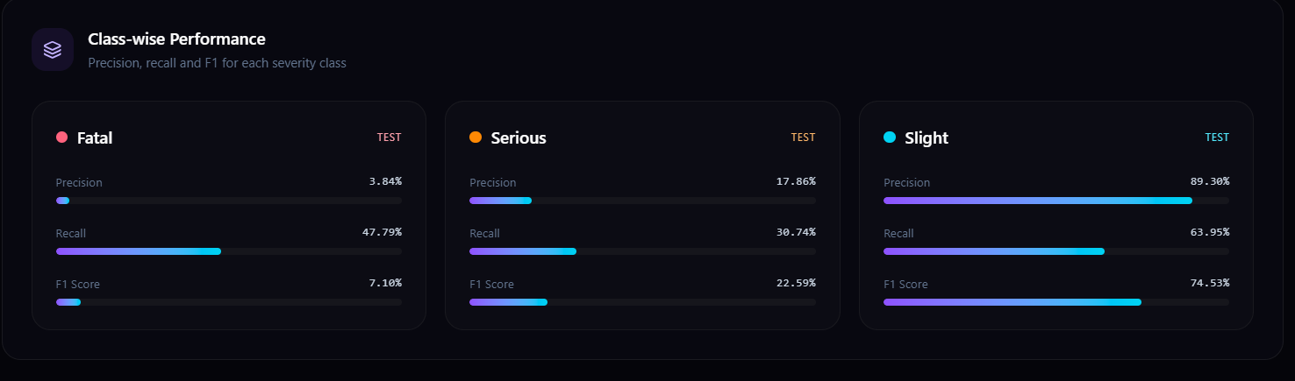
7.6 Model Explainability
SHAP was applied to examine how the trained model uses accident attributes when generating predictions. The recorded global importance analysis indicates that speed limit, junction details, urban or rural area, accident hour, and geographical features contribute prominently to model predictions.
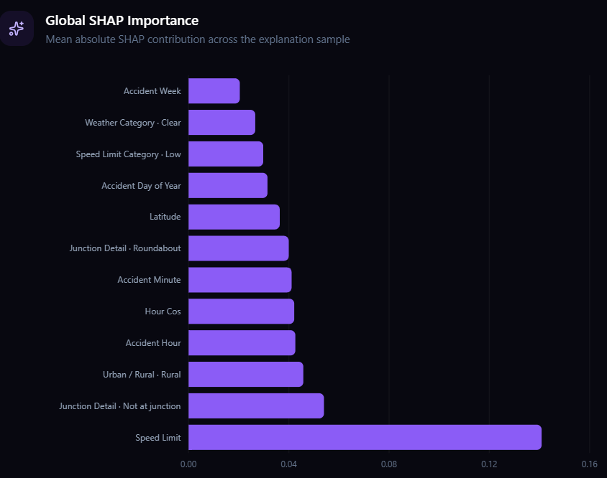
Figure 7.6: SHAP Global Feature-Importance Summary.
Discussion: The SHAP results help explain the model's learned associations between accident attributes and predicted severity. They provide insight into model behavior, but they do not establish that a feature directly causes an accident or determines its severity.
7.7 Discussion of Limitations
The experimental results reveal several limitations. First, the dataset has a substantial imbalance between Slight, Serious, and Fatal accident records, which affects minority-class performance. Second, the model makes errors between severity categories, particularly for Serious and Fatal cases. Third, the evaluation results represent performance on the available dataset and do not by themselves demonstrate generalization to other geographical regions or future traffic conditions.
The project also includes NLP-based contextual representations and a retrieval-augmented generation component for road-safety guidance. These components provide additional contextual and explanatory functionality; however, the available experiments do not establish that TF-IDF or DistilBERT embeddings improve the performance of the deployed structured-feature XGBoost classifier. Further evaluation with independent datasets, stronger minority-class analysis, and additional testing is needed before the system can be considered suitable for operational road-safety decisions.

8. CONCLUSION AND FUTURE SCOPE

8.1 Conclusion

The Urban Traffic Accident Risk Assessment and Prediction project was developed to classify reported traffic accidents into three severity categories: Slight, Serious, and Fatal. The project addresses the challenge of analyzing road accident data and identifying patterns that help explain accident severity. A machine-learning pipeline was implemented using data preprocessing, feature engineering, model training, evaluation, and explainability techniques.

Four primary machine-learning algorithms—Logistic Regression, Decision Tree, Random Forest, and XGBoost—were compared, with an additional SVM benchmark conducted on a sample of 10,000 records. The optimized XGBoost configuration achieved a validation accuracy of 61.35% and a macro F1-score of 0.3568. Although it achieved the highest macro F1-score among the recorded validation comparisons, the results demonstrate that accurately classifying all severity categories remains challenging.

SHAP was incorporated to interpret the features influencing model predictions, while a Retrieval-Augmented Generation (RAG) component was implemented to retrieve relevant road-safety guidance and support contextual explanations. The machine-learning pipeline was integrated with a FastAPI backend and a React-based web interface to provide access to prediction, analytics, explainability, and safety-information features.

The major project objectives were addressed through dataset analysis, preprocessing, feature engineering, model comparison, hyperparameter optimization, explainability, and application integration. However, the substantial class imbalance and limited performance for minority severity categories remain important limitations. Furthermore, the system classifies the severity of reported accidents; it does not establish the probability that a future accident will occur. Therefore, its outputs should be treated as analytical support rather than definitive safety assessments.

8.2 Future Scope

The project can be extended in the following directions:

Improved Class Imbalance Handling: Investigate class-weighting strategies, resampling techniques, and cost-sensitive learning to improve classification performance for Serious and Fatal accidents.

Larger and More Diverse Datasets: Evaluate the model using independent datasets from different regions and time periods to assess its generalization ability.

Advanced Machine-Learning Models: Experiment with additional boosting algorithms and carefully evaluated model architectures to improve classification performance across all severity categories.

Enhanced Explainability: Extend SHAP-based analysis with class-specific explanations and clearer explanations for individual predictions, while evaluating their reliability.

Improved NLP and RAG Capabilities: Expand the road-safety knowledge base and evaluate retrieval quality and generated explanations. Multilingual safety guidance could also be introduced to support users who prefer regional languages.

Deployment and Performance Testing: Deploy the application in a controlled environment and evaluate API response time, model inference latency, resource consumption, reliability, and scalability.

Model Drift Monitoring: Monitor changes in accident characteristics and prediction performance over time, with periodic model evaluation and retraining when justified by new data.

Privacy and Data Governance: Establish appropriate data access controls, secure handling of accident records, and documented data-use practices for future deployment.

These improvements could strengthen the model's reliability, improve its usefulness across different contexts, and support the responsible application of machine learning and explainable AI in road-safety analysis.

9. REFERENCES
[1] T. Chen and C. Guestrin, “XGBoost: A Scalable Tree Boosting System,” in Proceedings of the 22nd ACM SIGKDD International Conference on Knowledge Discovery and Data Mining, 2016, pp. 785–794. DOI: 10.1145/2939672.2939785.
[2] S. M. Lundberg and S.-I. Lee, “A Unified Approach to Interpreting Model Predictions,” in Advances in Neural Information Processing Systems, vol. 30, 2017. Available: https://papers.nips.cc/paper/2017/hash/8a20a8621978632d76c43dfd28b67767-Abstract.html
[3] V. Sanh, L. Debut, J. Chaumond, and T. Wolf, “DistilBERT, a Distilled Version of BERT: Smaller, Faster, Cheaper and Lighter,” arXiv preprint arXiv:1910.01108, 2019. Available: https://arxiv.org/abs/1910.01108
[4] P. Lewis et al., “Retrieval-Augmented Generation for Knowledge-Intensive NLP Tasks,” in Advances in Neural Information Processing Systems, vol. 33, 2020. Available: https://papers.nips.cc/paper/2020/hash/6b493230205f780e1bc26945df7481e5-Abstract.html
[5] F. Pedregosa et al., “Scikit-learn: Machine Learning in Python,” Journal of Machine Learning Research, vol. 12, pp. 2825–2830, 2011. Available: https://jmlr.org/papers/v12/pedregosa11a.html
[6] Scikit-learn Developers, “Scikit-learn User Guide: Model Selection and Evaluation.” Available: https://scikit-learn.org/stable/model_selection.html
[7] Hugging Face, “Transformers Documentation.” Available: https://huggingface.co/docs/transformers
[8] Hugging Face, “Sentence Transformers Documentation.” Available: https://sbert.net/
[9] FastAPI, “FastAPI Documentation.” Available: https://fastapi.tiangolo.com/
[10] Meta Open Source, “React Documentation.” Available: https://react.dev/
[11] XGBoost Developers, “XGBoost Documentation.” Available: https://xgboost.readthedocs.io/
[12] Kaggle, “Road Accident Dataset.” Dataset source and uploader to be confirmed against the original downloaded dataset. Available: https://www.kaggle.com/datasets/xavierberge/road-accident-dataset
[13] Anjali Kasarla, “Urban Traffic Accident Risk Assessment & Prediction,” project source code repository. Available: https://github.com/AnjaliKasarla/KLH-CSE-2026-27-2420030170-UrbanTrafficAccidentRisk

