

**Maratha Vidya Prasarak Samaj’s**

**Karmaveer Shantaram Bapu Kondaji Wavare Arts ,Science & Commerce College, Nashik**

**Affiliated to Savitribai Phule Pune University**

**A**

**PROJECT REPORT ON**

**“COACHING MANAGEMENT SYSTEM”**

**SUBMITTED TO**

**DEPARTMENT OF COMPUTER SCIENCE**

**BY**

# Miss. Mali Anjali Prakash

**BSc. (Computer Science) Sem IV**

**2023-2024**

UNDER THE GUIDENCE OF

**Smt.V.S.Shirore**



**Maratha Vidya Prasarak Samaj’s**

**K.S.K.W. Arts, Science & Commerce College, Cidco, Nasik-8**

Phone: (0253) 2391110 Email: [cidcocollegenasik@rediffmail.com](mailto:cidcocollegenasik@rediffmail.com)

Web: www.cidcocollegenashik.ac.in Principle: Prof. Dr. S. K. Kushare

Affiliated to Savitribai Phule Pune University Awarded as the Best College by SPPU

NAAC reaccrediated CPE Status by UGC, Delhi

**CERTIFICATE**

This is to certify that the Project entitled

[ **COACHING MANAGEMENT SYSTEM**]

has been successfully completed by

[ Anjali Prakash Mali ]

in partial fulfilment of the requirements for Project (CS – 3611) Sem. – VI of B. Sc. (Computer Science), under graduate degree to Savitribai Phule University for the academic year 2023-2024.

Project Guide Head of the Department

External Examiner Internal Examiner

Index

|  |  |  |
| --- | --- | --- |
| Sr.No | Content | Page No. |
| 1. | Acknowledgments | 4 |
| 2. | Abstract | 5 |
| 3. | Introduction | 6 |
| 4. | Problem Statements | 7 |
| 5. | Existing System | 8 |
| 6. | Proposed System | 9 |
| 7. | Functional Requirement | 10 |
| 8. | Feasibility Study | 11 |
| 9. | Software/Hardware  Specification | 14 |
| 10. | ER Diagram | 15 |
| 11. | UML Diagram | 16 |
| 12. | Data Dictionary | 20 |
| 13. | Input/Output Screen | 23 |
| 14. | Testing | 29 |
| 15. | Conclusion And  Recommendation | 32 |
| 16. | Bibiliography | 33 |

# Acknowledgments

We are sincerely, thankful to our guide Smt.V.S.Shirore

Any project require the guidance, contribution of time along with effort by many people. It is difficult task to acknowledgement all those who have been helping in our academic project work. We take opportunity

express out my deepest gratitude and heartly thankful to out computer

science department. Project guide Smt. V. S. Shirore for her valuable

guidance during development of our project ,during the project we learned a lot which will be helpful in our and many people who uses this project for future studies. Finally , we are also thankful to my parents, all my classmate’s and those who had lend me a helping hand for the completion of this project.

# Abstract

Coaching Management System (CMS) is a comprehensive software solution designed to streamline and optimize coaching processes across various domains, ranging from sports to professional development. This abstract presents an overview of the functionalities, benefits, and significance of CMS in enhancing coaching effectiveness and efficiency.

CMS serves as a centralized platform for coaches, athletes, clients, and administrators to facilitate communication, scheduling, performance tracking, and data analysis. The system offers features such as athlete/client management, session scheduling, progress tracking, resource sharing, and reporting tools. Through intuitive user interfaces and customizable workflows, CMS caters to the specific needs and objectives of coaches and their clients.

# 

# Problem Statement

I

In today's fast-paced world, coaching has emerged as a crucial tool for personal and professional development, sports training, and overall performance enhancement. Whether it's guiding athletes to reach their full potential, helping individuals navigate career transitions, or supporting teams to achieve collective goals, effective coaching requires robust management systems to optimize processes and outcomes. Enter the Coaching Management System (CMS) – a comprehensive software solution designed to revolutionize the way coaching is delivered and managed across various domains.

The introduction of CMS marks a significant milestone in the evolution of coaching practices, leveraging technology to streamline administrative tasks, enhance communication, and provide actionable insights for coaches and their clients. By offering a centralized platform for scheduling, tracking progress, sharing resources, and analyzing data, CMS empowers coaches to focus more on their core competency – guiding and motivating individuals or teams towards success.

# Purpose/Objective and Goals

The purpose of the Coaching Management System (CMS) is to streamline and optimize coaching processes across various domains, including sports, professional development, and personal wellness. The primary objective is to enhance coaching effectiveness and efficiency by providing coaches with a centralized platform to manage administrative tasks, facilitate communication, track progress, and leverage data-driven insights.

Goals:

1. Simplify Administrative Tasks: Automate scheduling, resource management, and data entry processes to reduce administrative burden and free up more time for coaches to focus on coaching.

2. Improve Communication: Foster seamless communication and collaboration among coaches, athletes/clients, and administrators through intuitive interfaces and real-time messaging features.

3. Enhance Performance Tracking: Provide coaches with comprehensive tools for tracking individual and team performance, setting goals, and monitoring progress over time.

4. Enable Data-Driven Decision-Making: Offer robust data analytics and reporting capabilities to empower coaches to identify trends, assess strengths and weaknesses, and tailor coaching strategies for optimal outcomes.

5. Ensure Scalability and Customization: Design the CMS to be scalable and customizable to meet the diverse needs of coaching across different domains, from grassroots sports programs to corporate leadership development initiatives.

# Project Scope

.

**User Management**: Define roles and permissions for coaches, administrators, and users. This includes features for user registration, profile management, and authentication to ensure secure access to the platform.

**Session Scheduling and Tracking**: Implement a calendar system for coaches to schedule coaching sessions with clients, along with reminders and notifications. Track session attendance, progress, and outcomes, providing tools for coaches to assess client development and tailor future sessions accordingly.

**Performance Evaluation and Reporting**: Develop tools for coaches to conduct assessments and evaluations of their clients' progress. This may include creating custom evaluation forms or surveys to gather feedback on coaching sessions. Implement reporting features to generate analytics and insights on client performance trends, allowing coaches to make data-driven decisions and demonstrate the effectiveness of their coaching programs.

Existing systems for Coaching Management:

1. **Manual Systems**: Many coaches still rely on manual methods for managing coaching processes, including paper-based schedules, spreadsheets for tracking progress, and email for communication. While inexpensive, these methods are often time-consuming, prone to errors, and lack scalability.
2. **Spreadsheets and Documents**: Some coaches use spreadsheets or documents stored on local drives or cloud services to manage coaching-related information. While more organized than manual systems, these methods still lack integration, real-time collaboration, and advanced analytics capabilities.
3. **Generic Productivity Tools**: Coaches may utilize generic productivity tools such as Google Calendar for scheduling, Trello for task management, and Slack for communication. While versatile, these tools may not be tailored specifically for coaching needs and may lack features such as performance tracking and progress analysis.

The proposed Coaching Management System represents a cutting-edge solution to the challenges faced by coaches in managing coaching processes effectively and efficiently. By providing a centralized platform with advanced features and functionality tailored specifically for coaching needs, the CMS will empower coaches to deliver personalized, high-quality coaching services and support to their clients or athletes. We believe that the development and implementation of the CMS will

revolutionize coaching practices and drive better outcomes for coaches and their clients

## Hardware Requirements:

* Computer with either Intel Pentium processor or AMD processor.
* 128MB DDR RAM
* 40GB hard disk drive

## Software Requirements:

* Windows 11 operating system.
* Microsoft Office package.
* Microsoft Visual Studio 6.0
* PHP
* HTML, CSS, Bootstrap,
* XAMPP

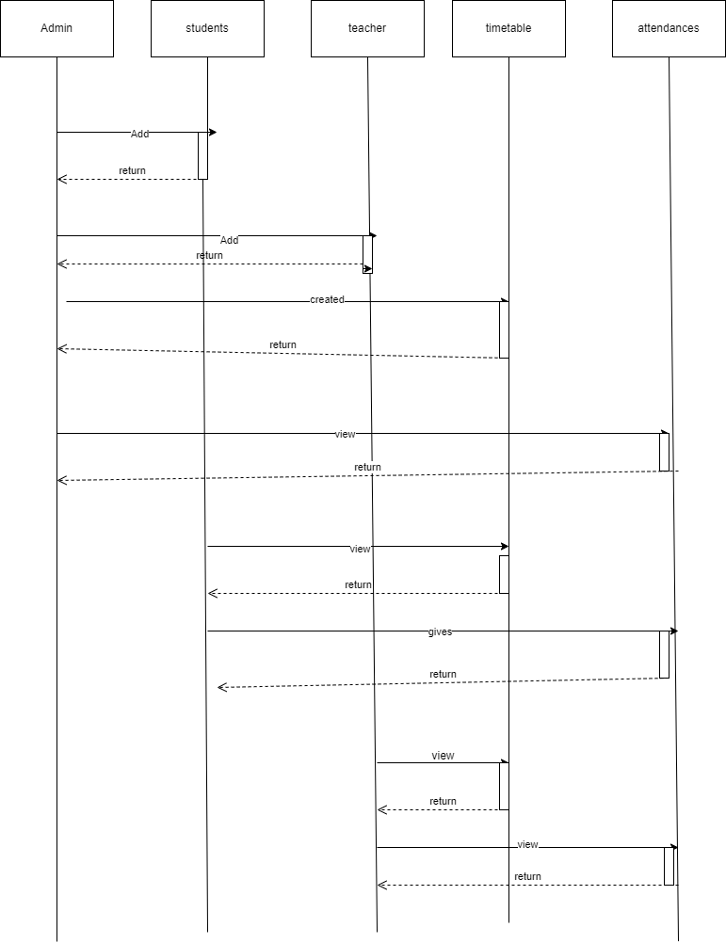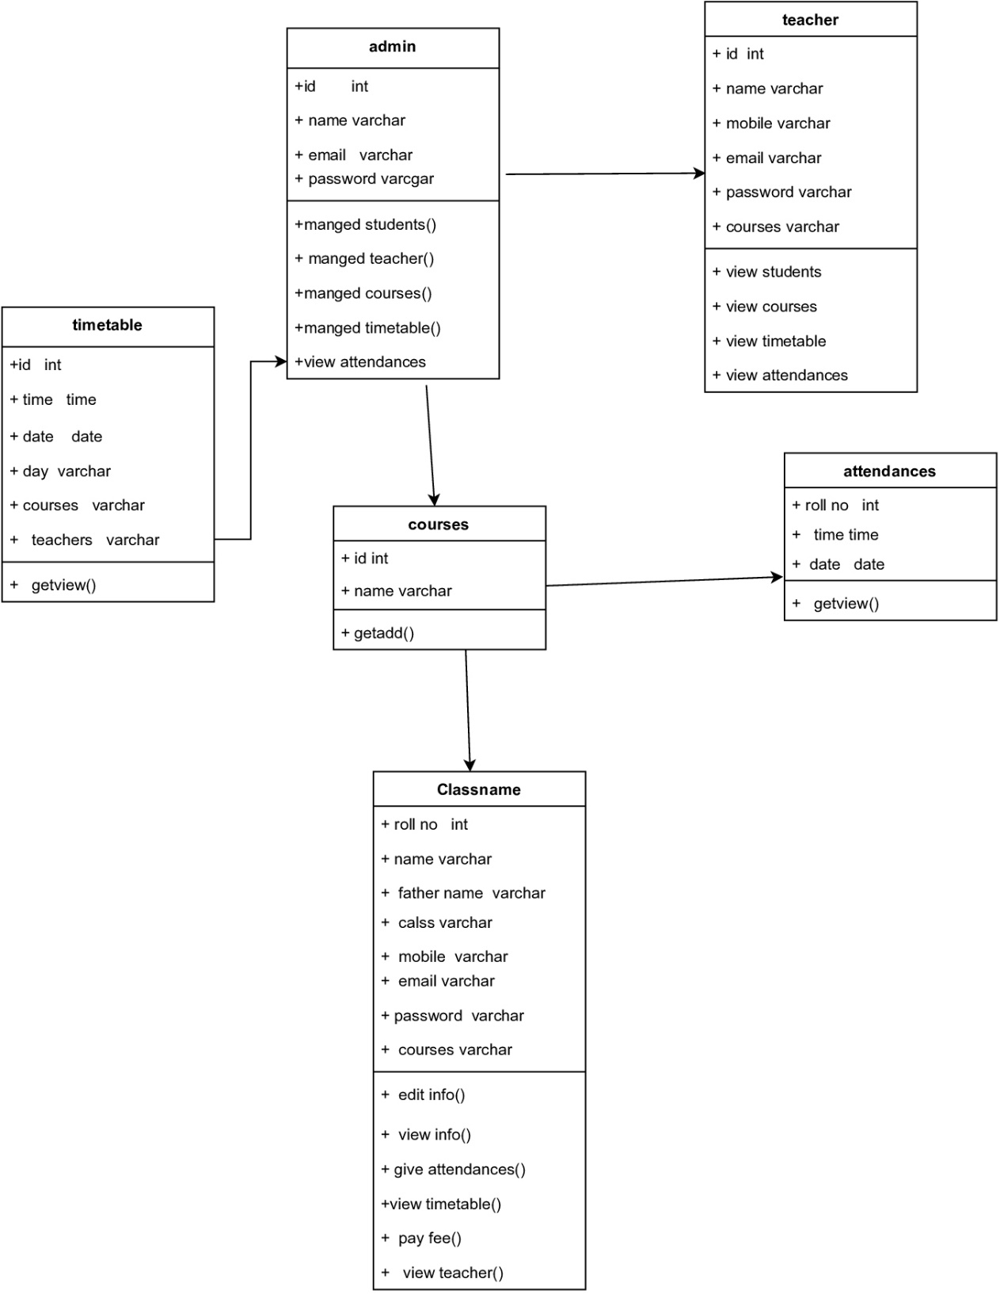



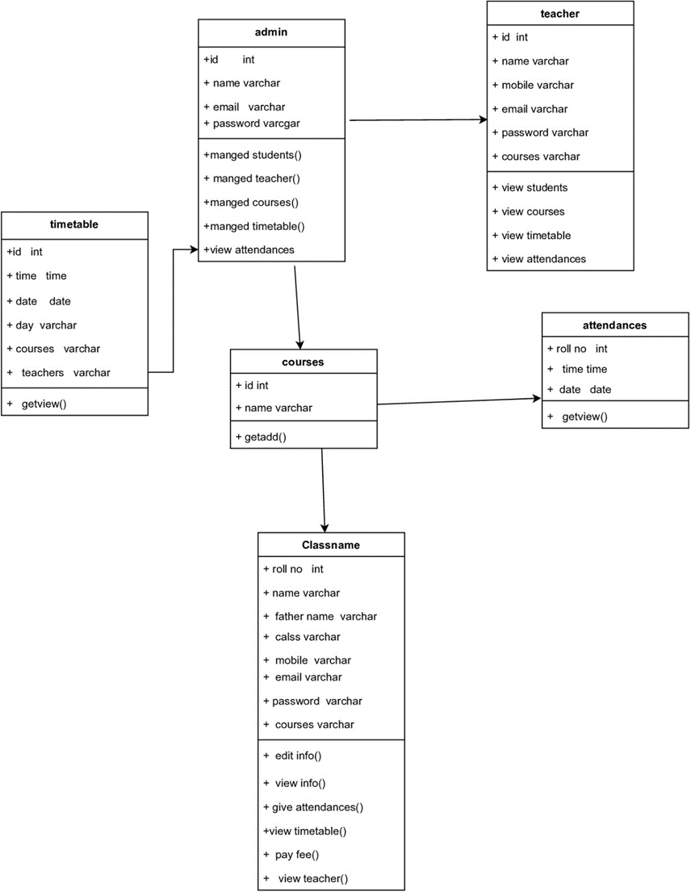

hhh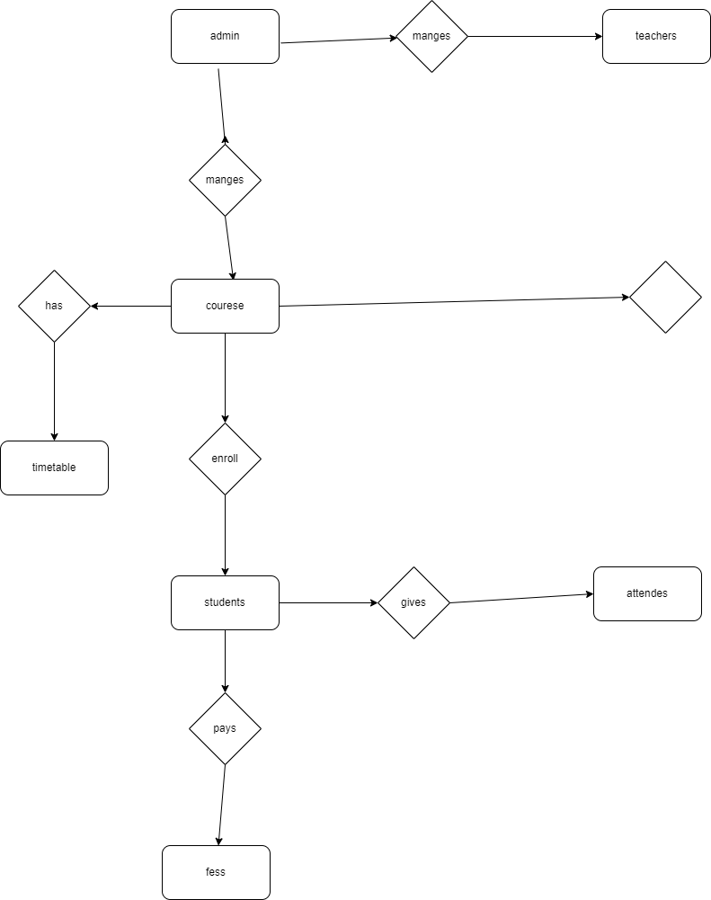jf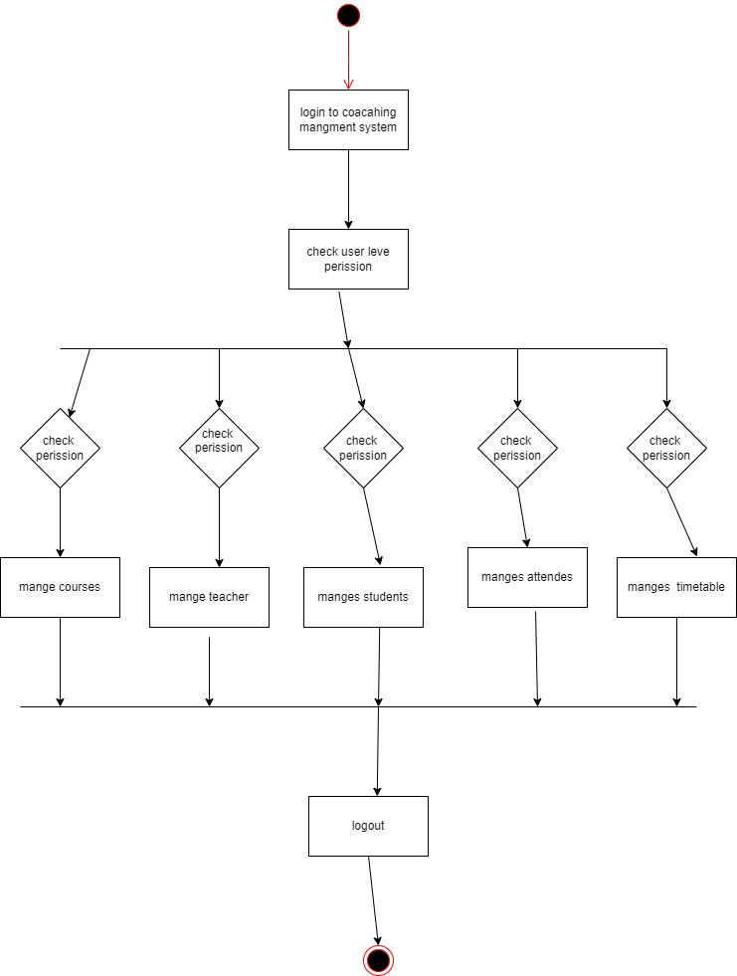

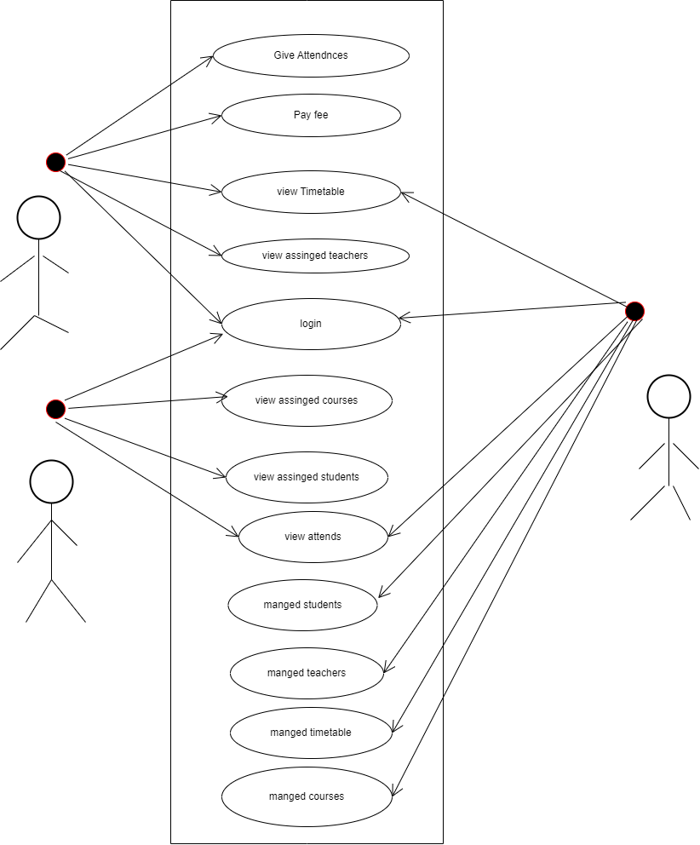

# Test Case Design

**Introduction**

Testing is set of activities that can be planned in advanced and conducted systematically. Testing requires that the developer discard preconceived notation of the correctness of the software just developed and overcome a conflict of interest that occurs when errors are encountered .Testing principles are.

* All tests should be traceable to customer requirements.
* Testing should be planned long before the testing begins.
* Testing should be begin “in the small” and progress towards testing “in the large”.
* To be most effective ,testing should be conducted by an independent third party.
* Testing objective are :-
  + Testing is the process of executing a program within the intent of finding an error.
  + A good test case is one that has high probability of finding an as-yet-undiscovered error.
  + A successful test is one that run un covers an yet – undiscovered error

There are various testing strategies available to accommodate from low- level testing to high-level testing as discussed below.

# Test plan

Testing is the major quality control measure employed during software development .In the project ,the first test considered is the unit testing .In this each module of the system tested separately .This is carried out during code level performed by developers.

After the entire module are checked independently and completed then the integration testing is performed to check whether there are any interface errors .Then those error are verified and corrected.

And also , the security test is performed to allow only authorized persons to this system .Finally ,the validation testing is performed to validate whether the customer requirements are satisfied are not.

# Unit Testing

The unit testing is carried out on coding .Here different module are tested against the specifications produced during design for the module. Unit testing mainly focused first in the smallest and low-level modules.

Proceeding one at a time .Each module was tested against required functionality and test case where developed to test the boundary value.

Unit testing focused verification effort on the smallest unit of software design the software component or module. The unit testing focus on the internal processing logic and data structure within the boundary the component. This type of testing can be conducted in parallel for multiple components.

# Integration Testing

Integration testing is systematic technique for consulting the software architecture while at the same time conducting test to uncover errors associated with interfacing. The objective is to take unit tested component and build a program structure that has been dictated by design.

# Validation Testing

Validation testing is validation succeeds. When software functions in a manner that can be reasonably expected by user. Validation testing begins after the culmination of integration testing. Software is completely assemble as a package. Interfacing errors have been uncovered and corrected.

The error detecting during this testing is –

* Incorrect function.
* Input condition errors
* Database error.
* Performance error.
* Initialization and interface error.

# Security Testing

Security testing verifies that protection mechanisms built into a system will, in fact, protect it from improper penetration. The system security must, of course, be tested for invulnerability from flank or rear attack.

# Test case

The system provides authentication by means of validating the username and password. It won’t allow the user gives the exact password and username.

In conclusion, the implementation of a coaching management system holds significant potential in revolutionizing how coaching services are delivered, managed, and optimized. Throughout this analysis, we have examined the various benefits such a system offers, including streamlined administrative tasks, enhanced communication between coaches and clients, improved tracking of progress and performance, and the ability to leverage data-driven insights for better decision-making. These advantages not only contribute to operational efficiency but also facilitate the delivery of higher quality coaching services, ultimately leading to greater client satisfaction and improved outcomes.

Recommendations:

**1.Customization and Flexibility**: Develop the coaching management system with customization features that allow coaching organizations to tailor the platform according to their specific needs and preferences. This could include customizable dashboards, reporting tools, and integration capabilities with existing systems.

**2.User-Friendly Interface**: Prioritize user experience by designing an intuitive and easy-to-navigate interface for both coaches and clients. Incorporate features such as calendar synchronization, notification alerts, and mobile accessibility to enhance usability and convenience

**5. Data Security and Privacy**: Implement robust security measures to safeguard sensitive client information and ensure compliance with data protection regulations such as GDPR or CCPA. Encryption, access controls, and regular security audits should be integral components of the system.

**4.Comprehensive Training and Support**: Provide thorough training and ongoing support to coaches and administrators to maximize their proficiency in using the coaching management system effectively. This may include instructional videos, user manuals, and dedicated support channels for troubleshooting and assistance.

* W3School(<https://www.w3schools.com/html>)
* W3School(https://[www.w3schools.com/css/default.asp)](http://www.w3schools.com/css/default.asp))
* W3School([https://www.w3schools.com/php/](https://www.w3schools.com/js/default.asp)default)