**FINAL SPECIFICATION DOCUMENT**

**Simplilearn-**

**Full stack Java**

**Developer (Assignment-2)**

**Name of Project: Learner’s Academy- Admin Portal**

**Documentation prepared by: Anjali Gopalakrishnan**

**Date submitted:**

**18-11-2022**

**Version 0.1**

| REVISION HISTORY | | | |
| --- | --- | --- | --- |
| DATE | VERSION | DESCRIPTION | AUTHOR |
| 18/11/22 | 0.1 | First version of final specification document | Anjali Gopalakrishnan |
|  |  |  |  |
|  |  |  |  |
|  |  |  |  |
|  |  |  |  |
|  |  |  |  |
|  |  |  |  |

**Table of Contents**

Name of Project: Learner’s Academy- Admin Portal 1

Documentation prepared by: Anjali Gopalakrishnan 1

Date submitted: 1

18-11-2022 1

Version 0.1 1

INTRODUCTION 4

PURPOSE 4

PROJECT DETAILS 4

SOFTWARE, PROGRAMMING LANGUAUGE AND OTHER CONCEPTS TO BE USED 4

SCRUM PLANNING 5

SPRINTS PLANNED 5

FLOWCHART 6

CORE JAVA CONCEPTS USED 6

Flow of control 7

• Login page 7

• Homepage 7

• Add (Subjects, classes, teachers) 8

• Add Student 8

• List (Subject, class, teachers) 9

• Assign (Subjects to course & Teachers to subjects) 9

• Generate class report 10

LINKS TO GITHUB REPOSITORY 10

Project Folder, Final specification document and screenshots – 10

CONCLUSION 10

# INTRODUCTION

## PURPOSE

Learner’s Academy is a school that has an online management system. The system keeps track of its classes, subjects, students, and teachers. It has a back-office application with a single administrator login.

## PROJECT DETAILS

The goal of the company is to deliver a high-end quality product as early as possible.

The administrator can:

● Set up a master list of all the subjects for all the classes  
● Set up a master list of all the teachers  
● Set up a master list of all the classes  
● Assign classes for subjects from the master list  
● Assign teachers to a class for a subject (A teacher can be assigned to different classes for different subjects)  
● Get a master list of students (Each student must be assigned to a single class)

There will be an option to view a Class Report which will show all the information about the class, such as the list of students, subjects, and teachers

## SOFTWARE, PROGRAMMING LANGUAUGE AND OTHER CONCEPTS TO BE USED

● Eclipse/IntelliJ: An IDE to code for the application   
● Java: A programming language to develop the web pages, databases, and others  
● SQL: To create tables for admin, classes, students, and other specifics  
● Git: To connect and push files from the local system to GitHub   
● GitHub: To store the application code and track its versions   
● Scrum: An efficient agile framework to deliver the product incrementally   
● Specification document: Any open-source document or Google Docs 

# SCRUM PLANNING

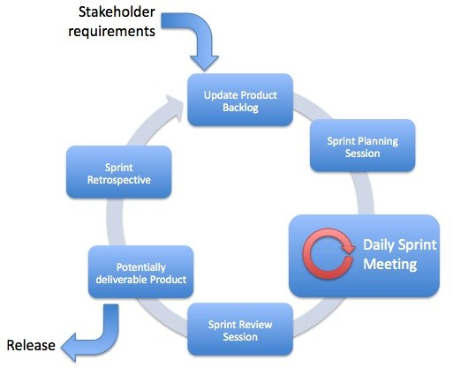

## SPRINTS PLANNED

* SPRINT 1
  + Goal to be accomplished – Creation of specification document and uploading to GitHub
  + Software – MS Word
  + Deliverable product – The final product specification document
* SPRINT 2
  + Goal to be accomplished – Coding the JSP pages
  + Software – Eclipse (IDE), Java, GitHub
    - Pages for
      * Add Subjects
      * Add Students
      * Add Courses
      * Add Teachers
      * Assign Subject to Courses
      * Assign Teachers to Subjects
      * Generate report
  + Deliverable product – JSP page code
* SPRINT 3
  + Goal to be accomplished – Coding servlet, models and create database
  + Software – Eclipse (IDE), Java, GitHub
  + Deliverable product – The final product

# FLOWCHART

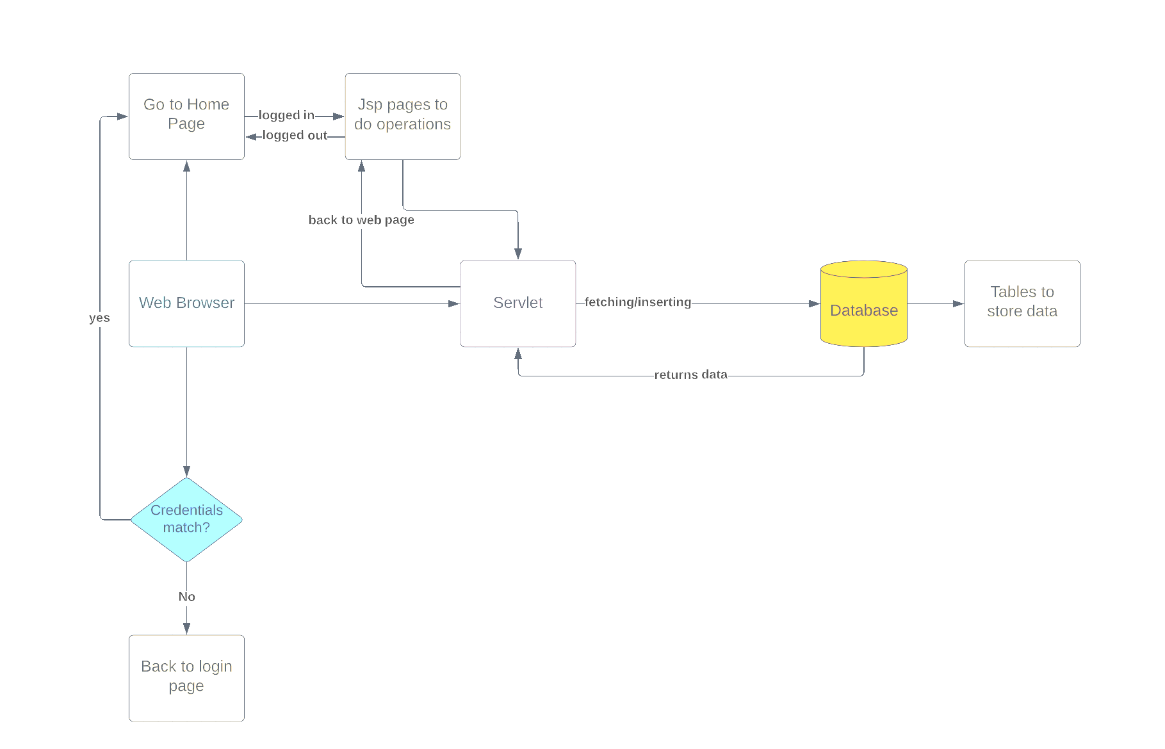

# CORE JAVA CONCEPTS USED

* Servlet: to do the business logic and works a controller for the project
* JSP: to handle the presentation view
* SQL: to create and manage the database Files
* JDBC: to make operations on the database for the project
* CSS: to format the contents.
* Eclipse: to write and run the code
* Tomcat: to run and deploy servlet application
* Hibernate: To establish one to one mapping

# Flow of control

# Login page

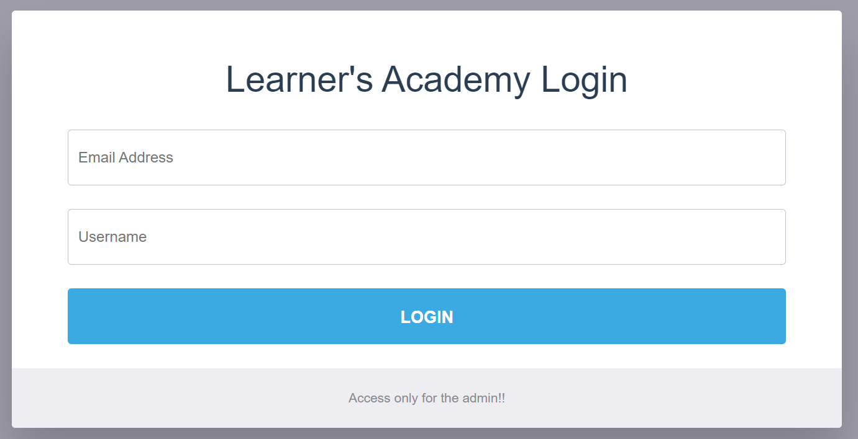

### **Homepage**

# 

### **Add (Subjects, classes, teachers)**

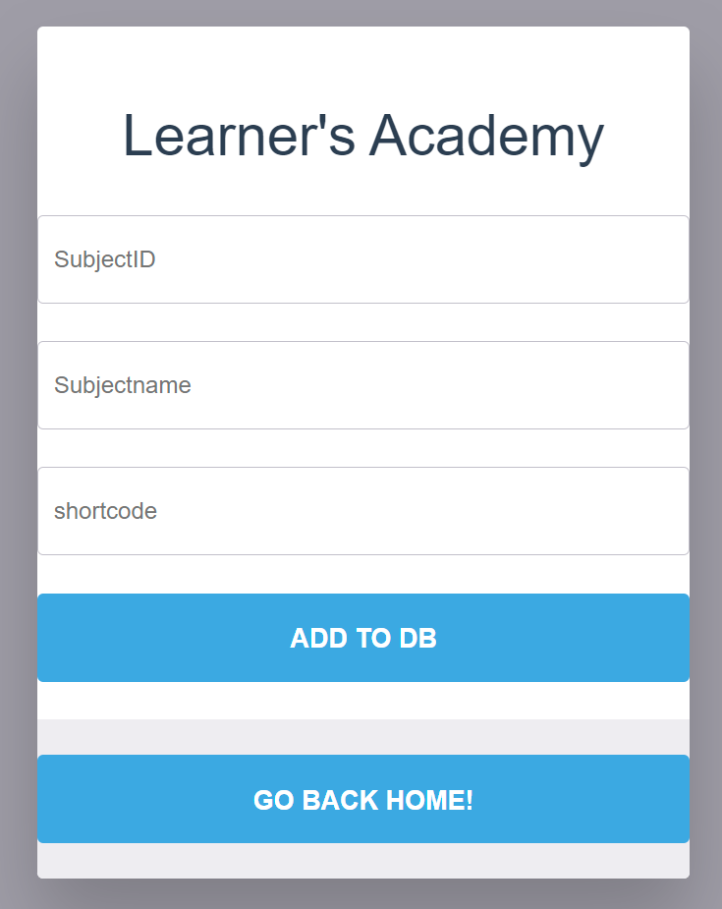

### **Add Student**

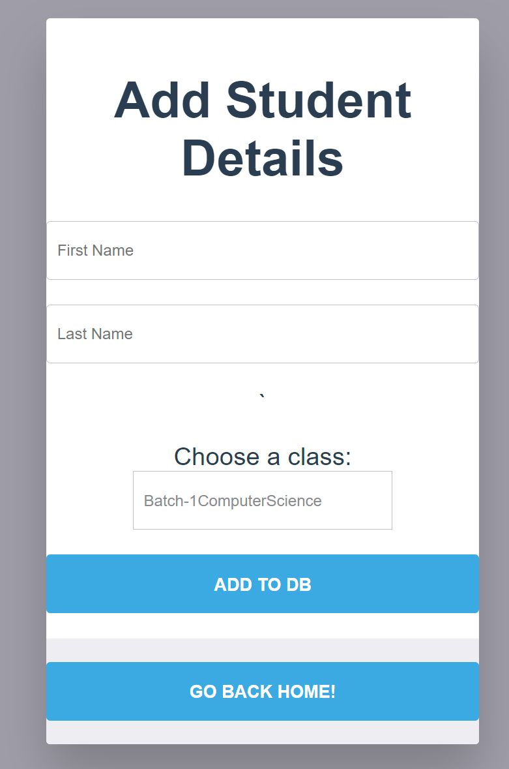

### **List (Subject, class, teachers)**

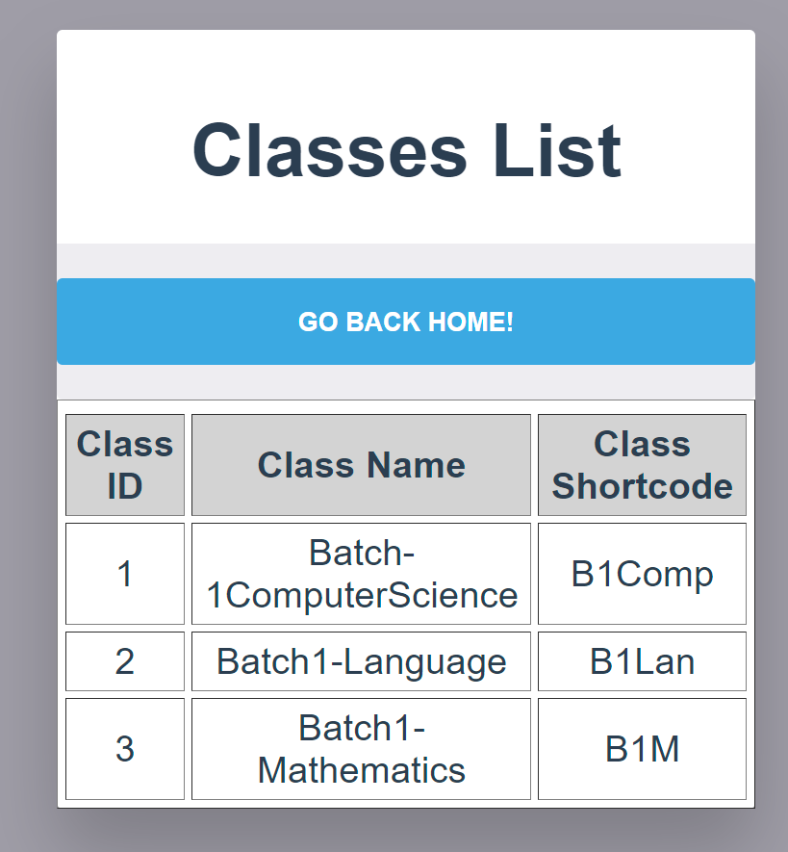

### **Assign (Subjects to course & Teachers to subjects)**

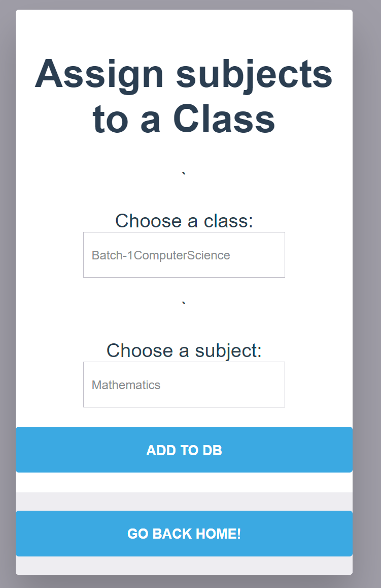

### **Generate class report**

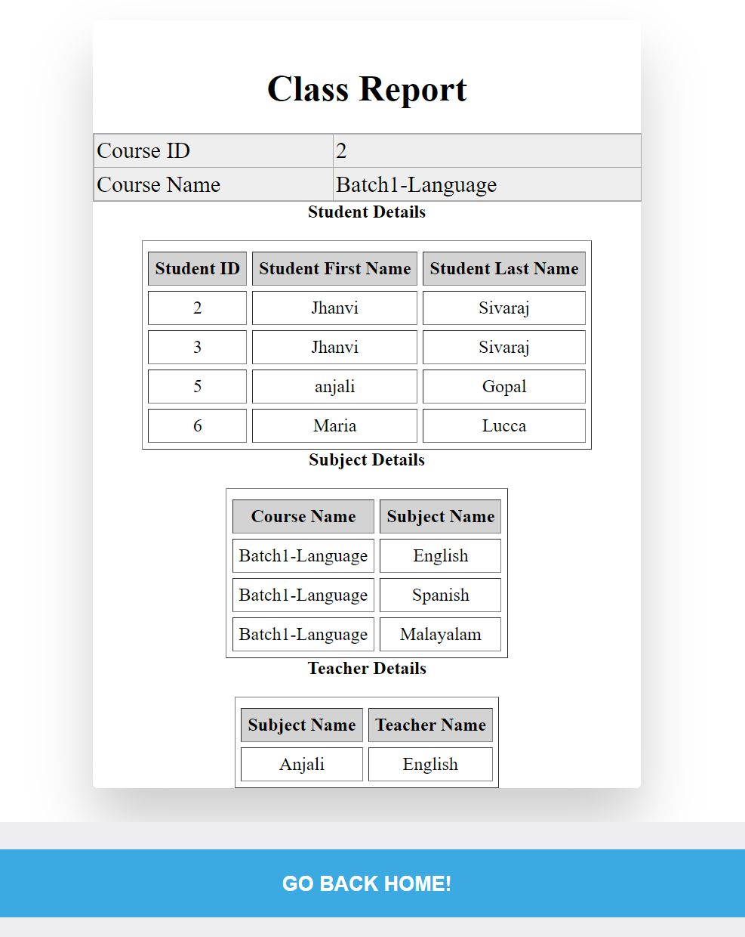

# LINKS TO GITHUB REPOSITORY

## Project Folder, Final specification document and screenshots –

<https://github.com/AnjaliRadhe/LearnersAcademy.git>

# CONCLUSION

 The project is to design and develop a highly functional backend administrative portal for the Learner’s Academy.