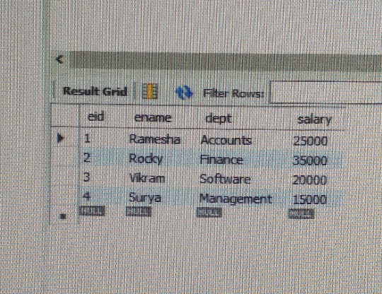Employee table :

Write a query to find the Nth highest salary from the Employee table (eid,ename,dept,salary).

* SLECT \* FROM employee WHERE salary=(select Max(salary)FROM employee);

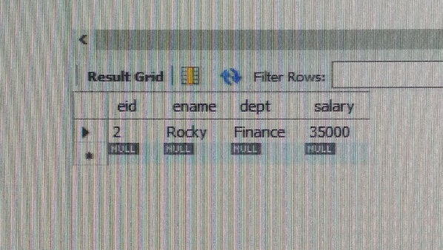

Write a query to fetch details of all employees excluding the employees with names, “Rocky” and “Vikram” from the Employee(eid,ename,dept,salary) table.

* SLECT \* FROM employee WHERE ename <> ‘Rocky’ AND ename <> ‘Vikram’ ;

