Codveda Technology
Level 1 – Basic
Data Cleaning, EDA & Visualization
Data Analytics Internship Program

Overview
This report covers Level 1 (Basic) of the Codveda Technology Data Analytics Internship. Two of the three available tasks were completed: Task 1 (Data Cleaning and Preprocessing) and Task 2 (Exploratory Data Analysis). All code was written in Python using pandas, matplotlib, and seaborn.

Task 1: Data Cleaning and Preprocessing
Dataset used: Stock Prices Data Set.csv — historical daily stock prices for 505 symbols (2014–2017), 497,472 rows. The raw file contained missing values in the open/high/low columns and a date field stored as plain text.

Objectives
- Load the dataset using pandas.
- Identify and handle missing values (imputation or removal).
- Remove duplicate rows and standardize inconsistent data formats (dates, categorical text).

Approach
The dataset was sorted by symbol and date, then missing open/high/low values were imputed using forward-fill within each stock symbol group (falling back to backward-fill for any leading gaps) — the standard approach for time-ordered price data, since it carries forward the last known valid price rather than distorting the series with a global mean.
df = df.sort_values(["symbol", "date"])
for col in ["open", "high", "low"]:
df[col] = df.groupby("symbol")[col].transform(
lambda s: s.ffill().bfill()
)
df = df.drop_duplicates()
df["date"] = pd.to_datetime(df["date"], errors="coerce")
df["symbol"] = df["symbol"].astype(str).str.strip().str.upper()
The date column was converted from text to a proper datetime type, the symbol column was standardized (trimmed and upper-cased), and numeric columns were coerced to numeric dtype to catch any hidden formatting issues.

Results
Metric | Before Cleaning | After Cleaning
Rows | 497,472 | 497,472
Missing values (open/high/low) | 27 | 0
Duplicate rows | 0 | 0
Date column type | text (string) | datetime64

A data-quality check also flagged 1 row where the daily high price was lower than the low price — an inconsistency worth flagging to the data owner rather than silently altering. The cleaned dataset was exported as stock_prices_cleaned.csv for downstream analysis.

Task 2: Exploratory Data Analysis (EDA)
Dataset used: House Prediction Data Set.csv — the classic Boston Housing dataset (506 records, 13 features + target MEDV, the median home value in $1000s).

Objectives
- Calculate summary statistics (mean, median, mode, standard deviation).
- Visualize data distributions using histograms, boxplots, and scatter plots.
- Find correlations between numerical features.

Summary Statistics (selected variables)
Variable | Mean | Median | Std Dev | Min | Max
MEDV (price, $1000s) | 22.53 | 21.20 | 9.20 | 5.00 | 50.00
RM (rooms/dwelling) | 6.28 | 6.21 | 0.70 | 3.56 | 8.78
LSTAT (% lower status pop.) | 12.65 | 11.36 | 7.14 | 1.73 | 37.97
CRIM (crime rate) | 3.61 | 0.26 | 8.60 | 0.006 | 88.98

Distributions
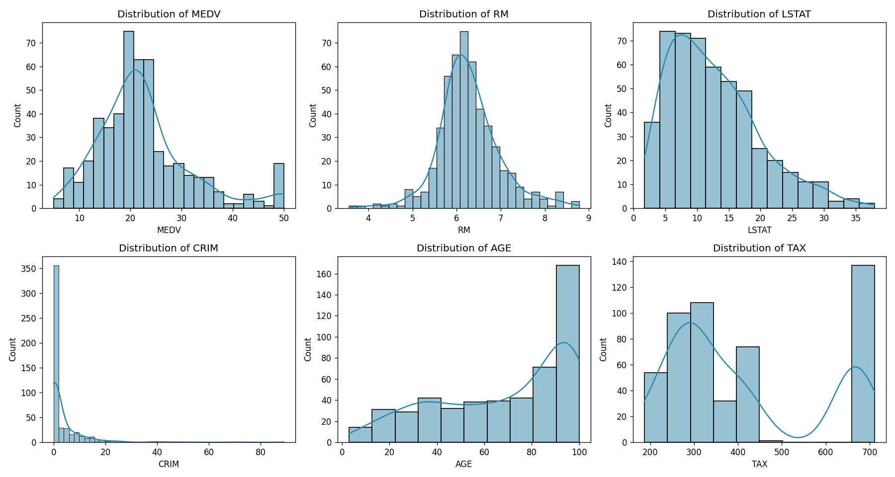
Figure 1. Distributions of key variables — most are right-skewed (e.g., CRIM), while RM is roughly normal.
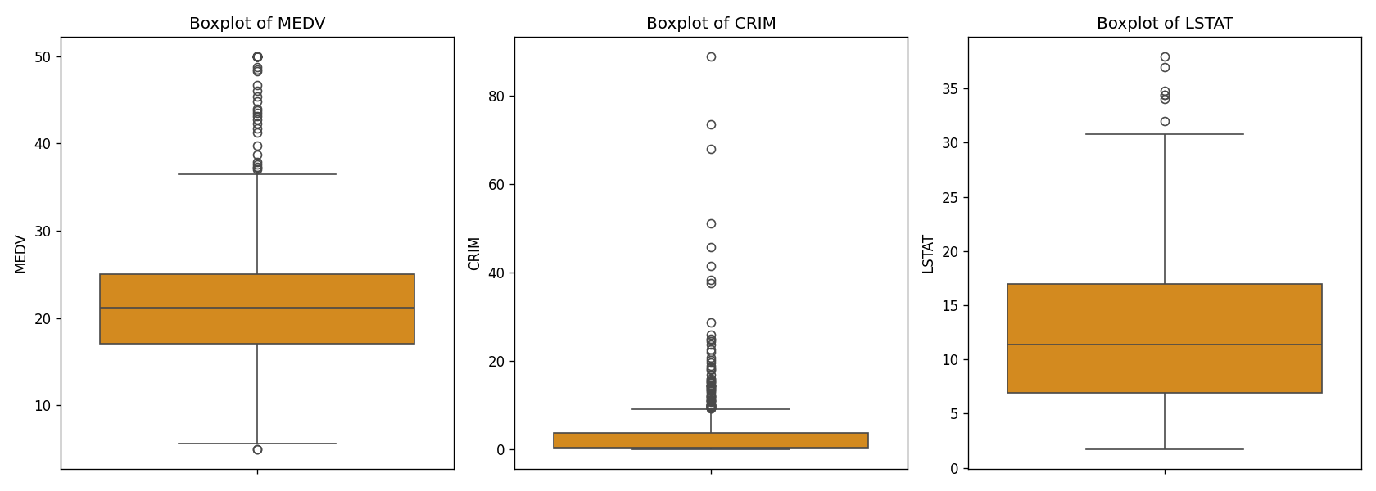
Figure 2. Boxplots highlighting outliers, particularly in MEDV (capped at 50) and CRIM (long tail of high-crime areas).
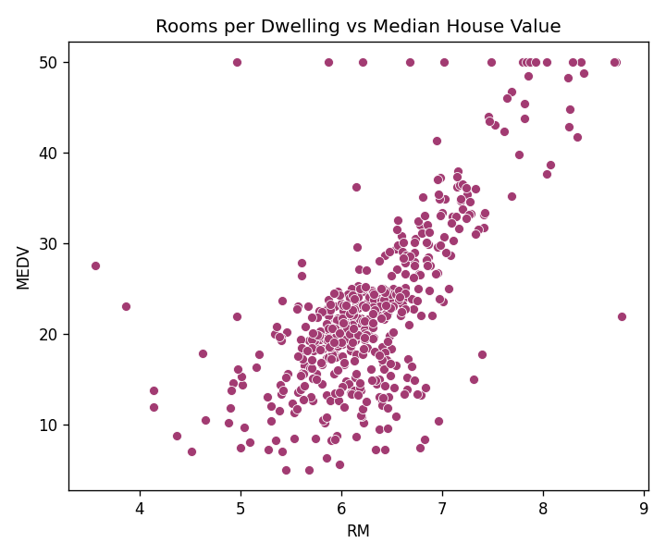
Figure 3. Rooms per dwelling (RM) shows a clear positive relationship with median house value (MEDV).

Correlation Analysis
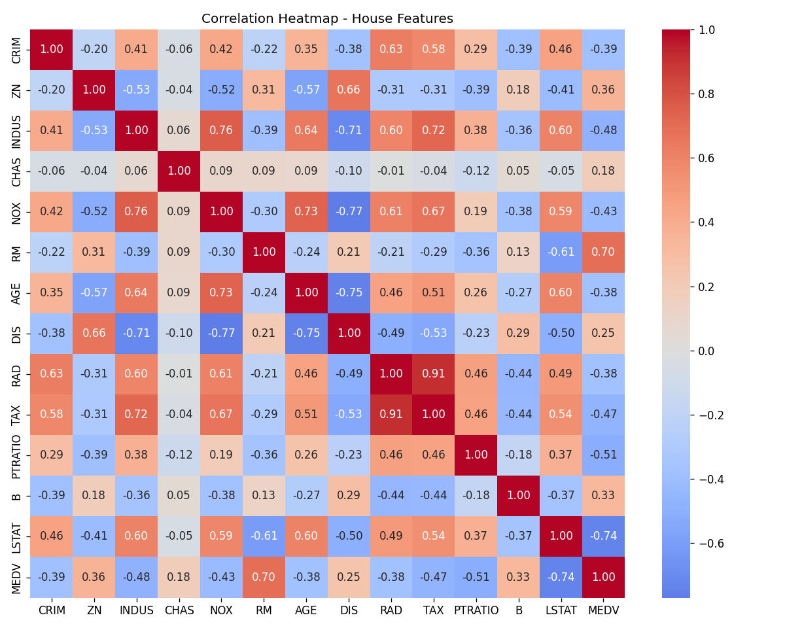
Figure 4. Correlation heatmap across all numeric features.
The features most strongly correlated with house price (MEDV) are:
- RM (rooms per dwelling): +0.70 — more rooms, higher price.
- LSTAT (% lower-status population): −0.74 — the strongest correlation overall (negative).
- PTRATIO (pupil-teacher ratio): −0.51 — neighborhoods with more crowded schools tend to have lower home values.

Conclusion
Both Level 1 tasks were completed successfully. The data cleaning task demonstrated handling of missing values, duplicates, and format standardization on a large real-world time series dataset. The EDA task surfaced clear, interpretable relationships in the housing dataset — most notably that room count and neighborhood socioeconomic status are the two strongest predictors of home value, which sets up the regression modeling done in Level 2.

