Codveda Technology
Level 2 – Intermediate
Regression & Clustering Analysis
Data Analytics Internship Program

Overview
This report covers Level 2 (Intermediate) of the Codveda Technology Data Analytics Internship. Two of the three available tasks were completed: Task 1 (Regression Analysis) and Task 3 (Clustering Analysis with K-Means). All modeling was done in Python using scikit-learn.

Task 1: Regression Analysis
Dataset used: House Prediction Data Set.csv (Boston Housing, 506 records). Goal: predict median house value (MEDV) from average rooms per dwelling (RM) using simple linear regression.

Objectives
- Split the dataset into training and testing sets.
- Fit a linear regression model using scikit-learn.
- Interpret the coefficients and evaluate the model using R-squared and mean squared error.

Approach & Code
X_train, X_test, y_train, y_test = train_test_split(
X, y, test_size=0.2, random_state=42
)
model = LinearRegression()
model.fit(X_train, y_train)
y_pred = model.predict(X_test)
r2 = r2_score(y_test, y_pred)
mse = mean_squared_error(y_test, y_pred)

Results
Metric | Value
Intercept | -36.25
Coefficient (RM) | 9.35
R-squared (test set) | 0.371
RMSE (test set) | 6.79 ($1000s)

Interpretation: each additional room is associated with an average increase of approximately $9,348 in median house value, holding all else constant. The single-feature model explains about 37% of the variance in price (R² = 0.37). For comparison, a multiple regression using all 13 available features raised R² to 0.669 and lowered RMSE to 4.93 — showing that price is driven by a combination of factors (location, socioeconomic status, pollution, etc.), not rooms alone.
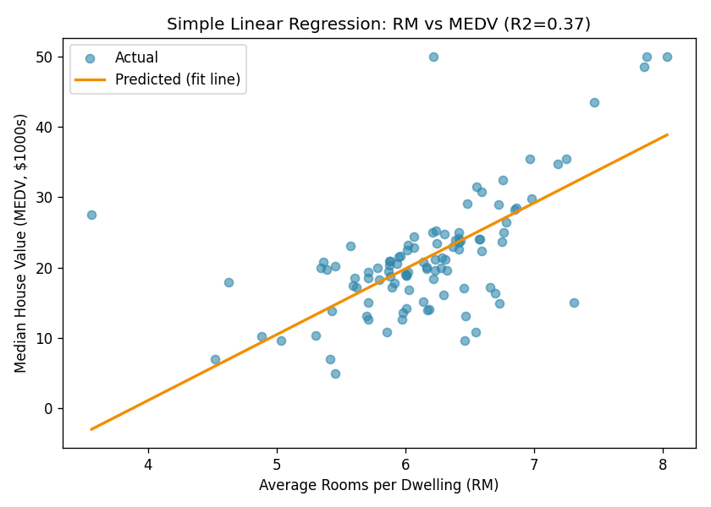
Figure 1. Fitted regression line: rooms per dwelling vs. median house value.
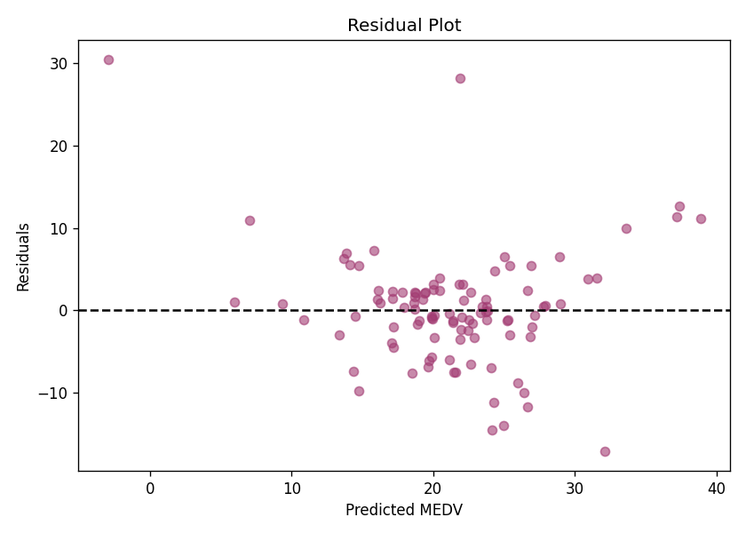
Figure 2. Residual plot — residuals fan out at higher predicted values, indicating the simple model underfits at the high end of the price range (a known ceiling effect in this dataset, where MEDV is capped at 50).

Task 3: Clustering Analysis (K-Means)
Dataset used: iris.csv (150 records, 4 numeric features describing flower measurements, 3 species).

Objectives
- Standardize the dataset using StandardScaler.
- Apply K-Means clustering and determine the optimal number of clusters using the elbow method.
- Visualize the resulting clusters using 2D scatter plots.

Approach & Code
scaler = StandardScaler()
X_scaled = scaler.fit_transform(X)
for k in range(2, 9):
km = KMeans(n_clusters=k, random_state=42, n_init=10)
km.fit(X_scaled)
inertias.append(km.inertia_)

Determining the Optimal k
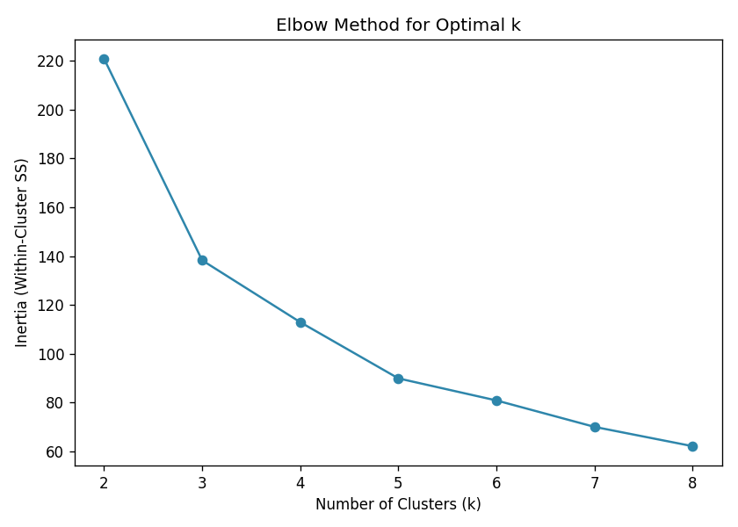
Figure 3. Elbow method — inertia drops sharply up to k=3, then flattens, indicating 3 as the optimal cluster count. This matches the silhouette score analysis and the fact that the dataset genuinely contains 3 iris species.

Cluster Visualization
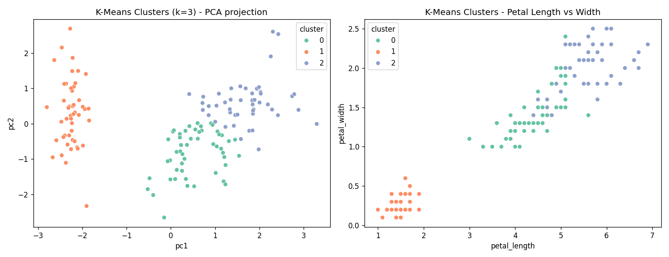
Figure 4. K-Means clusters (k=3) shown via PCA projection (left) and raw petal measurements (right).
Cross-tabulating the discovered clusters against the true species labels shows that K-Means recovers the setosa cluster perfectly (48/48), while versicolor and virginica overlap slightly (13 virginica points fall into the versicolor-dominant cluster) — expected, since these two species are known to be less linearly separable in petal/sepal measurements.

Conclusion
Level 2 demonstrated both supervised (regression) and unsupervised (clustering) machine learning techniques. The regression task showed how model complexity (single vs. multi-feature) trades off against interpretability and accuracy. The clustering task confirmed that K-Means, guided by the elbow method, can recover a dataset's natural groupings without being given the labels.

