Codveda Technology
Level 3 – Advanced
Predictive Modeling & NLP Sentiment Analysis
Data Analytics Internship Program

Overview
This report covers Level 3 (Advanced) of the Codveda Technology Data Analytics Internship. Two of the three available tasks were completed: Task 1 (Predictive Modeling / Classification) and Task 3 (NLP Sentiment Analysis). Task 2 (Power BI/Tableau dashboards) requires a licensed BI tool outside this environment and was not attempted here.

Task 1: Predictive Modeling (Classification)
Dataset used: Telecom Churn Prediction data (churn-bigml-80.csv for training with 2,666 records, churn-bigml-20.csv for testing with 667 records). Goal: predict whether a customer will churn based on account and usage features.

Objectives
- Preprocess the data (encode categorical variables, scale features).
- Train and test multiple classification models (Logistic Regression, Decision Tree, Random Forest).
- Evaluate models using accuracy, precision, recall, and F1-score.
- Perform hyperparameter tuning using grid search.

Approach & Code
models = {
"Logistic Regression": LogisticRegression(max_iter=1000),
"Decision Tree": DecisionTreeClassifier(random_state=42),
"Random Forest": RandomForestClassifier(n_estimators=200),
}
# ... fit + predict + score each model
grid = GridSearchCV(RandomForestClassifier(random_state=42),
param_grid={"n_estimators": [100, 200],
"max_depth": [None, 10, 20],
"min_samples_split": [2, 5]},
cv=5, scoring="f1")
grid.fit(X_train, y_train)

Model Comparison (Default Hyperparameters)
Model | Accuracy | Precision | Recall | F1-Score
Logistic Regression | 0.853 | 0.459 | 0.179 | 0.258
Decision Tree | 0.918 | 0.704 | 0.726 | 0.715
Random Forest | 0.954 | 0.957 | 0.705 | 0.812

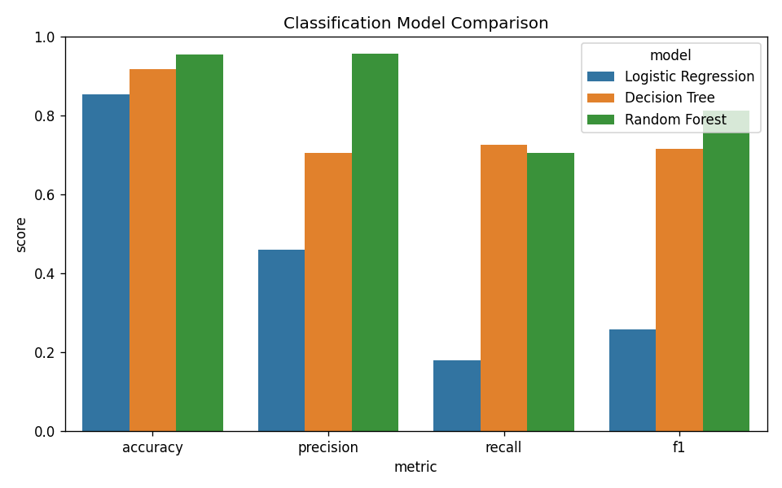
Figure 1. Model comparison across all four metrics — Random Forest is the strongest baseline.

Hyperparameter Tuning
A grid search (5-fold cross-validation, optimizing F1-score) was run over the Random Forest's n_estimators, max_depth, and min_samples_split. The best configuration was n_estimators=200, max_depth=20, min_samples_split=2, giving a tuned test-set F1-score of 0.805 (accuracy 0.952, precision 0.957, recall 0.695). Precision is very high, meaning churn predictions are trustworthy when made, while recall (≈70%) shows some churners are still missed — a common trade-off in imbalanced churn datasets (churners are the minority class).
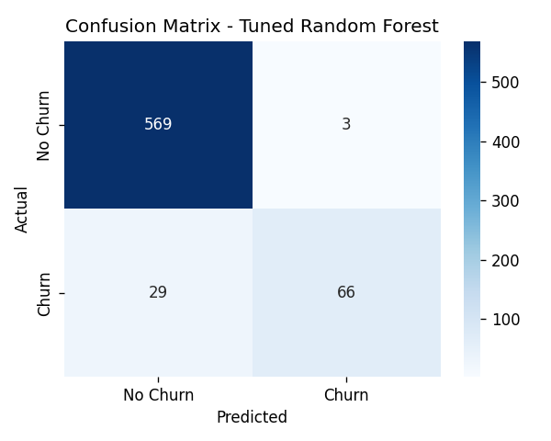
Figure 2. Confusion matrix for the tuned Random Forest on the held-out test set.
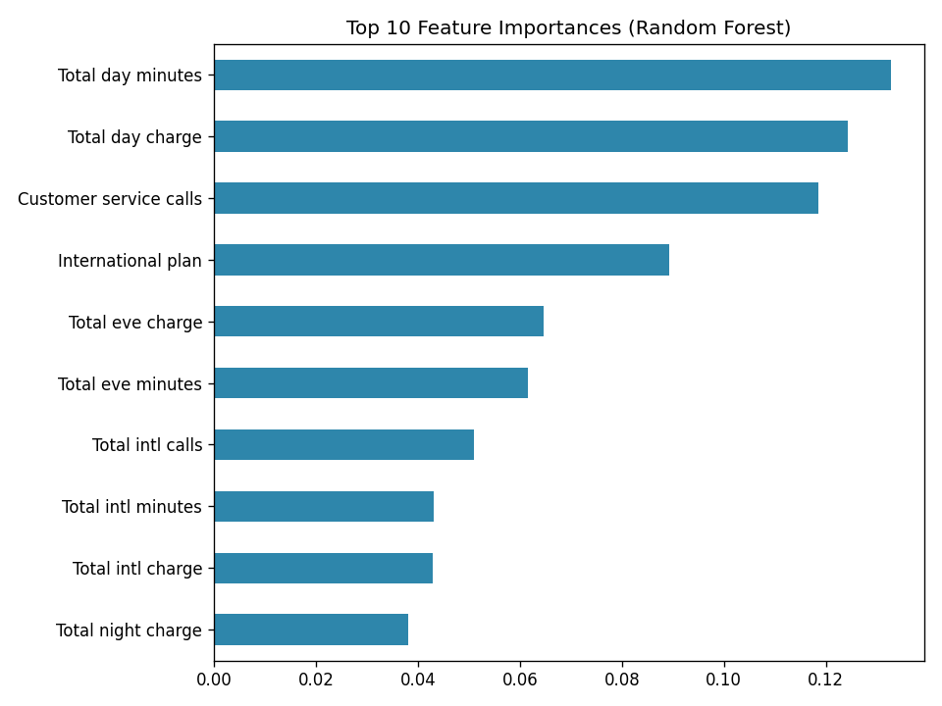
Figure 3. Top drivers of churn: total day charge/minutes, customer service calls, and international plan status are the strongest predictors.

Task 3: NLP Sentiment Analysis
Dataset used: Sentiment dataset.csv — 732 short social media posts with free-text content.

Objectives
- Preprocess text data (tokenization, stopword removal, lemmatization).
- Use TextBlob for polarity-based sentiment classification.
- Visualize the sentiment distribution and word frequencies using word clouds.

Approach & Code
def preprocess_text(text):
text = text.lower()
text = re.sub(r"[^a-z\s]", " ", text)
tokens = word_tokenize(text)
tokens = [lemmatizer.lemmatize(t) for t in tokens
if t not in stop_words and len(t) > 2]
return " ".join(tokens)
df["polarity"] = df["clean_text"].apply(
lambda t: TextBlob(t).sentiment.polarity
)
df["sentiment"] = df["polarity"].apply(classify_sentiment)

Results
Sentiment | Post Count | Share
Neutral | 395 | 54.0%
Positive | 251 | 34.3%
Negative | 86 | 11.7%

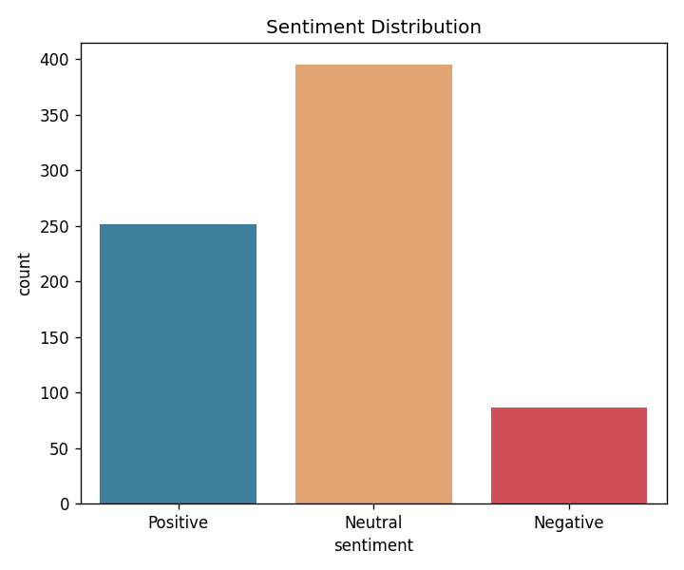
Figure 4. Sentiment distribution across all posts.
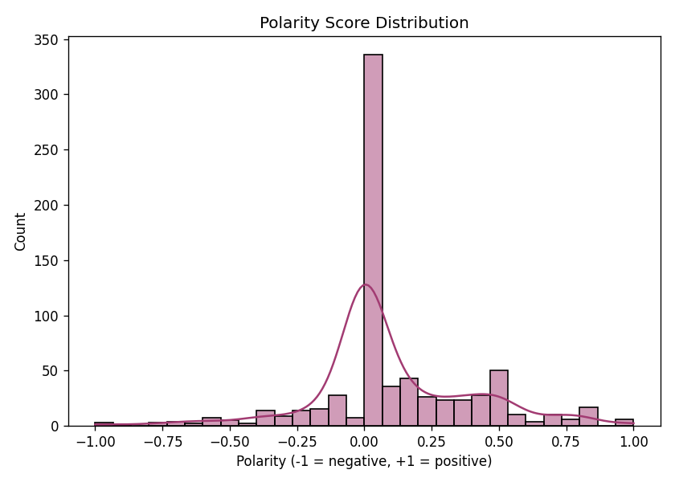
Figure 5. Polarity score distribution — skewed toward the positive/neutral range, consistent with typical social-media posting behavior.
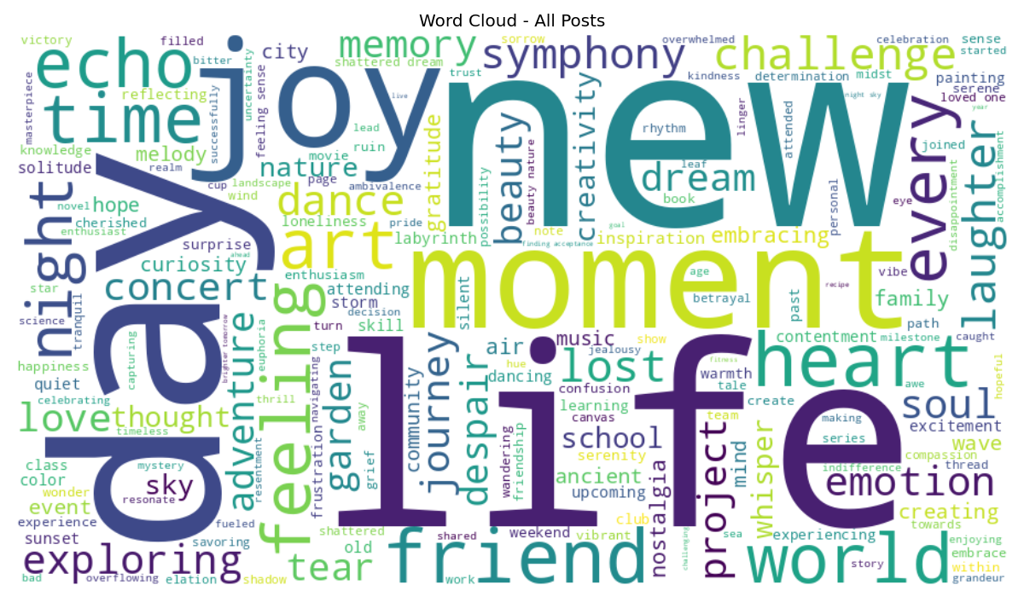
Figure 6. Word cloud of the most frequent terms across all posts.
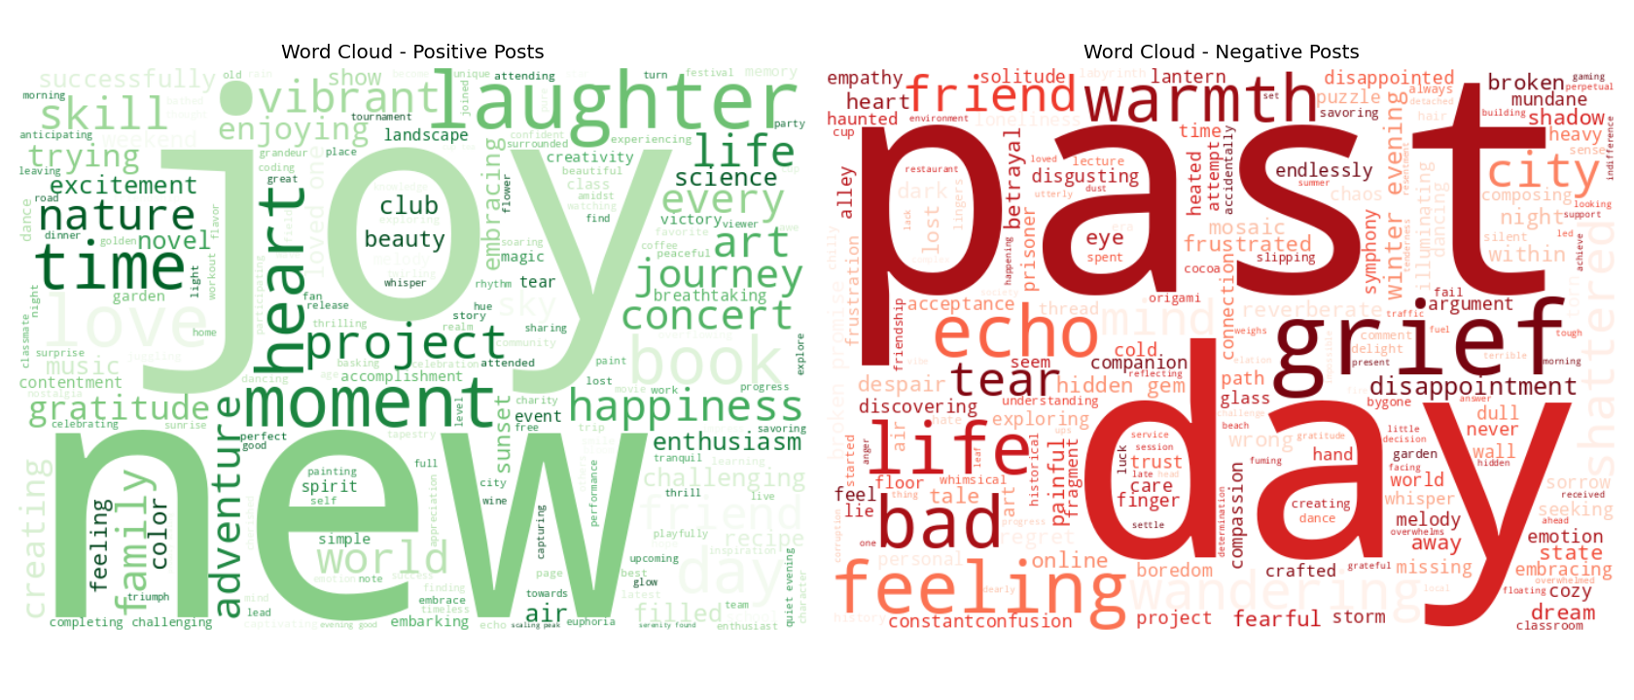
Figure 7. Word clouds split by sentiment — positive posts cluster around leisure/gratitude words, negative posts around frustration/complaint words.

Conclusion
Level 3 combined a structured-data classification problem with unstructured-text sentiment analysis. The churn model reached a strong F1-score of 0.81 after tuning, with customer service call volume and usage charges emerging as the leading churn drivers — actionable insight for a retention team. The sentiment analysis pipeline successfully classified social posts into positive/neutral/negative categories and surfaced the vocabulary driving each sentiment class.

