How citizens evaluate immigration in Ireland

The immigration has been a bigger concern for the government and the people of a country. To look at this perspective from the opinion of citizens of a country makes much difference. To understand the behaviour towards immigration, the survey data from European Social survey(ESS) which monitors and interpret changing public attitudes and values within Europe.

To understand these attitudes towards immigration of citizens, the ESS round 7 for the year 2014 is more detailed towards immigration. Immigration can have a positive or negative impact on citizens of the countries. This module will be dealing with the behaviours of Irish people towards immigrants in two ways:

* Trust in legal system
* Immigration is good or bad for a country

The key attributes of immigration

Which attributes of immigration should be evaluated?

Why Quantitative approach?

Statistical methods deal with qualitative as well as quantitative data. For this analysis quantitative approach will be apt since it is based on ordinal variables which are coded in number form but with less precise numerical meaning. For this data the variable is either in either binary form: e.g. Citizens Yes/No or data in an order e.g. 0 1 2 3 to 10 (for No trust at all to 10 being complete trust) to explain the behaviour towards immigration. The proportions or percentage of the number of people satisfaction towards immigration can be explained using quantitative approach.

Data

This data is based on an observational study which can only help in determining the association between the variables and not the causal conclusions. The views on immigration were based on these predictors:

The control variables or predictors of attitudes towards immigration in Ireland, helps us examine the behaviour of citizens of Ireland.

To understand the relationship between independent and dependent variables of attitudes for positive or negative impact of each independent variable on the immigration. From the survey the below variables are used to analyse citizen’s attitudes. This essay comprises a variety of indicators measuring how citizens evaluate different aspects of immigration.

Dependent Variables: The dependent variables considered here are trstlgl which tells the people attitudes towards legal system and imwbcnt which tells the attitudes towards immigrant making a better place to live or no.

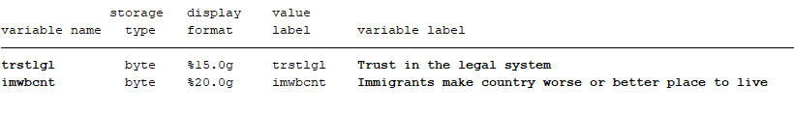

Independent variables: The control variables shape up the

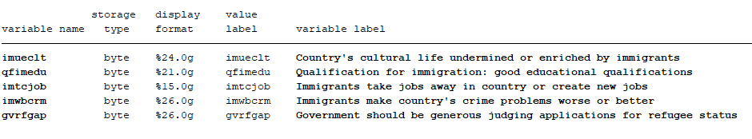

The missing values of each variable from dataset whose possible answers is ranging from “don’t know” and “refusal” have been changed and will not cause hinder in the results.

Descriptive statistics or Univariate Analyses: To understand the nature of each variable.

To get an estimate of the number of people participating in this survey are either anti-immigrants or immigrants. We computed the count or frequency of anti-immigrants in this survey is much larger than immigrants which is also the mean value or the average number of people who are anti-immigrants.

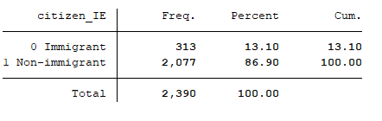

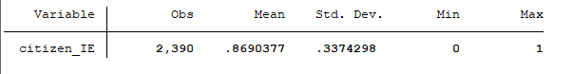

D:\18202322\downloads\citizen_IE1.tif

FIGURE 1: The percentage of immigrants and anti-immigrants in this survey

Dependent variables: The variables are being evaluated on a scale of 0 to 10 for each variable.

* trstlgl - Trust in the legal system

0 for “No trust at all” and 10 for “complete trust”

* imwbcnt - Immigrants make country worse or better place to live

0 for “Worse place to live” and 10 for “better place to live”

The number of people or percentage who have more faith in legal system is 67.35 when measured on a scale above 5. Hence, more People can be considered having faith in legal system.

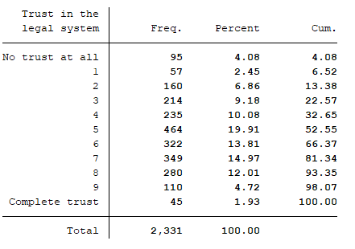

The other dependent variable which tells whether immigrants make country worse or better place to live estimates that mostly people are inclined towards the immigrants and thinks they makes country a better place to live and stands with a percentage of 69.45% when measured on a scale above 5. Hence, more People can be considered saying immigrants make a better place to live in.

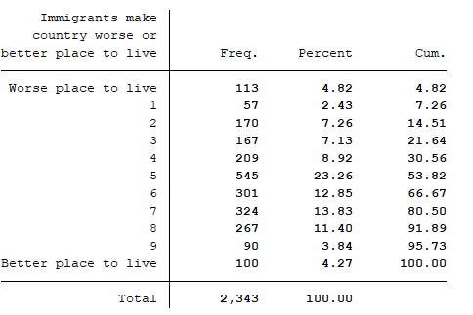

Independent variables or predictors: The variables are being evaluated on a scale of 0 to 10 for each variable.

* imueclt - 0 is for “cultural life undermined” and 10 is for “cultural life enriched”
* qfimedu - 0 is for “Extremely unimportant” and 10 is for “Extremely important”
* imtcjob - 0 is for “Takes jobs away” and 10 is for “Creates new jobs”
* imwbcrm - 0 is for “Crimes problems made worse” and 10 is for “Crimes problems made better”

68.68% of people believe on an average scale that country’s cultural life is enriched by immigrants.

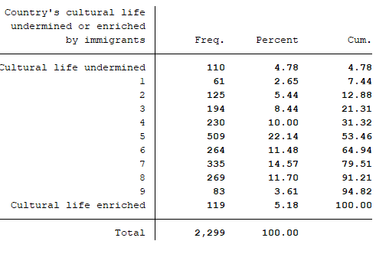

People are inclined towards good educational qualification to immigrant. The percentage of people who feel it that way is 87.47 which is on a scale of 0 to 10 and above 5.

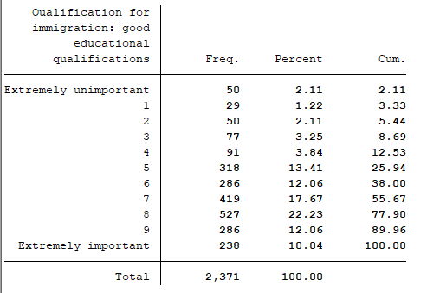

The percentage of people who feel immigrants creates jobs is 56.08 which is on a scale of 5 to 10 and rest of the people i.e.43.92 feels that they take their jobs away. The relationship is nearly equal towards jobs perspective.

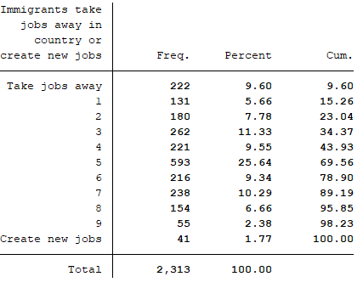

The number of people who feel neither it makes worse nor better is higher and is computed as 35.78%. Whereas 47.07% feel it has become worse while the rest of the 17.15% feels it is better.

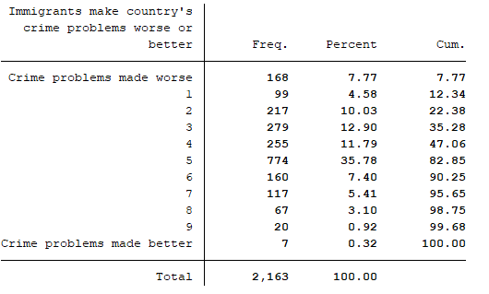

Centre of Measure: The centre of measures can be computed through mean while the scattered data can be or dispersion can be computed through standard deviation and range.

Dependent Variables:

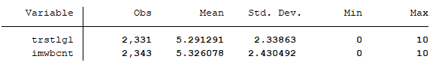

It can also be seen in the graph, people are inclined towards trust in legal system whether they are immigrants or anti-immigrants.



 







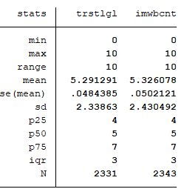

Independent Variables:

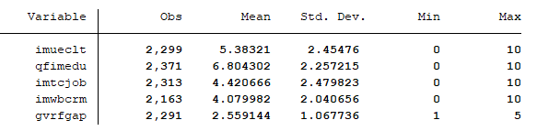

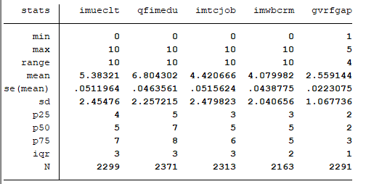



Regression Analysis:

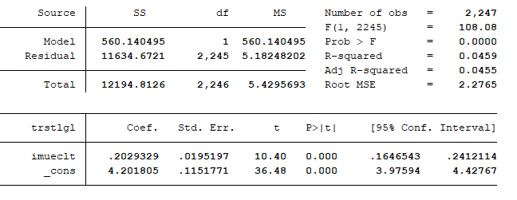

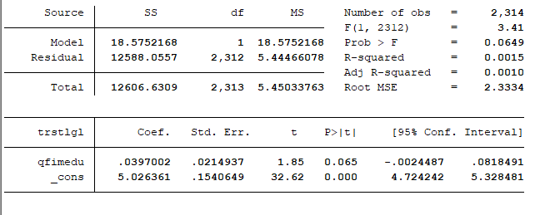

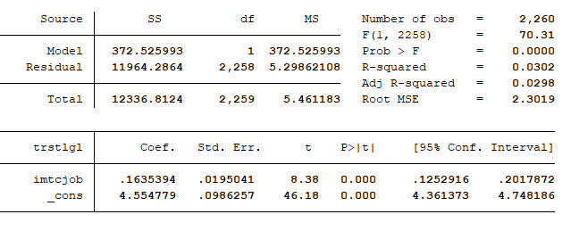

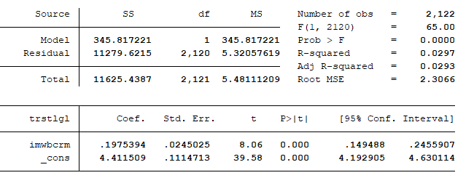

Another regression

regress imwbcnt imueclt

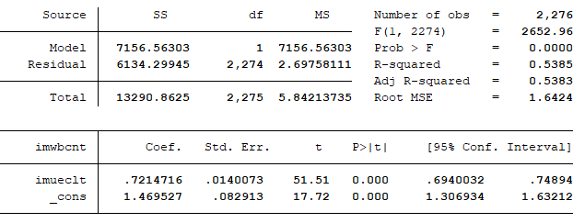

regress imwbcnt qfimedu

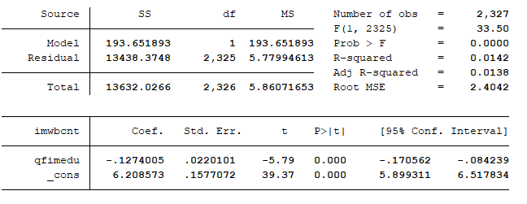

regress imwbcnt imtcjob

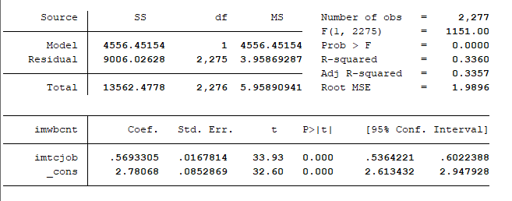

regress imwbcnt imwbcrm

