VAPT TASK 4

API Security Testing Lab

Testing a DVWA API for BOLA (Broken Object Level Authorization)
Run the following commands to access dvwa.
sudo systemctl start docker
sudo docker pull vulnerables/web-dvwa
sudo docker run -d -p 8080:80 --name dvwa --security-opt apparmor=unconfined vulnerables/web-dvwa
http://127.0.0.1:8080

Steps followed:
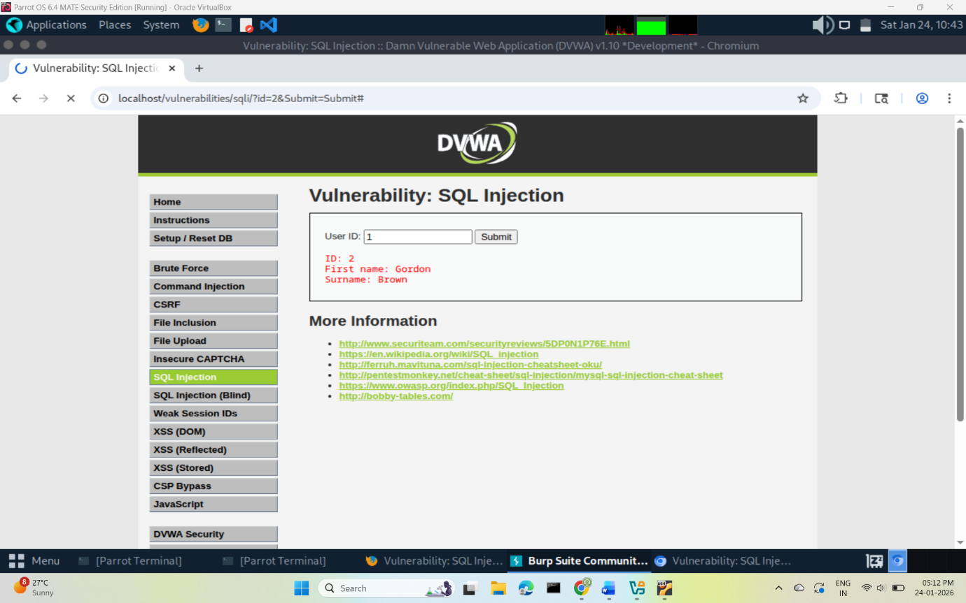
- Open BurpSuite In Proxy tab, turn the intercept on access dvwa navigate to SQL Injection tab type 1 in userid and submit.

- In the proxy tab, right click the request and send to repeater.
- Manipulate the value of “id” from 1 to 5 and click “send” and note the username and password.
- Forward the request in proxy tab and compare the o/p to the previous one.
- The response returns a different username and password.

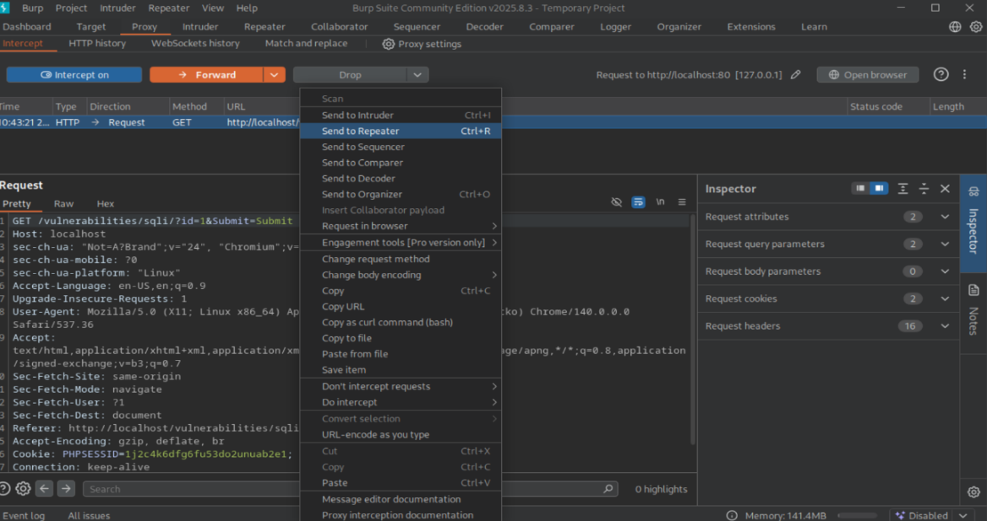
- This reveals the BOLA vulnerability.

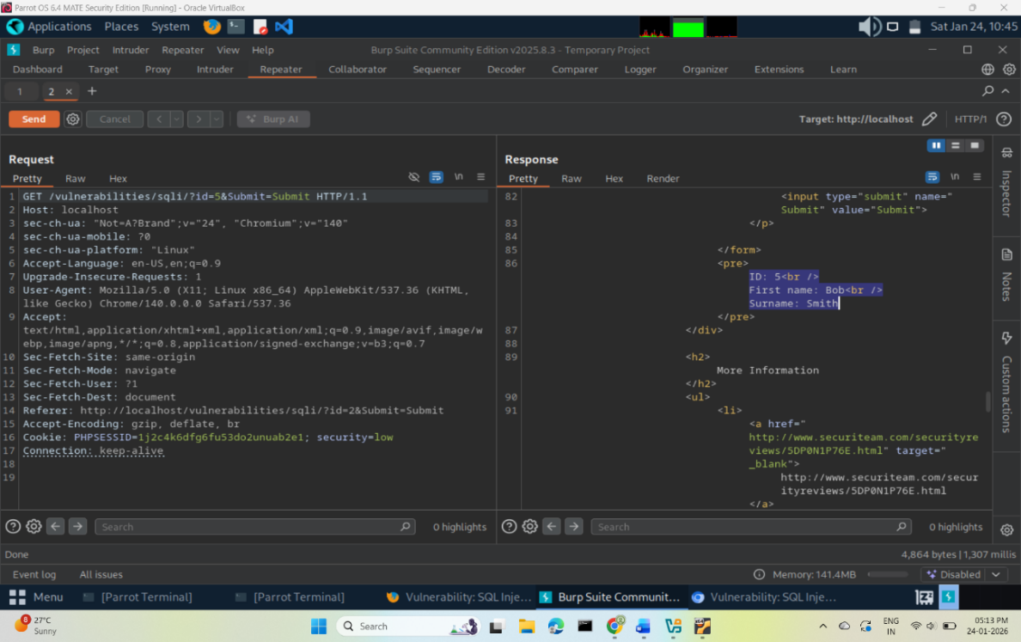

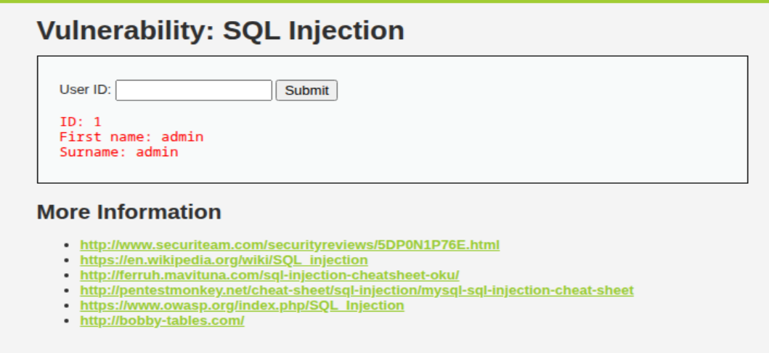

Testing Graphql Injection on OWASP Juice shop
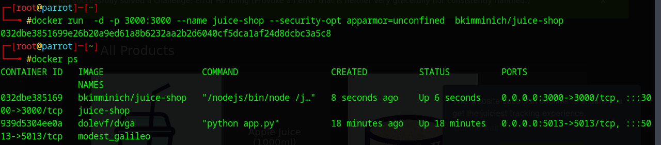
Running the juice shop on port 3000
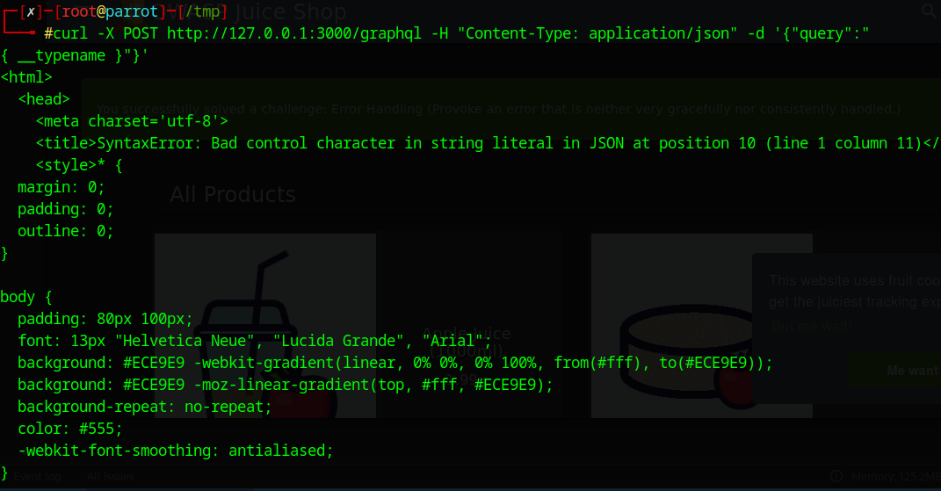
By using curl, raw and direct control over http requests can be taken.

Summary
BOLA was identified by manipulating the “id“ parameter in the url. This was performed on dvwa application.
GraphQL fuzzing was performed against the OWASP Juice Shop application deployed via Docker. The /graphql endpoint was tested using curl and Burp Suite for introspection, over-fetching, invalid fields, and depth-based query abuse in alignment with OWASP API Top 10.

Test ID | Vulnerability | Severity | Target Endpoint
1 | BOLA | CRITICAL | /vulnerabilities/sqli/
2 | Graphql Injection | HIGH | localhost:3000/graphql

Privilege Escalation and Persistence Lab

Step 1: Enumeration
I used LinPEAS to automate the discovery of misconfigurations. After transferring the script from Parrot OS via Netcat, I executed it on the target.
- Finding: LinPEAS highlighted several SUID binaries in red/yellow, specifically identifying that nmap was configured with the SUID bit, allowing it to run with root privileges.
Step 2: Exploitation
I exploited the SUID nmap binary using the interactive mode escape:
- Executed nmap --interactive.
- Escaped to a shell using the !sh command.
- Verified root access with whoami.
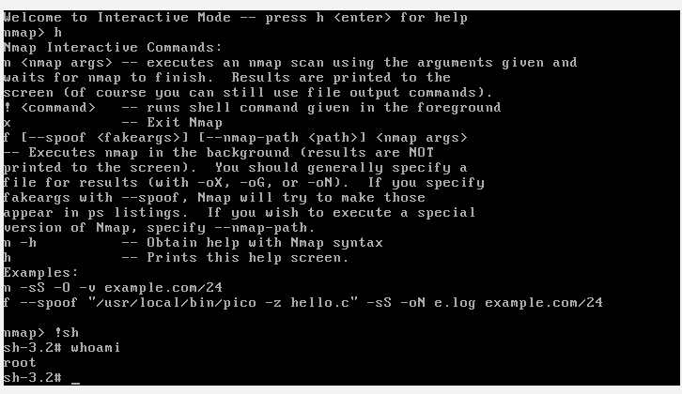
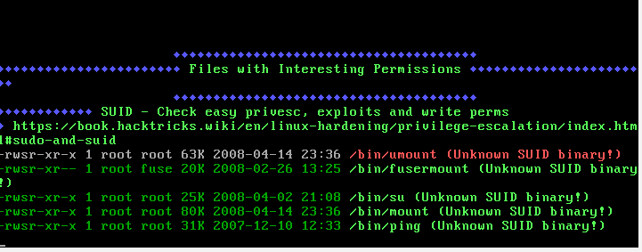
Summary
Established persistence by modifying the system's /etc/crontab file; added a cron job that executes a bash reverse shell every minute as the root user. This ensures an automated reconnection to my Parrot OS listener (port 4444), maintaining access even if the machine reboots or the current session is terminated.

Task ID | Technique | Target IP | Status | Outcome
010 | SUID Exploit | 192.168.64.8 | Success | Root Shell via SUID binary using /usr/bin/nmap

Network Protocol Attacks
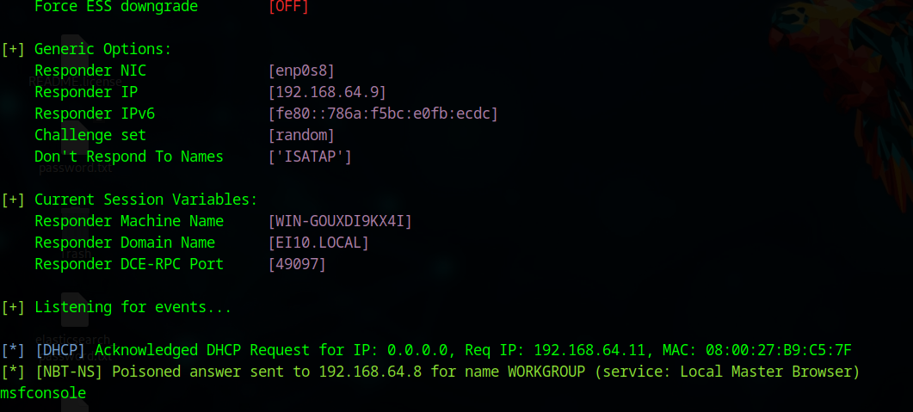
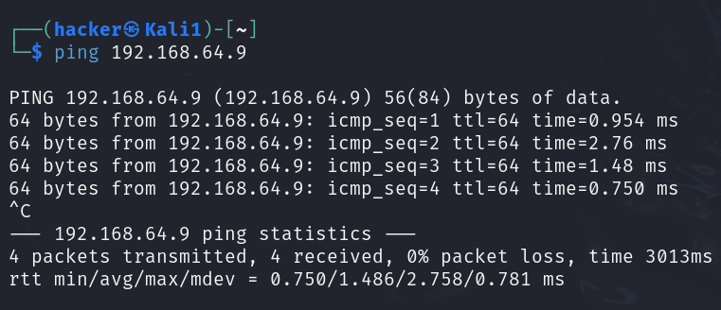
Attacker machine: Parrot (192.168.64.9)
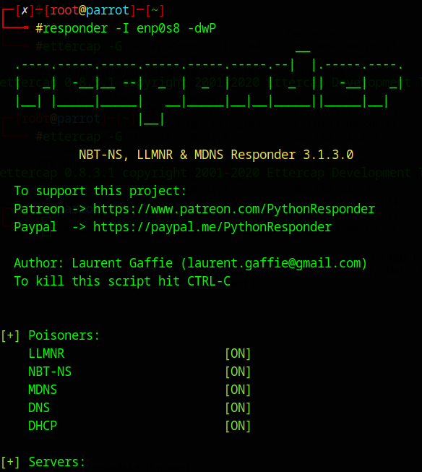
Victim machine: Kali (192.168.64.11)

Open responder in attacker and ping the attacker from victim machine.

Perform the following on victim using Metasploit framework.

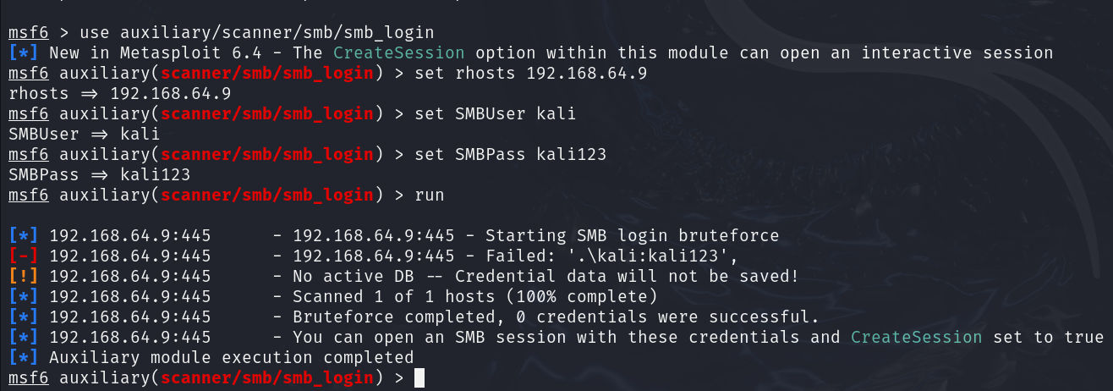

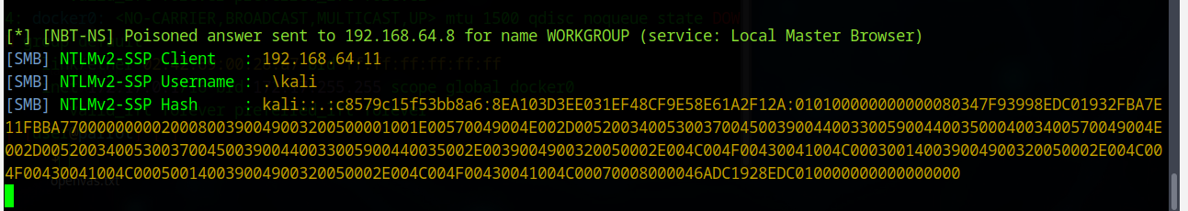
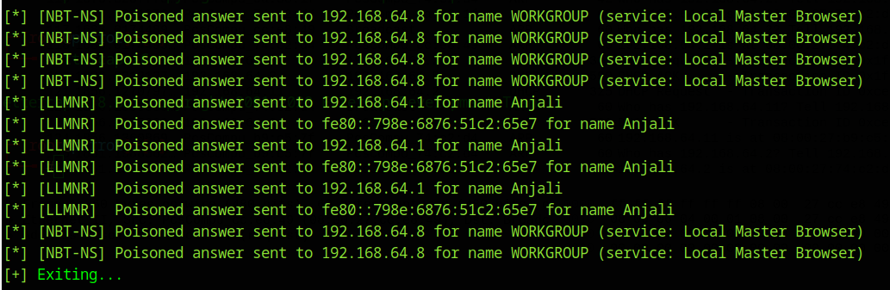
This produces a hash value.

Steps for MITM Attack
1. Perform ARP Spoofing (The MitM Task)
- Open Ettercap: sudo ettercap -G
- Sniff > Unified Sniffing > Select your interface (enp0s8).
- Hosts > Scan for hosts.
- Select Metasploitable (192.168.64.8) and add to Target 1.
- Select your Gateway (usually .1 or .2) and add to Target 2.
- Mitm > ARP Poisoning > Check "Sniff remote connections" > OK.
2. Perform DHCP Spoofing (The Checklist Task)
To check off "Spoof DNS" from your Google Docs list:
- In the Ettercap menu, go to Plugins > Manage Plugins.

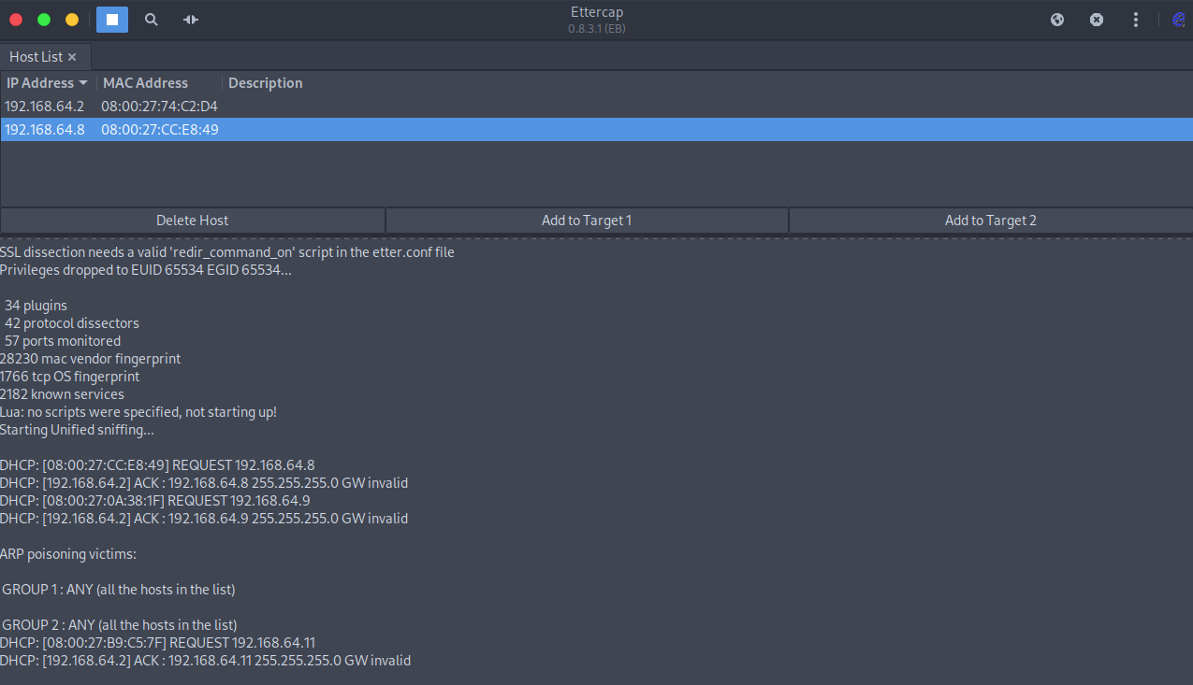
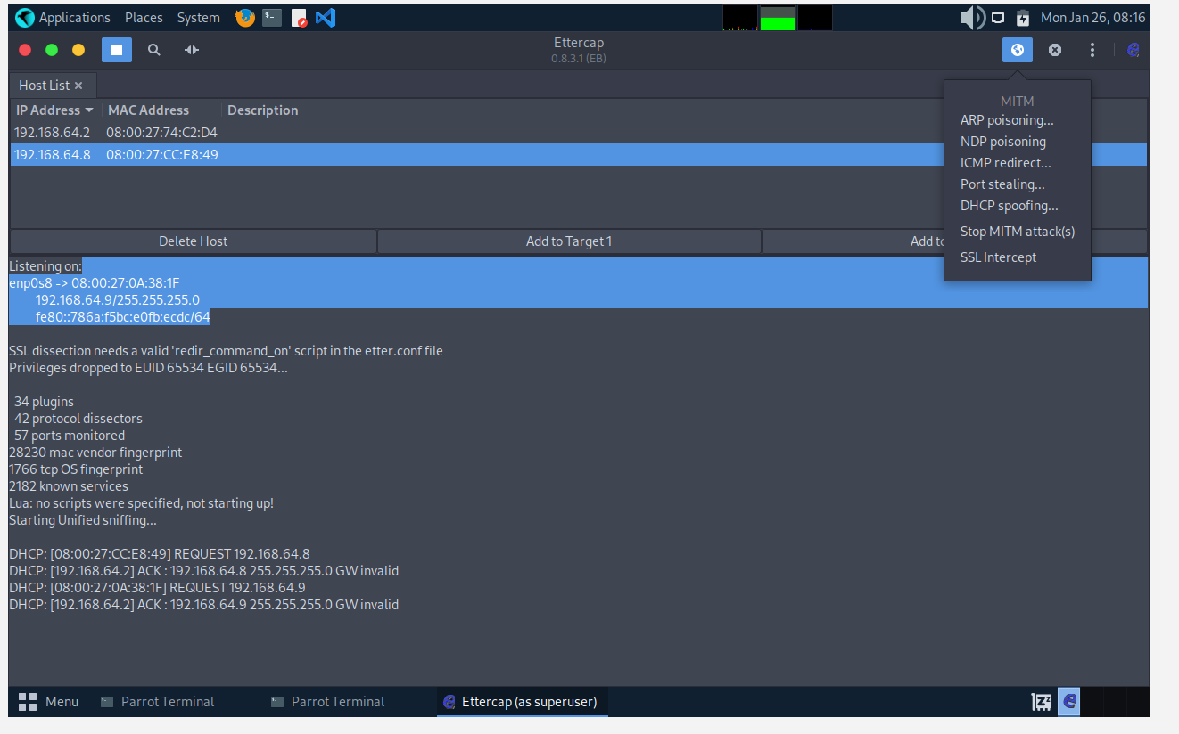

Attack ID | Technique | Target IP | Status | Outcome
01 | SMB Capture | 192.168.64.11 | Success | Captured NTLMv2 Hash (User: kali)

Summary
I established a Man-in-the-Middle position using Ettercap for ARP spoofing on the local subnet. By deploying Responder to poison NBT-NS broadcasts, I successfully intercepted an authentication handshake from the target (192.168.64.11). This resulted in the capture of a valid NTLMv2 password hash

Mobile Application Testing Lab
Execute the following commands to install mobsf
sudo apt install docker.io -y
sudo docker pull opensecurity/mobile-security-framework-mobsf:latest
sudo docker run -it -p 8000:8000 opensecurity/mobile-security-framework-mobsf:latest
Open http://localhost:8000 in browser and upload the .apk file.
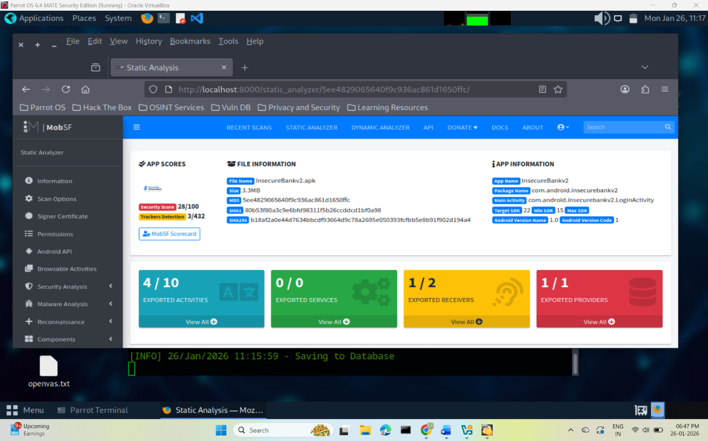
Following screenshots show the o/p.
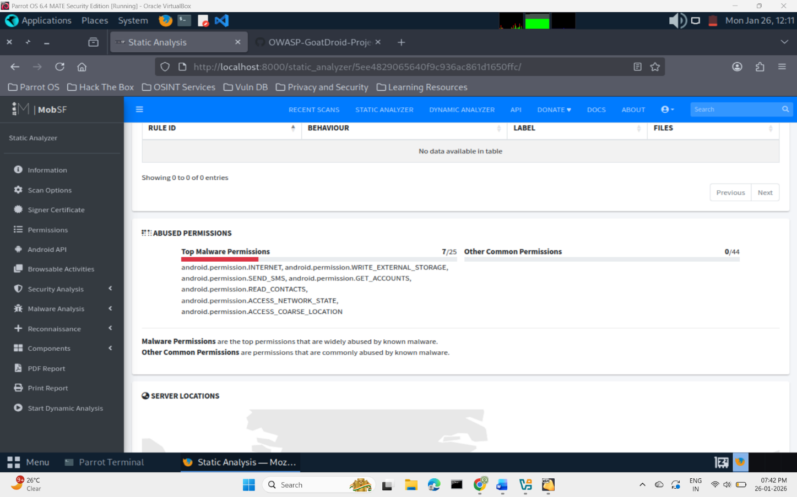

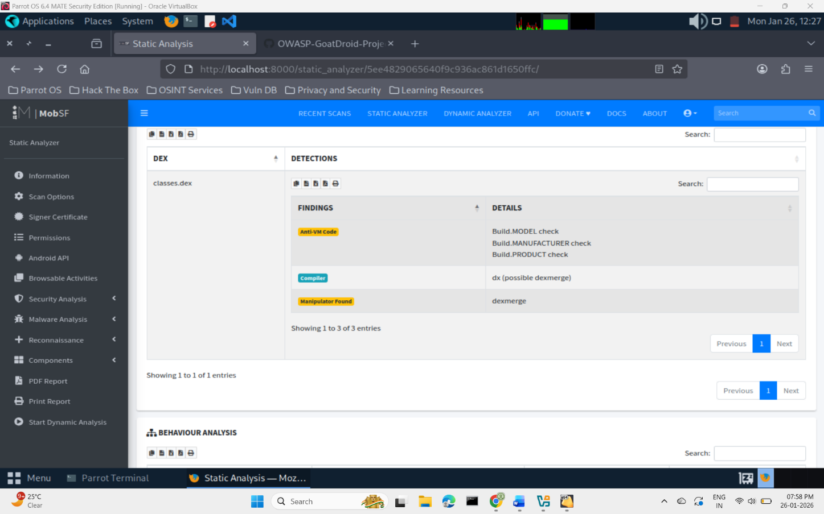

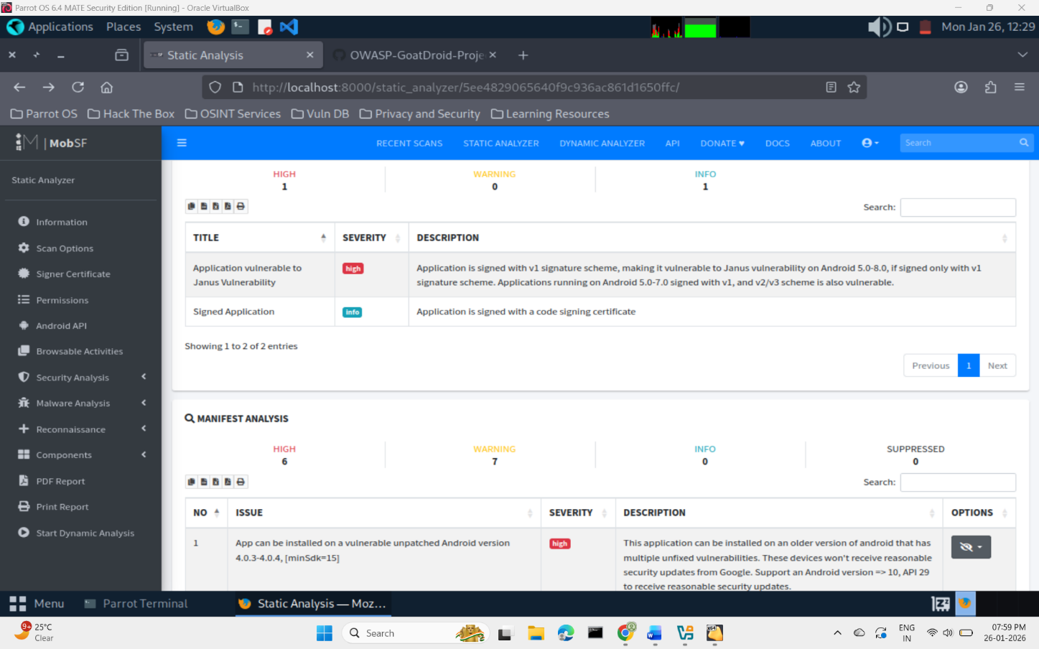

Capstone Project: Full VAPT Engagement
Exploiting the vsftpd backdoor vulnerability
Find the ip address of target machine by executing the following command:
netdiscover -r 192.168.64.0/24
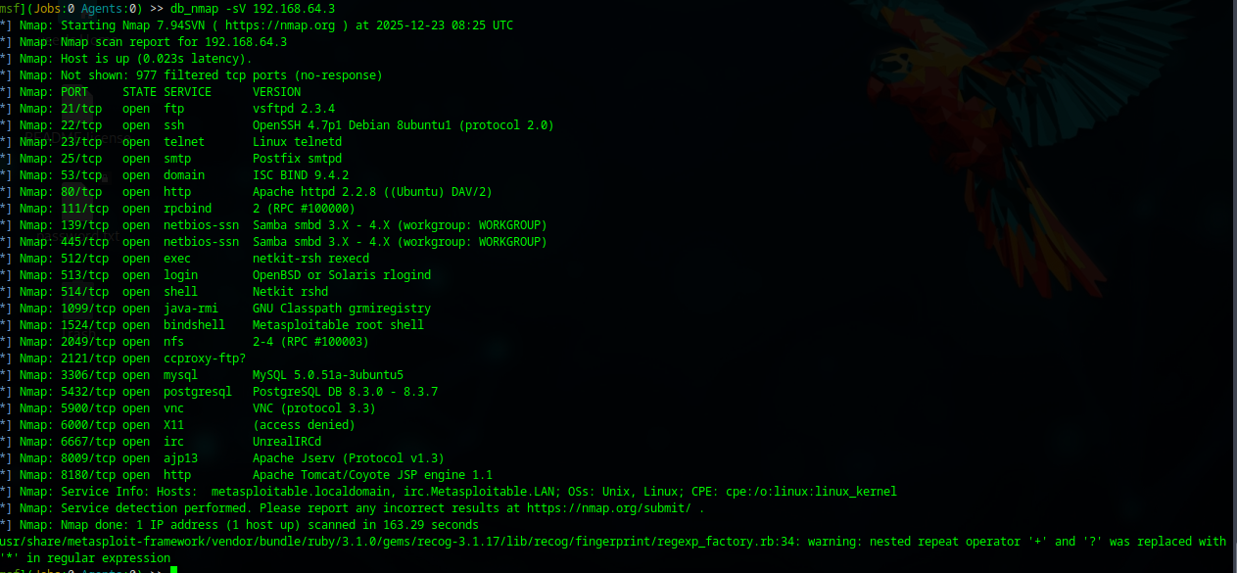
Use nmap scan or ping discover the host is up or not.
Use the tcp port scanning module

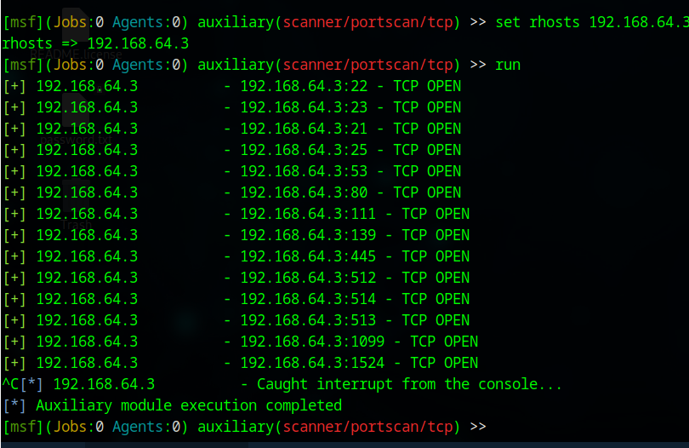
Run the commands as shown in adjacent figure

Open metasploitable by typing msfconsole in terminal.
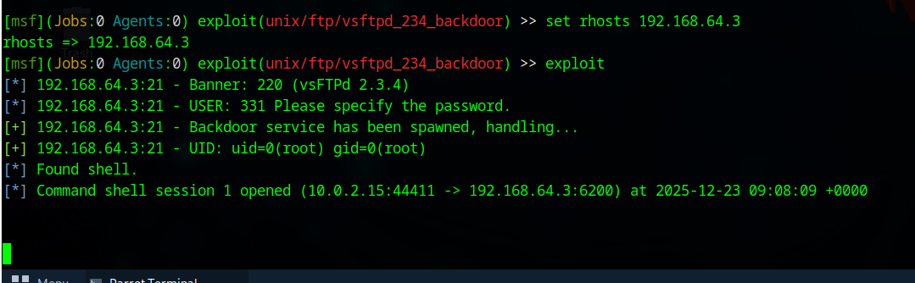
Search for vsftpd
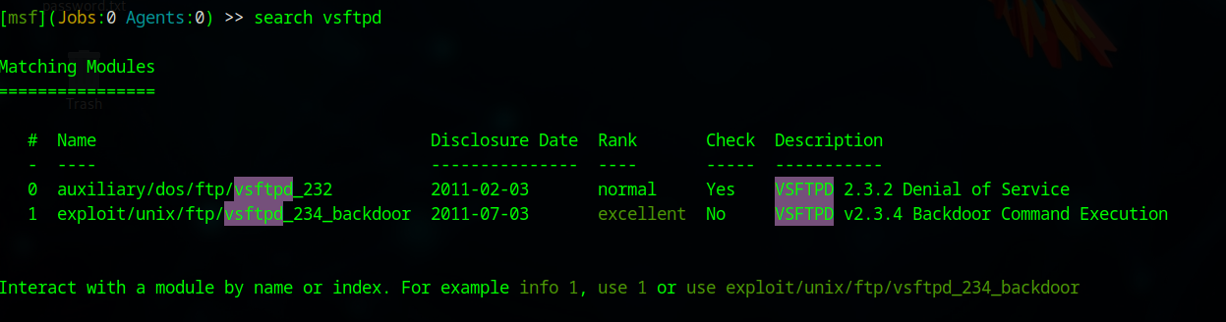
The connection has been established between the parrot machine (attacker machine) and the metasploitable (target machine).
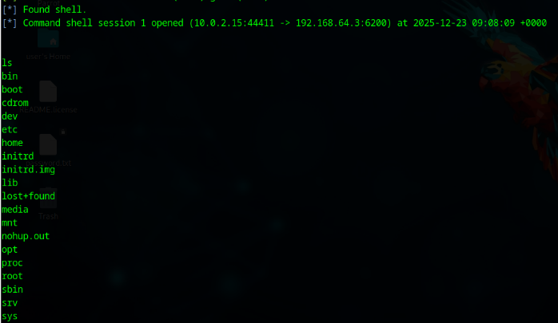
Type ls to view all directories in target machine.
Adjacent image shows the output:

Timestamp | Target IP | Vulnerability | PTES Phase
23-01-2026 14:00:20 | 192.168.64.3 | VSFTPD RCE | Exploitation

Remediation
Upgrade vsftpd immediately to the latest stable version
Vulnerable versions (e.g., vsftpd 2.3.4 backdoored build) must be removed, not just disabled
Use official repositories only to download and install patches for vulnerabilities.
Summary
The penetration test assessed the security posture of a Linux server exposing an FTP service running a vulnerable version of vsftpd. It allowed unauthorized command execution on the target system. Successful exploitation resulted in full compromise of the FTP service and demonstrated the potential for privilege escalation and lateral movement.
Attack Timeline
- Reconnaissance: Network scanning identified TCP port 21 open with vsftpd service exposed.
- Enumeration: Service fingerprinting revealed a vulnerable vsftpd version susceptible to RCE.
- Exploitation: A publicly available Metasploit module was used to trigger the backdoor, resulting in remote shell access.
- Post-Exploitation: Command execution was confirmed, demonstrating the attacker’s ability to read files and execute system commands.
- Impact Validation: The compromise confirmed potential for full system takeover if combined with privilege escalation techniques.
Non-technical Summary
During security testing, a serious vulnerability was identified in the system’s file transfer service. The service was running an outdated version of FTP software that allowed attackers to remotely execute commands without authorization. This means an attacker could gain control of the server, access sensitive data, or disrupt operations with minimal effort. The issue is well-known in the security community and has readily available attack tools, making exploitation highly likely if left unaddressed. To reduce risk, the affected software should be updated immediately.

