CHATBOT
A Project Report
By
Brahmankar Anjali Vijay
Seat Number:3025111

Chapter 1
Introduction
- What is a Chabot?
A conversational application that aids in customer service, engagement, and support by replacing or augmenting human support agents with artificial intelligence (AI) and other automation technologies that can communicate with end-users via chat; a computer program designed to simulate conversation with human users, especially over the internet. It is an application of AI.

- Purpose of Chatbot
Due to the growing fast life, customers tend to acquire all the information/resources altogether in one place. They don’t take efforts to search the complete website to gain information. This is decreasing patience of customers has made the developers think about the strategies to retain customers and maintain healthy customer relationships. A Facebook survey shows that over 50 percent of customers prefer dealing with an organization that has a conversational interface whereas a study by Oracle reveals that more than half of online customers expect businesses to be available 24/7. The developers therefore developed an assistant who will assist and help customers 24/7 with whatever they need, known as Chatbot.
Types of chatbots are shown in the figure below:
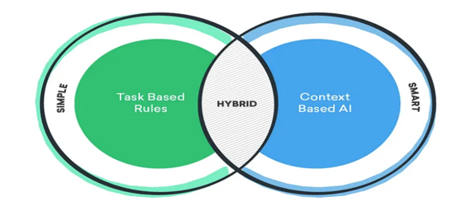
Fig 1.1 Types of Chatbots

- Depending upon the type of application domain, the chatbots are classified as: Voice Bots, Hybrid Chatbots, Social Messaging Chatbots, Menu-based Chatbots, Skills Chatbots & Keyword-based Chatbots, Rule-based Chatbots, AI-powered contextual chatbots, Support Chatbots, Transactional Chatbots, No-code / low-code chatbots.
- Application domains of chatbot: Customer Support, E-Commerce and Sales, Human Resource, Healthcare, Finance, Information and Education, Booking and reservation requests, I.T Services and Entertainment.
- Common examples of deployed chatbots: Siri, Google Assistant, Alexa, Cortana, Meena (Google), Watson Assistant (IBM), ShopBot (eBay), and many more.

Chapter 2
Survey of Technologies
2.1 Bootstrap
Bootstrap is the world’s most popular free, open-source CSS framework for building responsive, mobile-first sites, with jsDelivr and a template starter page. It contains HTML, CSS and JavaScript-based design templates for typography, forms, buttons, navigation, and other interface components. is an HTML, CSS and JS library that focuses on simplifying the development of informative web pages (as opposed to web applications). The primary purpose of adding it to a web project is to apply Bootstrap's choices of colour, size, font and layout to that project. Once added to a project, Bootstrap provides basic style definitions for all HTML elements. The result is a uniform appearance for prose, tables and form elements across web browsers. In addition, developers can take advantage of CSS classes defined in Bootstrap to further customize the appearance of their contents. Bootstrap also comes with several JavaScript components which do not require other libraries like jQuery. They provide additional user interface elements such as dialog boxes, tooltips, progress bars, navigation drop-downs, and carousels.
Also, Bootstrap Studio is a proprietary web design and development application. It offers a large number of components for building responsive pages including headers, footers, galleries and slideshows along with basic elements, such as spans and divs.
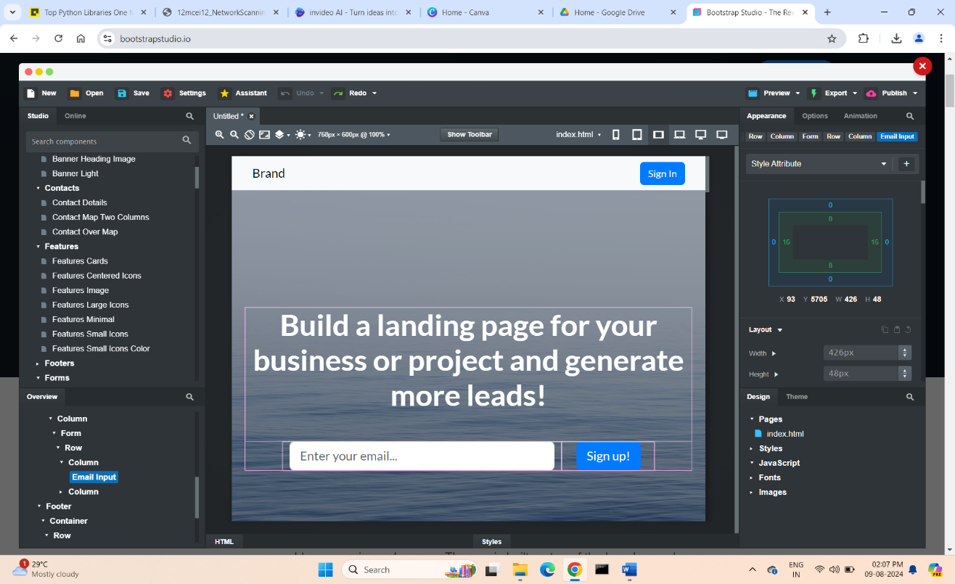

Fig 2.1 Bootstrap Studio

2.2 Python
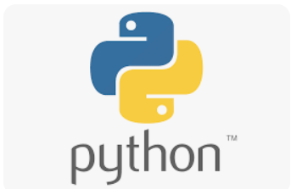
Python is a popular programming language that is interpreted, object-oriented, and considered to be high-level too. Python is one of the easiest yet most useful programming languages which is widely used in the software industry. The major focus behind creating it is making it easier for developers to read and understand, also reducing the lines of code. It is used to create workflows, web application development (server-side), for rapid prototyping, or for production-ready software development, system scripting, handling big data and perform complex mathematics, web scrapping, CAD. Its demand is growing at a very rapid pace due to its vast use cases in Modern Technological fields like Data Science, Game development, Artificial Intelligence, Machine learning, and Automation Tasks. For many years now, it has been ranked among the top Programming languages. Python has plenty of features that make it the most demanding and popular.

- Easy to read and understand
- Interpreted language
- Object-oriented programming language
- Free and open-source
- Versatile and Extensible
- Multi-platform
- Hundreds of libraries and frameworks
- Flexible, supports GUI
- Dynamically typed
- Huge and active community

2.3 CSS- Cascading Style Sheets
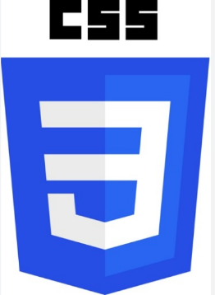
Cascading Style Sheets (CSS) is a stylesheet language used to describe the presentation of a document written in HTML or XML (including XML dialects such as SVG, MathML or XHTML). CSS describes how elements should be rendered on screen, on paper, in speech, or on other media. CSS is among the core languages of the open web and is standardized across Web browsers. CSS is designed to enable the separation of content and presentation, including layout, colours, and fonts. Separation of formatting and content also makes it feasible to present the same markup page in different styles for different rendering methods, such as on-screen, in print, by voice (via speech-based browser or screen reader), etc. CSS also has rules for alternative formatting if the content is accessed on a mobile device.
Advantages:
- Separation of content from presentation: CSS facilitates the publication of content in multiple presentation formats by adjusting styles based on various nominal parameters.
- Site-wide consistency: When CSS is used effectively, in terms of inheritance and "cascading", a global style sheet can be used to affect and style elements site-wide. A stylesheet, internal or external, specifies the style once for a range of HTML elements selected by class, id, etc.
- Easier Maintenance and Efficient Updates
- Time-Saving and Faster Loading Times: Utilizing external CSS files allows web browsers to cache the styling information, resulting in more efficient and faster page load times.
- SEO-Friendly: Employing clean and structured CSS code can enhance your website’s search engine optimization.
Limitations:
- You cannot add more than 10,000 characters within the CSS section per event.
- Cross-Browser Issues and Browser Compatibility: CSS might not always look the same across different web browsers.
- Security Concerns: Unlike some other web technologies, CSS doesn’t come with built-in security features. If misused, it can even become a security vulnerability, prone to attacks like Cross-Site Scripting (XSS).
****

Chapter 3
Requirements and Analysis
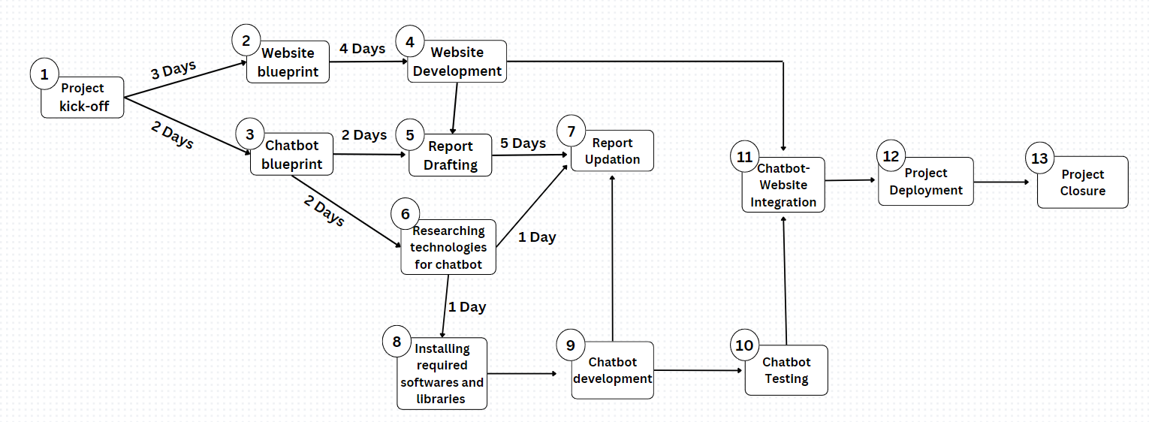
PERT CHART

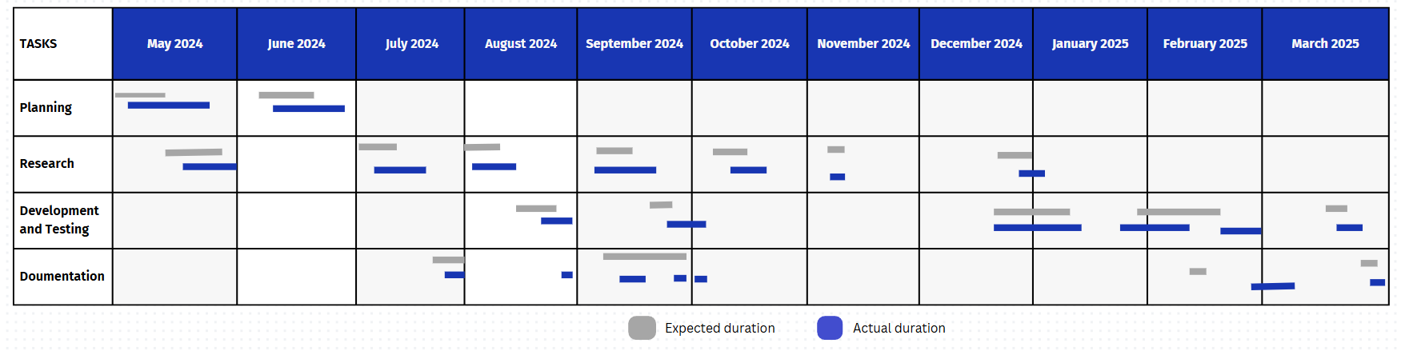
GANTT CHART

Software and Hardware requirements:
Hardware requirements:
- Minimum 2GB of RAM.
- Internet Connection
- Windows 7 or later
- AMD or Intel x86-64 CPU
- Minimum 5GB free space in ssd/hdd
Software requirements:
- Python 3 or later
- An IDE or a text editor like Sublime Text, VS Code, etc.
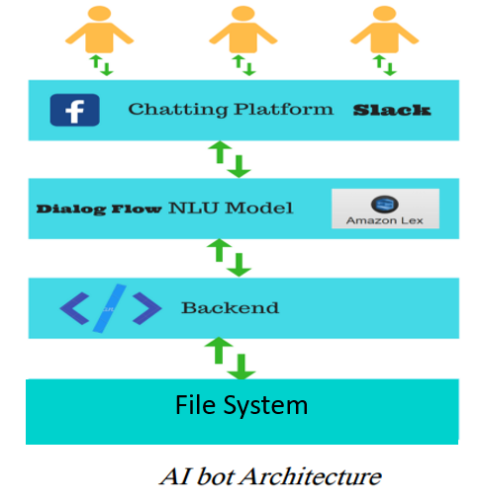
- Python libraries like SpaCy, NLTK, ChatterBot, Tkinter, TextBlob, Bootstrap, etc.
- Installation of the above libraries using pip package manager.
- Setting up a virtual environment
- Any web browser
- Conceptual models:

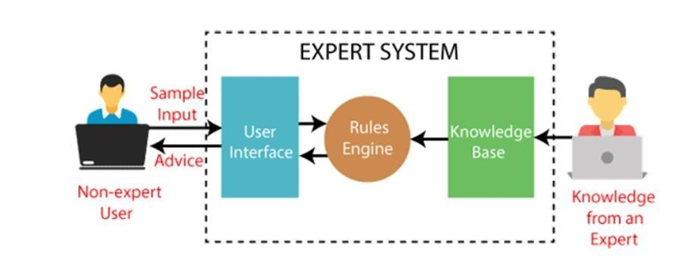

Flowchart
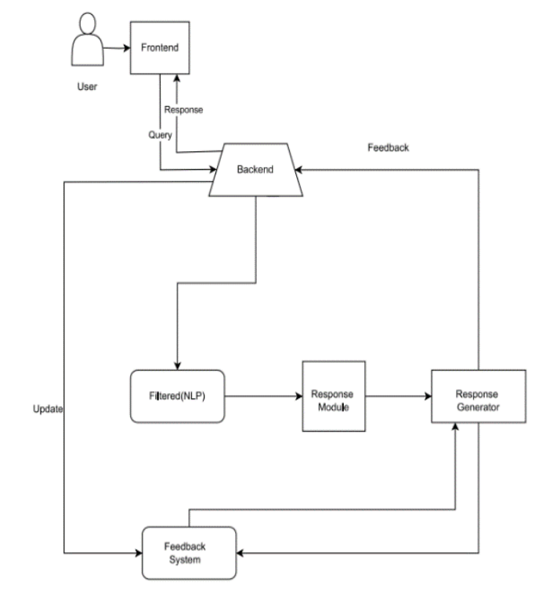

Fig 3.1 Chatbot working

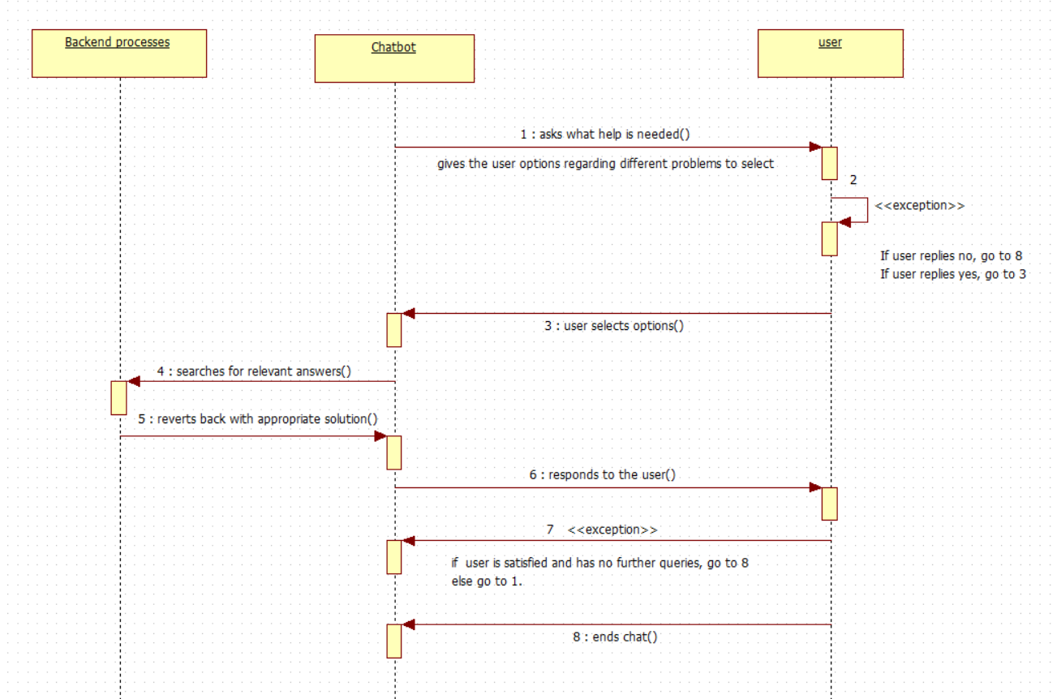
Sequence Diagram:
Fig 3.2 Sequence diagram of user-chatbot interaction
****

Chapter 4
System Design

Basic modules:
This project consists of two major modules ie. the company website to which the chatbot will be integrated and the chatbot itself.
- The Website: The website is a static website created using Bootstrap, HTML and CSS. This website provides information about a software company such as the services it provides, the various technologies it uses to build the softwares, some information about new technology, details about a few notable company members, contact details, etc.
- The ChatBot: The chatbot is meant for easy access of the content in the website; to maintain customer relationships and save customer’s time and efforts to gain information.
Data Design:
The data used by the chatbot is stored in file system. It matches the queries given by the user in the file and finds appropriate responses.
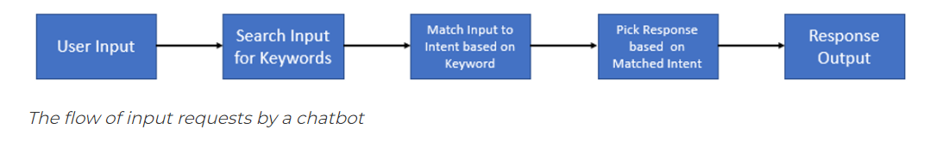
Logic Diagrams:
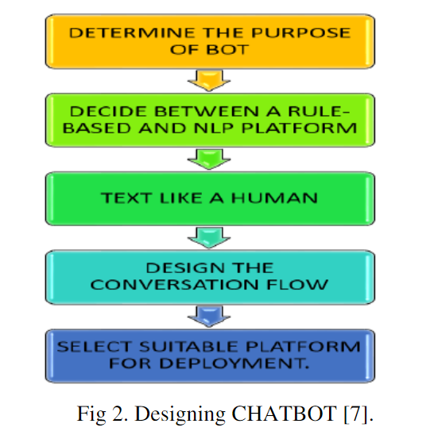

Fig 4.2 Process diagram for chatbot
Algorithms:
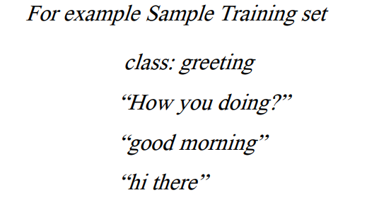
Input and Output Data sample

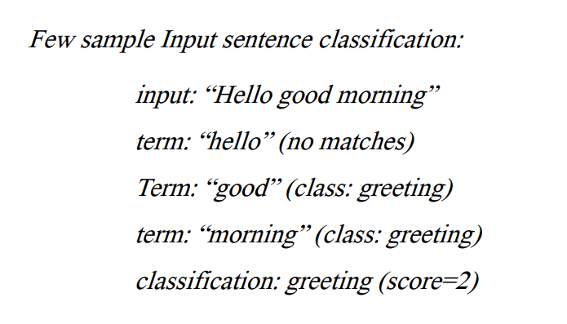
With the help of equation, word matches are found for given some sample sentences for each class. Classification score identifies the class with the highest term matches but it also has some limitations. The score signifies which intent is most likely to the sentence but does not guarantee it is the perfect match. Highest score only provides the relativity base.
Algorithm working sample -

Proposed User Interface Design:
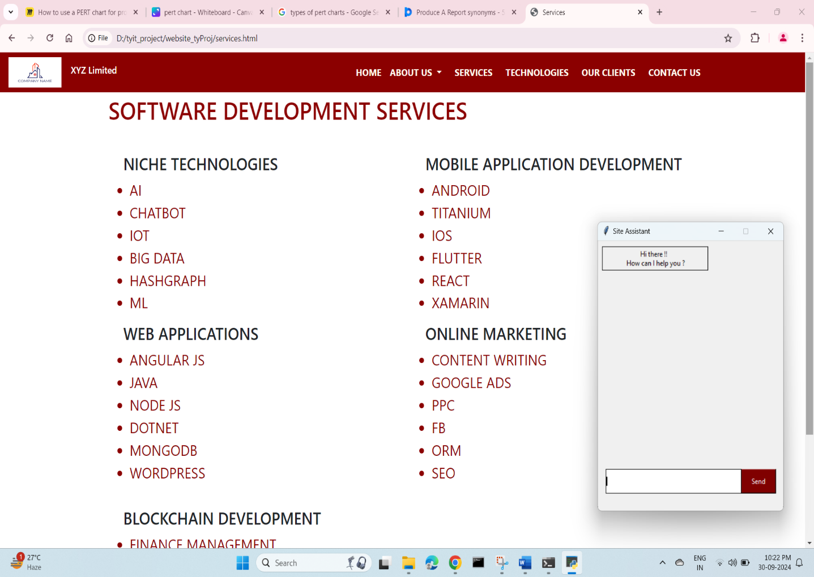
The website

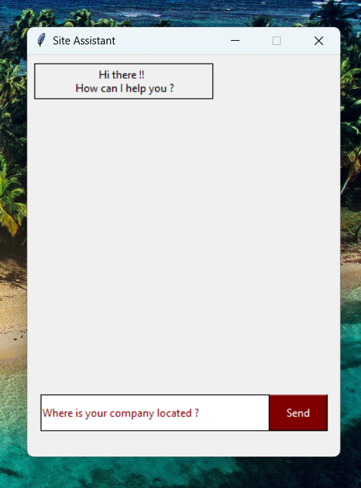
The chatbot

Security Issues:
There are no security issues as such. Because…
- As this project uses a file system and not a database, there are less to no chances of the information getting hacked or compromised through SQL injection.
- As this website is static and does not require any login, there arises no question of credential’s safety and security.
- As the chatbot is a simple rule-based chatbot that uses a predefined set of answers and responses, there is no chance that a user will misuse it.
****

Chapter 5
Implementation And Testing

Implementation Approach: Phased Implementation Approach
This approach incorporates developing the whole project in different phases step by step. This project follows phased implementation approach. Initially, the website for which the chatbot works was developed followed by the chatbot development.
The project development follows the SDLC where all the requirements were gathered initially and then the development of the entire software took place.
Coding Details and Efficiency
Source code
Code for a responsive navigation bar built in bootstrap.
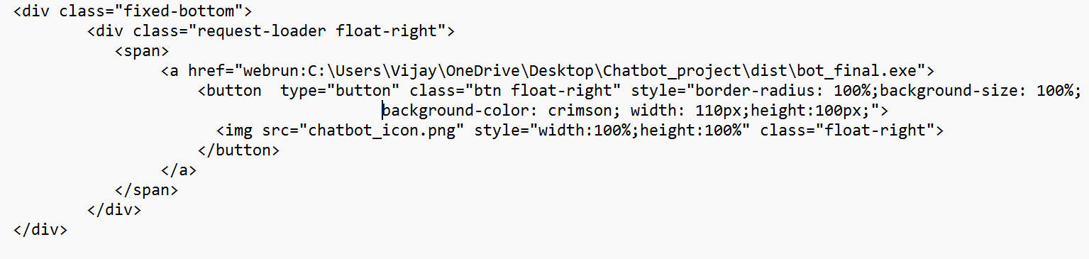
Code for positioning of chatbot on the website.
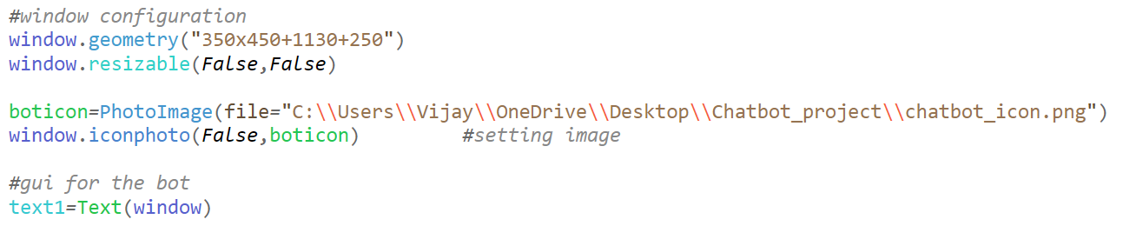
Code for Graphical User Interface (GUI) of the chatbot.

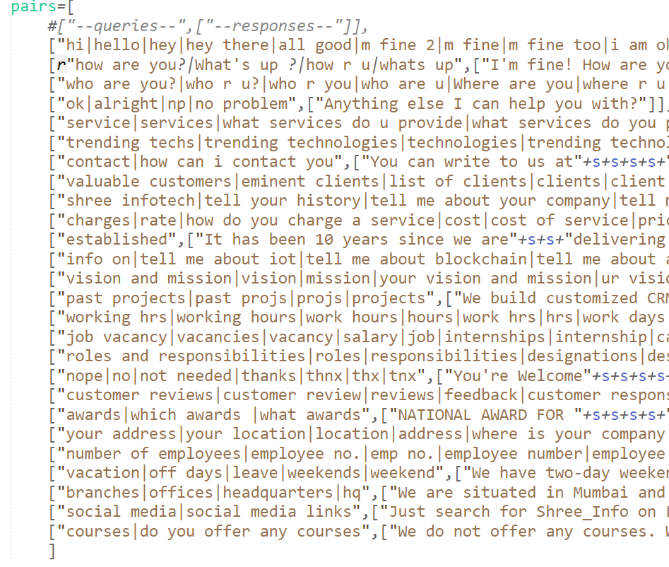
Code that maps user queries and its responses.
Code for responding to user queries when clicked on send button.
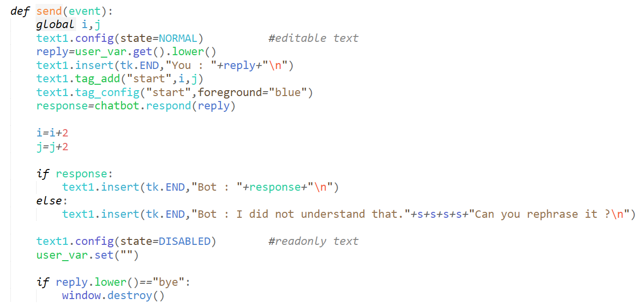

Unit Testing
The Chatbot: The chatbot has two units- Graphical User Interface (GUI) and the backend part which responds to the queries of the user. Unit testing involves the following:
- Look and feel, correctness of GUI.
- Structure and arrangement of individual components on the main component.
- Functioning of the individual components like button.
The Website: Tested for inappropriate colour combinations, visibility of text on coloured backgrounds, carousel direction and duration, text alignments and card structures.
Black Box Testing
The chatbot underwent black box testing by my classmates/friends and many improvements were done. Following are the improvements done: -
- Upgraded the GUI of the chatbot.
- Added many relevant questions like-
- What are the job roles in your company?
- Are there any vacancies in your organisation?
- Social media handles of the company.
- Do you offer any courses?
- Updated the wordlist of the chatbot, like contact, vacancies, testimonials, etc.
White Box Testing
Tested by the developer itself, following improvisations were made: -
- Added client testimonials and reviews.
- Enhanced the look and feel of the website by adding appropriate colours to it.
- Beautification of the website by adding CSS EFFECTS like gradient background, gradient text colour.

Integration Testing
It’s a crucial task to integrate the chatbot and the website. Integration testing was done to check the following:
- To attach the chatbot button on a fixed position ie. on the bottom right. It shouldn’t move with the scrolling screen.
- Whether the chatbot button is visible on the website or not.
- Whether the chatbot wakes up or not when the button on the website is clicked.
- Since the chatbot is a python application, it will open a command prompt. But it shouldn’t open on the website.
Modifications and Improvements
Following modifications were made to website as well as the chatbot:
- Matched the colour combinations of all components of the GUI of the website.
- Modified website text to professional fonts and upgraded text colour effects for more attractive GUI.
- Enhanced the CSS effects and styling, making it look more professional and attractive.
- Altered the navigation bar of the website to make it responsive.
- Created a footer with important and quick links to access the web content.
- Developed a CSS RIPPLE EFFECT for the chatbot button on website to make it more engaging and visible.
- Updated the VISION & MISSION of the company.
- Added a logo to the chatbot window.
- Changed the colours of user queries and chatbot responses so as to differentiate them.
- Improved the scrolling effect of the chatbot.

Test Cases
Sr. no. | Test Case | Expected output
1 | Valid input by user | Relevant response
2 | Invalid user query | Tell the user to input appropriate queries and questions
3 | Asking for unnecessary  information of company | Must recognize it as irrelevant input and should ask for relevant query.
4 | User enters “bye” | The chatbot window should get closed and should restart with no previous interaction saved.

****

Chapter 6
Results and Discussions
Test Report
- If the user queries are valid and are related to the website’s content, resolve them by providing appropriate solutions.
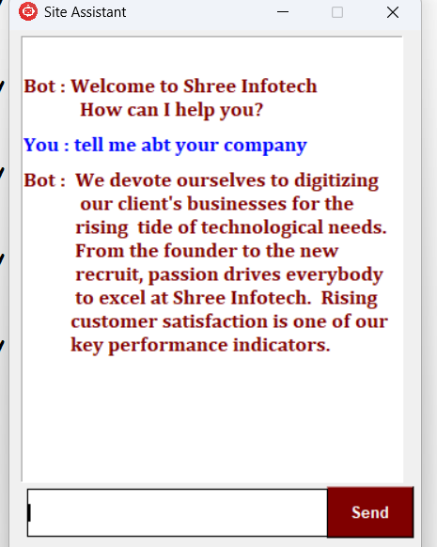

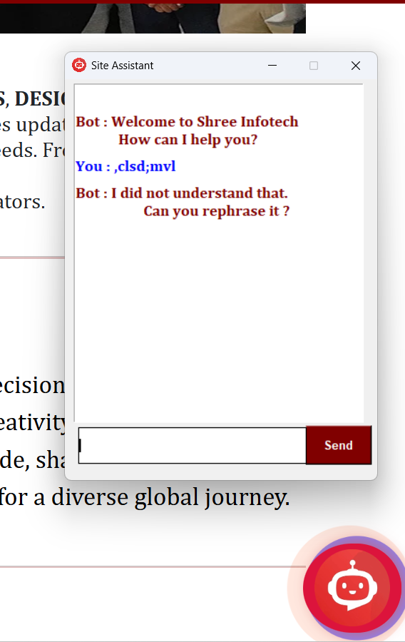
- If the input is invalid or meaningless, tell the user to input relevant and related data and ignore such kind of input and handle them by not reacting to it.

User Documentation
This is a website of a software development company which showcases everything the company does. It gives information about its past projects, technologies it uses to build them, the various services it provides, some of the well working employees, their major clients and their testimonials, the vision and mission of the company, its awards and achievements, etc.
The website is very user-friendly and it is very easy for a new user to navigate through the website. The menu items are self-explanatory and the GUI is pretty good enough.
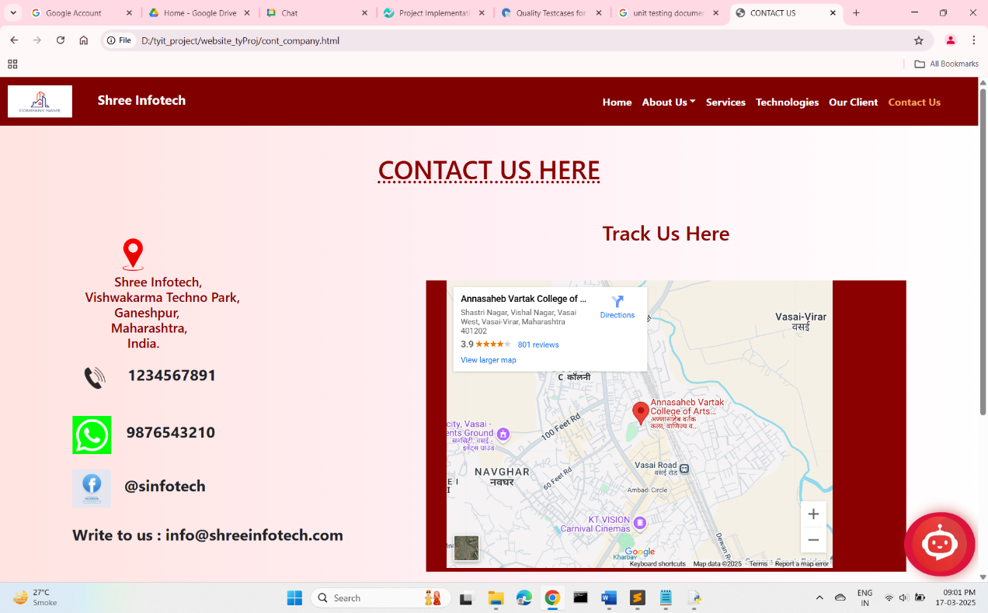

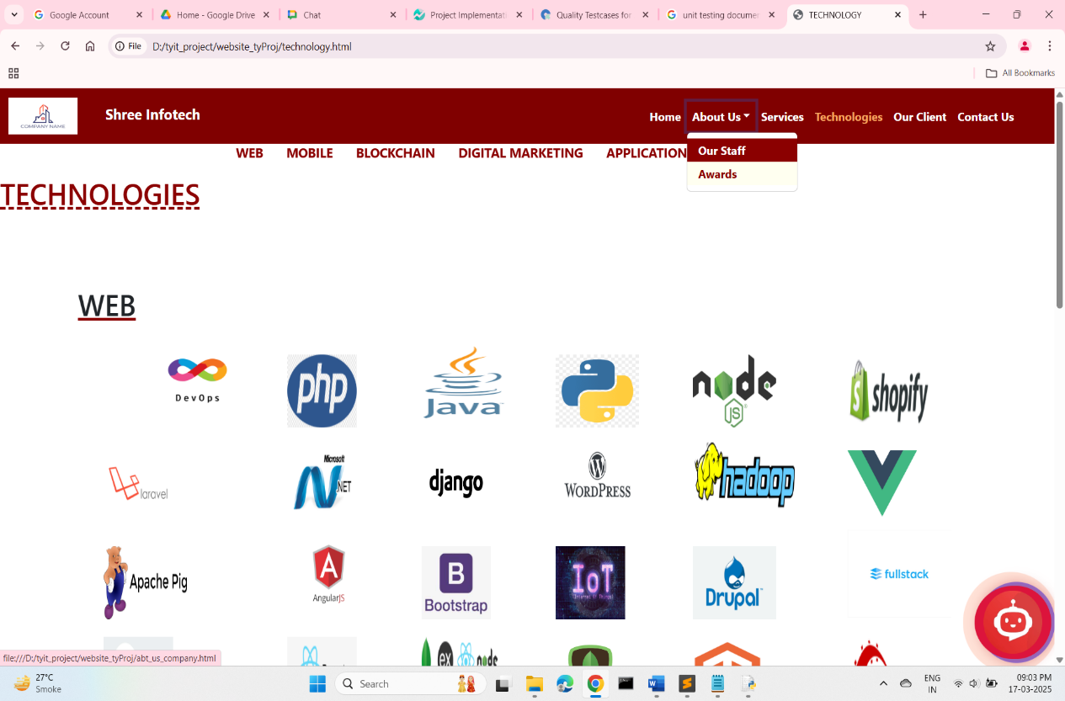

****

Chapter 7
Conclusion
Conclusion
Due to the growing fast life, customers tend to acquire all the information/resources altogether in one place. The decreasing patience of customers has made the developers think about the strategies to retain customers and maintain healthy customer relationships. This project not only enhances the user experience but also reduces the load on human agents as the chatbot will be automated by routine tasks. It can prove a cost-effective solution as it is a one-time investment.

Limitations
- The chatbot is a rule based chatbot and it might not answer a genuine query if it’s not fed in its rules.
- Since the chatbot is not a self-learning model, any new changes in the website will require the developer to update the chatbot’s knowledge (data) and regressive testing will be needed each time after it gets updated.
- The chatbot works on keywords and finds them in the input provided by the user. It checks for the keywords, searches them in the code and outputs the matched response. If any important keyword is by-chance missing, the chatbot would fail to respond and may lead to user dissatisfaction.

Future Enhancements

- To make the chatbot self-learning and update it according to the information available on its website.
- To implement voice assistance in chatbot.
- To make the website more dynamic and interactive.
- To make website more secure to avoid attacks like clickjacking.
- To improve website by adding modules like Gallery, Blog System, Direct messaging from website system, User Authentication and Login, etc.

****

REFERENCES

[1]https://analyticsindiamag.com/ai-trends/top-python-libraries-for- chatbot-development/
[2] https://www.geeksforgeeks.org/building-a-rule-based-chatbot-with- natural-language-processing/
[3] fig. Process diagram of chatbot:
https://datasciencedojo.com/blog/rule-based-chatbot-in-python/
[4] https://youtu.be/zHj1axji6Dc
[5] https://youtu.be/c7VeJkd8Ntg
[6] https://www.analyticsvidhya.com/blog/2021/12/creating-chatbot- building-using-python/
[7] https://www.youtube.com/watch?v=Iv_dECet_oM
[8] https://getbootstrap.com/docs/4.0/components/carousel/
[9] https://freefrontend.com/css-ripple-effects/
[10] https://getbootstrap.com/docs/4.0/components/navbar/
[11] https://www.geeksforgeeks.org/python-tkinter-text-widget/
[12] https://www.geeksforgeeks.org/iconphoto-method-in-tkinter-python/

****

