Vulnerability Assessment and
Penetration Testing Report

Target - https://bwapp.hakhub.net/
Prepared by – Anjali Brahmankar
Role – Security Auditor
Date – 8th April 2026

Table of Contents

Executive Summary | 2
About Bwapp | 2
Background | 3
Scope | 3
Methodology | 3
About tools | 4
Findings | 8
Risk Ratings | 14
Overall Remediation | 15
References | 16

Executive Summary
The demo website chosen for this task is https://bwapp.hakhub.net/. The security assessment identified several misconfigurations that could expose the system to unauthorized access and data compromise. While no active exploitation was performed, the presence of exposed services and missing security protections increases the attack surface. The purpose of these Web Security Assessments was to identify exploitable vulnerabilities and insufficiently configured security controls to determine the likelihood that users with considerable, little, or no prior knowledge of the applications.
Immediate action is recommended to secure exposed services and implement standard web security protections.
About Bwapp
bWAPP, or a buggy web application, is a free and open source deliberately insecure web application developed by MME. It helps security enthusiasts, developers and students to discover and to prevent web vulnerabilities. It prepares one to conduct successful penetration testing and ethical hacking projects. "A security testing framework made for educational purposes". it has over 100 different web vulnerabilities and issues!
It covers all major known web bugs, including all risks from the OWASP Top 10 project. The OWASP Top 10 represents a broad consensus about what the most critical web application security flaws are. is an open source PHP application that uses a MySQL database. It can be hosted on Linux/Windows with Apache/IIS and MySQL. It can also be installed with WAMP or XAMPP. Another possibility is to download our bee-box, a virtual machine pre-installed with bWAPP.
Background
This exercise aimed to perform Penetration Testing of the Applications in scope to determine if they were vulnerable to attacks and exploitation. The test consisted of manual testing to detect and exploit vulnerabilities. The assessment was conducted to identify the security vulnerabilities in the Application in scope and propose solutions for the project team to remediate the identified vulnerabilities to make the Application more secure.
The Security Assessment was performed between 6th April to 17th April 2026.
Scope
Target: https://bwapp.hakhub.net/
Type of Test: Read-only security assessment
Testing Method: Non-intrusive reconnaissance only
Tools Used: Nmap, browser developer tools, public scanners
No exploitation or active attacks were performed.
Methodology
The assessment was conducted using publicly available tools and techniques:
- Scanning open ports using Nmap
- Technology detection via Builtwith online tool
- Scanning missing headers with securityheaders.com and Nikto
- Vulnerability testing using Owasp Zap

About Tools
Nmap (Network Mapper) is an open-source network scanning tool used to discover devices, identify open ports, detect services and their versions, and gather information about operating systems on a network. It is widely used for network auditing, security assessments, and troubleshooting. Nmap allows users to do a bunch of things that are related to a wide range of network-related tasks.
- Network Discovery: With Nmap, users can scan networks and discover devices and hosts on a network, allowing network admins to understand the network more efficiently.
- Port Scanning: It can determine which ports are open and which services are running on those ports, which is critical for security assessments and vulnerability scanning.
- OS Fingerprinting: Nmap can attempt to identify the operating system running on a target host by analyzing various characteristics of network packets.
- Vulnerability Assessment: It's a valuable tool for identifying potential vulnerabilities in systems and services, aiding in proactive security measures.
- Network Monitoring: Nmap can be used for continuous monitoring to detect changes in the network environment.
BuiltWith
BuiltWith is a web technology profiling tool used to identify the technology stack—such as CMS, analytics, hosting, and advertising tools—behind any website. It is primarily used by B2B marketers, sales teams, and developers for lead generation, competitor analysis, and market research, tracking over 111,000 technologies across millions of websites.
Key uses for BuiltWith include:
- Lead Generation & Prospecting: Identify businesses using specific technologies (e.g., Shopify, HubSpot) to target them for sales outreach.
- Competitor Analysis: Analyze the technology infrastructure of competitors to gain insights into their marketing and operational strategies.
- Market Intelligence: Track technology trends and market share to understand which technologies are gaining or losing popularity.
- Technology Profiling: Quickly discover the analytics, advertising, and content management systems a site uses via the BuiltWith Chrome Extension.
- Sales Prospecting Filters: Filter potential leads by location, spend, and industry.
Nikto
Nikto is an open-source, command-line web server scanner used by security professionals to quickly find vulnerabilities, dangerous files, misconfigurations, and outdated software on web servers. It tests for over 6,700 potentially dangerous items and supports Full HTTP Proxy and SSL.
Key Uses and Features:
- Vulnerability Scanning: Identifies outdated server software (1,200+ servers) and specific version problems (200+ servers).
- Misconfiguration Detection: Checks for insecure HTTP headers, default files, and improperly configured settings.
- Dangerous File Detection:
Scans for dangerous files, CGI scripts, and files that can be exploited.
- Web Enumeration: Identifies installed software, plugins, and server plugins.
- Performance & Stealth: Designed for speed, though its high-volume requests are easily detected by security logs.
- Reporting & Options: Saves results in multiple formats (XML, CSV, HTML) and allows scanning using specific plugins.
Securityheaders.com
SecurityHeaders.com is a free online tool used to analyze and grade the HTTP response headers of a website, providing a security assessment. It allows developers to evaluate how well their site implements modern security features to defend against attacks like Cross-Site Scripting (XSS), clickjacking, and code injection, ultimately offering guidance on how to fix missing headers.
Key features and uses include:
- Free Analysis: Enter a website URL to get an instant, detailed report card (from A+ to F) on its security headers.
- Security Assessment: Identifies missing headers that could leave a site vulnerable to browser-level attacks.
- Guidance and Improvement: Provides specific recommendations on how to implement essential headers, such as Content Security Policy (CSP), HTTP Strict Transport Security (HSTS), and X-Frame-Options.
- Best Practices: Helps developers and security professionals enforce safe browser behavior and strengthen defenses.

Owasp ZAP
OWASP ZAP (Zed Attack Proxy) is a free, open-source dynamic application security testing (DAST) tool designed to find vulnerabilities in web applications and APIs. It is used by developers and penetration testers to identify security flaws—such as SQL injection and XSS—during development or testing, acting as a "man-in-the-middle" proxy.
Key uses of OWASP ZAP include:
- Automated Scanning: Automatically craws and scans web applications for security vulnerabilities.
- Manual Penetration Testing: Intercepts and modifies web traffic between the browser and server to test for vulnerabilities in real-time
- API Security Testing: Supports scanning of SOAP, REST, and GraphQL APIs to detect security flaws.
- CI/CD Integration: Integrates into development pipelines to automate security tests and catch vulnerabilities early.
- Active/Passive Scanning: Performs both passive monitoring (analyzing traffic) and active attacks (simulating attackers).
- AJAX Spidering: Navigates modern web applications that heavily use JavaScript to discover hidden links and pages.

Findings
  - Found open ports using nmap network scanner
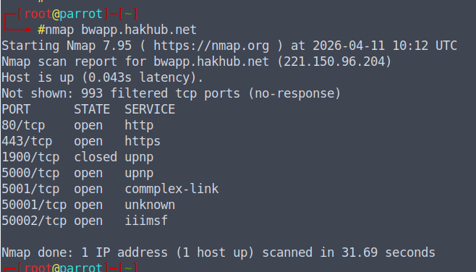
Possible vulnerabilities for above open ports
PORT NO. | Function | Vulnerabilities | Mitigation
80 | - Default network port for unencrypted Hypertext Transfer Protocol (HTTP).  - Loading, viewing, and navigating webpages. | - Interception  - Man-in-the-Middle-Attacks (MITM)  - Data Exposure  - Compliance Issues | - Enforce HTTPS (HSTS)  - Web Application Firewall (WAF)  - Restrict Access  - Disable/Block Port 80  - Remove Server Information
443 | Encrypted HTTPS | •SSL/TLS Misconfigurations  •Certificate Issues  •Man-in-the-Middle (MitM) Attacks  •Heartbleed Bug (OpenSSL).  •Distributed Denial of Service (DDoS  •Application-Level Exploits  •Command Injection/Direct Exploits | - Disabling weak protocols (sslv3, TLS 1.0/1.1), enabling TLS 1.2/1.3, implementing HSTS, using robust cipher suites, and validating certificates to prevent MITM attacks
1900 | Simple Service Discovery Protocol (SSDP) within Universal Plug and Play (UPnP) to discover network devices. | •Unauthorized Port Mapping  •Remote Code Execution (RCE  •Information Disclosure | - Disable UPnP.  - Block Port 1900  - Segment Networks  - Update Firmware
5000 | Primarily used by Universal Plug and Play (UPnP), Docker Registry, and various development frameworks (like Flask). | - UPnP Vulnerabilities  - Docker Registry Exposure  - Lack of Authentication (Web APIs)  - Malware Utilization (Bobax Trojan)  - Static Key Ciphers:  - Device-Specific Vulnerabilities | - Block External Access  - Use VPNs  - Implement Authentication  - Update Softwares
5001 | A registered TCP port commonly used by applications like Synology NAS, specialized Commplex Link, and voip systems. | - Forcepoint User ID (FUID) Arbitrary File Upload (CVE-2019-6139)  - Phoenix Contact CHARX SEC-3150 Authentication Bypass (ZDI-25-622)  - 3CX Phone System Directory Traversal (CVE-2017-15359)  - ZTE Conference Management System Command Execution (CVE-2021-21741) | - Block external access to port 5001 unless required.  - Upgrade software that utilizes port 5001 (e.g., FUID)  - Check exposed devices.
50001  &  50002 | Non-standard port commonly used for Discord media streaming, Serv-U FTP, Java Remote Shell, and specialized enterprise software like SAP or M*Modal Fluency. | - Denial of Service (DoS)  - PCI Compliance Failures  - Unauthorized Access/Information Disclosure  - Unencrypted Traffic. | - Block Port 50001  - Update Firmware  - Implement SSL/TLS
Table 1: Open ports
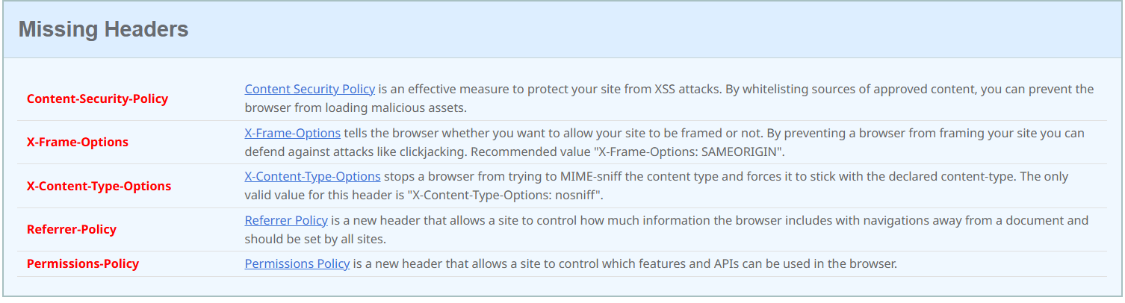
2) Found missing headers

Header | Vulnerability
Content Security Policy (CSP) | Leaves websites open to Cross-Site Scripting (XSS), clickjacking, and data injection attacks.
X-Frame-Options | This absence allows a website to be embedded within a frame on other websites, making it susceptible to Clickjacking attacks.
X-Content-Type-Options header | Allows browsers to perform MIME-sniffing.
Referrer-Policy header | A security vulnerability where browsers default to less secure policies, potentially leaking full urls (containing sensitive user ids, tokens, or personal data) to third-party sites via the Referer header. This leakage happens when navigating away from the site or loading external resources, increasing the risk of data exposure
Permissions-Policy header (formerly known as Feature-Policy) | Security misconfiguration that leaves a web application vulnerable to the unauthorized use of sensitive browser features.
Table 2: Missing Headers
3) Identified Tech stack with Builtwith
BuiltWith is a popular web technology lookup tool that reveals the technology stack—such as CMS, hosting, analytics, and frameworks—used by any website. It provides market intelligence, competitor analysis, and lead generation data, allowing users to track over 113,000 technologies across millions of websites.
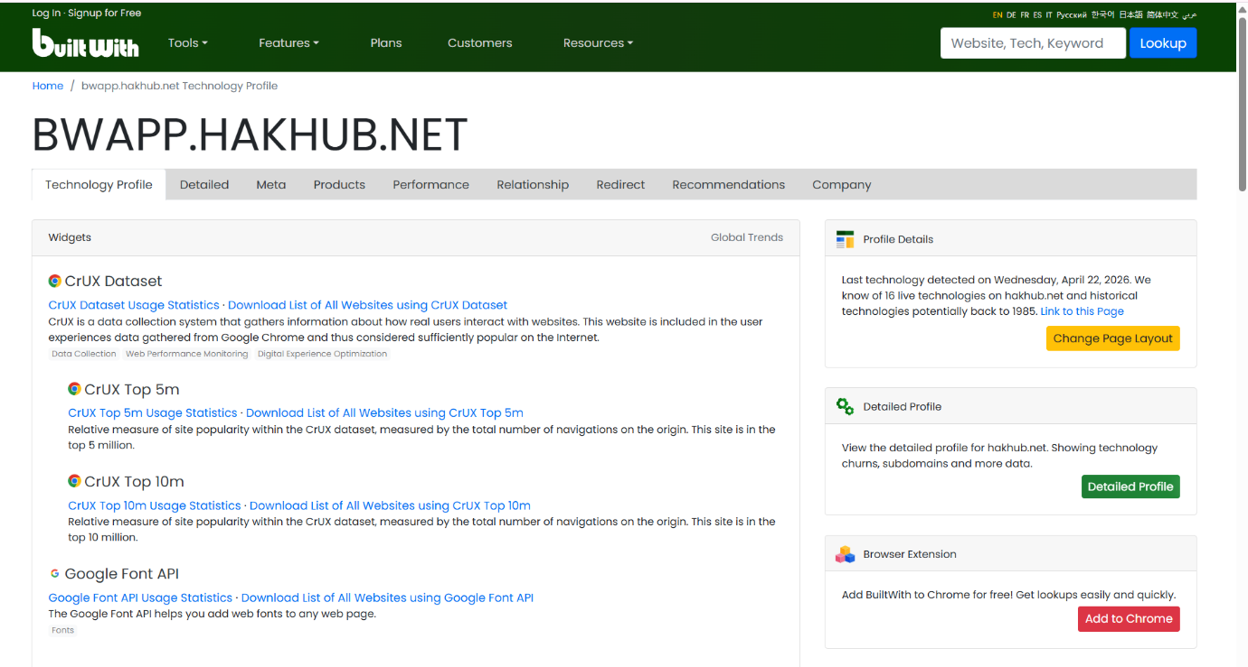

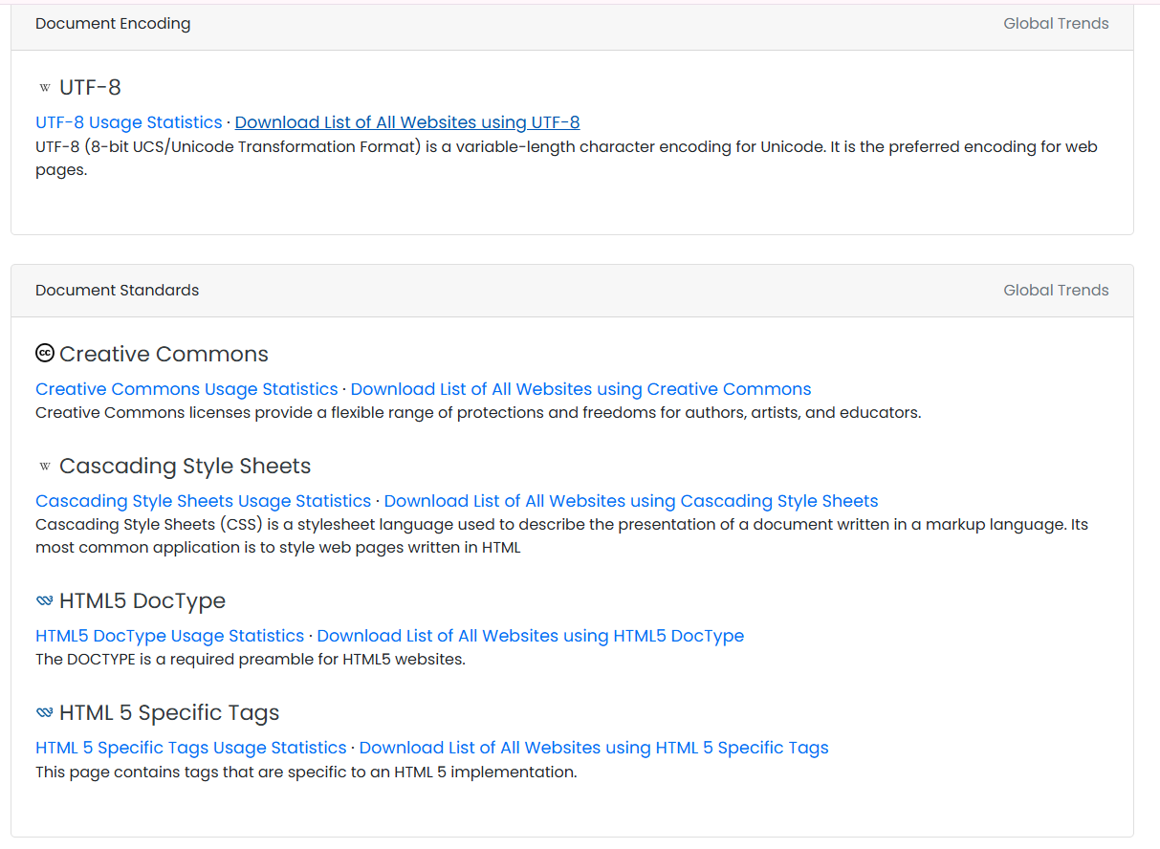
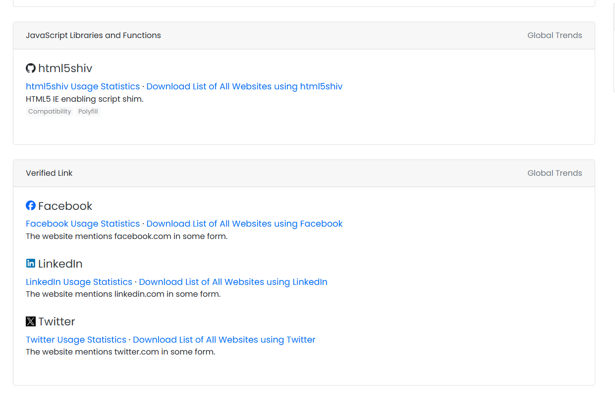

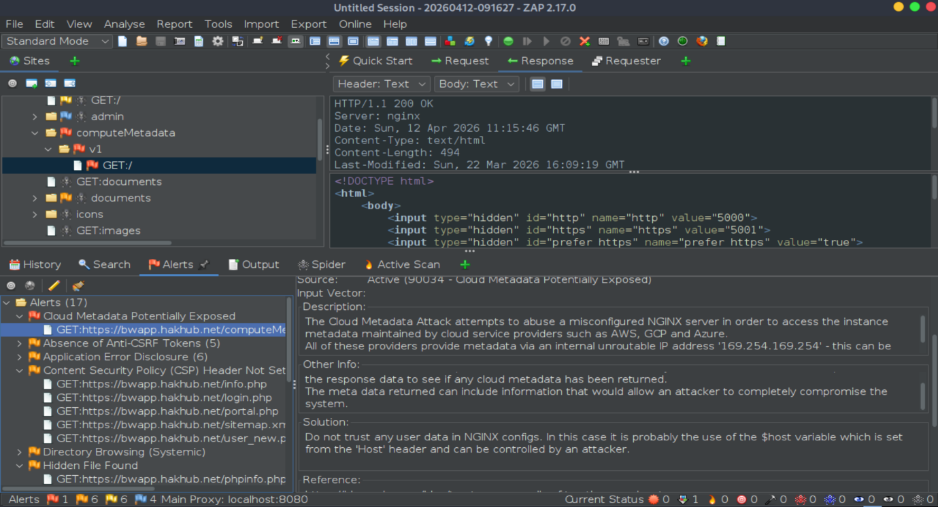
4) Findings from Owasp ZAP
Cloud Metadata Potentially Exposed is a security finding, indicating that an application may be vulnerable to Server-Side Request Forgery (SSRF). This allows attackers to access sensitive instance data—such as IAM credentials, network config, and SSH keys—stored by cloud providers (AWS, GCP, Azure) at the internal IP.
Information Disclosure (Sensitive Files): Exposure of phpinfo.php. This file reveals the entire PHP configuration, loaded modules, environment variables, and internal path structures. It provides an attacker with a roadmap for more sophisticated exploits.
Risk Ratings
High Risk vulnerabilities: Cloud Metadata Potentially Exposed, Information Disclosure (Sensitive Files)
Medium Risk vulnerabilities: Missing Content Security Policy (CSP), Absence of Anti-CSRF Tokens, Missing X-Frame-Options
Low Risk vulnerabilities: Cookie Security (Secure/HttpOnly Flags), Insecure Referrer-Policy, Server Version Disclosure
Overall Remediation
- Block Cloud Metadata & Information Disclosure
Block Metadata Access: Add the below block inside the server context to prevent external requests from hitting the internal metadata IP.
location /computeMetadata {
deny all;
return 404;
}
Physically delete the file phpinfo.php from your web root or add the following code to restrict it to your local IP:
location /phpinfo.php {
allow 127.0.0.1;
deny all;
}
2.Implement Security Headers
Add these globally within the server block:
# Prevent Clickjacking
add_header X-Frame-Options "SAMEORIGIN" always;
# Prevent MIME-sniffing
add_header X-Content-Type-Options "nosniff" always:
# Control Referrer information
add_header Referrer-Policy "strict-origin-when-cross-origin" always;
# Basic Content Security Policy (Adjust based on your app's needs)
add_header Content-Security-Policy "default-src 'self'; script-src 'self'; object-src 'none';" always;
# Permissions Policy (Disables sensitive browser features)
add_header Permissions-Policy "geolocation=(), microphone=(), camera=()" always;
3. Cookie Security & Version Hiding
Secure PHP Cookies - update php.ini file to ensure session cookies are protected:
session.cookie_httponly = 1
session.cookie_secure = 1
Hide Nginx Version: Adding this to the nginx.conf (within the http block) to stop Nginx from sending its version number in error pages and headers: - server_tokens off;
Hide PHP Version: In your php.ini, set: expose_php = Off

References
[1] https://www.42gears.com/blog/why-blocking-port-80-is-essential-for-modern-security-practices/
[2] https://invia.com.au/App/media/sample%20vapt%20report.pdf

