- Do not edit/delete any heading or section with red text.
- Type /paste you answers in relevant sections (below Final Answer (in all questions , Approach (wherever required ) and Charts & tables (wherever required)) of the solution
- Link to submission guidelines
- Please note that submission not following the guidelines will not be accepted

OBJECTIVE QUESTIONS

Question 1: What is the total no. of tables present in the data?

Solution:

Final Answer (if any):
The workbook contains 1 table/sheet named “data”.

Approach (if any):
Examined the workbook structure and identified the total number of worksheets available in the dataset. The workbook contains a single sheet named data, which serves as the primary source for analysis.

Charts & Tables (if any):
- WorkBook Name:AstroSage_analysis
- Sheet name: data
- Description: Displays the workbook structure and identifies the worksheet used for analysis.

Question 2: What is the total no. of attributes present in the data?

Solution:

Final Answer (if any):
The dataset contains 35 attributes (columns) .

Approach (if any):
Reviewed the dataset structure and counted the total number of column headers present in the data sheet to identify all available attributes for analysis.

Charts & Tables (if any):
- Sheet Name: Data
- Description: Provides a summary of all attributes available in the dataset, including user details, guru information, consultation details, transaction information, and customer feedback metrics.

Question 3: The data consists of some inconsistent and missing values so ensure that the data used for further analysis is cleaned.

Solution:

Final Answer (if any):
The dataset was cleaned by handling missing values, validating duplicate records, removing extra spaces, correcting data types, and ensuring consistency across the dataset. The cleaned dataset was stored in the sheet named Cleaned Data and used for further analysis.

Approach (if any):
- Checked the dataset for duplicate records using Data → Data Cleanup → Remove Duplicates and found no duplicate rows.
- Identified missing values using filters and handled them appropriately:
  - Replaced missing values in numerical columns (chatSeconds, amount, netAmount, etc.) with 0.
  - Replaced missing values in the region column with "Unknown".
  - Retained missing values in conditional columns (chatStartTime, chatEndTime, callStatus, etc.) as they were applicable only to specific consultation types.
- Removed extra spaces from text fields using Data → Data Cleanup → Trim Whitespace.
- Standardized inconsistent categorical values by correcting naming variations (such as inconsistent guru names) to ensure accurate grouping and analysis.
- Converted date and numerical columns to appropriate data types.
- Verified Boolean columns to ensure they contained only TRUE and FALSE values.

Charts & Tables (if any):
- Table / Chart Name: Cleaned data
- Description: Contains the cleaned and transformed dataset after performing duplicate validation, missing value treatment, whitespace removal, and data type validation. This cleaned dataset was used for all subsequent analyses.

Question 4: What is the change in daily call volume day by day and also find the average daily call volume.

Solution:

Final Answer (if any):
The daily call volume fluctuated throughout the analysis period, showing variations in customer call activity from day to day. The average daily call volume was found to be 246.03 calls per day.

Approach (if any):
- Extracted the date component from the createdAT timestamp and created a separate Date column.
- Created a Pivot Table with:
  - Rows: Date
  - Values: CallSid (COUNTA)
- Calculated the total number of calls for each day using COUNTA(CallSid).
- Calculated the day-over-day change in call volume by subtracting the previous day's call count from the current day's call count.
- Computed the average daily call volume using the following formula:
=AVERAGE(B13:B46)

Charts & Tables (if any):
- Table / Chart Name: Q-4 I Objective
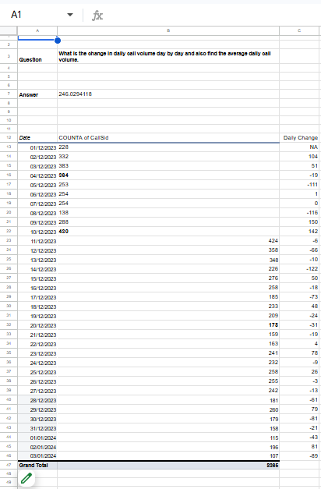
- Description: The Pivot Table in the Q-4 I Objective sheet displays the day-wise call volume based on CallSid, along with the daily change in call volume. This analysis was used to identify daily call trends and calculate the average daily call volume.

Question 5: Which months experienced the highest and lowest call volumes?

Solution:

Final Answer (if any):
December-2023 experienced the highest call volume with 7,947 calls, whereas January-2024 experienced the lowest call volume with 418 calls.

Approach (if any):
- Extracted the month and year from the createdAT field using the following formula:
=TEXT(Date_Cell,"mmmm-yyyy")
- Created a Pivot Table with:
  - Rows: Month
  - Values: Count of CallSid (COUNTA)
- Compared the monthly call volumes to identify the months with the highest and lowest number of calls.

Charts & Tables (if any):
- Table / Chart Name:Q-5 I Objective
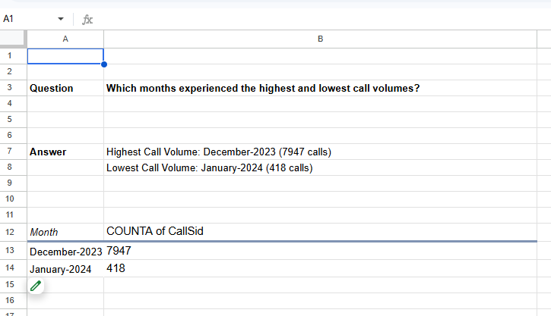
- Description:
Displays the total number of call interactions for each month based on CallSid, enabling identification of the months with the highest and lowest call volumes.

Question 6: What is the total operational cost for that month?

Solution:

Final Answer (if any):
The total operational cost for December-2023 (the month with the highest call volume) was ₹93,786.16.
Approach (if any):
- Identified December-2023 as the month with the highest call volume from the previous analysis.
- Created a Pivot Table using:
  - Rows: Month
  - Values: SUM of astrologersEarnings
- Considered astrologersEarnings as the operational cost metric because it represents the amount paid to astrologers for handling customer consultations.
- Compared the monthly operational costs and retrieved the cost for December-2023.

Charts & Tables (if any):
- Table / Chart Name:Q-6 I Objective
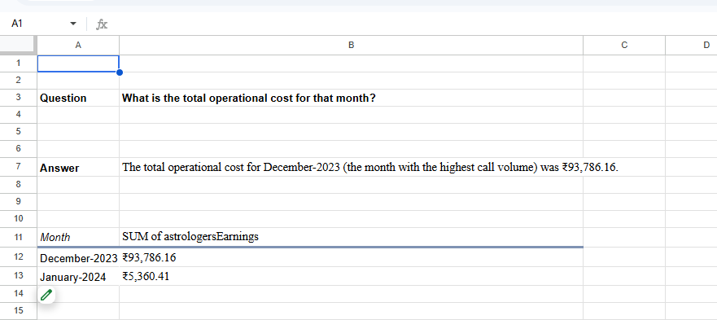
- Description:
The Pivot Table in the Q-6 I Objective sheet displays the total operational cost by month based on the sum of astrologersEarnings. The values are formatted in Indian Rupees (₹) to represent the operational expenses incurred by the platform.

Question 7: What is the average number of calls handled per agent per day?

Solution:

Final Answer (if any):
The average number of calls handled per agent per day is 1.88 calls.
This value was calculated using 8,365 total call records, 131 unique agents (gid), and 34 unique dates in the dataset.
.

Approach (if any):
- Calculated the total number of calls using the CallSid column from the Cleaned Data sheet:
=COUNTA('Cleaned data'!AD:AD)-1
- Calculated the number of unique agents (gid) using:
=COUNTUNIQUE('Cleaned data'!F2:F)
- Calculated the number of unique dates (createdAT Date) using:
=COUNTUNIQUE('Cleaned data'!Q2:Q)
- Calculated the average number of calls handled per agent per day by dividing the total number of calls by the product of the number of unique agents and unique dates:
=Total Calls/(Unique Agents × Unique Dates)
or
=C7/(C8*C9)

Charts & Tables (if any):
- Table / Chart Name: Q-7 I Objective
- Description:
The table summarizes the total number of calls (CallSid), the number of unique agents (gid), and the number of unique dates (createdAT Date) present in the dataset. These values are used to calculate the average number of calls handled per agent per day.
Formula :
Average Calls per Agent per Day = Total Number of Calls ÷ (Number of Unique Agents × Number of Unique Dates)
This approach considers all valid call records in the dataset and provides an overall measure of agent workload across the observed time period.

Question 8: How many repeat callers are there, and what percentage of total calls do they represent?

Solution:

Final Answer (if any):
There are 1,275 repeat callers in the dataset. After excluding the first call made by each repeat caller, the total number of repetitive calls is 4,737, which represents 56.63% of the total 8,365 calls recorded in the CallSid column.

Approach (if any):
- Created a Pivot Table with:
  - Rows: uid
  - Values: COUNTA(CallSid)
- Filtered the Pivot Table to exclude users with 0 or 1 call, retaining only users with more than one call (repeat callers).
- Determined the number of repeat callers by counting the remaining rows in the filtered Pivot Table using:
=SUBTOTAL(3,A14:A10351)
- Calculated the number of repetitive calls made by each repeat caller by subtracting one from their total number of calls using:
=B14-1
- Calculated the total number of repetitive calls using:
=SUBTOTAL(9,C14:C10351)
- Calculated the total number of calls (CallSid) from the Cleaned Data sheet using:
=COUNTA('Cleaned data'!AD:AD)-1
- Calculated the percentage of total calls represented by repetitive calls using:
=(D7/D5)*100
where:
- D5 = Total Calls (8,365)
- D7 = Total Number of Repetitive Calls (4,737)

Charts & Tables (if any):
- Table / Chart Name:Q-8 I Objective

- Description:
The table groups customer interactions by uid and counts the number of calls (CallSid) made by each user. After excluding users with 0 or 1 call, the remaining users are identified as repeat callers. The analysis further calculates the total number of repetitive calls by excluding the first call of each repeat caller and determines the percentage contribution of these repetitive calls to the overall call volume.

Question 9: What are the total sales generated by the call centre for each product category?

Solution:

Final Answer (if any):
The call centre generated a total sales revenue of ₹214,065.90 across all platforms. Among the platforms, app generated the highest sales of ₹125,345.97, followed by gurucool with ₹88,719.93. The dashboard platform did not generate any sales.

Approach (if any):
- Since the dataset did not contain a dedicated product category column, the website field was considered as the product category.
- Created a Pivot Table with:
  - Rows: website
  - Values: SUM of amount
- Calculated the total sales generated for each platform by summing the amount values.
- Compared the sales values to identify the contribution of each platform.

Charts & Tables (if any):
- Table / Chart Name: Q-9 I Objective
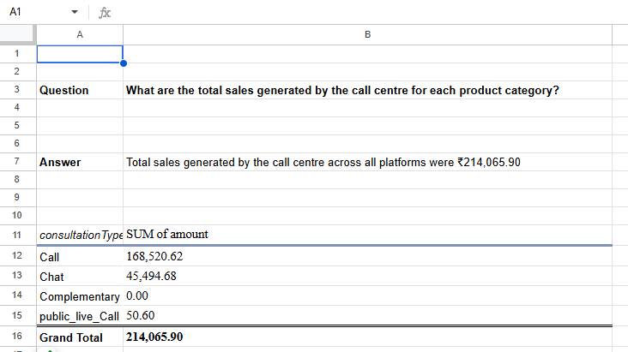
- Description:
The Pivot Table displays the total sales generated across different platforms (app, dashboard, and gurucool) based on the sum of amount. It highlights the revenue contribution of each platform and the overall sales generated by the call centre.

Question 10: How many calls were made for each user ID and guru ID?

Solution:

Final Answer (if any):
Separate call counts were calculated for each User ID (uid) and Guru ID (gid). The results indicate the total number of consultations/calls associated with each user and guru.

Approach (if any):
- Created a Pivot Table to calculate the number of calls made by each User ID (uid).
  - Rows: uid
  - Values: consultationType (COUNTA)
- Created another Pivot Table to calculate the number of calls handled by each Guru ID (gid).
  - Rows: gid
  - Values: consultationType (COUNTA)
- The count of consultation records was used to determine the total number of calls for each user and guru

Charts & Tables (if any):
- Table / Chart Name:Q-10 I Objective
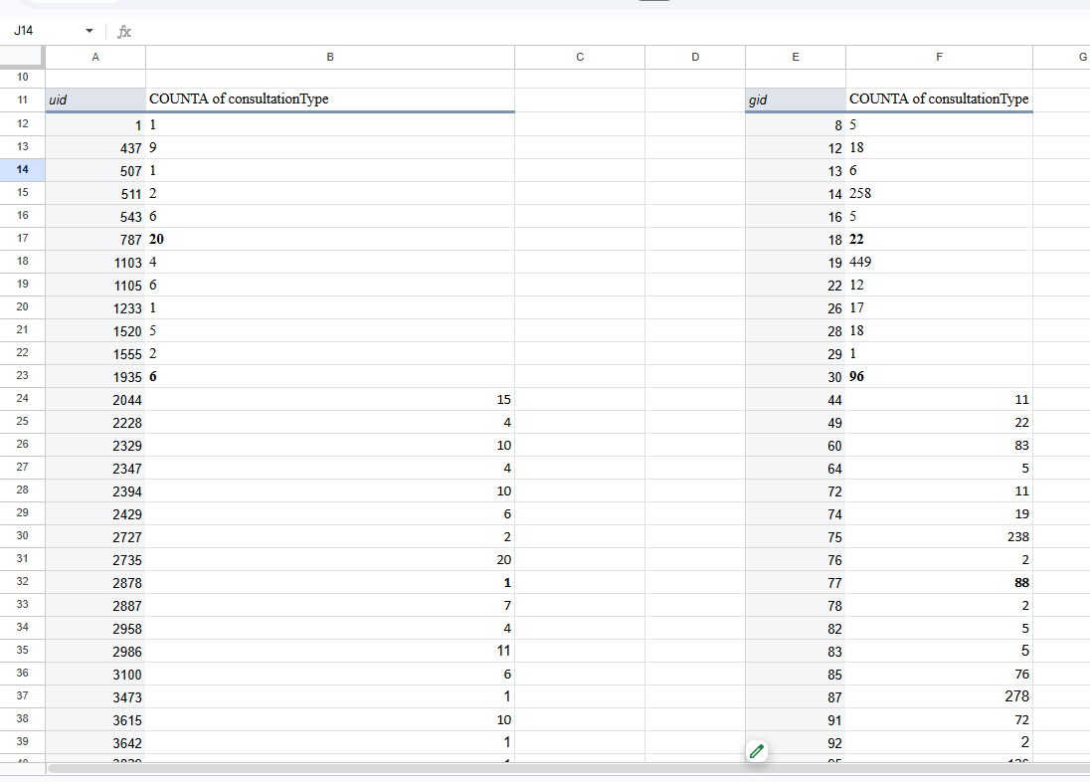

- Description:
This Pivot Table displays the total number of calls made for each User ID (uid) and Guru ID (gid) combination based on the count of _id records.

Question 11: What is the correlation between call duration and customer satisfaction?

Solution:

Final Answer (if any):
The correlation coefficient between call duration and customer satisfaction is 0.055, indicating a very weak positive correlation. Therefore, call duration has minimal impact on customer satisfaction ratings.

Approach (if any):
- Selected timeDuration as the measure of call duration.
- Selected rating as the measure of customer satisfaction.
- Applied the Google Sheets CORREL function:
=CORREL('Cleaned data'!AJ:AJ,'Cleaned data'!AK:AK)
- Interpreted the resulting correlation coefficient to determine the relationship between call duration and customer satisfaction.

Charts & Tables (if any):
- Table / Chart Name:Q-11 I Objective

Question | What is the correlation between call duration and customer satisfaction?
Answer | 0.05475818095

- Description:
The analysis calculates the Pearson correlation coefficient between call duration (timeDuration) and customer satisfaction (rating) to evaluate the strength and direction of their relationship.

Question 12: Which guru has the highest and lowest customer satisfaction scores?

Solution:

Final Answer (if any):
The guru(s) with the highest average customer satisfaction score are:
- Tarot Mystical – 7.50
- Astro Pujaa Rai – 7.50 (tie)
The guru with the lowest average customer satisfaction score is:
- Tarot Rittika – 0.00

Approach (if any):
- Created a Pivot Table from the cleaned dataset.
- Added guruName to the Rows section.
- Added rating to the Values section and summarized it using AVERAGE.
- Sorted the average ratings in descending order to identify the highest-rated guru and in ascending order (or observed the last record) to identify the lowest-rated guru.

Charts & Tables (if any):
- Table / Chart Name: Q-12 I Objective
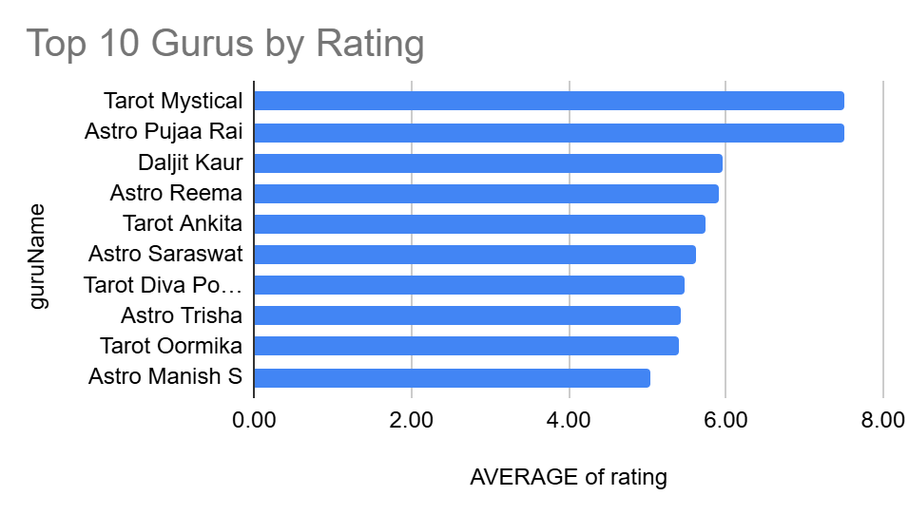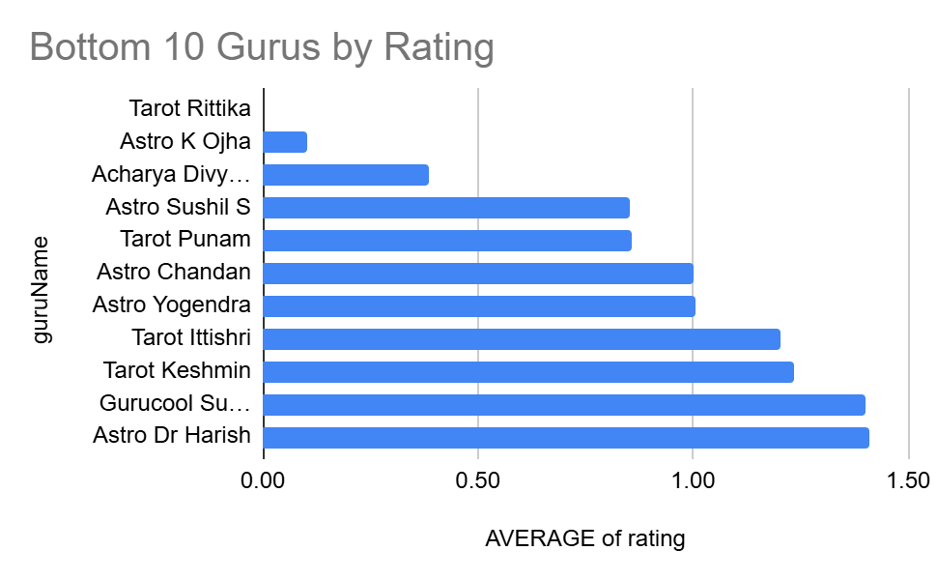

- Description:
The charts display the top 10 and bottom 10 gurus based on their average customer satisfaction ratings. They are used to compare guru performance, identify the highest- and lowest-performing gurus, and highlight areas of excellence as well as opportunities for improvement.

Question 13: What is the average customer satisfaction score by month?

Solution:

Final Answer (if any):
The average customer satisfaction score by month is:
- December-2023: 2.95
- January-2024: 2.68
The overall average customer satisfaction score across all months is 2.93.

Approach (if any):
- Created a Pivot Table from the Cleaned Data sheet.
- Added Month to the Rows section.
- Added rating to the Values section.
- Summarized the rating field using AVERAGE to calculate the average customer satisfaction score for each month.
- Compared the monthly averages to identify changes in customer satisfaction over time.

Charts & Tables (if any):
- Table / Chart Name: Q-13 I Objective

Month | AVERAGE of rating
December-2023 | 2.95
January-2024 | 2.68
Grand Total | 2.93

- Description:
A Pivot Table showing the average customer satisfaction (rating) for each month, allowing comparison of monthly customer satisfaction scores.

Question 14: How many categorical columns are there in the data? [Search about categorical and continuous data, and try to answer this question]

Solution:

Final Answer (if any):
There are 22 categorical columns in the dataset.

Approach (if any):
- Reviewed all columns in the dataset.
- Classified columns containing labels, identifiers, Boolean values, and text as categorical.
- Classified measurable numeric columns as numerical.
- Classified timestamp fields (createdAT, updatedAt, chatStartTime, and chatEndTime) as datetime variables.
- Counted the categorical columns, resulting in 22 categorical columns.

Charts & Tables (if any):
- Table / Chart Name: data

- Description:
Classification of the dataset columns into categorical, numerical, and datetime variables, with the total number of categorical columns reported.

SUBJECTIVE QUESTIONS

Question 1: Should the investment be used to hire more agents, improve training programs, or upgrade call center technology?

Solution:

Approach:
- Created Pivot Tables using guruName as Rows and COUNTA(_id) and AVERAGE(rating) as Values to evaluate variations in guru performance and customer satisfaction.
- Created Pivot Tables using chatStartTime-Year-Month as Rows and COUNTA(_id) and AVERAGE(rating) as Values to analyze performance improvements over time.
- Created Pivot Tables using callStatus and chatStatus as Rows and COUNTA(_id) as Values to analyze successful and unsuccessful customer interactions.
- Compared completed, failed, busy, incomplete, and no-answer interactions to identify operational bottlenecks and evaluate investment priorities.
- Used the historical performance trends and operational status distributions to recommend the most suitable investment strategy.

Charts & Tables:

Q-1 Subjective – Guru Performance, Performance Improvement Over Time, and Call & Chat Status Analysis
Description:
The pivot tables and charts summarize variations in guru performance, changes in customer satisfaction over time, and the distribution of call and chat statuses. Together, these analyses provide evidence to evaluate whether investment should focus on hiring additional agents, improving training programs, or upgrading call center technology.

Insights:
- Customer satisfaction varies across different gurus, indicating opportunities for targeted training and skill development.
- The average customer rating improved from December 2023 to January 2024, indicating positive improvements in service quality over time.
- Out of 28,027 total records, 3,453 calls were completed successfully, while 1,214 failed, 875 were incomplete, and 1,729 resulted in no-answer interactions.
- Chat interactions include 5,535 completed conversations, while 7,256 failed and 6,641 incomplete interactions indicate opportunities to improve customer handling processes.
- The presence of unsuccessful interactions highlights opportunities to improve agent performance, workforce management practices, and operational efficiency.

Recommendations:
- Prioritize improving agent training programs to enhance service quality and reduce failed and incomplete interactions.
- Implement targeted training initiatives based on guru performance analysis to improve consistency in customer experience.
- Continue monitoring customer satisfaction trends and optimize workforce management practices to improve operational efficiency.
- Evaluate staffing requirements periodically and recruit additional agents if future workload analysis indicates resource shortages.
- Consider technology upgrades such as intelligent call routing and workforce management tools after operational improvements have been implemented.

Question 2: What are the potential risks of each investment option (hiring, training, technology upgrades), and how can they be mitigated?

Name the chart/spreadsheet function you will use for solving the problem.

Solution:

Approach:
- Analyzed call volume, agent workload, operational cost, and customer satisfaction.
- Compared the risks associated with hiring, training, and technology investments.
- Used the analysis to recommend mitigation strategies for each investment option.

Charts & Tables:
- Table / Chart Name:
Q-5 I Objective (Monthly Call Volume)

Month | COUNTA of CallSid
December-2023 | 7947
January-2024 | 418

Q-7 I Objective (Average Calls per Agent per Day)

Question | What is the average number of calls handled per agent per day?
 |  | Total Number of Calls | 28027
Answer | 5.85 | Unique Agents | 141
 |  | Unique Dates | 34

Q-11 I Objective (Correlation between Call Duration and Customer Satisfaction)

Question | What is the correlation between call duration and customer satisfaction?
Answer | 0.05475818095

Q-12 I Objective (Guru-wise Average Customer Satisfaction)
The guru(s) with the highest average customer satisfaction score are:

Tarot Mystical – 7.50
Astro Pujaa Rai – 7.50 (tie)

The guru with the lowest average customer satisfaction score is:

Tarot Rittika – 0.00

Q-13 I Objective (Monthly Average Customer Satisfaction)
Month | AVERAGE of rating
December-2023 | 2.95
January-2024 | 2.68
Grand Total | 2.93

- Description:
Spreadsheet Functions Used:
- Pivot Table
- SUM
- AVERAGE
- COUNT / COUNTA
- CORREL
Recommended Charts:
- Column Chart (Monthly Call Volume)
- Bar Chart (Average Customer Satisfaction by Guru)
- Scatter Chart (Call Duration vs Customer Satisfaction)

Insights:

Investment Option | Potential Risk | Mitigation
Hiring More Agents | Higher recruitment and salary costs; risk of overstaffing if call volume decreases. | Hire based on workload forecasts and monitor agent utilization.
Training Programs | Training requires time before performance improves and may temporarily reduce productivity. | Provide role-specific training, monitor KPIs, and conduct regular refresher sessions.
Technology Upgrades | High implementation cost, system downtime, and employee adaptation challenges. | Roll out upgrades in phases, test thoroughly, and train employees before implementation.

Recommendations:
Based on the analysis, investing in training programs is the most suitable option because:
- The overall customer satisfaction score is 2.93, indicating room for improvement.
- Customer satisfaction varies considerably across gurus, suggesting inconsistent service quality.
- The very weak correlation (0.0548) between call duration and satisfaction indicates that simply increasing call time is unlikely to improve customer experience.
- The average calls handled per agent per day do not strongly suggest a staffing shortage, so hiring more agents is a lower priority.

Question 3: How does AstroSage's call center performance compare to AstroGuru's average call volume, customer satisfaction, and agent performance?

Will you use any aggregation function or a visualization here to solve the problem?

Solution:

Approach:
- Calculated AstroSage's key performance indicators (KPIs), including:
  - Average daily call volume
  - Average customer satisfaction score
  - Average calls handled per agent per day
- Planned to compare these KPIs with AstroGuru's corresponding metrics.
- Since the provided dataset contains only AstroSage data, a direct comparison could not be performed.

Charts & Tables:
- Table / Chart Name:
Q-5 I Objective (Monthly Call Volume)

Month | COUNTA of CallSid
December-2023 | 7947
January-2024 | 418

Q-7 I Objective (Average Calls per Agent per Day)

Question | What is the average number of calls handled per agent per day?
 |  | Total Number of Calls | 28027
Answer | 5.85 | Unique Agents | 141
 |  | Unique Dates | 34

Q-12 I Objective (Guru-wise Customer Satisfaction)
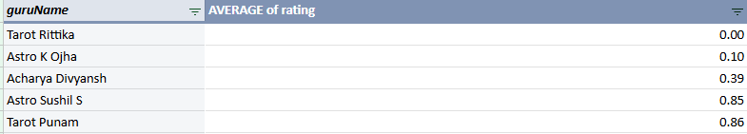
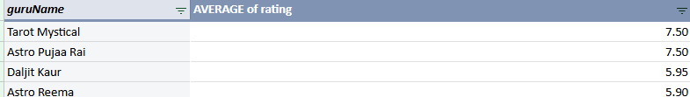

Q-13 I Objective (Monthly Average Customer Satisfaction)

Month | AVERAGE of rating
December-2023 | 2.95
January-2024 | 2.68
Grand Total | 2.93

- Description:
These Pivot Tables summarize AstroSage's operational performance and customer satisfaction. They would serve as the basis for comparison if AstroGuru's data were available.
Aggregation Functions Used:
- Pivot Table
- COUNT
- COUNTUNIQUE
- AVERAGE
- SUM
Visualization Used:
- Clustered Column Chart
- Bar Chart

Insights:
- The available dataset contains only AstroSage call center data.
- AstroSage's overall average customer satisfaction score is 2.93.
- The average daily call volume is approximately 246 calls per day.
- Without AstroGuru's corresponding data, it is not possible to determine which call center performs better.

Recommendations:
- Obtain AstroGuru's call center dataset or benchmark KPIs.
- Compare both organizations using:
  - Average daily call volume
  - Average customer satisfaction score
  - Average calls handled per agent per day
- Use Pivot Tables and comparison charts to identify strengths, weaknesses, and areas for improvement.

Question 4: How can the call center improve its handling of peak call periods to ensure high customer satisfaction?

Mention the functionality you will use for giving the suggestions, will it be any aggregated function or a visualization?

Solution:

Approach:
- Created Pivot Tables using chatStartTime-Hour as Rows and COUNTA(_id) as Values to identify hourly call-volume trends and peak call periods.
- Used COUNTA(_id) as an aggregated function to determine the busiest hours of the day and evaluate workload patterns.
- Created Pivot Tables using chatStartTime-Hour as Rows and both COUNTA(_id) and AVERAGE(rating) as Values to analyze the relationship between call volume and customer satisfaction.
- Used a Line Chart and a Combination Chart (Column + Line Chart) to visualize hourly call trends and customer ratings across all 24 hours.
- Based on the historical hourly workload patterns, recommended workforce planning and operational improvements to maintain customer satisfaction during peak periods.

Charts & Tables:
- Table / Chart Name: Q-4 Subjective – Hour vs. Number of Calls
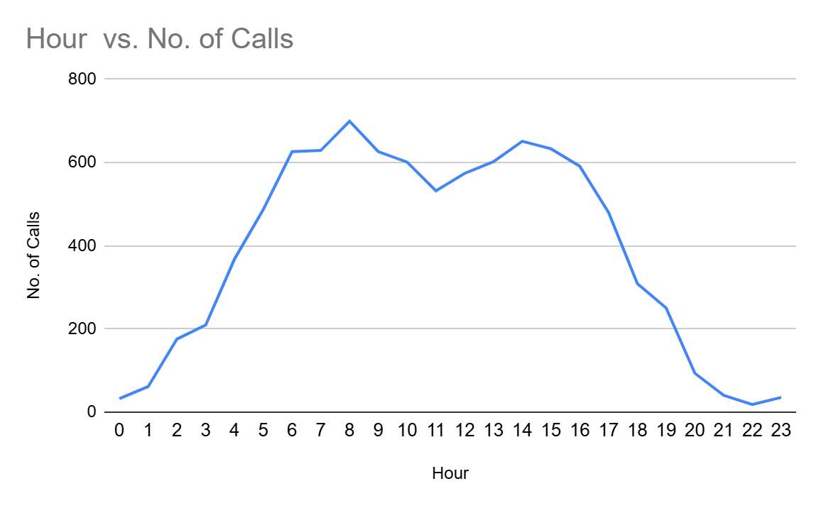
Visualization: Line Chart showing hourly call-volume trends across all 24 hours.

Q-4 Subjective – Hourly Call Volume and Average Customer Rating Analysis
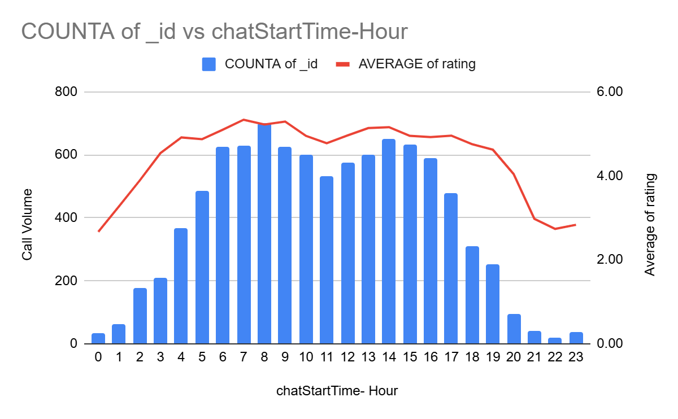
Visualization: Combination Chart showing hourly call volume (Column Chart) and average customer rating (Line Chart).

Insights:
- Call volumes increase significantly between 6 AM and 4 PM, indicating the primary peak service period.
- The highest hourly call volume was recorded at 8 AM (699 interactions), followed by sustained high activity during the daytime hours.
- Customer ratings remain consistently high (approximately 4.7 to 5.3) during most peak periods, indicating that service quality is generally maintained despite increased workloads.
- Call volumes decline considerably after 7 PM, suggesting opportunities for more efficient shift planning during off-peak hours.
- Historical hourly patterns indicate that staffing requirements vary significantly throughout the day and should be aligned with anticipated customer demand.

Recommendations:
- Schedule additional or experienced agents during peak call periods (6 AM to 4 PM) to minimize customer wait times and maintain service quality.
- Implement workforce planning strategies based on historical hourly call-volume trends to optimize shift scheduling.
- Continuously monitor customer ratings during peak periods to identify potential declines in service quality and address them proactively.
- Utilize Pivot Tables and visual dashboards to monitor hourly performance metrics and respond quickly to changing call volumes.
- Review staffing allocations periodically based on peak-hour trends to ensure an optimal balance between operational efficiency and customer satisfaction.

Question 5: Based on historical data, what strategic initiatives should be prioritized to improve efficiency and customer satisfaction?

Solution:

Approach:
- Created Pivot Tables using chatStartTime-Hour as Rows and COUNTA(_id) as Values to analyze historical hourly interaction patterns.
- Used AVERAGE(rating) as an aggregated function to evaluate customer satisfaction across different hours of the day.
- Compared hourly call volumes with average customer ratings to identify periods of high demand and assess service quality.
- Utilized a Combination Chart (Column + Line Chart) to visualize the relationship between interaction volume and customer satisfaction.
- Based on historical trends, identified strategic initiatives that can improve operational efficiency while maintaining high customer satisfaction.

Charts & Tables:
- Table / Chart Name:
Q-5 Subjective – Historical Hourly Interaction and Customer Satisfaction Analysis


Visualization: Combination Chart showing hourly interaction volume (Column Chart) and average customer rating (Line Chart).
Insights:
- Interaction volumes are highest between 6 AM and 4 PM, indicating the primary peak operating period.
- The highest interaction volume was recorded at 8 AM (699 interactions), while customer ratings remained above 5 during most peak periods.
- Customer satisfaction remains relatively stable during busy hours, suggesting that existing processes are effective but may require additional support as demand increases.
- Significant declines in interaction volume during late evening hours present opportunities for optimizing staffing schedules.
- Historical patterns indicate that aligning workforce capacity with hourly demand can improve both efficiency and customer experience.

Recommendations:
- Prioritize workforce planning by allocating additional agents during historically high-demand hours.
- Invest in continuous agent training programs to maintain consistently high customer satisfaction during peak periods.
- Implement real-time performance monitoring dashboards to track hourly interaction volumes and customer ratings.
- Optimize shift scheduling using historical demand patterns to improve operational efficiency and reduce resource underutilization.
- Regularly review customer satisfaction trends to identify opportunities for service improvements and proactive workforce adjustments.

Strategic Initiatives to Prioritize:
- Workforce Optimization: Align agent schedules with peak-hour demand patterns.
- Agent Training: Strengthen customer-handling capabilities to sustain high satisfaction levels during busy periods.
- Performance Monitoring: Use Pivot Tables and dashboards to continuously monitor hourly workloads and customer ratings.
- Data-Driven Planning: Leverage historical interaction trends for demand forecasting and resource allocation.

Question 6: What can be the key factors contributing to high customer satisfaction scores, and how can these be leveraged to improve overall performance?

What is the basis for the suggestions? And mention how you decided if the satisfaction score affects the ratings.

Solution:

Approach:
- Created Pivot Tables using Grouped astrologerOnCallDuration as Rows and AVERAGE(rating) as Values to analyze how customer ratings vary across different interaction durations.
- Grouped astrologer on-call durations into meaningful intervals to identify patterns between conversation length and customer satisfaction.
- Used AVERAGE(rating) as an aggregated function to measure customer satisfaction levels for each duration group.
- Compared ratings across duration intervals to determine whether longer interactions positively influence customer satisfaction.
- Based on historical rating trends, identified factors contributing to higher satisfaction scores and recommended performance improvement initiatives.

Charts & Tables:
- Table / Chart Name:Q-6 Subjective – Interaction Duration vs Average Customer Rating Analysis

Grouped astrologerOnCallDuration | AVERAGE of rating
0.00 - 199.00 | 2.91
200.00 - 399.00 | 3.47
400.00 - 599.00 | 3.46
600.00 - 799.00 | 3.54
800.00 - 999.00 | 3.56
1,000.00 - 1,199.00 | 3.77
1,200.00 - 1,399.00 | 3.79
1,400.00 - 1,599.00 | 3.89
1,600.00 - 1,799.00 | 2.90
1,800.00 - 1,999.00 | 3.40
2,000.00 - 2,199.00 | 2.00
2,200.00 - 2,399.00 | 3.00
2,400.00 - 2,599.00 | 4.00
2,600.00 - 2,799.00 | 3.50
2,800.00 - 2,999.00 | 2.00
3,000.00 - 3,199.00 | 4.00
3,200.00 - 3,399.00 | 4.00
4,000.00 - 4,199.00 | 2.00
Grand Total | 2.93

Summary: Longer interaction durations are generally associated with higher customer ratings, suggesting that customers tend to provide better feedback when they receive sufficient time and attention during consultations.

Description:
The grouped interaction-duration analysis highlights how customer ratings change across varying consultation lengths. Average ratings tend to improve as interaction duration increases, indicating that longer and more engaging conversations contribute positively to customer satisfaction. This analysis provides valuable insights into customer behavior and helps identify service practices that enhance overall performance.

Insights:
- Customer ratings generally increase as astrologer interaction durations become longer.
- Consultations lasting between approximately 1,000 and 1,600 seconds tend to receive higher average ratings compared to shorter interactions.
- Very short interactions are associated with comparatively lower customer ratings, suggesting that customers may value more detailed consultations.
- Providing sufficient consultation time appears to positively influence customer satisfaction levels.
- Historical data indicates a relationship between interaction quality (represented by consultation duration) and customer ratings.

Recommendations:
- Encourage agents/astrologers to provide comprehensive consultations without unnecessarily shortening customer interactions.
- Identify and adopt best practices followed during higher-rated consultations.
- Monitor average ratings across different duration groups regularly to maintain service quality.
- Provide training focused on effective customer engagement and problem resolution.
- Utilize historical rating trends to establish appropriate service benchmarks for customer interactions.

Question 7: How should the call center balance the workload among agents to ensure optimal performance and avoid burnout?

Mention your approach and spreadsheet function for the answer.

Solution:

Approach:
- Created Pivot Tables using guruName as Rows and COUNTA(_id) as Values to determine the number of customer interactions handled by each agent.
- Used AVERAGE(astrologerOnCallDuration) as an aggregated function to evaluate the average consultation duration handled by individual agents.
- Compared interaction volumes and average consultation durations to identify workload variations across agents.
- Analyzed whether certain agents are handling disproportionately higher workloads that could potentially affect performance and increase burnout risks.
- Based on historical workload patterns, recommended strategies for improving workload distribution and operational efficiency.

Charts & Tables:
- Table / Chart Name:Q-7 Subjective – Agent Workload Distribution Analysis

Aggregated Functions Used:
- COUNTA(_id)
- AVERAGE(astrologerOnCallDuration)

- Description:
The Pivot Table summarizes agent workloads by comparing the number of customer interactions handled and their corresponding average consultation durations. The analysis helps identify workload imbalances among agents and provides insights into workforce utilization patterns. Monitoring both interaction volume and consultation duration enables better workforce planning while minimizing burnout risks.

Insights:
- Significant variations exist in the number of interactions handled by different agents.
- Some agents handle substantially higher interaction volumes than others, indicating potential workload imbalances.
- Consultation durations also vary considerably across agents, suggesting differences in customer engagement and service delivery patterns.
- Agents handling both high interaction volumes and longer consultation durations may face increased workload pressures if appropriate resource allocation is not maintained.
- Historical workload trends suggest opportunities for improving workforce distribution and optimizing agent utilization.

Recommendations:
- Implement workload-balancing strategies to distribute customer interactions more evenly among available agents.
- Continuously monitor interaction volumes and consultation durations to identify agents who may require workload adjustments.
- Optimize shift scheduling to ensure adequate staffing during periods of increased customer demand.
- Provide appropriate break schedules and performance support mechanisms to minimize agent burnout risks.
- Establish workforce management dashboards using Pivot Tables to monitor agent utilization and operational efficiency regularly.
- Utilize historical workload data to improve resource allocation and maintain consistent service quality across all agents.

Question 8: What new technologies or tools could be implemented to enhance call center operations and customer service?

Solution:

Approach:
The recommendations are based on the analysis of call volume, customer satisfaction, guru performance, and customer rating distribution. Areas with varying performance and workload were identified, and suitable technologies were suggested to improve operational efficiency, customer experience, and decision-making.
No statistical calculation is required for this question. The recommendations are derived from insights obtained through Pivot Tables, KPI analysis, and dashboard visualizations.

Charts & Tables:
- Table / Chart Name:
- AstroSage Call Center Performance Dashboard
- Monthly Call Volume
- Monthly Customer Satisfaction
- Top 10 Gurus by Customer Rating
- Bottom 10 Gurus by Customer Rating
- Customer Rating Distribution

- Description:
These dashboard components provide an overview of operational performance, customer satisfaction, workload trends, and agent performance, helping identify areas where technology can improve efficiency.

Insights:
- Customer satisfaction varies across gurus, indicating opportunities for better quality monitoring and training.
- Call volumes fluctuate significantly between months, highlighting the need for better workforce planning.
- Customer ratings are concentrated in the mid-range, suggesting room for improving customer experience.
- High-performing gurus can be used as benchmarks for quality improvement.

Recommendations:
- AI-powered chatbots to handle common customer queries and reduce agent workload.
- Automatic Call Distribution (ACD) to assign calls evenly based on agent availability and expertise.
- CRM (Customer Relationship Management) system to provide agents with customer history and improve personalized service.
- Speech Analytics and Sentiment Analysis to monitor customer interactions, identify customer emotions, and improve service quality.
- Workforce Management (WFM) software to forecast call volumes and optimize staff scheduling during peak periods.
- Real-time performance dashboards to monitor KPIs such as call volume, customer ratings, operational cost, and agent performance.
- Quality Monitoring Tools to automatically evaluate calls and identify coaching opportunities for lower-performing agents.

Question 9: What metrics should be included in the final dashboard to comprehensively view call center performance and guide investment decisions?

Solution:

Approach:
- Designed an interactive dashboard to provide a comprehensive view of operational performance, customer satisfaction, workforce utilization, and financial outcomes.
- Selected the dashboard metrics based on the historical analyses performed in both the objective and subjective questions.
- Incorporated aggregated functions such as COUNTA(), AVERAGE(), and SUM() through Pivot Tables to summarize performance indicators.
- Utilized KPI Cards, Column Charts, Line Charts, Pie Charts, Horizontal Bar Charts, and Slicers to enable interactive performance monitoring and trend analysis.
- Included metrics that support strategic investment decisions related to workforce planning, customer experience improvements, and operational optimization.

Charts & Tables:
- Table / Chart Name: Dashboard
- KPI Cards
- Monthly Call Volume
- Sales by Category
- Monthly Customer Satisfaction
- Top 10 Gurus by Customer Rating
- Bottom 10 Gurus by Customer Rating
- Customer Rating Distribution

- Description:
The dashboard combines key performance indicators with interactive charts and slicers to monitor call center performance, financial outcomes, customer satisfaction, and guru performance. The visualizations enable users to identify trends, compare performance, and filter the data for detailed analysis.

Insights:
- Historical hourly analysis revealed that customer demand peaks between 6 AM and 4 PM, with the highest interaction volume of 699 interactions recorded at 8 AM, indicating that workforce planning should prioritize staffing during these periods.
- Monthly interaction analyses showed that December recorded substantially higher interaction volumes than January, highlighting the importance of forecasting seasonal demand patterns when allocating operational resources.
- Customer ratings remained relatively high during peak periods, ranging approximately between 4.7 and 5.3, suggesting that service quality was maintained despite increased workloads.
- Consultation-duration analysis demonstrated that average customer ratings generally improve as interaction durations increase. Ratings increased from approximately 2.91 for shorter interactions (0-199 seconds) to approximately 3.89 for consultations lasting between 1,400 and 1,599 seconds, indicating that meaningful customer engagement positively influences satisfaction levels.
- Agent workload analysis identified considerable variations in interaction volumes among gurus, suggesting opportunities for improved workload balancing and optimized workforce utilization.
- Customer-rating distribution and guru-performance metrics provide valuable insights for recognizing consistently high-performing agents and identifying opportunities for targeted coaching and performance improvement initiatives.
- Interactive dashboard filters facilitate detailed month-wise, consultation-type-wise, and guru-wise analyses, enabling management to investigate performance trends efficiently and support data-driven decision-making.

Recommendations:
- Continue monitoring KPI metrics regularly to evaluate operational performance and identify emerging trends.
- Prioritize workforce planning initiatives by aligning staffing schedules with historical peak-hour demand patterns identified through dashboard analyses.
- Allocate investments toward technologies and operational improvements that enhance customer satisfaction during peak service periods.
- Utilize monthly performance trends to optimize resource allocation and proactively address seasonal fluctuations in customer demand.
- Reward consistently high-performing gurus and provide targeted coaching and workload adjustments for agents requiring additional support.
- Monitor consultation durations and customer ratings continuously to ensure service quality standards are maintained across all customer interactions.
- Leverage interactive dashboard filters to perform detailed performance analyses and support strategic investment decisions related to staffing, training programs, and technology adoption.
- Regularly update dashboard metrics with operational data to measure the effectiveness of implemented business improvements and monitor long-term performance trends.

Functionality Used:
- Spreadsheet Functionalities: Pivot Tables, KPI Cards, Slicers, and Interactive Dashboards.
- Aggregated Functions: COUNTA(), AVERAGE(), and SUM().
- Visualizations: Column Charts, Line Charts, Pie Charts, Horizontal Bar Charts, and Dashboard KPI Cards.

Final Conclusion:
The final dashboard integrates historical operational, financial, and customer-service metrics into a comprehensive performance-monitoring framework. By combining numeric trend analyses, interactive visualizations, and aggregated performance indicators, the dashboard enables management to make informed investment decisions related to workforce planning, customer satisfaction initiatives, and technology adoption while continuously improving overall call center performance.

Question 10: How would you allocate a 1 crore rupee investment to optimize operational efficiency, enhance customer satisfaction, and boost profitability, and what analysis-based recommendations would you offer to support this?

[you have to give bullet pointers to answer this question]

Solution:

Approach:

Investment Allocation
- ₹35 Lakhs (35%) – Technology Upgrades
  - Implement AI-powered chatbots for common customer queries.
  - Introduce Automatic Call Distribution (ACD) and Workforce Management (WFM) tools.
  - Deploy speech analytics and real-time performance monitoring dashboards.
- ₹30 Lakhs (30%) – Agent Training & Quality Improvement
  - Conduct regular customer service and communication training.
  - Mentor lower-performing gurus using best practices from top-performing gurus.
  - Introduce quality monitoring and performance feedback programs.
- ₹20 Lakhs (20%) – Hiring & Workforce Expansion
  - Recruit additional agents to handle peak call periods.
  - Reduce workload on high-performing gurus and improve response times.
- ₹10 Lakhs (10%) – Customer Experience Enhancement
  - Improve CRM systems for personalized customer interactions.
  - Implement customer feedback collection and follow-up mechanisms.
- ₹5 Lakhs (5%) – Data Analytics & Dashboard Automation
  - Automate KPI reporting and dashboard updates.
  - Enhance reporting for management to support faster decision-making.

Charts & Tables:
- Table / Chart Name:
- AstroSage Call Center Performance Dashboard
- Monthly Call Volume
- Monthly Customer Satisfaction
- Top 10 Gurus by Customer Rating
- Bottom 10 Gurus by Customer Rating
- Sales by Consultation Category

- Description:
These charts provide insights into call volume trends, customer satisfaction, guru performance, and revenue contribution by consultation category. They help identify areas where investment can improve operational efficiency, customer satisfaction, and profitability.

Insights:
- Monthly call volume analysis shows fluctuations in workload, indicating the need for better workforce planning.
- Customer satisfaction differs across gurus, highlighting opportunities for targeted training and performance improvement.
- The Call consultation category generates the highest revenue, making it the primary area for operational investment.
- The correlation between call duration and customer satisfaction is 0.0548, indicating that longer calls do not significantly improve customer satisfaction.
- The dashboard enables continuous monitoring of KPIs, helping management make data-driven investment decisions.

Recommendations:
- Invest in automation technologies to improve efficiency and reduce manual workload.
- Prioritize training programs to improve service quality and increase customer satisfaction.
- Recruit additional agents to manage peak call periods and balance workloads.
- Enhance CRM capabilities to provide faster and more personalized customer support.
- Continue monitoring KPIs through dashboards to evaluate the effectiveness of investments and support continuous improvement.
- Regularly review guru performance and customer feedback to identify improvement opportunities and maximize return on investment.

