Assignment 2
LLM Chatbot Architecture and Vector Databases
Submitted by: Anjali Yadav
Role: AI/ML
Date: September 2026
GitHub: github.com/AnjaliYadav-04/Python_Data_Engineering_Projects

Contents
- Self-assessment: LLM, Deep Learning, AI, ML
- Key architectural components of an LLM-based chatbot
- Vector databases, and which one I would choose for a real problem
- References

1. Self-assessment
Rating scale used: A = can code independently, B = can code under supervision, C = little or no understanding.
Area | Rating | What I can do today
Machine Learning (ML) | A | I have hands-on experience building ML pipelines using Python, scikit-learn, Pandas and NumPy, including data preparation, feature engineering, model training and evaluation.
Deep Learning | B | I have hands-on experience with CNNs, U-Net and transformer-based models using PyTorch, TensorFlow and Keras, including work on computer vision and breast MRI research. I’m currently exploring more advanced deep learning topics and working on strengthening my understanding beyond standard architectures.
Artificial Intelligence (AI) | A | I have worked on practical AI systems across NLP, computer vision and intelligent applications. I’ve built a medical RAG chatbot, a multi-agent voice orchestration system and an AI-powered drone inspection platform.
Large Language Models (LLM) | A | I have practical experience using GPT-4o, Qwen, LangChain and LangGraph to build RAG and multi-agent systems, including embeddings, vector search, retrieval, prompting, orchestration and evaluation. I’ve also worked on deploying these systems with Docker and AWS.

I’m strongest in practical AI/ML engineering, particularly LLM applications, RAG, computer vision and backend integration. I’m currently expanding my knowledge of advanced deep learning, multimodal AI, agentic systems and AI evaluation.

2. Architecture of an LLM-based chatbot

2.1 Why an LLM on its own is not a chatbot
A large language model is very good at one thing: given some text, it predicts a sensible continuation. That is enough to hold a conversation, but it leaves real gaps when you try to use it for an actual product:
- It has no memory. Each API call is independent. If the application does not send the earlier messages again, the model has no idea what was said a minute ago.
- Its knowledge is frozen. It only knows what was in its training data, so it cannot answer questions about a company’s own documents or anything that changed recently.
- It can sound confident while being wrong (hallucination), especially when asked about details it never saw.
- It cannot act. On its own it cannot look up an order, run a SQL query or send an email.
So the way I think about chatbot architecture is simple: every extra component exists to close one of these gaps. The LLM is the “brain”, and the rest of the system gives it memory, facts, abilities and safety limits.

2.2 The components
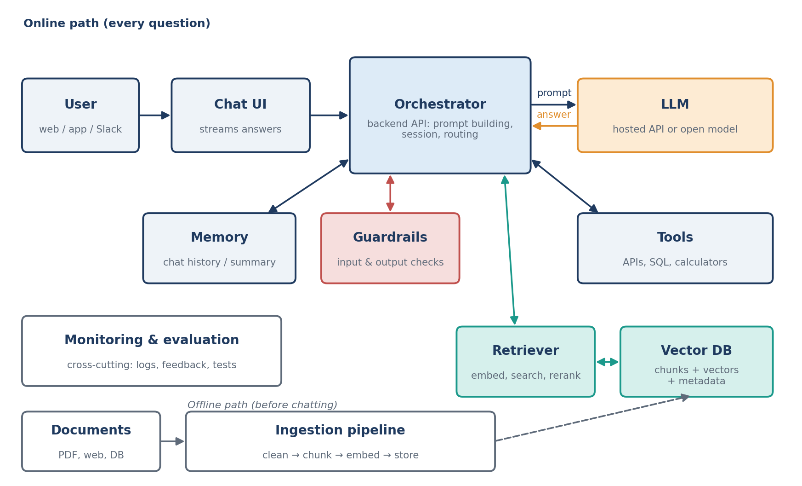
Figure 1 – High-level architecture of an LLM chatbot with retrieval (RAG)
Component | What it does | Typical choices
Chat interface | Where the user types. Shows answers as they are generated (streaming) so the bot feels fast. | Web app (React, Streamlit), mobile app, Slack / WhatsApp / Teams integration
Orchestrator (backend) | The coordinator. Receives each message, loads history, calls retrieval and tools, builds the prompt, calls the LLM and returns the answer. | Python with FastAPI; frameworks such as LangChain, LlamaIndex, or plain code
LLM | Understands the question and writes the answer from the prompt it receives. | Hosted APIs (Claude, GPT, Gemini) or open models (Llama, Mistral, Qwen) served on own GPUs
Prompt layer | The system prompt: the bot’s role, tone, rules (“answer only from the provided context”), and output format. | Versioned prompt templates stored alongside the code
Memory | Keeps the conversation coherent. Recent turns are sent as-is; older ones are summarised to save space. | Redis or a database for sessions; summary memory for long chats
Knowledge retrieval (RAG) | Finds the few passages from the organisation’s documents that are relevant to the question and gives them to the LLM. | Embedding model + vector database + optional reranker
Ingestion pipeline | Runs before anyone chats: loads documents, cleans and splits them into chunks, creates embeddings and stores them. | Scheduled Python jobs; document parsers for PDF/HTML
Tools / function calling | Lets the model ask the backend to do something: check a record, call an API, run a calculation. | Function-calling APIs, MCP servers, internal REST APIs
Guardrails | Checks input and output: blocks prompt-injection attempts, removes personal data, refuses unsafe or off-topic requests. | Moderation models, rule filters, PII detection
Monitoring & evaluation | Logs every turn, tracks cost and latency, collects thumbs up/down, and runs test questions after every change. | Logging + dashboards; evaluation datasets; tools like LangSmith or Langfuse

2.3 What happens when a user asks a question
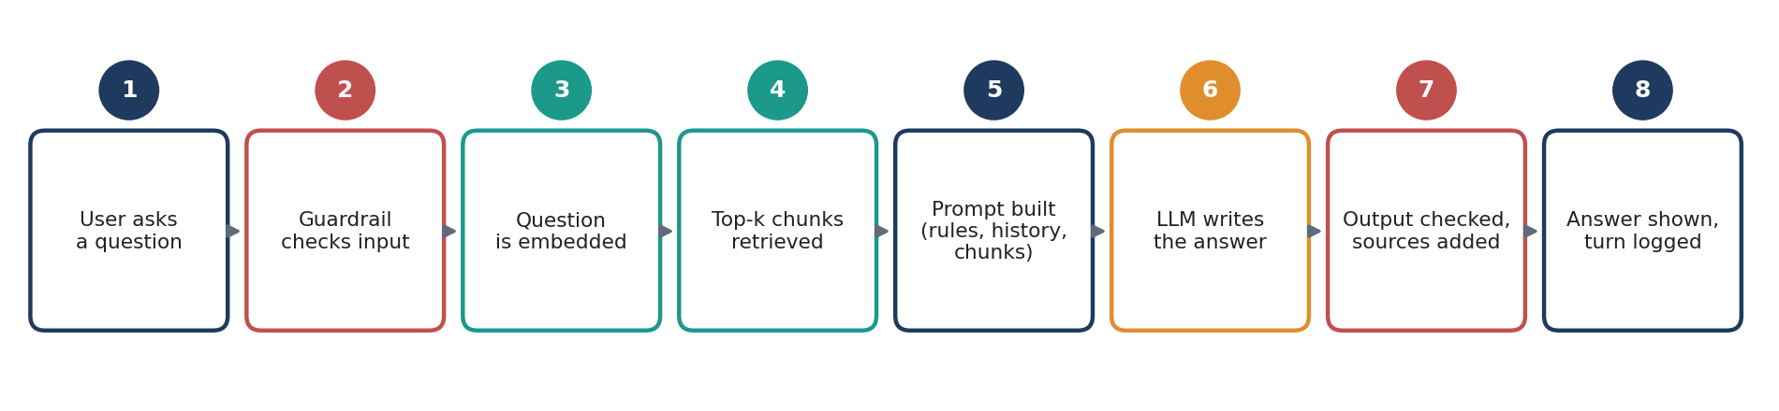
Figure 2 – The life of a single question
Taking the example of a university help-desk bot, suppose a student asks “What is the last date to pay hostel fees?”
- The guardrail first checks that the message is a normal question and not an attempt to override the bot’s instructions.
- The retriever converts the question into an embedding and asks the vector database for the most similar chunks, for example the latest hostel fee circular.
- A reranker (optional) re-orders those chunks so the most relevant two or three are kept.
- The orchestrator builds the prompt: system rules + the last few chat turns + the retrieved chunks + the question.
- The LLM writes the answer using that context, and is instructed to say “I don’t know” if the context does not contain it.
- The output is checked, the source document is cited, the answer is streamed to the student, and the whole turn is logged for later review.

2.4 The offline side: preparing the knowledge
Retrieval quality depends almost entirely on how the documents were prepared, so I treat ingestion as a proper data pipeline rather than a one-off script:
- Load and clean – extract text from PDFs and web pages, remove headers, footers and duplicate pages.
- Chunk – split into passages of a few hundred tokens with a small overlap, keeping headings attached so a chunk still makes sense on its own.
- Embed – run each chunk through an embedding model to get a vector.
- Store with metadata – save the vector, the text, and fields such as source, department and date, so searches can be filtered later.
- Keep it fresh – re-process documents when they change and delete outdated ones, otherwise the bot will confidently quote last year’s rules.
This is the same idea I used in my Assignment 1 projects: validate data before storing it, make re-runs safe (no duplicates), and record where each record came from.

2.5 Key design decisions
Decision | Option A | Option B | How I would decide
Which LLM | Hosted API (Claude, GPT, Gemini) | Open-source model on own servers | Start with an API for quality and speed of development; move to open models only if data cannot leave the premises or volume makes APIs too costly.
Adding knowledge | RAG (retrieve at question time) | Fine-tuning the model | RAG for facts that change and need citations. Fine-tuning mainly for style, format or a narrow specialised task.
Chunk size | Small chunks (precise matches) | Large chunks (more context) | Test both on real questions and measure which one retrieves the right passage more often.
Search type | Pure vector (semantic) search | Hybrid: vector + keyword | Hybrid when users type codes, names or IDs (e.g. “CS301”), which pure semantic search can miss.
Memory | Send the full history | Recent turns + a running summary | Summaries keep cost and latency under control in long conversations.

2.6 My approach to building one
- Define the scope and success criteria. Who uses it, what questions it must answer, what it must refuse, and how success is measured (accuracy, response time, cost per conversation).
- Collect and prepare the data with the ingestion pipeline described above.
- Build a simple prototype first: one LLM, basic RAG, a minimal chat page. Get something working end to end before optimising.
- Create an evaluation set of 50–100 real questions with expected answers. Measure whether the right chunk was retrieved and whether the answer stays faithful to it.
- Improve step by step – chunking, hybrid search, reranking, prompt wording – re-running the evaluation after each change so improvements are measured, not guessed.
- Harden for production – guardrails, authentication, rate limits, caching of repeated questions, error handling when the LLM API is slow or down.
- Deploy, monitor and learn from logs and user feedback; unanswered questions show which documents are missing.

2.7 Common problems and how the architecture handles them
Problem | Mitigation
Hallucinated answers | Answer only from retrieved context, require citations, allow “I don’t know”.
Right document exists but is not found | Better chunking, hybrid search, reranking, metadata filters; track retrieval accuracy in evaluation.
Prompt injection (“ignore your instructions…”) | Input guardrails, clear separation of instructions and user content, least-privilege tools.
Outdated information | Scheduled re-ingestion, validity dates in metadata, filter out expired documents.
High cost or slow replies | Smaller model for simple questions, caching, shorter prompts, streaming output.
Leaking personal data | PII masking, access control on documents, filtering retrieval by the user’s permissions.

3. Vector databases

3.1 The problem they solve
Traditional databases, like the SQLite databases in my Assignment 1 projects, are excellent at exact questions: “give me all books where author = ‘George Orwell’”. They struggle with questions about meaning. A student may type “last date to pay hostel fees” while the official circular says “deadline for residential charges”. The words barely overlap, but the meaning is the same.
Vector databases solve this by storing embeddings. An embedding model turns a piece of text (or an image or audio clip) into a long list of numbers, typically a few hundred to a few thousand values. The model is trained so that texts with similar meaning end up with similar numbers, which means they sit close together in this high-dimensional space. Searching by meaning then becomes a geometry problem: find the stored vectors nearest to the query vector.
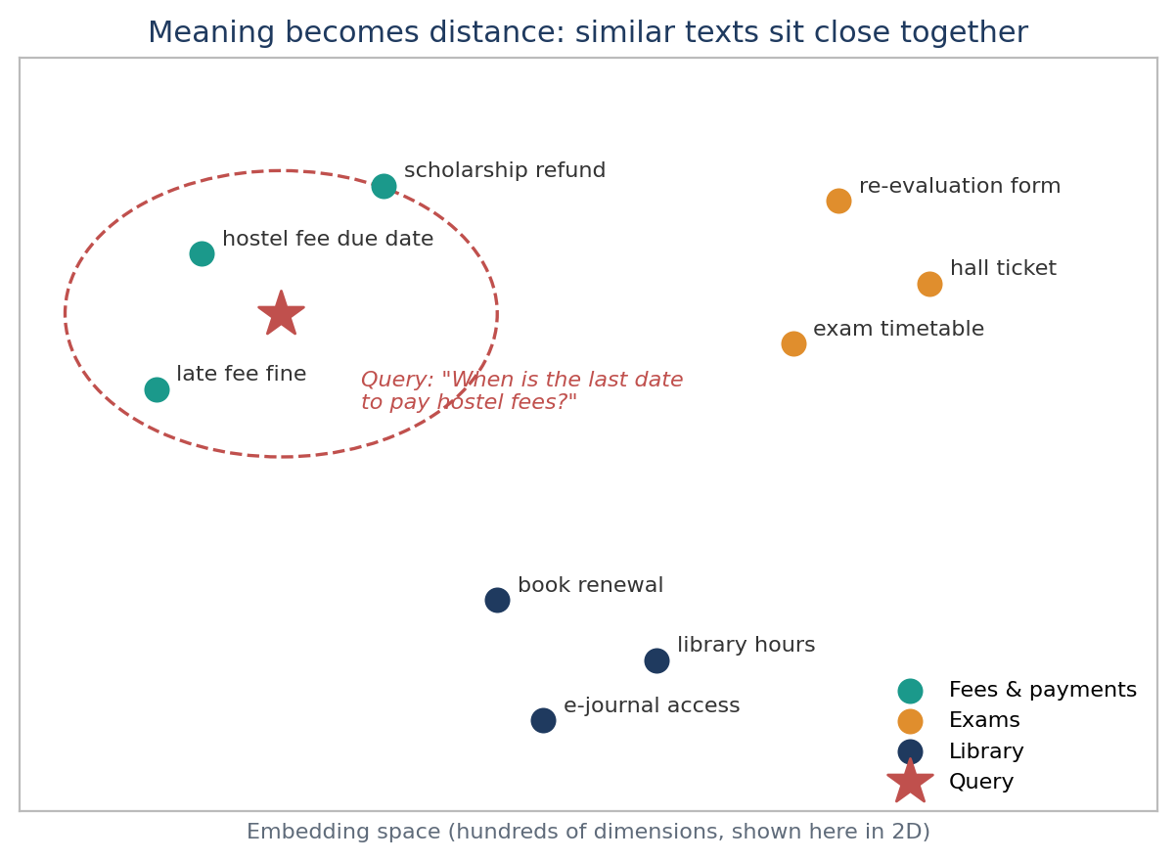
Figure 3 – Similar meanings cluster together; the query lands near the fee documents

3.2 Measuring “closeness”
Metric | Idea | When it is used
Cosine similarity | Compares the direction of two vectors, ignoring their length. | Most common choice for text embeddings.
Dot product | Direction and length together; equals cosine when vectors are normalised. | Models trained for it; fast to compute.
Euclidean (L2) distance | Straight-line distance between two points. | Image features and some older models.
The rule of thumb is to use the metric the embedding model was trained with; the model’s documentation states it.

3.3 Why search needs special indexes
The simple approach is to compare the query with every stored vector. That is exact, but with millions of vectors and hundreds of dimensions each, it becomes too slow for a chatbot that should answer in about a second. Vector databases use Approximate Nearest Neighbour (ANN) indexes, which accept a tiny loss in accuracy in exchange for searches that are orders of magnitude faster.
Index | How it works (simplified) | Trade-off
Flat (brute force) | Compares against every vector. | 100% accurate, slow at scale; fine for small data.
IVF (inverted file) | Groups vectors into clusters; only the nearest clusters are searched. | Fast and memory-friendly; accuracy depends on how many clusters are checked.
HNSW (graph) | Builds a layered graph linking each vector to its neighbours; search hops through the graph towards the query. | Very fast with high recall; uses more memory. The default in most vector databases.
PQ (product quantisation) | Compresses vectors into short codes. | Huge memory savings; some accuracy loss. Often combined with IVF.

3.4 A vector index is not yet a vector database
Libraries such as FAISS provide excellent indexes, but a production system needs more than fast search. What a vector database adds:
- Metadata filtering – search only within documents where department = “Hostel” and the date is still valid.
- Hybrid search – combine semantic similarity with keyword matching for codes and names.
- Live updates – insert, update and delete vectors without rebuilding the whole index.
- Persistence, backups and replication, so data survives restarts and the service stays available.
- Access control and APIs that the application can call safely.

3.5 The main options
Database | Type | Strengths | Watch out for
Pinecone | Fully managed cloud service | No servers to run, scales automatically, quick to start | Data lives in the vendor’s cloud; costs grow with usage; no self-hosting
Qdrant | Open source (Rust), self-host or cloud | Strong filtering during search, hybrid (dense + sparse) search, light to run | One more service to operate when self-hosted
Weaviate | Open source (Go), self-host or cloud | Built-in hybrid search and modules that can create embeddings | More moving parts to configure and run
Milvus | Open source, distributed | Designed for very large scale (up to billions of vectors) | Operational complexity is overkill for small projects
pgvector | Extension for PostgreSQL | Vectors next to normal tables, SQL joins, one system to manage | Tuning needed at larger scale; fewer vector-specific features
Chroma | Lightweight, open source | Easiest for prototypes and local experiments | Not the first choice for large production deployments

3.6 Choosing one for a real problem

The hypothetical problem: a Campus Help Desk chatbot
A university with around 40,000 students gets thousands of repetitive queries every semester about fees, exams, hostels, scholarships and library services. The answers exist, but they are spread across roughly 5,000 PDFs, circulars and web pages. The university wants a chatbot that answers questions from these official documents and links to the source.
Once the documents are split into chunks, that is about 150,000 vectors, possibly growing to a few million if other campuses join later. The requirements that matter for the database choice:
Requirement | Why it matters
Filtering by metadata | A first-year B.Tech student should not get answers from an M.Sc. exam circular or an expired notice. Filters on programme, year, department, audience and validity date must work during the search, not after it.
Hybrid search | Students type exact codes such as “CS301”, “Form 7B” or scholarship scheme names that pure semantic search can miss.
Data stays on campus | Documents and logs may contain student information, so the system should be self-hostable on university servers.
Frequent updates | New circulars arrive weekly and old ones expire, so inserts and deletes must be simple and immediate.
Small team, low budget | Two developers will maintain it; licence costs and heavy operations are not acceptable.
Room to grow | Should handle millions of vectors without a redesign.

Evaluation
I weighted each criterion by how much it matters for this project and scored each option from 1 to 5 based on its documented features and typical deployment effort. These scores are my own assessment for this specific use case, not a general ranking.
Criterion (weight) | Qdrant | Weaviate | Pinecone | pgvector | Chroma
Metadata filtering (25%) | 5 | 4 | 4 | 4 | 3
Hybrid search (20%) | 4 | 5 | 4 | 3 | 2
Self-hosting / cost (20%) | 5 | 4 | 2 | 5 | 5
Ease of setup (15%) | 4 | 3 | 5 | 4 | 5
Scale headroom (10%) | 4 | 4 | 5 | 3 | 2
Managed option later (10%) | 4 | 4 | 5 | 4 | 3
Weighted score / 100 | 89 | 81 | 79 | 78 | 68
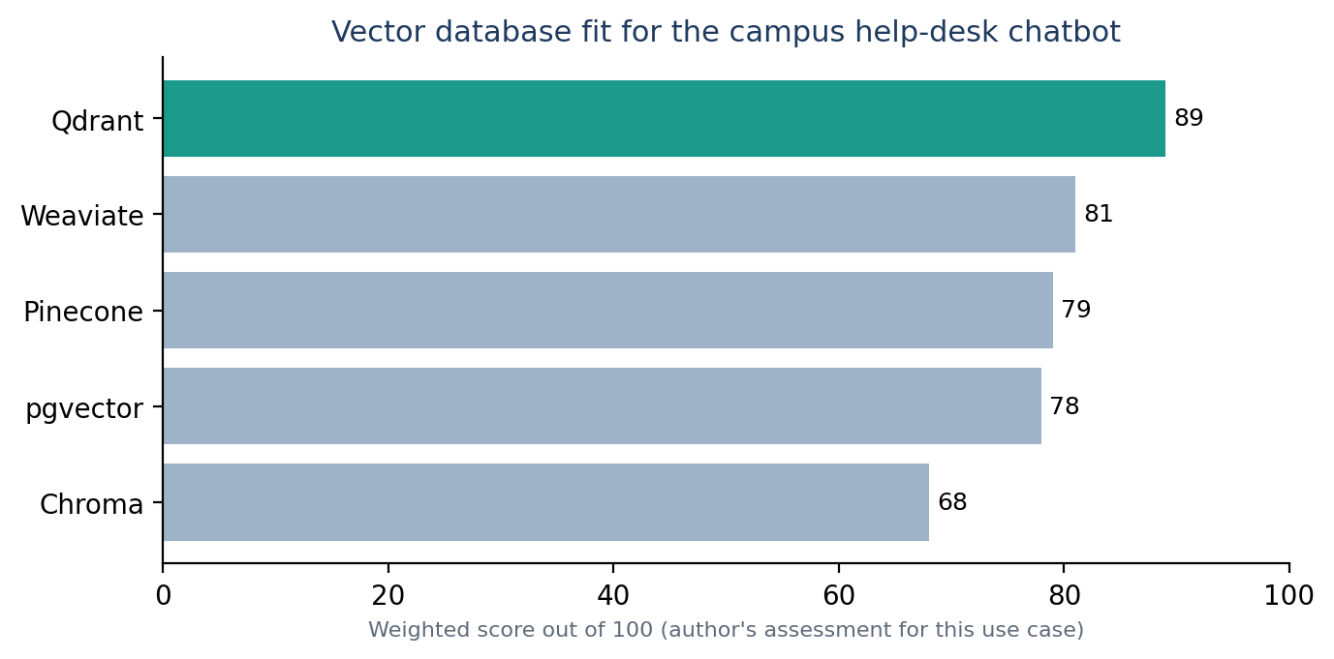
Figure 4 – Weighted fit for the Campus Help Desk requirements

My choice: Qdrant
- Filtering is a core strength. Qdrant stores metadata (called a payload) with each vector and applies filters during the search itself, so results respect programme, year and validity date without losing relevant matches.
- Hybrid search is supported natively by storing a dense vector for meaning and a sparse vector for keywords, then combining both result lists.
- It keeps data on campus. It is open source (Apache 2.0) and runs as a single Docker container, which is plenty for 150,000 vectors, at no licence cost.
- It leaves a path to grow. Distributed mode and a managed cloud version exist if the project expands to other campuses.
- Simple updates – adding or deleting a circular is a single API call, which suits weekly changes.
Trade-off I accept: it is one more service to run, back up and upgrade compared with using PostgreSQL alone.

Why not the others
- pgvector is my strong second choice. If the university already runs PostgreSQL with a team that knows it, keeping vectors next to student and course tables is very attractive. I would revisit the decision in that case.
- Weaviate has excellent hybrid search, but for a two-person team it involves more configuration than the problem needs.
- Pinecone is the fastest route to a managed service, but sending university documents to an external cloud and paying per usage conflicts with the requirements.
- Milvus is built for billion-scale workloads; that operational weight is not justified here.
- Chroma is what I would use in the first week to build the prototype quickly, before moving to Qdrant.

How the data would be stored
Field | Example | Purpose
id | hostel-2026-circular-12#chunk-3 | Stable ID, so re-ingesting a document updates instead of duplicating
dense vector | [0.021, -0.113, …] | Semantic meaning of the chunk
sparse vector | {"hostel": 2.1, "fee": 1.7, …} | Keyword matching for codes and names
text | “Hostel fees for the odd semester must be paid by…” | Passed to the LLM as context
source_url | https://…/circulars/12.pdf | Shown to the student as the citation
department, programme, year, audience | Hostel, B.Tech, 1, student | Metadata filters
valid_until | 2026-12-31 | Hide expired notices automatically

How I would confirm the choice
Before committing, I would run a small benchmark on the university’s own data: load the chunks into Qdrant and pgvector, run 100 real student questions with filters, and compare recall (did the right chunk appear in the top 10, checked against exact brute-force search), 95th-percentile latency, and how much effort setup and updates took. Published benchmarks are a useful starting point, but results on your own data and queries are what should decide.

3.7 Summary
A chatbot that is useful in practice is mostly good engineering around the model: clean data coming in, reliable retrieval, clear prompts, guardrails and continuous evaluation. Vector databases are the part that lets the model find the right knowledge by meaning rather than exact words. For the Campus Help Desk, Qdrant gives the best balance of filtering, hybrid search, privacy and simplicity, with pgvector as a close alternative when PostgreSQL is already in place.

4. References
- Lewis, P. et al. (2020). Retrieval-Augmented Generation for Knowledge-Intensive NLP Tasks. NeurIPS 2020.
- Malkov, Y. A. and Yashunin, D. A. (2018). Efficient and robust approximate nearest neighbor search using Hierarchical Navigable Small World graphs. IEEE TPAMI.
- Jégou, H., Douze, M. and Schmid, C. (2011). Product Quantization for Nearest Neighbor Search. IEEE TPAMI.
- Qdrant documentation – qdrant.tech/documentation
- pgvector – github.com/pgvector/pgvector
- Weaviate documentation – weaviate.io/developers/weaviate
- Pinecone documentation – docs.pinecone.io
- Milvus documentation – milvus.io/docs
- Chroma documentation – docs.trychroma.com

MY Projects links:
https://github.com/AnjaliYadav-04/CliniqBot-Clinical-Intelligence-Chatbot
https://github.com/AnjaliYadav-04/CortexRAG_Intelligence

https://github.com/AnjaliYadav-04/Food_App
https://github.com/AnjaliYadav-04/EmployeeManagementSystem
https://github.com/AnjaliYadav-04/Advance_Brain_Tumor_Using_DeepLearning

