**A**

**TECHNICAL SEMINAR REPORT**

**ON**

**VIRTUAL SMART PHONE**

**BY**

**ALLEPU ANJALI**

**20UD1A0501**

**BACHELOR OF TECHNOLOGY**

**IN**

**COMPUTER SCIENCE & ENGINEERING**



**TRINITY COLLEGE OF ENGINEERING AND TECHNOLOGY**

**(Approved by AICTE, New Delhi, Affiliated to JNTU, Hyderabad)**

**PEDDAPALLI, KARIMNAGAR-505172**

**2020-2024**

**DEPARTMENT OF COMPUTER SCIENCE & ENGINEERING**

**TRINITY COLLEGE OF ENGINEERING AND TECHNOLOGY**

**(Approved by AICTE, New Delhi, Affiliated to JNTU, Hyderabad)**

**PEDDAPALLI, KARIMNAGAR-505172**

**2020-2024**

**DEPARTMENT OF COMPUTER SCIENCE & ENGINEERING**

**CERTIFICATE**



This is to certify that the seminar report entitled “**VIRTUAL SMART PHONE”**.

is Submitted by **ALLEPU ANJALI** Bearing H.T No (20UD1A0501) in

IV B.Tech (CSE) I Semester.

**Head of the Department**

**ABSTRACT**

The paper describes the- Traditional personal computer are preferred less compared to smartphone in daily life because smartphone have become ubiquitous. Sometimes due to hardware differences of smartphones varies immensely and sometimes it cannot meet the expectations of users. Hence virtual smartphone came into picture which consists of tiny projectors, Camera, Speaker, mike and cloud computing to connect both the physical and virtual world. There are malicious application which can harm the smartphone and cause the local private information to be leaked which can cause huge losses. This paper is about Virtual Smartphone Platform shortly termed as VSP. It introduces virtual smartphone deployed in cloud in physical smartphone to increase its capability. Virtual smartphone communication can be done with help of natural hand gesture. Virtual smartphone end physical dependency of mobile phone. Virtual smartphone can be operated remotely with the help of thin client of VSP and overcomes the limitations of physical mobile devices. Virtual smartphone with the help of radio waves and tiny projectors and cloud computing technology make virtual image of our smartphone available on our palm through which user can control its smartphone virtually without physical touch. Virtual image of smartphone can be created through scanners and made available on user palm through tiny projectors and can be used to make call and also for watching movies.

**INDEX**

|  |  |  |
| --- | --- | --- |
| **S.NO** | **TITLE** | **PAGE NUMBERS** |
|  | Abstract |  |
| 1. | Introduction | 1 |
| 2. | Advantages over mobile device | 2 |
| 3. | Objective | 3-4 |
| 4. | Working of virtual smart phone | 5-6 |
| 5. | Enabling VSP | 7 |
| 6. | Make Call | 8 |
| 7. | Additional Features chat system | 9 |
| 8. | Video calling | 10 |
| 9. | Security Features | 11 |
| 10. | Virtual smart phone in health monitoring system | 12 |
| 11. | Technologies Used | 13 |
| 12. | Applications | 14 |
| 13. | Computer vision-based algorithm | 15 |
| 14. | Conclusion | 16 |
| 15. | Future scope | 17 |
| 16. | References | 18 |

**1.INTRODUCTION**

With the portability, connectivity and increasing popularity of smart mobile device, smartphone has become a better choice for general work and entertainment than laptop and desktop computer. The development of multi-touch and gesture-based interactions increase due to advancement of novel sensing and display technologies. Mobile devices become more powerful and are developed with high resource consumption like 3D games which may not function well with low-end devices Users may retrieve information directly with the help of natural hand gestures. To connect to the digital world in the controlled environment users may use multi-touch and gesture- based interaction. Since mobile and small mobile devices are not compactable with gesture and multi-touch based interactive systems hence fail to provide experience of full-sized gesture systems. As mobile and other small mobile devices are not gestural and multi-touch based interactive systems hence information still remains on screens and projectors. Virtual smartphone replace the physical mobile phone device with the virtual image which help user to connect to other devices over the network. Virtual smartphone enables users to connect to their friends and relatives and also the digital world

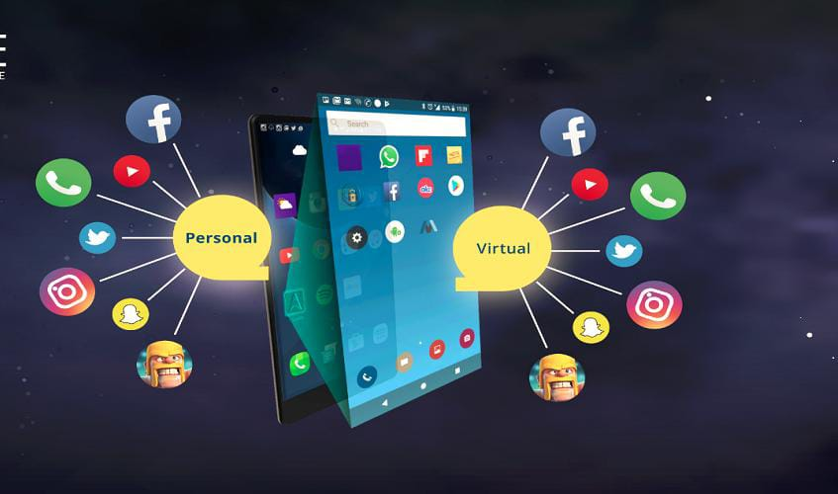

**1**

**2.ADVANTAGES OVER MOBILE DEVICE**

This application provides users the flexibility to access and use their personal information on their smartphone from anywhere from any internet-enabled device and at any time. The application is highly secure too- users will have their own account created with a unique username and password. Also in case the user losses their smartphone they will not lose all the data available on their mobile device. All that users need to do is to sync-up their device with the server and download all their information into new mobile device. Variety of multi-touch interaction and mobile devices allow user to acquire user interface components using natural hand gestures. The digital aspect of our lives becomes more interactive, intuitive and natural because of virtual smartphone. Virtual smartphone allows users to access and use real-time mobile content from any place from any internet enabled device.

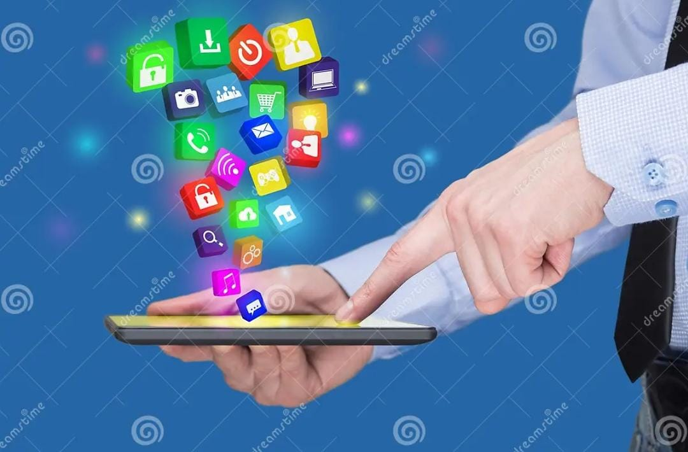

2

**3.OBJECTIVE**

The objective of virtual smartphone is to provide access to digital devices virtually with the help of gesture-based interaction on the user palm or hand. Virtual smartphone provides transfer of data from user to user or from user to digital devices without need of any platform or platform dependency. The communication between users and digital devices become more tangible and interactive because of virtual smartphone. Data transfer is done in two ways in virtual smartphone.

With the help of GSM technology voice communication between the users

without any physical cellular phone.

* VSP is basically an attempt to make the communication between users and Digital devices more tangible and interactive.
* First, it establishes voice communication between the users with the help of GSM Technology without any physical cellular phone.
* Second, For Transfer of Data between the humans and also with digital devices.
* It makes use of the internet through which device and humans are connected to and the distinguish from one user to another by the authentication methods Palm recognition using palm lines or fingerprint detection can be used.
* In VSP voice communication form one human to another can be done either by using GSM or Internet/Intranet technology.

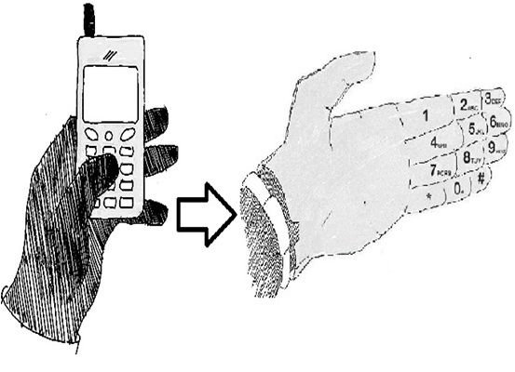

3

**4.WORKING OF VIRTUAL SMART PHONE**

Working of virtual smartphone consists of 5 main steps that is enable and authenticate VSP, make call, Receive Call, Capture Image/Video, Copying Data and paste data to other VSP and digital devices.

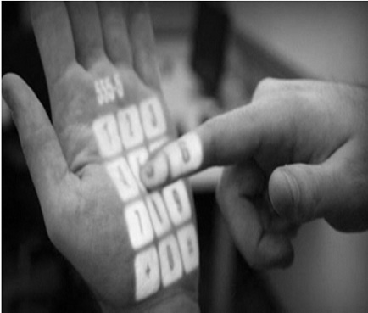

**5.ENABLING VSP**

Virtual smartphone being a wearable device can be enables and disable with the help of power button. As the virtual smartphone is enabled an icon appears on user palm or arm which shows status of user. The status of user can be sign in or not. If the status of user is not login then user can login by clicking the icon. Virtual smartphone users can be change with the help of authentication methods like username and password, Face recognition, picture selection, palm line selection, secret sign or pattern and finger print selection with the help of which user can login successfully.

4

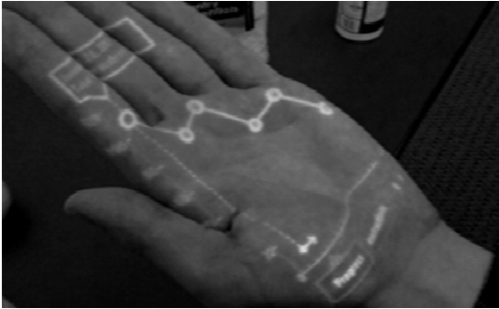

**VI.MAKE CALL**

User can make call to its friends and relatives once VSP is enabled. Using virtual key or using voice recognition system user can dial number and make call. Call is established using VSP two methods.

1. Call established using SIM

SIM stands for Subscriber Identity Module. In VSP its micro SIM with the help of which device established call using GSM/CDMA (Global System for Mobile Communications/Code division multiple access) technology.

B. Call using VOIP

Virtual smartphone connects to internet/intranet using WIFI and mobile data option using which user can make call using Voice over IP. With the help of Voice over IP

5

user is able to make call to other users as well as other GSM and digital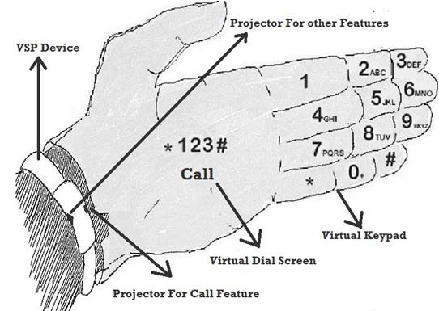

C.Receiving call

The notification of digital device of incoming call or a virtual smartphone user called by Other virtual smartphone user is shown to the user. The notification of incoming call is shown based on user selection of profile if user is in vibrate mode small vibrator motor shows incoming call by vibration and also identity of calling user is shown on backside of palm using projector of high density. Sound mode gives notification of calling user by ring tone and shows identity of calling user on backside of palm. The silent mode indicates only calling user identity on back side of palm. The user can touch or swipe the incoming call icon to attend call. The Bluetooth headset or wired headset is connected to virtual smartphone using 3.0 connector with help of which user can speak with other user. With the help of VSP device speaker and mice user can receive call directly.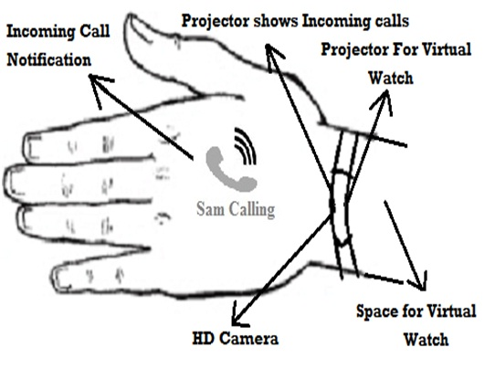

D. Capture Image/Video

Virtual smartphone uses high quality camera to capture high quality images by click of an image button or by using gestures. After capturing image it shows image on user hand using VSP system. Video can also be shot using same process just change camera mode to video mode. While capturing image/video user can also zoom in or zoom out using hand gesture.

E. Copy Data

Data can be copied from one device to another device using touch gesture.

**VII.ADDITIONAL FEATURES OF CHAT SYSTEM**

User can use any chat apps like snap chat to chat with their friends and relatives. Chat system can be kept secure by authenticating each user with their own face recognition, secret sign or pattern, face recognition and palm line detection. Two virtual users can communicate through chat system with the help of internet/intranet and their chat data may be stored on cloud. With the help of voice recognition user can virtual user with whom want to chat. User can use virtual keypad with the help of which can type data or can use voice recognition to capture words and chat with their friends. User can use store data of cloud to upload images and video through internet/intranet from One user to another.

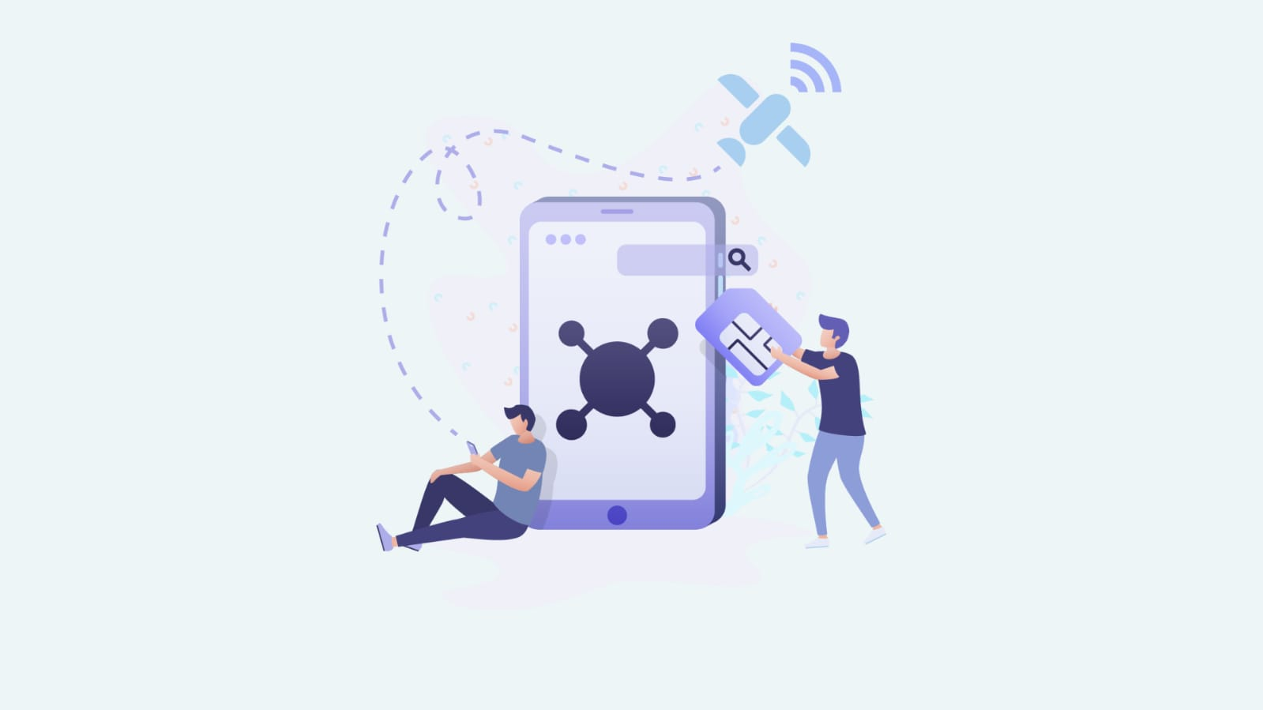

**8.VIDEO CALLING**

For video calling user can select person from contact list to whom wants to do video call.

There should be a video calling button which has features of calling and video mode which enables to do video call.

• There should be one feature which consists of scanner and high

A **video call** is a phone call using an Internet connection, sometimes called [VoIP](https://www.computerhope.com/jargon/v/voip.htm) (Voice over Internet Protocol), that utilizes video to transmit a live picture of the person making the call. Video calls are made using a computer's webcam or other electronic hardware devices with a video-capable camera, like a smartphone

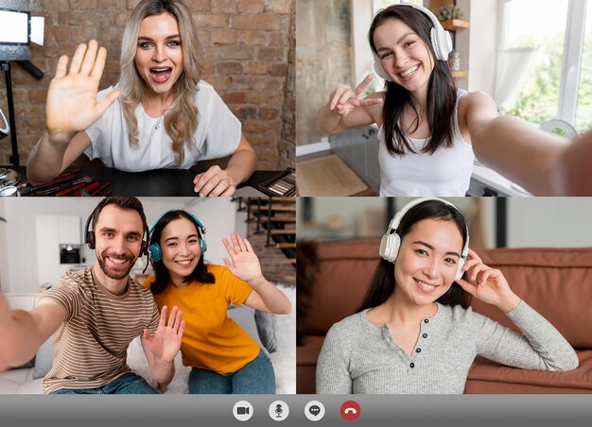

**9.SECURITY FEATURES**

The key of smartphone can be forgotten or can be known by an unknown user hence for security purpose user can use his/her hand palm detection, finger print detection, face recognition, secret sign, username and password to open the phone.

**10.VIRTUALSMARTPHONE HEALTH MONITORING SYSTEM**

Virtual smartphone consists of wearable sensors which can be used in applications like physiological, biochemical and motion sensing. These sensors are used in monitoring health indicators and body positions of patients. Virtual smartphone can consists of health monitoring applications which may consist of

biosensor which monitors heart data. Virtual smartphone should consists of applications which consists of wearable sensors to transfer patient diagnostic data wirelessly through Bluetooth to doctor smartphone.

**11.TECHNOLOGIES USED**

* VSP is basically a wearable device which is combination of hardware as well as software

Hardware:

1.Processor Unit

2.Ram & Rom Memory

3.Power Supply

4.Sensors (Accelerometer)

5.LED Indicator for Device Mode

6.Micro Vibrator Motor

7.USB port

* 1. Micro Projectors
  2. HD Camera For Capturing Images and videos

10.Low energy Required WI-FI and Bluetooth devices, GPS system

Software:

1.Gesture recognition system

2.Touch based interaction system

3.Augmented reality

4.Computer vision -based algorithm to fulfil all the objectives

VSP uses SIM(GSM/CDMA) or though Internet Using VOIP

**12.APPLICATIONS**

1. Used In Health Monitoring system.
2. Used To Find information of any Product/Item.
3. Used to Connect News and Weather update.
4. Used To Connect Different Devices Virtually.
5. Used in Education & Training System.

**13.COMPUTER VISION BASED ALGORITHM**

Computer vision is the science and technology of machines that can see. As a scientific discipline, computer vision is concerned with the theory behind artificial systems that extract information from images. The image data can take many forms, such as video sequences, views from multiple cameras, or multi-dimensional data from a medical scanner. The software tracks the user’s gestures using computervision based algorithms. The computer vision system for tracking and recognizing the hand postures that control the menus is based on a combination of multi-scale colour feature detection, view based hierarchical hand models and particle filtering. The hand postures or states are represented in terms of hierarchies of multi-scale colour image features at different scales, with qualitative interrelations in terms of scale, position and orientation. In each image, detection of multistage colour features is performed

**14.CONCLUSION**

Virtual smartphone is a gesture and computer-vision based wearable interface that augments physical world with digital information and provides user the mechanism to interact with information using natural hand gestures. Virtual smartphone is free of physical dependencies and connects physical world to virtual world.

VSP invention fulfill our two future requirements. First, it’s free form physical dependencies of devices. Second, it connect our physical world to virtual world.

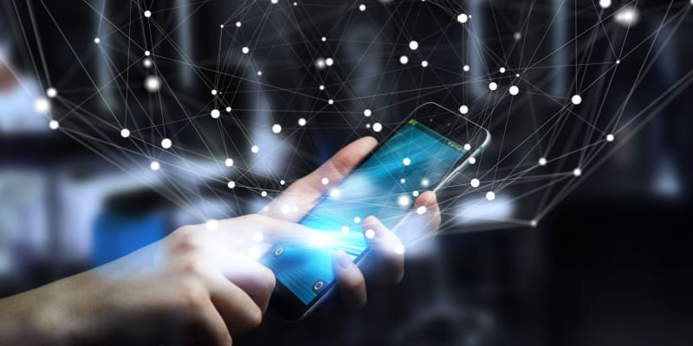

**15.FUTURE SCOPE**

As a user, you’re more than likely reading this on a smartphone right now. If not, there’s probably one near you, in your bag or back pocket at this moment. Smartphones like Android and iPhone phones are incredibly easy to navigate and highly mobile. What does this mean?

Well, this means by adapting smartphones for virtual reality apps, companies will start making it easier for consumers to make the leap into the virtual world. Universal adoption will certainly be less difficult to achieve if people can pull their pre-existing phones out of their bags or pockets and plug them into a VR receiver and get connected

There are many future scopes for this paper and hopefully it will emerge into biggest benefit in the field of artificial intelligence.

**16.REFERENCES**

1. [www.google.com](http://www.google.com)
2. [www.Seminarsonly.com](http://www.Seminarsonly.com)