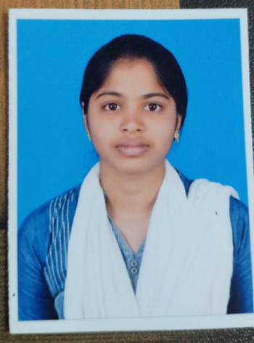**Bio Data**

Name : Anjali

Father’s Name : B.Thiruvengadam

Mobile : 9597018847

Email id : Anjalithiruvengadam@gmail.com

Gender : Female

Date of Birth : 24-12-2005

Religion : Hindu

Nationality : Indian

Languages known : Tamil, English

**Education :**

|  |  |  |  |
| --- | --- | --- | --- |
| **Exam name** | **Year of pass** | **Institution Name** | **Marks** |
| 10th | 2021 | AKD matric higher secondary school | All pass |
| 12th | 2023 | SRI Lakshmi vidhyalaya matric higher secondary school | 368 |
| UG | 2026 | Queen Mary’s college Mylapore,chennai | - |

Computer knowledge : C , HTML , Python

Work Experience : Fresher

Address :2/152,mid middle street Karanai, perichanur Karanai,Viluppuram,Tamilnadu-605755

**Declaration:**

I do hereby declare that the above information is true to the best of my knowledge .

Place : Chennai

Date : 22.03.2025

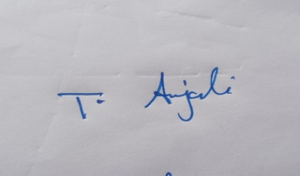

**Signature**