Adding Spring Boot REST layer safely
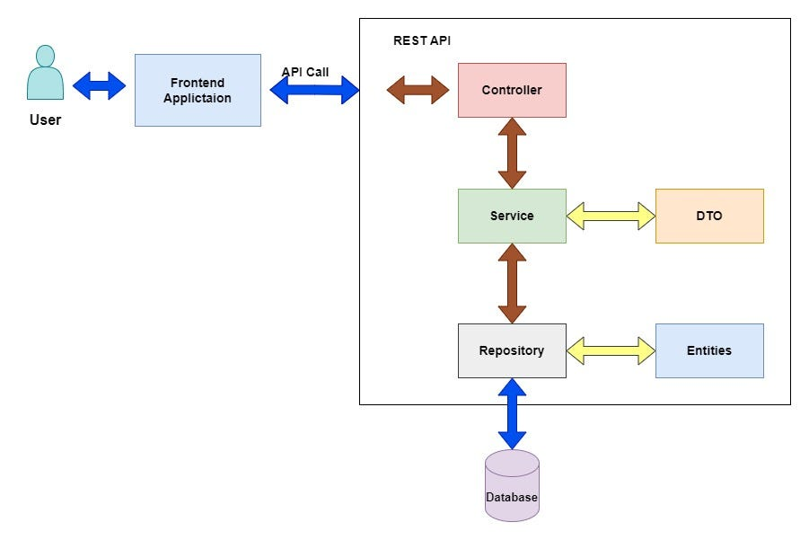
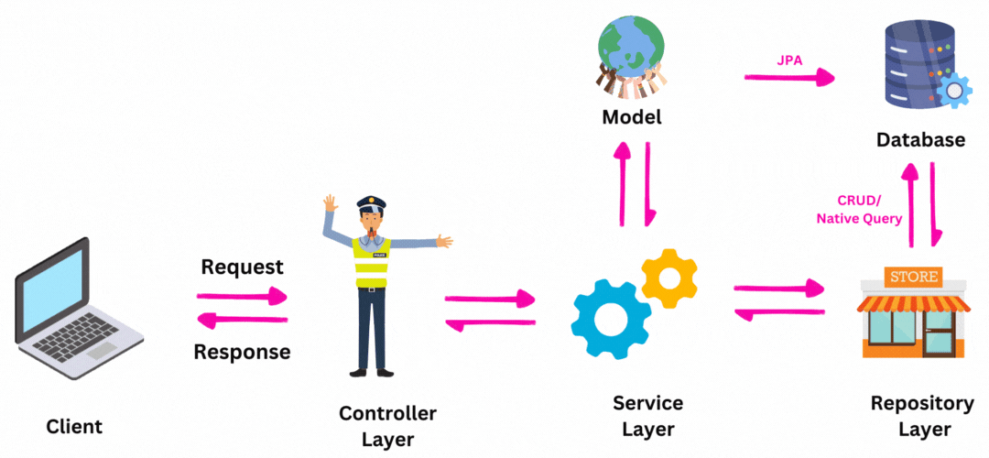
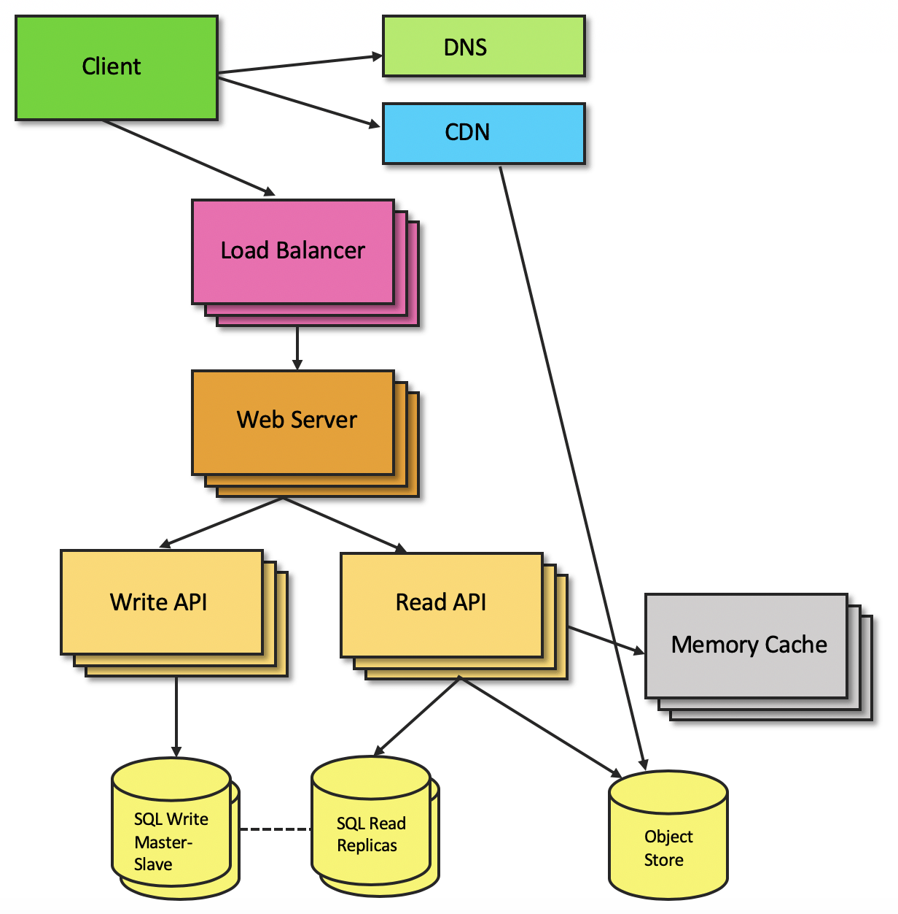

✅ We will ADD:
- Spring Boot bootstrap
- REST Controller
- DTOs (to avoid leaking domain objects)
- Config-driven wiring
Why adding a Spring Boot REST layer?
Spring Boot REST exposes your core system as a real, consumable backend service, proving it works beyond a main() method.
Right now, Apex Data Processor is:
- A core engine
- Triggered from MainApplication
- Excellent for system design & performance
But interviewers often think:
“Okay… but how does this run in the real world?”
👉 Spring Boot REST layer answers that question.
✅ What Spring Boot Adds (WITHOUT breaking your design)
What You Have | What REST Layer Adds
Core logic | External access
Thread pool | HTTP request handling
Processor | Controller calls
Metrics | Real API timing
Local simulation | Real client (Postman / browser)
Step 1:
pom.xml
💡 Why only spring-boot-starter-web?
Because:
- We want REST only
- No JPA, no DB, no magic
- Keep it minimal & safe

Step 2:
config/AppConfig.java
Why this is the RIGHT solution
- Avoids overriding Spring’s internal executor
- Keeps your executor domain-specific
- Makes intent crystal clear
🎤 Interview line (memorize this 💋):
“I explicitly named my custom executor to avoid colliding with Spring Boot’s internal task executor.”
Step 3:
Controller Package: com.apex.controller
controller/ProfileController.java
Why constructor injection?
- Immutable dependency
- Easier to test
- No hidden wiring
🎤 Say this:
“I used constructor injection to make dependencies explicit and immutable.”

Why ResponseEntity?
- Proper HTTP semantics
- Clean status codes
- Production-ready API style

Why NO executor here?
Because:
- REST thread ≠ business thread
- We’ll integrate executor later, safely
🎤 Interview line:
“The controller only maps HTTP to business calls. Concurrency is handled elsewhere.”

