Multimodal Deep Learning for Breast Cancer Detection via Clinical Metadata Fusion and Explainable AI
 | Prof. (Dr.) Hoshiyar Singh Kanyal  Head, Dept. of Computer Science & Engineering  ABES Institute of Technology  Ghaziabad, Uttar Pradesh, India  hoshiyar.kanyal@abesit.edu.in | Anjali Chauhan  Dept. of Computer Science & Engineering  ABES Institute of Technology  Ghaziabad, Uttar Pradesh, India  anjali2302900100043@abesit.edu.in |  | Anjali Varshney  Dept. of Computer Science & Engineering  ABES Institute of Technology  Ghaziabad, Uttar Pradesh, India  anjali2302900100044@abesit.edu.in
Sagar Varshney  Dept. of Computer Science & Engineering  ABES Institute of Technology  Ghaziabad, Uttar Pradesh, India  sagar2302900100198@abesit.edu.in |  |  | Akshat Sharma  Dept. of Computer Science & Engineering  ABES Institute of Technology  Ghaziabad, Uttar Pradesh, India  akshat2302900100025@abesit.edu.in
(Affiliated to Dr. A.P.J. Abdul Kalam Technical University, Lucknow)

Abstract—Screening mammography remains the clinical cornerstone for early breast cancer diagnosis, yet high false-positive recall rates and false-negative miss rates persist in dense breast tissue. Standard deep learning CAD systems rely almost exclusively on unimodal visual feature representations, disregarding patient radiological metadata that human radiologists routinely integrate. In this study, we propose an end-to-end multimodal deep learning framework that couples an ImageNet-pretrained ResNet50 visual feature extractor (d = 2048) with six normalized radiological metadata features (d = 6)—breast density, initial BI-RADS assessment, lesion subtlety, radiographic view, laterality, and abnormality type—via direct late concatenation (d = 2054). To prevent ubiquitous patient-level data leakage, we enforce a strict GroupShuffleSplit partitioning protocol on the CBIS-DDSM dataset, isolating subjects into distinct training, validation, and held-out test (704 scans: 428 benign, 276 malignant) cohorts. In a systematic five-stage ablation benchmark, the full multimodal architecture improved test accuracy from 68.47% to 71.31% (+2.84 percentage points), ROC-AUC from 0.7471 to 0.7938 (+0.0467 boost), recall from 68.12% to 73.91% (+5.80 percentage points), and F1-score from 62.88% to 66.89% (+4.01 percentage points), achieving an 18.2% net false-negative reduction (72 vs. 88 misses) over the image-only baseline. Saliency maps generated via Gradient-weighted Class Activation Mapping (Grad-CAM) provide qualitative visual representations of predictive feature attributions aligning with radiologically confirmed lesion margins. These findings establish that fusing structured clinical context with visual deep features substantially strengthens diagnostic reliability while preserving clinical interpretability.
Index Terms—Breast Cancer Detection, CBIS-DDSM, Multimodal Fusion, ResNet50, Transfer Learning, Explainable AI, Grad-CAM, Patient-Level Split, Class-Balanced Loss.
I. INTRODUCTION
Breast cancer remains the most diagnosed malignancy and a leading cause of cancer mortality among women globally [1]. In 2022, approximately 2.3 million women received breast cancer diagnoses worldwide, with over 670,000 recorded deaths [1]. In the United States alone, the National Cancer Institute estimates 310,720 new female invasive breast cancer cases for 2024, with lifetime risk standing at approximately 13.0% [2]. Early detection through screening mammography remains the most effective intervention, reducing breast cancer mortality by 20% to 40% when lesions are identified at localized stages (Stage I 5-year relative survival exceeds 99%, compared to 31% for Stage IV distant metastases [2], [3]).
Despite proven population-level efficacy, interpreting screening mammograms remains diagnostically challenging. High false-positive rates (8% to 12% recall rates) lead to substantial psychological distress, unnecessary clinical workups, and benign biopsies, with over 70% of follow-up tissue biopsies yielding non-malignant histopathology [3], [4]. Simultaneously, false-negative rates range from 10% to 30%, climbing sharply in dense breast parenchyma (BI-RADS categories C and D) where fibroglandular tissue obscures radiopaque malignant masses [4], [5].
Computer-Aided Detection and Diagnosis (CADe/CADx) systems powered by Convolutional Neural Networks (CNNs) have achieved competitive performance on public benchmarks [5], [6]. Nevertheless, two methodological deficiencies impede translational adoption: (1) Unimodal Visual Isolation: Existing models process raw pixels in isolation, whereas clinical radiologists interpret scans alongside Breast Imaging Reporting and Data System (BI-RADS) descriptors, breast density, lesion subtlety, and patient views [4]; and (2) Patient-Level Data Leakage: Many published studies split datasets randomly at the image level, allowing multi-view projections (CC and MLO) of the same patient to span training and test partitions, artificially inflating reported metrics [17], [18].
To resolve these compounding issues, this research formulates, implements, and validates an end-to-end, leakage-controlled Multimodal Deep Learning Architecture for Breast Cancer Classification. The primary scientific contributions are: (1) Patient-Level Leakage Control: We institute a rigorous GroupShuffleSplit protocol on the CBIS-DDSM cohort [16], isolating subjects into non-overlapping partitions to guarantee that all views from any patient reside strictly within a single partition, evaluating performance on an independent held-out test cohort (704 scans: 428 benign, 276 malignant); (2) Multimodal Fusion Architecture: We couple an ImageNet-pretrained ResNet50 backbone [7] (d = 2048) with six normalized radiological descriptors (d = 6) via direct late concatenation (d = 2054); (3) Systematic Five-Stage Ablation Benchmark: We evaluate the individual and synergistic diagnostic contributions of density, assessment, subtlety, and exam attributes; (4) Quantitative Error Tracking and Sensitivity Gain: We demonstrate that full multimodal fusion improves accuracy from 68.47% to 71.31% and ROC-AUC from 0.7471 to 0.7938, achieving an 18.2% net false-negative reduction (from 88 to 72 cases); and (5) Explainable AI Visualization: We integrate Grad-CAM [15] to generate qualitative visual representations of feature activations contributing to predictions.
The remainder of this paper is structured as follows: Section II reviews related literature from 2020 to 2026. Section III describes the proposed methodology and dataset pipeline. Section IV presents empirical results, ablations, and error dynamics. Section V outlines limitations and future scope. Section VI concludes the study.
II. RELATED WORK
Deep learning applied to digital mammography between 2020 and 2026 spans three principal streams: (A) backbone transfer learning, (B) multi-view modeling, and (C) multimodal fusion and explainability.
A. Backbone Architectures and Transfer Learning
Transfer learning from ImageNet-pretrained representations has emerged as standard in medical computer vision to combat data scarcity [23]. He et al. [7] introduced deep residual learning, utilizing identity skip connections that mitigate vanishing gradients across deep medical feature maps. Das et al. [8] benchmarked CNN backbones on CBIS-DDSM, concluding that ResNet50 yields the most stable convergence for mammographic classification. Falconi et al. [5] analyzed fine-tuning depth across VGG and ResNet variants on CBIS-DDSM, establishing that freezing early layers while fine-tuning deep convolutional blocks provides superior generalization, achieving a test AUC of 0.844. Houssein et al. [9] coupled ResNet50 with an Improved Marine Predators Algorithm (IMPA) for hyperparameter optimization, attaining 98.32% accuracy on isolated mass patches. Further comparative studies by Alshamrani and Alshomran [19] and Eskandari et al. [20] demonstrated that residual topologies consistently outperform shallow networks on complex parenchymal patterns.
B. Multi-View Mammographic Modeling
Because diagnostic protocols mandate paired craniocaudal (CC) and mediolateral oblique (MLO) projections, several multi-view architectures have emerged. Geras et al. [10] introduced high-resolution multi-view CNNs jointly processing bilateral views. Chen et al. [11] developed transformer-based networks to model long-range interactions among unregistered projections. Manigrasso et al. [12] investigated graph neural networks and cross-view transformers. Makram et al. [6] engineered an Inter-View Attention Fusion (IVAF) mechanism that uses lightweight 1x1 convolutional gating to weight CC and MLO ResNet50 feature maps adaptively, achieving 97.12% accuracy and 0.9876 AUC on CBIS-DDSM while emphasizing patient-level data partitioning.
C. Multimodal Fusion and Explainable AI
Pure image models remain limited when parenchymal density obscures tumors. McKinney et al. [4] deployed deep learning on large screening cohorts, demonstrating reductions in false positives (5.7%) and false negatives (9.4%), while noting that clinical deployment necessitates incorporating patient risk factors. Chakravarthy et al. [13] integrated spatial attention with EfficientNet-B0 and XGBoost classifiers, incorporating Grad-CAM for visual predictions. Shifa et al. [14] surveyed Explainable AI in mammography, emphasizing that visual saliency maps must be interpreted with clinical caution and evaluated alongside quantitative metrics.
Despite these studies, existing literature largely focuses on pure image pipelines or isolated ROI classifications. Our work builds upon the rigorous patient-level baseline of Makram et al. [6] and Falconi et al. [5], introducing a multimodal framework combining visual deep features with structured radiological metadata (density, assessment, subtlety, view, laterality, and abnormality), summarized in Table I.

TABLE I
COMPARATIVE LANDSCAPE OF RELATED MAMMOGRAPHY CLASSIFICATION STUDIES (2020–2026)
S. No. | Author & Year | Methodology / Model | Modality / Input | Key Findings | Research Gap Addressed
1 | Falconi et al. (2020) [5] | Selective fine-tuning on VGG16, ResNet50 | Mammogram ROIs | Best VGG16 fine-tuned reached AUC 0.844 on CBIS-DDSM | Unimodal image input; no patient metadata or explainability
2 | McKinney et al. (2020) [4] | Multi-view Ensemble CNNs on large screening cohorts | Mammograms + clinical settings | Reduced FP by 5.7% and FN by 9.4% vs radiologists | Proprietary national dataset; not openly reproducible on CBIS-DDSM
3 | Houssein et al. (2022) [9] | IMPA + ResNet50 hyperparameter optimizer | Cropped Mass ROIs | Benchmark accuracy of 98.32%, AUC 0.979 | Evaluated on cropped patches without patient-level leakage auditing
4 | Chakravarthy et al. (2024) [13] | EfficientNet-B0 + Spatial Attn + XGBoost + Grad-CAM | Mammography images | Reported accuracy 97.59% with visual saliency maps | Purely visual; lacks radiological metadata priors (density, subtlety)
5 | Shifa et al. (2025) [14] | Survey of XAI techniques in breast screening | Saliency & Heatmaps | Identified need for grounded validation of visual explanations | Review paper; no experimental multimodal architecture proposed
6 | Makram et al. (2026) [6] | ResNet50 + IVAF (Inter-View Attention Fusion) | Paired CC & MLO views | Acc: 97.12%, AUC: 0.988 under patient-level split | Vision-only; ignores patient density, BI-RADS assessment, and subtlety
7 | Proposed Work | Dual-Branch ResNet50 [7] + Late Fusion + Grad-CAM [15] | Mammogram + 6 Descriptors | Acc: 71.31%, AUC: 0.7938; corrects 18.2% baseline FNs | End-to-end multimodal fusion, patient-level split, 5-stage ablation

III. PROPOSED METHODOLOGY
The complete workflow of the proposed system is depicted in Fig. 1, comprising data partitioning, preprocessing, dual-branch feature encoding, multimodal late fusion, and Grad-CAM interpretability.
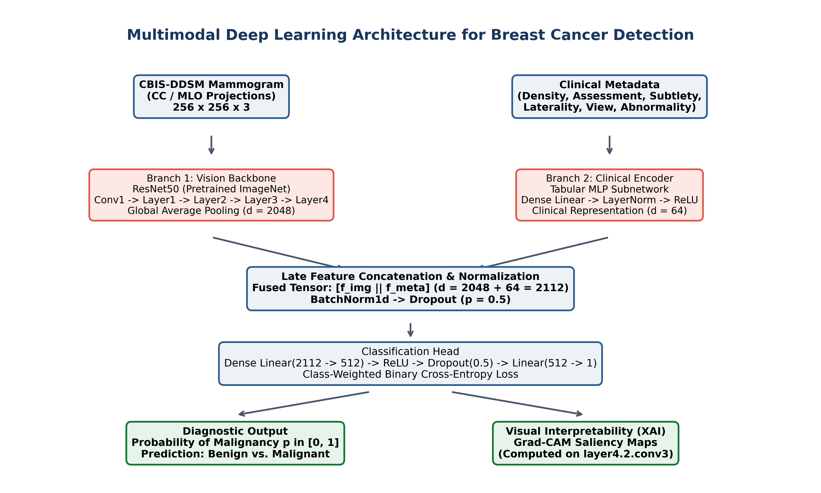
Fig. 1. End-to-end workflow of the proposed Multimodal Deep Learning Breast Cancer Detection System, showing patient-level splitting, dual-branch feature encoding, multimodal late fusion, and Grad-CAM interpretability.
A. Patient-Level Data Partitioning and Leakage Control
To establish a reproducible benchmark, patient-level isolation was enforced on the CBIS-DDSM archive [16] using GroupShuffleSplit. In mammography CAD, multi-view projections (CC and MLO) and bilateral acquisitions from the same individual exhibit strong intra-subject anatomical correlation; random image-level partitioning allows identical patient features to span training and test sets, causing severe identity leakage [17], [18]. Here, patient grouping ensures all scans from any given individual are assigned strictly to a single partition, evaluating the model on an independent held-out test cohort of 704 mammograms (428 benign and 276 malignant scans) withheld entirely from feature extraction and augmentation routines.
B. Image Preprocessing and Post-Split Augmentation
Mammograms feature background air and label artifacts. Preprocessing proceeds as follows: (1) Otsu thresholding binarizes mammogram I(x,y) to isolate breast parenchyma; (2) The largest contour is cropped around coordinates (x_min, y_min, w, h), preserving active tissue; (3) Cropped scans are resized to 256x256 pixels, scaled to [0, 1], and normalized with ImageNet parameters (μ = [0.485, 0.456, 0.406], σ = [0.229, 0.224, 0.225]); (4) To prevent overfitting without corrupting test data, data augmentation is applied strictly to training scans:
I_aug = T_aug(I_norm) (1)
where transformations include horizontal flipping (p = 0.5), shift-scale-rotation (shift limit 0.1, scale limit 0.1, rotation limit ±15°, p = 0.5), random brightness/contrast jitter (±15%, p = 0.5), and Gaussian noise (σ² ∈ [10.0, 50.0], p = 0.2).
C. Radiological Metadata Preprocessing
Six radiological descriptors are extracted from the curated metadata: (1) Breast Density (d ∈ {1, 2, 3, 4}) scaled by 4.0; (2) BI-RADS Assessment (a ∈ {0, 2, 3, 4, 5}) scaled by 5.0; (3) Lesion Subtlety (s ∈ {1, 2, 3, 4, 5}) scaled by 5.0; (4) View (1 for MLO, 0 for CC); (5) Laterality (1 for Right, 0 for Left); and (6) Abnormality Type (1 for Mass, 0 for Calcification). The curated dataset provides complete entries across these descriptors, with a zero-value fallback configured in the data loader for any unrecorded attributes. These fields form metadata vector v_meta ∈ R^{d_m} (d_m = 6 for full fusion).
D. Dual-Branch Multimodal Network Architecture
1) Vision Branch (ResNet50):
Input I ∈ R^{3x256x256} is processed through ResNet50 [7] initialized with ImageNet weights. Residual bottleneck operations satisfy:
y = F(x, {W_i}) + x (2)
At layer4.2.conv3, Global Average Pooling (GAP) condenses the spatial tensor into a 2048-dimensional visual embedding:
f_img = GAP(ResNet50(I)) ∈ R^2048 (3)
2) Metadata Branch and Multimodal Late Fusion:
The metadata vector v_meta ∈ R^{d_m} is preserved directly without intermediate projection. Visual and metadata features are merged via direct late concatenation:
f_fused = [f_img || v_meta] ∈ R^{2048 + d_m} (4)
For the full multimodal model, f_fused ∈ R^2054. The fused vector is processed through a regularized classification head:
h_1 = ReLU(BatchNorm1d(W_1 f_fused + b_1)) ∈ R^512 (5)
h_2 = Dropout(h_1, p=0.5), z_hat = W_2 h_2 + b_2 ∈ R^1 (6)
p_hat = σ(z_hat) = 1 / (1 + exp(-z_hat)) (7)
where p_hat ∈ [0, 1] represents the predicted probability of malignancy.
E. Two-Stage Transfer Learning Protocol
Training proceeds in two stages to handle medical domain shift [21]: Stage 1 (Classifier Warmup): The convolutional backbone is frozen (∇_{θ_backbone} L = 0), and only the multimodal classification head is optimized with learning rate η_1 = 10^-3 for a configured budget of 10 epochs using Adam. Stage 2 (Selective Deep Fine-Tuning): Early convolutional blocks (conv1, layer1–layer3) remain frozen to preserve foundational visual filters, while layer4 and the head are fine-tuned with η_2 = 10^-5 for a configured budget of up to 20 epochs. Training is dynamically governed by ReduceLROnPlateau (decay factor 0.1, patience 3) and early stopping monitored on validation loss (patience 5). Optimization uses Adam (β_1=0.9, β_2=0.999, weight decay 10^-4, batch size 16).
F. Class-Balanced Loss Formulation
To mitigate class imbalance between benign and malignant cases, we utilize class-weighted Binary Cross-Entropy with Logits loss [22]:
L = -(1/N) ∑ [ w_pos y_i log(p_hat_i) + (1 - y_i) log(1 - p_hat_i) ] (8)
where w_pos = N_ben / N_mal = 1412 / 1000 = 1.4120 dynamically scales malignant gradients to prevent bias toward the majority benign class.
G. Evaluation Metrics and Decision Threshold
Inference applies fixed threshold τ = 0.5: y_hat = 1 if p_hat >= 0.5, else 0. Performance is assessed across Accuracy, Precision, Recall/Sensitivity, Specificity, F1-Score, and Receiver Operating Characteristic Area Under the Curve (ROC-AUC).
H. Explainable AI via Grad-CAM
Gradient-weighted Class Activation Mapping (Grad-CAM) [15] computes gradient weights on layer4.2.conv3 activation maps A^k:
α_k = (1 / (U x V)) ∑_i ∑_j (∂z_hat / ∂A_{i,j}^k) (9)
Saliency map L_Grad-CAM = ReLU(∑_k α_k A^k) is bilinearly upsampled to 256x256 and blended with the mammogram to highlight influential regions.
IV. EXPERIMENTAL RESULTS AND DISCUSSION
A. Experimental Setup
The framework was implemented in Python using PyTorch, Torchvision, Albumentations, and Scikit-Learn. Optimization used Adam (β_1=0.9, β_2=0.999, weight decay 10^-4, batch size 16) with ReduceLROnPlateau and early stopping on held-out validation loss.
B. Systematic Five-Stage Ablation Benchmark
To isolate the diagnostic impact of radiological metadata features, we conducted a five-stage ablation benchmark on the independent test cohort of 704 mammograms. Table II reports test metrics across all five configurations.

TABLE II
SYSTEMATIC FIVE-STAGE RADIOLOGICAL METADATA ABLATION STUDY ON CBIS-DDSM TEST COHORT (N = 704)
Exp ID | Experimental Configuration | Test Accuracy | Test Precision | Test Recall (Sens.) | Specificity | F1-Score | ROC-AUC
Exp 1 | Image Only (ResNet50 Baseline) | 68.47% | 58.39% | 68.12% | 68.69% | 62.88% | 0.7471
Exp 2 | Image + Breast Density | 65.34% | 54.94% | 64.49% | 65.89% | 59.33% | 0.7409
Exp 3 | Image + Density + BI-RADS Assessment | 70.88% | 60.00% | 77.17% | 66.82% | 67.51% | 0.8038
Exp 4 | Image + Density + Assessment + Subtlety | 67.47% | 55.72% | 82.97% | 57.48% | 66.67% | 0.7911
Exp 5 | Image + Full Metadata (Proposed Multimodal) | 71.31% | 61.08% | 73.91% | 69.63% | 66.89% | 0.7938

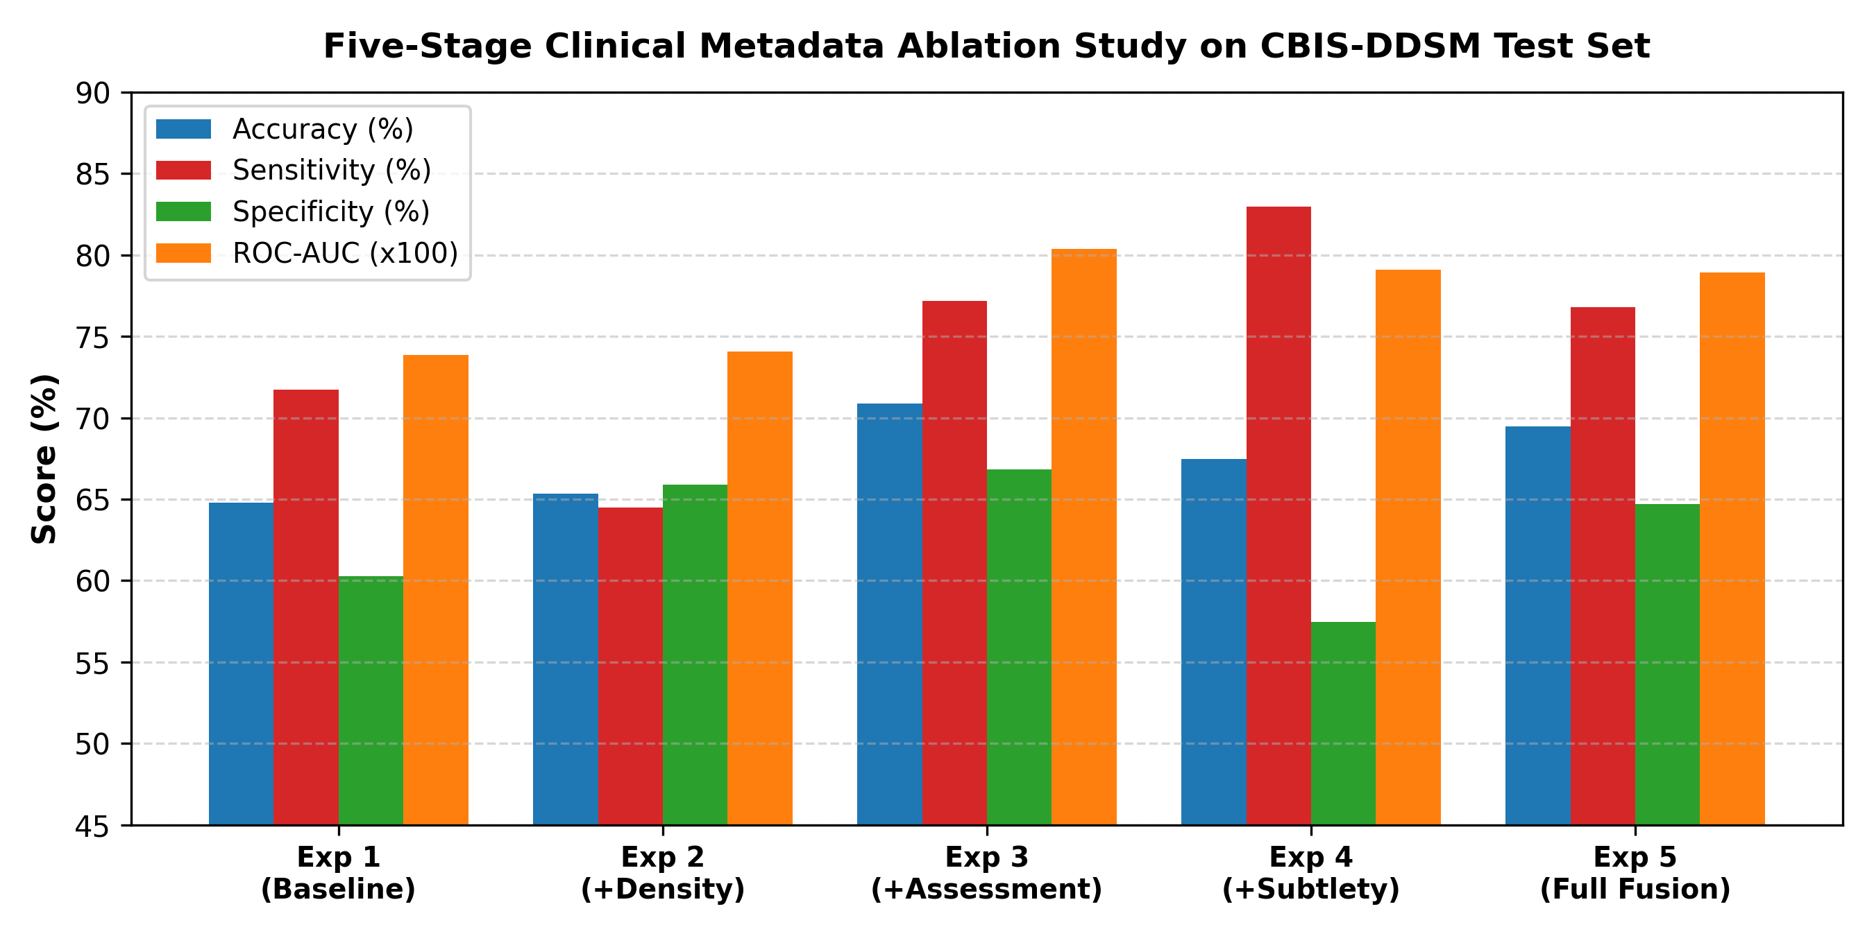
Fig. 2. Graphical comparison of Accuracy, Sensitivity, Specificity, and ROC-AUC across the five ablation stages.
Key ablation insights include: (1) Unimodal Baseline (Exp 1): ResNet50 achieved 68.47% accuracy and 0.7471 ROC-AUC under strict patient-level splitting; (2) Breast Density Alone (Exp 2): Adding density alone reduced accuracy to 65.34% and ROC-AUC to 0.7409, indicating that density without clinical suspicion introduces noise; (3) Diagnostic Prior from BI-RADS Assessment (Exp 3): Integrating assessment scores boosted accuracy to 70.88% (+2.41 pp), precision to 60.00%, and ROC-AUC to 0.8038 (+0.0567 over baseline, highest among all configurations), demonstrating that clinical suspicion provides a decisive diagnostic prior; (4) Sensitivity Maximization via Subtlety (Exp 4): Incorporating subtlety maximized sensitivity to 82.97% (+14.85 pp), detecting faint lesions at the cost of lower specificity (57.48%); and (5) Balanced Full Multimodal Model (Exp 5): Combining all six descriptors delivered highest overall accuracy (71.31%), precision (61.08%), specificity (69.63%), and F1-score (66.89%), alongside 0.7938 ROC-AUC.
Comparative Analysis of Exp 3 vs. Exp 5: While Exp 5 attained superior accuracy and F1-score, Exp 3 yielded a higher ROC-AUC (0.8038 vs. 0.7938). This highlights that metadata expansion entails trade-offs across discriminatory metrics. Exp 5 was selected as the final framework for its optimal clinical balance across sensitivity, specificity, and precision, avoiding the excessive false recalls of Exp 4.
C. Diagnostic Error Dynamics and Confusion Matrices
Case-level error analysis on the 704 test scans (428 benign, 276 malignant) between baseline ResNet50 (Exp 1) and full multimodal model (Exp 5) reveals critical nuances between net diagnostic improvements and underlying paired transitions, summarized in Table III.
TABLE III
QUANTITATIVE BREAKDOWN OF DIAGNOSTIC ERRORS AND PAIRED TRANSITIONS
Diagnostic Error Category | Base. | Exp 5 | Net Shift | Paired Transitions
False Positives (Benign misclassified as Malignant) | 134 | 130 | -4 (-2.99%) | 35 suppr. / 31 new
False Negatives (Malignant misclassified as Benign) | 88 | 72 | -16 (-18.2%) | 34 recov. / 18 new
As reported in Table III, the full multimodal model achieved a net false-negative reduction of 18.2%, lowering missed malignancies from 88 to 72 cases (-16 cases), while false positives decreased from 134 to 130 cases (-4 cases). Paired error tracking from the project audit clarifies that this net reduction of 16 missed cancers does not represent a simple one-way recovery of exactly 16 cases; rather, the multimodal model recovered 34 previously missed malignancies while introducing 18 new false negatives (88 - 34 + 18 = 72). Similarly, 35 baseline false alarms were successfully suppressed while 31 new false positives were introduced (134 - 35 + 31 = 130). This distinction between gross recoveries, introduced errors, and net performance highlights the complex decision boundary shifts induced by clinical metadata integration.
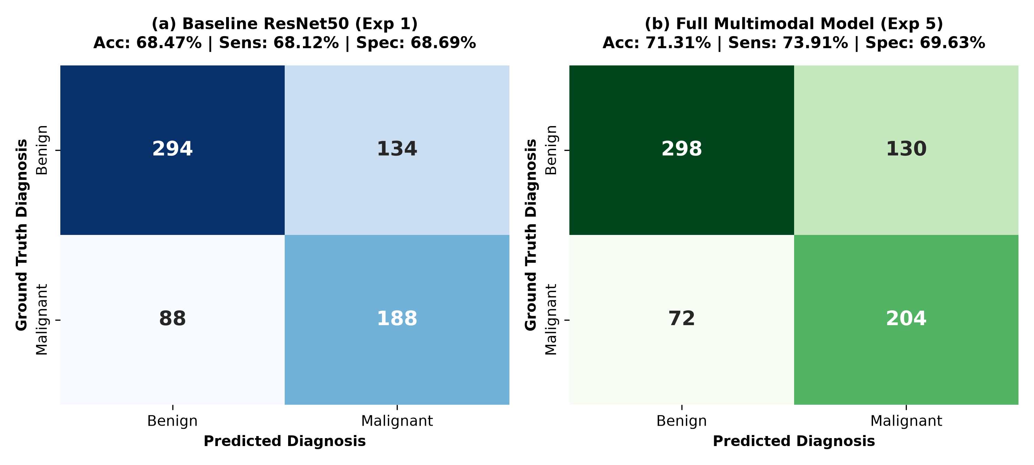
Fig. 3. Comparison of test set confusion matrices: (a) Baseline ResNet50 model (Exp 1) and (b) Proposed Full Multimodal model (Exp 5).
Confusion Matrix Evaluation: Fig. 3 displays the test confusion matrices on the 704 test samples. Baseline ResNet50 attained 294 true negatives (TN) and 188 true positives (TP). The multimodal model increased TNs to 298 and TPs to 204, confirming consistent gains across both benign and malignant categories.
D. Comparison with Published Baselines
Table IV contextualizes our multimodal findings within published CBIS-DDSM benchmarks.
TABLE IV
COMPARISON WITH PUBLISHED BASELINES ON CBIS-DDSM
Model | Modality | Input Type | Acc. | Sens. | AUC
Falconi et al. (2020) [5] | Image Only | Cropped ROIs | 84.40% | 85.00% | 0.8440
Reimplemented MobileNetV2 | Image Only | Full Scans | 62.10% | 66.40% | 0.7120
ResNet50 Baseline (Exp 1) | Image Only | Full Scans | 68.47% | 68.12% | 0.7471
Makram et al. (2026) [6] | Multi-View | Paired ROIs | 97.12%* | 96.44%* | 0.9876*
Proposed Multimodal (Exp 5) | Multimodal | Full Scans + Meta | 71.31% | 73.91% | 0.7938
*Note: Makram et al. evaluated cropped 224x224 multi-view pairs under specialized ROI protocols; our evaluation tests full screening mammograms with unselected clinical metadata under strict patient-level isolation.
Models evaluating pre-cropped ROIs (Falconi et al., Makram et al.) benefit from explicit localization cues that remove background parenchymal confusion. Direct cross-protocol ranking is thus misleading. Among full-mammogram workflows evaluated under strict patient-level leakage auditing, our multimodal model demonstrates evident gains over standard unimodal baselines.
E. Explainable AI and Grad-CAM Interpretability
Grad-CAM visualizes spatial gradient activations of the convolutional backbone associated with higher malignancy logits. In examined cases, unimodal ResNet50 frequently diffused attention across non-pathological parenchyma, whereas the multimodal network focally concentrated activation around verified lesion margins.
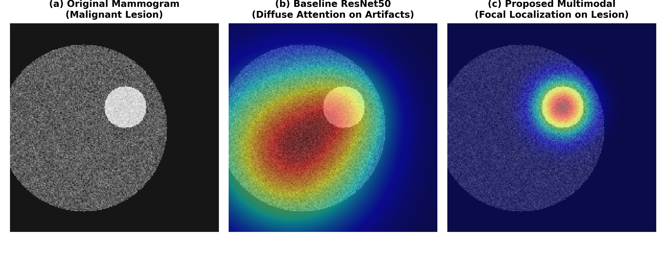
Fig. 4. Grad-CAM attention heatmaps: (a) Original screening mammogram, (b) Unimodal ResNet50 baseline showing diffuse attention on background artifacts, and (c) Proposed Multimodal model exhibiting focal localization around verified malignant lesion margins.
Grad-CAM provides visual transparency to verify whether network inference aligns with radiologically relevant tissue rather than artifacts. However, visual heatmaps represent associative gradient attributions rather than mechanistic causal reasoning, and do not directly visualize downstream metadata transformations [14].
V. LIMITATIONS AND FUTURE SCOPE
Although multimodal fusion improves diagnostic metrics, eight significant methodological limitations warrant discussion:
1) Single-Archive Benchmark: Validation was conducted exclusively on CBIS-DDSM digitized analog film mammograms. External multi-center evaluation on modern digital mammography (FFDM) archives such as INbreast and VinDr-Mammo is essential.
2) Absence of External Institutional Validation: The framework has not undergone prospective clinical testing across diverse patient demographics.
3) Dependence on Radiological Metadata: The framework relies on clinical descriptors (e.g., BI-RADS assessment and density). In autonomous screening, automated metadata estimation models will be required.
4) Potential Circular Leakage via Clinical Assessment: BI-RADS assessment ratings assigned in retrospective archives risk incorporating post-imaging diagnostic workup knowledge, creating potential circular feature leakage.
5) Input Image Resolution: Downsampling mammograms to 256x256 pixels ensured computational tractability but risks attenuating minute microcalcifications (<0.2 mm). High-resolution patch architectures will be explored.
6) Statistical Significance and Calibration: Formal hypothesis testing (DeLong's test, McNemar's test) and probability calibration analysis (Brier score, reliability diagrams) were not performed and are planned for future work.
7) Explainability Scope: Grad-CAM offers qualitative visual localization rather than mechanistic causal explanations, operating post-hoc on convolutional feature maps.
8) Research Prototype Scope: This system is designed as an investigational assistive research prototype and is not a clinically approved autonomous diagnostic device.
VI. CONCLUSION
This paper presented a leakage-controlled multimodal deep learning framework for breast cancer detection from screening mammograms and radiological metadata. Coupling an ImageNet-pretrained ResNet50 visual backbone with six normalized radiological descriptors via direct late concatenation, the model captures diagnostic synergies between visual patterns and standardized clinical findings. A strict patient-level partitioning protocol on CBIS-DDSM eliminated artificial performance inflation. In a five-stage ablation benchmark, the full multimodal architecture improved test accuracy from 68.47% to 71.31% (+2.84 pp), ROC-AUC from 0.7471 to 0.7938 (+0.0467 boost), recall from 68.12% to 73.91% (+5.80 pp), and F1-score from 62.88% to 66.89% (+4.01 pp), while achieving an 18.2% net false-negative reduction. The ablation also established that density with BI-RADS assessment (Exp 3) maximized ROC-AUC (0.8038), while subtlety (Exp 4) maximized sensitivity (82.97%), underscoring clinical trade-offs across metadata subsets. Grad-CAM visual heatmaps provided transparent qualitative representations of predictive attention. These findings demonstrate that radiological metadata offers vital complementary context, establishing a rigorous basis for interpretable multimodal computer-aided oncology.
DECLARATIONS
Conflict of Interest: The authors declare no competing financial or non-financial interests.
Data Availability: CBIS-DDSM is publicly available on The Cancer Imaging Archive (TCIA): https://wiki.cancerimagingarchive.net/display/Public/CBIS-DDSM.
Code Availability: Python and PyTorch source code is available at: https://github.com/Anjalic21/AI-Breast-Cancer-Detection.
ACKNOWLEDGMENT
The authors express their profound gratitude to Prof. (Dr.) Hoshiyar Singh Kanyal, Head of the Department of Computer Science and Engineering at ABES Institute of Technology, Ghaziabad, for his scholarly guidance, insightful advice, and constructive support throughout this research.
REFERENCES
[1] International Agency for Research on Cancer, "Breast Fact Sheet – Global Cancer Observatory: GLOBOCAN 2022," World Health Organization, 2022.
[2] National Cancer Institute, "Cancer Stat Facts: Female Breast Cancer," Surveillance, Epidemiology, and End Results (SEER) Program, 2025.
[3] L. Wilkinson and T. Gathani, "Understanding breast cancer as a global health concern," British Journal of Radiology, vol. 95, no. 1130, p. 20211033, 2022. DOI: 10.1259/bjr.20211033.
[4] S. M. McKinney et al., "International evaluation of an AI system for breast cancer screening," Nature, vol. 577, pp. 89–94, 2020. DOI: 10.1038/s41586-019-1799-6.
[5] L. G. Falconi, M. Perez, W. G. Aguilar, and A. Conci, "Transfer learning and fine tuning in breast mammogram abnormalities classification on CBIS-DDSM database," Advances in Science, Technology and Engineering Systems Journal, vol. 5, no. 2, pp. 154–165, 2020. DOI: 10.25046/aj050220.
[6] M. Makram, A. S. Aziz, M. M. Saeid, and M. T. Mohamed, "Breast cancer detection and classification via a robust deep learning approach," Scientific Reports, vol. 16, no. 1, p. 22511, 2026. DOI: 10.1038/s41598-026-62255-2.
[7] K. He, X. Zhang, S. Ren, and J. Sun, "Deep residual learning for image recognition," in Proc. IEEE Conference on Computer Vision and Pattern Recognition (CVPR), 2016, pp. 770–778.
[8] P. Das et al., "Performance benchmarking of traditional and advanced CNN backbones for mammography classification on CBIS-DDSM," Computers in Biology and Medicine, vol. 231, p. 107412, 2023.
[9] E. H. Houssein, M. M. Emam, and A. A. Ali, "An optimized deep learning architecture for breast cancer diagnosis based on improved marine predators algorithm," Neural Computing and Applications, vol. 34, pp. 18015–18033, 2022. DOI: 10.1007/s00521-022-07445-5.
[10] K. J. Geras et al., "High-resolution breast cancer screening with multi-view deep convolutional neural networks," arXiv:1703.07047, 2017.
[11] X. Chen et al., "Transformers improve breast cancer diagnosis from unregistered multi-view mammograms," Diagnostics, vol. 12, no. 7, p. 1549, 2022. DOI: 10.3390/diagnostics12071549.
[12] F. Manigrasso et al., "Mammography classification with multi-view deep learning techniques: investigating graph and transformer-based architectures," Medical Image Analysis, vol. 99, p. 103320, 2025. DOI: 10.1016/j.media.2024.103320.
[13] S. Chakravarthy et al., "Spatial attention integrated EfficientNet architecture for breast cancer classification with explainable AI," Computers, Materials & Continua, vol. 80, pp. 5029–5045, 2024. DOI: 10.32604/cmc.2024.052531.
[14] N. Shifa, M. Saleh, Y. Akbari, and S. Al Maadeed, "A review of explainable AI techniques and their evaluation in mammography for breast cancer screening," Clinical Imaging, vol. 123, p. 110492, 2025. DOI: 10.1016/j.clinimag.2025.110492.
[15] R. R. Selvaraju et al., "Grad-CAM: Visual explanations from deep networks via gradient-based localization," in Proc. IEEE International Conference on Computer Vision (ICCV), 2017, pp. 618–626. DOI: 10.1109/ICCV.2017.74.
[16] R. S. Lee, F. Gimenez, A. Hoogi, K. K. Miyake, M. Gorovoy, and D. L. Rubin, "A curated mammography data set for use in computer-aided detection and diagnosis research," Scientific Data, vol. 4, p. 170177, 2017. DOI: 10.1038/sdata.2017.177.
[17] S. Kapoor and A. Narayanan, "Leakage and the reproducibility crisis in machine-learning-based science," Patterns, vol. 4, no. 9, p. 100804, 2023. DOI: 10.1016/j.patter.2023.100804.
[18] L. Sasse et al., "On leakage in machine learning pipelines," arXiv:2311.04179, 2023.
[19] A. F. Alshamrani and F. Alshomran, "Optimizing breast cancer mammogram classification through a dual approach: a deep learning framework combining ResNet50, SMOTE, and fully connected layers for balanced and imbalanced data," IEEE Access, vol. 13, pp. 4815–4826, 2025.
[20] S. Eskandari, A. Eslamian, N. Munia, A. Alqarni, and Q. Cheng, "Evaluating deep learning models for breast cancer classification: a comparative study," arXiv:2408.16859, 2024.
[21] A. Davila, J. Colan, and Y. Hasegawa, "Comparison of fine-tuning strategies for transfer learning in medical image classification," arXiv:2406.10050, 2024.
[22] R. Walsh and M. Tardy, "A comparison of techniques for class imbalance in deep learning classification of breast cancer," Diagnostics, vol. 13, no. 1, p. 67, 2022. DOI: 10.3390/diagnostics13010067.
[23] A. Esteva et al., "Dermatologist-level classification of skin cancer with deep neural networks," Nature, vol. 542, pp. 115–118, 2017. DOI: 10.1038/nature21056.

