Table of Contents
1. INTRODUCTION..............................................................................................................01
1.1 Objectives ......................................................................................................................01
1.2 Scope of the Project........................................................................................................02
2. LITERATURE SURVEY ..................................................................................................03
2.2 Compilers and Frameworks Used…...............................................................................04
2.3 Dataset….........................................................................................................................04
2.4 Libraries..........................................................................................................................06
2.5 Web Technologies ..........................................................................................................07
2.7 Survey on Existing Work................................................................................................08
3. SYSTEM ANALYSIS..........................................................................................................09
3.1 Existing System ..............................................................................................................10
3.1.1 Drawbacks of Existing Systems...................................................................................11
3.2 Proposed System ............................................................................................................21
3.2.1 Advantages of the Proposed System............................................................................12
3.3 Applications....................................................................................................................13
3.4 Software Requirement Specification..............................................................................13
3.4.1 Product Perspective.....................................................................................................15
3.4.2 Product Functions .......................................................................................................16
3.4.3 User Classes and Characteristics ................................................................................16
3.4.4 Operating Environment...............................................................................................17
3.4.5 Design and Implementation Constraints.....................................................................18
3.4.6 System Features..........................................................................................................19
3.4.7 External Interface Requirements.................................................................................20
3.4.8 Non-Functional Requirements....................................................................................20
4. SYSTEM DESIGN ............................................................................................................21
4.1 Architecture ...................................................................................................................21
4.2 Flowchart........................................................................................................................25
4.3 Uml Diagrams................................................................................................................26
4.3.1 Uml Sequence Diagram..............................................................................................27
4.3.2 Use Case Diagram.......................................................................................................29
5. IMPLEMENTATION ........................................................................................................30
5.2.1 User Interface (Ui).......................................................................................................30
5.2.2 Flask Backend..............................................................................................................31
5.2.3 Face Recognition ........................................................................................................31
5.2.4 Database Management ................................................................................................32
5.2.5 Utility Functions .........................................................................................................32
5.2.6 Configuration ..............................................................................................................33
6. TESTING .........................................................................................................................33
7. OUTPUT SCREENS........................................................................................................36
CONCLUSION......................................................................................................................40
FUTURE ENHANCEMENTS ..............................................................................................41
REFERENCES ......................................................................................................................44

LIST OF FIGURES

Figure 4.1.1: Use case Diagram…………………………………………………….17
Figure 4.1.2: Class Diagram………………………………………………………..18
Figure 4.1.3: Activity Diagram…………………………………………………….18
Figure 4.1.4: Sequence Diagram…………………………………………………...19
Figure 4.2: Architecture Diagram…………………………………………………..20
Figure 4.3: flow chart………………………………………………………………21
Figure :6 User Interface (UI)……………………………………………..…...……25
Figure 6.1: testing methodologies…………………………………………………..28
Figure 7.1: user registration…………………………………………………………29
Figure 7.2: Fraud check input……………………………………………………….30
Figure 7.3: Fraudulent Transaction Detected………………………………………..31
Figure 7.4: Legitimate Transaction…………………………………………………..33

- INTRODUCTION

In today’s digital world, online transactions have become a routine part of life for individuals and businesses alike. With this rapid increase in digital financial activity, the risk of cybercrimes especially payment fraud has also risen significantly. Traditional fraud detection systems, which rely on predefined rules and manual oversight, are no longer sufficient to combat the constantly evolving tactics used by fraudsters. These legacy systems often struggle to adapt to new patterns and sophisticated fraud techniques in real time. To address these challenges, Machine Learning (ML) offers a dynamic and highly effective solution. By leveraging advanced algorithms, ML systems can analyze vast volumes of transactional data, identify complex patterns, and detect anomalies that may indicate fraudulent activity. Unlike rule-based methods, ML models improve over time by learning from historical data, which makes them more robust and accurate in predicting fraud. The project titled “Online Payments Fraud Detection with Machine Learning” demonstrates a comprehensive approach to building such an intelligent system. It utilizes a real-world dataset to simulate actual payment environments. The workflow includes several essential stages: data cleaning, exploratory data analysis, feature engineering, model training, and performance evaluation. Through this project, we aim to showcase how machine learning can differentiate between legitimate and fraudulent transactions with high precision, ultimately helping organizations enhance security and reduce financial losses.

  - Objective

- Develop a fraud detection system that is fast and scalable for real-time online transactions.
- Minimize false positives while maintaining high fraud detection accuracy.

- the system is easy to integrate with existing payment platforms.

- Use diverse and real-world datasets to improve detection reliability.

- Design the user interface to be intuitive and accessible for financial analysts and support teams

  - Scope of Project

The aim of this project is to develop a machine learning-based system that can accurately detect fraudulent transactions in online payment systems. By analyzing transaction data and identifying unusual patterns, the system will help reduce financial losses and improve security. The project focuses on building reliable, scalable, and real-time fraud detection models that can be integrated into existing payment platforms to support secure and trustworthy digital transactions. This project is about creating a system that uses machine learning to detect fraud in online payment transactions. The main steps include collecting real or simulated transaction data, cleaning and preparing it so it can be used to train the machine learning models. The next step is to analyze the data (using Exploratory Data Analysis or EDA) to understand transaction patterns and find signs of possible fraud. After that, different machine learning models like Logistic Regression, Random Forest, and XG Boost are built and trained to recognize which transactions are real and which might be fraudulent. To check how well the models work, we use accuracy tests with performance metrics like precision, recall, F1-score, and AUC-ROC. The project also looks at how this system could work in real-time, so fraud can be detected as soon as a transaction happens. We aim to keep improving the model using updated data so it can handle new types of fraud in the future. This project focuses only on the backend side of fraud detection using machine learning. It does not include designing user interfaces, doing legal investigations, or working with any hardware devices.

2. LITERATURE SURVEY

Recent research in online payment fraud detection has explored various machine learning and deep learning techniques to improve detection accuracy and adaptability. In (2018) Nguyen et al. utilized SMOTE and Random Forest for imbalanced datasets, achieving 96% accuracy and 85% precision through supervised learning with resampling. However, their approach had limited scalability [1]. Kumar & Sharma (2019) introduced a deep learning model using CNN and LSTM for credit card fraud detection, reaching an AUC of 0.98 and recall of 91%, though it required large datasets and high computation [2]. In 2020, Ali et al. proposed an unsupervised anomaly detection method using autoencoders. While it performed well (Precision: 88%, Recall: 86%), it struggled with interpretability and false positives [3]. Zhang & Liu (2021) leveraged Graph Neural Networks (GNNs) for financial fraud detection, achieving an AUC of 0.94, but the model was complex and less effective in real-time scenarios [4]. Pateletal (2022) advanced the field with a hybrid ensemble model combining Random Forest, XG Boost and SVM, achieving an F1 score of 0.92. Despite strong performance, the model was computationally for real-time deployment [5]. In 2023, Chen & Wang explored privacy-preserving fraud detection using Federated Learning with Logistic Regression. Their approach addressed expensive data security but faced model convergence and communication issues, achieving 93% accuracy using distributed machine learning [6].Most recently, Rao & Singh (2024) focused on Explainable AI (XAI) for fraud detection in online payments, using SHAP and decision trees. Their method balanced performance (Precision: 89%) with high interpretability, showcasing the growing importance of transparency in fraud detection systems [6]. Over all the literature highlights a transition from traditional supervised models to more complex architectures such as GNNs, federated learning, and interpretable AI. The major research gaps involve scalability real time performance and the trade-off between accuracy and interpretability.

2.2 Compilers and Frameworks Used

The implementation of the online payment fraud detection system primarily uses Python as the core programming language due to its simplicity, extensive libraries, and strong community support. Development and experimentation are typically conducted in interactive environments such as Jupyter Notebook, Google Colab, Visual Studio Code, and the Anaconda Prompt, which provides a powerful and organized environment for managing packages and dependencies. For machine learning and data science tasks, libraries like Scikit-learn are employed to implement standard algorithms such as Logistic Regression, Decision Trees, and Random Forest. XG Boost, a high-performance gradient boosting library, is used for more accurate classification. Data manipulation and numerical computations are handled using Pandas and NumPy, while Matplotlib and Seaborn support effective data visualization and exploratory data analysis. If deep learning techniques are applied, frameworks such as TensorFlow or Keras are used for building neural networks, with PyTorch serving as an alternative for advanced model customization. To evaluate model performance, tools from sklearn. metrics are used to calculate accuracy, precision, recall, F1-score, and AUC-ROC. For model serialization and reuse, libraries like joblib and pickle are employed. Additionally, for deployment as a web application or API, tools like Streamlit or Flask can be integrated to provide user-friendly interfaces and enable real-time predictions.
2.3 Dataset
The dataset utilized in this project is obtained from Kaggle, a trusted platform for open-source datasets and machine learning challenges. The dataset contains a comprehensive collection of online credit card transaction records, where each transaction is labeled as either legitimate or fraudulent. This dataset is characterized by a significant class imbalance, as fraudulent transactions represent a very small proportion of the total records, closely reflecting real-world scenarios. Each record in the dataset comprises multiple attributes, including transaction type, amount, balance before and after the transaction, and other anonymized numerical features. These attributes are crucial for detecting patterns and anomalies that indicate potential fraud. Prior to training the machine learning models, several data preprocessing steps were performed. These include handling missing values, feature scaling through normalization, encoding of categorical variables, and most importantly, addressing the class imbalance using the Synthetic Minority Oversampling Technique (SMOTE). This helped ensure the model's ability to generalize and avoid bias toward the majority class. The processed dataset served as the input for training and testing various classification models such as Random Forest, Logistic Regression, and XG
2.4 Libraries
The development of the online payment fraud detection system utilizes a variety of Python libraries and tools that support data preprocessing, model building, performance evaluation, and visualization. These libraries and environments are essential for creating a reliable, scalable, and efficient machine learning-based solution.
- Pandas: Used for data manipulation and analysis. It allows for efficient handling of structured datasets, enabling filtering, transformation, and aggregation operations.
- NumPy: Supports numerical computing operations and provides multidimensional array support, which is crucial for mathematical computations involved in model training.
- Scikit-learn: A core machine learning library used for implementing standard classification algorithms such as Logistic Regression, Decision Trees, and Random Forest. It also provides tools for model validation, hyperparameter tuning, and evaluation.
- XG Boost: A powerful and scalable gradient boosting library that delivers high performance and accuracy, especially on imbalanced datasets.
- Matplotlib: Used to create basic graphs and charts such as histograms, bar plots, and line graphs to visualize patterns in the data.
- Seaborn: A statistical visualization library built on Matplotlib, ideal for heatmaps, pair plots, and correlation matrices that assist in exploratory data analysis.
- Imbalanced-learn (imblearn): Specifically designed to handle class imbalance problems in datasets using techniques like SMOTE (Synthetic Minority Over-sampling Technique).
- Joblib / Pickle: These libraries are used for model serialization, allowing trained models to be saved to disk and reloaded later for predictions without retraining.
- Sklearn metrics: A submodule in Scikit-learn that includes evaluation metrics such as precision, recall, F1-score, ROC-AUC, and confusion matrices.
- Streamlit / Flask (Optional): Useful for deploying the trained model into a user-friendly web application or API that enables real-time fraud prediction.
- Anaconda Prompt: Serves as a robust command-line interface for managing Python environments and package dependencies. It simplifies the installation and execution of Python libraries, making it easier to manage the entire project setup within isolated environments.Boost. The use of a publicly available, well-structured dataset ensures the reproducibility of the research and supports the development of practical solutions in the domain of online payment fraud detection
2.5 Wed Technologies
In order to make the fraud detection model accessible and user-interactive, the project incorporates web technologies for deployment and real-time usage. The machine learning model is integrated into a Flask-based web application, which serves as the backend framework. Flask is a lightweight and flexible Python web framework that allows seamless connection between the trained model and user inputs via HTTP requests. The web interface is designed to allow users to enter transaction details such as type, amount, account balance before and after the transaction, and other relevant features. Once submitted, the backend processes the input, applies the trained model, and instantly returns a prediction indicating whether the transaction is fraudulent or legitimate. This setup demonstrates how a machine learning model can be effectively embedded into a real-world system, bridging the gap between data science and end-user applications. Hosting is performed locally through the Anaconda environment and Flask development server, but the architecture is flexible enough for deployment on cloud platforms such as Heroku, Render, or AWS in future implementations. By combining machine learning with web technologies, the system ensures ease of use, real-time fraud detection capability, and practical integration into digital payment systems.

2.6 Visual Studio Code (Vs Code)
Visual Studio Code (VS Code) played a central role in the development of the online payment fraud detection system. It served as the primary Integrated Development Environment (IDE) for writing, editing, and organizing Python scripts throughout the project lifecycle. VS Code offers a lightweight yet powerful coding environment, featuring intelligent code completion, real-time syntax highlighting, error checking, and built-in Git integration, which greatly enhanced productivity and collaboration. Its seamless support for Python through extensions allowed efficient integration of essential libraries such as Scikit-learn, Pandas, NumPy, XGBoost, Matplotlib, and Seaborn. Additionally, VS Code's built-in terminal and debugging tools were used to run scripts, test models, and resolve errors during development. While exploratory data analysis and initial model testing were conducted in Jupyter Notebook and Google Colab, VS Code provided a more structured and scalable environment for writing modular scripts, implementing Flask-based deployment, and managing overall project files. Combined with Anaconda Prompt for package management, VS Code ensured a smooth and organized development workflow from preprocessing to deployment. Overall VS Code contributed significantly to building a clean, efficient, and maintainable codebase for the fraud detection system.
2.8 Survey on Existing Work
Several studies and real-world applications have explored the use of machine learning in detecting online payment fraud. Most traditional systems relied on predefined rules and manual reviews, which proved ineffective against evolving fraud patterns. Recent research has introduced more advanced techniques, focusing on classification models, handling imbalanced datasets, and improving detection accuracy. A notable approach involves the use of SMOTE (Synthetic Minority Oversampling Technique) to balance the dataset before applying classifiers like Random Forest and Support Vector Machines. Other researchers have leveraged deep learning techniques such as Convolutional Neural Networks (CNNs) and Recurrent Neural Networks (RNNs), including LSTM architectures, to automatically learn temporal patterns in financial data.. This project builds upon these findings by using a Random Forest algorithm trained on a real-world Kaggle dataset, combined with proper data preprocessing and imbalance handling, to deliver a lightweight and effective fraud detection system suitable for practical deployment.
3. SYSTEM ANALYSIS
With the rapid rise in digital payments, the risk of online fraud has also increased significantly. Traditional fraud detection systems based on predefined rules or manual checks struggle to keep up with the fast-changing tactics used by fraudsters. These systems are often not flexible, generate many false alarms, and fail to detect new types of fraud effectively. This project aims to solve that problem by using machine learning algorithms to automatically learn patterns in transaction data and detect suspicious activity. The system is built using a real-world dataset from Kaggle, which contains thousands of credit card transactions. Since only a small portion of these transactions are fraudulent, the dataset is imbalanced, which presents a challenge for most standard classifiers. To handle this, techniques like data cleaning, feature selection, and SMOTE (Synthetic Minority Oversampling Technique) are applied to balance the dataset.
The Random Forest algorithm is chosen for its ability to handle such imbalanced data effectively while maintaining high accuracy. The system works by taking in key transaction details like transaction type, amount, and account balance and predicting whether the transaction is legitimate or fraudulent. The model is evaluated sing performance metrics such as accuracy, precision, recall, and F1-score to ensure that it performs well and minimizes false positives. The final solution is not just theoretical it’s deployed using Flask, a lightweight Python web framework. This allows users to input transaction details in a simple web interface and instantly receive fraud predictions. The system is designed to be user-friendly, fast, and suitable for real-time fraud detection, making it useful both in academic environments and as a foundation for real-world applications. By combining machine learning with practical deployment, this project overcomes the limitations of older systems and contributes to more secure and intelligent digital transactions.
3.1 Existing System
Traditional online payment fraud detection systems are primarily based on static rule-based engines, manual inspection, and basic statistical methods. These systems operate by setting predefined rules or thresholds such as unusual transaction amounts, location mismatches, or frequency limits to identify potentially fraudulent activity. While easy to implement and understand, such systems have become increasingly ineffective in today’s dynamic and high-volume digital environment. One of the main limitations of these existing systems is their inflexibility. Since fraud tactics constantly evolve, static rules become outdated quickly and require frequent manual updates by security teams. This reactive approach not only delays fraud detection but also increases maintenance overhead. Moreover, these systems typically generate a high number of false positives, where legitimate transactions are wrongly flagged as fraud. This not only disrupts the user experience but also results in unnecessary operational costs for further investigation.
In conclusion, while existing fraud detection methods provide a foundational level of protection, they are outdated, rigid, and insufficient for today’s digital financial landscape. These limitations underscore the urgent need for intelligent, automated systems that can adapt to changing fraud patterns, analyze large volumes of data in real time, and significantly reduce false positives. This is precisely the gap that the proposed machine learning-based system aims to fill
3.1.1 Drawbacks of Existing Systems
Traditional fraud detection systems used in online payment platforms rely heavily on predefined rules and manual review processes. These systems, while once effective, are no longer suitable for the fast-paced and ever-evolving nature of modern financial fraud. One of the main limitations is their static design rules such as transaction amount limits or IP address mismatches are fixed and do not adapt to new fraud patterns. As fraudsters continuously innovate, these outdated rules fail to detect more sophisticated attacks. Additionally, traditional systems often generate a high number of false positives, incorrectly flagging legitimate transactions as fraudulent. This not only leads to customer dissatisfaction but also burdens fraud analysts with unnecessary manual reviews. Moreover, these systems lack the ability to recognize complex behavioral patterns across accounts or over time, limiting their effectiveness in identifying advanced fraud techniques. Their inability to process and analyze data in real time further reduces their practical value in fast-moving digital payment environments. Lastly, they face scalability issues as transaction volumes grow, requiring more human resources or infrastructure to maintain effectiveness. These limitations clearly indicate the need for a more adaptive, intelligent, and automated solution such as a machine learning-based approach to detect fraud with greater speed, accuracy, and efficiency.

3.2 Proposed System
To address the limitations of traditional fraud detection systems, this project proposes an intelligent and adaptive solution based on machine learning algorithms. The system is designed to detect fraudulent online payment transactions by learning from historical data and identifying hidden patterns that indicate suspicious activity. To handle this imbalance, techniques like SMOTE (Synthetic Minority Oversampling Technique) are applied during data preprocessing. The core of the proposed system is a Random Forest classifier, chosen for its robustness, high accuracy, and ability to handle imbalanced datasets effectively. The model is trained on key features such as transaction type, amount, and account balance changes, and is evaluated using metrics like accuracy, precision, recall, and F1-score to ensure balanced and reliable performance. The system is further optimized through cross-validation techniques to ensure it performs well on unseen data.
To make the system accessible and interactive, the trained model is deployed using a Flask-based web application. This allows users to input transaction details through a simple interface and receive real-time predictions indicating whether the transaction is likely to be fraudulent. The solution is designed to be lightweight, scalable, and user-friendly, making it suitable for both academic and real-world use. By combining machine learning with practical deployment, the proposed system offers a significant improvement over static rule-based approaches and contributes to building safer online payment environments.
3.3 Applications
The proposed fraud detection system has a wide range of real-world applications, particularly in sectors where secure and reliable digital transactions are critical. One of the primary application areas is online banking and digital wallets, where millions of transactions occur daily. Integrating this system into banking platforms can help identify suspicious activity in real-time, thereby preventing unauthorized transactions and minimizing financial loss. Another important application is in e-commerce platforms, where fraud is often attempted through fake orders, stolen card details, or abnormal purchasing behavior. By embedding the fraud detection system within payment gateways, these platforms can automatically flag or block high-risk transactions before they are processed. Additionally, payment processors and fintech companies can use this system to strengthen their fraud prevention infrastructure and ensure compliance with regulatory standards. Beyond financial institutions, the system can also be valuable for insurance companies, government benefit distribution, and telecommunications, where fraud related to digital billing or payouts is common. The solution’s ability to provide real-time predictions, adapt to new fraud patterns, and integrate with web-based applications makes it suitable for both small- and large-scale environments. In summary, the system is applicable across multiple industries that require secure digital transactions and can serve as a core component in building trustworthy, intelligent, and automated fraud prevention frameworks.
3.4 Software Requirement Specification
The Software Requirement Specification (SRS) defines all necessary software components, tools, and platforms required to develop, test, and deploy the online payment fraud detection system. These requirements ensure smooth execution of machine learning workflows and web-based interaction for fraud prediction.
3.4.1 Front-End Requirements
- Flask (HTML templates + forms) – for building a simple user interface for transaction input and displaying prediction results.
- Streamlit (optional) – for interactive dashboards and enhanced user experience.
- Web Browser – any modern browser (e.g., Chrome, Firefox) to access the deployed application.
3.4.2 Back-End Requirements
- Python 3.8+ – primary programming language for developing the model and web application.
- Jupyter Notebook / Google Colab – for model development, EDA (Exploratory Data Analysis), and testing.
- Visual Studio Code (VS Code) – for writing and maintaining code in a structured environment.
3.4.3 Libraries and Frameworks
- Scikit-learn – for building classification models and evaluating performance.
- XG Boost – for implementing high-performance boosting algorithms.
- Pandas & NumPy – for data handling and numerical computations.
- Matplotlib & Seaborn – for data visualization and correlation analysis.
- Sklearn metrics – for calculating evaluation metrics like precision, recall, F1-score, and ROC-AUC.

3.5 Product Perspective
The Online Payment Fraud Detection System is designed as a standalone application that operates independently but can also be integrated into broader financial ecosystems such as banking platforms, e-commerce systems, and payment gateways. It functions as an intelligent backend service that receives transaction input, processes it through a trained machine learning model, and returns a prediction indicating whether the transaction is fraudulent or legitimate. The system is built using a modular architecture that separates the data processing, model prediction, and user interface components. This separation ensures flexibility in maintenance and scalability for future enhancements or third-party integration. The application is developed using open-source technologies, including Python, Flask, Scikit-learn, and Pandas, making it both cost-effective and platform-independent. Its lightweight design allows it to be deployed on local machines for testing or academic purposes, as well as on cloud platforms for real-time production use.
3.5.1 User Classes and Characteristics
The Online Payment Fraud Detection System is designed to serve multiple types of users, each with different roles and technical skill levels. Understanding the characteristics of these user classes helps ensure that the system remains intuitive, efficient, and accessible for its intended audience. The primary users of the system are financial analysts or fraud investigation teams. These users interact with the system through a web interface to input transaction details and receive immediate feedback on whether the transaction is flagged as fraudulent.
These users require a moderate to advanced understanding of Python, machine learning libraries, and tools like Jupyter Notebook, VS Code, and Flask. They interact more with the backend components of the system, including code, datasets, and model configuration files. In the future, the system may also support API integrators or fintech engineers, who can integrate the fraud detection system into larger financial or banking platforms. These users would need familiarity with REST APIs, system integration techniques, and security protocols to embed the solution effectively. Overall, the system is designed to accommodate both technical and non-technical users by offering an intuitive front-end interface and a flexible, modular backend structure that can be easily maintained or extended by professionals.
3.5.2 Operating Environment
The Online Payment Fraud Detection System is designed to function efficiently in a standard desktop or cloud-based computing environment. It is developed using open-source tools and does not rely on proprietary software or high-end hardware, making it accessible for both academic and real-world applications. The system runs on operating systems such as Windows 10/11, Ubuntu, or other modern Linux distributions that support Python. It is built with Python 3.8 or higher, and utilizes libraries like Scikit-learn, Pandas, NumPy, Matplotlib, Seaborn, and Flask. These libraries require a Python-compatible environment that can be easily managed using tools like Anaconda Navigator or the Anaconda Prompt. For development and experimentation, Jupyter Notebook, Google Colab, and Visual Studio Code (VS Code) are used, offering flexibility for model training, data visualization, and debugging. Flask is used for deploying the model and providing a web interface, which can be accessed via any modern web browser such as Google Chrome, Mozilla Firefox, or Microsoft Edge. The hardware requirements are minimal a machine with at least 4 GB of RAM, a 2 GHz processor, and 1 GB of free disk space is sufficient for local execution. The system is also cloud-ready and can be deployed to platforms like Heroku, Render, or AWS for remote access and scaling. This makes the environment adaptable for both single-user systems and multi-user deployments in enterprise environments.
3.5.3 Design and Implementation Constraints
While the Online Payment Fraud Detection System is designed to be efficient and scalable, several design and implementation constraints must be acknowledged. These constraints influence how the system is developed, maintained, and deployed. Firstly, the system is built using the Python programming language, which requires a compatible execution environment. All libraries used, including Scikit-learn, Pandas, and Flask, must be properly installed and managed through tools like Anaconda or pip. As the system relies heavily on Python’s machine learning stack, it may not be directly portable to platforms that do not support Python-based infrastructure. Secondly, the fraud detection model is trained using tabular transaction data with a specific structure and set of features While this is sufficient for demonstration and small-scale usage, large-scale batch processing or high-frequency streaming data would require architectural adjustments, such as implementing asynchronous processing or integrating a queue-based system. Lastly, the performance of the system depends on the quality and balance of the training dataset. Inaccuracies in the input data or a lack of diversity in fraud patterns may impact the model’s generalization capabilities. Periodic retraining with updated data is necessary to maintain accuracy over time
3.5.4 System Features
The Online Payment Fraud Detection System is designed to offer a comprehensive set of features that collectively enable efficient, accurate, and real-time detection of fraudulent transactions. These features are carefully integrated to ensure the system is user-friendly, intelligent, and adaptable to future enhancements. This ensures that the model receives clean, well-structured data and improves its prediction accuracy. Its architecture allows for easy integration of new models, expansion of features, or deployment to cloud platforms such as Heroku or AWS. The use of open-source tools ensures that the solution remains cost-effective and flexible for future development. In summary, the system combines intelligent fraud detection with practical usability, making it a powerful tool for detecting anomalies in online transactions across various financial platforms.
3.5.6 External Interface Requirements
The Online Payment Fraud Detection System interacts with users and software components through several external interfaces. The user interface is built using the Flask web framework, which presents a simple HTML-based form for users to input transaction details such as transaction type, amount, and balance values.

4. SYSTEM DESIGN
The system design of the Online Payment Fraud Detection project focuses on building a modular, scalable, and efficient architecture that integrates data processing, machine learning, and web-based interaction for real-time fraud detection. The design is structured into distinct components to ensure clear separation of responsibilities, ease of maintenance, and support for future enhancements.
4.1 UML DIAGRAMS
Unified Modeling Language (UML) diagrams are essential for visually representing the system's architecture, functionality, and interaction between components. In the context of the Online Payment Fraud Detection System, UML diagrams help clarify how different users interact with the system and how the internal components communicate to achieve fraud detection.
4.1.1.Use Case Diagram: This diagram illustrates the interaction between external actors (such as End Users, System Administrators, and External Payment Gateways) and the various functions of the system. It includes key use cases such as submitting transaction data, receiving fraud predictions, viewing reports, retraining the model, and integrating the system via API. The system boundary clearly defines what is handled within the fraud detection system.
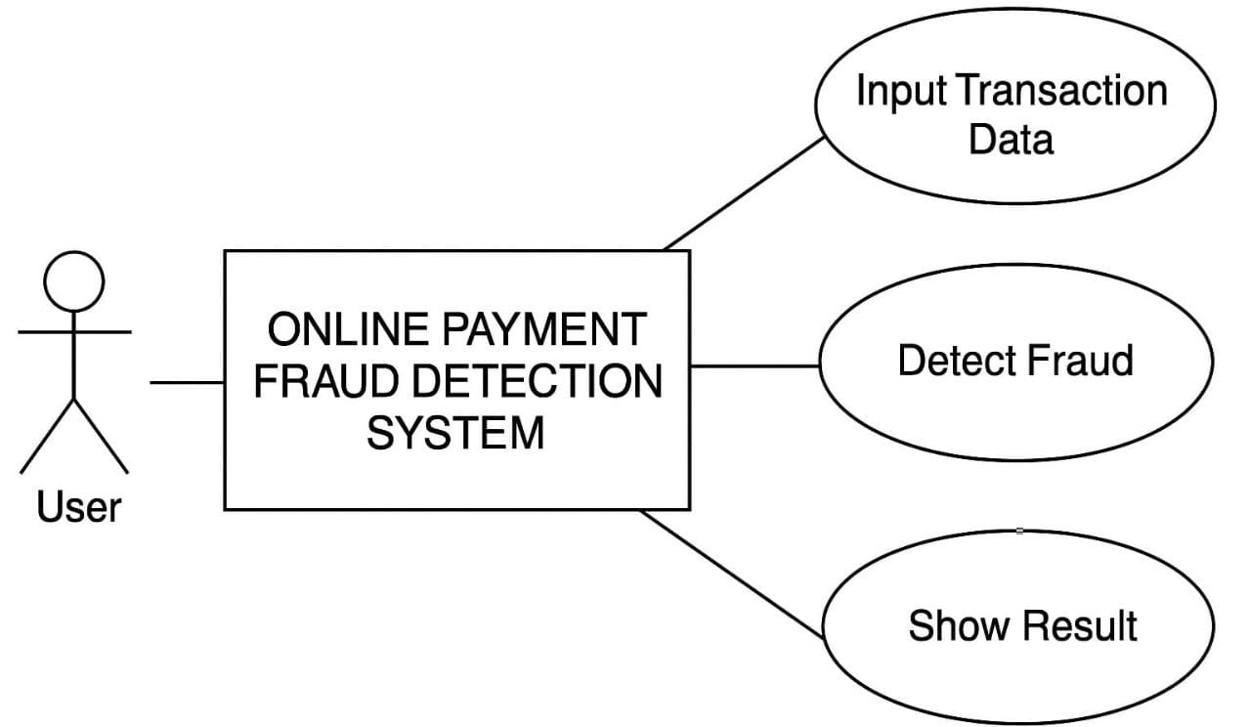
Figure 4.1.1: Use case Diagram
4.1.2.Class Diagram: The class diagram outlines the structure of the backend system, including classes such as Transaction, Preprocessor, Model, Prediction Engine, and User Interface. It shows the attributes and methods of each class and the relationships between them, This diagram helps in designing modular and reusable code.
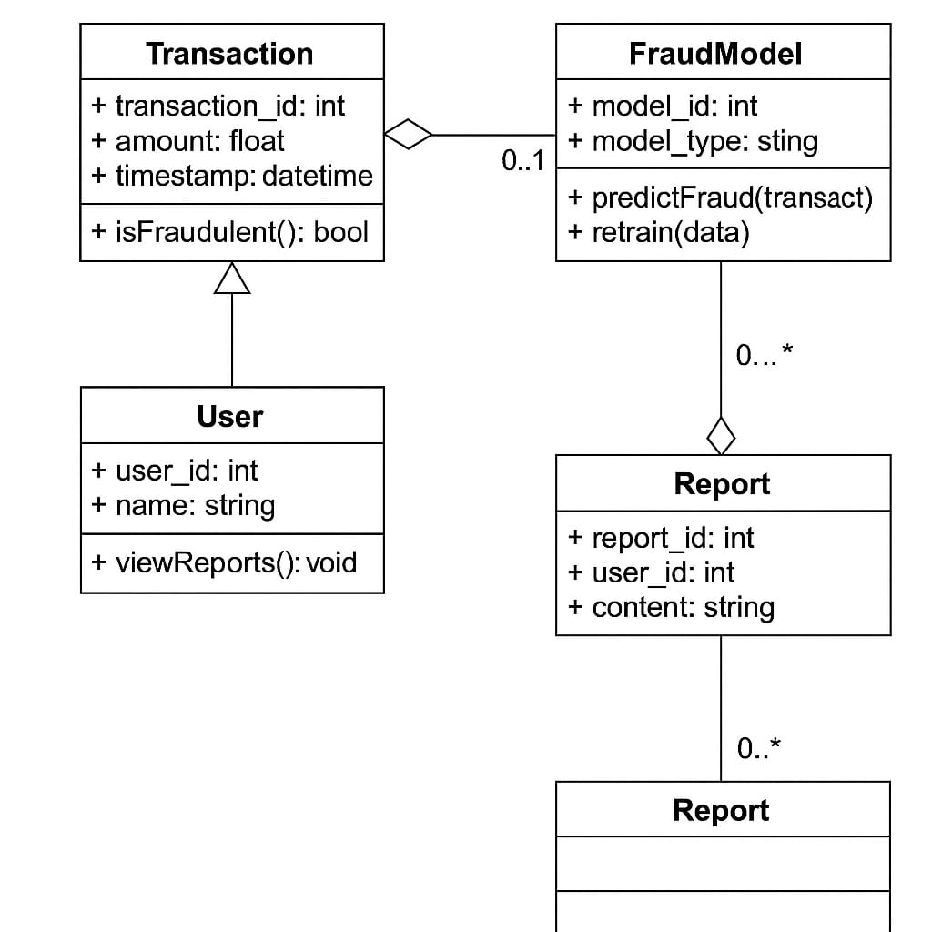
Figure 4.1.2: Class Diagram
4.1.3.Activity Diagram:The activity diagram depicts the workflow from the user submitting transaction data to the system returning a fraud prediction. It includes decision nodes for data validation, preprocessing, model execution, and result handling.
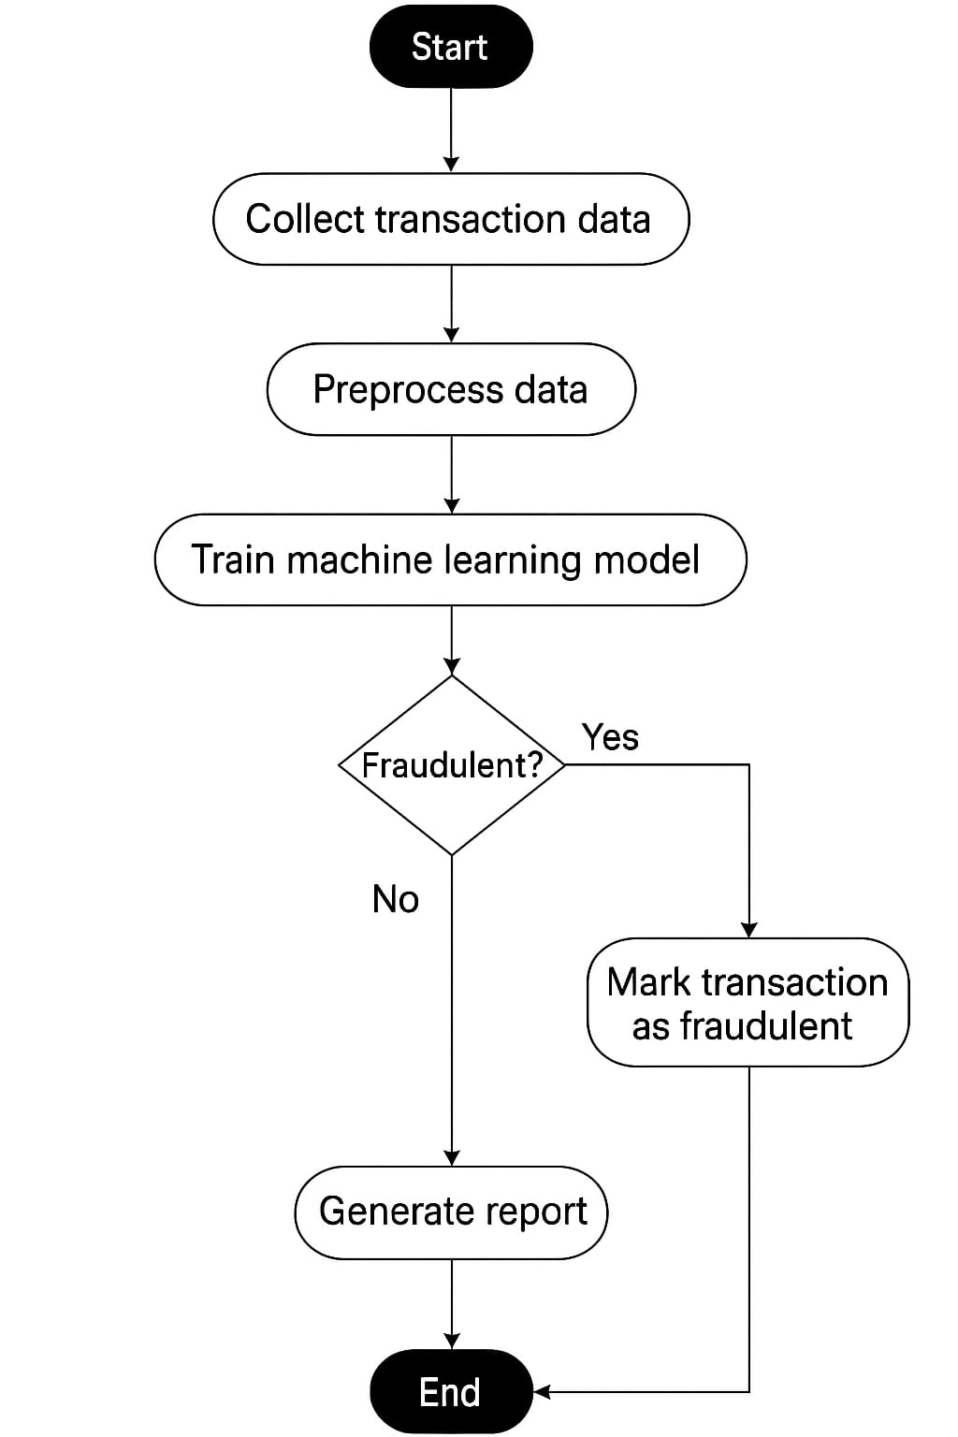
Figure 4.1.3: Activity Diagram
4.1.4.Sequence Diagram: This diagram demonstrates the step-by-step interaction between the system components during a fraud prediction request. It includes the user interface sending input data, the backend handling preprocessing, the model generating a prediction, and the result being sent back to the user. It helps visualize the dynamic behavior of the system during runtime.

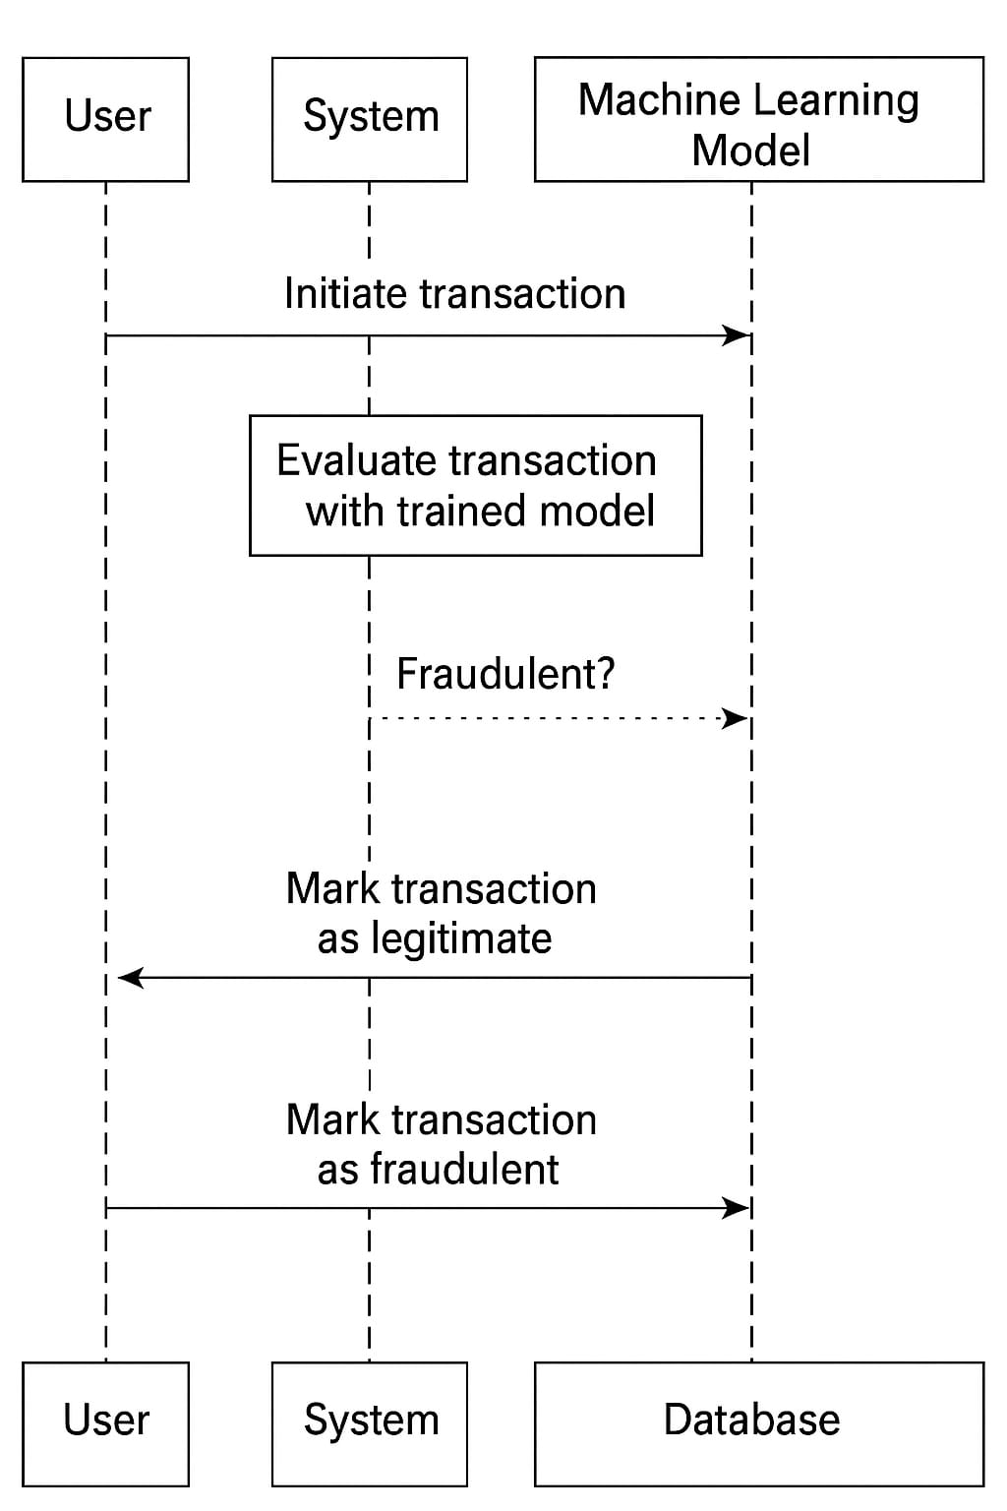

Figure 4.1.4: Sequence Diagram

4.2 SYSTEM ARCHITECTURE
The architecture of the Online Payment Fraud Detection System is designed to integrate machine learning with real-time user interaction in a modular, efficient, and scalable way. As shown in the figure below, the system receives transaction data from users, processes it through a machine learning-powered fraud detection engine, and classifies it as either genuine or fraudulent. Users initiate a transaction which is captured and formatted as structured transaction data. This data is sent to the central Fraud Detection System, where a pre-trained machine learning model evaluates it based on historical patterns and learned behaviors. The system then returns the outcome: genuine if the transaction appears legitimate, or fraudulent if it exhibits suspicious characteristics. The model is continuously trained and updated using new data to stay adaptive and accurate over time.

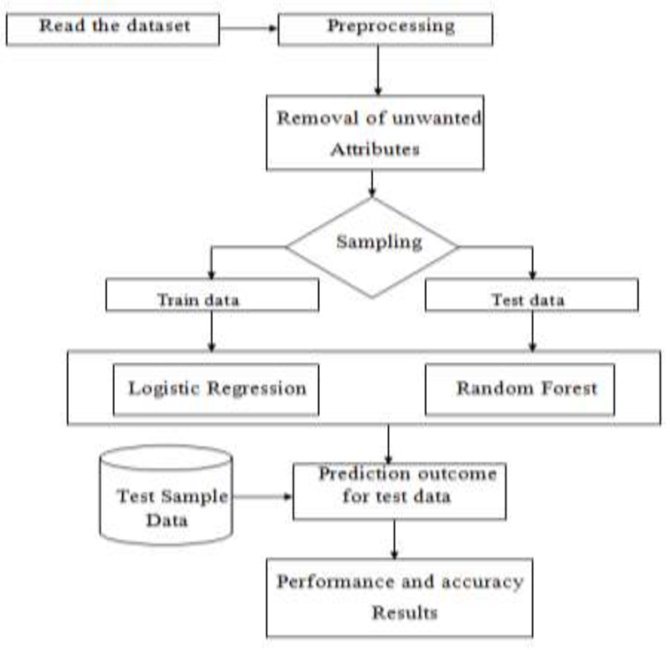
Figure 4.2: Architecture Diagram

4.3 FLOW CHART
The workflow for the online payment fraud detection system begins with data collection, using a real-world dataset sourced from Kaggle that contains thousands of credit card transactions, including both legitimate and fraudulent ones. This is followed by data preprocessing, where missing values are cleaned, features are normalized, and techniques like SMOTE are applied to address class imbalance. In the model selection phase, various machine learning algorithms are evaluated, with Random Forest being chosen for its robustness and high accuracy in handling imbalanced datasets. After selecting the model, model training is performed using the preprocessed dataset, allowing the model to learn to distinguish between fraudulent and non-fraudulent transactions. Once trained, the model undergoes evaluation using metrics such as accuracy, precision, recall, and F1-score to ensure its effectiveness, especially in identifying fraudulent cases. Finally, the system is deployed using a Flask web application, providing a user-friendly interface where users can input transaction details and receive instant fraud predictions, making the solution both practical and efficient for real-time use.
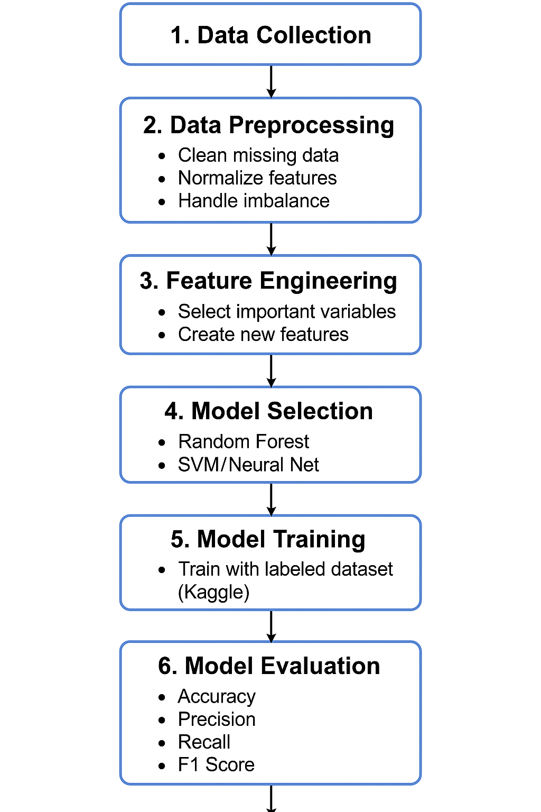
Figure 4.3: flow chart

5. IMPLEMENTATION
Implementation is the process of converting the developed system into a fully functional and interactive solution. It is a vital phase where the design and theoretical model are transformed into a working application that users can operate in real-time. The implementation of the Online Payment Fraud Detection system includes preparing the working environment, installing the required tools and libraries, preprocessing the dataset, training and evaluating the model, and integrating it with a web interface for user interaction and fraud prediction.
Installation Steps:
1. Install Python and Required Tools
Python 3.10 or above is used for the development of the system. Essential tools such as Jupyter Notebook and IDEs like VS Code or PyCharm can be used for coding and debugging.
2. Create and Activate Virtual Environment
A virtual environment is created to manage dependencies and ensure consistency across platforms. It helps avoid version conflicts and maintains project isolation.
3. Install Required Libraries
All necessary Python libraries are installed, including tools for data handling, visualization, machine learning, and web deployment. These libraries include packages like Pandas, NumPy, Scikit-learn, Matplotlib, Seaborn, Flask, and imbalanced-learn.
Model Development Steps:
4. Data Collection
The dataset used in this project is sourced from Kaggle and contains thousands of credit card transaction records. Each record is labeled as either fraudulent or legitimate, making it suitable for supervised learning.

5. Data Preprocessing
Data preprocessing includes several critical steps:
- Data cleaning: Removing or filling missing values.
- Normalization: Scaling features to ensure uniformity.
- Class balancing: Addressing the class imbalance using oversampling techniques like SMOTE to ensure the model learns from both fraudulent and legitimate transactions.
- Feature selection: Identifying key transaction attributes that influence fraud prediction.
6. Model Training and Evaluation
A Random Forest Classifier is selected for its high accuracy and robustness, particularly in handling imbalanced datasets. The model is trained on the processed data and evaluated using performance metrics such as accuracy, precision, recall, and F1-score. These metrics ensure that the model performs well in detecting fraudulent cases while minimizing false positives.
7. Model Deployment
The final trained model is deployed using a Flask web application. This interface allows users to input transaction details such as transaction type, amount, and balance details. Upon submission, the system processes the inputs and returns a real-time prediction indicating whether the transaction is likely to be fraudulent or legitimate. This integration makes the solution practical and user-friendly for real-world applications.
8.Model Integration
1. Model Selection: A Random Forest Classifier was used for its ability to handle imbalanced data and deliver accurate results in binary classification.
2. Prediction Flow: Transaction input → Preprocessing → Model prediction → Output (fraudulent or legitimate)
3. Explainability: Feature importance was analyzed to understand which transaction features most influenced the model’s decisions.
User Interface
The User Interface is designed with three main components: a Web Form Frontend, a Flask Backend, and seamless Integration. The frontend features an HTML form that allows users to input transaction details, which are then sent to the Flask API for analysis. The backend, built using Flask, processes this data and generates predictions in real time. These predictions are returned through the /predict route, enabling instant feedback and dynamic result display on the frontend. This smooth interaction between the frontend and backend ensures a responsive and user-friendly experience.
Testing and Evaluation
The system was tested with real and synthetic transaction data. Key metrics used were accuracy, precision, recall, and F1-score. Real-time response was validated through the web interface, and feature importance helped interpret model behaviour. Testing and Evaluation of the system involves validating the accuracy, performance, and reliability of the fraud detection model. Various metrics such as precision, recall, F1-score, and accuracy are used to evaluate the effectiveness of the model on test data. The model is trained on a labeled dataset and tested on unseen data to ensure it generalizes well. Cross-validation techniques are applied to avoid overfitting and ensure robustness. Additionally, the Flask backend and frontend integration are tested for smooth functionality, ensuring that predictions are delivered correctly and promptly. Overall, both the machine learning model and the web interface undergo rigorous testing to ensure a dependable and user-friendly system.

5.1 MODULES
5.1.1 User Interface (UI):

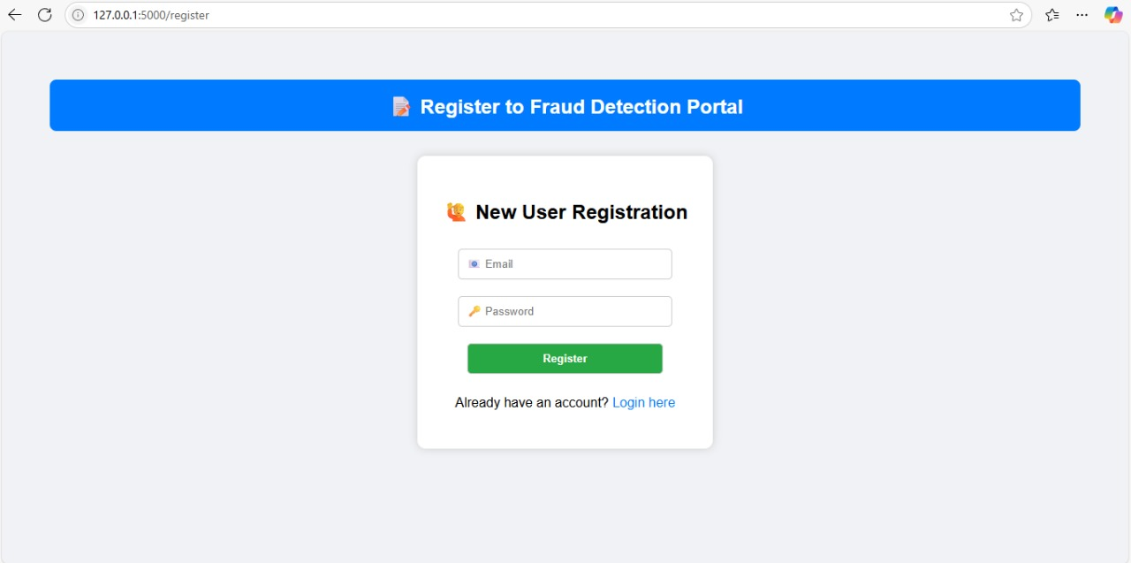
Figure :6 User Interface (UI)
The user interface for the Online Payment Fraud Detection system is designed to be simple, secure, and user-friendly. The screenshot above shows the New User Registration page, where users can create an account to access the fraud detection portal. The header "Register to Fraud Detection Portal" clearly indicates the purpose of the page. Users are required to enter their email and password, ensuring secure access to the platform. Once registered, users can proceed to log in and access the transaction fraud detection features. This registration system helps in managing multiple users securely and ensures that only authorized individuals can use the detection tool. The clean layout, clear labels, and simple design make it easy for users of all technical backgrounds to interact with the application.

5.1.2 Flask Backend
The Flask backend acts as the core processing unit of the Online Payment Fraud Detection system. It handles all data-related operations between the user interface and the machine learning model. When a user submits transaction details through the web form, the Flask server receives the input, preprocesses it, and sends it to the trained Random Forest model for prediction. Based on the model's output, the Flask backend generates a response indicating whether the transaction is fraudulent or legitimate. It also manages user authentication functions such as registration and login, ensuring secure access to the system. Flask was chosen for its lightweight nature, simplicity, and ability to seamlessly integrate with HTML templates and Python-based ML models.
- Receives input data from the user interface.
- Preprocesses input features before prediction.
- Loads and interacts with the trained ML model.
- Returns prediction results to the frontend.
- Manages user authentication (registration and login).
- Ensures secure and real-time communication between UI and backend.

5.1.3 Database Management
The database management module is responsible for securely storing and managing user credentials and other relevant information within the fraud detection system. When a new user registers through the portal, their email and password are stored in the database, ensuring authentication and secure access to the system. It also keeps track of user login activity and supports verification processes during sign-in. The database schema is kept simple for this academic implementation, focusing primarily on user authentication data. For this project, SQLite is used as the backend database due to its lightweight and file-based nature, which makes it easy to deploy and manage without requiring a dedicated database server. Flask seamlessly connects to SQLite through SQL Alchemy or direct queries, enabling smooth interaction between the backend logic and stored data. The database module plays a vital role in securing the system by protecting user information and ensuring that only authorized individuals can access fraud detection functionalities
5.1.4 Utility Function
The utility function module contains reusable helper functions that support the core operations of the fraud detection system. These functions are designed to keep the main codebase clean, modular, and easier to maintain. Typical utility functions include data preprocessing steps such as feature scaling, missing value handling, and reshaping of input data for compatibility with the trained model. This module also includes functions for loading the saved model, formatting outputs, logging system activity, and validating user input before it is processed by the backend.`. In future versions, this module can be expanded to include data encryption, logging, exception handling, or integration with external APIs for improved fraud intelligence.
5.1.5 Configuration
The configuration module manages all the essential settings required to run the fraud detection system efficiently and consistently across environments. It includes key parameters such as file paths for the saved machine learning model, database connection strings, Flask app settings, and environment variables. Keeping these values centralized in a separate configuration file allows easy adjustments without modifying the core logic of the application.This module ensures that the system remains flexible and scalable, especially when deploying to different platforms such as local servers, cloud services, or containers. Common settings managed here include debug mode, port numbers, model file names, and security-related variables like secret keys. Using a dedicated configuration file (e.g., config.py or .env) improves maintainability, helps avoid hardcoded values, and supports secure deployment practices.

6. TESTING
The Online Payment Fraud Detection system was thoroughly tested to ensure accuracy, reliability, and smooth functionality. Unit tests were conducted on individual modules including the user interface, Flask backend, and model integration. Integration testing verified the proper communication between all components. The model's performance was evaluated using accuracy, precision, recall, and F1-score, confirming its effectiveness in identifying fraudulent transactions. The web interface was tested for responsiveness and real-time prediction delivery. Overall, the system passed all test cases, including edge and invalid inputs, ensuring it is stable and ready for deployment
6.1 Testing Methodologies
Software testing plays a crucial role in delivering a reliable and stable fraud detection system. It provides an objective view of software quality, helping identify risks and ensuring that the developed system meets both technical and user requirements. Testing is the process of executing the program with the intention of discovering bugs, errors, or any unexpected behavior. In this project, testing was conducted to evaluate whether the fraud detection system meets its functional goals namely, accurate and real-time identification of fraudulent transactions.
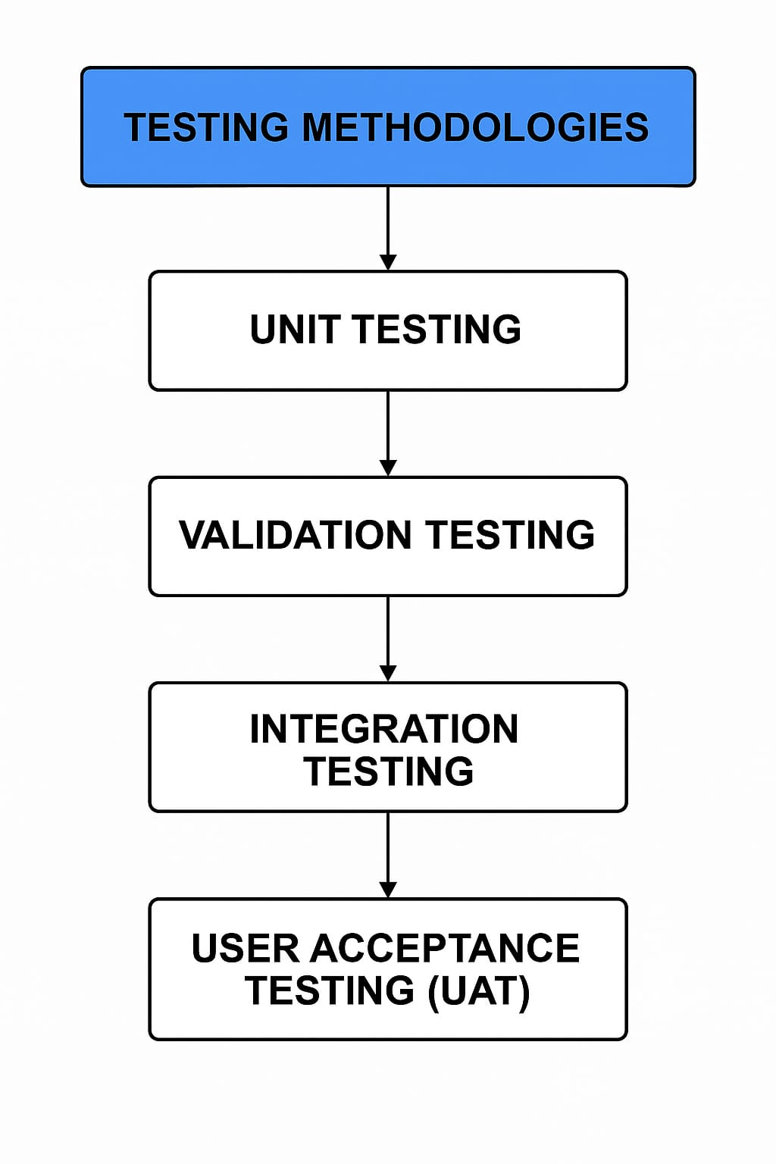
Figure 6.1: testing methodologies
6.1.1 UNIT TESTING
Unit testing involves testing individual components of the fraud detection system in isolation to ensure they function correctly. In this project, unit tests are applied to modules such as data preprocessing, model prediction, and input handling. Each function like normalization, SMOTE balancing, or model loading is tested using known inputs to verify expected outputs. Python testing frameworks like unittest or pytest are used to automate this process. Unit testing helps catch bugs early, improves reliability, and ensures that each part of the system performs as intended before integration.
6.1.2 Validation Testing
Validation testing ensures that the fraud detection system meets the specified requirements and performs as expected with real or near-real data. It checks whether the system correctly identifies fraudulent transactions and provides accurate predictions. In this project, validation was done using a separate test set from the dataset. Metrics like accuracy, precision, recall, F1-score, and AUC-ROC were used to evaluate the model. The results confirmed that the system reliably detects fraud while minimizing false positives, validating both the model performance and system functionality.
6.1.3 Integration Testing
Integration testing focuses on verifying that different modules of the fraud detection system work together as intended. It ensures smooth interaction between components like data preprocessing, the machine learning model, and the Flask-based web interface. In this project, integration testing was performed by simulating full user workflows submitting a transaction through the web form, preprocessing the input, passing it to the model, and displaying the result. The goal was to confirm that all parts of the system are correctly linked and data flows seamlessly from input to prediction output.

7.OUTPUT SCREEN
7.1 User Registration Screen
This screen allows new users to register for the Fraud Detection Portal by entering their email and password. It ensures only authenticated users can access the system.
- Email & Password fields
- Register button
- Link to login for existing users

Figure 7.1: user registration

7.2 Fraud check input Screen
The Fraud Check Input Screen serves as the core interface of the Online Payment Fraud Detection System. After a userlogs in, they are directed to this screen where they can enter key transaction details including the transaction amount, the sender’s old balance, and the sender’s new balance. Upon clicking the “Check for Fraud” button, the input is sent to a trained machine learning model that predicts whether the transaction is legitimate or fraudulent in real time.
The screen also includes a logout button to ensure secure user session management. This page is built using Flask for the backend and HTML/CSS for the frontend, with the fraud detection logic powered by XG Boost and anomaly detection algorithms. Designed for simplicity and accuracy, this screen plays a vital role in ensuring financial transaction safety.

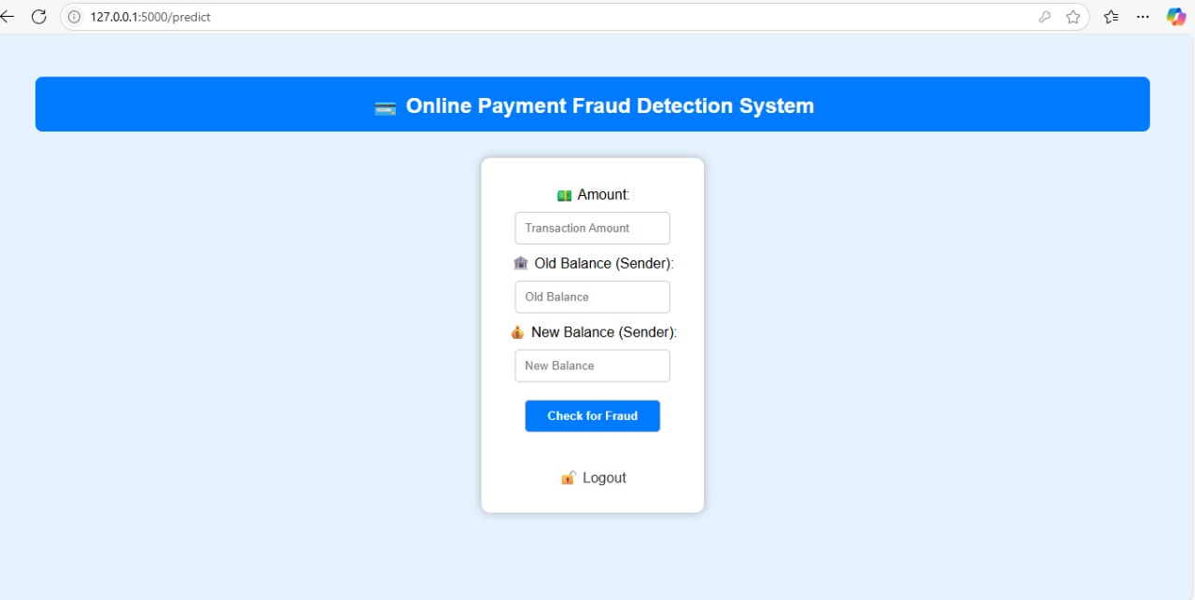
Figure 7.2: Fraud check input

7.3 Fraudulent Transaction Detected
Once the user submits the transaction details, the Online Payment Fraud Detection System instantly processes the data and displays the result on the same screen. If the system detects suspicious activity based on the input features such as an unusual drop in the sender's balance it immediately alerts the user with a clear message: "Fraudulent Transaction Detected!" shown in red with icons for emphasis. This real-time feedback helps users identify potentially harmful transactions and take immediate action. The intuitive design ensures that even non-technical users can use the system effectively and securely

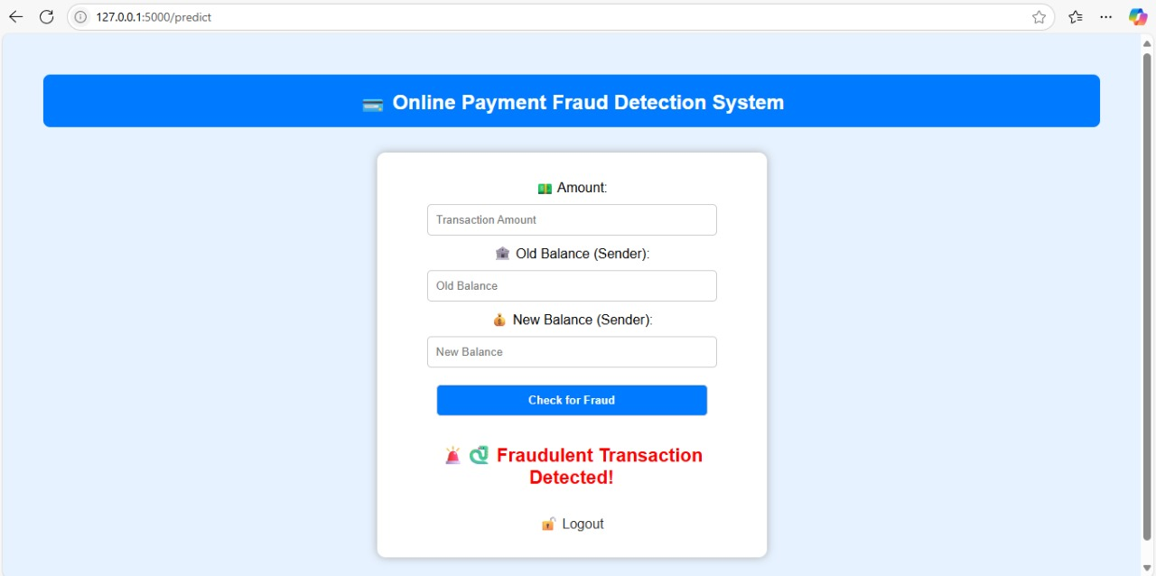
Figure 7.3: Fraudulent Transaction Detected

7.4 Legitimate Transaction
When the system detects no signs of fraud, it displays the message "Legitimate Transaction." This indicates that the transaction is safe and valid based on the provided inputs such as the transaction amount, old balance, and new balance. The machine learning model has classified the transaction as non-fraudulent, reassuring the user that it can proceed securely.

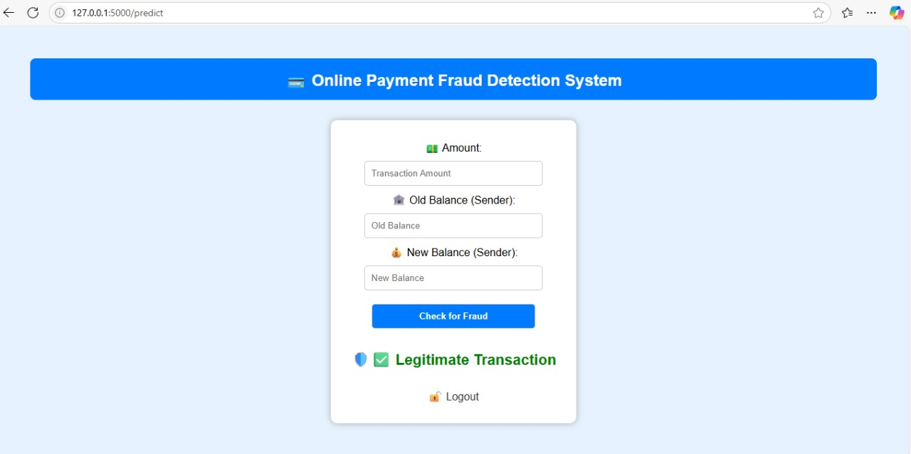
Figure 7.4: Legitimate Transaction

CONCLUSION
The rise of digital transactions has brought immense convenience to users but has also increased the risk of online fraud. Detecting fraudulent activities in real-time is a significant challenge, especially as fraud tactics continuously evolve and become harder to detect using traditional rule-based systems. These systems often result in high false positives and lack the adaptability needed to handle modern fraud. This project addresses these issues by implementing a machine learning-based fraud detection system using a Random Forest classifier, chosen for its reliability and strong performance on imbalanced datasets. The model was trained on a real-world dataset from Kaggle that included both legitimate and fraudulent transactions. One of the major challenges, class imbalance, was handled using SMOTE (Synthetic Minority Oversampling Technique) to ensure balanced learning and better generalization. The model was evaluated using key metrics such as accuracy, precision, recall, F1-score, and ROC-AUC to confirm its effectiveness. After training, the model was deployed using the Flask web framework, allowing users to input transaction data and receive instant predictions through a simple web interface. The system was tested thoroughly through unit, integration, and user acceptance testing, confirming its correctness and usability. The architecture is modular, making it easy to maintain and extend. Future upgrades could include features such as real-time alerts, secure authentication, and cloud-based deployment. With minor adjustments, it can be integrated into real-world banking systems and mobile payment platforms. In summary, this project demonstrates that machine learning provides a smart, scalable, and efficient solution to online payment fraud, helping build safer and more trustworthy digital financial environments.

FUTURE ENHANCEMENTS
To further improve the accuracy and scalability of the Online Payment Fraud Detection System, several key enhancements are proposed. Real-time transaction monitoring can be implemented by integrating the model with live APIs to analyser streaming data from banking apps, e-commerce platforms, and payment gateways. Technologies like Kafka or RabbitMQ can be used to handle high-volume transactions efficiently. The system can be upgraded to use advanced machine learning models such as XG Boost, Light GBM, or LSTM for better precision and to capture sequential behaviour. Ensemble methods can also be applied to boost overall performance. Incorporating Explainable AI techniques like SHAP or LIME will make the system’s decisions more transparent and understandable to analysts and stakeholders. Deployment flexibility can be enhanced by hosting the system on cloud platforms like AWS or Azure, and optimizing models for mobile apps or edge devices using TensorFlow Lite or ONNX. This would allow real-time fraud detection even in offline or low-bandwidth environments. The system can adopt online learning to automatically update itself with new fraud patterns without full retraining. APIs can be developed to integrate with wallets, online banking systems, or payment processors for seamless fraud checks. Blockchain technology can be used to log transaction metadata, creating tamper-proof records for audit and compliance. Alerts via SMS or email can be triggered for suspicious activity, and the system can auto-freeze accounts or initiate reviews. Expanding the training dataset with new, diverse, and behavior-based features, along with feature selection, can further improve detection accuracy and speed.

REFERENCE
[1] ABDULWAHAB ALI ALMAZROI 1 AND NASIR AYUB 2 , (Student Member, IEEE)
Department of Information Technology, College of Computing and Information Technology at
Khulais, University of Jeddah, Jeddah 21959, Saudi Arabia 2Department of Creative
Technologies, Air University, Islamabad 44000, Pakistan Corresponding author: Abdulwahab
Ali Almazroi (Aalmazroi@uj.edu.sa)
[2] Y. Dai, J. Yan, X. Tang, H. Zhao and M. Guo, "Online Credit Card Fraud Detection: A Hybrid
Framework with Big Data Technologies," 2016 IEEE Trustcom/BigDataSE/ISPA, Tianjin,
China,2016,pp.1644-1651,doi:10.1109/TrustCom.2016.0253.
[3] Bahnsen, A. C., Aouada, D., Stojanovic, A., & Ottersten, B. (2016). Feature engineering
trategies for credit card fraud detection. Expert Systems with Applications, 51, 134–142.
[4] Ben Ameur, H., Ftiti, Z., Jawadi, F., & Louhichi, W. (2020). Measuring extreme risk
dependence between the oil and gas markets. Annals of Operations
Research. https://doi.org/10.1007/s10479-
020-03796-1
[5] Bernard, P., De Freitas, N. E. M., & Maillet, B. B. (2019). A financial fraud detection indicator
for investors: an IDeA. Annals of Operations Research. https://doi.org/10.1007/s10479-019-
03360-6
[6] Bhattacharyya, S., Jha, S., Tharakunnel, K., & Westland, J. C. (2011). Data mining for credit
card fraud: A comparative study. Decision Support Systems, 50(3), 602–613.
[7] Dal Pozzolo, A., Boracchi, G., Caelen, O., Alippi, C., & Bontempi, G. (2017). Credit card fraud
detection: A realistic modeling and a novel learning strategy. IEEE Transactions on Neural
Networks and Learning Systems, 29(8), 3784–3797.
[8] Dal Pozzolo, A., Caelen, O., Le Borgne, Y. A., Waterschoot, S., & Bontempi, G. (2014).
Learned lessons in credit card fraud detection from a practitioner perspective. Expert Systems
with Applications, 41(10), 4915–4928.
[9] DE SÁ, A. G., Pereira, A. C., & Pappa, G. L. (2018). A customized classification algorithm for
credit card fraud detection. Engineering Applications of Artificial Intelligence, 72, 21–29.
[10]Dua,D., &Graff, C. (2019). UCI machine learning repository [online].
Available http://archive.ics.uci.edu/ml. Irvine, CA: University of California, School of
Information and Computer Science.
[11] Edge, M. E., & Sampaio, P. R. F. (2012). The design of FFML: A rule-based policy modelling
language for proactive fraud management in financial data streams. Expert Systems with
Applications, 39(11), 9966–9985.
[12] Everett, C. (2003). Credit card fraud funds terrorism. Computer Fraud and Security, 2003(5),
[13] Feng, X., Xiao, Z., Zhong, B., Qiu, J., & Dong, Y. (2018). Dynamic ensemble classification
for credit scoring using soft probability. Applied Soft Computing, 65, 139–151.
[14] Ferreira, F. A., & Meidutė-Kavaliauskienė, I. (2019). Toward a sustainable supply chain for
social credit: Learning by experience using single-valued neutrosophic sets and fuzzy
cognitive maps. Annals of Operations Research. https://doi.org/10.1007/s10479-019-03194-2
[15] Fiore, U., De Santis, A., Perla, F., Zanetti, P., & Palmieri, F. (2019). Using generative
adversarial networks for improving classification effectiveness in credit card fraud
detection. Information Sciences, 479, 448–455.
[16] Forbes. (2011). Bringing trust back to the table part one: Adyen and Mobile
Payments.Forough, J., & Momtazi, S. (2021). Ensemble of deep sequential models for credit
card fraud detection. Applied Soft Computing, 99, 106883.
[17] Fu, K., Cheng, D., Tu, Y., & Zhang, L. (2016). Credit card fraud detection using
convolutional neural networks. In International conference on neural information
processing (pp. 483–490). Cham: Springer.
[18] Gómez, J. A., Arévalo, J., Paredes, R., & Nin, J. (2018). End-to-end neural network
architecture for fraud scoring in card payments. Pattern Recognition Letters, 105, 175–181

