Mallow-Tech-Assignment
Architecture Diagram
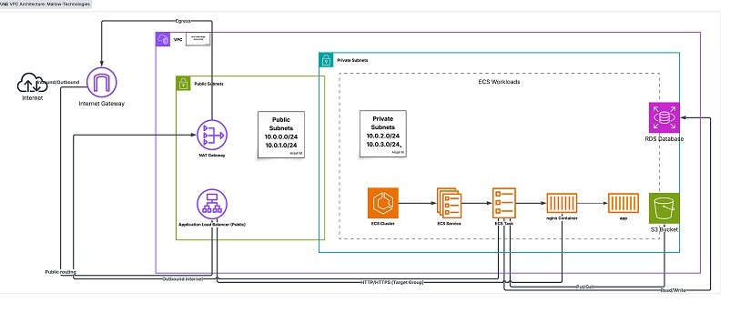

LB-web Access Validation
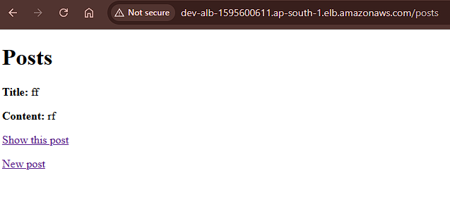

CI/CD Automation Validation
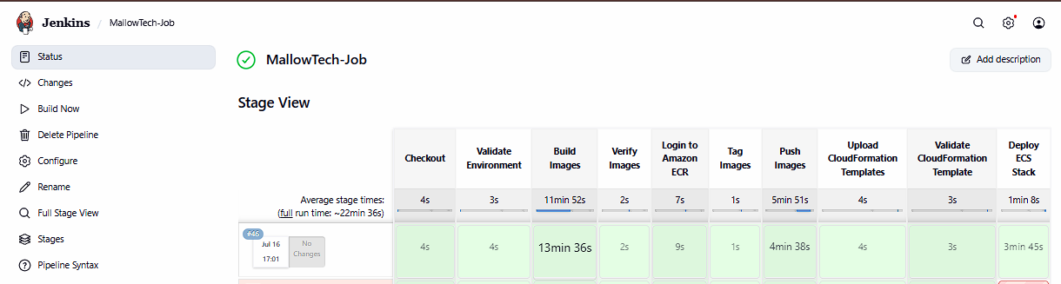
CF-Stack validation
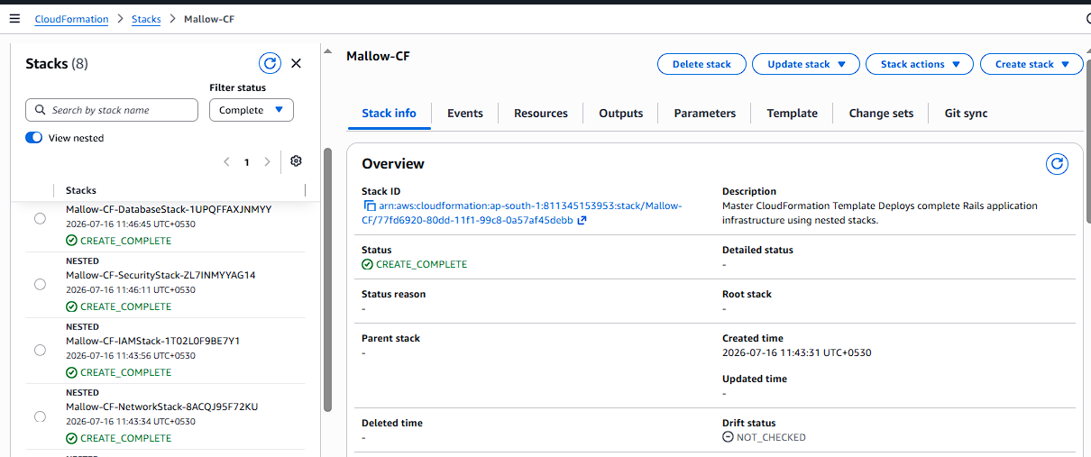
ECS- Cluster- Validation
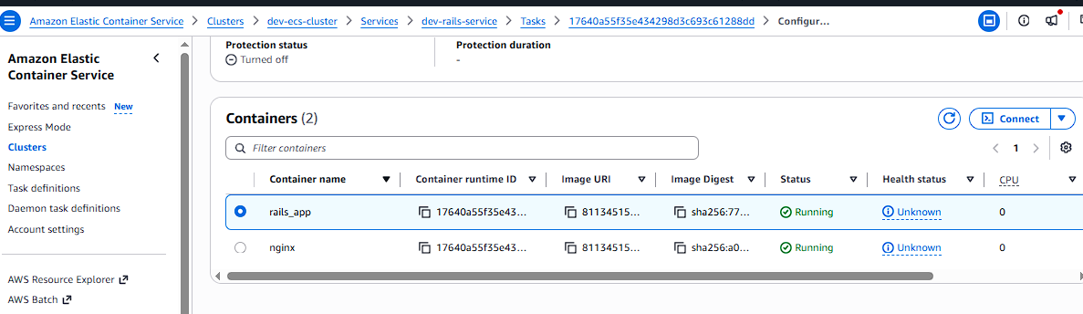
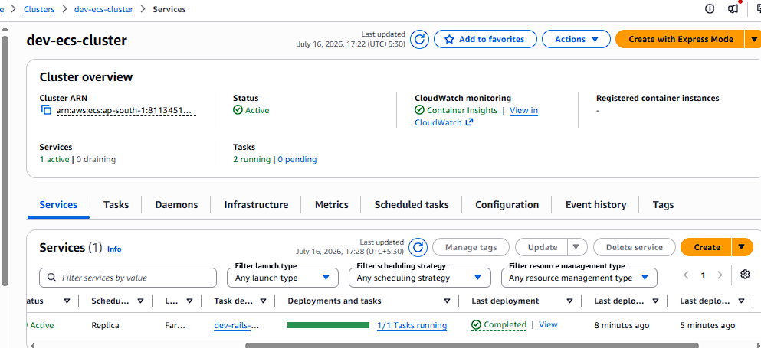

Repo
