Supply Chain Analytics Dashboard
Project Report with Dashboard Images and Explanations
Name: Anjali Bhat
Roll no: 16014223013
Batch: B2

1. Introduction
The Supply Chain Analytics Dashboard is an interactive Streamlit application for analysing supply chain performance across revenue, inventory, supplier quality, cost, demand, lead time, and profitability metrics. The dashboard combines business KPIs, interactive charts, statistical techniques, and machine learning models in one interface.
Users can move between multiple analytical sections using the sidebar and can apply filters for product type, location, and supplier. This makes the dashboard useful for both high-level performance review and detailed metric-level analysis.

2. Objectives
- Present supply chain KPIs in a clear and interactive dashboard.
- Analyse revenue trends, product contribution, supplier quality, and location-level inventory behaviour.
- Use box plots and IQR logic to identify variation and outliers.
- Apply regression analysis for prediction and relationship study.
- Compare simple random, systematic, and stratified sampling methods.
- Use K-Means clustering to identify meaningful operational segments.
- Study probability distributions and calculate interval probabilities for selected metrics.

3. Tools and Technologies
Technology | Purpose
Python | Core programming language
Streamlit | Web dashboard framework
Pandas | Data manipulation and tabular analysis
NumPy | Numerical computation
Plotly | Interactive charts
Scikit-learn | Linear regression and K-Means clustering
SciPy | Probability modelling and statistical testing

4. Dataset Fields
The dashboard works with supply chain records containing product, supplier, location, price, demand, revenue, stock, lead time, shipping cost, manufacturing cost, defect rate, profit margin, and month fields. These attributes allow analysis of commercial performance, operational efficiency, and quality performance.

5. Overview Dashboard
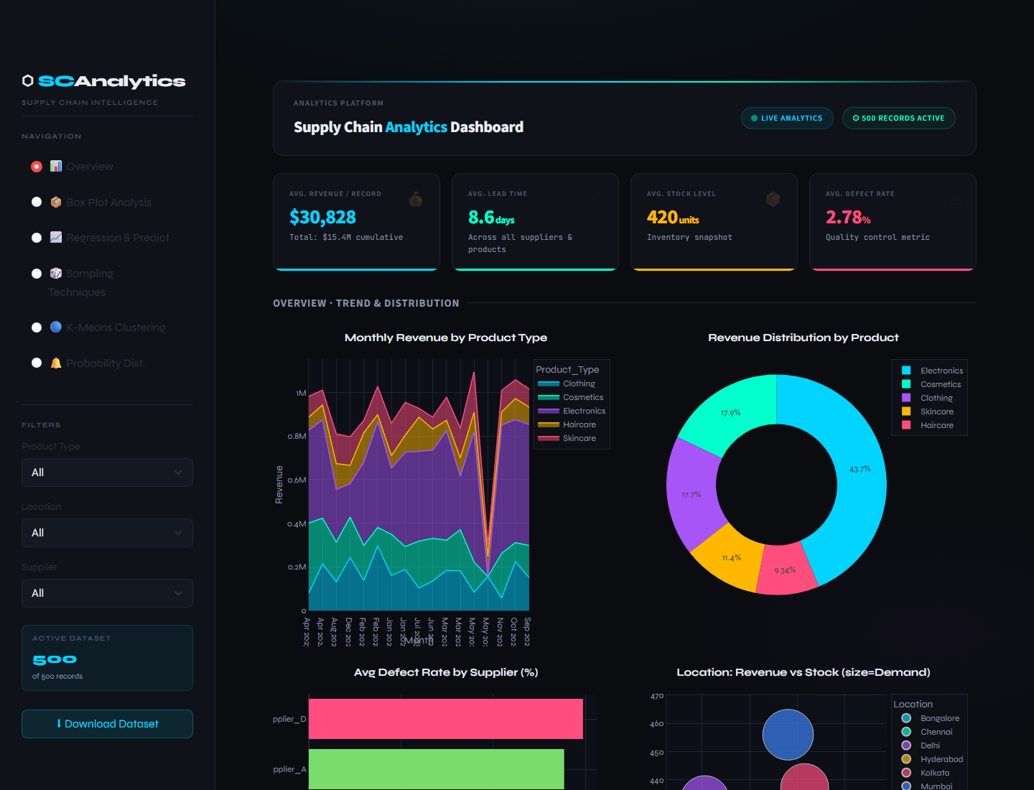
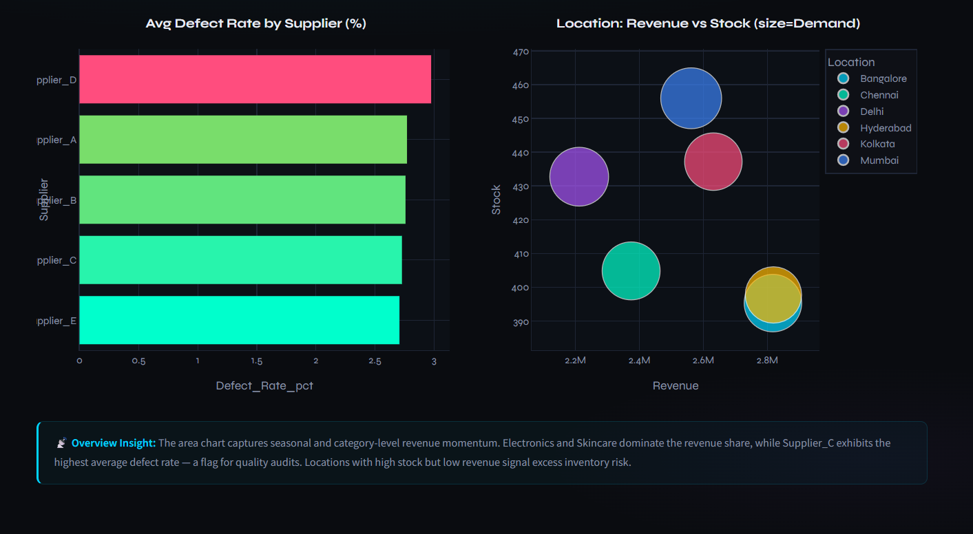
Figure 5: Overview Dashboard

Explanation
The Overview page is the main summary screen of the application. It combines KPI cards with visual charts to provide a quick understanding of supply chain performance.
The KPI cards show average revenue per record, average lead time, average stock level, and average defect rate. Below the KPIs, the dashboard visualizes monthly revenue, product revenue share, supplier defect rate, and location-level stock behaviour.

Key Observations
- The revenue trend chart helps compare product category performance over time.
- The donut chart highlights the relative revenue contribution of each product type.
- The supplier defect chart is useful for quality monitoring and supplier review.
- The location scatter plot connects revenue, demand, and stock level in one visual view.

6. Box Plot Analysis
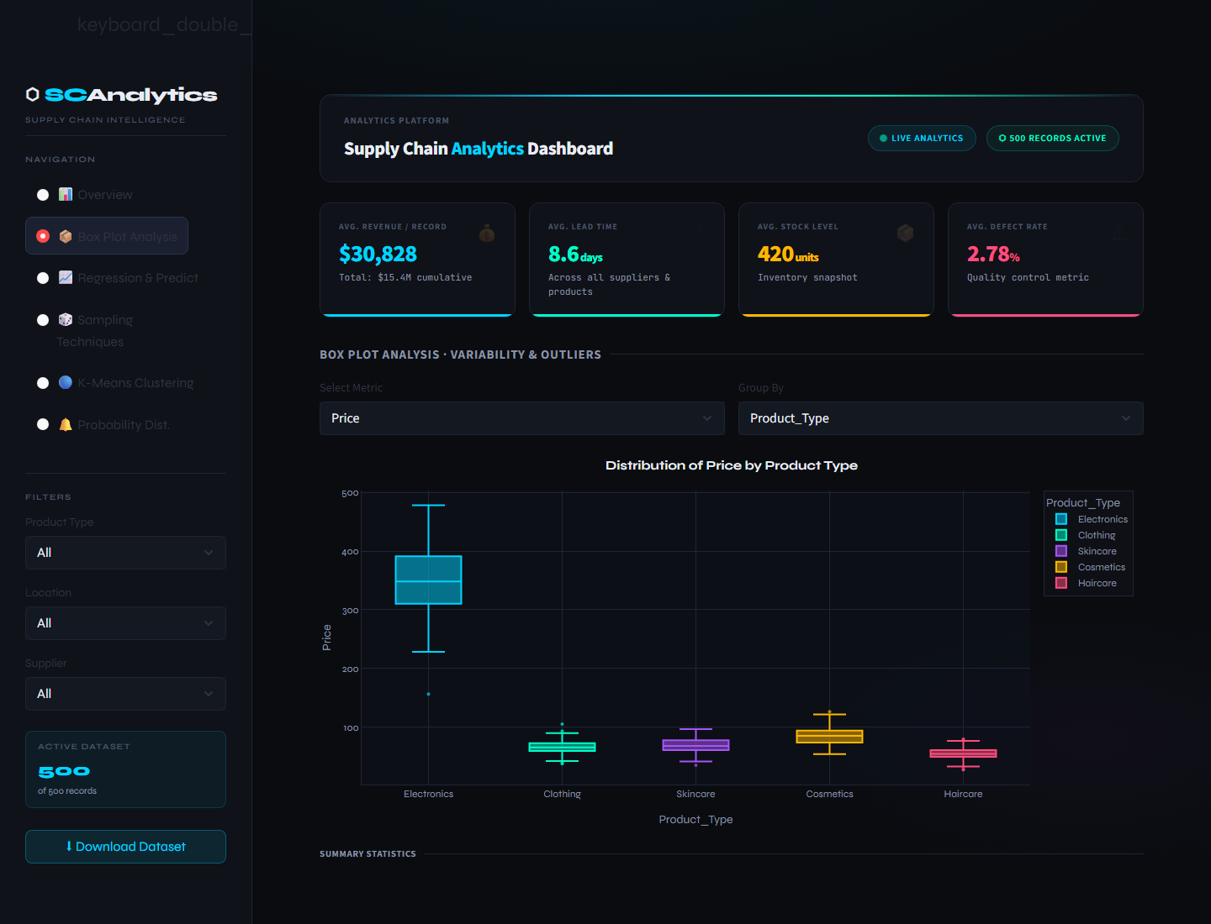
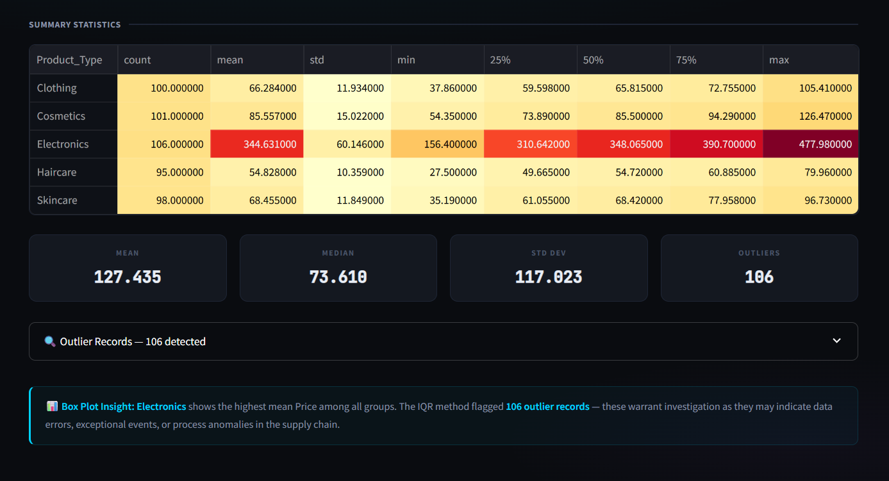
Figure 6: Box Plot Analysis

Explanation
The Box Plot Analysis section is designed to compare the distribution of a selected numerical metric across a selected grouping variable. Users can choose metrics such as revenue, demand, price, stock level, lead time, shipping cost, manufacturing cost, defect rate, and profit margin.
The dashboard also calculates summary statistics and identifies outliers using the interquartile range method. This makes the module useful for detecting extreme values and understanding variability across product types, suppliers, or locations.

Key Observations
- Box plots show the median, spread, and possible outliers for each group.
- The summary table supports numeric comparison between groups.
- Outlier counts help identify unusual records that may need investigation.
- This view is especially helpful for quality, demand, cost, and revenue analysis.

7. Regression and Prediction
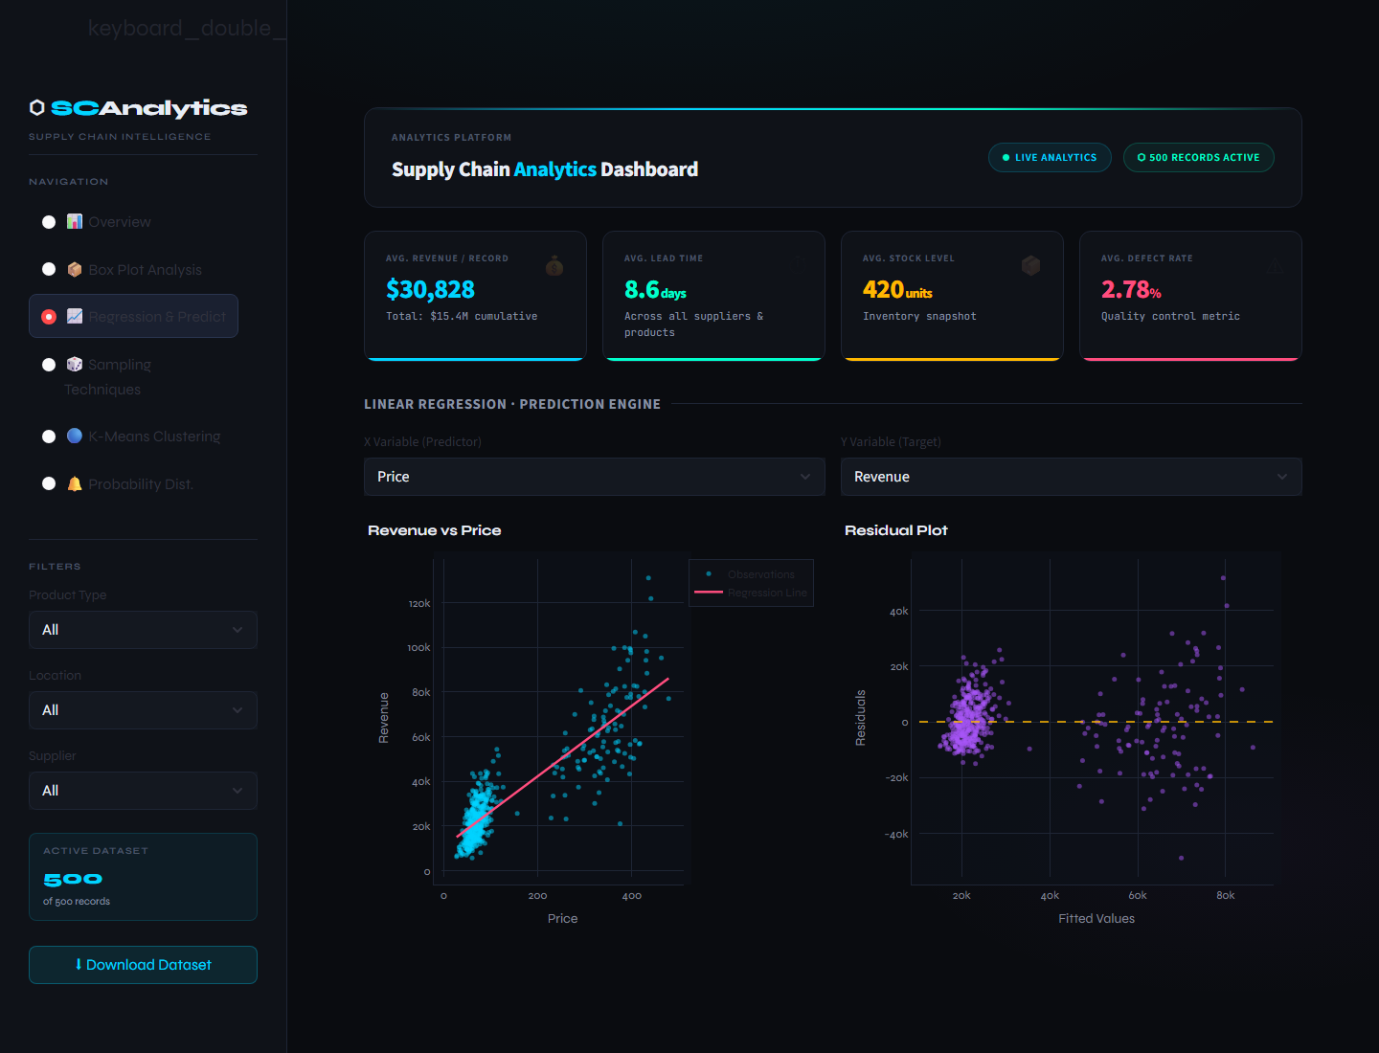
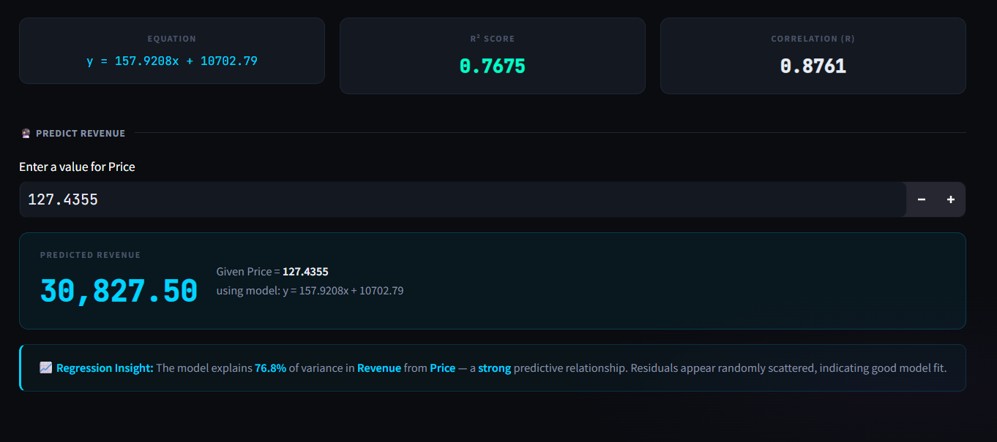
Figure 7: Regression and Prediction

Explanation
The Regression and Prediction section applies simple linear regression between a selected predictor variable and target variable. The chart shows the relationship between the variables along with a fitted regression line.
The section also includes a residual plot, regression equation, R-squared score, correlation coefficient, and prediction input. This allows users to explore how strongly two metrics are related and estimate a target value from a selected input.

Key Observations
- The scatter plot and regression line show the direction and strength of the relationship.
- The residual plot helps judge whether the linear model fits the data well.
- The R-squared value explains how much variation is captured by the model.
- The prediction box makes the model interactive and useful for quick estimation.

8. Sampling Techniques
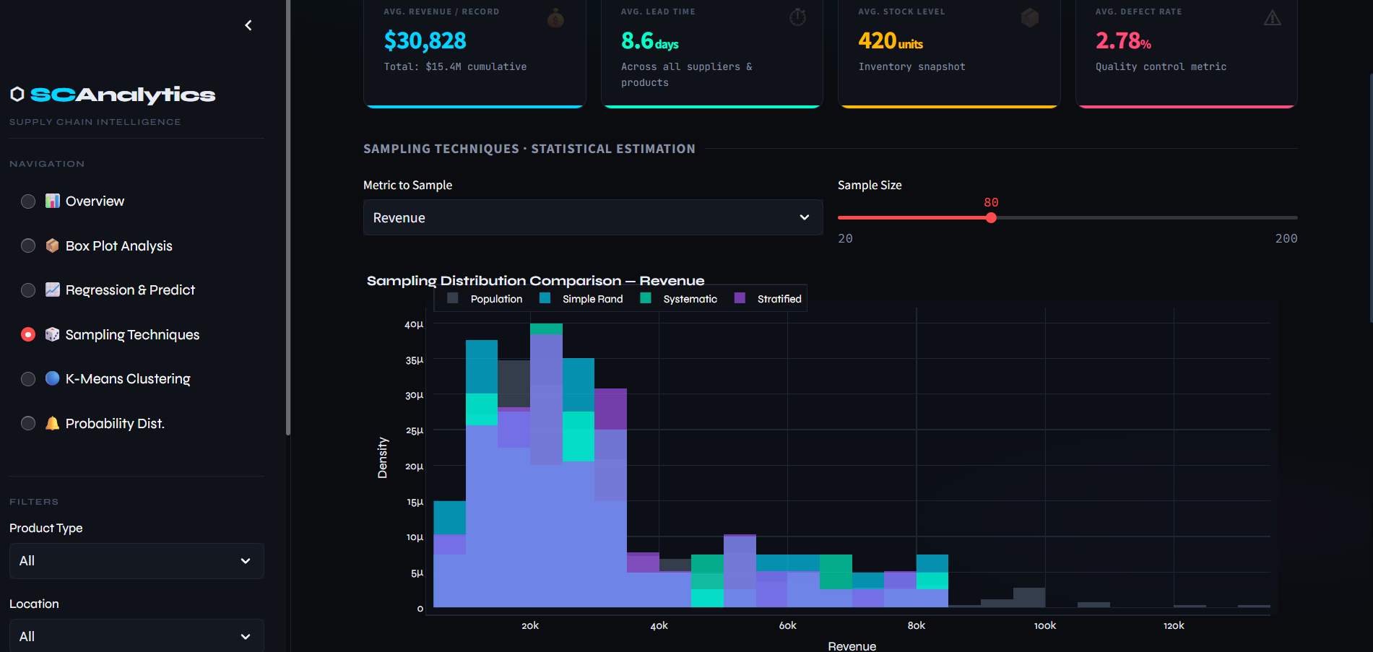
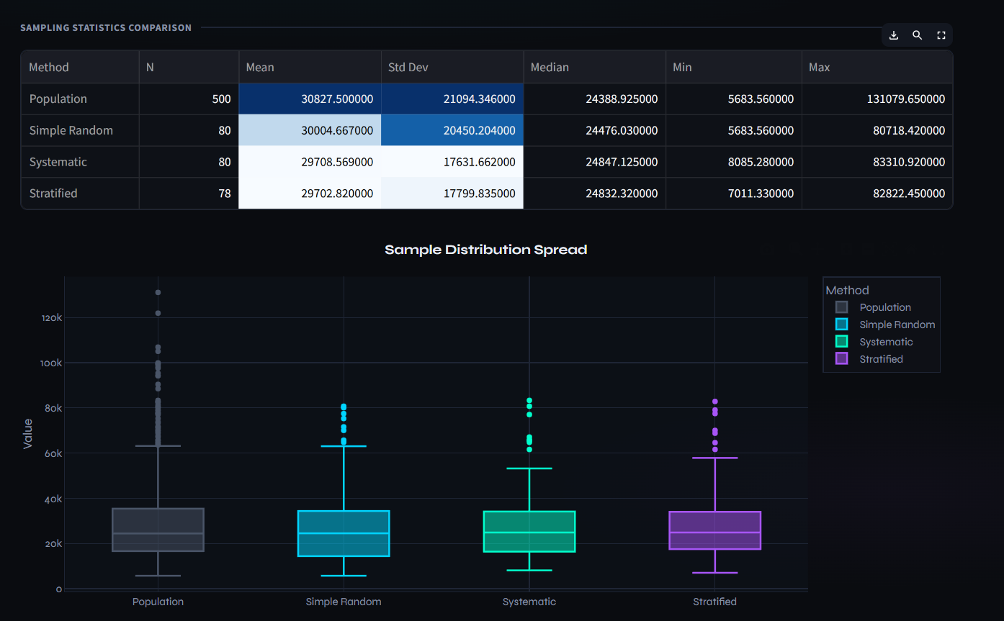

Figure 8: Sampling Techniques

Explanation
The Sampling Techniques section compares simple random sampling, systematic sampling, and stratified sampling. Users can select a metric and sample size, and the dashboard compares each sample with the full population.
The section includes distribution comparison, sampling statistics, box plot comparison, and bias interpretation. It demonstrates how different sampling methods may produce different levels of accuracy depending on the selected variable.

Key Observations
- The histogram comparison shows how closely each sample follows the population distribution.
- The statistics table compares mean, standard deviation, median, minimum, and maximum values.
- The box plot compares spread and variation across sampling methods.
- The bias result identifies which sampling method gives the closest mean estimate.

9. K-Means Clustering
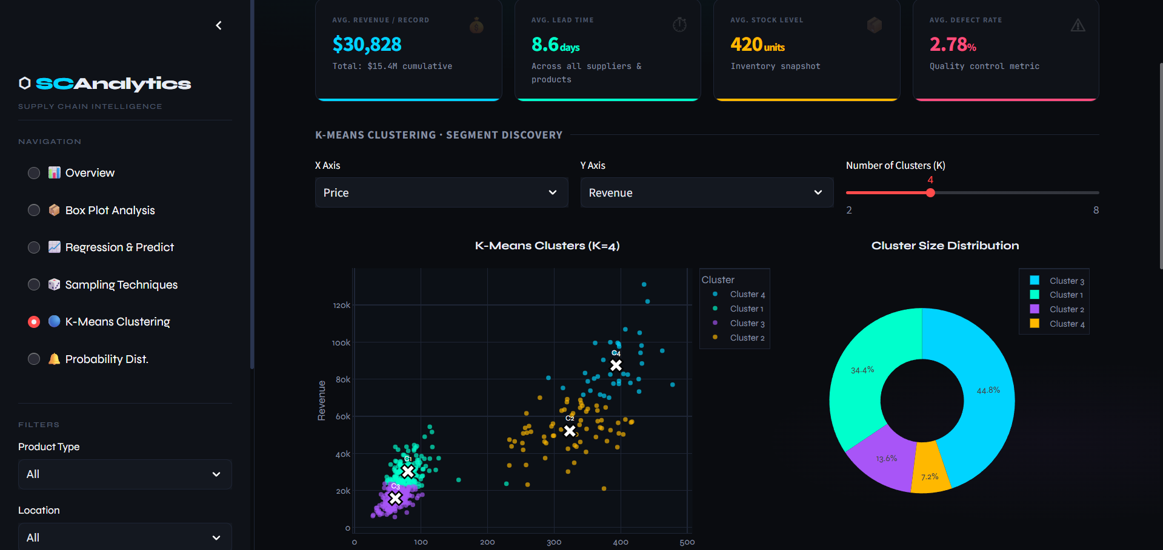
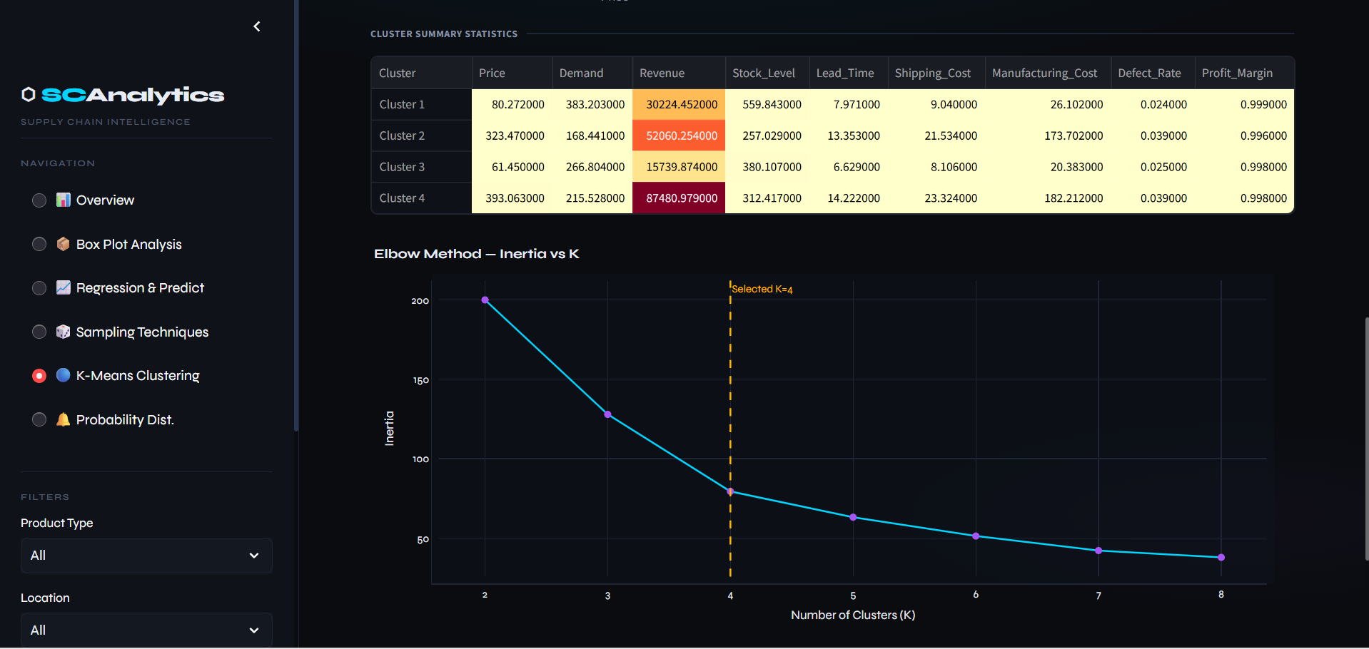
Figure 9: K-Means Clustering

Explanation
The K-Means Clustering section groups records into clusters based on two selected numerical variables. Users can select the X-axis variable, Y-axis variable, and the number of clusters.
The dashboard displays the clustered scatter plot, centroid markers, cluster size distribution, cluster summary statistics, and elbow method chart. This helps identify groups of records with similar operational or financial behaviour.

Key Observations
- The cluster scatter plot shows how records are grouped based on selected metrics.
- Centroid markers represent the centre point of each cluster.
- The cluster distribution chart shows whether clusters are balanced or uneven.
- The elbow chart helps judge whether the selected number of clusters is suitable.

10. Probability Distribution
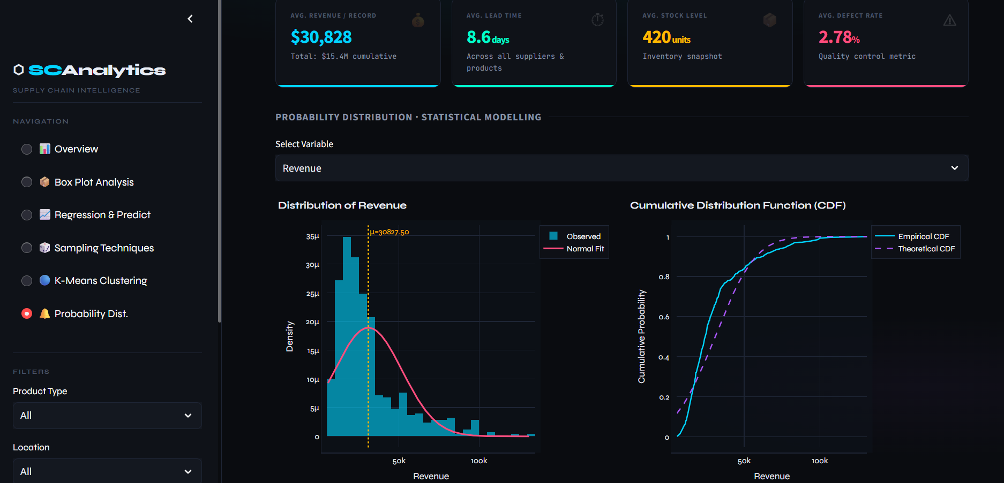
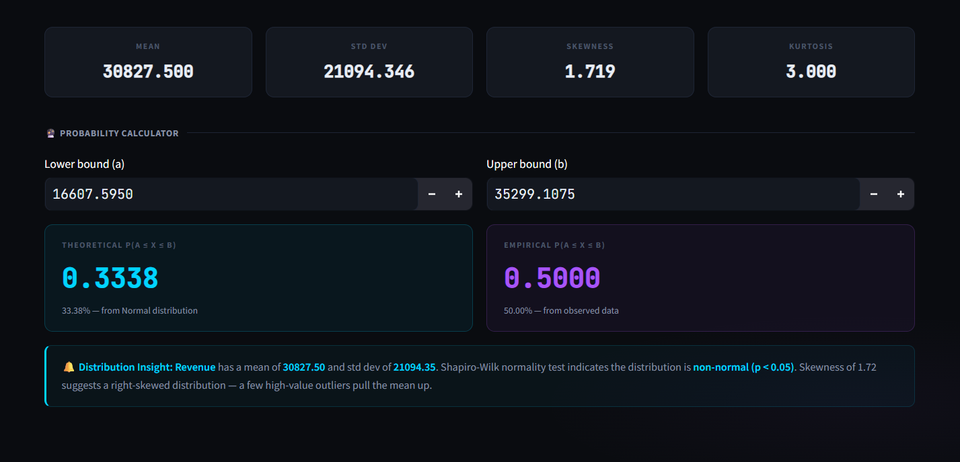
Figure 10: Probability Distribution

Explanation
The Probability Distribution section studies the distribution of a selected numerical metric. It displays a histogram with a normal curve and compares the empirical cumulative distribution with the theoretical cumulative distribution.
The module also reports mean, standard deviation, skewness, kurtosis, and a normality test interpretation. A probability calculator estimates the chance of values falling within a selected interval.

Key Observations
- The histogram shows the observed shape of the selected metric.
- The normal curve helps compare observed behaviour with a theoretical model.
- The CDF chart shows cumulative probability across the metric range.
- The probability calculator converts statistical analysis into an easy interval-based result.

11. Conclusion
The Supply Chain Analytics Dashboard successfully combines descriptive analytics, statistical methods, and machine learning techniques into one interactive tool. The dashboard gives users a clear way to study supply chain performance, compare important business metrics, investigate outliers, build simple predictive models, compare sampling methods, identify clusters, and interpret probability behaviour.
Overall, the project demonstrates how Python, Streamlit, Plotly, Scikit-learn, and SciPy can be used together to create a practical analytics application for supply chain decision support.

