**Experiment :- 1**

**Aim :-** Study of Unix Operating System and its Fundamentals.

**1.Operating System :-**

An **operating system** (**OS**) is [system software](https://en.wikipedia.org/wiki/System_software) that manages [computer hardware](https://en.wikipedia.org/wiki/Computer_hardware) and [software](https://en.wikipedia.org/wiki/Software) resources, and provides common [services](https://en.wikipedia.org/wiki/Daemon_(computing)) for [computer programs](https://en.wikipedia.org/wiki/Computer_program).

An operating system is software that enables applications to interact with a computer's hardware. The software that contains the core components of the operating system is called the **kernel**.

**2.List of the Operating system:-**

Microsoft Windows, Apple macOS, Linux, Android and Apple's iOS.

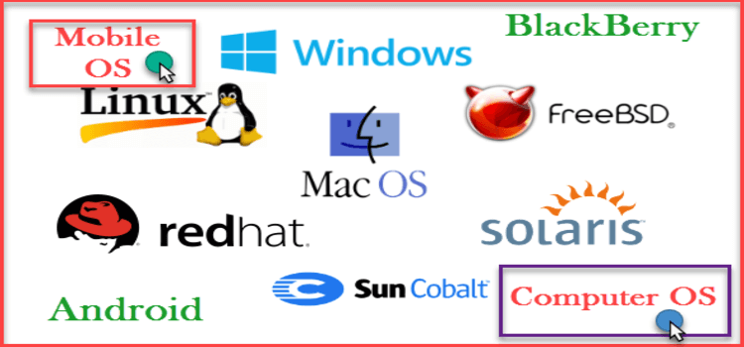

**Windows:-** Windows is a **graphical operating system** developed by Microsoft. It allows users to view and store files, run the software, play games, watch videos, and provides a way to connect to the internet. It was released for both home computing and professional works.

**Linux:-** Linux is an open-source Unix-like operating system-based family on the Linux kernel, and the OS kernel was first published on 17 September 1991 by Linus Torvalds.

**Mac:-** MacOS (previously known as OS X) is the [operating system](https://www.javatpoint.com/operating-system) developed by Apple Inc. for its Mac line of personal computers and workstations. The abbreviation "macOS" stands for **"Macintosh** Operating System. It was first introduced in 2001 as the successor to the classic Mac OS. Since then, it has undergone many updates and improvements to become the sophisticated and user-friendly operating system it is today.

**Andriod:-** Android is a mobile operating system based on a modified version of the Linux kernel and other open-source software, designed primarily for touchscreen mobile devices such as smartphones and tablets.

**IOS:-** iOS is an abbreviation for the iPhone operating system. iOS is the operating system that runs on many of Apple's mobile devices, including the iPhone and iPod Touch. It is the world's second most popular mobile OS, trailing only Android. It is the basis for three other Apple operating systems: iPadOS, tvOS, and watchOS. It is a part of proprietary software. Some are open source under the Apple Public Source License and other licenses.

**3.Unix**

UNIX is a powerful Operating System initially developed by Ken Thompson, Dennis Ritchie at AT&T Bell laboratories in 1970. It is prevalent among scientific, engineering, and academic institutions due to its most appreciative features like multitasking, flexibility, and many more. In UNIX, the file system is a hierarchical structure of files and directories where users can store and retrieve information using the files.

**4.Features :-**

**Multiuser System**

It is a feature that allows the execution of multiple programs for effective utilization of the CPU, also known as Multithreading. This happens in the following two ways:

1. Multiple users are running multiple jobs or applications
2. A single user is running multiple applications or jobs

### Portability

### UNIX systems are portable because it is written in high-level language making them easier to read, write and understand, and hence can be moved to other machines as well. This means that the code can be compiled and changed on other machines as well.

### Hierarchical File System

For storing information, the UNIX system uses a hierarchical file structure which has maximum flexibility in storing and retrieving information. Its implementation is efficient and maintenance is easy to handle.

### UNIX Toolkit

### UNIX provides various facilities regarding types of tools like awk, UNIX grep, sed, etc. The general-purpose tool used is a network application, compiler, interpreter, etc. Various server programs are also included for providing remote administrative services.

### Program Execution

To execute UNIX programs, the only thing that a user needs to do is type its name, and preceding name, type ./ for checking if the file is executable or not.

### Multitask system

A user might run multiple tasks concurrently, for instance, editing a file, browsing the net, printing the file, etc. To cater to users' multiple needs, a kernel is designed which means it can be done parallelly.` In this, in the foreground, only one task is seen as running while all the other tasks run in the background. Users can block/terminate any of the tasks and can switch between them.

### Pattern Matching

UNIX provides a complex feature for matching patterns in file names. A special character, meta-char ‘’ is used by the system for matching the file name. The matching is not limited to a filename, instead, there are various meta-char in UNIX. There are advanced tools available that use regular expression which is framed with characters of its set.

### The Building-Block Approach

For every kind of work that is performed by the UNIX system, the developers thought of keeping a short command for simple tasks. It is used when two commands are to be connected and used. Two commands can be used by using (‘|’) pipes. For instance, $ ls | wc is used for connecting two commands to create a pipeline. The command counts the number of files that resides in the directory. Commands like these can be used for filtering or manipulating the data.

**5.Distribution:-**

Famous Linux distributions are Ubuntu, Fedora Linux, and Debian, the latter of which is composed of several different modifications and distributions, including Xubuntu and Lubuntu.

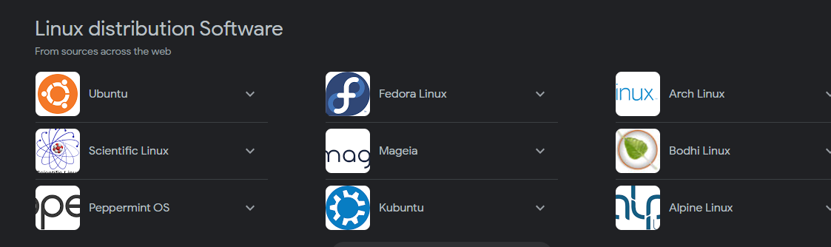

**6.History:-**

UNIX was originally developed at Bell Laboratories as a private research project by a small group of people starting in 1969. This group had experience with a number of different operating systems research efforts in the 1970's. The goals of the group were to design an operating system to satisfy the following objectives:

• Simple and elegant

• Written in a high level language rather than assembly language

• Allow re-use of code

**7.Applications :-**

#### 1.Multi-tasking.

#### 2.A backbone of modern technologies.

#### 3. Impactful towards other OS

#### 4. An invention of Linux

#### 5. A host of services

#### 6. Command-line functionality

#### 7. Text-based processes

#### 8. Regular Expression

#### 9. Modularity and reusability

#### 10. Network protocol

**8.Comparision of Windows And Linux**

|  |  |  |
| --- | --- | --- |
| **Feature** | **UNIX** | **Windows** |
| **Origin** | Developed at Bell Labs by AT&T in the 1970s | Developed by Microsoft Corporation |
| **Type** | Unix-like operating system | Proprietary operating system |
| **Kernel** | Monolithic | Hybrid (monolithic with microkernel-like components) |
| **User Interface** | Primarily command-line interface (CLI) | Graphical User Interface (GUI) with CLI capabilities |
| **File System** | Hierarchical file system (typically using the Unix File System or variants) | NTFS (New Technology File System) |
| **Licensing** | Various flavors of UNIX are open-source or commercial | Proprietary license |
| **Hardware Compatibility** | Runs on a wide range of hardware platforms | Primarily designed for Intel-compatible processors |
| **Multitasking** | Preemptive multitasking and multiprocessing | Preemptive multitasking and multiprocessing |
| **Security** | Built-in security features with fine-grained access controls | Security features with user account control and permissions |
| **Networking** | Native support for networking protocols and services | Native support for networking protocols and services |
| **Development Environment** | Robust development tools and compilers | Integrated Development Environment (IDE) with compilers |
| **Popular Use Cases** | Servers, supercomputers, embedded systems | Personal computers, servers, gaming consoles, embedded systems |