Report summary

(dobox)

Dobox (a website in which you can add your autobiography to others so that other will also get motivated from you).



It not just a website it is a platform to motivate thousands of people who are reading your autobiographies. so **share your journey with us.**

Let make your story motivation for others!!

**TEAM MEMBERS:**

* 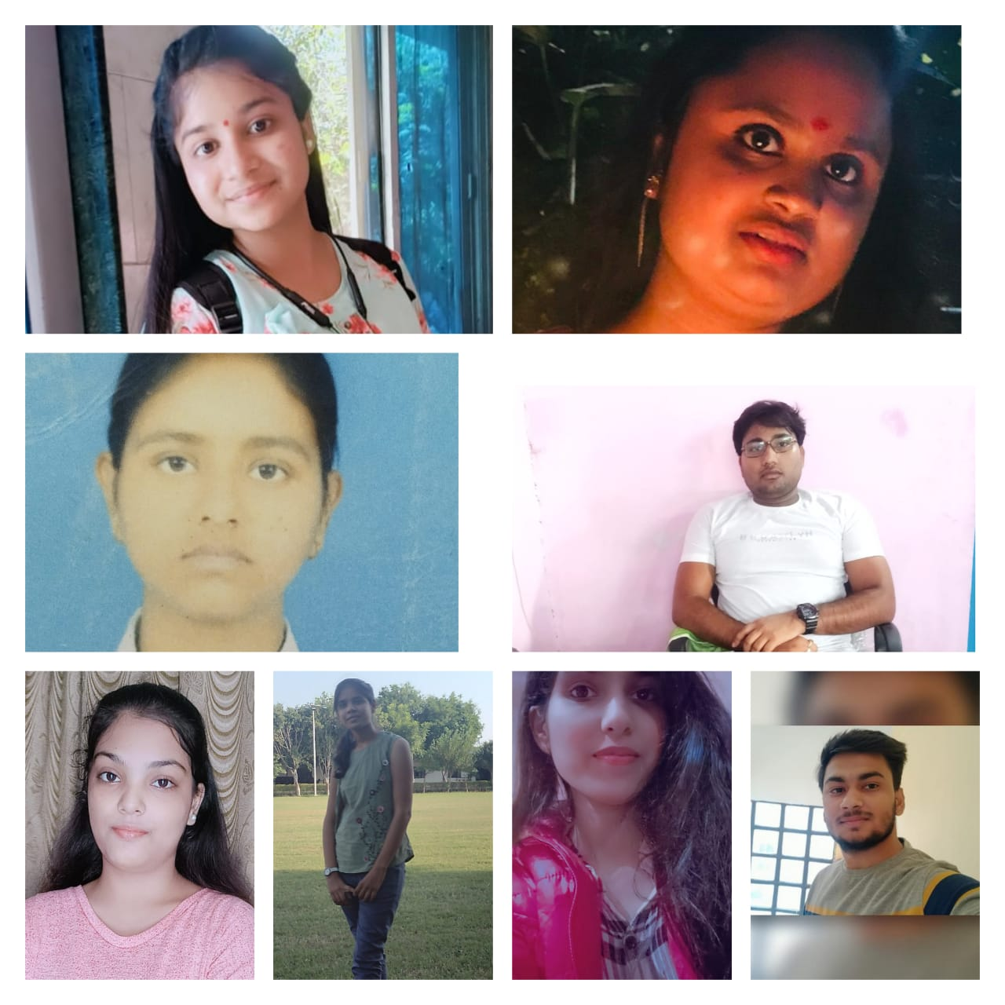**Anjali Jain (201500094)**
* **kajal Rathore (201500323)**
* **Naina Johri (201500422)**
* **Shubhi Agrawal(201500682)**
* **Anjali Singh (201500096 )**
* **ShivamParashar(201500652)**
* **Anjali Kumari (201500095)**
* **Jashvant Kumar (201500311)**
* **Priya Sengar (2115990014)**

LANGUAGE’S USED:-

HTML:- HTML stands for Hyper Text Markup Language. It’s the core markup language of every web page. With HTML, we use it to build the structure of the website block by block with HTML elements. This is all the web programmer start from and it’s super easy to learn.

CSS:- The CSS stands for 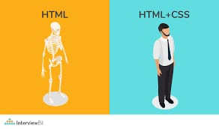Cascading Style Sheets. Obviously,

CSS is a style sheets, it’s able to control how the website looks like and how the website should appear at the front-end of the web page.As we said, the HTML are building the structure of the site ,

and now we are using the CSS to make the site looks great and better.

JAVASCRIPT:- When you’d like to make your site more interactive or add motion logics to your site. 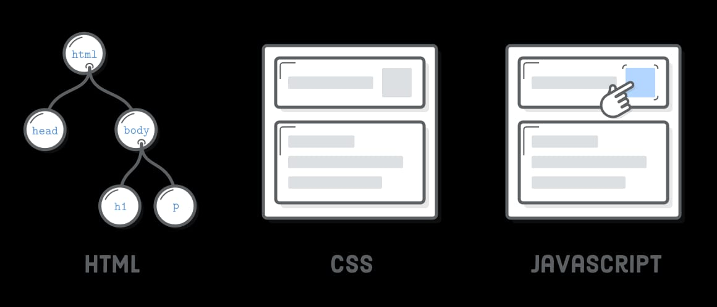We use JavaScript to implement it. For example, you can display a pop-up window or dynamically change the HTML and CSS code with Java-script

Main page :

The main page is the**opening page that visitors navigate to a site from a search engine**. it is also called as a landing page that is created to to attract all visitors.

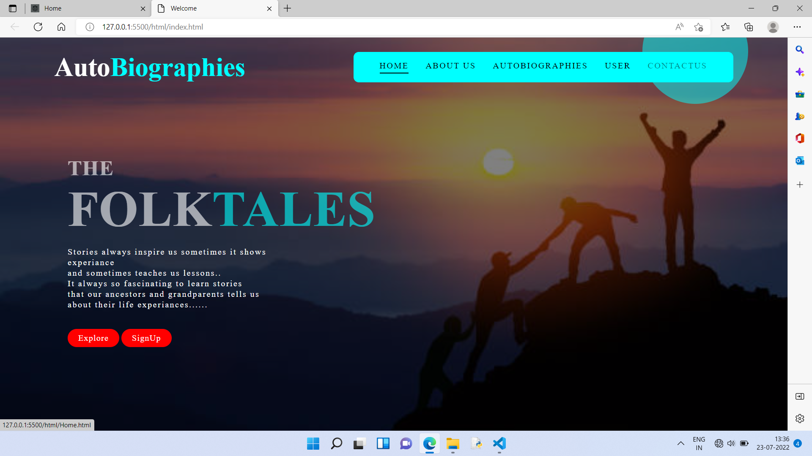

**Home page:**

For a Web user, the home page is the first Web page that is displayed after starting a Web browser.

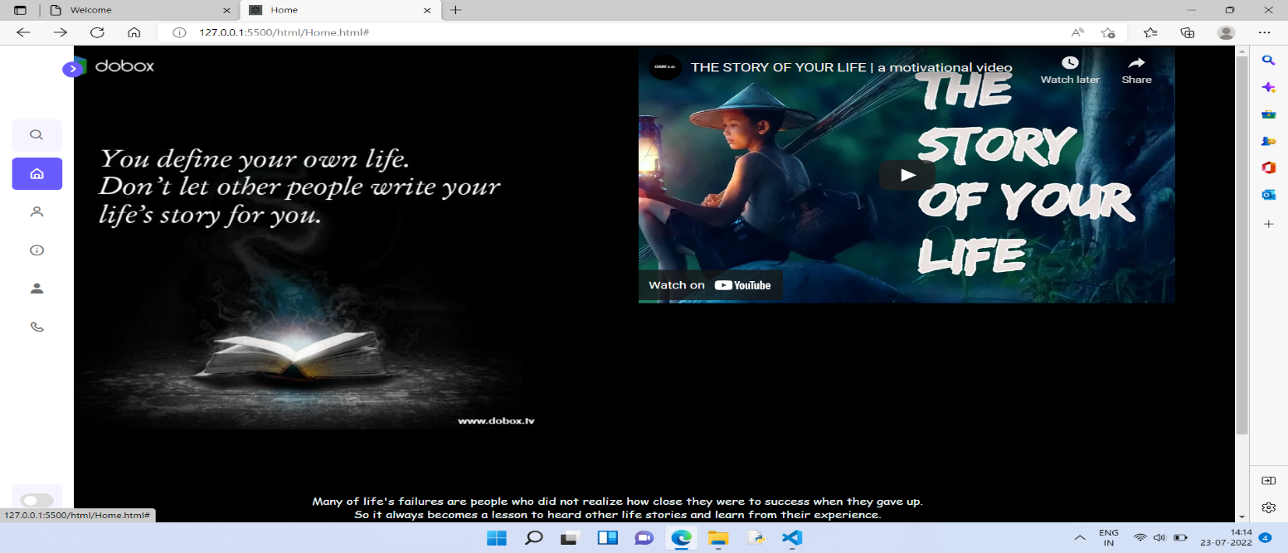

**USER LOGIN PAGE:**

A login page is a web page or an entry page to a website that requires user identification and authentication, regularly performed by entering a username and password combination.

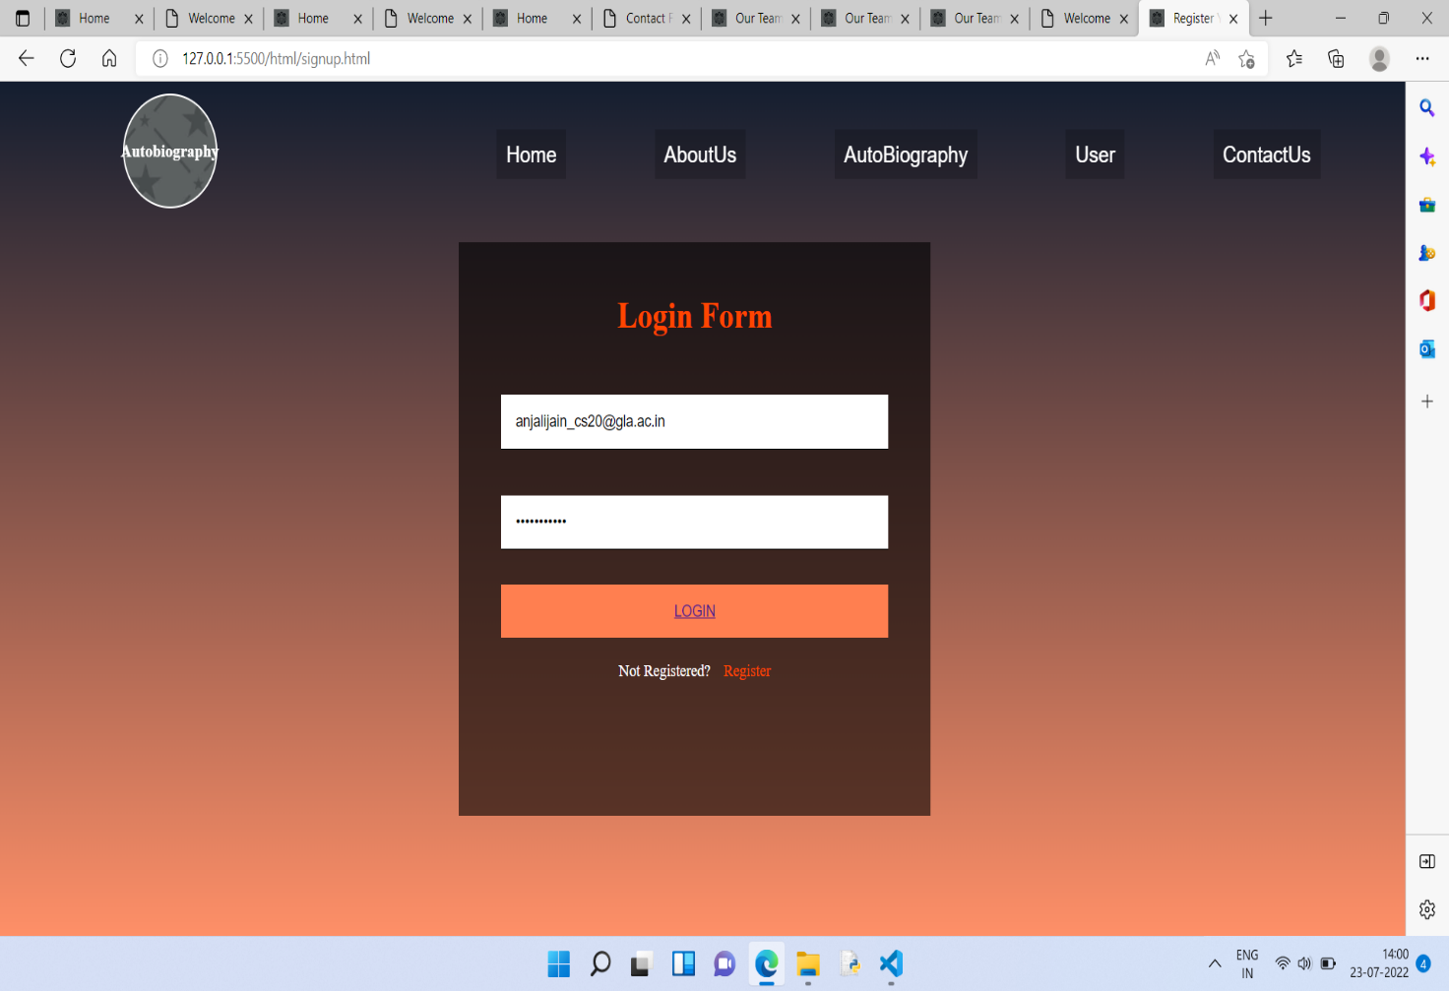

Logins may provide access to an entire site or part of a website. Logging in not only provides site access for the user, but also allows the website to track user actions and behaviour. Logging off a webpage or site may be manual by the user or they can occur automatically when certain conditions (such as closing the page, turning off the computer, a long-time delay, etc.) occur.

BECAME A PART OF DOBOX:-

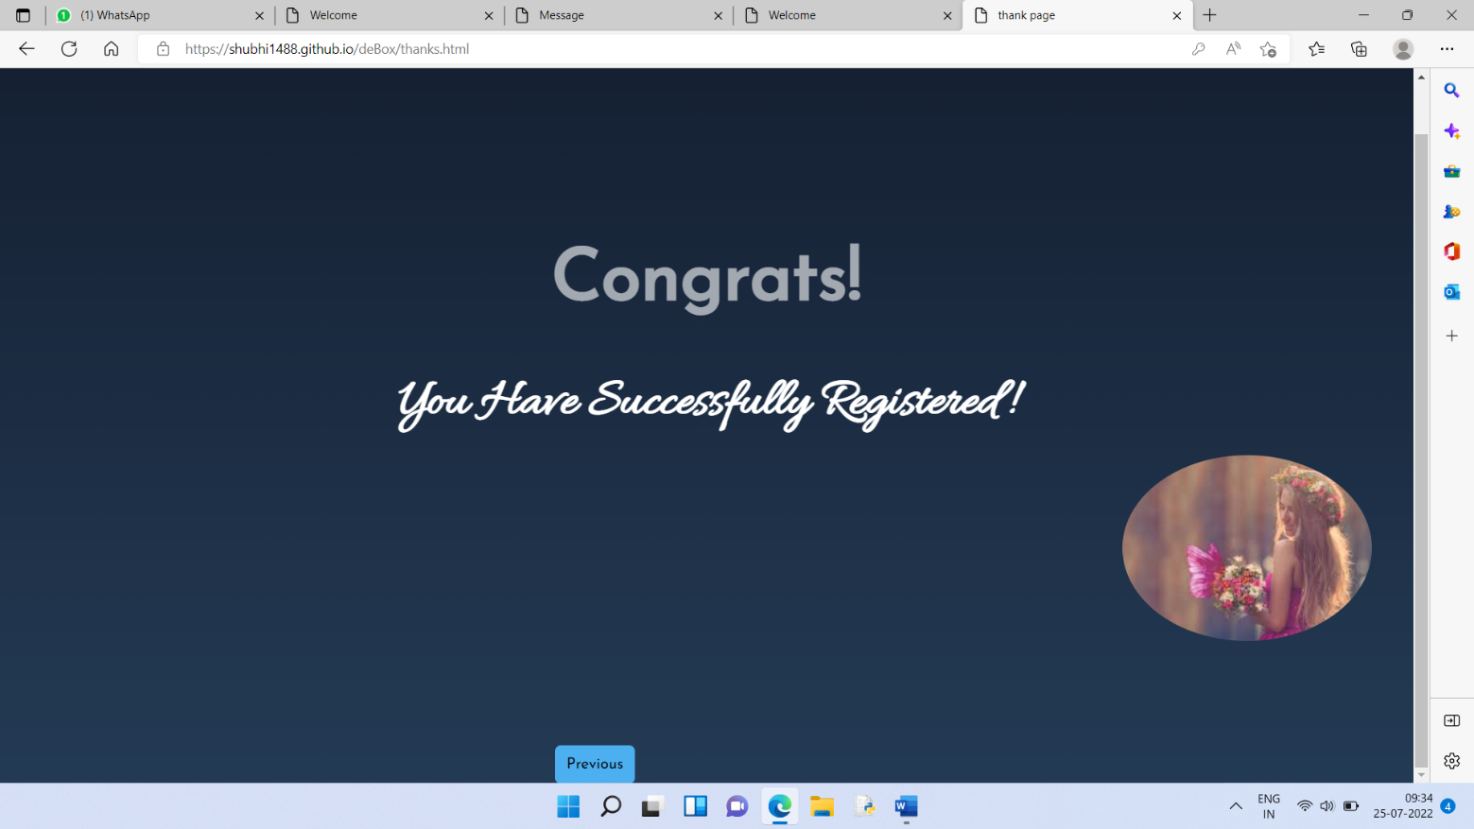

Let explore and share your struggle with others so that everyone can get motivated from you.

**Navigation bar:**

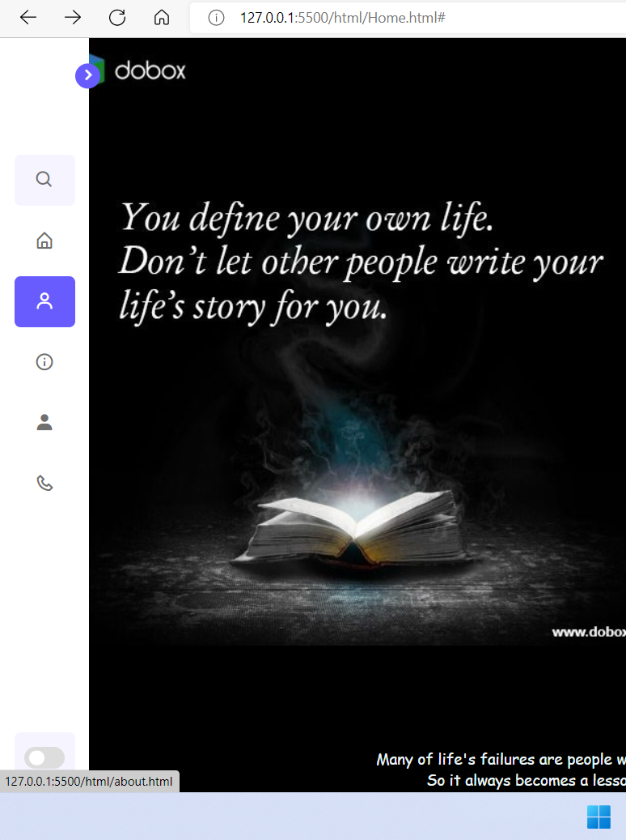

A navigation bar (or navigation system) is a section of a graphical user interface intended to aid visitors in accessing information. Navigation bars are implemented in file browsers, web browsers and as a design element of some web sites.

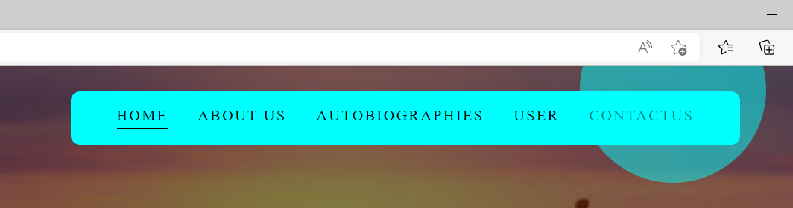

File browsers use a navigation bar to assist the user in traversing the filesystem.

**About us:**

The about us page helps online retailers develop a relationship with customers and build trust by putting a face and a story to the name on the storefront.

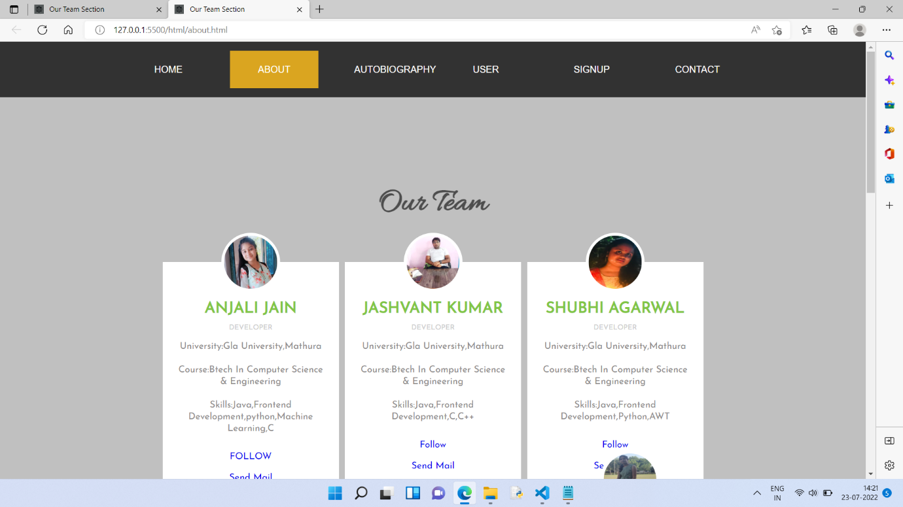

About us pages serve much the same purpose for retailers who sell less-common or unique items as well. This page of your website is an essential source of information for all who want to know more about your business.

About Us pages are where you showcase your history, what is unique about your work, your company’s values, and who you serve.

**Contact us:**

A contact page provides guidance for existing customers and offers an overview of your brand for new visitors.

If you ask customers to submit inquiries on your page, ensure you use the Contact Us form wisely.

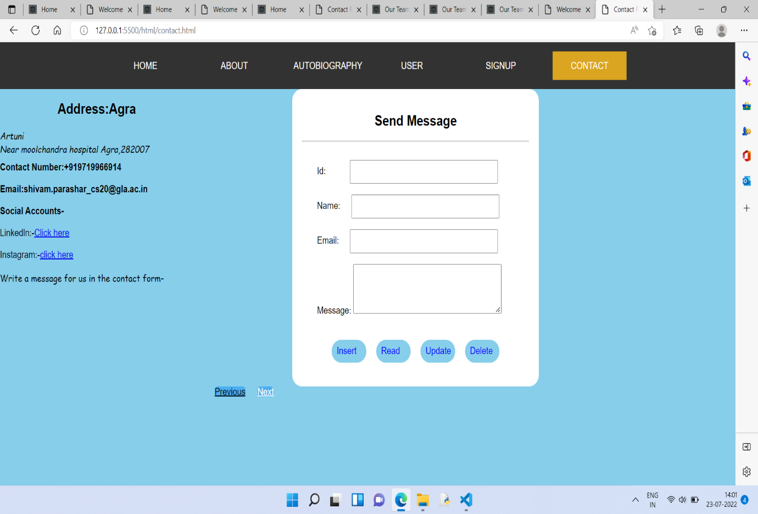

**Advantages of Contact Us page**

A new visitor can quickly get in touch with you.

Describe how your business can help solve the visitor’s problems.

Include an email and phone number so visitors can get in touch with you on their first attempt.

Have a call-to-action to provide visitors with another action to take if they choose not to complete the form.

adding and searching your favourite autobiography:

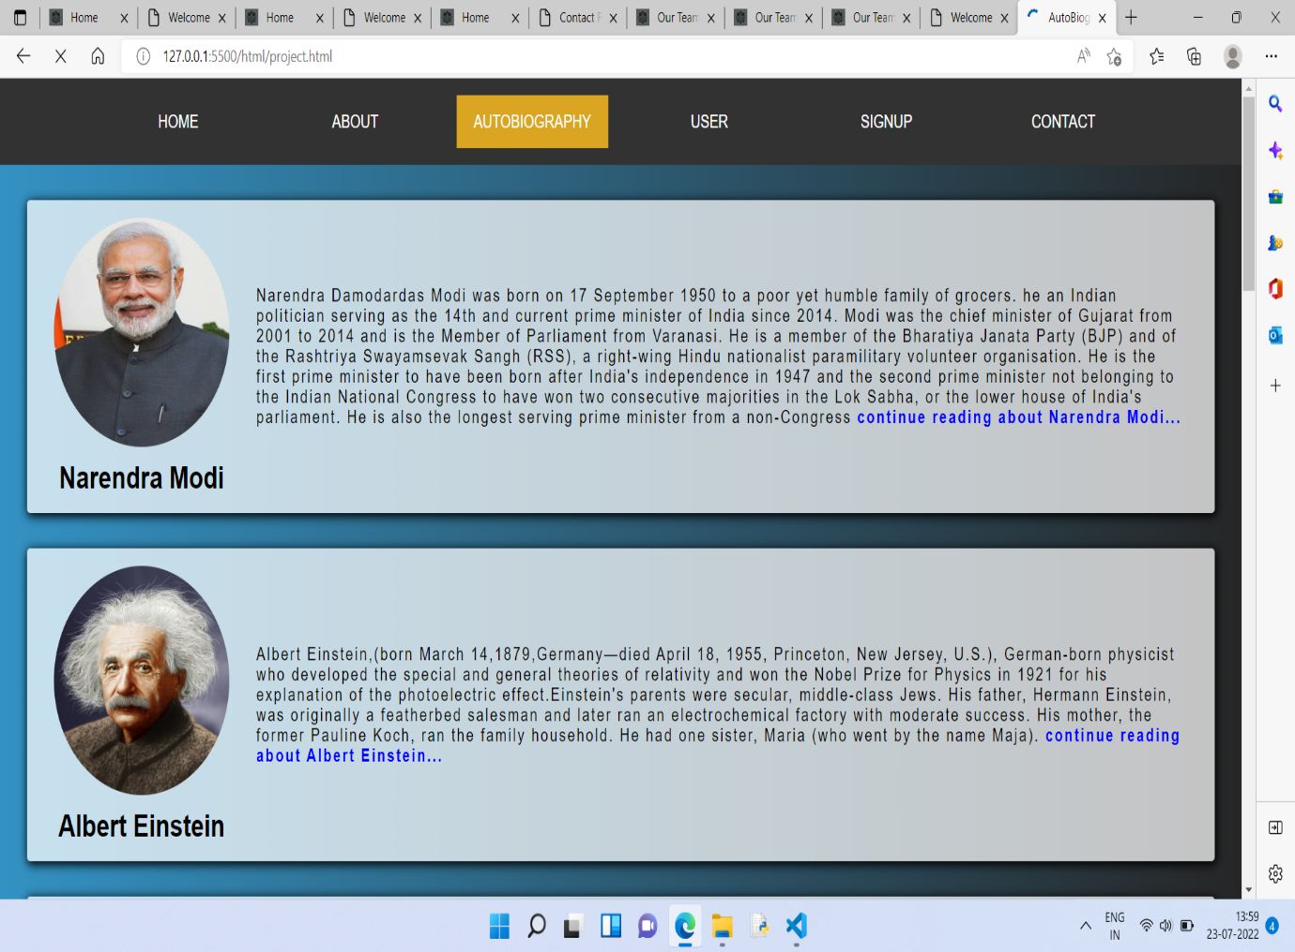

Add your autobiography:

If user want to share their own motivational journey so here is best opportunity to them

So let share your experience with others so that no one repeat those mistakes in their life and also get connected with others.

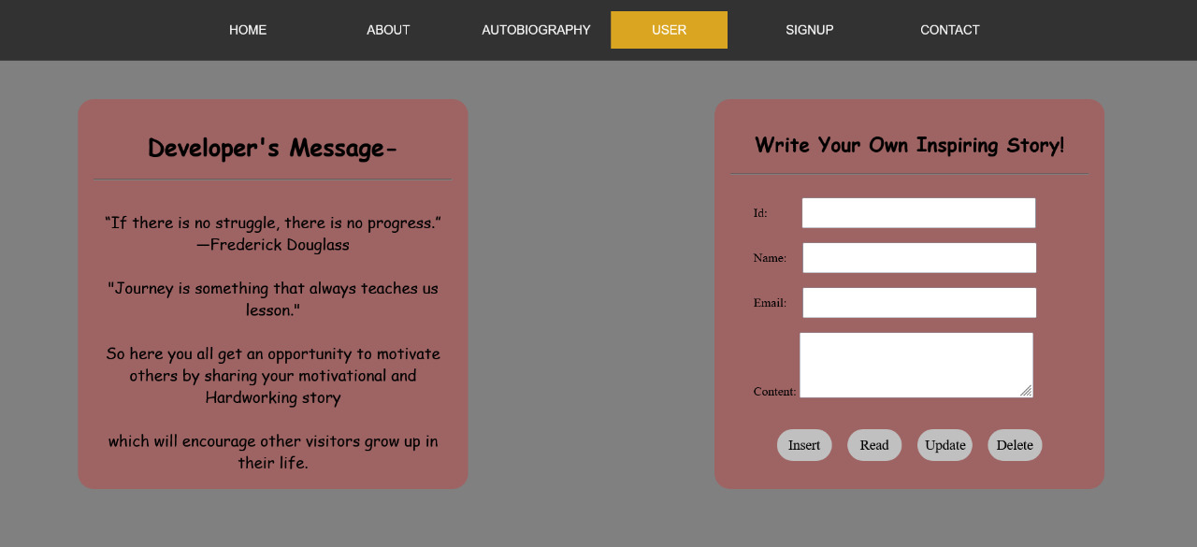

**Stay connected with “do-box “!!**

What is an autobiography??

the biography of oneself narrated by oneself. Autobiographical works can take many forms, from the intimate writings made during life that were not necessarily intended for publication (including letters, diaries, journals, memoirs, and reminiscences) to a formal book-length autobiography.

**TYPES OF AUTOBIOGRAPHY:**

**An autobiography may be placed into one of four very broad types: thematic, religious, intellectual, and fictionalized.**

**An autobiography is a written literary work that is in the form of a novel or a short story. An autobiography is the story of the life of a person, written by that person himself, for example, Mahatma Gandhi’s My Experiments with Truth.**

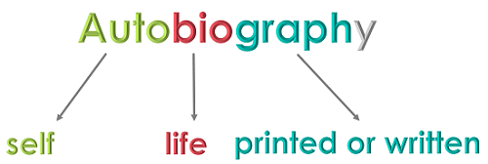

**An autobiography can be identified easily, as its written in the first person point of viewpoint, the writers, I, me, and myself.**

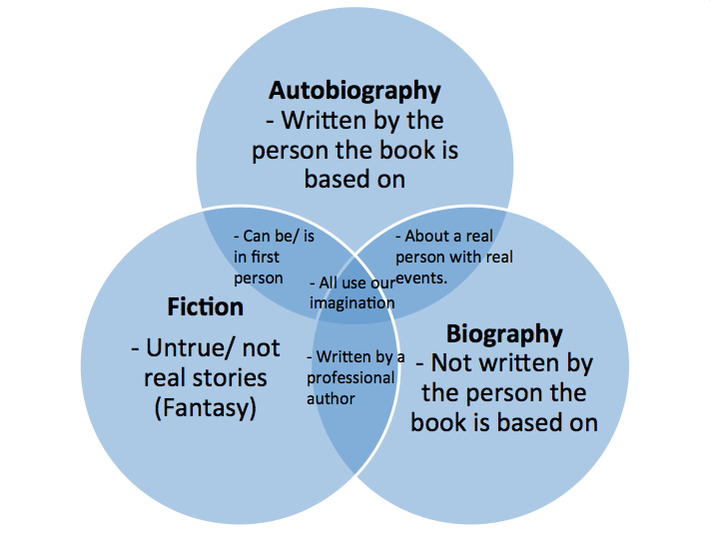

**REFERENCES:**

<https://shubhi1488.github.io/deBox/>

let share your beautiful journey

with others so that

every0ne can get motivation from it.

**We are waiting for your valuable feedback.**

