# MPMC LAB EXERCISE

# EXERCISE NO: 03

AIM:

To write an assembly language program for Addition of two 16-bit numbers.

ALGORITHM:

1. Load the first data into register AX from memory.

2. Load the second data into register BX from memory.

3. ADD content of register BX with the content of register AX.

4. Now load the result value from AX to memory.

PROGRAM:

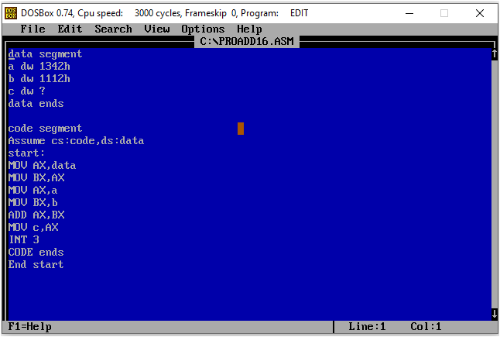

EXECUTION: 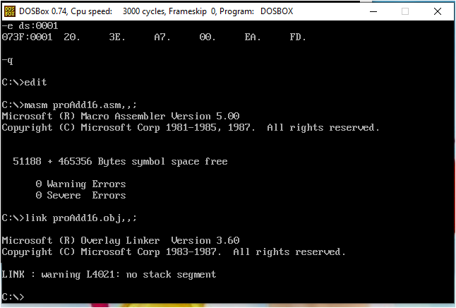

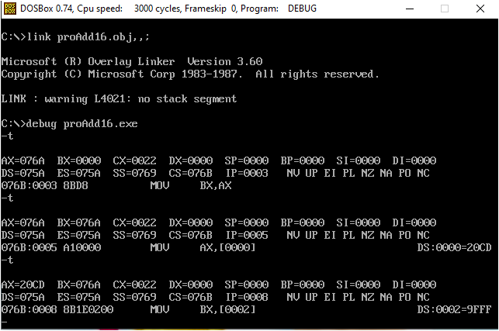

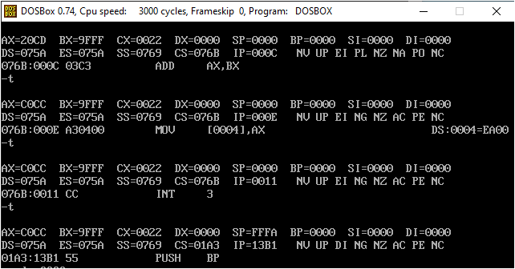

# RESULT:

HENCE ,THE PROGRAM IS SUCCESSFULLY EXECUTED.