# MPMC LAB EXERCISE

# EXERCISE NO: 08

# AIM: To write an assembly language program for Displaying a string.

# ALGORITHM:

1. Create a string
2. Load the effective address of the string in dx using LEA command
3. Print the sting by calling the interrupt with 9H in AH
4. The string must be terminated by ‘$’ sign.

# PROGRAM:

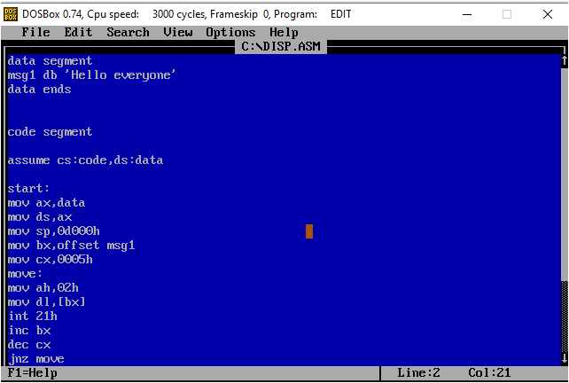

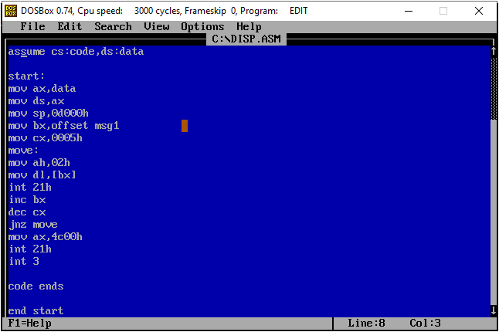

# EXECUTION:

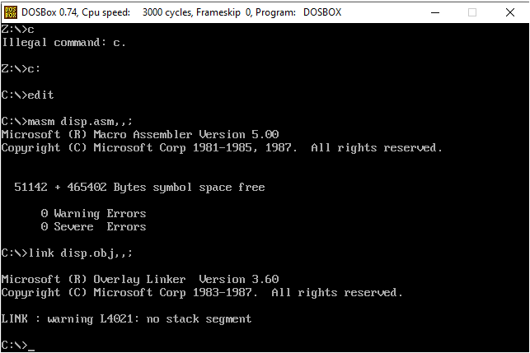

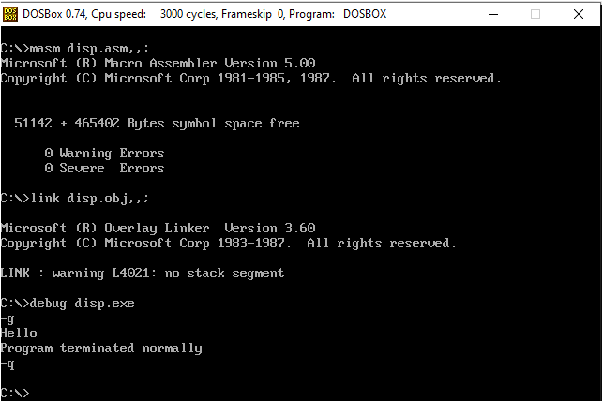

# RESULT:

Hence, the program is executed successfully.