# MPMC LAB EXERCISE

# EXERCISE NO: 07

AIM: To write an assembly language program for logical operations using 8086.

# ALGORITHM (AND):

1. Move the first 8 bit operand from [0010] address to AL.
2. Move the second 8 bit operand from [0100] address to BL.
3. AND AL and BL (The result is stored in AL).
4. Move AL to AX.
5. Terminate the program.

# PROGRAM (AND):

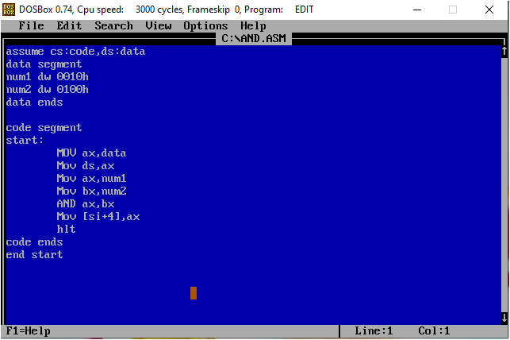

# EXECUTION (AND):

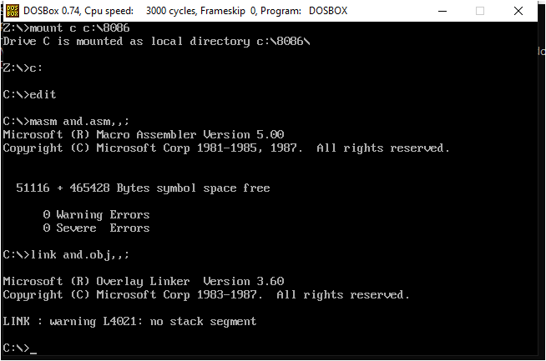 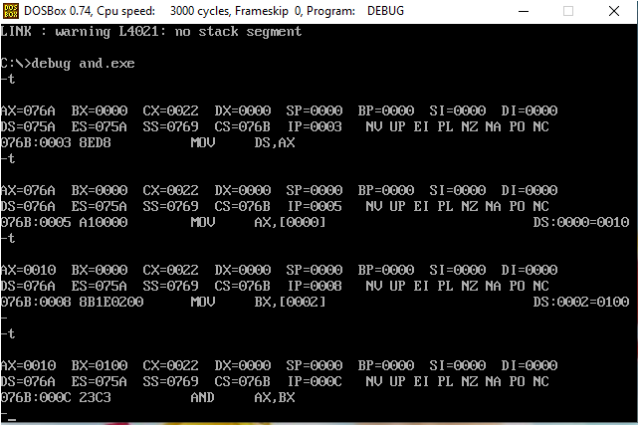

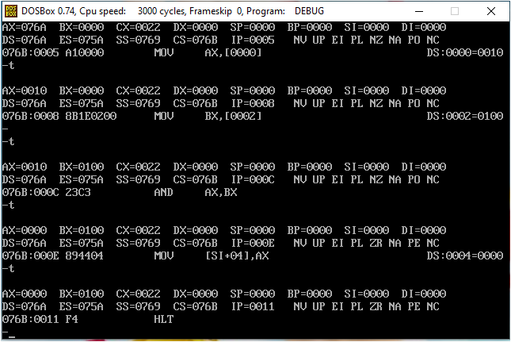 ALGORITHM (OR):

1. Move the first 8 bit operand from [0010] address to AL.

2. Move the second 8 bit operand from [0100] address to BL.

3. OR AL and BL (The result is stored in AL).

4. Move AL to AX.

5. Terminate the program.

# PROGRAM (OR):

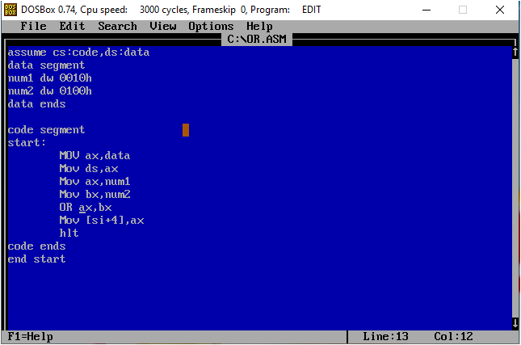

# EXECUTION (OR):

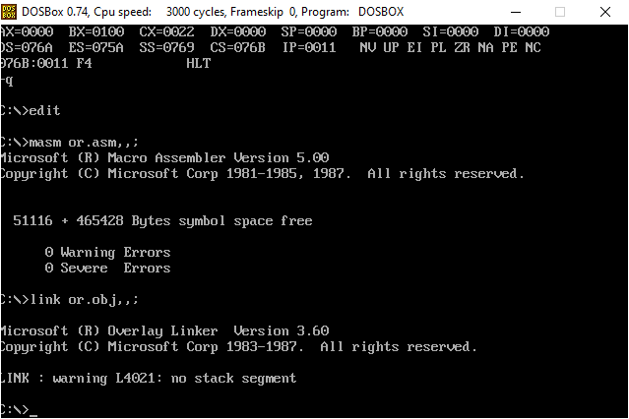

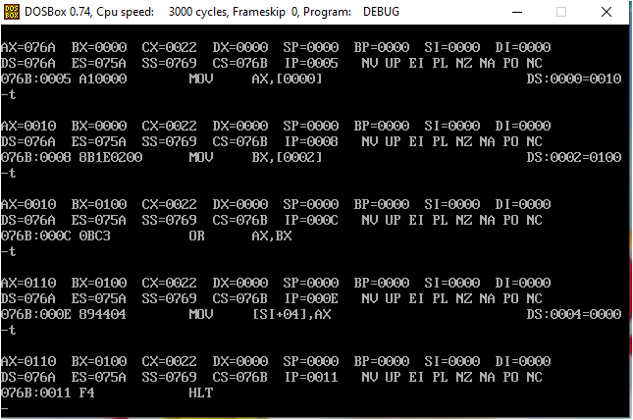

# ALGORITHM (XOR):

1. Move the first 8 bit operand from [0010] address to AL.

2. Move the second 8 bit operand from [0100] address to BL.

3. XOR AL and BL (The result is stored in AL).

4. Move AL to AX.

5. Terminate the program.

# PROGRAM (XOR):

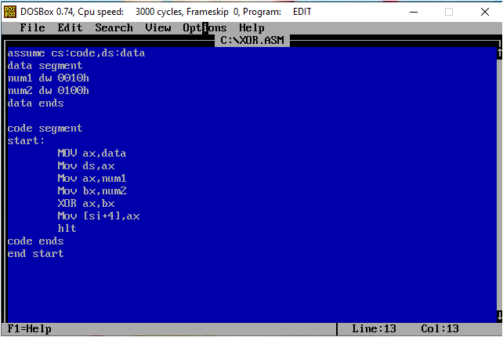

# EXECUTION (XOR):

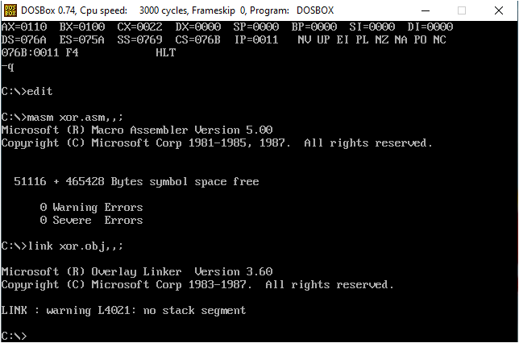

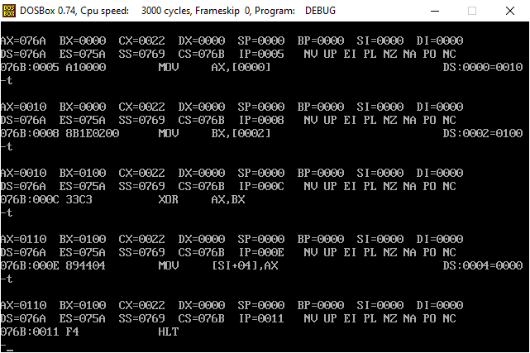

# RESULT:

Hence, the program is successfully executed.