# MPMC LAB EXERCISE

# EXERCISE NO: 05

# AIM:

To write an assembly language program for Multiplication of two 16-bit numbers.

# ALGORITHM:

1. MOV is used to load and store data.

2. MUL is used to multiply two 16-bit numbers.

3. HLT is used to stop the program.

4. AX is an accumulator which is used to store the result.

5. BX, DX are general purpose registers where BX is used for multiplication and DX is used for result.

PROGRAM: 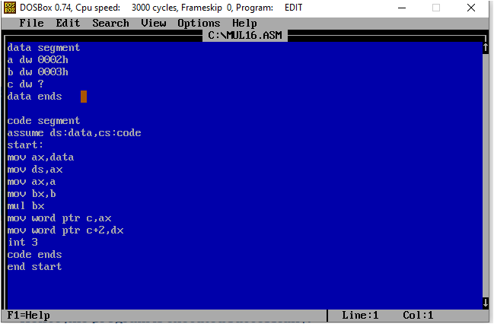

# Execution:

# 

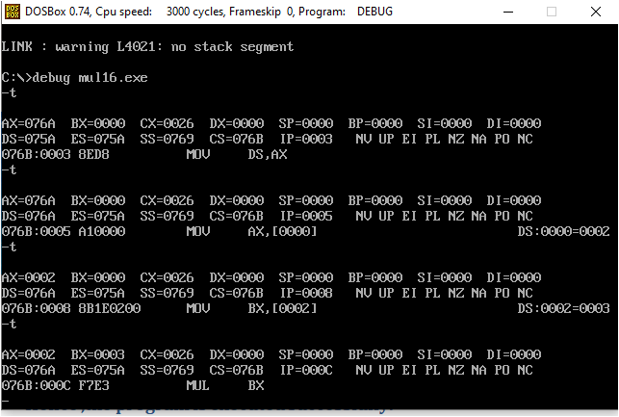

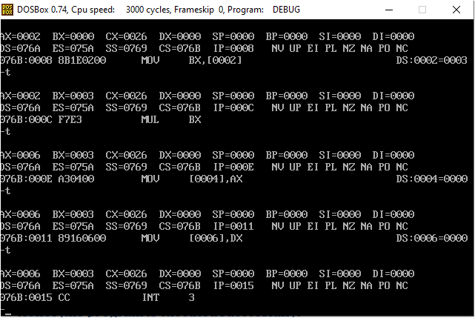

# Result:

Hence, the program is executed successful.