# MPMC LAB EXERCISE

EXERCISE NO: 02

AIM:

To write an assembly language program for Subtraction of two 8-bit numbers.

ALGORITHM:

1. Load the first data into register AX from memory.

2. Load the second data into register BX from memory.

3. SUB content of register BX with the content of register AX.

4. Now load the result value from AX to memory.

PROGRAM:

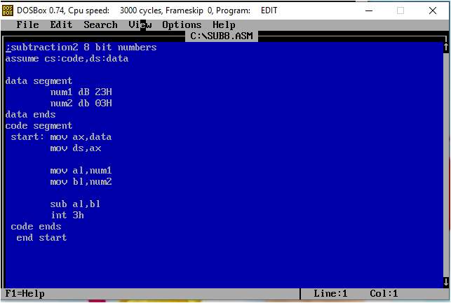

EXECUTION:

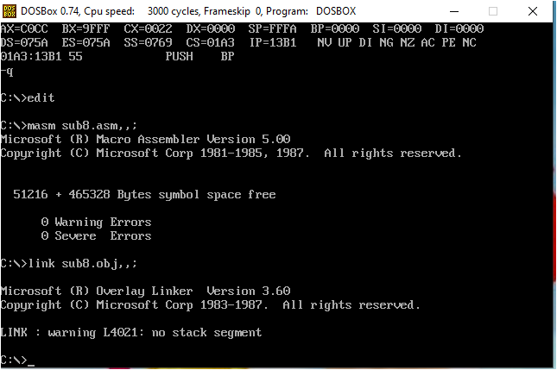

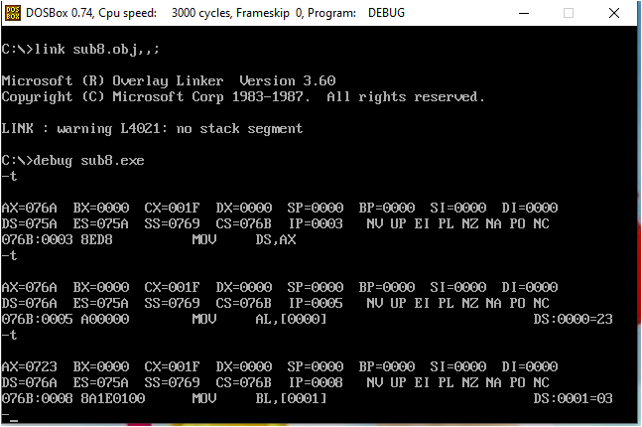

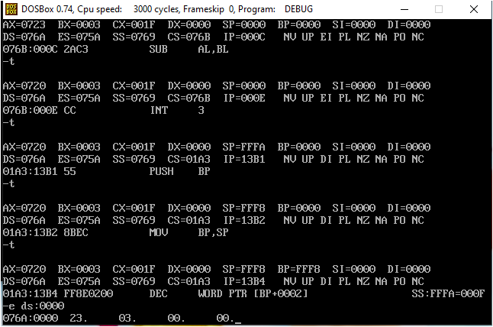

# RESULT:

INPUT -> AL=23H AND BL=03H

OUTPUT->AL=20H (23-03)

HENCE, THE PROGRAM IS SUCESSFULLY COMPLATED.