# MPMC LAB EXERCISE

# EXERCISE NO: 06

# AIM:

To write an assembly language program for Divide of two 16-bit numbers.

# ALGORITHM:

1. Initialize register BC as 0000H for Quotient.
2. Load the divisor in HL pair and save it in DE register pair.
3. Load the dividend in HL pair.
4. Subtract the content of accumulator with E register.
5. Move the content A to C and H to A.
6. Subtract with borrow the content of A with D.
7. Move the value of accumulator to H.
8. If CY=1, goto step 10, otherwise next step.
9. Increment register B and jump to step 4.
10. ADD both contents of DE and HL.
11. Store the remainder in memory.
12. Move the content of C to L & B to H.
13. Store the quotient in memory.

# PROGRAM:

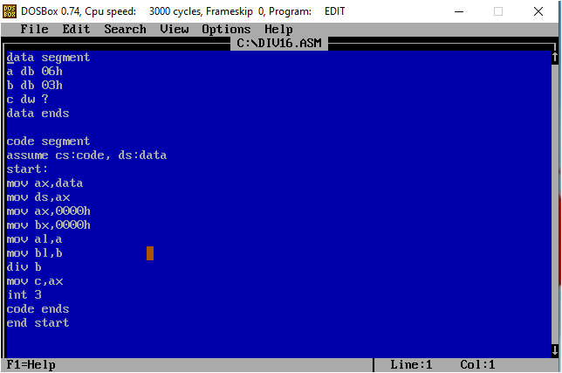

# Execution:

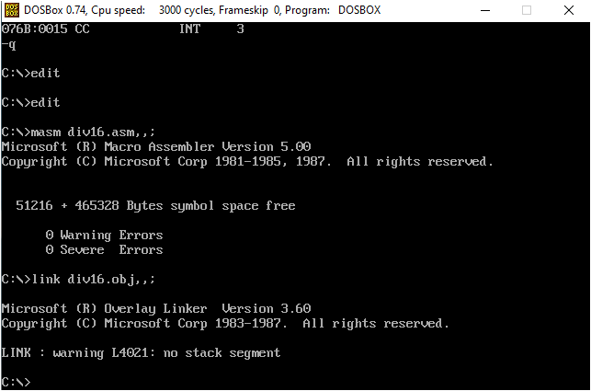

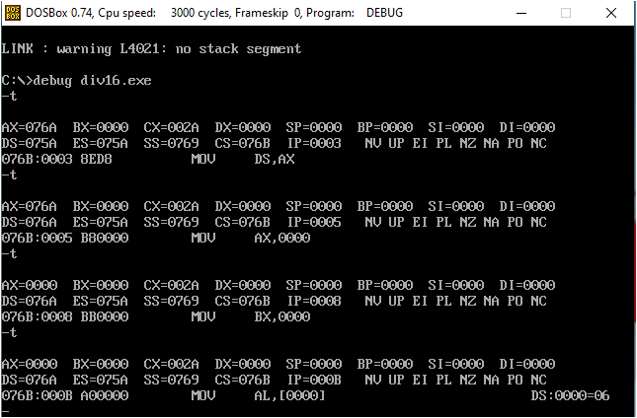

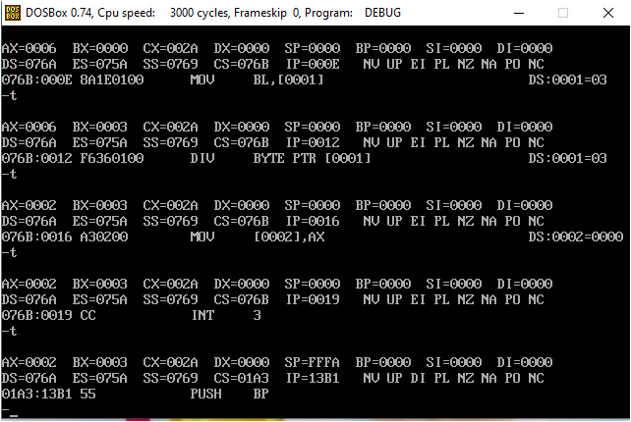

# Result:

Hence, the program is successfully executed.