# MPMC LAB EXERCISE

# EXERCISE NO: 09

AIM: To write an assembly language program for String copy.

# ALGORITHM:

1. Set the value of offset SI.
2. Set the value of offset DI.
3. Load the value 0000 into register AX.
4. Load the data of AX register into DS (data segment).
5. Load the data of AX register into ES (extra segment).
6. Load the data of offset SI into CL register and load value 00 into CH register.
7. Increment the value of SI by one.
8. Clear the directional flag so that data is read from lower memory to higher memory location.
9. Check the value of CX, if not equal to zero then repeat step10 otherwise go to step 11.
10. Transfer the data from source memory location to destination memory location and decrease the value of CX by one.
11. Stop.

# PROGRAM:

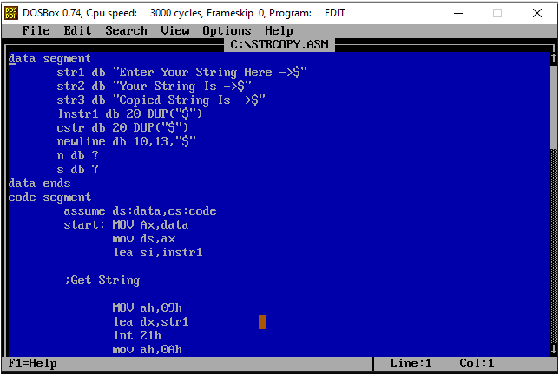

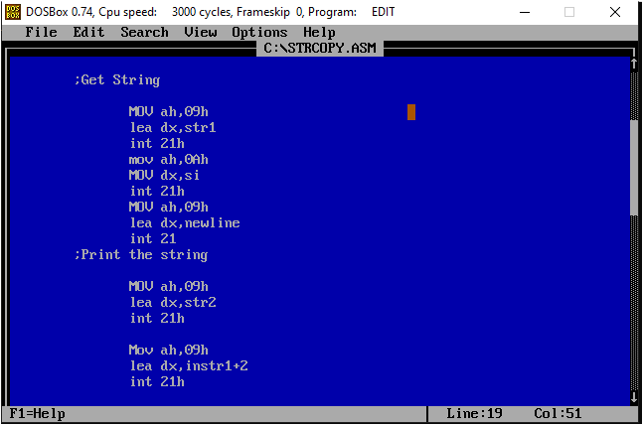

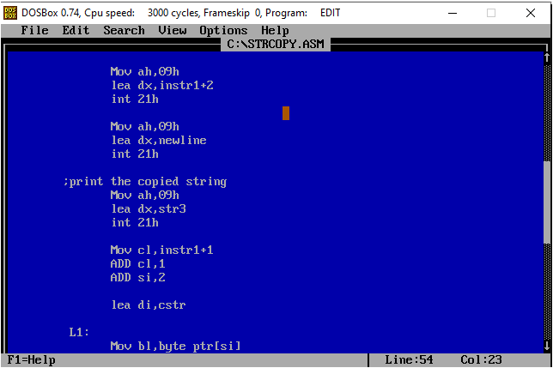

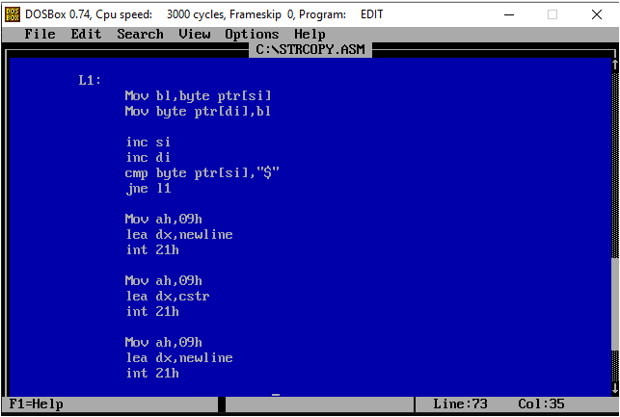

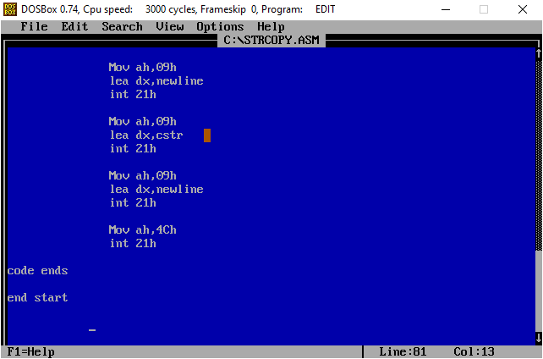

# EXECUTION:

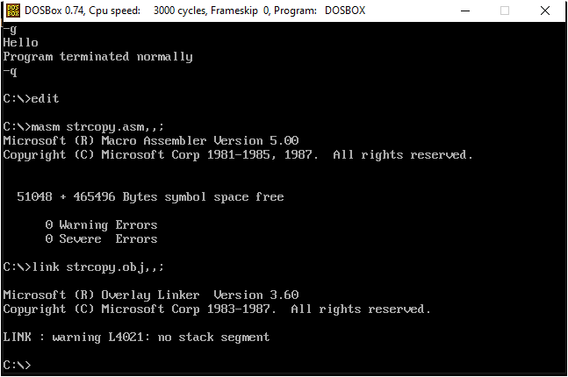

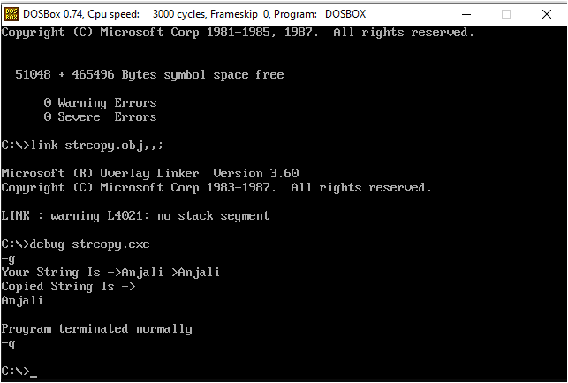

# RESULT:

Hence, the program is executed successfully.