# MPMC LAB EXERCISE

EXERCISE NO: 04

AIM:

To write an assembly language program for Subtraction of two 16-bit numbers.

ALGORITHM:

1. Load the first data into register AX from memory.

2. Load the second data into register BX from memory.

3. SUB content of register BX with the content memory.

4. Now the result is in AX.

PROGRAM:

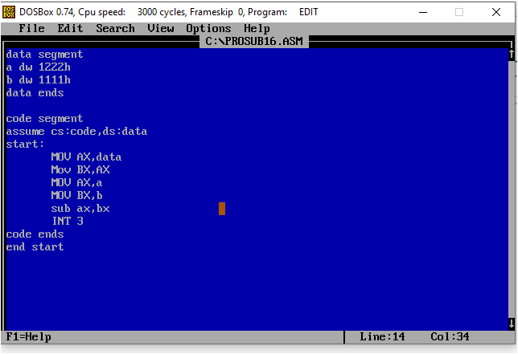

EXECUTION:

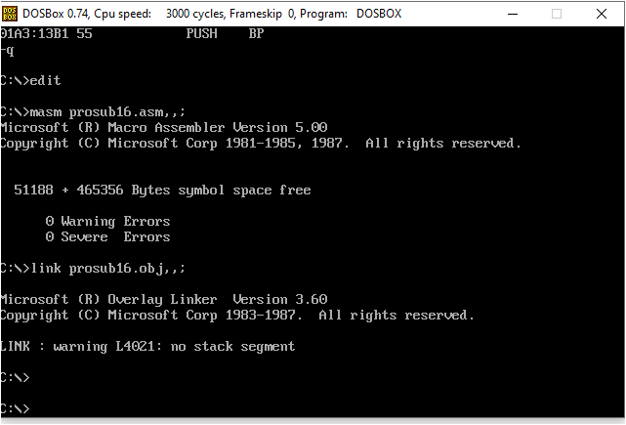

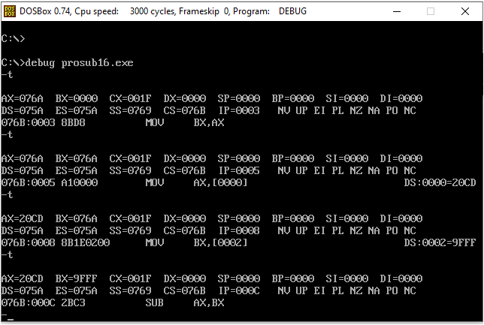

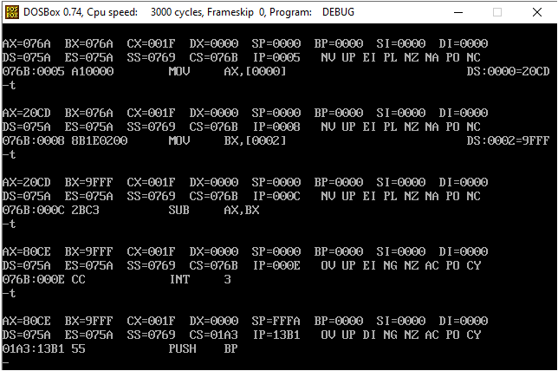

# RESULT:

# Hence ,the program is executed successfully.