**Case 1:**

**1) Test cases for Automation.**

a. Go to website.

b. Add new item to the inventory with name and price only, and click on submit.(should failed with error".

c. again add the item with valid details.

d. search the item added to inventory and validate the details.

e. delete the items from inventory and search item again.

**2) Test cases for front end.**

a. open the page and add new item with price having null value/spaces/special character.// Should failed with error message.

b. Check the visual style , It should be both horizontally and vertically central.

**3) Test cases for backend requirement.**

a. Validate item details in table fields.

**Case 3:**

1) After entering the spaces or special characters into fields "Total Load" page load failed with error "Error in ex.Try after sometime".

3) Load signature page loading again and again when user click on random place on the pages, even if signature uploaded successfully.

4) After uploading the signature and the document deleted by the system when user click on "Upload Signature" again(Valid if user need to re-upload the signature, but what if by mistake user clicked on that button or link), which is incorrect.

5) After uploading the signature and the document deleted by the system when user click on "Upload Signature" again(Valid if user need to re-upload the signature, but what if by mistake user clicked on that button or link), which is incorrect.

6)User can select file other than "jpg" or "jepg".

7) As a end user , not able to upload the signature/occupancy proof/identity proof.

8) Below field is disable even after user click on "view Terms & conditions Declaration".

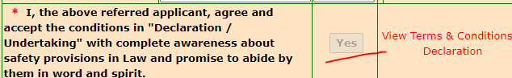

9)Below fields still have a value , after clicking on "Reset All".

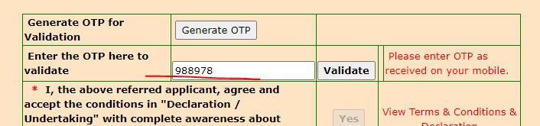

10 )Image is not nullified after clicking on "Reset All".

