Vi Editor - Assignments
- Invoke the vi editor with a filename (which is to be created)
Ans : vi editor.c
- Type a few lines(at least 10) in the editor. Let one or more lines contain the words given below.
delhi mumbai chennai Mumbai
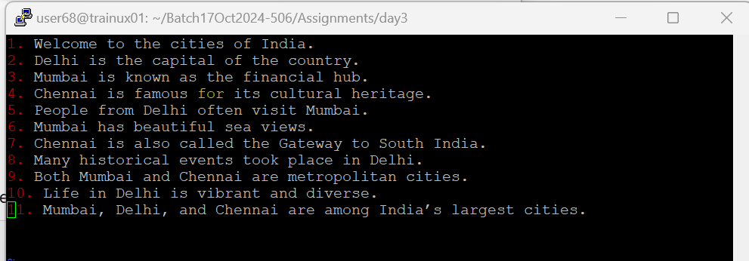
- Save the file without exiting the editor
Ans: To save the file without existing the editor we use :w.
- Navigate quickly to the beginning & end of the file
Ans: To the beginning: Press gg.
To the end: Press G.
- Delete first two lines & copy it after the last line.
Ans: Delete: 2dd
Go to the end: G
Paste: p

- Now Copy the last two lines & paste them before the first line.
Ans: Copy: 2yy
Go to the beginning:
gg Paste: P
- Combine last two lines of the file in a single line.
Ans: Navigate to the last two lines, then use J to join them
- How will you insert a line before the first line? (Hint : Find such an option in the tutorial document)
Ans: Go to the beginning: gg
Press O to insert a new line above.
- How will you paste a yanked buffer before the current line?
Ans: Use P to paste before the current line
- Search the document for a string “delhi”
Ans: Type /delhi and hit Enter.
- Replace a single occurrence of “delhi” with “Mumbai”
Ans: Use :s/delhi/Mumbai/ and hit Enter.
- Replace all occurrences of “delhi” on a particular line with “Mumbai” using one command
Ans: Use :s/delhi/Mumbai/g for that specific line.
- Replace “delhi” with “mumbai” for the entire document using one command.
Ans: Use :%s/delhi/mumbai/g.
- Replace all occurrences of “delhi” with “mumbai” for part of a document (e.g. line number 13 to 37).
Ans: Use :13,37s/delhi/mumbai/g.
- Undo the above command
Ans: Press u to undo.
- Replace only the first occurrence of “delhi” with “mumbai” in each line, for part of a document (e.g. line number 13 to 37).
Ans: Use :13,37s/delhi/mumbai/.
- Undo the above comment. Redo it. Undo it again.
Ans: Press u to undo, then Ctrl + r to redo, and u again to undo.
- Replace all occurrences of “delhi” with “mumbai” for complete file interactively.
Ans: Use :%s/delhi/mumbai/gc (the c prompts for confirmation).
- Search for a word backwards. Loop through all matches.
Ans: Type ?word and hit Enter, then use n to loop through matches.
- Search for a word forwards. Loop through all matches
Ans: Place the cursor on the first line and type J.
- Join two lines together.
Ans: Place the cursor on the first line and type J.
- Enable line numbering and then disable it
Ans: Enable: :set number
Disable: :set nonumber
- Make the search case insensitive
Ans: Use :set ignorecase.
- Delete 4 lines (and then paste them somewhere else)
Ans: Delete: 4dd
Navigate to the desired location and paste: p.
- What is the command to delete part of the line starting from the current cursor position?
Ans: Use d$.
- What is the command to delete the current word?
Ans: Use dw

