Static Code analysis hands-on

Instruction:

In all assignments, as part of fixing the reported issues, add comments in the code spacifying change details above code changes and share the final solutions.

Getting Started

- Login into the Linux server

- Create a new directory called splint in your home directory <home>
mkdir splint

- Go inside the directory you have created in (2) /<home>/splint
cd splint

- Copy the following files from the path as mentioned by the trainer:
  - sample1.c
  - sample2.c
  - sample3.c
  - sample4.c
  - sample5.c
  - sample6.c
  - 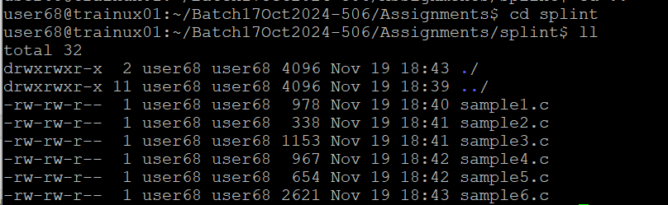

Static Code analysis using Splint

- Read through the code for sample1.c and statically check the file

splint sample1.c
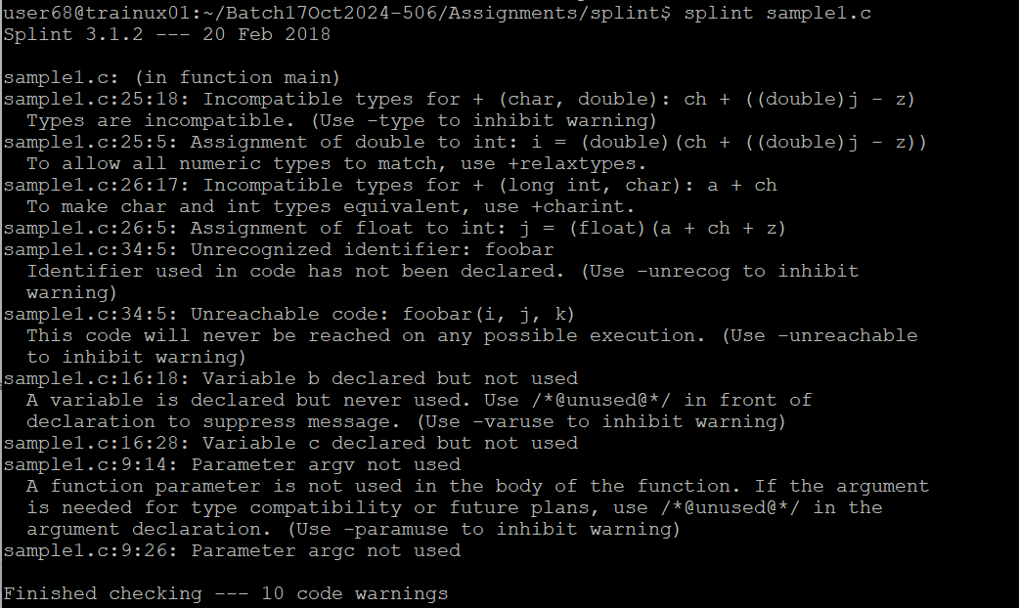

Closely analyze the warnings given by Splint. Some of the warnings given by a static code analyzer may not be valid for your code.
E.g. suppose in this example you do not want the warnings related to unused parameters and variables. Try giving the splint command with –paramuse and –varuse to inhibit these warnings:

splint –paramuse –varuse sample1.c
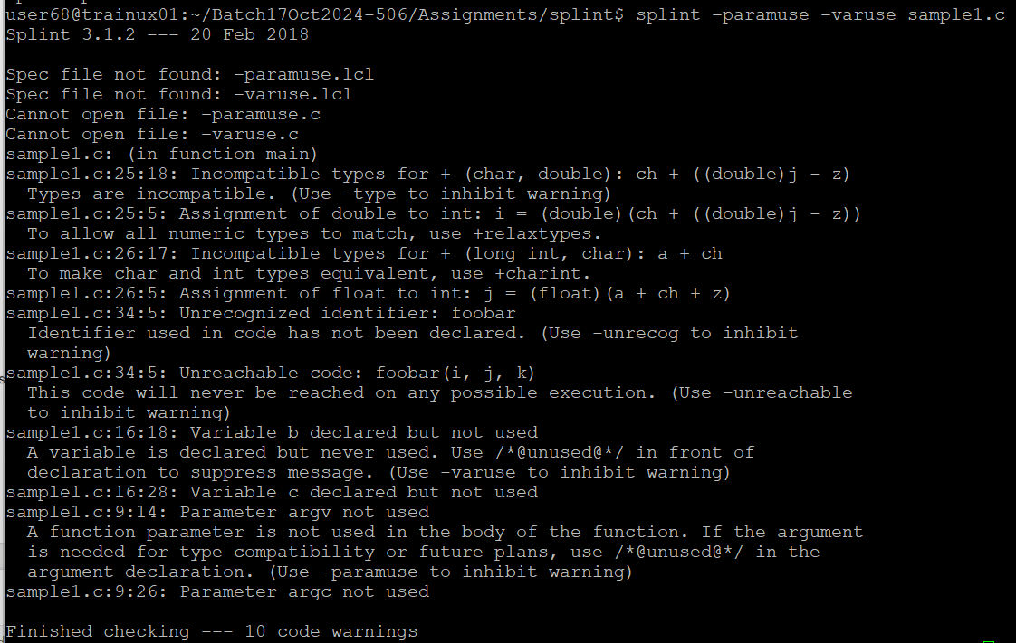

- Read through the code for sample2.c and statically check the file

splint sample2.c

Edit this file to fix all the warnings and re-run splint on the updated program
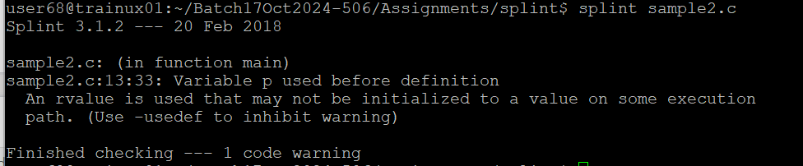

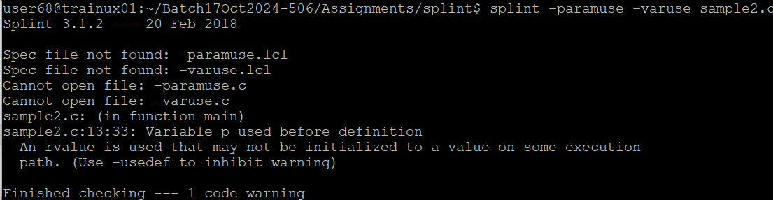
- Read through the code for sample3.c and statically check the file

splint sample3.c

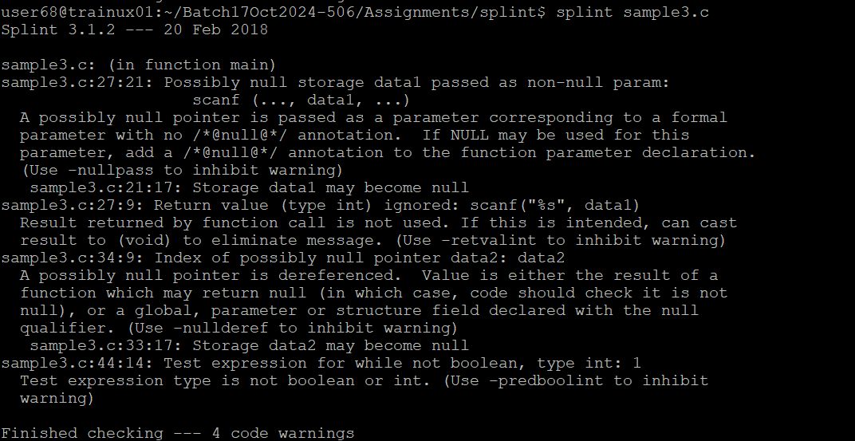

Edit this file to fix all the warnings and re-run splint on the updated program
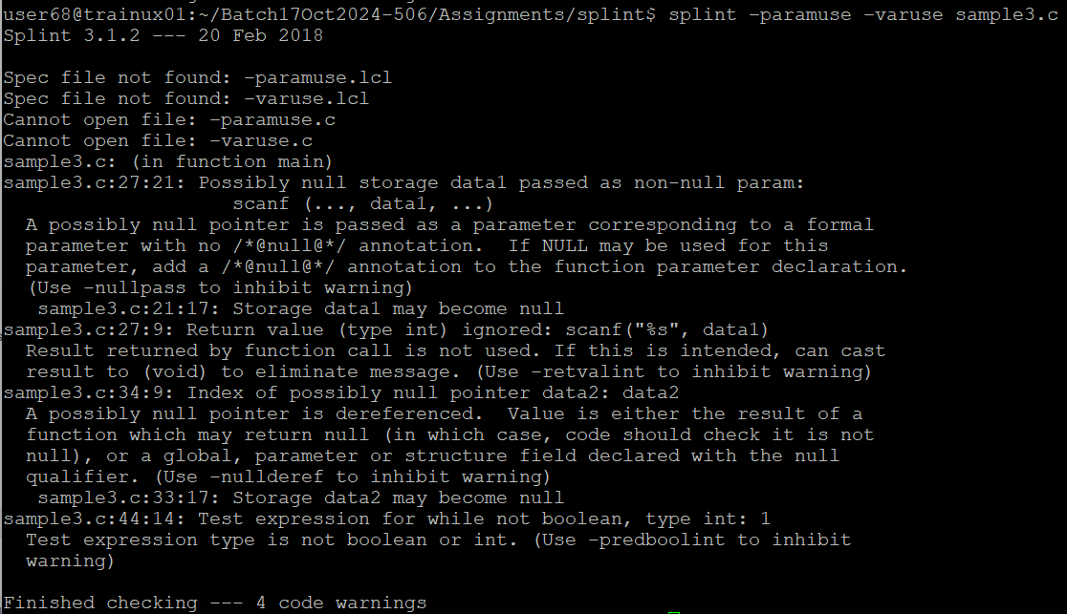

- Read through the code for sample4.c and statically check the file

splint sample4.c

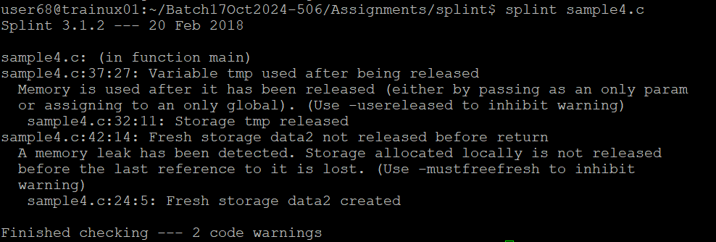
Edit this file to fix all the warnings and re-run splint on the updated program
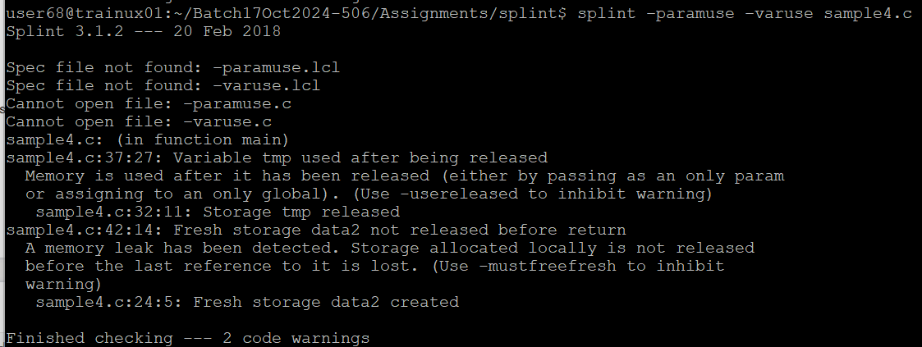

- Read through the code for sample5.c and statically check the file

splint sample5.c
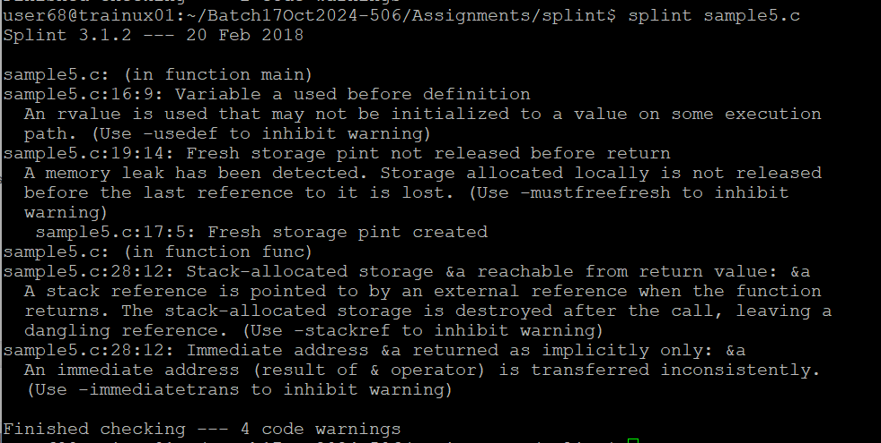

Edit this file to fix all the warnings and re-run splint on the updated program
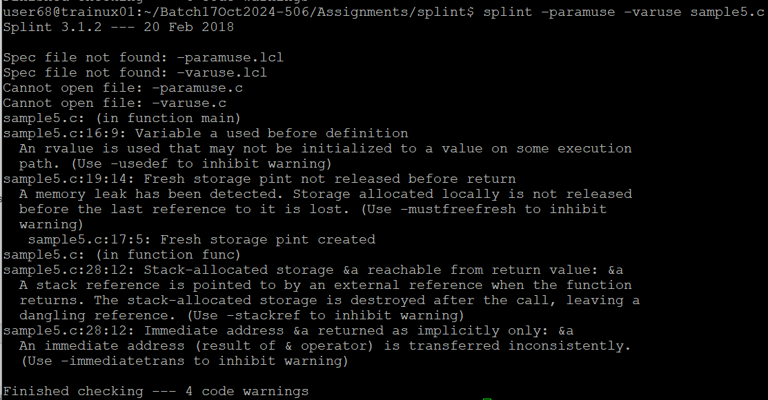

- Read through the code for sample6.c and statically check the file

splint sample6.c

Edit this file to fix all the warnings and re-run splint on the updated program

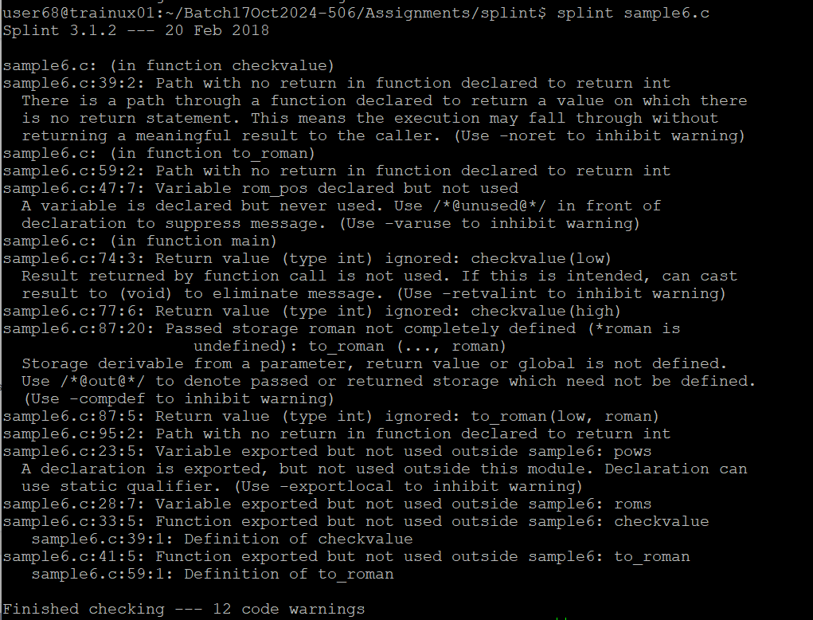
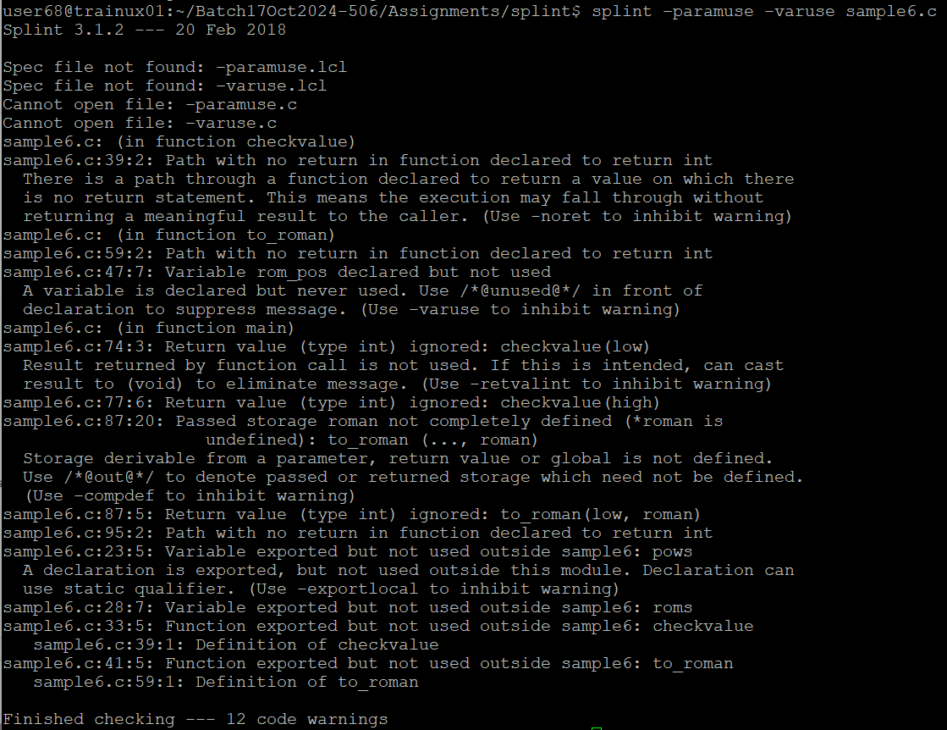

Including Static Code analysis as part of the makefile

- Copy the files below to your working directory (which were used in makefile assignment). Create the project directory structure and copy them to appropriate directory. Add a makefile in make directory to include options to run splint tool on files program.c, simplelink.c. Fix the issues reported.
  - program.c
  - simplelink.h
  - simplelink.c
[You may reuse the makefile created earlier and edit to include splint static analysis]
