GhadiHours
UX Design & Development Documentation
Heuristic Evaluation · Development Methodology · UX Laws · Conclusion

6. Nielsen's 10 Heuristic Evaluation
Each of Nielsen's 10 usability heuristics is evaluated against the GhadiHours smartwatch storefront, with a supporting screenshot, an assessment of current implementation, and an improvement where relevant.

1. Visibility of System Status
Principle: The checkout flow keeps users informed via a persistent navbar and a live cart badge updating instantly on every add or remove.
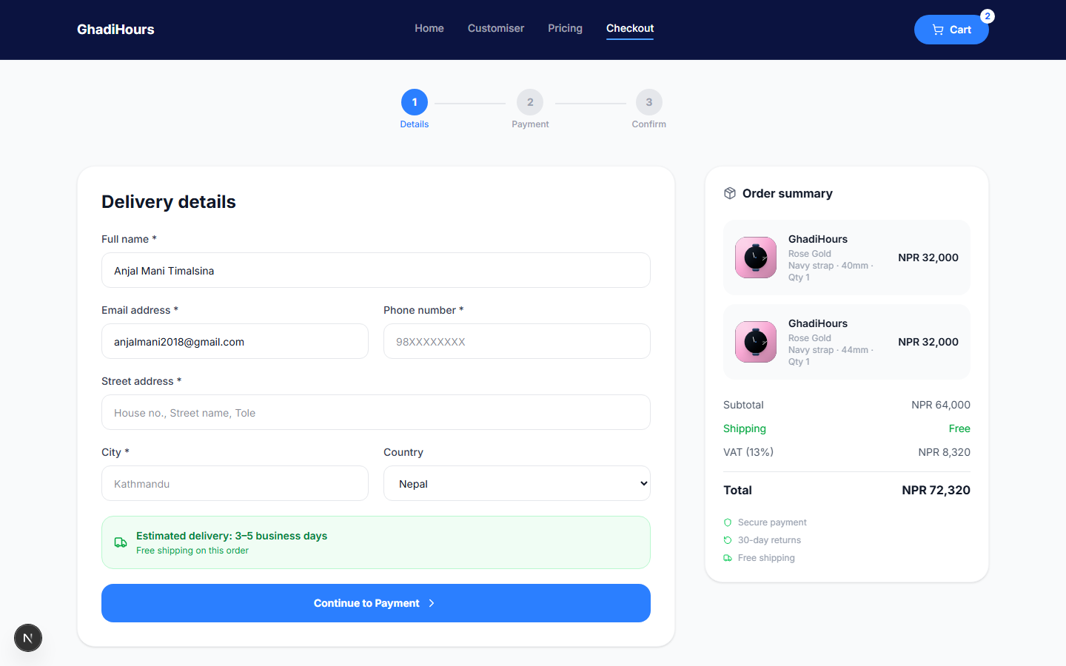
1. Visibility of System Status
Evaluation: Step indicator and badge give constant feedback with no page reload.
Improvement: Add a numbered step tracker (Cart, Delivery, Payment) above the form.

2. Match Between System and the Real World
Principle: Pricing shows in NPR with familiar trust icons (warranty, delivery, secure payment) rather than abstract jargon.
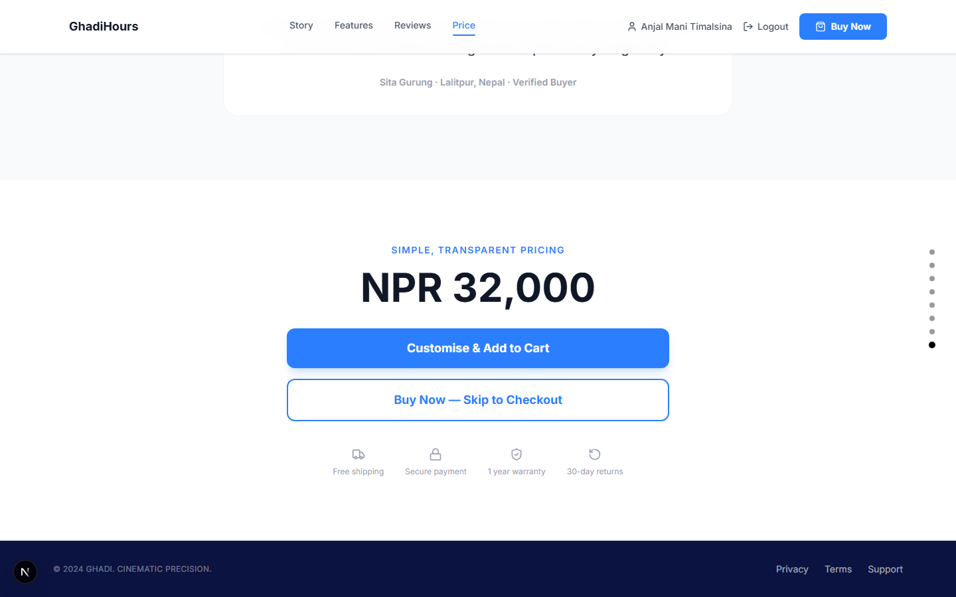
2. Match Between System and the Real World
Evaluation: Local currency and plain language make the store feel native to Nepal.
Improvement: Show delivery dates in a consistent local date format sitewide.

3. User Control and Freedom
Principle: The cart page allows editing or removing any item, with a clear 'Continue Shopping' escape hatch.
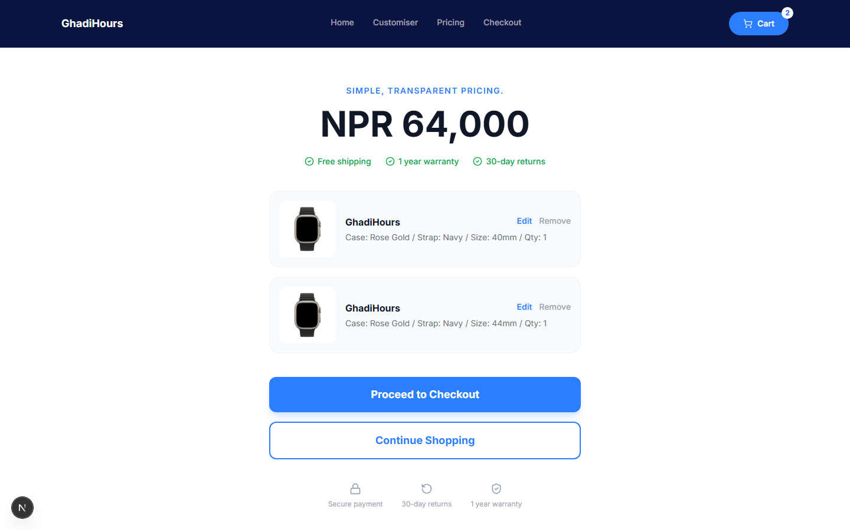
3. User Control and Freedom
Evaluation: Users can reverse any action without contacting support or restarting.
Improvement: Add an 'Undo remove' toast for accidental deletions.

4. Consistency and Standards
Principle: One dark navy FlowNavbar persists across Customiser, Cart, and Checkout, sharing typography and colour with the marketing navbar.

4. Consistency and Standards
Evaluation: Navigation placement and button styling never change mid-flow.
Improvement: Reuse the same cart icon position on the marketing navbar too.

5. Error Prevention
Principle: The quantity stepper disables minus at 1 and caps at 10, preventing invalid orders before submission.
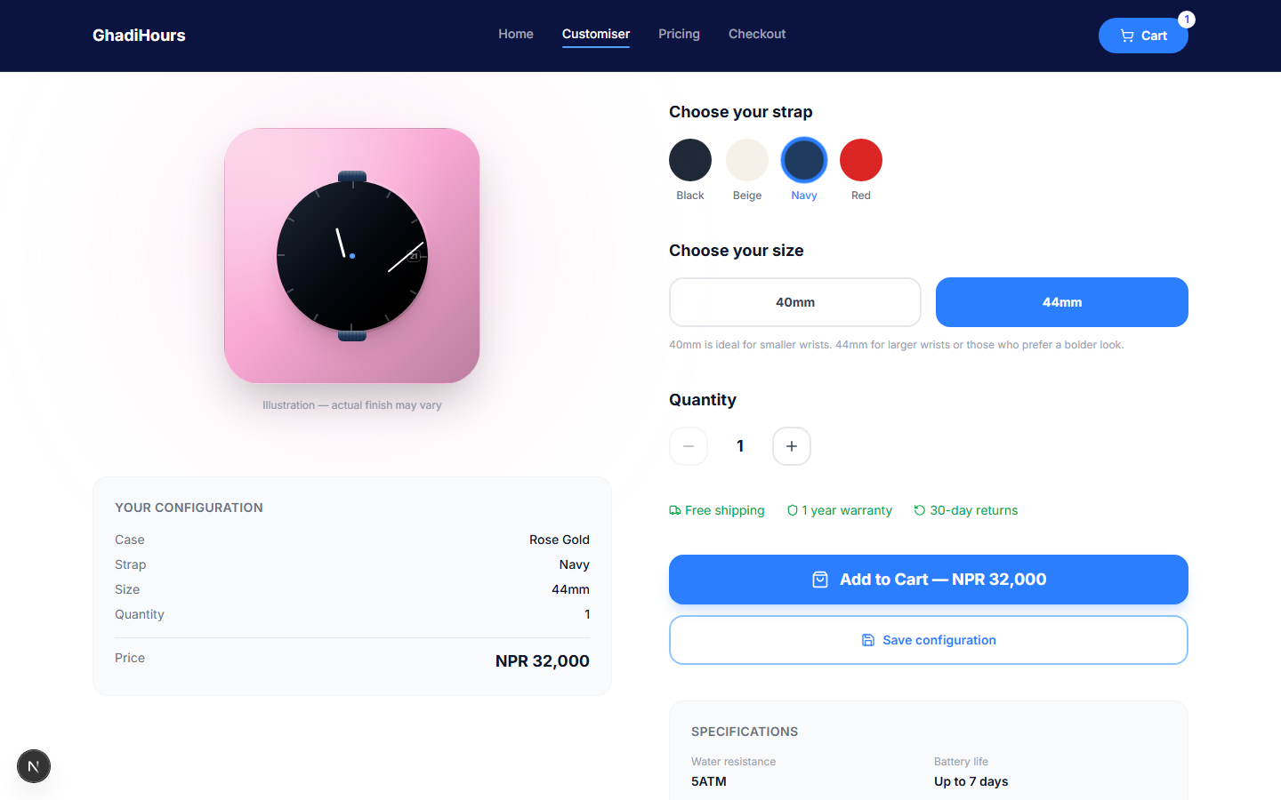
5. Error Prevention
Evaluation: Invalid states are blocked structurally, not caught after submit.
Improvement: Disable 'Add to Cart' for out-of-stock variants instead of erroring after click.

6. Recognition Rather Than Recall
Principle: Selected case, strap, and size show a checkmark plus a live summary card so users never rely on memory.
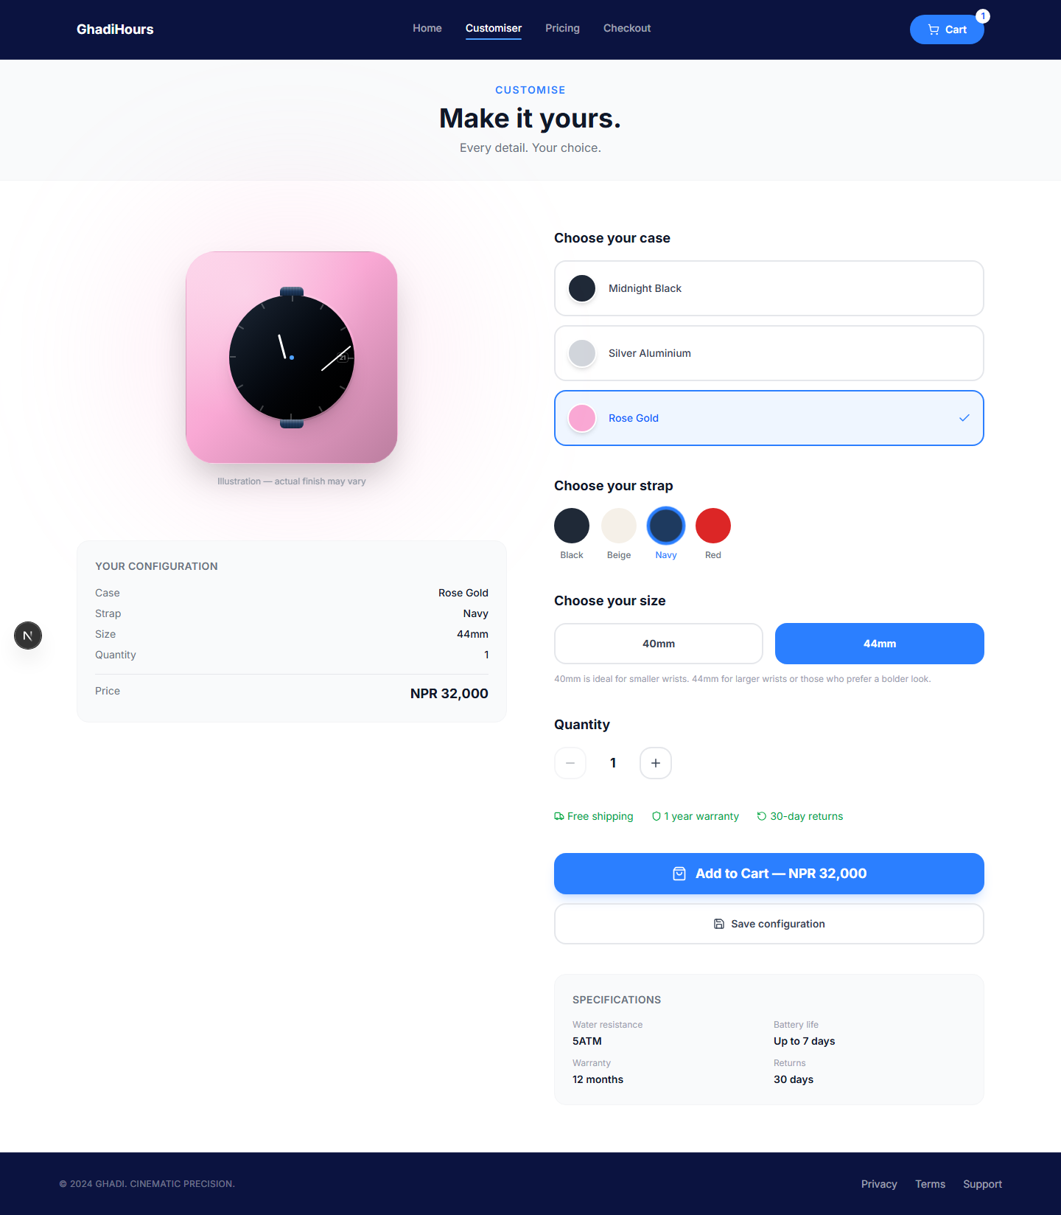
6. Recognition Rather Than Recall
Evaluation: The live preview and summary remove any memory burden.
Improvement: Persist the last configuration in local storage for returning visitors.

7. Flexibility and Efficiency of Use
Principle: The login screen offers tabbed Login/Register plus a 'Continue as Guest' path for new and returning users.
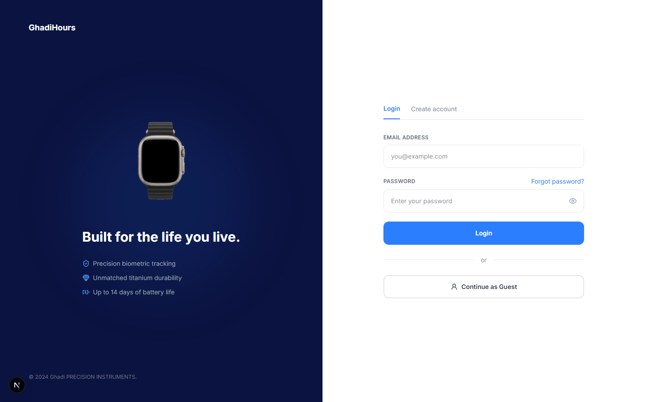
7. Flexibility and Efficiency of Use
Evaluation: Guest checkout removes friction for first-time buyers.
Improvement: Add 'remember me' to skip re-authentication on trusted devices.

8. Aesthetic and Minimalist Design
Principle: The home hero uses generous white space, one focal watch image, and restrained navy/blue accents.
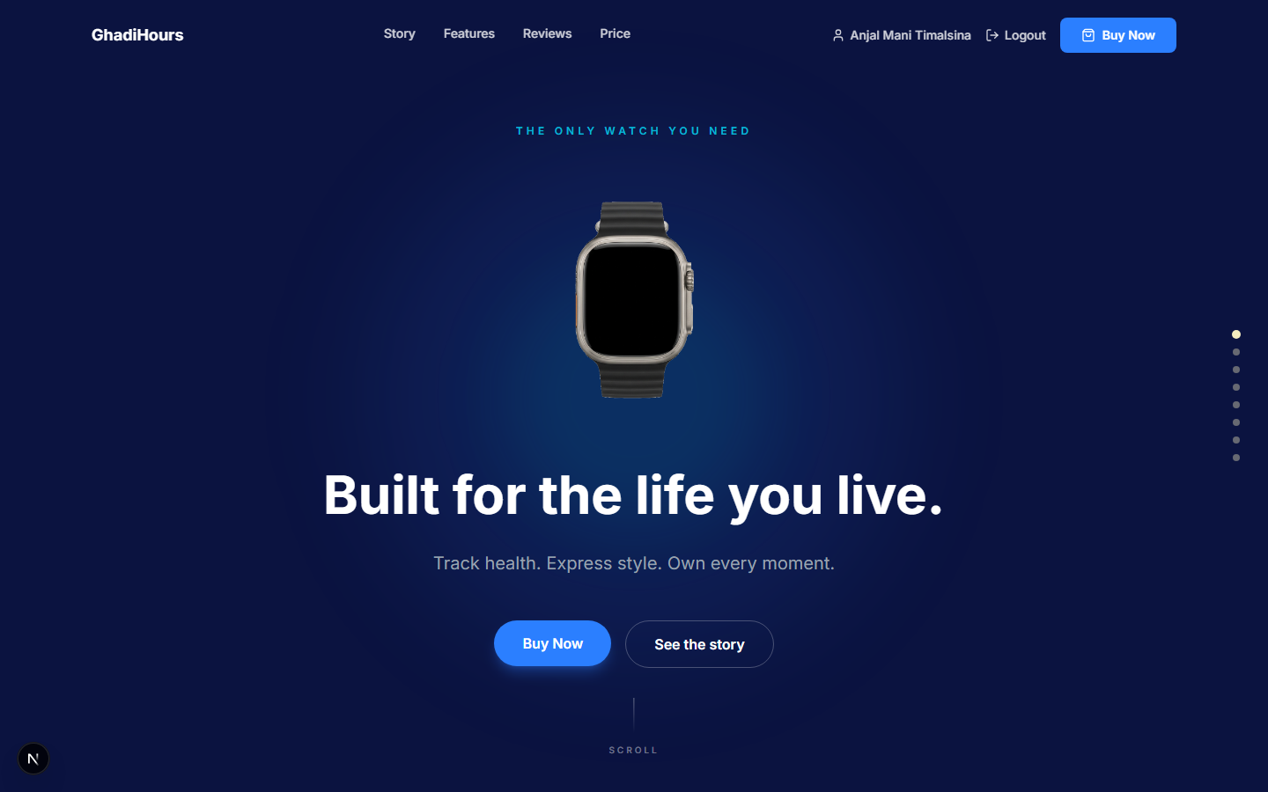
8. Aesthetic and Minimalist Design
Evaluation: Content hierarchy is immediately clear on load.
Improvement: Reduce competing CTAs on the hero for sharper focus.

9. Help Users Recognize, Diagnose, and Recover from Errors
Principle: An invalid login shows a plain-language red banner ('Invalid credentials') instead of a raw server error.
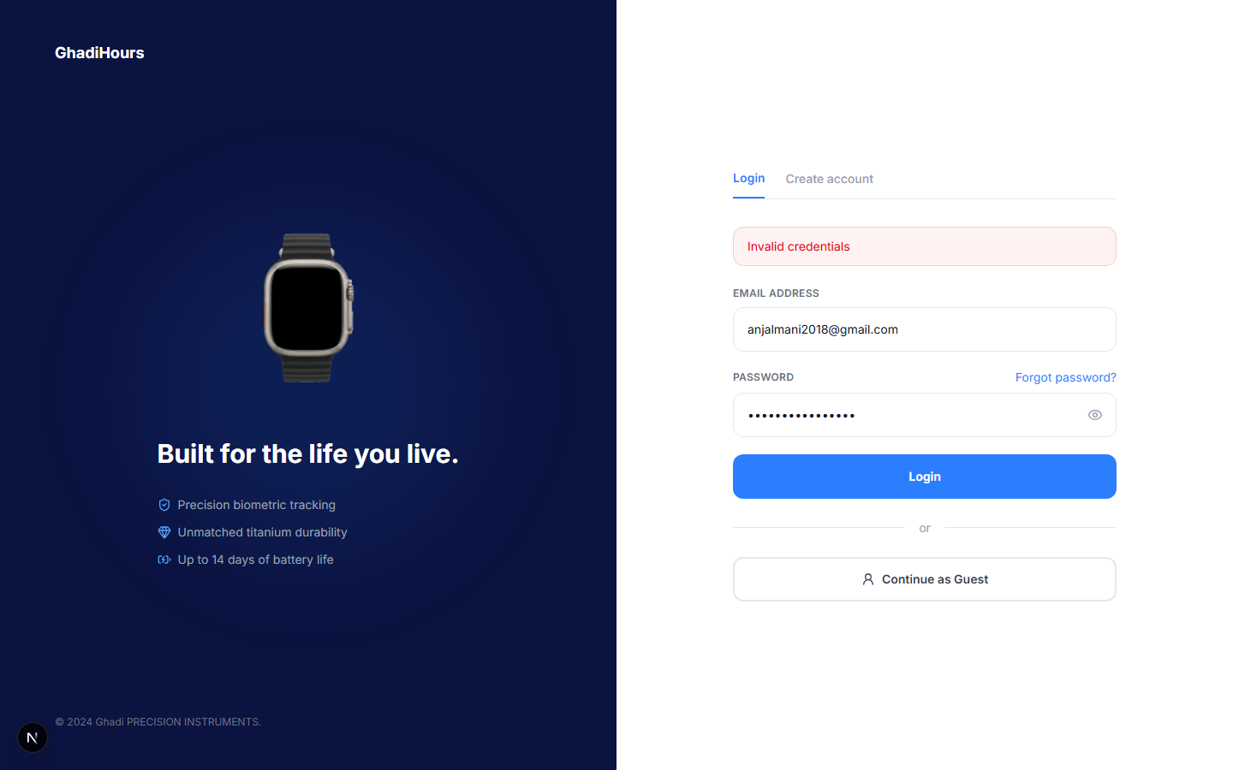
9. Help Users Recognize, Diagnose, and Recover from Errors
Evaluation: The message is specific and non-technical.
Improvement: Add inline field-level highlighting alongside the banner.

10. Help and Documentation
Principle: The footer links directly to Privacy, Terms, and Support, so help is reachable from any page.

10. Help and Documentation
Evaluation: Coverage exists but is easy to miss below the fold.
Improvement: Add a lightweight FAQ/chat widget for in-context help during checkout.

7. Development Methodology

7.1 Methodology Selection
GhadiHours was built using Agile Scrum. Requirements evolved directly from user feedback and mockups shared mid-project (admin dashboard, order detail panel, customer management), which an iterative model absorbs far better than a fixed waterfall plan. Each feature — authentication, customiser, cart, checkout, admin moderation — was scoped, built, demoed, and refined as its own short cycle.

7.2 Sprint Planning
Work was organised into focused sprints, each targeting one vertical slice of the product rather than one technical layer:
- Sprint 1 — Authentication, landing page, and core UX law redesign
- Sprint 2 — Product customiser, cart, and multi-item checkout
- Sprint 3 — Admin dashboard, orders, and customer management
- Sprint 4 (current) — Review moderation and UX documentation
Each sprint closed with a working, demoable increment, followed by a review against real screenshots before the next sprint began.

7.3 Project Management Tools
- Trello — sprint backlog and task-status tracking (To Do / In Progress / Done)
- GitHub — version control, branching (feature branches into sprint_4), and commit history
- Figma — high-fidelity mockups for login, admin dashboard, orders, and customers pages
- FigJam — early affinity mapping of user pain points (e.g. TRU-03) that shaped the review moderation feature

8. UX Laws and Design Principles
Ten UX laws were deliberately applied across GhadiHours. Each entry gives the definition, how it shaped the product, and a supporting screenshot.

Jakob's Law
Definition: Users prefer your product to work like the other products they already know.
Application: Login uses a standard tabbed Login/Register card with a familiar email + password form.

Jakob's Law

Fitts's Law
Definition: The time to acquire a target depends on its distance and size.
Application: Primary actions (Add to Cart, Place Order) are large, high-contrast buttons placed where the eye lands after a decision.

Fitts's Law

Hick's Law
Definition: Decision time increases with the number and complexity of choices.
Application: The customiser presents one option group at a time — case, then strap, then size — instead of one overwhelming grid.

Hick's Law

Miller's Law
Definition: The average person holds only about seven items in working memory at once.
Application: The order summary and admin tables group data into short chunks (item, spec, price) rather than long unbroken rows.
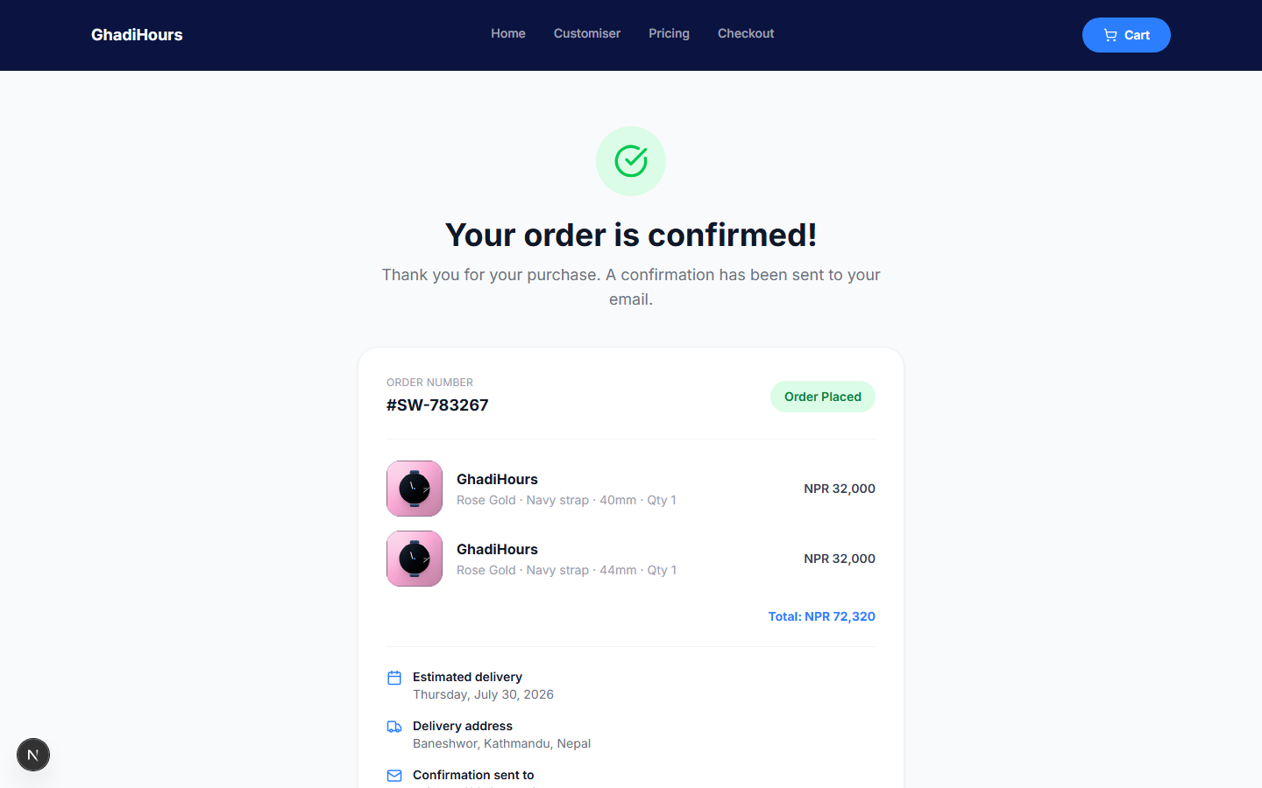
Miller's Law

Law of Proximity
Definition: Objects placed near one another are perceived as related.
Application: Delivery details, pricing, and per-item specs sit in distinct spaced blocks on the confirmation card.

Law of Proximity

Law of Similarity
Definition: Elements sharing visual traits are perceived as part of the same group.
Application: All primary CTAs share one blue, and all status states share one consistent pill styling across customer and admin views.

Law of Similarity

Von Restorff Effect (Isolation Effect)
Definition: An item that visually stands out is more likely to be remembered.
Application: The Before/After comparison pairs red 'before' points against green 'after' outcomes, making the contrast unmissable.
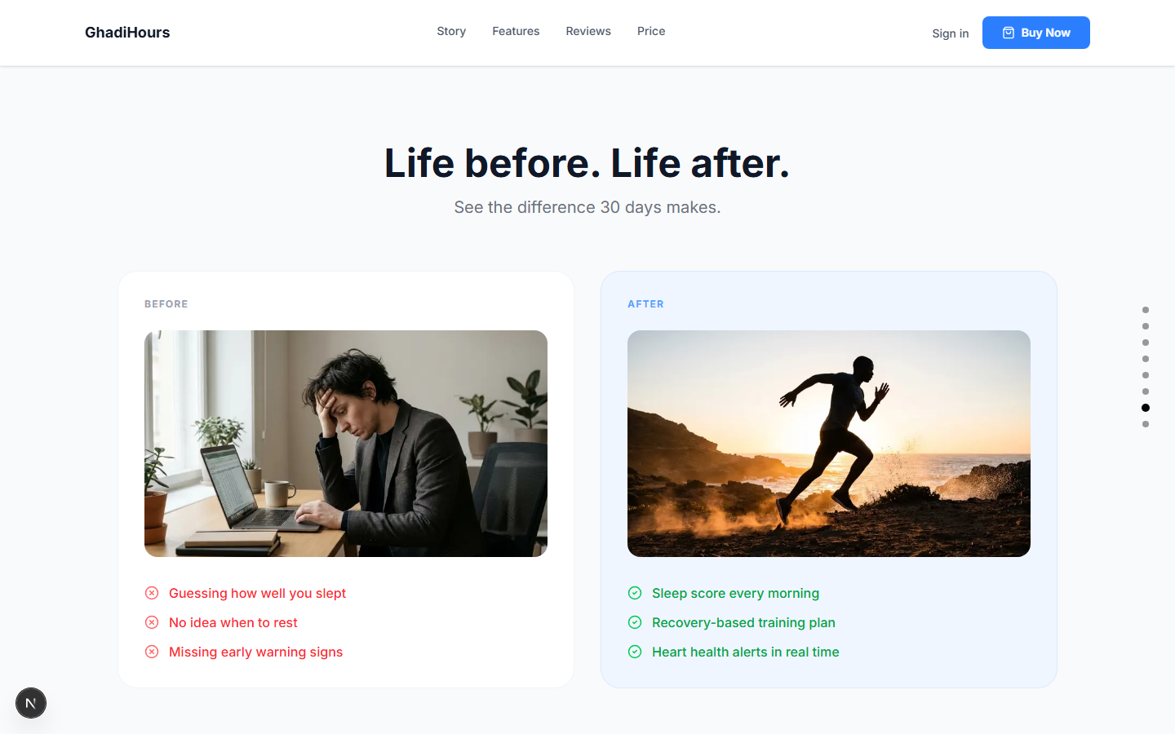
Von Restorff Effect (Isolation Effect)

Peak-End Rule
Definition: People judge an experience mainly by its peak moment and its ending.
Application: The confirmation page closes checkout on a clear success state — checkmark, order number, full summary — as a strong final impression.

Peak-End Rule

Aesthetic-Usability Effect
Definition: Users perceive more aesthetically pleasing designs as easier to use.
Application: The navy-and-white brand system with generous whitespace builds immediate trust for an e-commerce checkout flow.

Aesthetic-Usability Effect

Doherty Threshold
Definition: Productivity rises when a system responds within 400ms, keeping users in flow.
Application: Cart badge counts and stock checks update instantly via client state, without full page reloads.

Doherty Threshold

9. Conclusion
Building GhadiHours applied the full UX process end to end: research-informed design, heuristic evaluation, and iterative development guided by real user feedback. Ten UX laws and all ten Nielsen heuristics were not treated as a checklist but as active constraints on layout, colour, and flow decisions — from the Hick's Law-driven step-by-step customiser to the Peak-End-optimised order confirmation screen.
The key finding across sprints was that real screenshots and direct user corrections consistently outperformed assumptions. Issues such as checkout totals merging multiple cart items into one card, or out-of-stock errors on valid product combinations, were only caught because feedback was reviewed against the live product rather than a spec document. This reinforced an iterative Agile Scrum approach over a rigid upfront plan.
User feedback directly reshaped scope: the admin panel, the richer order detail layout, the customer management page, and the review moderation system all originated from feedback and mockups introduced mid-project, not the original brief. Each was absorbed into a sprint without destabilising already-shipped features, validating the chosen methodology.
Project objectives were achieved: a full customer journey from landing page to customisation, cart, checkout, and confirmation now works end to end, backed by an admin system for orders, customers, and review moderation. Future improvements include persisted customiser state, inline field-level error highlighting, and a lightweight in-context help widget during checkout to close the remaining gaps identified in the heuristic evaluation.

