level 1
1

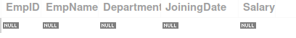

2

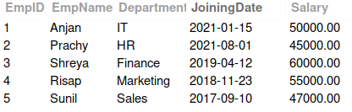

3

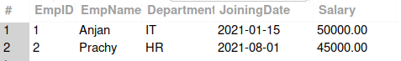

4

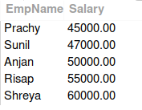

5

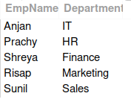

level 2

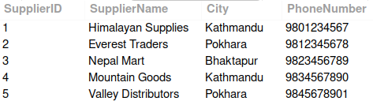
2

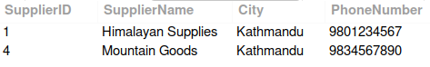
3

4

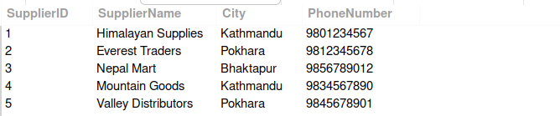

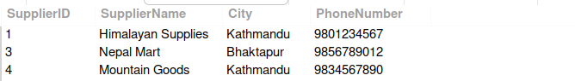

5



Level 3

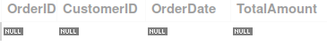

2

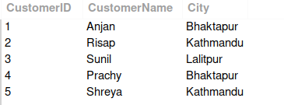

3

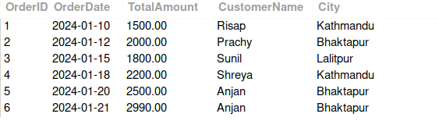

4

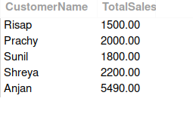
5

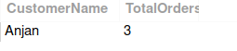

level 4

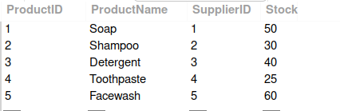

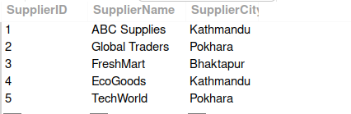

2

inventory table before

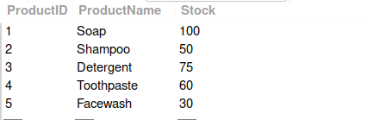

inventory table after

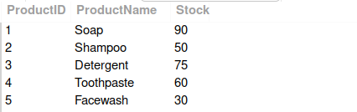

3 payroll table

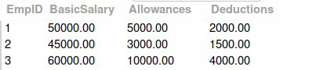



4

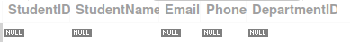

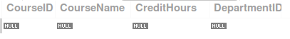

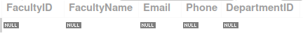



5





level 5

2

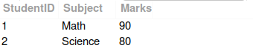

3

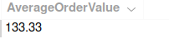

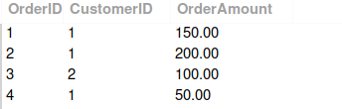

4

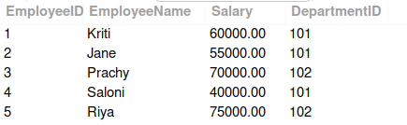

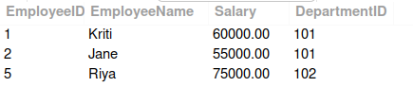

level 6



2

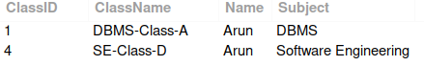

3

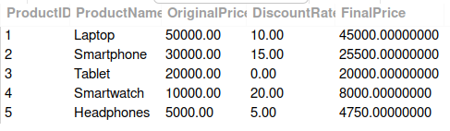

level 7

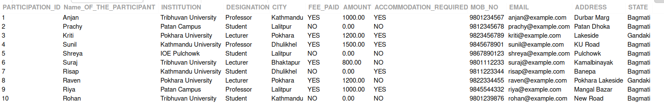

2a

b

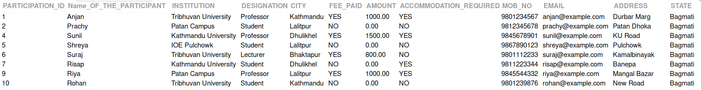

c

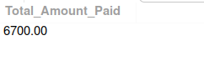

d

SWASTIK COLLEGE
Tribhuvan University
Faculty of Humanities and Social Sciences


Bachelor of Computer Application
(BCA)

Course: Database Management System (CACS255)
Semester: 4th

A Lab Report On:
Database Management System (DBMS)

Submitted To:

Mr. Arjun Sharma Poudel

(Subject Teacher)
Submitted by:

Name: Anjan khadka

Roll no. 3

Acknowledgement

I would like to express my heartfelt gratitude and sincere appreciation to my Database Management System (DBMS) course instructor, Mr. Arjun Sharma Poudel, whose guidance and expertise have been invaluable throughout this laboratory journey.His dedication to teaching and patient approach in explaining complex database concepts have significantly enhanced my understanding of the subject matter. The practical insights and real-world examples he provided during the lab sessions have helped bridge the gap between theoretical knowledge and practical implementation. I am particularly thankful for his constructive feedback and continuous support, which have been crucial in developing my problem-solving skills in database management. His enthusiasm for the subject and commitment to student learning have created an engaging learning environment that encourages curiosity and technical growth. Furthermore, his detailed explanations of database concepts, SQL queries, and best practices have laid a strong foundation for my future endeavors in the field of database management. This lab report stands as a testament to his effective teaching methodology and unwavering support throughout the semester.

