Infosys Springboard Virtual Internship 6.0 Completion Report
Batch Number: 13
Start date:02-Feb-2026
Name: Anjan Srivathsav Garudadri
Internship Duration: 8 Weeks

1. Project Title
NeuroFleetX – AI-Driven Urban Mobility Optimization System

2. Project Objective
The objective of this project is to develop a role-based vehicle booking and fleet management system that enables seamless interaction between customers, drivers, and fleet managers, ensuring efficient trip scheduling, real-time tracking, and optimized resource utilization through an integrated web platform.

3. Project description in detail
NeuroFleetX is a next-generation AI-driven platform designed to optimize urban
mobility and fleet operations for rental, transport, and smart city use cases. By
leveraging artificial intelligence, IoT, and geospatial data, NeuroFleetX enables real-
time vehicle tracking, intelligent routing, predictive maintenance, dynamic fleet
allocation, and customer-centric service models.
The system integrates machine learning models to predict traffic conditions, optimize
route plans, and monitor vehicle health. It also employs advanced dashboards and
mobile-first interfaces for fleet managers and end-users. Designed for scalability,
NeuroFleetX can be adapted for electric vehicle (EV) fleets, ride-sharing models, or
multi-modal transport networks, offering both operational efficiency and sustainable
mobility solutions for modern cities.

4. Timeline Overview
Week | Activities Planned | Activities Completed
Week 1 | Project planning, requirement analysis | Defined system architecture and user roles (Customer, Driver, Fleet Manager)
Week 2 | UI/UX design | Designed wireframes and layouts for dashboards and booking flow
Week 3 | Frontend setup (React + Vite + MUI) | Initialized project, built basic components and routing
Week 4 | Authentication & database setup (Supabase) | Implemented login/signup and role-based access control
Week 5 | Customer dashboard and booking system | Built booking form, trip creation, and data storage
Week 6 | Driver & Fleet Manager modules | Created dashboards and basic trip visibility features
Week 7 | Integration of modules | Connected frontend with backend, ensured data flow across roles
Week 8 | Testing, UI improvements, and final refinements | Fixed bugs, improved UI/UX, implemented driver assignment & status updates

5a. Key Milestones
Milestone | Description | Date Achieved
Project Kickoff | Finalized idea, defined scope, and planned system architecture | Week 1
Prototype/First Draft | Initial UI design and frontend setup completed | Week 3
Mid-Term Review | Core features like authentication and booking system implemented | Week 5
Final Submission | Full system integration with all dashboards and features completed | Week 8
Presentation | Demonstration of working system and explanation of architecture | Week 8

5b. Project execution details
The project was executed using a SaaS (Software as a Service) architecture, enabling a scalable and centralized platform accessible to multiple users based on roles (Customer, Driver, Fleet Manager). The process began with requirement analysis and system design, where system flow, user roles, and core functionalities were defined.
The frontend was developed using React.js with Vite and Material UI, ensuring a modular and responsive interface. Supabase was used as the backend service for authentication and database management, supporting secure role-based access and real-time data handling.
Core features such as vehicle booking, trip management, and role-specific dashboards were implemented in phases. These modules were integrated to ensure seamless interaction between users, including driver assignment and trip status updates.
Finally, the system was tested and refined with UI improvements, bug fixes, and performance optimizations, resulting in a robust and scalable SaaS-based fleet management solution.

6. Snapshots / Screenshots
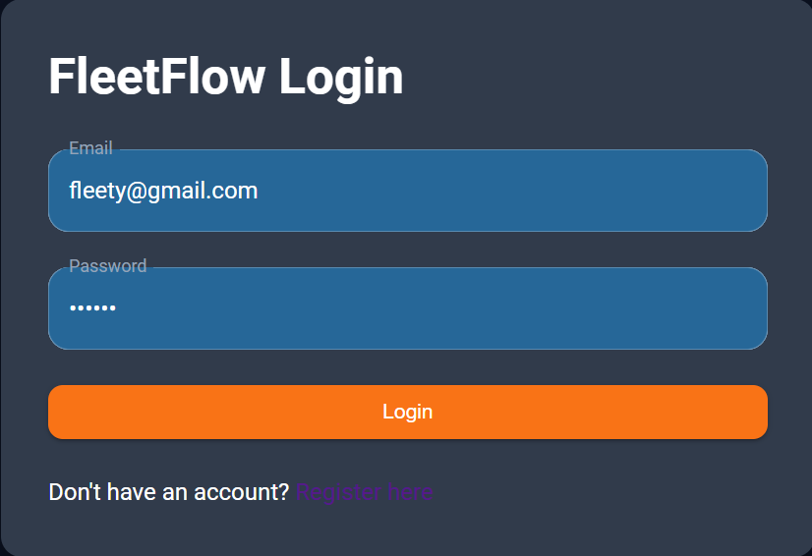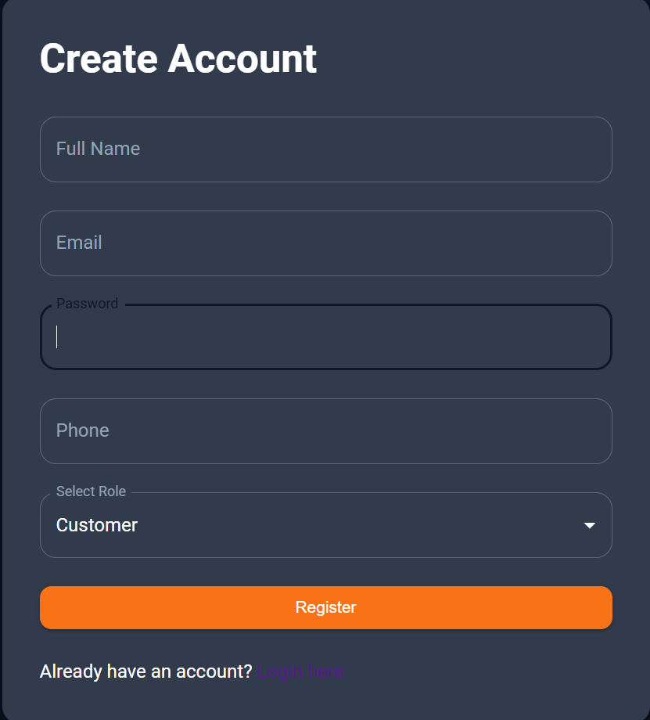
FIG 1. LOGIN FIG 2. REGISTRATION
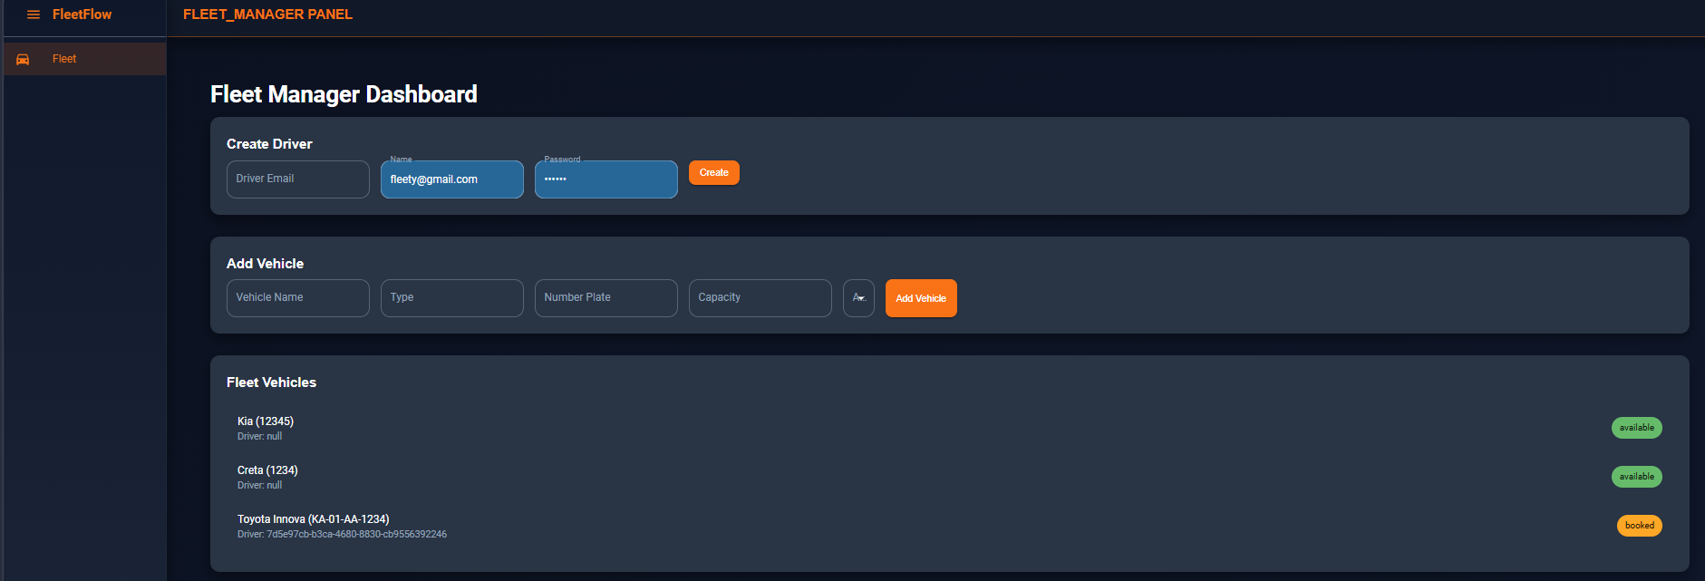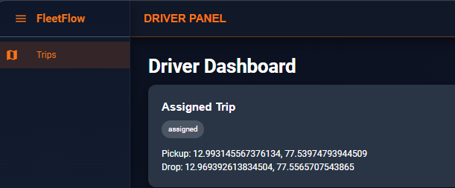
FIG 3. FLEET-MANAGER DASHBOARD FIG 4. DRIVER DASHBOARD
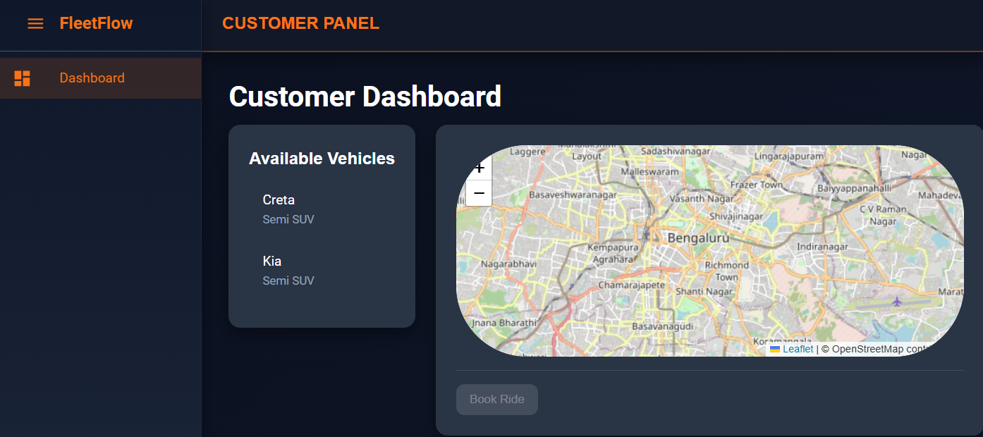
FIG 5. CUSTOMER DASHBOARD

7. Challenges Faced
- Integrating frontend with Supabase backend and handling real-time data updates
- Handling state management and data flow across multiple components
- Implementing driver assignment logic and syncing trip status across roles
- Debugging authentication issues and ensuring secure session handling8.

8. Learnings & Skills Acquired
- Strong understanding of SaaS architecture and system design
- Backend integration using Supabase (Auth + Database)
- Improved knowledge of role-based systems and access control
- Enhanced skills in debugging, API integration, and full-stack development

9. Testimonials from team
the project reflects self-driven learning, problem-solving ability, and independent execution of a full-stack application, demonstrating strong ownership and accountability.

10. Conclusion
The project successfully implements a role-based vehicle booking and fleet management system using a SaaS architecture. It demonstrates effective integration of frontend and backend technologies along with real-world system design and functionality.

11. Acknowledgements
I would like to express my sincere gratitude to my mentor for their continuous guidance, support, and valuable feedback throughout the development of this project. Their insights played an important role in successfully completing this work.
.

