Responsive Web Design using HTML5 and CSS3 and some JQuery

🡺 In brackets code editor there is a extension available for Auto save “autosave” select following plugin 🡪 “Auto save files on windows blur”

🡺 Html begins with <!DOCTYPE html>

🡺 Some html tags:

<strong>Strong text</strong>

<em>Emphasise</em>

<u>underline text</u>

<br> break

<br>

<img src="user.jpg" alt="Author photo">

<a href="html_css.png" target="_blank">HTML CSS</a>

<link rel="stylesheet" type="text/css" href="style.css">

🡺 Random user generator website has random users

🡺 some style attributes:

1. text-align: justify
2. color: blue
3. font-size: 40px;

🡺 RGB -- Colors

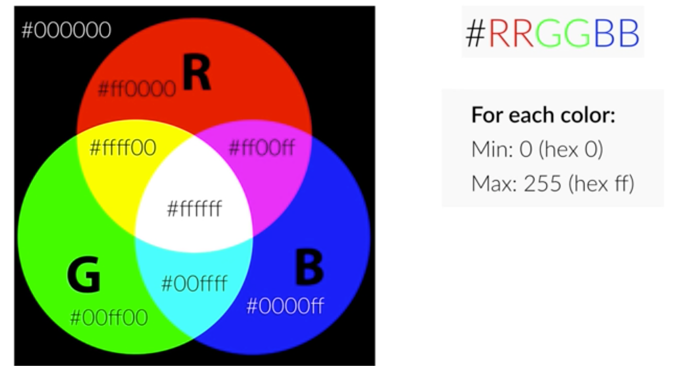

In case you want **transparency** also use rgba

Example: rgba(29, 167, 23, 0.75);

🡺 CSS Box model:

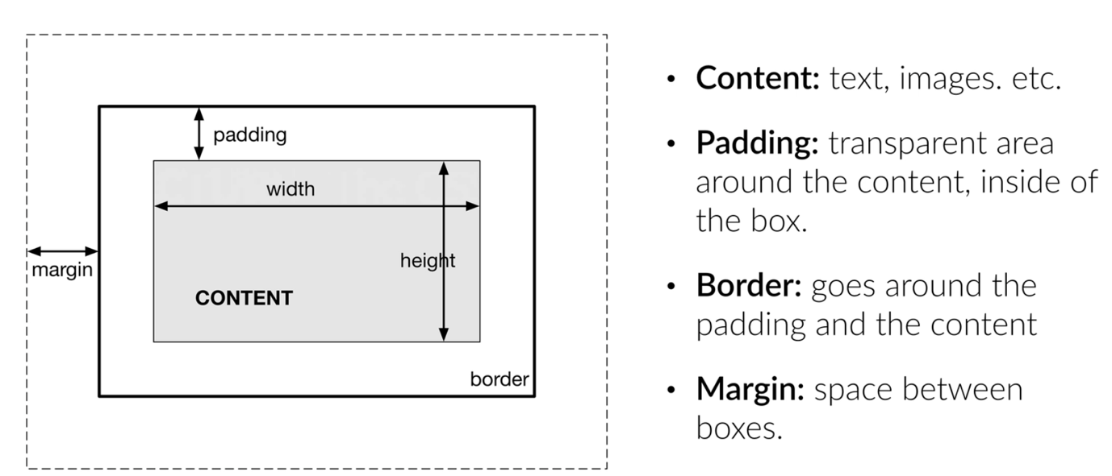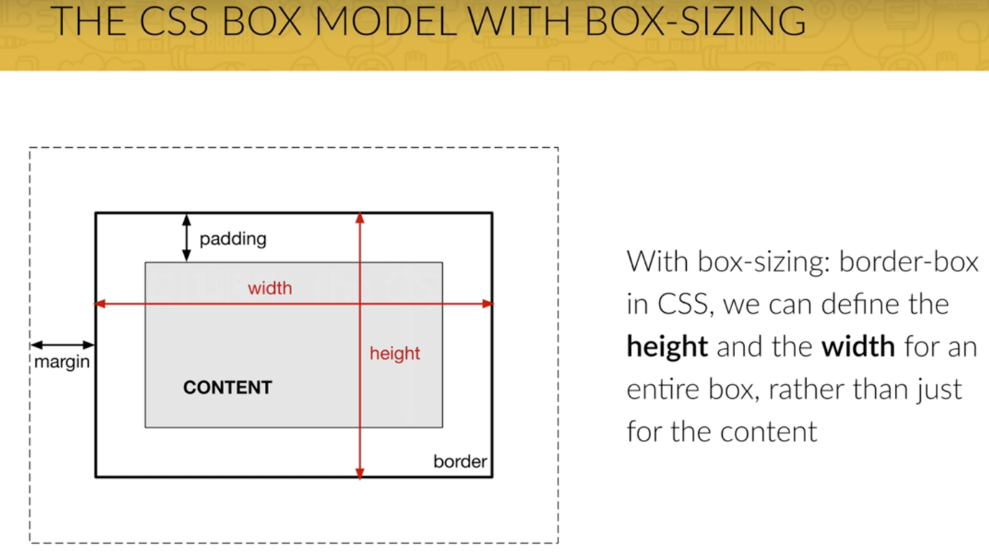

Use box-sizing to get rid of width = element + padding

**box-sizing: border-box**;

clear-fix -> can use to nullify float left or right or both:

.clear-fix {

content: "";

display: table;

clear: both;

}

**Position**:

Absolute position is applied with respect to the parent which has position property.

**Note**: float property is to put block elements side by side.

**Clip-path**: to clip the image

clip-path: polygon(0 0, 100% 0, 100% 75vh, 0 100%);

**multiple backgrounds**:

background-image: linear-gradient(

to right bottom,

#7ed56fa8,

#28b485a8) ,

url(../img/hero.jpg);

SASS:

* SASS is extension to CSS that helps us to write code more flexible stype
* We can use variables, functions, conditional statements and more
* Split our SASS files up into modules, making it easier to keep on top of CSS large projects.