Rainfall and Flood Risk Analysis Using Historical Weather Data
Applied Data Science Final Mini Project Report
Student details | Information
Project title | Rainfall and Flood Risk Analysis Using Historical Weather Data
Student name / Roll number
Semester | VII(A)
Course / Subject | Applied Data Science
Faculty name | Dakshayani R
Submission date

Report checklist
Checklist entries refer to the supporting sections. N/A denotes a task outside the scope of the study.
Done | Checklist item | Brief evidence / notes
☑ | Title, abstract, introduction, problem statement, objectives and scope are included. | Sections 1 and 2 define the problem, objectives and scope.
☑ | Dataset sources, collection periods, features and dimensions are documented. | Section 4.2 separates the GloFlo catchment records from the daily ERA5 rainfall archive.
☑ | Data quality issues and preparation steps are explained. | Section 4.3 explains missing values, categorical encoding and the preserved feature contract.
☑ | EDA includes descriptive statistics and relevant visualisations. | Sections 4.4 and 5.3 contain statistics and six data charts.
☑ | Analysis/model choice is justified and the evaluation method is documented. | Section 4.5 describes XGBoost, its settings and the reconstructed evaluation method.
☑ | Results include metrics, graphs and interpretations. | Section 5 contains class metrics, a baseline and interpreted figures.
☑ | Class imbalance is assessed and its treatment explained. | Section 4.6 records class counts and the positive-class weight.
N/A | For regression, suitable regression methods and error metrics are considered. | Classification and historical rainfall analysis are the analytical tasks.
☑ | Time series patterns are analysed and forecasting applicability is addressed. | Seasonality and anomalies are analysed; forecasting is N/A.
☑ | Conclusion and possible future improvements are included. | Sections 6 and 7 contain the conclusion and future development.

1 Abstract
Rainfall variability and catchment characteristics influence the occurrence and severity of high-flow conditions. This study presents a system for analysing historical rainfall and assessing flood susceptibility from climatic and geographical attributes. The analysis uses ERA5 daily rainfall estimates near Mumbai for 2000–2025 and catchment observations from the Global Flood characterization database. Seasonal comparisons and anomaly indicators characterise rainfall variability, while an XGBoost classifier estimates annual high-discharge susceptibility from rainfall, temperature, drainage, terrain, soil and land-cover attributes. Historical analysis shows that June–September accounts for 92.51% of rainfall at the study location, demonstrating the strong influence of the monsoon. Reconstructed holdout evaluation yields 96.89% accuracy, 65.64% precision, 79.08% recall and a 71.74% F1 score for the high-discharge class. The system presents historical patterns through interactive visualisations and expresses susceptibility assessments as Low, Medium or High categories. The findings support the combined use of rainfall analysis and catchment characteristics for accessible, evidence-based assessment of flood susceptibility.

2 Introduction

2 1 Background and context
Rainfall is a major component of the hydrological cycle and varies in intensity, duration and seasonal distribution. Annual totals alone do not describe the concentration of rainfall within a season or the occurrence of unusually wet periods. Analysis at daily, monthly and annual scales provides a more complete account of local rainfall behaviour.
The hydrological response to rainfall depends on drainage characteristics, terrain, soil and land cover. Similar rainfall amounts may therefore produce different runoff responses across catchments. Combining historical rainfall analysis with catchment attributes provides a basis for examining spatial susceptibility to high-flow conditions.

2 2 Problem statement
Rainfall and Flood Risk Analysis Using Historical Weather Data.
The study examines how rainfall varies over time and how climatic and catchment characteristics can inform susceptibility assessment. It combines historical rainfall analysis with classification of annual high-discharge conditions to support the interpretation of rainfall patterns and area characteristics.

2 3 Objectives
1. Organise the available rainfall and catchment data into traceable analytical inputs.
2. Show daily, monthly, yearly and June–September rainfall patterns with simple interactive visualisations.
3. Identify heavy-rainfall days and unusual months against a fixed historical baseline.
4. Transform manual rainfall and area values into the exact feature representation required by the flood-risk model.
5. Evaluate the active classifier using positive-class precision, recall, F1, ranking metrics, confusion counts and a simple baseline.
6. Present rainfall patterns and susceptibility assessments through an accessible interactive interface.

2 4 Scope
Historical rainfall analysis covers the ERA5 grid point near Mumbai from 2000 to 2025. Daily observations are aggregated into monthly, annual and June–September monsoon totals. Heavy-rainfall days and unusually wet months are identified relative to a fixed 2000–2015 reference period.
Susceptibility assessment uses annual rainfall, wettest-month rainfall, temperature, drainage, terrain, runoff, soil and land-cover attributes. The supervised target is annual peak discharge above the source 95th percentile. Low, Medium and High categories express score bands associated with this annual high-discharge target.
The ERA5 observations and GloFlo records are analysed at their respective daily and catchment-year scales. Rainfall history supports temporal analysis, while GloFlo supplies the attributes and discharge observations used in classifier reconstruction.

3 Hardware and Software Requirements
Category | Specification / tool | Purpose / version (if relevant)
Hardware | 64-bit personal computer | CPU-based local data analysis and inference.
Operating system | Windows | Runs the local Python application and browser.
Programming language | Python | Data preparation, model inference and application logic.
Libraries and packages | pandas, NumPy, scikit-learn, XGBoost and joblib | Tabular processing, numerical computation, classification and evaluation.
Application platform | Streamlit and Plotly | Interactive visualisation and manual susceptibility assessment.
Storage and delivery | CSV, JSON, PKL and a web browser | Saved data, cached history and local model files; no database is required.

4 Methodology and Data Science Life Cycle
The methodology combines descriptive rainfall analysis with supervised classification of annual high-discharge susceptibility. Data preparation, exploratory analysis, feature engineering and model evaluation are described in the following sections.

4 1 Business Problem Understanding
Done | Checklist item | Brief evidence / notes
☑ | Defined the real-world problem and the stakeholder/user. | Users need understandable historical rainfall patterns and a simple manual susceptibility assessment.
☑ | Identified the target outcome or question and success criteria. | Outputs are rainfall summaries and Low/Medium/High categories. Positive-class metrics and comparison with a majority baseline assess model usefulness.
☑ | Defined assumptions, constraints and potential impact. | The analytical units are a daily weather-grid record and a catchment-year source record; Section 2.4 defines each output.
The intended users are students and analysts examining rainfall variability and catchment susceptibility. The analytical requirements are reliable seasonal comparisons, identification of unusually wet periods and an interpretable assessment of specified climatic and geographical conditions.
The analysis is assessed through rainfall summaries, seasonal comparisons and anomaly indicators. Classification performance is assessed using positive-class precision, recall, F1 and ranking metrics, together with a majority-class baseline.

4 2 Data Understanding and Collection
Done | Checklist item | Brief evidence / notes
☑ | Identified the dataset source and documented how it was obtained. | GloFlo provides catchment observations; Open-Meteo ERA5 provides daily rainfall. References 1 and 2 identify the sources.
☑ | Checked data meaning, units, data types and collection period. | GloFlo contains catchment climate, terrain and annual peak discharge; ERA5 rain_sum is daily rainfall in mm. See the feature inventory.
☑ | Checked the number of rows/records and columns/features. | GloFlo has 45,932 rows and 93 columns; the rainfall history has 9,497 daily records.
☑ | Identified the target variable (if supervised learning is used). | The reconstructed binary target is annual peak discharge above the full-source 95th percentile, 1,145.198 in source units.
☑ | Considered data privacy, consent, licence and possible bias. | The sources contain environmental observations rather than personal data. Source attribution and their separate spatial and temporal coverage are retained.

Dataset details | Your response
Dataset names and sources | GloFlo kuntla_flooddatabase.csv, Zenodo record 7158028; saved Open-Meteo ERA5 rainfall history near Mumbai.
Report review and collection period | Reviewed 25 October 2026. GloFlo valid years: 1900–2015. Daily rainfall cache: 1 January 2000 to 31 December 2025.
Number of records | 45,932 source rows; 45,910 valid dated rows in the descriptive catalogue; 9,497 daily rainfall records.
Number of features | 93 source columns; 14 raw manual inputs; 13 fitted model features. The weather cache contains date and daily rain_sum.
Feature types | Numerical climate, terrain and flow attributes; categorical climate, land cover and soil; station identifiers, coordinates and year; daily weather dates.
Target variable | Reconstructed binary annual high-discharge class: 1 when peak discharge exceeds 1,145.198 source units; 0 otherwise.
File size and dimensionality | The source CSV is approximately 34.6 MB. The catalogue contains 9,710 station identifiers across 57 countries.
Data roles and coverage | The model reconstruction uses all 45,932 source rows. The dated descriptive catalogue excludes 22 invalid-year rows. ERA5 is a separate saved grid-point rainfall history.
The input inventory comprises 14 raw attributes. Two composite indices combine selected attributes to form a 13-feature model representation.
Feature / column | Meaning / unit | Data type | Role (input / target / ID / date) | Notes
Annual rainfall | mm per year | Numeric | Input | Retained raw.
Wettest-month rainfall | mm | Numeric | Input | Index input.
Rainfall variation | Source seasonality index | Numeric | Input | Index input.
Mean temperature | Degrees Celsius | Numeric | Input | Climate.
Temperature variation | Source seasonality index | Numeric | Input | Source index.
Drainage density and texture | Source drainage units | Numeric | Input | Density retained.
Basin relief | Source elevation units | Numeric | Input | Index and raw.
Curve number AMCII | Runoff index 0–100 | Numeric | Input | Runoff potential.
Ruggedness and infiltration | Source indices | Numeric | Input | Area indices.
Climate, land cover and soil | 6, 11 and 25 categories | Categorical | Input | Saved encoding.
Annual peak discharge | Source flow units | Numeric | Target source | Target only.
Station, coordinates and year | ID, degrees and year | Mixed | Context | Not predictors.
Date and rain_sum | Daily date and mm | Date/numeric | Rainfall history | Historical analysis.

4 3 Data Preparation
Done | Checklist item | Brief evidence / notes
☑ | Checked missing values and explained the treatment (drop, impute, retain, etc.). | Reconstruction applies numerical median filling and an explicit categorical missing token; see the treatment table.
☑ | Checked duplicate records and handled them where appropriate. | The source audit records no exact duplicate rows. Repeated catchment-year observations retain their source identity.
☑ | Checked invalid values, inconsistent formats, units and data types. | Dates and numeric values are parsed consistently. Only the descriptive dated catalogue excludes invalid years.
☑ | Investigated outliers/anomalies and justified retaining, correcting, capping or removing them. | Heavy rainfall is retained as a meaningful observation; feature-index caps reproduce the saved transformation.
☑ | Encoded categorical features and scaled/normalised features if required. | Categorical predictors use the model encoders and fitted feature order. Numerical scaling is not required for tree splits.
☑ | Recorded any feature engineering, feature selection or transformations. | Two composite indices and eleven retained inputs create thirteen ordered fitted features.

Issue / abnormality found | How it was detected | Action taken and reason | Records/features affected
Missing values | Column-level source inventory | Reconstruction fills numeric feature gaps by the existing median procedure and missing categories with the saved token. | Relief and ruggedness: 76 gaps each; land cover: 52; soil: 1,494.
Dates and duplicate records | Source rows and year parsing | Retain source observations. Exclude 22 invalid years only from dated descriptive analysis. | 45,932 raw rows; 45,910 valid dated rows; no exact duplicates.
Outliers and unusual rain | Rainfall percentiles and distributions | Retain real high-rainfall observations. Apply caps only inside the two original composite equations. | Baseline heavy-day threshold: 37.135 mm.
Encoding and features | Saved encoder vocabularies and schema | Map climate, land cover and soil consistently and order all thirteen fitted columns. | Three categorical predictors; no new scaler.
Separate data frequencies | Daily history versus catchment-year records | Keep the ERA5 daily rainfall table separate from GloFlo model records. | 9,497 daily rainfall values; no missing daily rain values.
The prepared classification table contains 45,932 records, 13 predictors and a binary high-discharge target. Station identifiers, year and source-row identifiers provide record traceability. The rainfall table contains 9,497 daily dates and rainfall amounts.
Precipitation index = 0.4 × min(annual rainfall, 3000) + 0.3 × min(wettest-month rainfall, 1000) + 0.3 × min(rainfall seasonality, 100).
Drainage index = 0.5 × min(drainage density, 10) + 0.3 × min(drainage texture, 50) + 0.2 × min(basin relief, 5000).
The model features, in fitted order, are precipitation index, drainage index, mean temperature, temperature seasonality, annual precipitation, curve number AMCII, drainage density, basin relief, ruggedness number, infiltration number, climate type, land-cover type and soil type. This representation combines climatic and catchment attributes while excluding station identifiers and the discharge variable used to define the target.
Manual inputs use finite numerical values and the categorical vocabularies associated with the model. Rainfall and terrain values are nonnegative. Annual rainfall and wettest-month rainfall must be mutually consistent, and curve number AMCII is represented on a 0–100 scale.

4 4 Exploratory Data Analysis
Done | Checklist item | Brief evidence / notes
☑ | Computed relevant descriptive statistics (e.g., mean, median, mode, min/max, range, standard deviation, quartiles). | Daily, annual and source-climate distributions are summarised in the statistics table.
☑ | Examined distributions and class/target frequencies where applicable. | Figure 4 reports the reconstructed target imbalance; Figures 1–3 show rainfall distributions through time.
☑ | Explored relationships/correlations among relevant variables. | Source annual rainfall and annual peak discharge have a row-level rank correlation of 0.324.
☑ | Created suitable visualisations and wrote an interpretation for each. | Figures 1–6 include measured values and interpretations; Figures 7–8 document the rainfall and susceptibility interfaces.

Statistic / EDA check | Variables examined | Main finding / implication
Count and coverage | ERA5 daily rainfall | 9,497 days during 2000–2025; no missing rain values in the saved series.
Mean, median and spread | Daily rainfall near Mumbai | Mean 4.55 mm; median 0 mm; standard deviation 11.75 mm; daily maximum 209.6 mm.
Quartiles and heavy days | Daily rainfall and baseline wet days | Daily Q1 = 0, Q3 = 4.2 mm. Wet-day 95th percentile in 2000–2015 = 37.135 mm.
Correlation | GloFlo annual rain and annual peak discharge | Row-level Spearman rank correlation = 0.324. This summarises association, not causation.
Target distribution | Reconstructed high-discharge class | 2,297 positive and 43,635 other records; approximately 5% versus 95%.
Annual and seasonal patterns | ERA5 annual and monsoon rainfall | Mean annual total 1,663.53 mm; annual range 1,084.7–2,122.8 mm; monsoon share 92.51%.
The visualisation register summarises the questions, observations and interpretations associated with each figure.
Figure no. and graph type | Variables / question | Important observation | What it means for the problem
Figure 1 Annual bars | Annual rainfall 2000–2025 | Totals range from 1,084.7 to 2,122.8 mm. | Year-to-year comparisons reveal wet and dry years.
Figure 2 Monthly bars | Mean rain for each calendar month | June–September dominates the annual cycle. | Seasonal context explains concentrated wet periods.
Figure 3 Monsoon bars | June–September rainfall by year | Monsoon totals vary around the fixed historical mean. | Compare seasons using the same months every year.
Figure 4 Class bars | Reconstructed target frequency | High-discharge cases form about 5% of rows. | Accuracy must be read with positive-class metrics.
Figure 5 Confusion matrix | Actual and predicted binary target | 363 positives detected; 96 missed; 190 false positives. | Shows the number and kind of classification errors.
Figure 6 Metric bars | Positive precision, recall and F1 | Precision 65.64%, recall 79.08%, F1 71.74%. | Balances detection against false positive assessments.
Figures 7 and 8 Interface images | Current Rainfall and Flood pages | Two focused user tasks. | Connects analytical results to the application.

4 5 Analysis Design Model Selection and Validation
Done | Checklist item | Brief evidence / notes
☑ | Selected an analysis technique/model suited to the problem and explained why. | Historical aggregation and anomaly detection support rainfall analysis; XGBoost handles nonlinear interactions among catchment inputs.
☑ | Specified input features and target variable, if applicable. | Section 4.3 lists all thirteen fitted features; the target definition appears in Sections 2.4 and 4.2.
☑ | Documented train/test split or other validation design. | The inferred original design is an 80/20 stratified row split with random state 42, giving 36,745 and 9,187 rows.
☑ | Used cross-validation or explained why a hold-out approach was suitable. | The holdout reconstruction reproduces the fitted classifier; cross-validation is not part of this evaluation.

Design choice | What was used | Reason / details
Analysis task | Descriptive analysis and binary classification | Historical rainfall and annual susceptibility.
Technique and model | Historical aggregation; XGBoost classifier | Nonlinear feature interactions.
Input features and target | 13 fitted predictors; reconstructed high-discharge class | Peak flow above 1,145.198 source units.
Baseline comparison | Always predict the other class | Same 9,187 rows; compares positive detection.
Training and holdout | Inferred 80% / 20%; stratified; seed 42 | 36,745 train; 9,187 holdout. Random row split.
Evaluation method | Fitted classifier reconstruction | Inferred target and stratified partition.
Evaluation metrics | Accuracy, precision, recall, F1, ROC-AUC and average precision | Class 1 is high discharge.
XGBoost forms an ensemble of decision trees using a binary logistic objective. Successive trees adjust the ensemble to reduce classification loss and represent nonlinear relationships among climatic and catchment attributes. The assessment score is mapped to Low at scores up to 0.4, Medium above 0.4 through 0.7, and High above 0.7.
The model configuration specifies objective binary:logistic, n_estimators 300, max_depth 8, learning_rate 0.2, colsample_bytree 0.8, subsample 1.0, reg_alpha 1, reg_lambda 0.1 and scale_pos_weight 2. Early stopping uses logloss with a patience of 20 rounds and random_state 42. The fitted ensemble contains 214 retained trees, with best_iteration 193.
Binary evaluation uses a score threshold of 0.5. The displayed Low, Medium and High categories are score intervals, whereas evaluation metrics refer to the binary annual high-discharge target.
Evaluation reconstructs the target as annual peak discharge above the full-source 95th percentile and reproduces the fitted classifier on the inferred stratified 80/20 partition. The threshold is 1,145.198 in source units. These results describe reconstruction of the existing classifier rather than an independently trained validation study.

4 6 Task Specific Checks

Classification
Done | Checklist item | Brief evidence / notes
☑ | Checked class counts / class imbalance. | Source counts: 43,635 class 0 and 2,297 class 1. Inferred holdout: 8,728 class 0 and 459 class 1.
☑ | If imbalanced, considered class weights, resampling or other suitable methods and explained the choice. | The classifier configuration uses scale_pos_weight = 2 to increase the contribution of positive-class errors.
☑ | Used suitable metrics such as precision, recall, F1-score, confusion matrix and/or ROC-AUC, not accuracy alone where misleading. | Section 5 reports positive-class metrics, ROC-AUC, average precision and confusion counts alongside accuracy.
The inferred training partition contains 34,907 other-discharge records and 1,838 high-discharge records. The evaluation partition retains approximately 5% positive prevalence and is not resampled.

Regression
Done | Checklist item | Brief evidence / notes
N/A | Identified the continuous target and candidate predictors. | The supervised target is categorical rather than continuous.
N/A | Checked relevant assumptions/diagnostics where appropriate (linearity, residual patterns, multicollinearity, influential points). | A regression fit is outside the final classification and historical-analysis scope.
N/A | Reported suitable metrics such as MAE, MSE/RMSE and R². | MAE, RMSE and R² do not evaluate this binary target; Section 5 reports classification metrics.
N/A | Compared actual vs predicted values or examined residuals. | No fitted continuous output or regression residuals are presented.
Regression is not applicable to the study. Rainfall amounts are historical observations, and susceptibility is assessed using classification.

Clustering
Done | Checklist item | Brief evidence / notes
N/A | Explained the similarity/distance measure and key settings. | The application does not group locations using a distance-based algorithm.
N/A | Explained how the number of clusters or structure was chosen. | No number of clusters is selected.
N/A | Interpreted the resulting groups and checked whether they were meaningful. | Rainfall views are date aggregations; risk bands are score intervals, not learned clusters.

Time Series Analysis
Done | Checklist item | Brief evidence / notes
☑ | Checked whether a meaningful time/date variable and sequential observations exist. | ERA5 history contains ordered daily dates from 2000 through 2025.
☑ | Checked frequency, missing periods, trend, seasonality and unusual events where relevant. | Daily completeness, monthly and annual aggregation, monsoon seasonality and unusual rainfall are included.
N/A | Used a chronological train/test split (not a random split) for forecasting evaluation. | No rainfall forecast is deployed, so there is no forecasting split to report.
N/A | Tried at least one taught forecasting method or suitable ML-based method when data and time permit. | Historical rainfall analysis is descriptive; forecasting is outside the study scope.
N/A | Compared forecasts against a simple baseline (e.g., last value or seasonal-naive) where possible. | Historical average reference lines are descriptive comparisons, not forecast baselines.
N/A | Plotted actual vs forecast and reported suitable error metrics. | Recorded rainfall charts and anomaly indicators are shown; no forecast error is claimed.

Time-series item | Your response
Time series availability | 9,497 daily rainfall values in the saved ERA5 cache near Mumbai.
Time variable and measurement | Date and daily rain_sum in mm; UTC daily intervals; 2000–2025.
Trend, seasonality and completeness | No missing saved daily rainfall values. Monsoon rainfall contributes 92.51% of total rain; yearly totals vary substantially.
Forecasting methods | N/A. The study examines historical rainfall and annual susceptibility.
Chronological forecast split | N/A. A forecast model is outside the study scope.
Forecast metrics | N/A. Historical aggregation is not evaluated using forecast MAE or RMSE.
Main time series finding | Mean annual rain is 1,663.53 mm. Fixed 2000–2015 baselines identify 82 heavy-rainfall days and 13 unusually wet months during 2016–2025.

5 Results and Discussion
Rainfall results describe temporal variability and seasonal concentration. Classification results quantify detection of the reconstructed annual high-discharge target using a common evaluation partition and baseline.

5 1 Summary of Key Results
The historical series contains 9,497 complete daily rainfall values. Mean annual rainfall is 1,663.53 mm, with 92.51% concentrated in June–September. The maximum daily rainfall is 209.6 mm, recorded on 20 September 2017.
During 2016–2025, cumulative rainfall is 18,215.7 mm. Eighty-two days exceed the baseline wet-day 95th percentile of 37.135 mm. Thirteen monthly totals exceed their calendar-month baseline mean by at least two standard deviations.
The reconstructed evaluation partition contains 9,187 records, including 459 high-discharge cases. The classifier identifies 363 positive cases and produces 190 false positive classifications.

5 2 Model Performance and Comparison
Method | Accuracy | Positive precision | Positive recall | Positive F1
XGBoost replay | 96.89% | 65.64% | 79.08% | 71.74%
Always other baseline | 95.00% | 0.00% | 0.00% | 0.00%
Both methods are evaluated against the same reconstructed target and partition. The majority-class baseline assigns every record to the other-discharge class, giving zero positive-class precision, recall and F1 under the zero-division convention. XGBoost increases accuracy by 1.88 percentage points and identifies high-discharge cases.
ROC-AUC is 0.9688 and average precision is 0.8296. Macro F1 is 0.8505 and weighted F1 is 0.9702. Positive-class F1 is 0.7174; this value provides the class-specific measure of performance for high-discharge detection.
Accuracy = (TP + TN) / all rows. Precision = TP / (TP + FP), measuring how many positive predictions match the target. Recall = TP / (TP + FN), measuring how many actual positives are detected. F1 = 2 × precision × recall / (precision + recall). ROC-AUC summarises ranking over false-positive and true-positive rates, while average precision summarises precision across recall levels.
The confusion matrix contains 8,538 true negatives, 190 false positives, 96 false negatives and 363 true positives. Recall means the model detects about 79 of every 100 reconstructed high-discharge cases. Precision means about 66 of every 100 positive predictions match that target.
The evaluation reproduces the fitted classifier on inferred labels and partitions. The source-wide percentile and repeated stations across the partition define the evaluation setting. Scores are interpreted as susceptibility indicators; the displayed categories do not represent calibrated flood probabilities.

5 3 Graphs and Interpretation
Rainfall patterns, class frequencies and classification performance are presented below, followed by the corresponding application interfaces.
Figure 1 Annual rainfall near Mumbai from 2000 to 2025
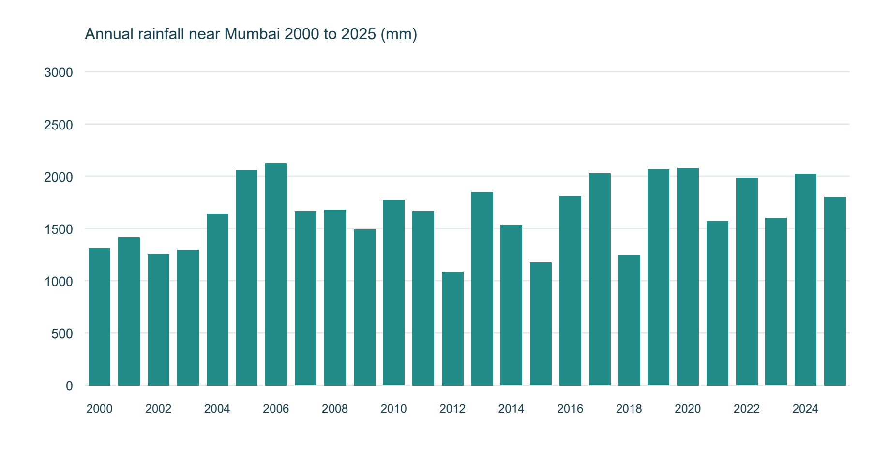
Annual totals range from 1,084.7 to 2,122.8 mm. Comparing complete years shows substantial variability rather than a constant yearly amount.
Figure 2 Mean rainfall for each calendar month
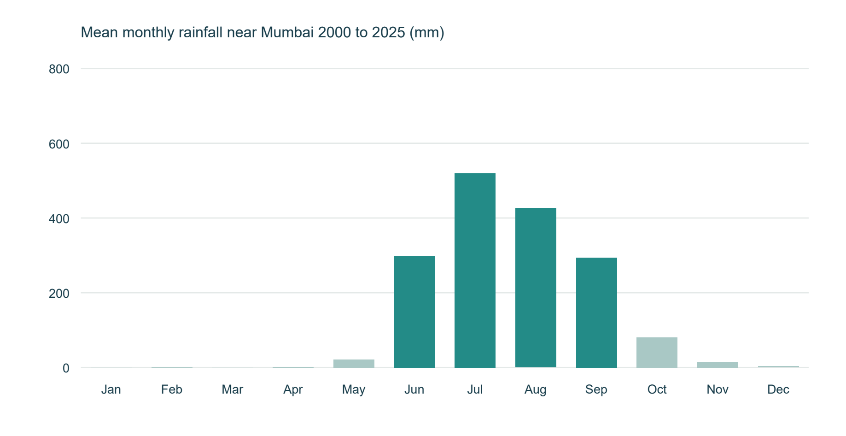
Rain is concentrated in the June–September monsoon. These four months account for 92.51% of the saved rainfall total.
Figure 3 June to September rainfall across years
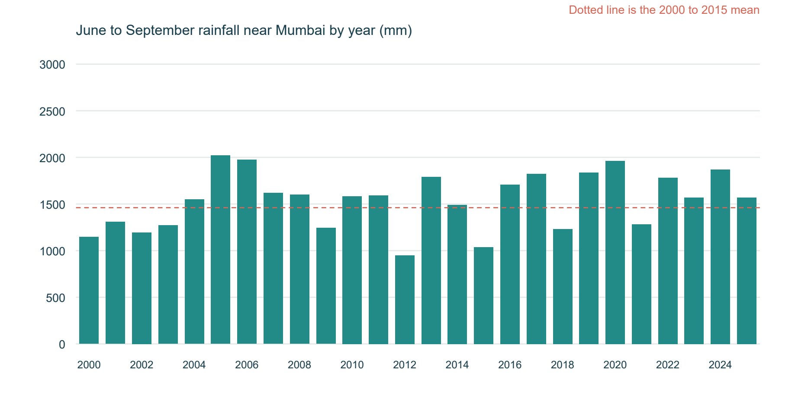
Each bar uses the same four months. The reference line is the 2000–2015 mean, making seasonal departures comparable across the full record.
Figure 4 Reconstructed annual high discharge class distribution
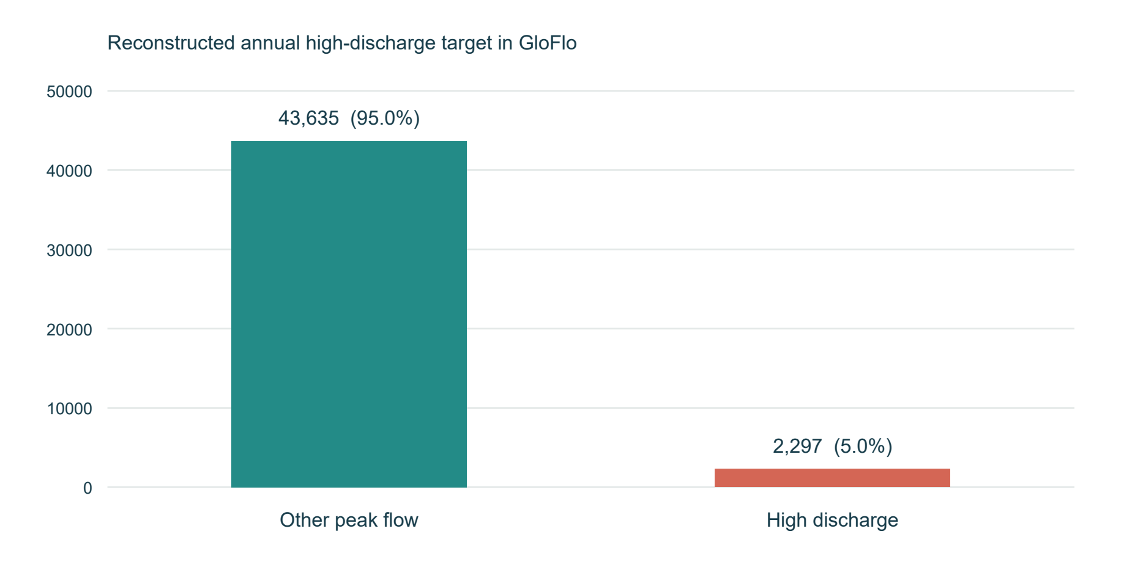
Only about 5% of the source rows receive the positive target. A majority-only classifier can therefore achieve approximately 95% accuracy while detecting no positives.
Figure 5 Reconstructed XGBoost holdout confusion matrix
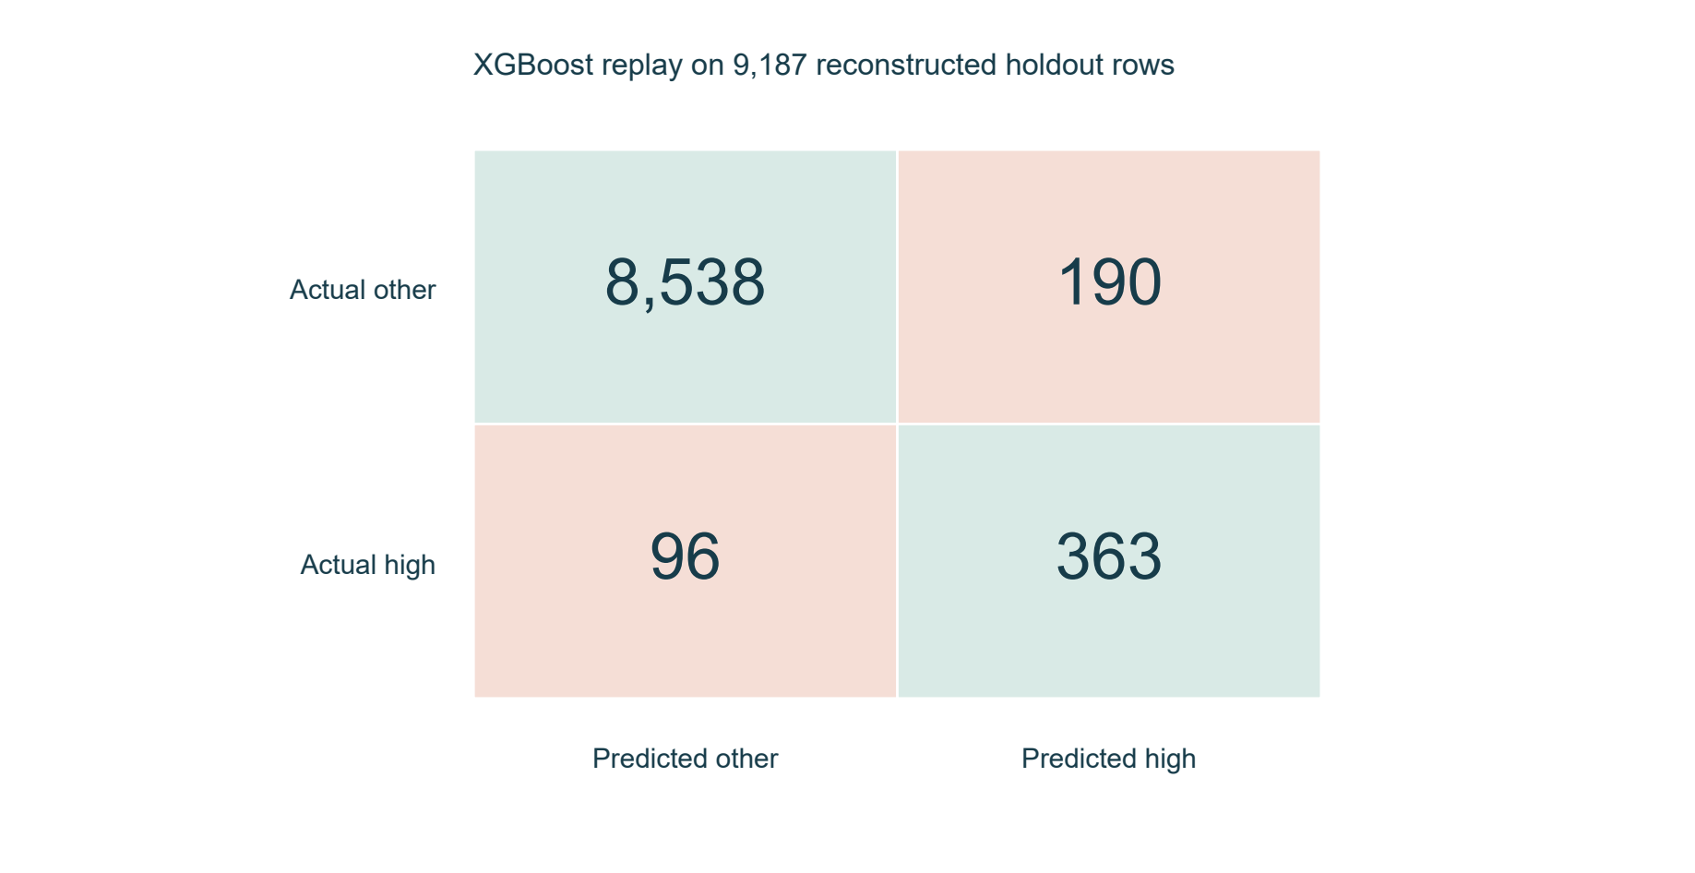
The model detects 363 of 459 positives. The 190 false positives and 96 missed positives explain the precision and recall values in Section 5.2.
Figure 6 Positive class precision recall and F1
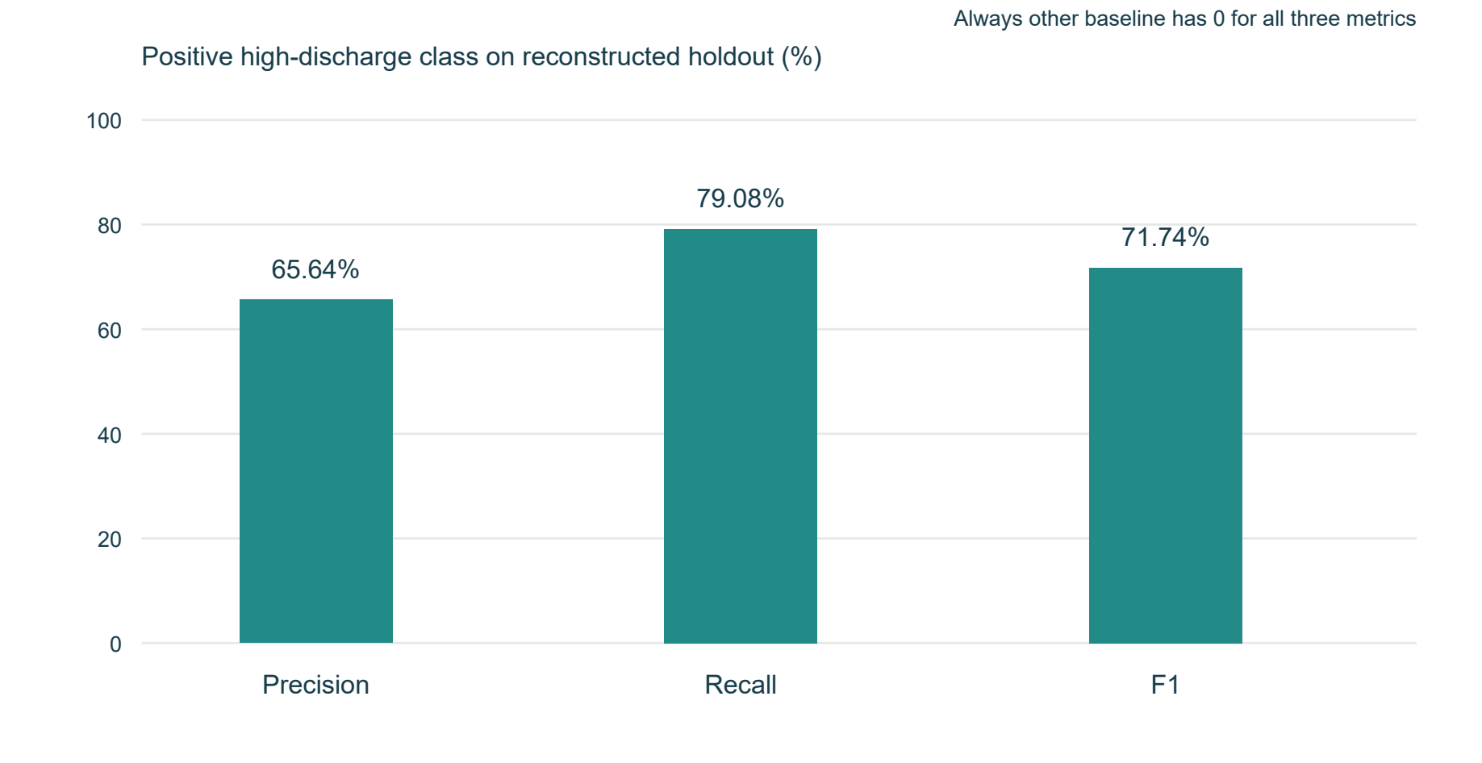
Recall is higher than precision. Positive-class F1 summarises their balance and is more informative here than the majority class F1.
Figure 7 Historical rainfall interface
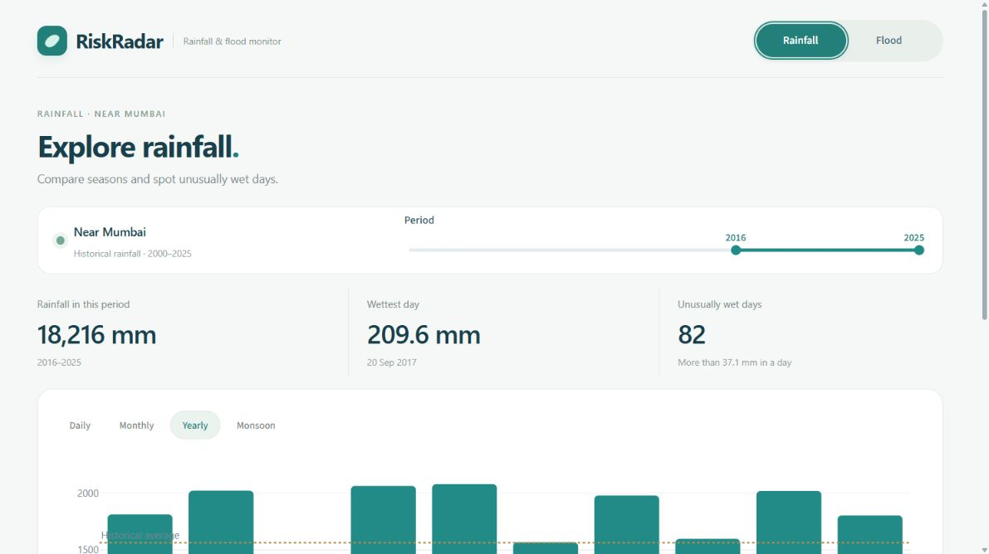
Users select a historical period, review rainfall summaries and switch between Daily, Monthly, Yearly and Monsoon views. A CSV download preserves the selected observations.
Figure 8 Flood susceptibility assessment interface

Users enter annual rainfall, wettest-month rain and variation, then expand Land and weather details when needed. The shown 2,200 mm annual and 550 mm wettest-month scenario receives Medium with other default values.

5 4 Discussion
Rainfall analysis demonstrates pronounced monsoon concentration and substantial interannual variability. The fixed reference period allows wet years, heavy-rainfall days and unusual monthly totals to be compared consistently. Calendar-month anomaly calculations account for the difference between expected wet-season and dry-season rainfall.
The classifier integrates rainfall with drainage, terrain and surface characteristics, enabling assessment of conditions that cannot be represented by rainfall amount alone. Recall exceeds precision for the high-discharge class: the model identifies most reconstructed positive cases while also producing false positive classifications. The confusion matrix makes this balance explicit.
Illustrative manual scenarios produce Low and High categories for the supplied drier and wetter examples. A scenario with 2,200 mm annual rainfall, 550 mm wettest-month rainfall and the remaining default attributes produces a Medium category. These scenarios demonstrate input interpretation and category presentation; predictive performance is established by the evaluation results.
Interactive rainfall charts support comparison of periods and seasonal patterns, while the assessment form presents the category associated with the entered conditions. The visualisations and assessment outputs provide complementary views of temporal rainfall variability and catchment susceptibility.

6 Conclusion
Historical rainfall analysis identifies substantial annual variability and a pronounced monsoon pattern near Mumbai, where June–September contributes 92.51% of recorded rainfall. The XGBoost classifier combines climatic and catchment characteristics to assess annual high-discharge susceptibility. Reconstructed holdout evaluation gives 96.89% accuracy, 65.64% precision, 79.08% recall and 71.74% F1 for the positive class. Compared with the majority-class baseline, the classifier provides positive-case detection while maintaining higher overall accuracy. The integration of historical visualisation and manual susceptibility assessment supports systematic examination of rainfall patterns and area conditions.

7 Future Development
Further work may extend geographical coverage, improve predictive evaluation and support the communication of assessment results.
Add more verified rainfall locations with the same complete-date checks, historical reference periods and chart controls.
Build a new dated training study using independently observed flood occurrence and matched rainfall, runoff and river observations. Predeclare chronological and station-separated evaluation before tuning.
Compare calibrated classifiers and training-only imbalance treatments using positive-class precision, recall, F1 and average precision. Select score bands using validation evidence for the new target.
Add an optional downloadable assessment summary that records user inputs, units, category and the saved model version.

8 References and Appendix
The following references identify the environmental datasets, analytical methods and software sources used in the study.
[1] Kuntla, S. K., Saharia, M., and Kirstetter, P. (2022). Global Flood characterization (GloFlo) Database. Zenodo. https://doi.org/10.5281/zenodo.7158028. Associated paper: Global-scale characterization of streamflow extremes, Journal of Hydrology 615, 128668. https://doi.org/10.1016/j.jhydrol.2022.128668.
[2] Open-Meteo. Historical Weather API documentation, ERA5 data source and rain_sum variable. https://open-meteo.com/en/docs/historical-weather-api. Existing saved history: 2000–2025 near Mumbai.
[3] XGBoost. Python API reference for XGBClassifier and parameter definitions. https://xgboost.readthedocs.io/en/stable/python/python_api.html.
[4] scikit-learn. Classification metrics and stratified train_test_split documentation. https://scikit-learn.org/stable/modules/model_evaluation.html and https://scikit-learn.org/stable/modules/generated/sklearn.model_selection.train_test_split.html.
[5] Streamlit and Plotly. Application and interactive chart documentation. https://docs.streamlit.io/ and https://plotly.com/python/.
[6] nitinc264. Flood-prediction-Model repository, RiskRadar application foundation and saved model artifacts. https://github.com/nitinc264/Flood-prediction-Model. The current project integrates the saved predictor with the revised Rainfall and Flood interface.
References reviewed on 25 October 2026.
The rainfall component reads the ERA5 history, prepares dated rainfall observations and calculates period totals and reference-based indicators for visualisation. The assessment component validates climatic and area attributes, applies categorical encoding, constructs the fitted feature vector and maps the XGBoost score to a susceptibility category.
The application is implemented in Streamlit with Plotly visualisations. CSV and JSON files store environmental observations, and PKL files store the classifier, encoders and feature order.
Application: app.py, monitor_page.py, rainfall_page.py and riskradar_page.py. Predictor: riskradar_predictor.py, flood_model.pkl, encoders.pkl and feature_columns.pkl. Shared presentation: assets/dashboard.css and assets/monitor.css.
Data: data/raw/kuntla_flooddatabase.csv, data/processed/data_audit.json and data/weather/IN_0000317_era5_2000_2025.json. Rainfall aggregation is implemented in historical_data.py; historical anomaly calculations are in rainfall_risk.py.
The reconstruction_summary.json and reconstructed_training_evidence.json files in evaluation/upstream_forensics contain the target definition, inferred partition and classification results. The reconstruction procedure is recorded in scripts/reconstruct_original_dataset.py.
Start from the RiskRadar project directory with: .venv\Scripts\python.exe -m streamlit run app.py --server.port 8501. Open http://127.0.0.1:8501/ in the browser.
Appendix Checklist
Done | Checklist item | Brief evidence / notes
☑ | Dataset source and citation included. | References 1–2 identify the GloFlo and ERA5 rainfall sources.
☑ | Important code/notebook or repository link provided, if required. | Section 8 identifies the application files and launch command; Reference 6 identifies the software foundation.
☑ | Additional graphs, tables or diagnostic outputs attached where useful. | Figures 1–6, the metric comparison and confusion counts provide measured evidence.
☑ | No confidential, personal or restricted data disclosed. | Only public environmental records and application images are included; student identity fields remain blank.

9 Team Members and Contributions
Complete the following fields with each member’s actual work before submission. Names, roll numbers, contribution percentages, confirmations and signatures are intentionally left blank.
S. No. | Member name / Roll No. | Tasks / Life-cycle stages handled | Specific contribution / deliverable | Approx. contribution (%)
1
2
3
4
Contribution areas may include data preparation, rainfall analysis, model study, interface development, result interpretation and report preparation. Record only work actually completed by the named member.
Member name / Roll No. | Confirmation of contribution | Signature (if required)
Team declaration: We confirm that the contribution details above accurately represent the work completed by each team member.
Team leader name / Roll No.: __________________________________ Date: ____________________

