Rainfall and Flood Risk Analysis Using Historical Weather Data
Applied Data Science Mini Project Report
Student details | Information
Project title | Rainfall and Flood Risk Analysis Using Historical Weather Data
Student name / Roll number
Semester | VII(A)
Course / Subject | Applied Data Science
Faculty name | Dakshayani R
Submission date

Report checklist
Checked items are completed. Open items identify remaining work. N/A includes a scope reason.
Done | Checklist item | Brief evidence / notes
☑ | Title, abstract, introduction, problem statement, objectives and scope are included. | Sections 1 and 2 define the study and its boundaries.
☑ | Dataset source, access date, features, dimensions and data limitations are documented. | Section 4.2 records sources, dates, dimensions and limitations.
☑ | Data quality issues and preparation steps are explained. | Section 4.3 documents missingness, duplicates and invalid years.
☑ | Exploratory Data Analysis (EDA) includes descriptive statistics and relevant visualisations. | Section 4.4 and Figures 1 to 4 contain calculated EDA.
☑ | Analysis/model choice is justified and the evaluation method is documented. | Section 4.5 distinguishes application tests from model accuracy.
☑ | Results include metrics, graphs/tables and interpretations—not screenshots alone. | Section 5 gives numeric results, graphs and interpretations.
☐ | Class imbalance is checked for classification tasks and addressed if needed. | Unresolved because verified flood and non-flood labels are absent.
N/A | For regression, suitable regression methods and error metrics are considered. | No rainfall-amount regression model is deployed in this scope.
☐ | Time-series data is checked; forecasting is attempted where suitable and feasible. | Daily history is analysed; forecasting was not implemented.
☑ | Conclusion, limitations and possible future improvements are included. | Sections 6 and 7 state conclusions and realistic next steps.

1. Abstract
We developed RiskRadar as a local dashboard for historical rainfall analysis and exploratory flood-risk assessment. We audited the public GloFlo database, containing 45,932 records and 93 columns for 9,710 stations in 57 countries. We also prepared an ERA5 archive obtained through Open-Meteo, comprising 9,497 daily rainfall estimates near Mumbai during 2000–2025. Our preparation workflow verifies the source checksum, standardises dates, preserves missing values and produces a unique station catalog. We examined descriptive statistics, annual totals, monthly patterns, rainfall frequencies and correlations among station attributes. Average annual rainfall at the example location is 1,663.5 mm, with 92.5% occurring during June–September. Our application integrates an XGBoost classifier that transforms 14 entered climate, terrain and land attributes into 13 features and returns a risk score. We validated navigation, charts, downloads, data handling and prediction-service behaviour, recording 73 passed checks and five failed API input checks. Independent classifier accuracy, precision, recall and F1 remain unestablished because verified binary labels and the original test split are unavailable. Our completed work supports reproducible historical analysis and controlled risk scenarios, with further labelled evaluation required before operational flood prediction.

2. Introduction

2.1 Background and context
Rainfall varies strongly between seasons and years. Heavy rainfall can increase runoff, while soil, land cover, drainage and terrain influence how water moves through a catchment. Flood occurrence also depends on hydrological conditions and local thresholds; rainfall alone does not establish that a flood happened.
We designed our dashboard around two user tasks: inspecting dated rainfall and testing environmental risk scenarios. We use top navigation, clear input controls and interactive charts to make these tasks accessible, while retaining technical methodology in the project documentation.

2.2 Problem statement
Our project addresses how to organise historical rainfall into understandable yearly, seasonal and daily views and provide environmental risk scenarios through an accessible dashboard, while distinguishing a model score from a verified flood forecast.

2.3 Objectives
1. Audit the public source data, including dimensions, station identifiers, dates, missing values and provenance.
2. Prepare a dated rainfall archive and develop descriptive statistics and interactive visualisations.
3. Integrate classifier inference with clear environmental inputs, risk results and scenario comparisons.
4. Validate dashboard navigation, exported results, data handling and direct API input behaviour.
5. Evaluate demonstrated functionality, document model-evaluation gaps and define practical improvements.

2.4 Scope and intended use
Our station catalog covers 57 source countries. We conducted detailed EDA on one cached location near Mumbai, India, at 19.1622° N and 73.2544° E, during 2000–2025. Other catalog locations can be loaded on demand; the report does not evaluate a global daily rainfall archive.
We implemented historical analysis, manual environmental scenarios, rainfall what-if comparisons and software/data validation. The application is an academic demonstration rather than an operational warning service. Dated flood forecasts, district-level predictions and independently validated flood probabilities remain outside this version. We archived Risk Map to keep the interface focused.

3. Hardware and Software Requirements
Category | Specification / tool | Purpose / version (if relevant)
Hardware | 64-bit personal computer | Runs the dashboard, stored datasets and prediction service locally.
Operating system | Windows 64-bit | PowerShell launcher starts the local API and dashboard.
Programming language | Python 3.12.10 | Pinned project environment; report analysis is generated from the same saved data.
Libraries / packages | pandas 3.0.6; NumPy 2.5.4; XGBoost 3.2.0; scikit-learn 1.6.1 | Tabular preparation, numeric operations and loading the supplied classifier/encoders.
IDE / notebook / platform | Local source checkout; Streamlit 1.66.1; Plotly 6.9.0 | Two browser views and interactive rainfall/risk charts. No training notebook is supplied.
Other tools | FastAPI 0.158.1; Uvicorn 0.54.0; requests 2.34.2; joblib 1.6.0 | Local HTTP prediction service, public historical-data retrieval, persistence and automated tests.

4. Methodology: Data Science Life Cycle
We followed the data-science lifecycle through problem definition, public-data collection, preparation, EDA, model integration and application validation. The following sections document our implementation and the labelled evaluation still required.

4.1 Business / Problem Understanding
Done | Checklist item | Brief evidence / notes
☑ | Defined the real-world problem and the stakeholder/user. | Students and exploratory users need readable rainfall history and controlled risk scenarios.
☑ | Identified the target outcome or question and success criteria. | Historical patterns and reliable execution are checked; predictive accuracy requires genuine labels.
☑ | Defined assumptions, constraints and potential impact. | Public data, one cached example site and a supplied model define the current scope.
Problem understanding and success criteria
We defined success through traceable data, complete-period aggregation, readable charts and repeatable inference. We developed the dashboard and historical-data workflow by adapting the open-source baseline in Reference 6 and integrating its pretrained XGBoost artifact; we did not train that artifact. A model score alone does not establish an observed flood or a calibrated future probability.

4.2 Data Understanding and Data Collection
Done | Checklist item | Brief evidence / notes
☑ | Identified the dataset source and documented how it was obtained. | The GloFlo CSV is downloaded from Zenodo and checked against its published MD5.
☑ | Checked data meaning, units, data types and collection period. | GloFlo climate fields are static by station; ERA5 rain_sum is dated daily rainfall in mm.
☑ | Checked the number of rows/records and columns/features. | The audit records 45,932 rows and 93 source columns; the weather table has 9,497 rows.
☐ | Identified the target variable (if supervised learning is used). | The classifier expects binary classes, but original target labels and their definition are missing.
☑ | Considered data privacy, consent, licence and possible bias. | Public station data contain no personal records; attribution, usage conditions and geographic bias are considered.

Dataset details | Your response
Dataset name and source / URL / citation | GloFlo database, Kuntla, Saharia and Kirstetter (2022), Zenodo record 7158028 [1,2]. Daily ERA5 rain_sum through Open-Meteo [3].
Date accessed; collection period | Source files verified for this report on 24 October 2026. GloFlo valid years: 1900–2015. Saved weather retrieved 23 October 2026 local time; rainfall covers 1 January 2000 to 31 December 2025.
Number of records (rows) | GloFlo: 45,932. Unique station catalog: 9,710. Dated peak extract: 45,910. Cached daily rainfall: 9,497.
Number of features (columns) | Raw GloFlo: 93. Station catalog: 5. Dated peak extract: 7. Weather analysis: 2. Classifier input vector: 13 derived from 14 entered values.
Feature types | 84 numeric and 9 non-numeric source columns on import. Types include identifiers, coordinates, mixed-format year, categorical land/climate/soil fields and numeric climate/catchment attributes.
Target variable and its type | Supplied classifier: binary outcome encoded as classes 0 and 1; the scientific label definition is unavailable. No verified binary target column exists in the source. Weather analysis describes rainfall, without a forecast target.
File size / dimensionality / complexity | GloFlo CSV: 34,553,889 bytes, about 34.6 MB. Cached weather JSON: 182,551 bytes. Multiple extreme-flow records repeat each station’s static attributes.
Known limitations and bias | Station coverage is uneven, with 4,974 stations in the United States. The example rainfall series is a gridded estimate near a gauge, not an observed gauge or basin average. Source records of extremes do not provide verified non-flood days.
Feature inventory of principal analysis and inference fields
Feature / column | Meaning / unit | Data type | Role (input / target / ID / date) | Notes
Station identifier | GloFlo gsim_code | Text | Identifier | Repeated in the raw event records; unique in the catalog.
Latitude and longitude | Geographical coordinates in degrees | Numeric | Location | Used to request nearby historical weather.
Year | Year of source flow record | Mixed then integer | Time | 22 unparsable entries excluded from the dated extract.
Annual and unit peak discharge | Peak-flow measures as supplied | Numeric | Observed descriptor | Not binary flood/no-flood labels; not used as classifier input.
Annual rainfall | Annual precipitation in mm | Numeric | Input | A static climate attribute in GloFlo.
Wettest-month rainfall | Precipitation in the wettest month in mm | Numeric | Input | Combined in the configured rainfall index.
Rainfall seasonality | Variation in rainfall through the year in percent | Numeric | Input | A climate index, not a date sequence.
Drainage density | API labels km per square km | Numeric | Input | Exact equivalence to original source units is not reconstructed.
Drainage texture | Drainage texture as supplied | Numeric | Input | Combined in the configured drainage index.
Basin relief | Elevation difference in m | Numeric | Input | Also retained separately in the 13-feature vector.
Mean temperature | Annual mean air temperature in °C | Numeric | Input | A climate summary.
Temperature seasonality | Source seasonality index | Numeric | Input | Not a temperature in degrees.
Runoff curve number | AMC II curve number | Numeric | Input | An index associated with runoff potential.
Ruggedness number | Terrain ruggedness index | Numeric | Input | Retained from the exported schema.
Infiltration number | Drainage-based index | Numeric | Input | Not a measured infiltration percentage.
Climate type | 6 supplied encoder choices | Category | Input | Readable names map to retained integer codes.
Land-cover type | 11 supplied encoder choices | Category | Input | Includes an unspecified category.
Soil type | 25 supplied encoder choices | Category | Input | Includes an unspecified category.
Rainfall and drainage indices | Configured weighted/capped combinations | Numeric | Engineered input | Two indices help form the 13 model features.
date | UTC calendar day, 2000–2025 | Date | Weather time | Daily frequency; unique and ordered.
rain_mm | Daily liquid rainfall in mm | Numeric | Analysis measure | Derived from ERA5 rain_sum; not a forecast.

4.3 Data Preparation
Done | Checklist item | Brief evidence / notes
☑ | Checked missing values and explained the treatment (drop, impute, retain, etc.). | Column missingness and absent weather days are checked; missing rain is not replaced with zero.
☑ | Checked duplicate records and handled them where appropriate. | No exact duplicate GloFlo rows; repeated station IDs are handled as distinct observations.
☑ | Checked invalid values, inconsistent formats, units and data types. | Dates, ranges, units and duplicate days are tested; five direct API guards remain missing.
☑ | Investigated outliers/anomalies and justified retaining, correcting, capping or removing them. | IQR flags and the rainfall tail are examined; credible heavy-rainfall days are retained.
☑ | Encoded categorical features and scaled/normalised features if required. | We integrate the existing categorical encoders without new scaling or training-time fitting.
☑ | Recorded any feature engineering, feature selection or transformations. | We verify the exported 13-feature order and configured index formulas.

Issue / abnormality found | How it was detected | Action taken and reason | Records/features affected
Missing values | Per-column null counts and date reindexing | Retain missingness. Do not report incomplete calendar totals. No new model imputation is fitted. | 10 source columns entirely empty; cached weather has 0 missing days.
Duplicates and invalid years | Exact-row check, station-key check and numeric year parsing | Keep separate station observations, validate a many-to-one metadata join and exclude unusable years from the dated extract. | 0 exact duplicates; 22 unusable years; 45,910 dated records.
Outliers and anomalies | Daily distribution, IQR and maximum-day inspection | Retain 1,212 days above the 10.5 mm IQR fence. Heavy rainfall is meaningful here; a flag is not proof of an error. | Weather maximum 209.6 mm on 20 September 2017.
Encoding and transformation | Encoder vocabularies, schema and index formulas | Preserve 6/11/25 climate/land/soil choices and the 13-feature vector; do not replace categories or silently rescale source units. | 14 raw inputs become 13 model features.
Other validation gaps | Eight valid/invalid direct API requests | Record invalid requests accepted by the backend. Server-side numeric, category and cross-field guards are required. | 3 API checks passed; 5 failed.
We prepared a station catalog of 9,710 × 5, a dated peak extract of 45,910 × 7 and a weather-analysis table of 9,497 × 2. We keep these purpose-specific outputs separate because they do not form a verified labelled training dataset.

4.4 Exploratory Data Analysis (EDA)
Done | Checklist item | Brief evidence / notes
☑ | Computed relevant descriptive statistics (e.g., mean, median, mode, min/max, range, standard deviation, quartiles). | Daily/annual statistics, quantiles, counts and spread are calculated from the saved archive.
☑ | Examined distributions and class/target frequencies where applicable. | Rainfall frequency bins and source coverage are examined; true flood class counts remain unknown.
☑ | Explored relationships/correlations among relevant variables. | Station-level Pearson correlations avoid counting repeated static attributes as new locations.
☑ | Created suitable visualisations and wrote an interpretation for each. | Four data-derived figures appear in Section 5.3, each with a caption and interpretation.

Statistic / EDA check | Variables examined | Main finding / implication
Count and missingness | Raw records, stations and daily rainfall | 45,932 source records; 9,710 stations; 9,497 consecutive rainfall days. No exact duplicate rows or missing cached days.
Mean, median, mode and spread | Daily rainfall over 2000–2025 | Mean 4.55 mm; median/mode 0 mm; SD 11.75 mm; range 0–209.6 mm. A dry-day majority and a long upper tail make the mean insufficient alone.
Quartiles and extremes | Daily and annual rainfall | Daily Q1 = 0, Q3 = 4.2 mm. Annual mean 1,663.5 mm, median 1,665.7 mm and SD 313.7 mm. The annual minimum is 1,084.7 mm in 2012; maximum 2,122.8 mm in 2006.
Correlation and relationships | Seven static station attributes | Annual precipitation versus wettest-month precipitation: Pearson r = 0.837. Pairwise n = 9,688–9,710. Association does not establish flood prediction skill.
Target or class distribution | Original binary classifier target | Verified class counts and imbalance cannot be calculated. Encoded classes 0/1 and saved predictions are not observed target frequencies.
Seasonality and wet days | Calendar months and rainfall occurrence | 92.5% of rainfall falls in June–September. There are 4,002 wet days (42.1%) and 5,495 zero-rainfall days.
Visualisation register for the four calculated figures in Section 5.3
Figure no. and graph type | Variables / question | Important observation | What it means for the problem
Figure 1 annual bars | How do yearly totals vary? | 1,084.7–2,122.8 mm across 26 years. | Rainfall is not constant between years; inspect spread before treating a single annual value as representative.
Figure 2 monthly means | When does most rainfall occur? | June–September contribute 92.5% of the total. | The example location has a concentrated rainy season.
Figure 3 daily frequencies | How frequent are dry and very wet days? | 5,495 zero-rainfall days; 24 days exceed 100 mm. | The distribution is skewed; retain the meaningful heavy-rainfall tail.
Figure 4 correlations | How related are the static inputs? | Annual and wettest-month precipitation are positively correlated. | Some rainfall inputs contain overlapping information; this is not causal or held-out model evidence.

4.5 Analysis Design, Model Selection and Validation
Done | Checklist item | Brief evidence / notes
☑ | Selected an analysis technique/model suited to the problem and explained why. | We use descriptive analysis for rainfall history and integrate XGBoost for scenario scoring. Comparative predictive skill is not established.
☑ | Specified input features and target variable, if applicable. | The 14 inputs and 13-feature vector are documented; the original binary target definition is unresolved.
☑ | Documented train/test split or other validation design. | Software/data validation is specified. No defensible predictive train/test split can be reconstructed.
☐ | Used cross-validation or explained why a hold-out approach was suitable. | Predictive hold-out/CV is pending verified labels and station-aware split membership.

Design choice | What was used | Reason / details
Analysis task | Descriptive and diagnostic analysis; exploratory classification inference | Our implemented scope covers history and classification scenarios; regression, clustering and forecasting are not deployed.
Technique / model | Year/month/day aggregation, frequency bins, station correlations and integrated XGBoost classifier | Tree ensembles accommodate nonlinear tabular relationships, but no comparative skill claim is established.
Inputs and target | 14 entered climate/terrain/land values; 13 model features | Two configured indices and selected raw fields form our inference vector. Verified binary outcome labels are absent.
Baseline or comparison | Selected-period rainfall mean for descriptive display | This is a descriptive reference, not a predictive baseline. A majority-class baseline requires true labels.
Train / validation / test split | Not reconstructed; no new supervised split was created | The source lacks the original target-generation pipeline and test membership. Repeating station attributes makes naive random-row splitting unsuitable for new-location claims.
Validation method | 39 dashboard + 15 history + 10 data + 6 artifact/consistency + 8 API checks | 73 passed and 5 failed. These establish runtime/data behaviour, not generalisation accuracy.
Evaluation metrics | Software pass/fail counts; data completeness; future classifier precision/recall/F1/PR-AUC/ROC-AUC | Predictive metrics and calibration remain unavailable. Rainfall MAE/RMSE/R² do not apply to the current binary model.

4.6 Task-specific checks
Classification checks
Done | Checklist item | Brief evidence / notes
☐ | Checked class counts / class imbalance. | True positive/negative counts are unavailable; the raw file describes flow extremes without a binary flooded column.
☐ | If imbalanced, considered class weights, resampling or other suitable methods and explained the choice. | No new balancing is performed. Training-only weights/resampling can be assessed after a valid labelled split exists.
☐ | Used suitable metrics such as precision, recall, F1-score, confusion matrix and/or ROC-AUC, not accuracy alone where misleading. | Precision, recall, F1, confusion matrix and AUC need verified outcomes; software success is not substituted.
We could not establish true class counts or imbalance from the available records. We therefore performed no new resampling; a defensible positive/negative target definition and labelled split must come first.
Regression checks
Done | Checklist item | Brief evidence / notes
N/A | Identified the continuous target and candidate predictors. | The current application does not fit a rainfall-amount regression model.
N/A | Checked relevant assumptions/diagnostics where appropriate (linearity, residual patterns, multicollinearity, influential points). | The current application does not fit a rainfall-amount regression model.
N/A | Reported suitable metrics such as MAE, MSE/RMSE and R². | The current application does not fit a rainfall-amount regression model.
N/A | Compared actual vs predicted values or examined residuals. | The current application does not fit a rainfall-amount regression model.
We summarise continuous rainfall descriptively. This version deploys a classifier rather than a rainfall regressor, so regression training and residual/error metrics are outside its implemented scope.
Clustering checks
Done | Checklist item | Brief evidence / notes
N/A | Explained the similarity/distance measure and key settings. | No clustering task, distance measure or cluster model is part of this project.
N/A | Explained how the number of clusters or structure was chosen. | No clustering task, distance measure or cluster model is part of this project.
N/A | Interpreted the resulting groups and checked whether they were meaningful. | No clustering task, distance measure or cluster model is part of this project.
Time series and forecasting checks
Done | Checklist item | Brief evidence / notes
☑ | Checked whether a meaningful time/date variable and sequential observations exist. | The saved archive is a unique, ordered daily series covering 2000–2025.
☑ | Checked frequency, missing periods, trend, seasonality and unusual events where relevant. | Missing days, annual variation, calendar-month seasonality and large rainfall values are examined.
☐ | Used a chronological train/test split (not a random split) for forecasting evaluation. | No forecast model was trained, so no forecasting split is claimed.
☐ | Tried at least one taught forecasting method or suitable ML-based method when data and time permit. | Forecasting is a possible extension; this implementation remains historical analysis and static risk scenarios.
☐ | Compared forecasts against a simple baseline (e.g., last value or seasonal-naive) where possible. | No out-of-sample forecast exists to compare against last-value or seasonal-naive predictions.
☐ | Plotted actual vs forecast and reported suitable error metrics. | Actual-versus-forecast plots and forecast error metrics require an implemented, held-out forecasting task.

Time-series item | Your response
Is time-series data available? | Yes. ERA5 daily liquid-rainfall estimates exist for the cached example location.
Time variable, frequency and target | date at daily UTC frequency; rain_mm is the analysed measure. No future-rainfall prediction target is deployed.
Trend / seasonality / missing periods | Annual totals vary by year; 92.5% of rainfall falls in June–September. No days are missing. A single location and 26 years do not establish a climate-change cause.
Forecasting methods attempted | None in the current scope. Suitable future comparisons include seasonal-naive and a trained regression model using causal lags.
Chronological train/test period | Not applicable to descriptive aggregation. A future forecast experiment must reserve later years before model selection.
Forecast metrics | Not reported. MAE/RMSE/R² would require paired held-out predictions and observed rainfall; MAPE is problematic on zero-rainfall days.
Main finding and limitations | The daily record supports clear seasonality and variability analysis. It does not establish a working or accurate forecast.

5. Results and Discussion
We evaluated our work through calculated rainfall findings and software/data checks. We report these separately from predictive skill, which requires independent labelled outcomes.

5.1 Summary of key results
We verified the published source checksum and prepared a catalog of 9,710 stations in 57 countries. Our cached example contains 9,497 complete daily rainfall values. We calculated a 26-year annual average of 1,663.5 mm, with 92.5% of rainfall during June–September.
Our dashboard, history and data checks produced 64 passes. Six further artifact/consistency checks passed, while eight direct API checks produced three passes and five failures. Our complete recorded validation outcome is therefore 73 passed and five failed checks.
Validation area | Passed | Failed | Total | Interpretation
Dashboard | 39 | 0 | 39 | Navigation, inputs, risk results, comparisons and downloads work.
Historical page | 15 | 0 | 15 | Real rainfall totals, dates, charts and offline recovery work.
Data handling | 10 | 0 | 10 | Missing dates, invalid values, duplicates and units are tested.
Artifacts and consistency | 6 | 0 | 6 | Hashes, feature schema and repeated inference are consistent.
Direct API inputs | 3 | 5 | 8 | The API accepts five unsupported or contradictory input cases.
Total | 73 | 5 | 78 | Strict software validation remains failed until the API guards are corrected.
We found that the API accepts negative annual rainfall, wettest-month rainfall above annual rainfall, negative drainage density, climate code 99 and soil code −1. Our web form constrains these values, but direct API callers can bypass it. We recorded these five failures as remaining backend work.
We verified repeatable runtime outputs: 7.79% Low for typical conditions, 0.38% Low for the drier example and 78.40% High for the wetter example. Repeated identical requests returned identical scores. These checks demonstrate execution and consistency, not correctness against observed flood events.

5.2 Model performance and comparison
We assessed model execution and input/output consistency. We did not establish independent accuracy, precision, recall, F1 or AUC because verified labels and held-out test membership are unavailable. We therefore report those metrics as not measured and make no claim that our integrated classifier outperforms another model.
Model or method | Accuracy | F1 | Recall | Evaluation status
Majority-class baseline | Not measured | Not measured | Not measured | True class counts and labelled test outcomes are absent.
Integrated XGBoost | Not measured | Not measured | Not measured | Integrated for inference. Original labels, split and preprocessing fit remain unavailable.
Alternative models | Not trained | Not trained | Not trained | No new supervised comparison is claimed without a defensible target and held-out evaluation.

5.3 Graphs and interpretation
We generated Figures 1 to 3 from the complete 2000–2025 daily archive near Mumbai and Figure 4 from one static record per GloFlo station. These charts explain observed data patterns; they are not actual-versus-predicted flood-performance plots.
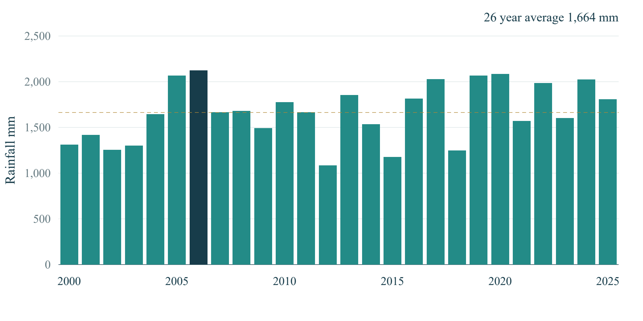
Figure 1 Annual rainfall totals near Mumbai from 2000 to 2025
Totals range from 1,084.7 mm in 2012 to 2,122.8 mm in 2006. The dotted line marks the 1,663.5 mm period mean. This variation supports inspecting individual years rather than treating one annual climate value as a weather history.
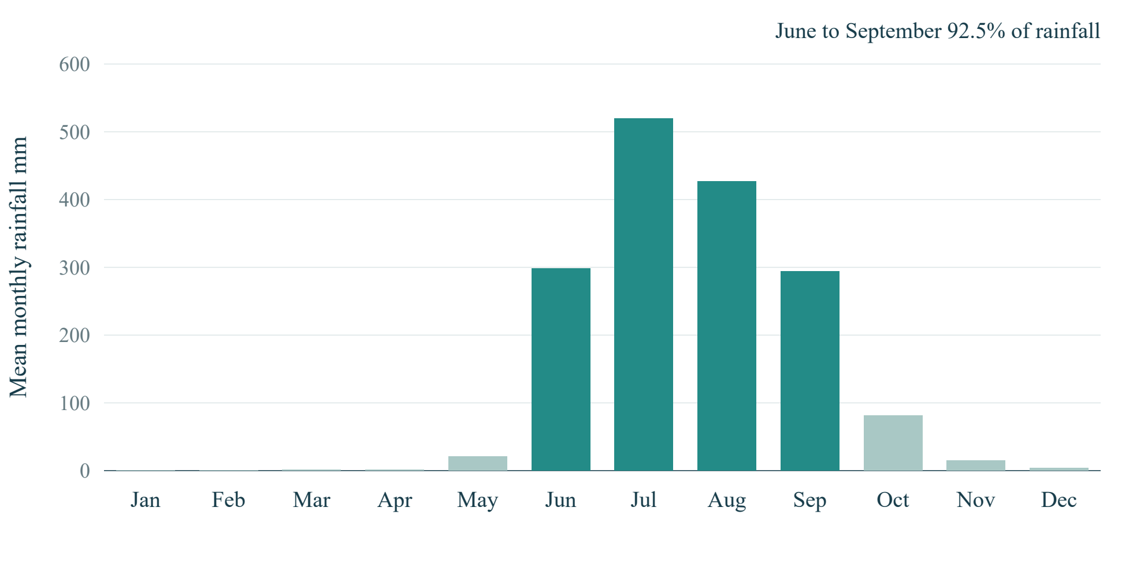
Figure 2 Mean monthly rainfall near Mumbai from 2000 to 2025
July has the highest mean monthly total, 519.3 mm. June–September together contribute 92.5% of rainfall. The concentration explains the prominent seasonal pattern; it does not mean that every rainy-season day floods.
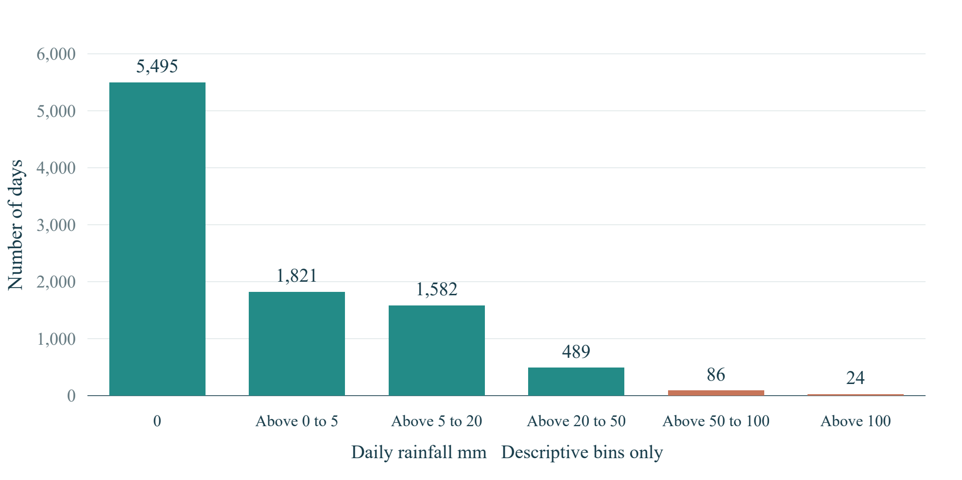
Figure 3 Daily rainfall frequency across the complete archive
There are 5,495 dry days, 4,002 days with rain and 24 days above 100 mm. A zero median coexists with a 209.6 mm maximum. The bins describe rainfall frequency only and are not flood-risk categories or event labels.
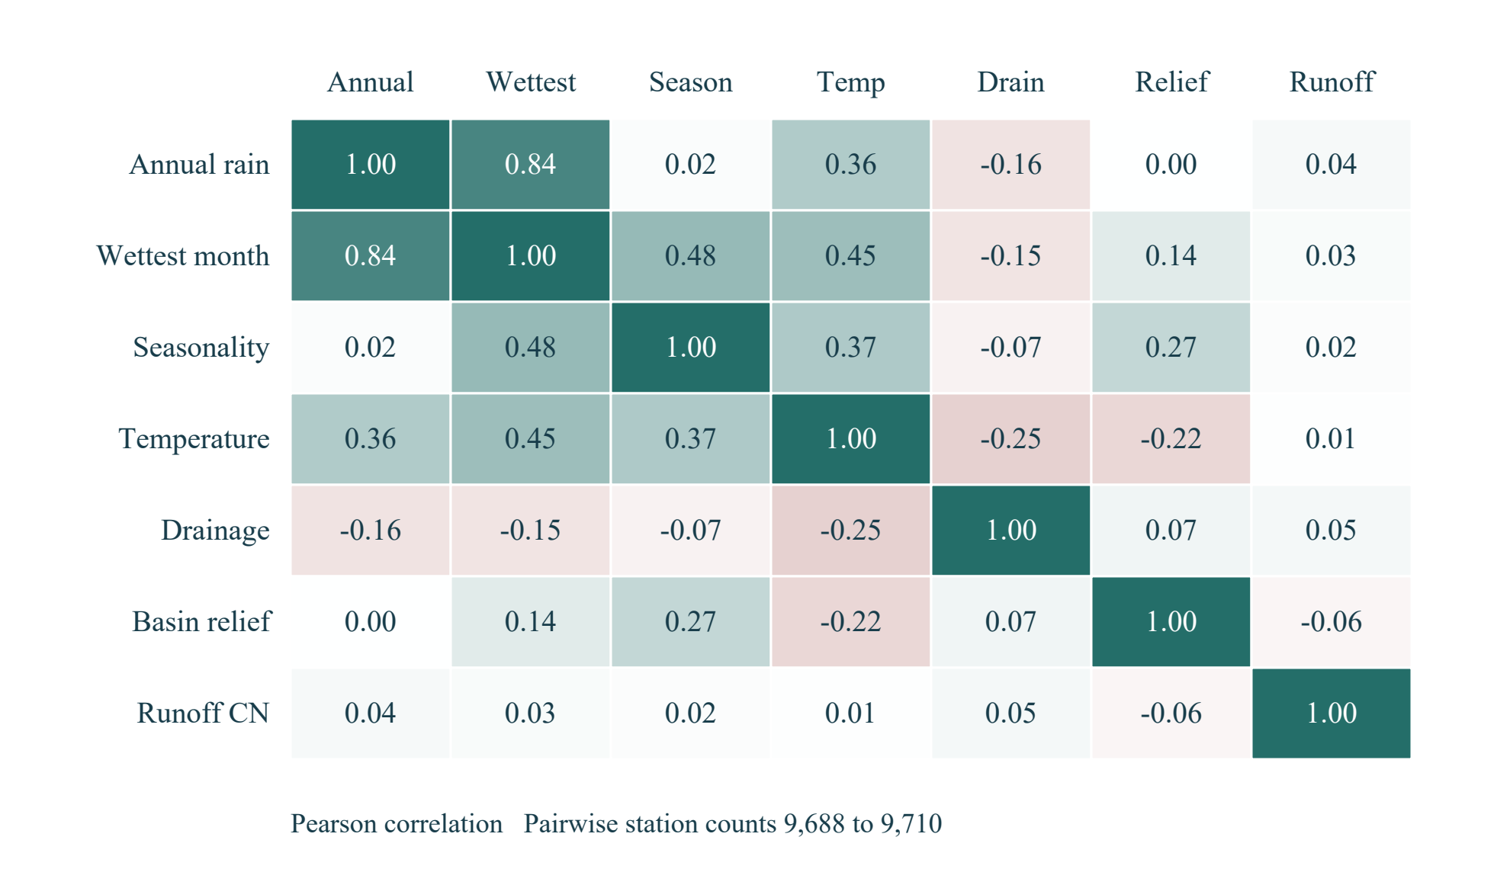
Figure 4 Correlations among static attributes at unique source stations
Annual rainfall and wettest-month rainfall have Pearson correlation 0.837. Pairwise sample counts range from 9,688 to 9,710 because some fields are missing. Overlapping information matters for later model design; correlation alone establishes neither causality nor forecast skill.

5.4 Discussion and practical implications
We achieved our historical-analysis objective for the prepared archive and implemented consistent scenario calculations. During preparation, we found that GloFlo rainfall attributes remain constant across repeated records for a station. We therefore used the separate dated ERA5 archive for yearly and seasonal analysis instead of treating static climate attributes as a rainfall time series.
Our evaluation also identified a target-definition gap: a peak-discharge record is not automatically a labelled flood, and an absent record is not a verified non-flood. Random-row splitting could repeat station attributes across sets. Future model evaluation must define whether it measures new-location susceptibility or event-date prediction and choose suitable station/time splits.
The five failed API checks identify a concrete engineering improvement. We need numeric, category and cross-field validation in the prediction service as well as the web form. These results show the value of testing the complete application, including requests that bypass dashboard controls.

6. Conclusion
We developed an accessible dashboard for traceable historical rainfall analysis and environmental risk scenarios. Our work covers data auditing, preparation, EDA, interactive presentation, classifier integration and software validation. We found strong June–September seasonality and recorded 73 passed checks and five failed API checks. The integrated classifier executes consistently; verified labels and an independent test design are still needed to establish predictive accuracy. Our implemented historical-analysis and application workflows provide a clear foundation for that further evaluation.

7. Limitations and Future Work
Our main limitations are unavailable binary labels, original split membership and fitted preprocessing provenance; uneven station coverage; one cached location for detailed rainfall analysis; and gridded estimates rather than gauge or basin measurements. The configured score thresholds and index weights are not calibrated operational warning thresholds. Source/API unit equivalence, particularly drainage density, requires verification before transferring measured attributes into inference. GloFlo records end in 2015 and cannot establish flood labels for later rainfall years.
Our next priorities are backend input guards, a defensible flood/non-flood outcome definition and independent evaluation. We would separate station groups and reserve future periods where relevant, fit preprocessing and imbalance handling only on training data, and compare baselines with candidate classifiers using precision, recall, F1, PR-AUC, ROC-AUC and calibration. Any rainfall-forecasting extension would first require causal features, chronological hold-out periods and naive baselines.

8. References and Appendix
[1] Kuntla, S. K., Saharia, M., and Kirstetter, P. (2022). Global Flood characterization GloFlo Database. Zenodo. https://doi.org/10.5281/zenodo.7158028
[2] Kuntla, S. K., Saharia, M., and Kirstetter, P. (2022). Global-scale characterization of streamflow extremes. Journal of Hydrology, 615, 128668. https://doi.org/10.1016/j.jhydrol.2022.128668
[3] Open-Meteo. Historical Weather API documentation. ERA5 daily rain_sum in mm. https://open-meteo.com/en/docs/historical-weather-api. Accessed 24 October 2026.
[4] Open-Meteo. Terms and Privacy. Non-commercial API use and CC BY 4.0 attribution conditions. https://open-meteo.com/en/terms. Accessed 24 October 2026. The GloFlo record is public; its redistribution terms should be confirmed before republishing the raw data.
[5] scikit-learn developers. Metrics and scoring quantifying the quality of predictions. https://scikit-learn.org/stable/modules/model_evaluation.html. Accessed 24 October 2026.
[6] Chauhan, N. Flood prediction Model repository. https://github.com/nitinc264/Flood-prediction-Model. Baseline source and pretrained model adapted for our application. Source commit 2d823f3692e891ac92de4435bbe2c006131c30b3.
Reproducibility appendix
We retained our model/data audit and individual validation outcomes in MODEL_REPORT.md, EVALUATION_RESULTS.md and evaluation/current_evaluation.json. Source missingness and checksum evidence are stored in data/processed/data_audit.json. Our calculated report statistics and figure-generation script are retained in reports/report_work/.
From the RiskRadar folder, run .\start-riskradar.ps1 to launch the two local services. With the project Python environment active, run scripts/prepare_historical_data.py for reproducible data acquisition, tests/verify_dashboard.py and tests/verify_history_page.py for integration checks, python -m unittest discover -s tests -p test_*.py for data tests, and scripts/evaluate_current_system.py for extended evaluation.
We verified GloFlo MD5 4e0d207c21c54577bd5a1e176a96ed3e and model SHA256 aad88a12f4645f3703c996641a15ce40603f6d5a608918fad4f37496d2f89395. We preserved the integrated model and original map CSV. Our reported results come from actual data and software checks; no new model training or predictive-accuracy estimate is claimed.
Appendix checklist:
Done | Checklist item | Brief evidence / notes
☑ | Dataset source and citation included. | References 1 to 4 provide source citations and usage context.
☑ | Important code/notebook or repository link provided, if required. | Reference 6 and the reproducibility appendix identify the code and source commit.
☑ | Additional graphs, tables or diagnostic outputs attached where useful. | Four figures, descriptive results and validation breakdowns are included.
☑ | No confidential, personal or restricted data disclosed. | No credentials or private records are included. Personal contribution/signature fields remain blank for completion.

9. Team Members and Individual Contributions
Complete the actual team details, work performed and contributions below. Contribution percentages, if used, must sum to 100%.
S. No. | Member name / Roll No. | Tasks / Life-cycle stages handled | Specific contribution / deliverable | Approx. contribution (%)
1
2
3
4
Contribution areas may include problem definition, data collection, preparation, EDA, interface work, model integration, validation, interpretation, report writing and presentation.
Member name / Roll No. | Confirmation of contribution | Signature (if required)
Team declaration: We confirm that the contribution details above accurately represent the work completed by each team member.
Team leader name and roll number __________________________ Date ______________

