Rainfall and Flood Risk Analysis Using Historical Weather Data
Applied Data Science Mini Project Report
Student details | Information
Project title | Rainfall and Flood Risk Analysis Using Historical Weather Data
Student name / Roll number
Semester | VII(A)
Course / Subject | Applied Data Science
Faculty name | Dakshayani R
Submission date

Report checklist
Checked items are completed. Open items identify remaining work. N/A includes a scope reason.
Done | Checklist item | Brief evidence / notes
☑ | Title, abstract, introduction, problem statement, objectives and scope are included. | Sections 1 and 2 define the study and its boundaries.
☑ | Dataset source, access date, features, dimensions and data limitations are documented. | Section 4.2 records sources, dates, dimensions and limitations.
☑ | Data quality issues and preparation steps are explained. | Section 4.3 documents missingness, duplicates and invalid years.
☑ | Exploratory Data Analysis (EDA) includes descriptive statistics and relevant visualisations. | Section 4.4 and Figures 1 to 6 contain calculated EDA.
☑ | Analysis/model choice is justified and the evaluation method is documented. | Section 4.5 explains analytical design and the limits of predictive evaluation.
☑ | Results include metrics, graphs/tables and interpretations—not screenshots alone. | Section 5 gives numeric results, graphs and interpretations.
☐ | Class imbalance is checked for classification tasks and addressed if needed. | Unresolved because verified flood and non-flood labels are absent.
N/A | For regression, suitable regression methods and error metrics are considered. | No rainfall-amount regression model is deployed in this scope.
☐ | Time-series data is checked; forecasting is attempted where suitable and feasible. | Daily history is analysed; forecasting was not implemented.
☑ | Conclusion, limitations and possible future improvements are included. | Sections 6 and 7 state conclusions and realistic next steps.

1. Abstract
We developed RiskRadar as a local dashboard for historical rainfall analysis and exploratory flood-risk assessment. Our dataset evaluation uses the supplied GloFlo CSV, containing 45,932 records and 93 columns for 9,710 stations in 57 countries. The records combine peak-discharge observations with station climate, terrain, soil and land-cover attributes. We prepared separate station and dated-flow tables because repeated station records share static climate values. Across unique stations, median annual precipitation is 1,007.1 mm, while 51.2% of stations are in the United States. The file contains no verified flood/no-flood target, so it cannot independently establish classifier accuracy. For dated rainfall analysis, our application uses a separate existing ERA5 archive from Open-Meteo with 9,497 daily estimates near Mumbai during 2000–2025. This archive has average annual rainfall of 1,663.5 mm, with 92.5% occurring during June–September. Our application integrates XGBoost to map 14 environmental inputs into 13 features and produce an exploratory risk score. The report presents data preparation, six figures, station distributions and the distinction between environmental scenario scoring and validated event forecasting. The completed analysis supports rainfall exploration and identifies the additional outcome data needed for predictive evaluation.

2. Introduction

2.1 Background and context
Rainfall varies strongly between seasons and years. Heavy rainfall can increase runoff, while soil, land cover, drainage and terrain influence how water moves through a catchment. Flood occurrence also depends on hydrological conditions and local thresholds; rainfall alone does not establish that a flood happened.
We designed our dashboard around two user tasks: exploring dated rainfall and comparing environmental risk scenarios. We use top navigation, clear input controls and interactive charts to make these tasks accessible, while documenting the analytical methods in this report.

2.2 Problem statement
Our project addresses how to organise historical rainfall into understandable yearly, seasonal and daily views and provide environmental risk scenarios through an accessible dashboard, while distinguishing a model score from a verified flood forecast.

2.3 Objectives
1. Describe the public dataset, its station coverage, variable types, record structure and analytical limitations.
2. Prepare station and dated-flow tables and use the existing daily archive for rainfall time-series analysis.
3. Integrate classifier inference with clear environmental inputs, risk results and scenario comparisons.
4. Explain rainfall distributions, seasonal patterns, geographic coverage and relationships among environmental attributes.
5. Identify suitable prediction targets and distinguish exploratory scenario scores from measured predictive performance.

2.4 Scope and intended use
Our station catalog covers 57 source countries. We conducted detailed EDA on one cached location near Mumbai, India, at 19.1622° N and 73.2544° E, during 2000–2025. Other catalog locations can be loaded on demand; the report does not evaluate a global daily rainfall archive.
We implemented historical analysis, manual environmental scenarios and rainfall what-if comparisons. This report evaluates the supplied dataset and the existing rainfall archive. Operational flood warnings, district-level predictions and independently validated flood probabilities remain outside this version. We archived Risk Map to keep the interface focused.

3. Hardware and Software Requirements
Category | Specification / tool | Purpose / version (if relevant)
Hardware | 64-bit personal computer | Runs the dashboard, stored datasets and prediction service locally.
Operating system | Windows 64-bit | PowerShell launcher starts the local API and dashboard.
Programming language | Python 3.12.10 | Pinned project environment; report analysis is generated from the same saved data.
Libraries / packages | pandas 3.0.6; NumPy 2.5.4; XGBoost 3.2.0; scikit-learn 1.6.1 | Tabular preparation, numeric operations and loading the supplied classifier/encoders.
IDE / notebook / platform | Local source checkout; Streamlit 1.66.1; Plotly 6.9.0 | Two browser views and interactive rainfall/risk charts. No training notebook is supplied.
Other tools | FastAPI 0.158.1; Uvicorn 0.54.0; requests 2.34.2; joblib 1.6.0 | Local HTTP prediction service, public historical-data retrieval and persisted models.

4. Methodology: Data Science Life Cycle
Our methodology covers problem understanding, public-data collection, preparation, exploratory analysis and model integration. We evaluate what the available variables can support and distinguish descriptive findings from predictive performance.

4.1 Business / Problem Understanding
Done | Checklist item | Brief evidence / notes
☑ | Defined the real-world problem and the stakeholder/user. | Students and exploratory users need readable rainfall history and controlled risk scenarios.
☑ | Identified the target outcome or question and success criteria. | The study describes rainfall patterns and environmental attributes. Predictive skill requires verified outcome labels.
☑ | Defined assumptions, constraints and potential impact. | Public data, one cached example site and a supplied model define the current scope.
Problem understanding and success criteria
Our analytical goal is to present traceable rainfall patterns and environmental risk scenarios. We developed the dashboard and historical-data workflow by adapting the open-source baseline in Reference 6 and integrating its pretrained XGBoost artifact. This work does not establish independent model training or calibrated flood probabilities.

4.2 Data Understanding and Data Collection
Done | Checklist item | Brief evidence / notes
☑ | Identified the dataset source and documented how it was obtained. | The supplied GloFlo CSV is the public source identified in References 1 and 2.
☑ | Documented data meaning, units, types and collection period. | GloFlo climate fields are static by station; ERA5 rain_sum is dated daily rainfall in mm.
☑ | Documented records, stations and variables. | The supplied file contains 45,932 rows and 93 columns; the daily weather archive has 9,497 rows.
☐ | Identified the target variable (if supervised learning is used). | The classifier expects binary classes, but original target labels and their definition are missing.
☑ | Considered data privacy, consent, licence and possible bias. | Public station data contain no personal records; attribution, usage conditions and geographic bias are considered.

Dataset details | Your response
Dataset name and source / URL / citation | GloFlo database, Kuntla, Saharia and Kirstetter (2022), Zenodo record 7158028 [1,2]. Daily ERA5 rain_sum through Open-Meteo [3].
Date accessed; collection period | Supplied CSV analysed on 24 October 2026. Usable GloFlo years span 1900–2015. Existing weather archive retrieved 23 October 2026 local time and covers 1 January 2000–31 December 2025.
Number of records (rows) | GloFlo: 45,932. Unique station catalog: 9,710. Dated peak extract: 45,910. Cached daily rainfall: 9,497.
Number of features (columns) | Raw GloFlo: 93. Station catalog: 5. Dated peak extract: 7. Weather analysis: 2. Classifier input vector: 13 derived from 14 entered values.
Feature types | 84 numeric and 9 non-numeric source columns on import. Types include identifiers, coordinates, mixed-format year, categorical land/climate/soil fields and numeric climate/catchment attributes.
Target variable and its type | Supplied classifier: binary outcome encoded as classes 0 and 1; the scientific label definition is unavailable. No verified binary target column exists in the source. Weather analysis describes rainfall, without a forecast target.
File size / dimensionality / complexity | GloFlo CSV: 34,553,889 bytes, about 34.6 MB. Cached weather JSON: 182,551 bytes. Multiple extreme-flow records repeat each station’s static attributes.
Known limitations and bias | The United States accounts for 51.2% of stations. India has 47 stations and 146 records. The file contains peak-flow records and static attributes, with no verified flood/non-flood labels or daily rainfall sequence.
Feature inventory of principal analysis and inference fields
Feature / column | Meaning / unit | Data type | Role (input / target / ID / date) | Notes
Station identifier | GloFlo gsim_code | Text | Identifier | Repeated in the raw event records; unique in the catalog.
Latitude and longitude | Geographical coordinates in degrees | Numeric | Location | Used to request nearby historical weather.
Year | Year of source flow record | Mixed then integer | Time | 22 unparsable entries excluded from the dated extract.
Annual and unit peak discharge | Peak-flow measures as supplied | Numeric | Observed descriptor | Not binary flood/no-flood labels; not used as classifier input.
Annual rainfall | Annual precipitation in mm | Numeric | Input | A static climate attribute in GloFlo.
Wettest-month rainfall | Precipitation in the wettest month in mm | Numeric | Input | Combined in the configured rainfall index.
Rainfall seasonality | Variation in rainfall through the year in percent | Numeric | Input | A climate index, not a date sequence.
Drainage density | API labels km per square km | Numeric | Input | Exact equivalence to original source units is not reconstructed.
Drainage texture | Drainage texture as supplied | Numeric | Input | Combined in the configured drainage index.
Basin relief | Elevation difference in m | Numeric | Input | Also retained separately in the 13-feature vector.
Mean temperature | Annual mean air temperature in °C | Numeric | Input | A climate summary.
Temperature seasonality | Source seasonality index | Numeric | Input | Not a temperature in degrees.
Runoff curve number | AMC II curve number | Numeric | Input | An index associated with runoff potential.
Ruggedness number | Terrain ruggedness index | Numeric | Input | Retained from the exported schema.
Infiltration number | Drainage-based index | Numeric | Input | Not a measured infiltration percentage.
Climate type | 6 supplied encoder choices | Category | Input | Readable names map to retained integer codes.
Land-cover type | 11 supplied encoder choices | Category | Input | Includes an unspecified category.
Soil type | 25 supplied encoder choices | Category | Input | Includes an unspecified category.
Rainfall and drainage indices | Configured weighted/capped combinations | Numeric | Engineered input | Two indices help form the 13 model features.
date | UTC calendar day, 2000–2025 | Date | Weather time | Daily frequency; unique and ordered.
rain_mm | Daily liquid rainfall in mm | Numeric | Analysis measure | Derived from ERA5 rain_sum; not a forecast.

4.3 Data Preparation
Done | Checklist item | Brief evidence / notes
☑ | Described missing values and their analytical treatment. | Column missingness and absent weather days are checked; missing rain is not replaced with zero.
☑ | Explained repeated records and the station-level analysis grain. | No exact duplicate GloFlo rows; repeated station IDs are handled as distinct observations.
☑ | Documented year formats, source units and variable types. | Mixed-format years are converted to numeric years for the dated extract. Twenty-two #VALUE! entries remain unusable; source values are retained in the raw file.
☑ | Investigated outliers/anomalies and justified retaining, correcting, capping or removing them. | IQR flags and the rainfall tail are examined; credible heavy-rainfall days are retained.
☑ | Encoded categorical features and scaled/normalised features if required. | We integrate the existing categorical encoders without new scaling or training-time fitting.
☑ | Recorded any feature engineering, feature selection or transformations. | The inference pipeline uses the documented 13-feature order and configured index formulas.

Preparation issue | Source characteristic | Analytical treatment | Extent
Missing values | 52 complete, 31 partly missing and 10 empty columns | Retain source missingness; wholly empty fields provide no information for future feature selection. | 23.88% of all CSV cells are missing.
Repeated stations and years | 36,222 rows repeat station identifiers; 22 year values are #VALUE! | Use one station record for climate/terrain statistics; keep distinct flow observations and exclude unusable years from dated summaries. | 9,710 stations; 45,910 dated flow records.
Extreme values | Peak discharge is right-skewed; AMCII curve number exceeds 100 at 144 stations | Retain source values and investigate definitions, scales and provenance before a new modelling study. Do not silently clip. | Peak maximum 100,000 source units; AMCII maximum 217.86.
Encoding and transformation | Climate, land-cover and soil categories accompany numerical environmental fields | Integrate the existing category encoders and configured indices in the deployed inference pipeline. | 14 entered values form 13 model features.
Static climate fields | Annual precipitation and wettest-month precipitation do not vary within a station | Avoid treating repeated climate summaries as independent yearly rainfall measurements. Use the separate daily archive for rainfall time analysis. | All 9,710 stations have static annual precipitation.
Our prepared outputs are a station catalog of 9,710 × 5, a dated peak extract of 45,910 × 7 and an existing daily weather table of 9,497 × 2. These serve different analytical purposes. The CSV contains static rainfall attributes and peak-flow records, rather than a daily rainfall series or labelled flood training set.

4.4 Exploratory Data Analysis (EDA)
Done | Checklist item | Brief evidence / notes
☑ | Computed relevant descriptive statistics (e.g., mean, median, mode, min/max, range, standard deviation, quartiles). | Daily/annual statistics, quantiles, counts and spread are calculated from the saved archive.
☑ | Examined distributions and class/target frequencies where applicable. | Rainfall frequency bins and source coverage are examined; true flood class counts remain unknown.
☑ | Explored relationships/correlations among relevant variables. | Station-level Pearson correlations avoid counting repeated static attributes as new locations.
☑ | Created suitable visualisations and wrote an interpretation for each. | Six data-derived figures appear in Section 5.3, each with a caption and interpretation.

Statistic / EDA check | Variables examined | Main finding / implication
Count and missingness | Raw records, stations and daily rainfall | 45,932 source records; 9,710 stations; 9,497 consecutive rainfall days. No exact duplicate rows or missing cached days.
Mean, median, mode and spread | Daily rainfall over 2000–2025 | Mean 4.55 mm; median/mode 0 mm; SD 11.75 mm; range 0–209.6 mm. A dry-day majority and a long upper tail make the mean insufficient alone.
Quartiles and extremes | Daily and annual rainfall | Daily Q1 = 0, Q3 = 4.2 mm. Annual mean 1,663.5 mm, median 1,665.7 mm and SD 313.7 mm. The annual minimum is 1,084.7 mm in 2012; maximum 2,122.8 mm in 2006.
Correlation and relationships | Seven static station attributes | Annual precipitation versus wettest-month precipitation: Pearson r = 0.837. Pairwise n = 9,688–9,710. Association does not establish flood prediction skill.
Target or class distribution | Original binary classifier target | Verified class counts and imbalance cannot be calculated. Encoded classes 0/1 and saved predictions are not observed target frequencies.
Seasonality and wet days | Calendar months and rainfall occurrence | 92.5% of rainfall falls in June–September. There are 4,002 wet days (42.1%) and 5,495 zero-rainfall days.
Visualisation register for the six calculated figures in Section 5.3
Figure and type | Question | Important observation | Interpretation
Figure 1 annual bars | How do yearly totals vary? | 1,084.7–2,122.8 mm across 26 years. | The Mumbai archive varies substantially between years.
Figure 2 monthly means | When does most rainfall occur? | June–September contribute 92.5% of the total. | The example location has a concentrated rainy season.
Figure 3 daily frequencies | How common are dry and very wet days? | 5,495 dry days; 24 days exceed 100 mm. | The daily distribution has a long upper tail.
Figure 4 correlations | How related are static inputs? | Annual and wettest-month rainfall have r = 0.837. | Some climate inputs contain overlapping information.
Figure 5 station coverage | Which countries dominate the CSV? | 4,974 US stations; 47 Indian stations. | Coverage limits the geographical representativeness of conclusions.
Figure 6 climate distribution | How does annual precipitation vary across stations? | Median 1,007.1 mm; 295 stations exceed 2,000 mm. | These are spatial climate summaries, not annual time-series observations.

4.5 Analysis Design and Model Evaluation
Done | Checklist item | Brief evidence / notes
☑ | Selected an analysis technique/model suited to the problem and explained why. | We use descriptive analysis for rainfall history and integrate XGBoost for scenario scoring. Comparative predictive skill is not established.
☑ | Specified input features and target variable, if applicable. | The 14 inputs and 13-feature vector are documented; the original binary target definition is unresolved.
☑ | Documented train/test split or other validation design. | The CSV lacks the model’s original labelled outcomes and split membership. Independent predictive evaluation is therefore unavailable.
☐ | Used cross-validation or explained why a hold-out approach was suitable. | Predictive hold-out/CV is pending verified labels and station-aware split membership.

Design choice | Approach | Reason and scope
Analysis task | Descriptive rainfall analysis, station-attribute analysis and exploratory classification inference | No new rainfall regression, clustering or dated forecast is deployed.
Technique and model | Year/month/day aggregation, frequency bins, station correlations and integrated XGBoost classifier | Data patterns and scenario outputs answer different questions and are interpreted separately.
Inputs and target | 14 entered environmental values form 13 model features | The CSV has continuous peak discharge but no verified binary flood label.
Baseline reference | Selected-period rainfall mean for descriptive comparison | A descriptive reference does not establish predictive improvement over a trained baseline.
Predictive split | No new supervised split is created in this report | A future study must define its target and use station groups or later periods as appropriate.
Dataset evaluation | Coverage, station structure, missingness, distributions and correlations | Static attributes are summarised once per station. Flow records and daily rainfall retain their own analytical grains.
Predictive metrics | Precision, recall, F1, PR-AUC and ROC-AUC require verified binary outcomes | These remain unmeasured. Rainfall MAE, RMSE and R² require a separate numeric forecasting task.

4.6 Task-specific checks
Classification checks
Done | Checklist item | Brief evidence / notes
☐ | Checked class counts / class imbalance. | True positive/negative counts are unavailable; the raw file describes flow extremes without a binary flooded column.
☐ | If imbalanced, considered class weights, resampling or other suitable methods and explained the choice. | No new balancing is performed. Training-only weights/resampling can be assessed after a valid labelled split exists.
☐ | Used suitable metrics such as precision, recall, F1-score, confusion matrix and/or ROC-AUC, not accuracy alone where misleading. | Precision, recall, F1, confusion matrix and AUC require verified outcomes and independent predictions.
Flood class counts and imbalance cannot be inferred from these records because no verified event/non-event label is supplied. We do not create negative examples from missing records or apply resampling without a defensible labelled target.
Regression checks
Done | Checklist item | Brief evidence / notes
N/A | Identified the continuous target and candidate predictors. | The current application does not fit a rainfall-amount regression model.
N/A | Checked relevant assumptions/diagnostics where appropriate (linearity, residual patterns, multicollinearity, influential points). | The current application does not fit a rainfall-amount regression model.
N/A | Reported suitable metrics such as MAE, MSE/RMSE and R². | The current application does not fit a rainfall-amount regression model.
N/A | Compared actual vs predicted values or examined residuals. | The current application does not fit a rainfall-amount regression model.
We summarise continuous rainfall descriptively. This version deploys a classifier rather than a rainfall regressor, so regression training and residual/error metrics are outside its implemented scope.
Clustering checks
Done | Checklist item | Brief evidence / notes
N/A | Explained the similarity/distance measure and key settings. | No clustering task, distance measure or cluster model is part of this project.
N/A | Explained how the number of clusters or structure was chosen. | No clustering task, distance measure or cluster model is part of this project.
N/A | Interpreted the resulting groups and checked whether they were meaningful. | No clustering task, distance measure or cluster model is part of this project.
Time series and forecasting checks
Done | Checklist item | Brief evidence / notes
☑ | Checked whether a meaningful time/date variable and sequential observations exist. | The saved archive is a unique, ordered daily series covering 2000–2025.
☑ | Checked frequency, missing periods, trend, seasonality and unusual events where relevant. | Missing days, annual variation, calendar-month seasonality and large rainfall values are examined.
☐ | Used a chronological train/test split (not a random split) for forecasting evaluation. | No forecast model was trained, so no forecasting split is claimed.
☐ | Tried at least one taught forecasting method or suitable ML-based method when data and time permit. | Forecasting is a possible extension; this implementation remains historical analysis and static risk scenarios.
☐ | Compared forecasts against a simple baseline (e.g., last value or seasonal-naive) where possible. | No out-of-sample forecast exists to compare against last-value or seasonal-naive predictions.
☐ | Plotted actual vs forecast and reported suitable error metrics. | Actual-versus-forecast plots and forecast error metrics require an implemented, held-out forecasting task.

Time-series item | Your response
Is time-series data available? | Yes. ERA5 daily liquid-rainfall estimates exist for the cached example location.
Time variable, frequency and target | date at daily UTC frequency; rain_mm is the analysed measure. No future-rainfall prediction target is deployed.
Trend / seasonality / missing periods | Annual totals vary by year; 92.5% of rainfall falls in June–September. No days are missing. A single location and 26 years do not establish a climate-change cause.
Forecasting methods attempted | None in the current scope. Suitable future comparisons include seasonal-naive and a trained regression model using causal lags.
Chronological train/test period | Not applicable to descriptive aggregation. A future forecast experiment must reserve later years before model selection.
Forecast metrics | Not reported. MAE/RMSE/R² would require paired held-out predictions and observed rainfall; MAPE is problematic on zero-rainfall days.
Main finding and limitations | The daily record supports clear seasonality and variability analysis. It does not establish a working or accurate forecast.

5. Results and Discussion
We evaluated the supplied CSV through its record structure, geographic coverage, variable distributions and suitability for the project. Daily rainfall findings are reported separately because they come from the existing ERA5 archive.

5.1 Summary of key results
The supplied file contains 45,932 records for 9,710 stations in 57 countries. Its usable year values span 1900–2015. The United States contributes 4,974 stations, or 51.2% of the catalog, while India contributes 47 stations and 146 records. Geographic coverage therefore limits how broadly the findings can be applied.
At unique stations, annual precipitation has mean 1,039.1 mm and median 1,007.1 mm. Its 5th–95th percentile interval is 419.4–1,790.1 mm. These are spatial climate summaries, not yearly rainfall observations. Across the flow records, median annual peak discharge is 127.99 and the mean is 317.52 in source units, indicating a strongly uneven distribution.
Dataset measure | Value | Unit | Level | Interpretation
Source records | 45,932 | Rows | Flow | Selected peak-flow observations with station attributes.
Unique stations | 9,710 | Sites | Station | Use once per station for static climate statistics.
Country coverage | 57 | Countries | Station | Coverage is geographically uneven.
India subset | 47 | Sites | Station | 146 records. No Maharashtra district field is supplied.
Missing cells | 23.88% | Cells | CSV | Includes 10 entirely empty columns.
Annual precipitation | 1,007.1 | mm | Median | Spatial station climate summary, not annual history.
Annual peak discharge | 127.99 | Source | Median | Continuous flow variable; not a binary flood label.
The source has 52 complete columns, 31 partly missing columns and 10 entirely empty columns. Overall, 23.88% of cells are missing, including the empty columns. Twenty-two year entries contain #VALUE! and are omitted from the dated extract. Repeated station records are retained because they describe separate peak-flow observations.
The CSV has no verified binary flood label and no daily rainfall sequence. It supports station-attribute analysis and peak-flow exploration. Peak discharge is a possible continuous target for a separate study, but its extreme-flow sampling and incomplete temporal coverage would need to be addressed. It cannot establish rainfall-forecast skill or classifier accuracy by itself.

5.2 Predictive Evaluation and Dataset Suitability
We cannot calculate independent accuracy, precision, recall, F1 or AUC from the supplied CSV because it lacks verified flood/non-flood outcomes and the model’s original labelled split. The table records this limitation without substituting model-generated scores for observed truth. No new model training or comparative predictive result is claimed.
Model or method | Accuracy | F1 | Recall | Evaluation status
Majority-class baseline | Not measured | Not measured | Not measured | True class counts and labelled test outcomes are absent.
Integrated XGBoost | Not measured | Not measured | Not measured | Integrated for inference. Original labels, split and preprocessing fit remain unavailable.
Alternative models | Not trained | Not trained | Not trained | No new supervised comparison is claimed without a defensible target and held-out evaluation.

5.3 Graphs and interpretation
Figures 1 to 3 use the existing 2000–2025 daily archive near Mumbai. Figure 4 uses static GloFlo attributes at unique stations. Figures 5 and 6 are calculated directly from the supplied CSV and describe geographic coverage and station annual precipitation. Each source is identified in its interpretation.
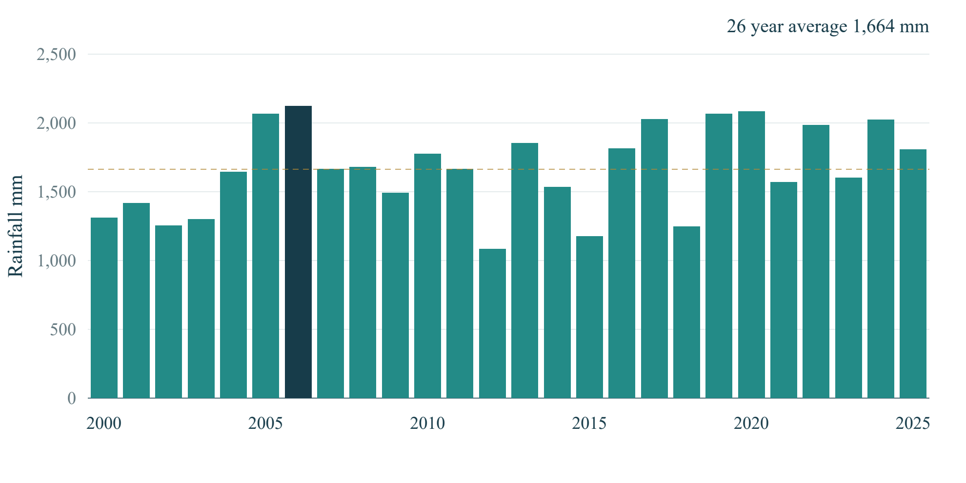
Figure 1 Annual rainfall totals near Mumbai from 2000 to 2025
Totals range from 1,084.7 mm in 2012 to 2,122.8 mm in 2006. The dotted line marks the 1,663.5 mm period mean. This variation supports inspecting individual years rather than treating one annual climate value as a weather history.
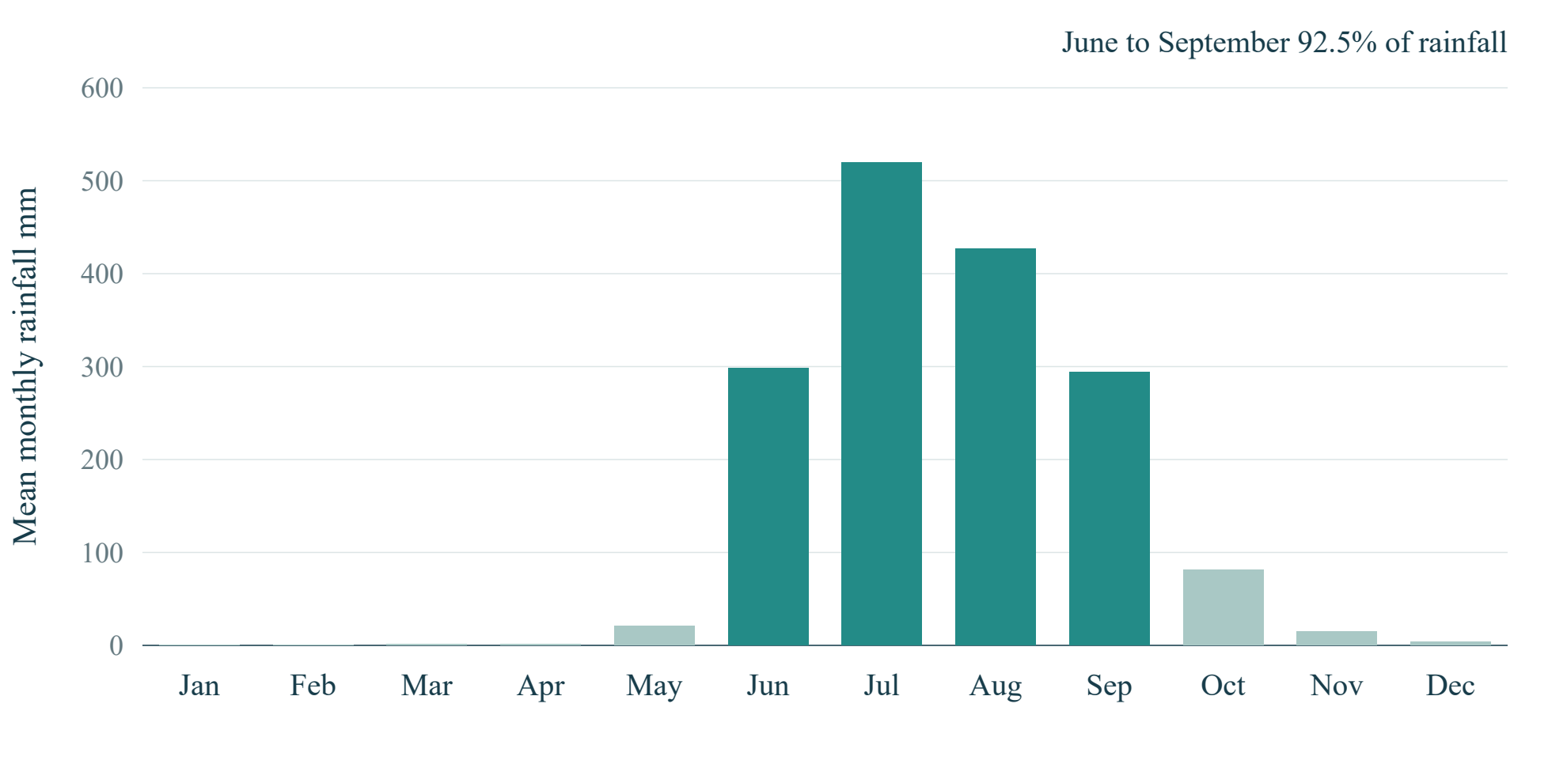
Figure 2 Mean monthly rainfall near Mumbai from 2000 to 2025
July has the highest mean monthly total, 519.3 mm. June–September together contribute 92.5% of rainfall. The concentration explains the prominent seasonal pattern; it does not mean that every rainy-season day floods.
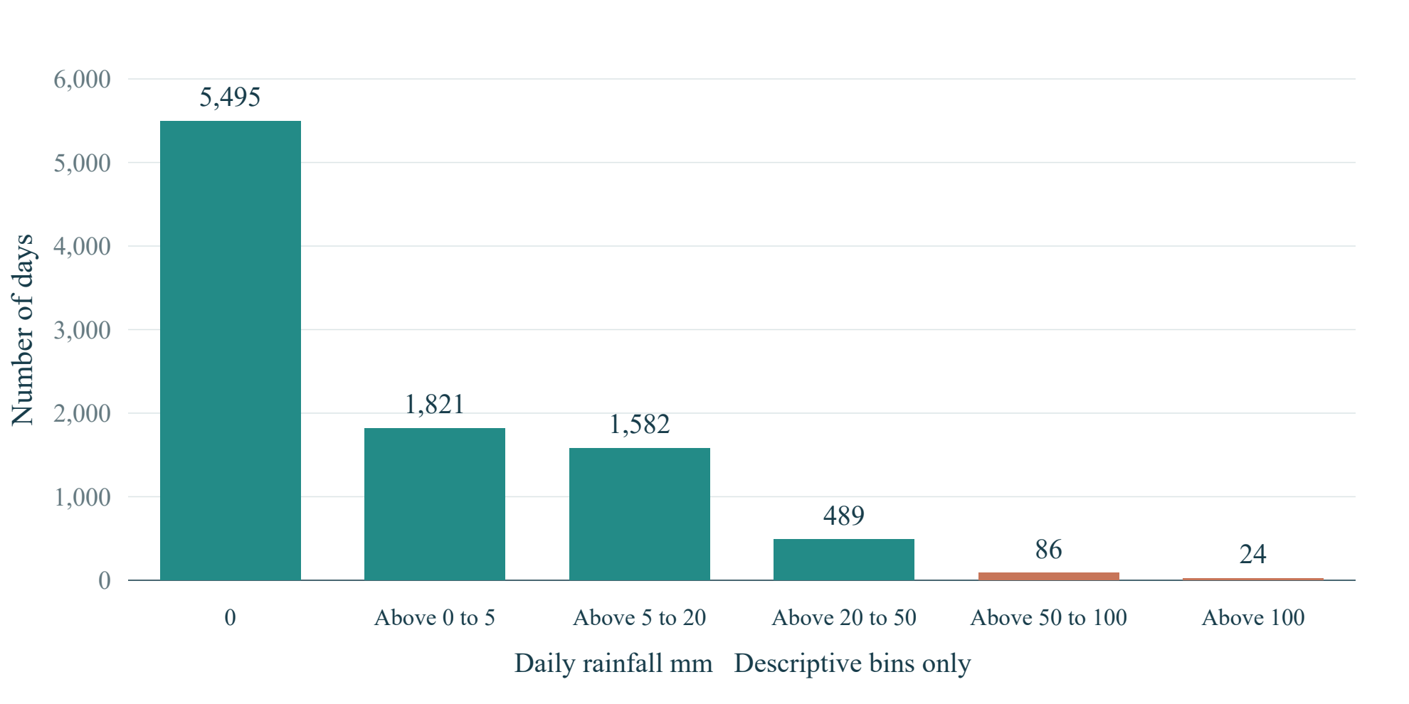
Figure 3 Daily rainfall frequency across the complete archive
There are 5,495 dry days, 4,002 days with rain and 24 days above 100 mm. A zero median coexists with a 209.6 mm maximum. The bins describe rainfall frequency only and are not flood-risk categories or event labels.
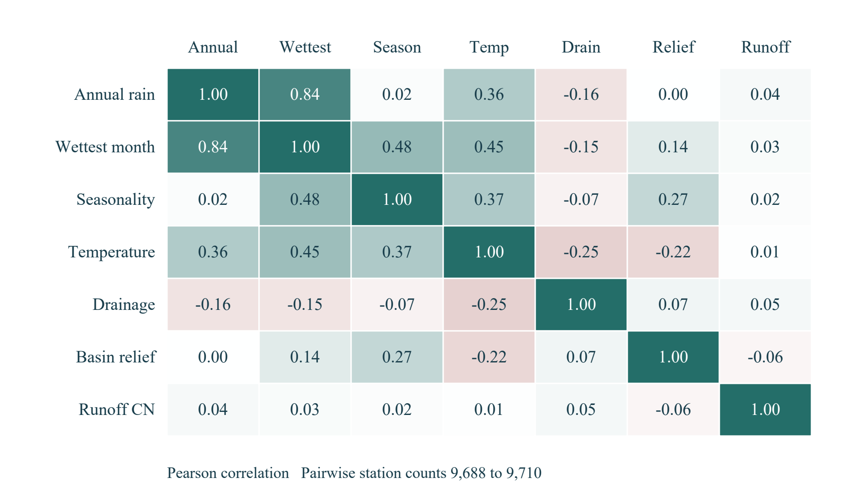
Figure 4 Correlations among static attributes at unique source stations
Annual rainfall and wettest-month rainfall have Pearson correlation 0.837. Pairwise sample counts range from 9,688 to 9,710 because some fields are missing. Overlapping information matters for later model design; correlation alone establishes neither causality nor forecast skill.
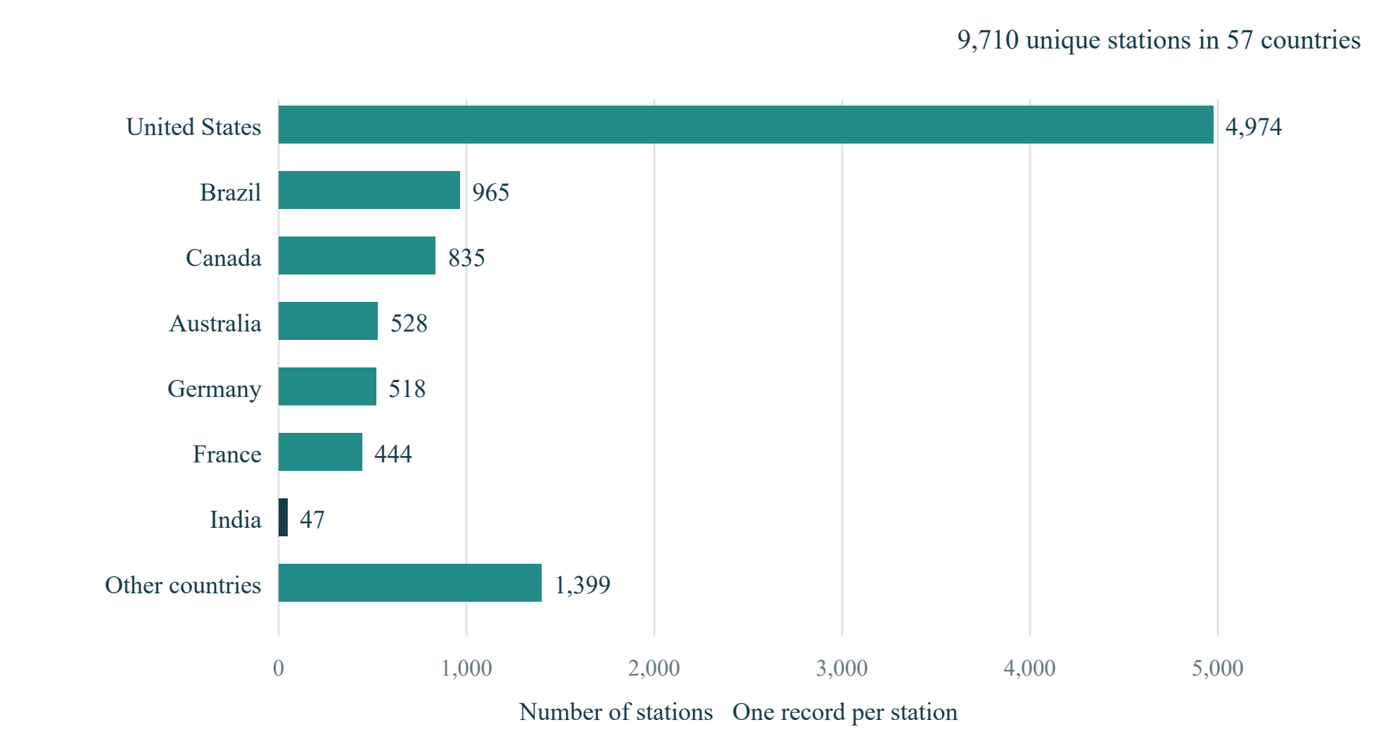
Figure 5 Geographic coverage of the supplied GloFlo station catalog
Counts use one record per gsim_code. The United States contributes 4,974 of 9,710 stations (51.2%). India contributes 47 stations (0.48%) and 146 flow records. The remaining-country bar groups all countries not individually named. This imbalance describes source coverage and does not measure flood frequency.
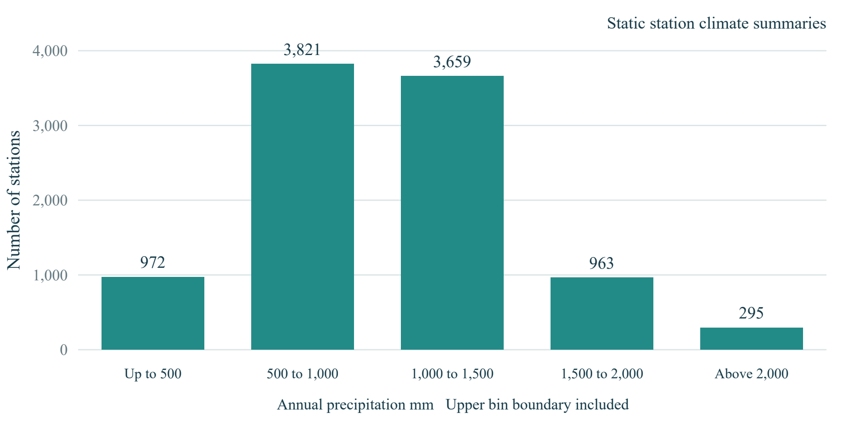
Figure 6 Annual precipitation distribution across unique source stations
The five intervals contain 972, 3,821, 3,659, 963 and 295 stations. Station annual precipitation ranges from 106.2 to 5,413.7 mm, with mean 1,039.1 mm and median 1,007.1 mm. These values are static climate attributes repeated across station records and must not be interpreted as a daily or yearly rainfall sequence.

5.4 Discussion and practical implications
We found that the GloFlo rainfall fields are constant within each station across its repeated records. Consequently, grouping those fields by the source year would not reconstruct rainfall history. We use the separate dated ERA5 archive for seasonal and annual rainfall analysis, and the supplied CSV for environmental attributes and peak-flow context.
The two data sources answer different questions. GloFlo describes station environments and selected flow extremes, while ERA5 provides a daily rainfall sequence near a chosen location. A peak-flow record is not automatically a labelled flood, and the absence of a record is not a verified non-flood. Any future predictive study must first define its target and evaluation population.
The station distribution is concentrated in the United States, and the India subset contains only 47 stations. Static annual precipitation and wettest-month precipitation are strongly associated, with Pearson r = 0.837. We interpret this as overlapping climate information. It neither demonstrates causation nor establishes that the classifier generalises to new locations.

6. Conclusion
We developed a dashboard that combines historical rainfall exploration with environmental risk scenarios. Our supplied-file evaluation describes 45,932 records, 9,710 stations and 93 variables, while six figures explain rainfall patterns, station coverage and attribute relationships. The separate daily archive shows strong June–September seasonality near Mumbai. The CSV supports descriptive environmental and flow analysis, but lacks the verified event labels required for independent flood-classifier evaluation. These findings define the project’s current analytical contribution and the outcome data required for further modelling.

7. Limitations and Future Work
The supplied CSV has no verified flood/non-flood target, incomplete year coverage by station, substantial geographic imbalance and missing values in several attributes. It contains static climate summaries rather than daily rainfall measurements. The detailed rainfall series is limited to one cached gridded location and does not represent gauge or basin-average rainfall. The model’s original split and fitted preprocessing provenance are unavailable, so independent predictive metrics and calibrated warning thresholds remain unestablished.
Future work should establish a scientific flood/non-flood definition and monitored non-event periods, resolve source variable scales and choose an evaluation design appropriate to new locations or future dates. Model preprocessing and any imbalance treatment should use training data only. A separate peak-discharge regression study could use the continuous source variable with station-aware evaluation; rainfall forecasting would require causal daily features, chronological held-out periods and simple baselines.

8. References and Appendix
[1] Kuntla, S. K., Saharia, M., and Kirstetter, P. (2022). Global Flood characterization GloFlo Database. Zenodo. https://doi.org/10.5281/zenodo.7158028
[2] Kuntla, S. K., Saharia, M., and Kirstetter, P. (2022). Global-scale characterization of streamflow extremes. Journal of Hydrology, 615, 128668. https://doi.org/10.1016/j.jhydrol.2022.128668
[3] Open-Meteo. Historical Weather API documentation. ERA5 daily rain_sum in mm. https://open-meteo.com/en/docs/historical-weather-api. Accessed 24 October 2026.
[4] Open-Meteo. Terms and Privacy. Non-commercial API use and CC BY 4.0 attribution conditions. https://open-meteo.com/en/terms. Accessed 24 October 2026. The GloFlo record is public; its redistribution terms should be confirmed before republishing the raw data.
[5] scikit-learn developers. Metrics and scoring quantifying the quality of predictions. https://scikit-learn.org/stable/modules/model_evaluation.html. Accessed 24 October 2026.
[6] Chauhan, N. Flood prediction Model repository. https://github.com/nitinc264/Flood-prediction-Model. Baseline source and pretrained model adapted for our application. Source commit 2d823f3692e891ac92de4435bbe2c006131c30b3.
Reproducibility appendix
We retained the dataset preparation workflow in scripts/prepare_historical_data.py. The supplied-file evaluation is recorded in reports/report_work/supplied_dataset_evaluation.json. Report statistics and figure-generation files document the analytical calculations. The raw CSV remains unchanged, and prepared station, flow and weather tables retain their distinct roles.
From the RiskRadar folder, run .\start-riskradar.ps1 to launch the local dashboard and prediction service. The raw source is data/raw/kuntla_flooddatabase.csv. The station catalog and dated peak extract are stored in data/processed/, and the existing Mumbai daily rainfall archive is stored in data/weather/IN_0000317_era5_2000_2025.json.
The supplied kuntla_flooddatabase.csv is identical to the project’s existing raw file. Its MD5 is 4e0d207c21c54577bd5a1e176a96ed3e. Our CSV summaries use one record per station for static attributes and all applicable records for flow statistics. All-year rainfall summaries and monthly charts use the separate 2000–2025 daily archive.
Appendix checklist:
Done | Checklist item | Brief evidence / notes
☑ | Dataset source and citation included. | References 1 to 4 provide source citations and usage context.
☑ | Important code/notebook or repository link provided, if required. | Reference 6 and the reproducibility appendix identify the code and source commit.
☑ | Additional graphs, tables or diagnostic outputs attached where useful. | Six figures, descriptive distributions and source-specific interpretations are included.
☑ | No confidential, personal or restricted data disclosed. | No credentials or private records are included. Personal contribution/signature fields remain blank for completion.

9. Team Members and Individual Contributions
Complete the actual team details, work performed and contributions below. Contribution percentages, if used, must sum to 100%.
S. No. | Member name / Roll No. | Tasks / Life-cycle stages handled | Specific contribution / deliverable | Approx. contribution (%)
1
2
3
4
Contribution areas may include problem definition, data collection, preparation, EDA, interface work, model integration, interpretation, report writing and presentation.
Member name / Roll No. | Confirmation of contribution | Signature (if required)
Team declaration: We confirm that the contribution details above accurately represent the work completed by each team member.
Team leader name and roll number __________________________ Date ______________

